Exercise: Computer Systems and Software - Git
Problems for exercises and homework for the "Software Technologies" course @ Software University

Note
Keep in mind that some of the steps might be slightly different. We assume that if you are considering exploring the QA profession, you have the basic skills to download, install, register and find workarounds in various software programs, without any difficulties.

What is it and why you need it
Git is a distributed version control system that allows developers to track changes in their code and collaborate with others. It is platform-agnostic and can be used on various operating systems, including Windows, macOS, and Linux. It is a useful tool for enhancing testers' efficiency and collaboration by providing version control and traceability for test artifacts, facilitating teamwork and streamlining the testing process.
Git for Windows, is a specific distribution of Git that is tailored to work seamlessly on the Windows operating system.

How to install
1. Navigate to https://gitforwindows.org/ and click Download
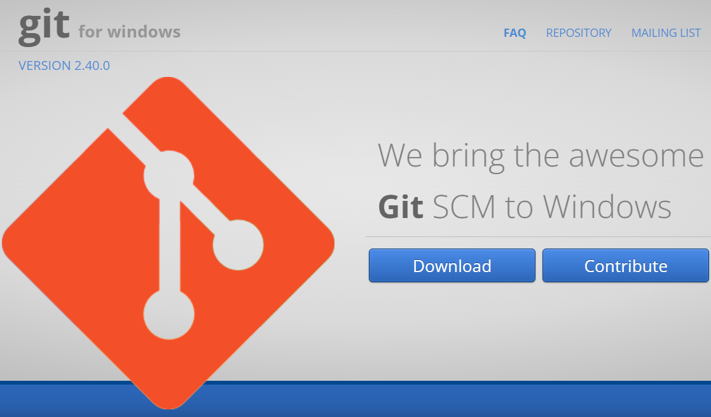

2. The .exe file will be downloaded to your browser.

If you need the 32-bit version, go to:
https://github.com/git-for-windows/git/releases/download/v2.40.0.windows.1/MinGit-2.40.0-32-bit.zip

3. Double click on .exe file to initiate the installation process. When prompted by Windows, give permission to make changes. You will get a General Public License Information screen. Click "Next" button.
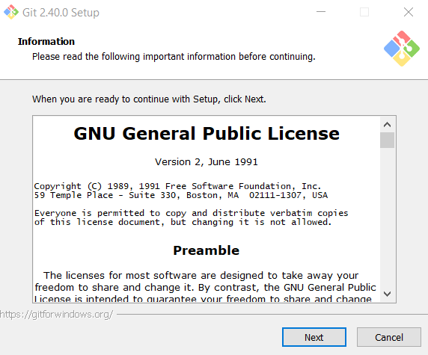

4. Choose the desired path where you want to install Git.
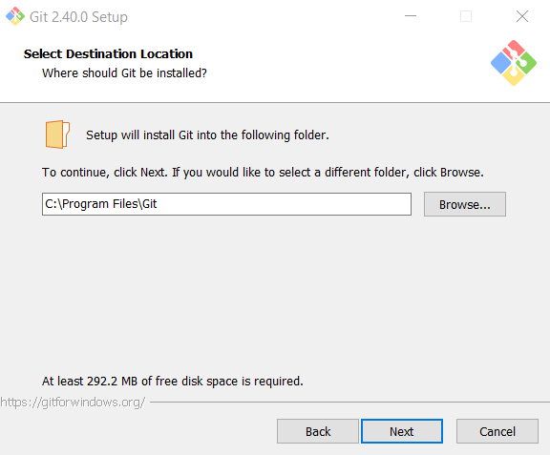

5. Leave the Select Components screen as it is. Don't change anything. Click Next.
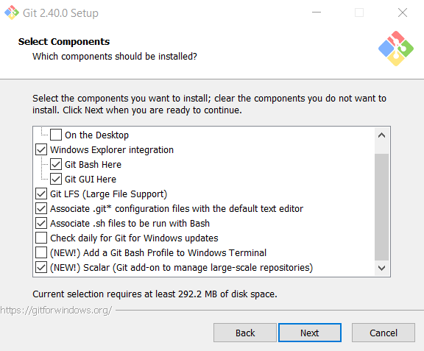
6. Select Start Menu Folder or not to create Start Menu Folder
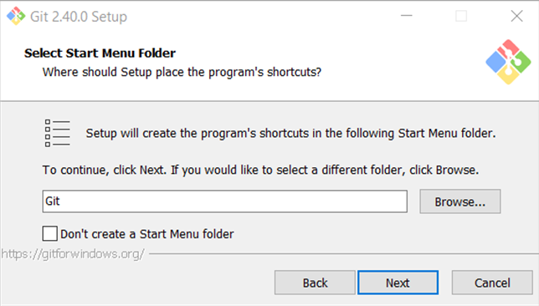

7. Choose Notepad or Notepad++ for the default editor.
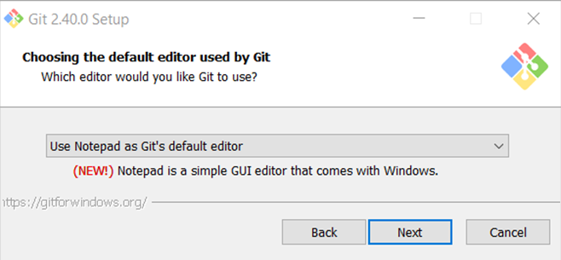

8. Let Git decide for the initial branch.
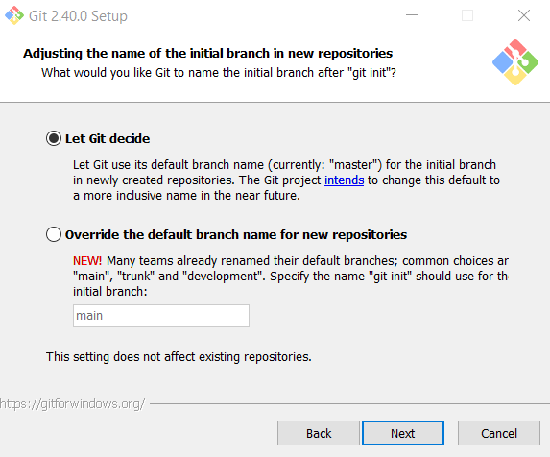

9. Choose the second option to be able to use Git from Command Prompt.
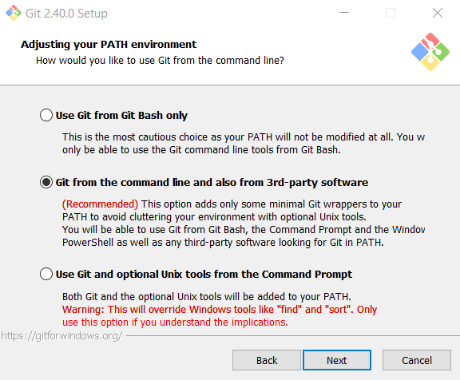

10. Leave this option as it is.
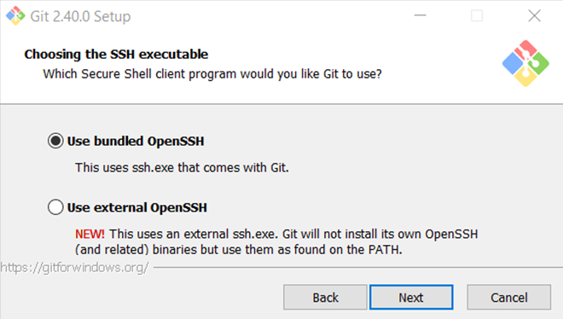

11. Leave this option as it is as well.
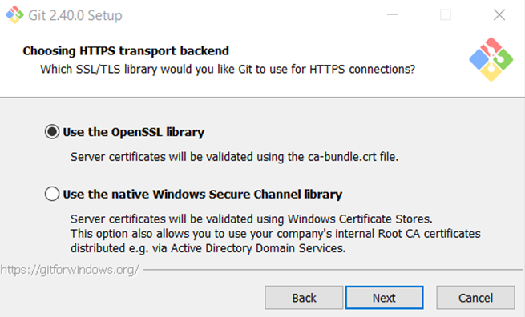

12. This one stays the same as well.
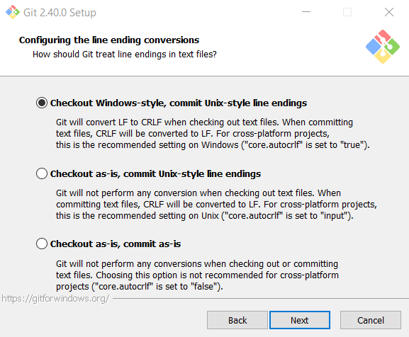

13. Select Use Windows' default console window option.
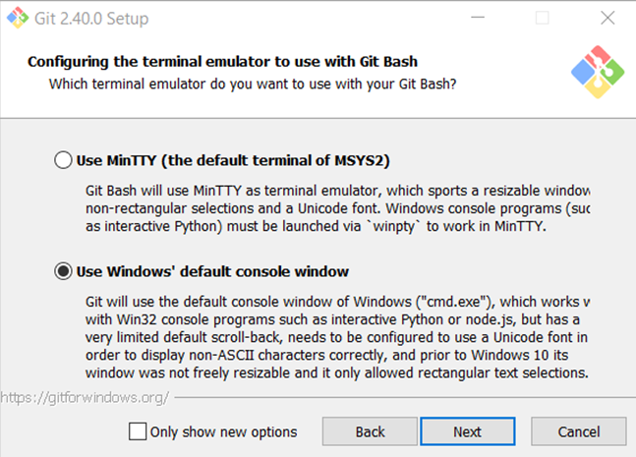

14. Default behavior – Default.
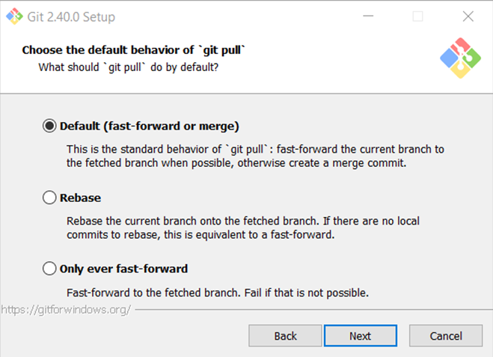

15. Git Credential Manager
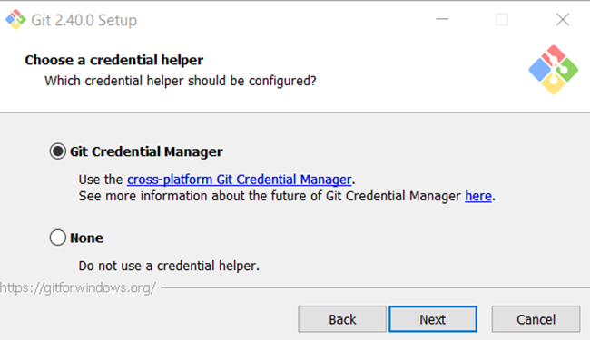
16. Enable file system caching
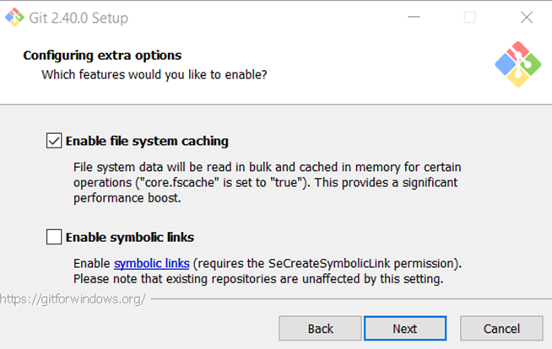

17. Leave the experimental options unchecked. Click Install.
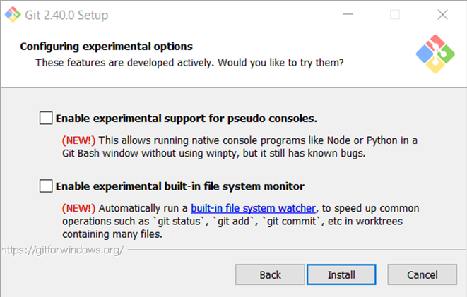

18. Installing…
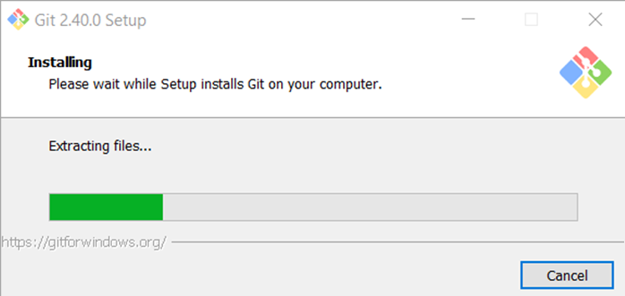

19. Complete the setup by pressing Finish.
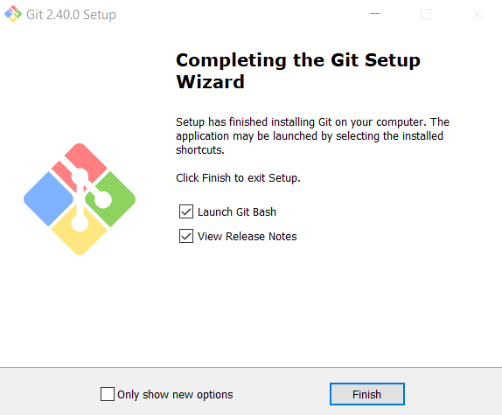

Check Git version
To check the Git version, run the following command:
- from the command prompt git version
- from git bash $ git –version

Turn on/off Copy/Paste options
Keep in mind that by default copy/paste options in git bash are disabled, so in order do use them, you have to right-click on the title bar and choose properties.
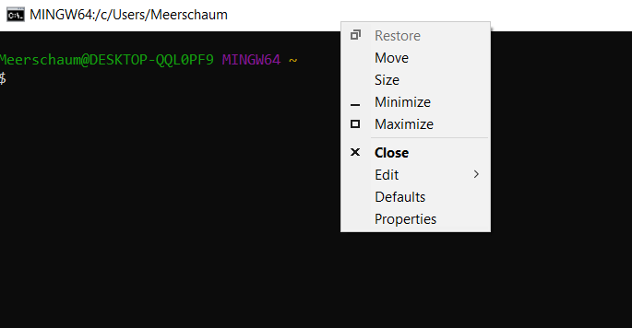
A new window will pop up, where you should make sure that the following option is checked:
Use Ctrl+Shift+C/V as Copy/Paste
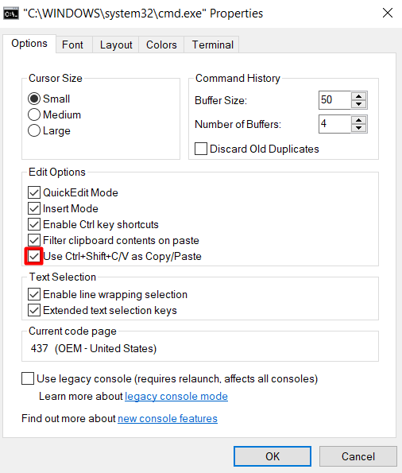

Clone GitHub repository
For the following exercise you can use command prompt or git bash. The syntax is very similar. We are using Git Bash, since it's colourful.

To change directories, use the command cd followed by the name of the directory. In our case we would like to clone the repository on drive D, so we're navigating to D:// by typing the following command:
$ cd d://
Now, on drive D, we want to create a folder in which to store the cloned repo. We do this by the following command:
$ mkdir MyFirstGitClone
Let's check if the folder is successfully created. We will try to open it. Type:
$ cd MyFirstGitClone
Now that we have our folder ready, we need a repo to clone. Don't worry if you don't have GitHub profile for now. Navigate to our demo repository https://github.com/QA-Automation-Testing-Demo/GitDemo and click on the green button, labeled "Code" and copy the address of the repo.
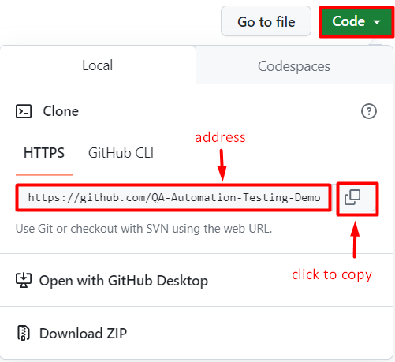

So now that we have our folder ready and our repository ready, let's clone. Type:
$ git clone https://github.com/QA-Automation-Testing-Demo/GitDemo.git
This is how the whole sequence of commands should look like:
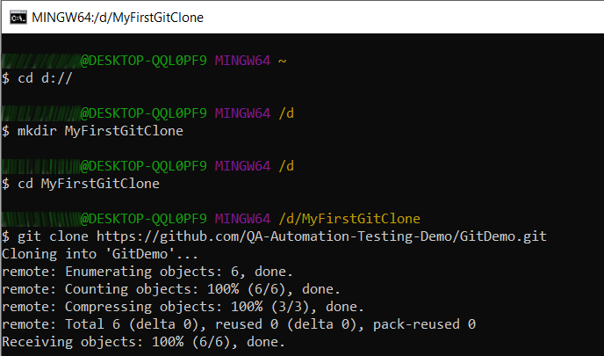

You can check vie Windows Explorer if everything is as it should be.
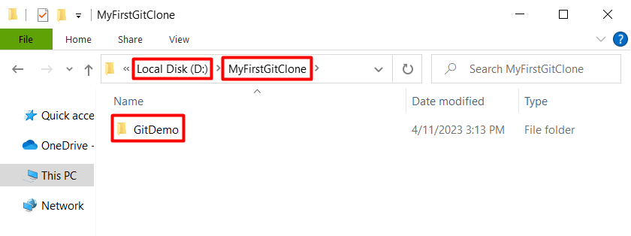
In GitDemo folder there should be a file called GitDemoFile, which you can open with Notepad.

