Exercise: Computer Systems and Software –
MySQL, Workbench
Advanced exercises for the "Software Technologies" course @ Software University

Note
Keep in mind that some of the steps might be slightly different. We assume that if you are considering exploring the QA profession, you have the basic skills to download, install, register and find workarounds in various software programs, without any difficulties.

What is it and why you need it
MySQL Workbench is a visual tool for database design, management, and administration, while MySQL Server is the actual database management system that stores, manages, and retrieves data. QA engineers need these tools to create, manipulate, and verify databases during testing, ensuring that the application's data-related functionalities work correctly and meet requirements.

How to install
1. Navigate to the official download site https://dev.mysql.com/downloads/installer/. Choose your operating system and click one of the two download buttons. It doesn't if you choose mysql-installer-web-community or mysql-installer-community. They are quite the same. The first one downloads the files needed while installing them, the other pre downloads the files needed and then installs them.
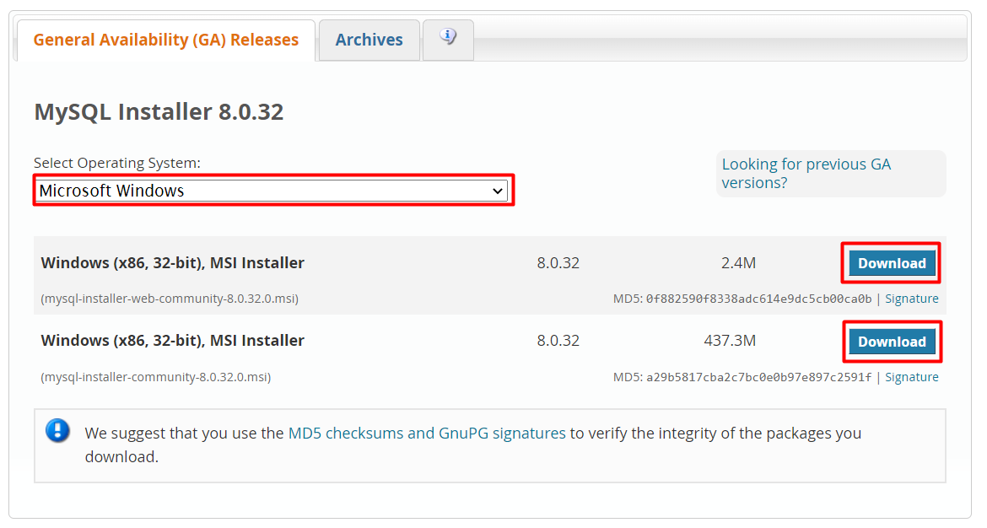
2. On the next page you will be prompted to Login or Sign up. Just skip this step.
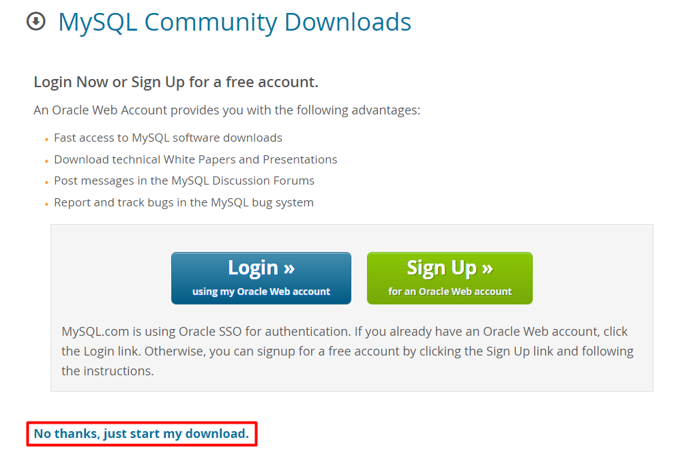
The .msi file will be downloaded to your browser.
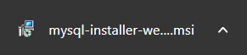
3. Open installation file and choose Setup type to be Custom. Then click Next.
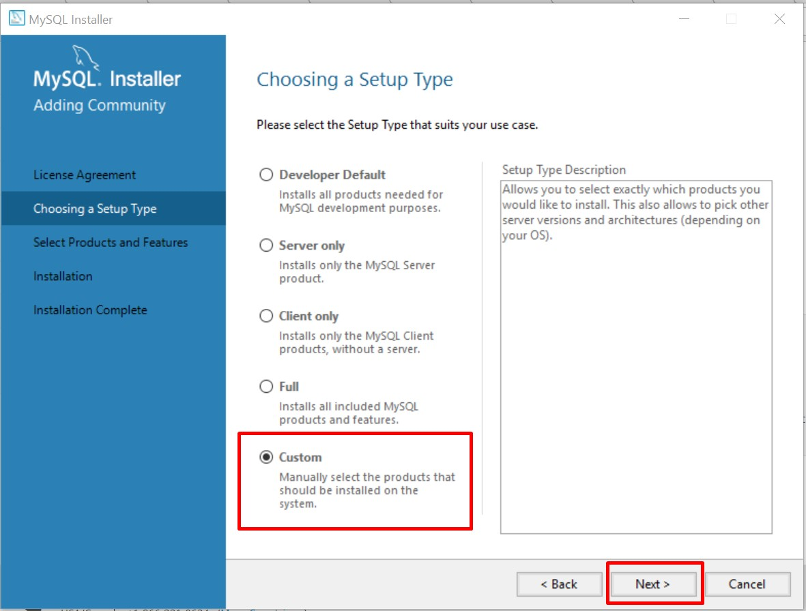
4. All the features we need are MySQL Server, MySQL Workbench, Connector/J, Connector/NET and MySQL Workbench. All other features are optional and won’t be needed for now.
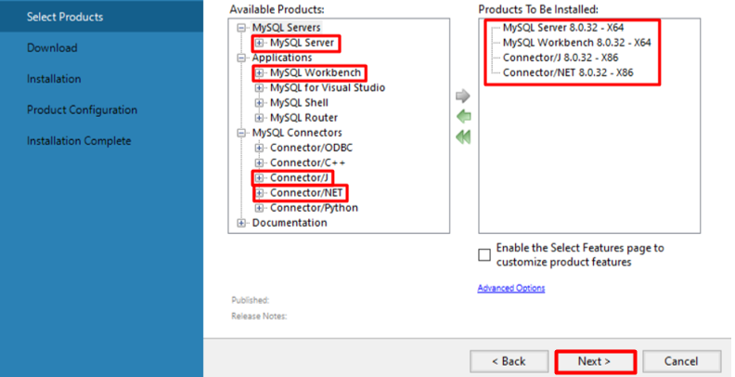
5. Click Execute and the setup will download the selected features.
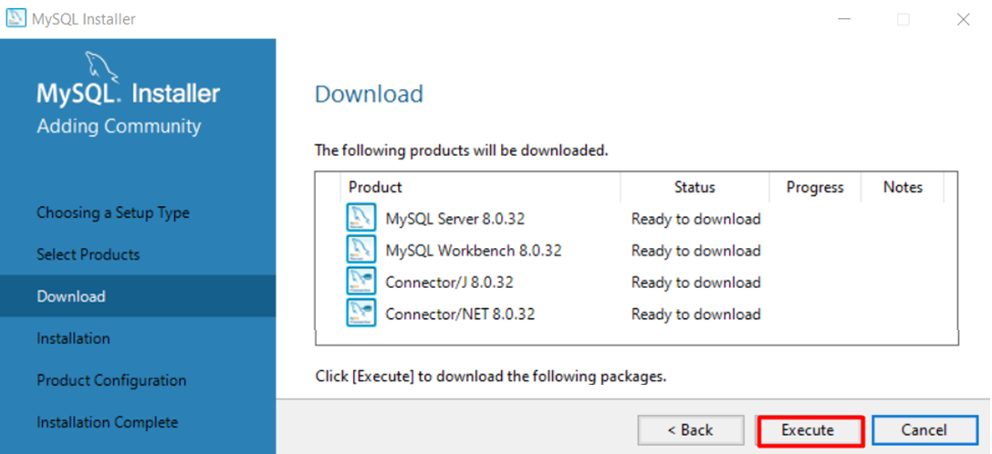
6. Wait for the downloads to complete. Click Next
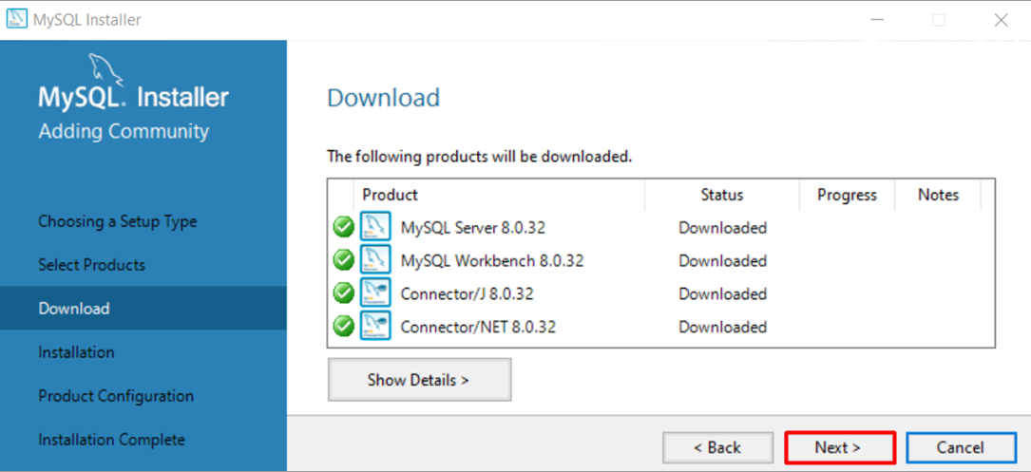
7. Click Execute to install the files.
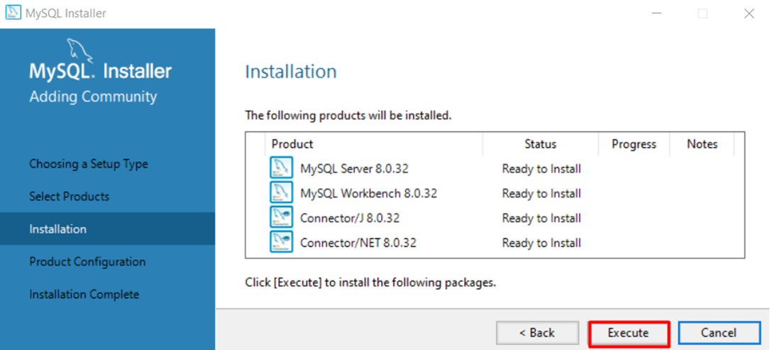
8. Wait for the installation to complete and click Next to start configuration wizard.
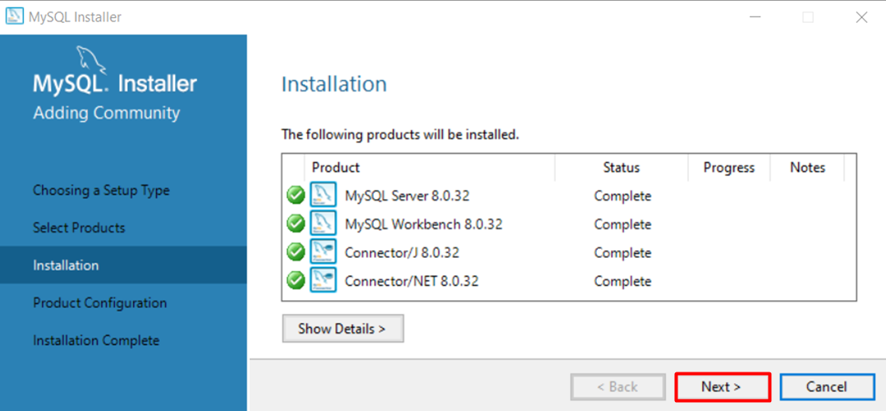
8. Now, you have to configure your product. Click Next.
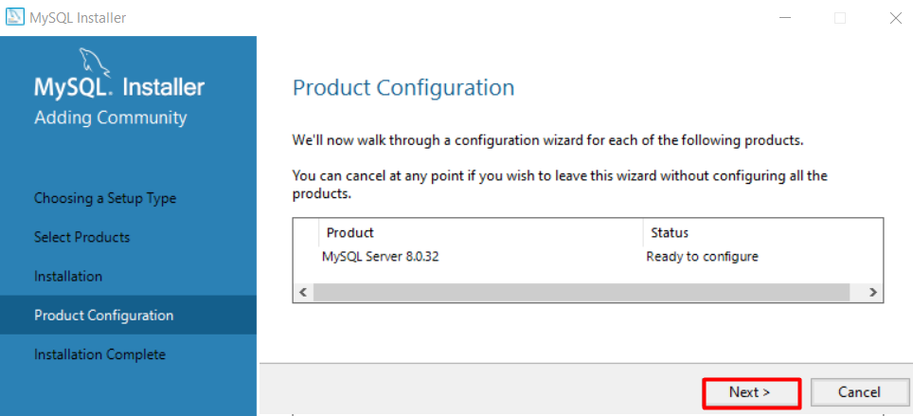
9. Choose the configuration type to be a Development Computer and click on Next.
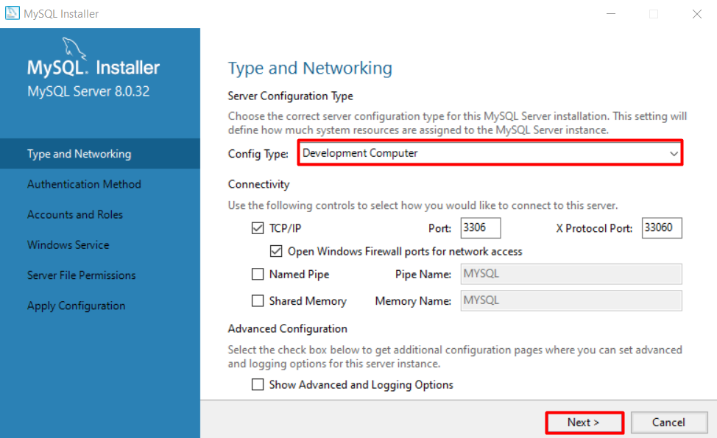
10. Choose Authentication method and click Next.
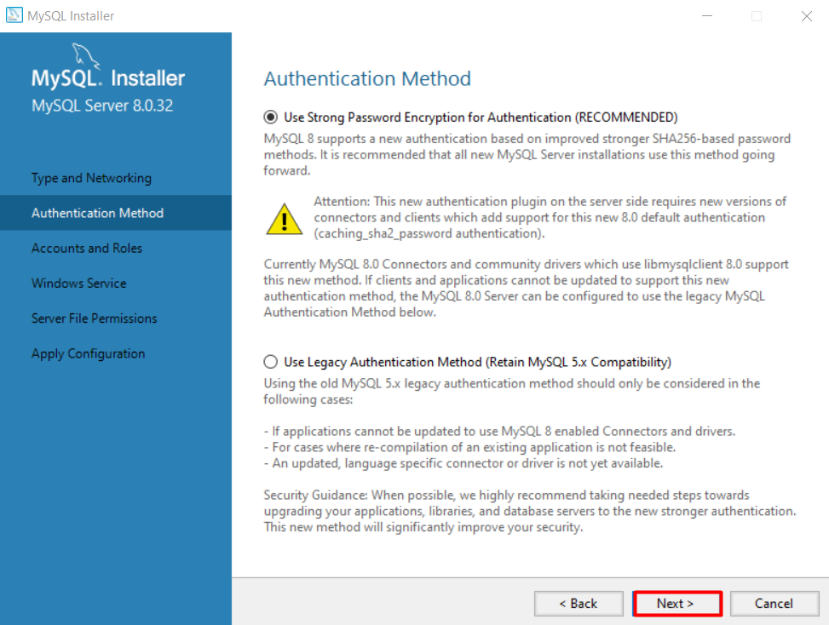
11. Set password to the Root account and click Next.
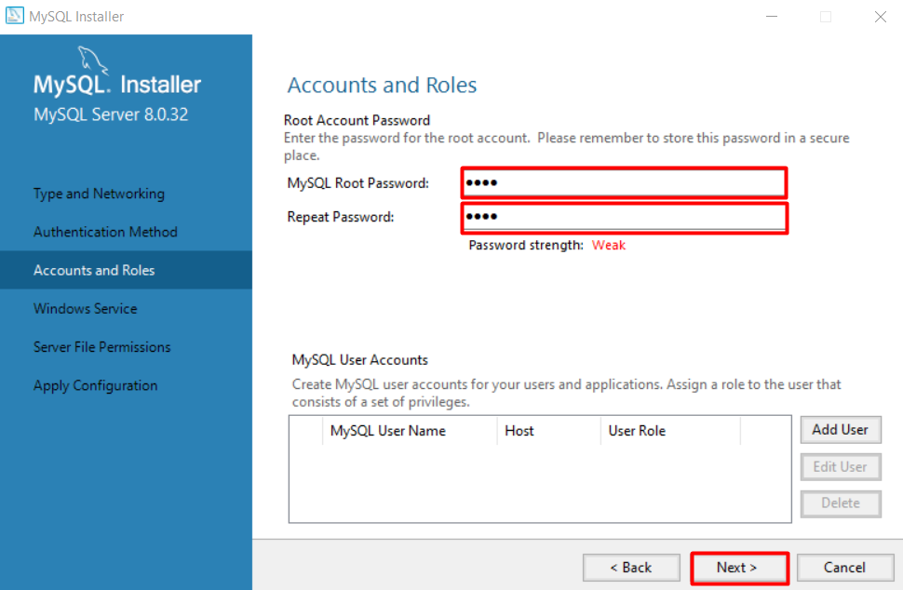

12. Here you can set the MySQL Server to run as Windows Service and to start automatically at Windows start up. Otherwise, you must start up MySQL every time before working with a database. Decide whichever suits you best.
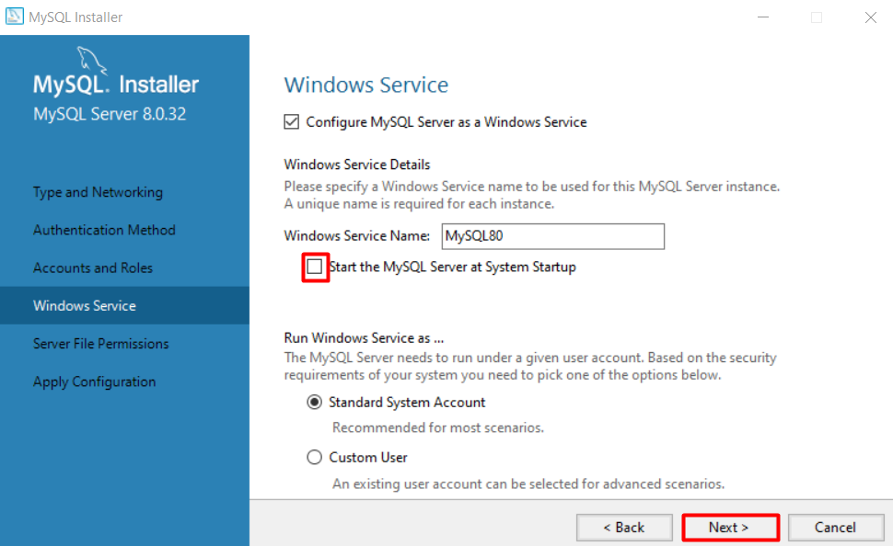
13. Server File Permission – Leave the chosen option as it as it is. Next.
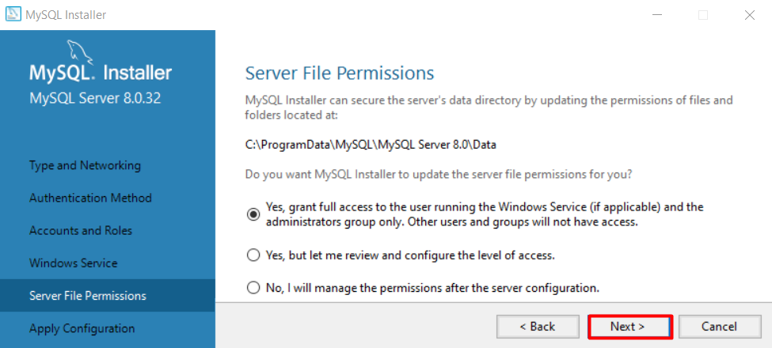
14. Hit Execute and wait for the Configuration to be applied.
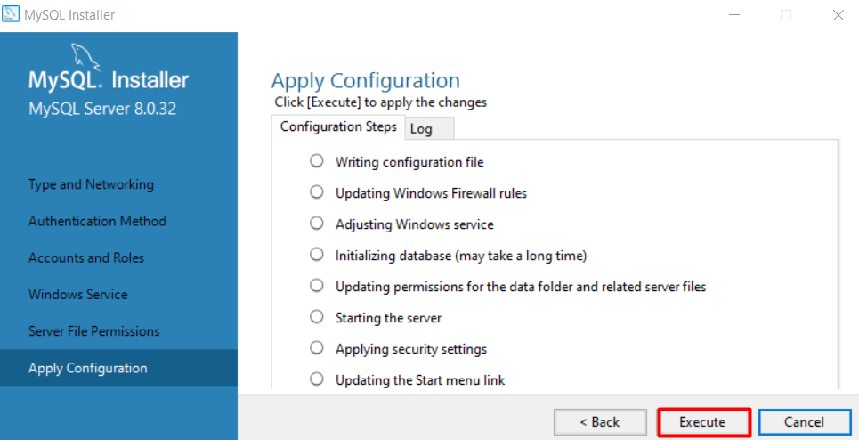
15. Click Finish.
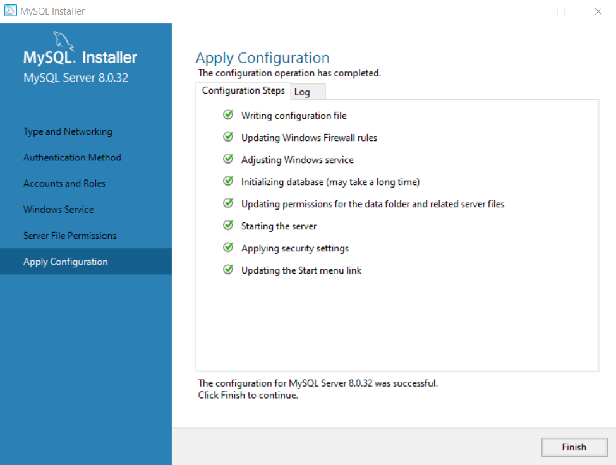
16. Another Next.
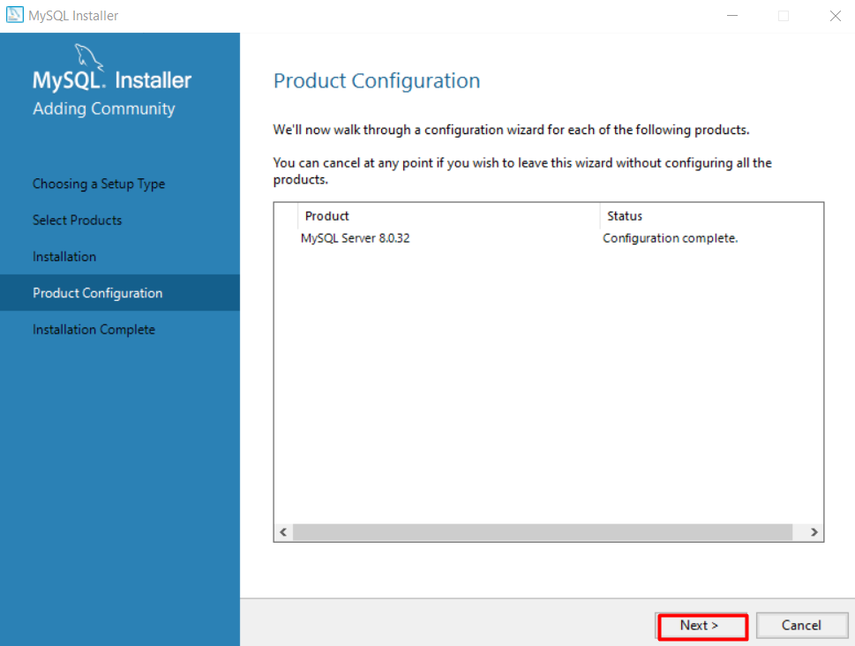
17. And one final Finish.
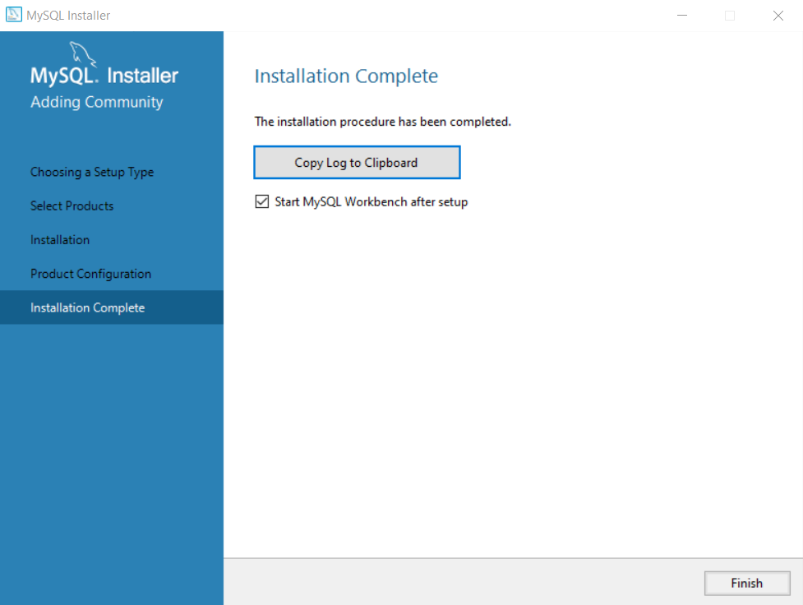

Simple Database and queries
1. Open Workbench and connect to the local server.
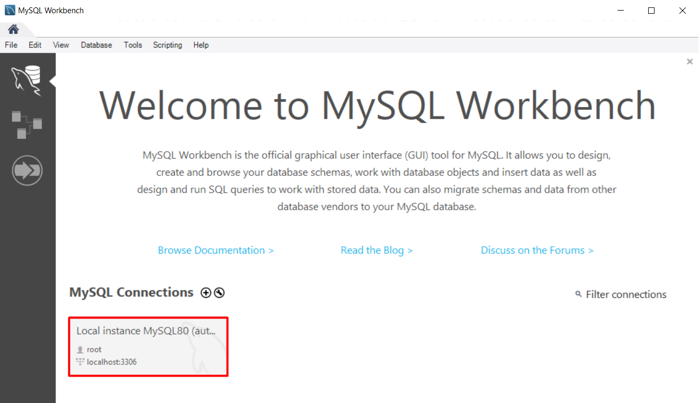
2. Enter the password you previously created.
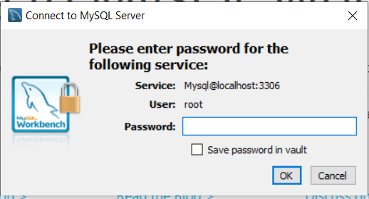
3. This is how Workbench looks like.
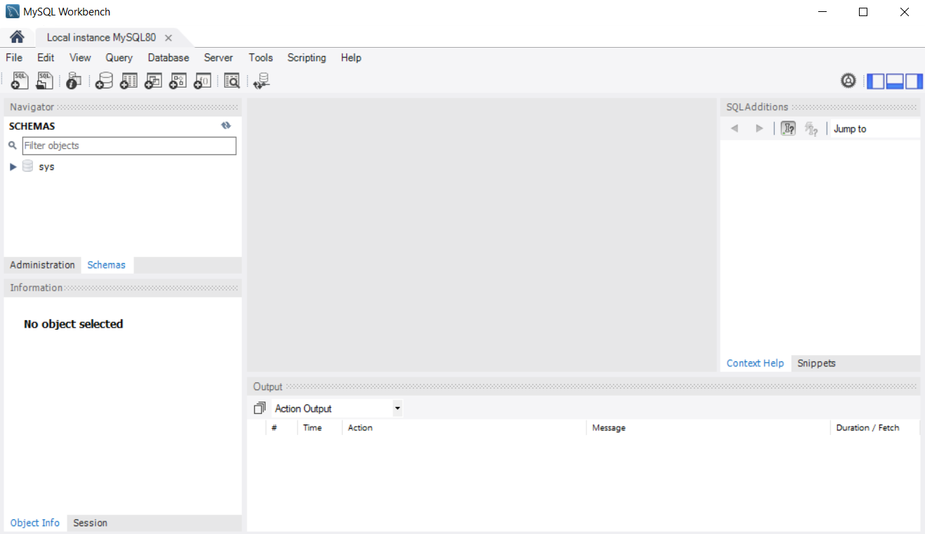
4. You can check the status of your server if you'd like.
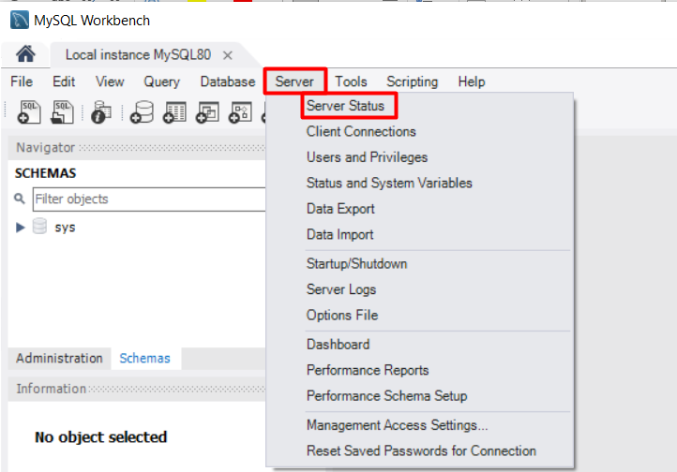
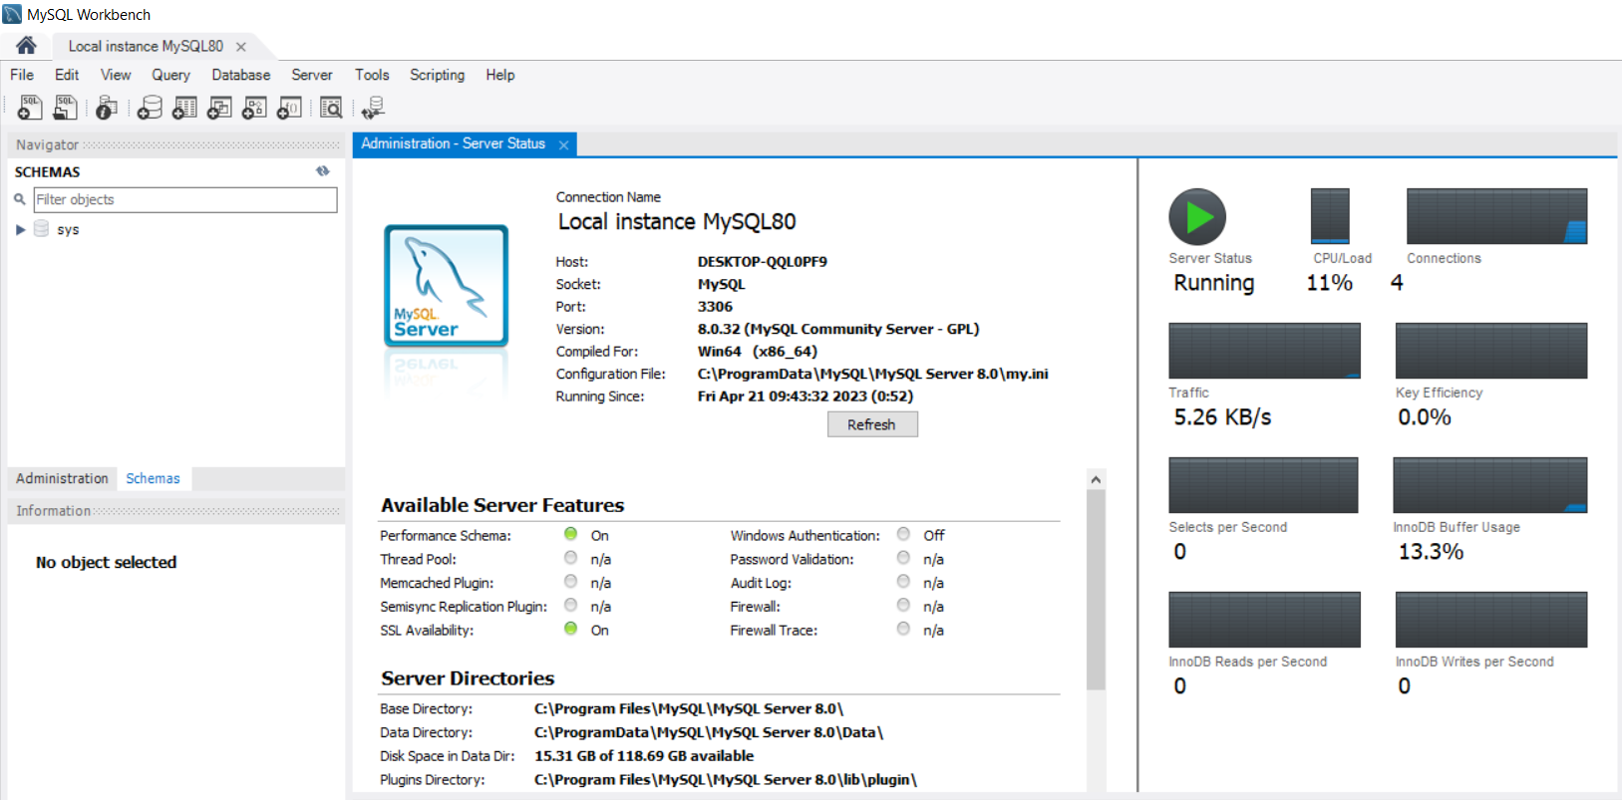
5. Now, we will open an existing SQL script, which will create a simple database, containing just one table and populate it with records. You are provided with the file "01.Computer-Systems-and-Software-Exercise-MySQL-Database.sql". You can open it in two ways:
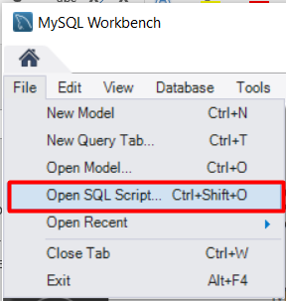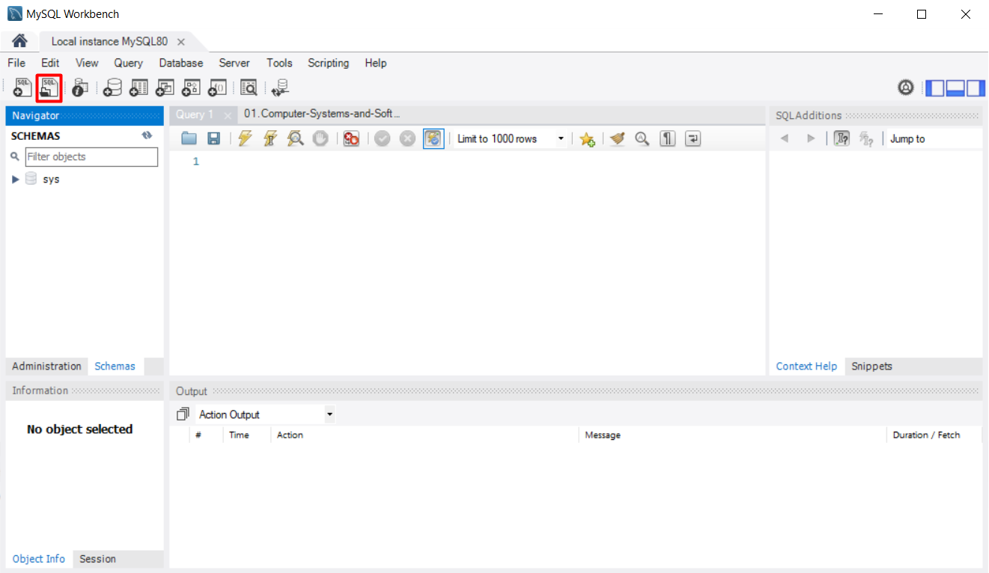
6. This is how the file would look like when you open it.
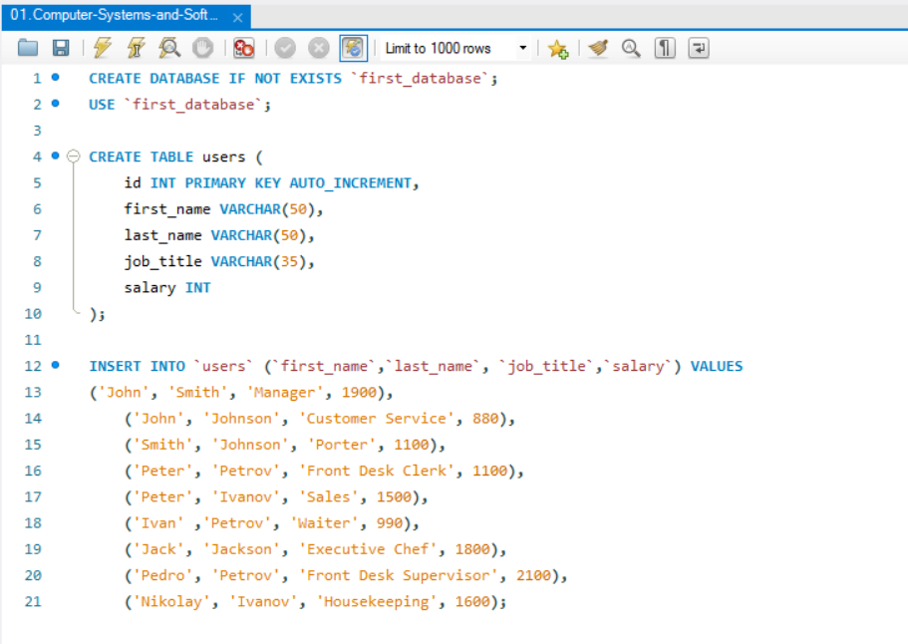
7. As you can see SQL is very logical and user friendly. The given script will create a database called "first_database" (if such database doesn’t already exist), then it will use the database to create a table "users" in it. Each user will have an id, first_name, last_name, job_title and salary fields. After creating the table, it will populate it with values.
In order to run the script, hit the yellow bolt button.
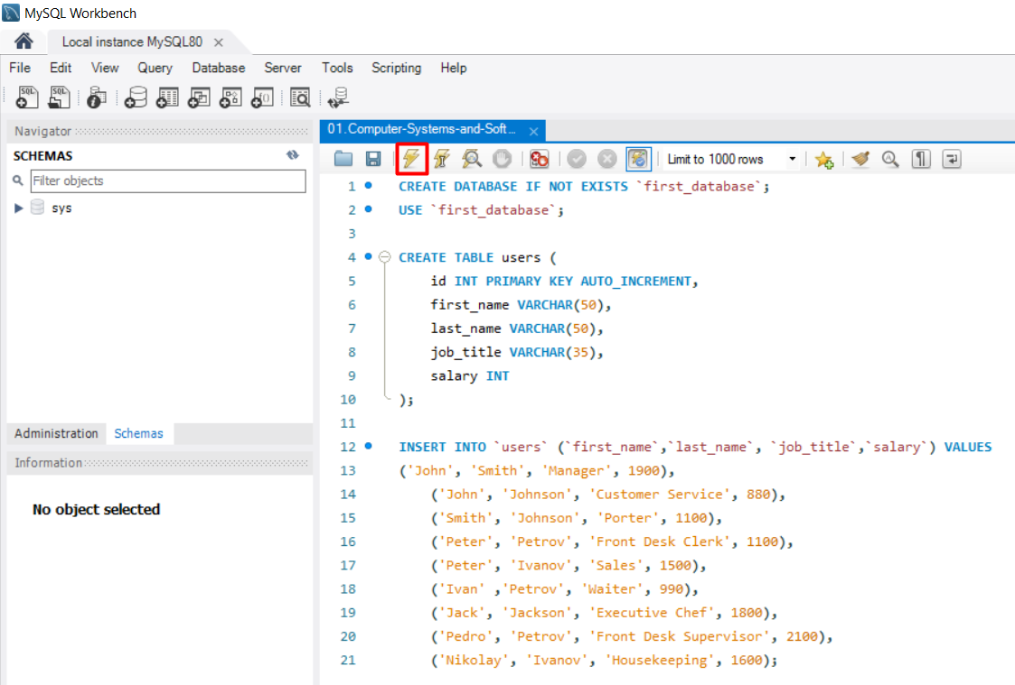
8. In the output section you should see the commands executed.
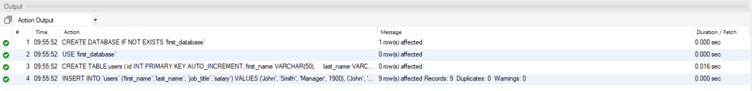
9. Hit the refresh button to see the newly created database.
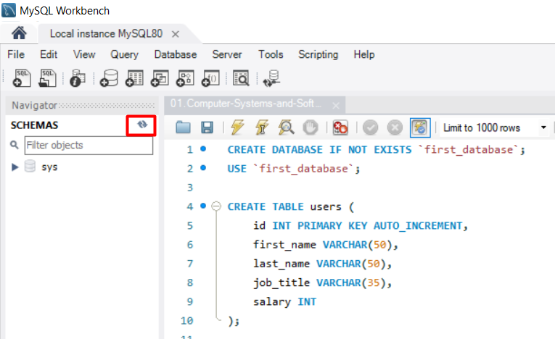
10. As you can see, the database was created with all it's attributes. Now, let's see how it looks like and write a few queries. Click on the "Create a new SQL tab…" button.
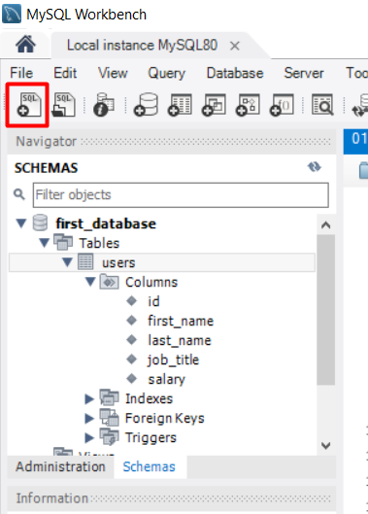
11. Now, we will select all the records from "users" table. Write the following query:
SELECT * FROM users;
Now hit the other bolt button, which has something like an "I" sing on it.
Note: The difference between those two buttons is, as follows:
 - Executes the selected portion of the script or everything, if there’s no selection
 - Executes the statement under the keyboard cursor
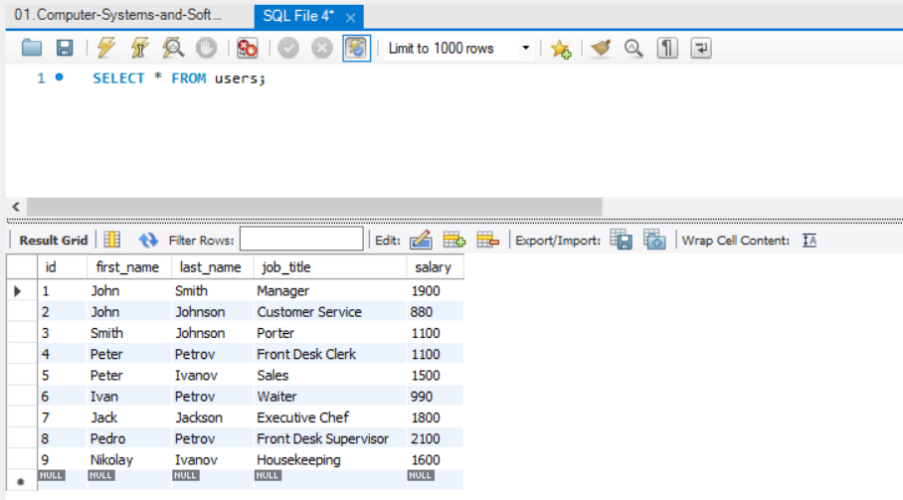
12. Now, that we know how all records looks like, let's execute a second query, which will select all records, where salary is equal or more than 1500.
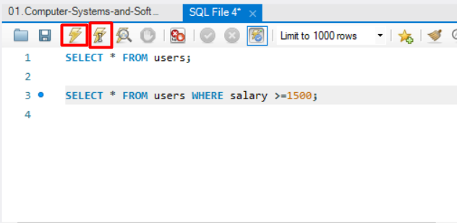
13. Try a few queries by yourself.
- Try to select all with last name "Petrov".
- Try to select all with first name "Peter".
- Try to select all with salary below 1800.

