Exercise: Computer Systems and Software -
Visual Studio Code
Problems for exercises and homework for the "Software Technologies" course @ Software University

Note
Keep in mind that some of the steps might be slightly different. We assume that if you are considering exploring the QA profession, you have the basic skills to download, install, register and find workarounds in various software programs, without any difficulties.

What is it and why you need it?
Visual Studio Code (VSC) is a free and open-source code editor developed by Microsoft that allows developers to create and edit source code for various types of applications, including web, mobile, and desktop. It supports multiple programming languages and frameworks, such as JavaScript, Python, C#, and .NET. VSC provides a unified development environment that simplifies testing, debugging, and code analysis across multiple languages and frameworks. With its rich feature set and flexibility, VSC has become a popular choice for developers and QA engineers alike.

How to install?
1. First, you will need to navigate to https://code.visualstudio.com/
For this tutorial we are installing Windows x64 version.
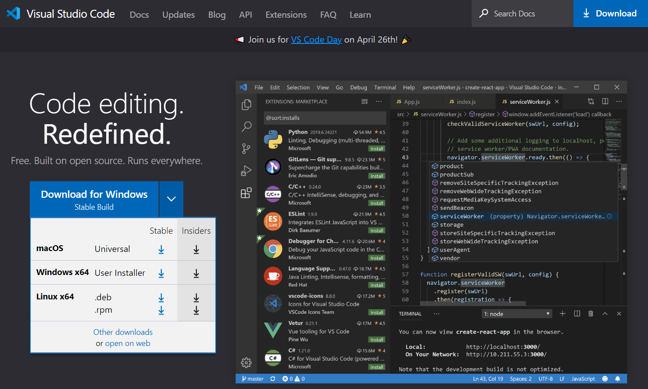

2. This will download the installation file.
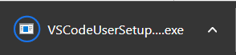

3. Open the .exe file. This will open the installer. Accept the License Agreement and hit "Next".
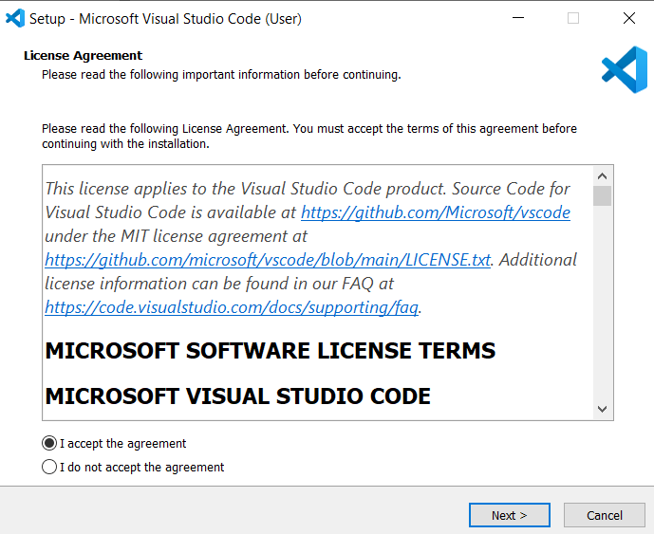

4. Choose where to install. Next.
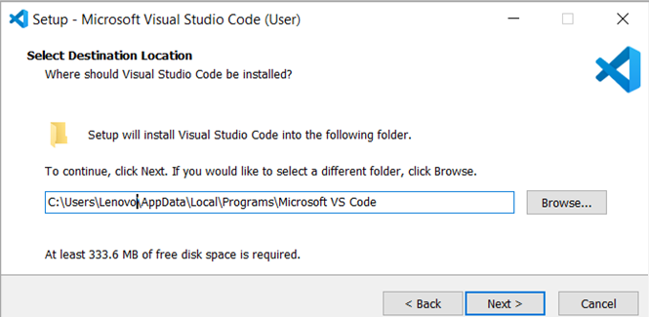

5. Choose where the shortcuts in the Start menu should be. Next.
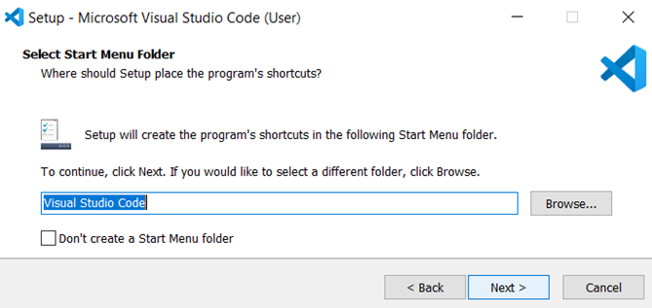
5. Check the pointed in red options. Next.
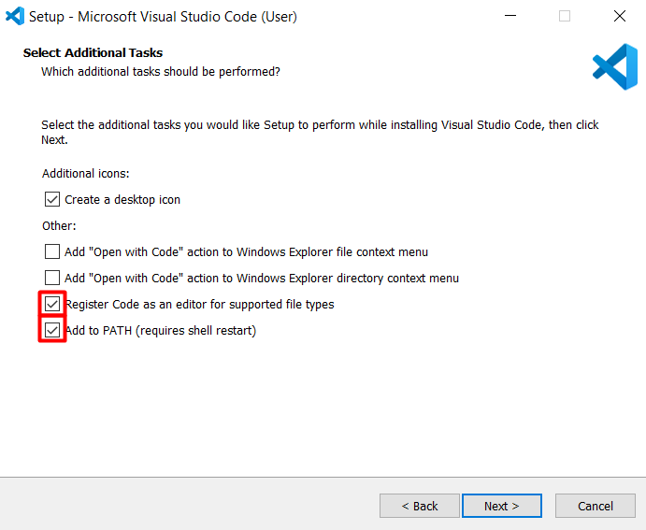

6. Check if everything is as expected. Install.
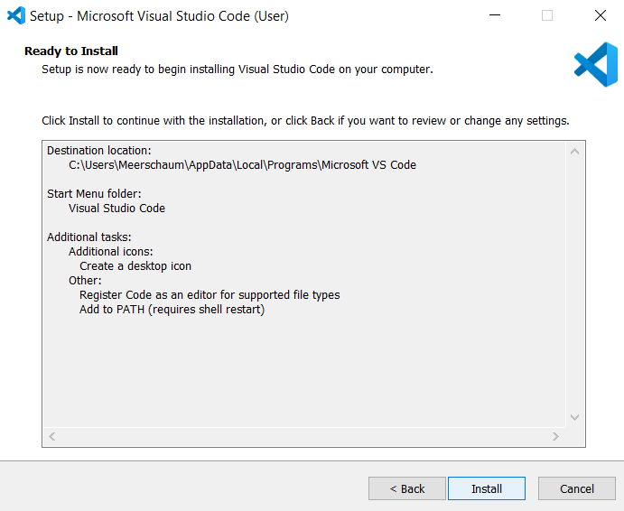

7. Check Launch Visual Studio Code. Finish.
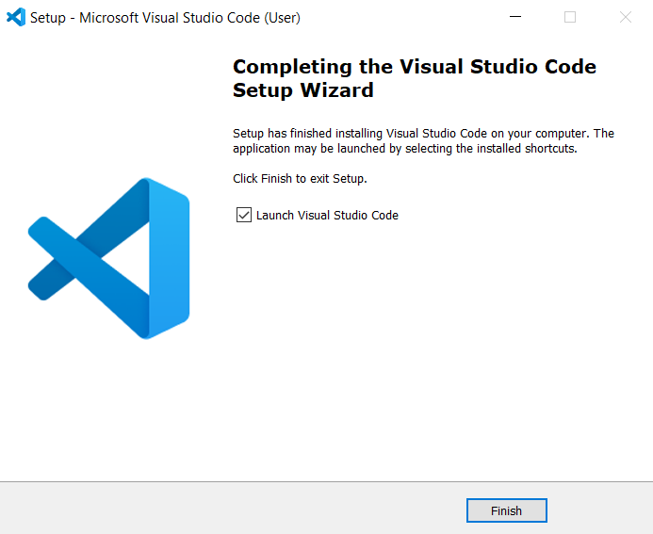

8. This is how VSC looks like.
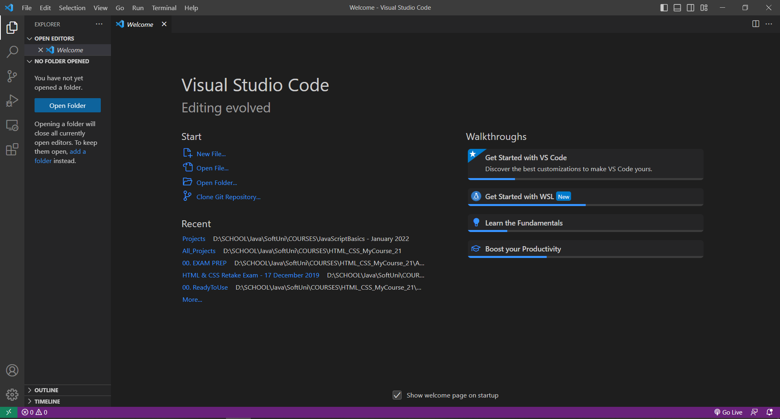

Create a sample README.md file and preview it
1. Open VSC and create a Click on "File" in the top menu and select "New File." Name the file "README.md" and press enter. Choose where to create the file.
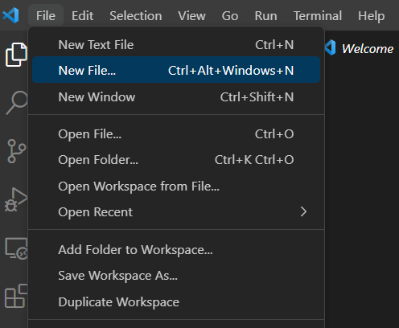

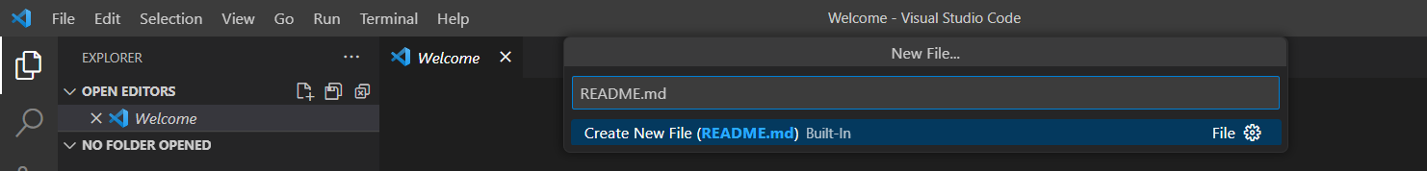

2. Paste the following in the file you just created or write one of your own. You can include information about your project, how to use it, and any other relevant details.
# Software Technologies

This is a sample QA course README.md

### Installation
Instructions for installing the required tools and software for the course.

### Usage
Instructions for using the sample code and exercises to practice QA testing.

### Contributing
Guidelines for contributing to the course repository.

### License
Information about the license for the course.

### Contact
Contact information for the course instructors.

### Additional Information
Any additional information or resources that may be helpful for the course.

### Credits
Acknowledgements for third-party resources used in the course.
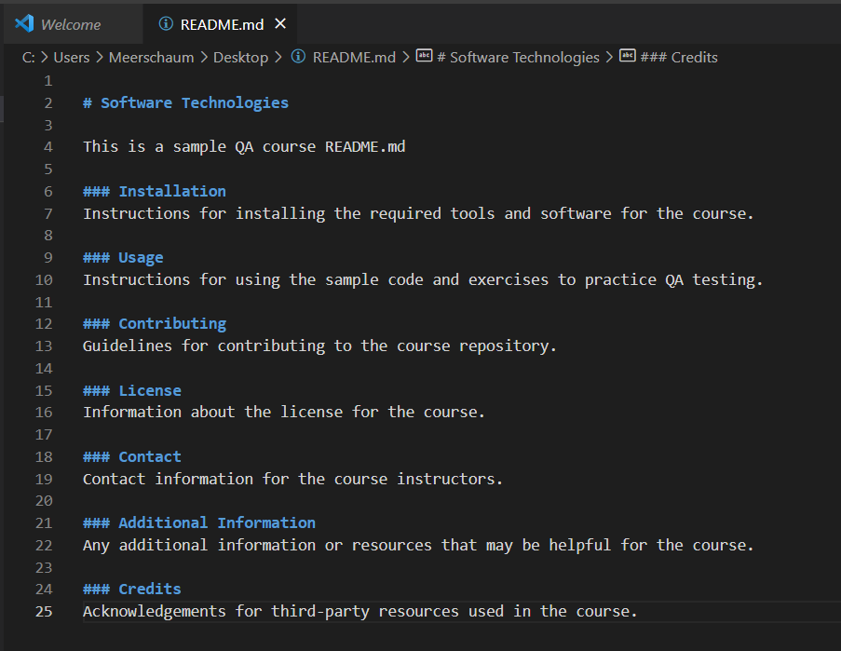

3. Once you've written your README.md file, you can preview it to see how it will look like. To do this, click Ctrl + Alt + V to open the preview in a new tab.
