Exercise: Computer Systems and Software - .NET 6.0
Advanced exercises for the "Software Technologies" course @ Software University

Note
Keep in mind that some of the steps might be slightly different. We assume that if you are considering exploring the QA profession, you have the basic skills to download, install, register and find workarounds in various software programs, without any difficulties.

What is it and why do you need it?
.NET is a versatile, open-source development framework created by Microsoft that allows developers to build various types of applications, such as web, mobile, and desktop, using multiple programming languages like C# and F#. QA engineers work with .NET to test the functionality, performance, and compatibility of applications built on this platform, ensuring high-quality and reliable software across different environments and devices.

How to install it?
1. First, you will need to navigate to https://dotnet.microsoft.com/en-us/download/dotnet/6.0
For this tutorial, we are installing .NET 6.0 Long Term Support, x64 version. Click on the button ".NET SDK x64
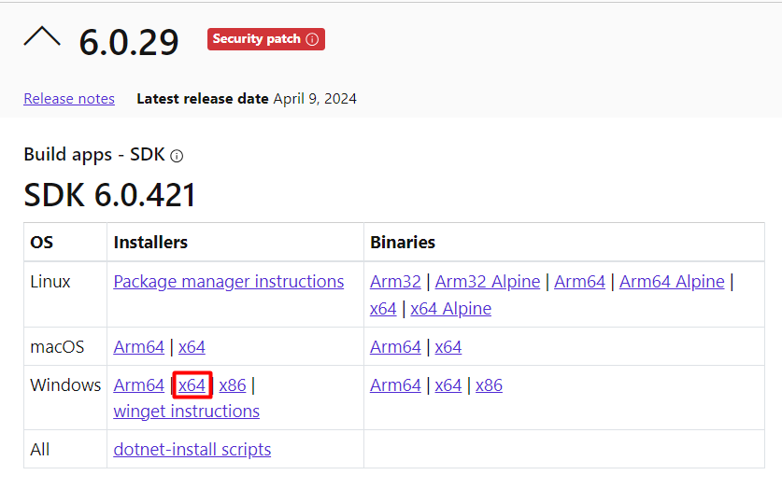

2. This will download the installation file.
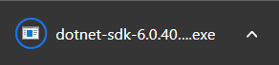

3. Open the .exe file. This will open the installer. Read the Privacy Statement and other provided information that might interest you and hit Install.
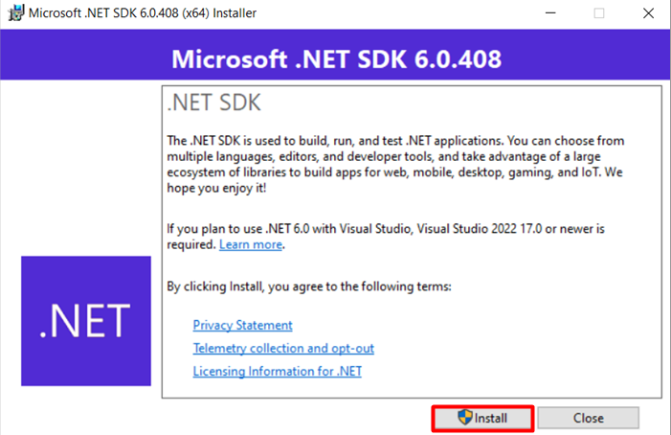
4. If prompted by Windows, give permission to make changes and your installation should begin.
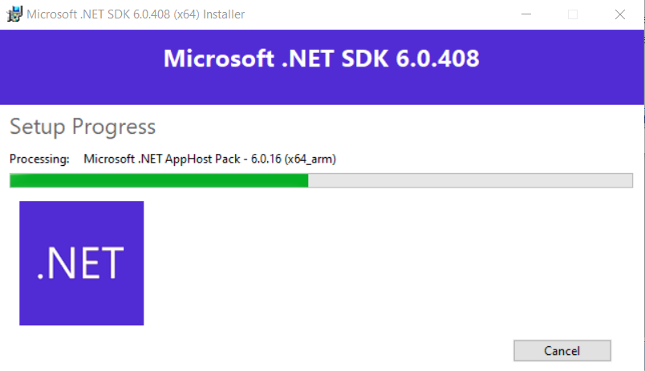

5. If the installation is successful, you will see the following window, which you should now close.
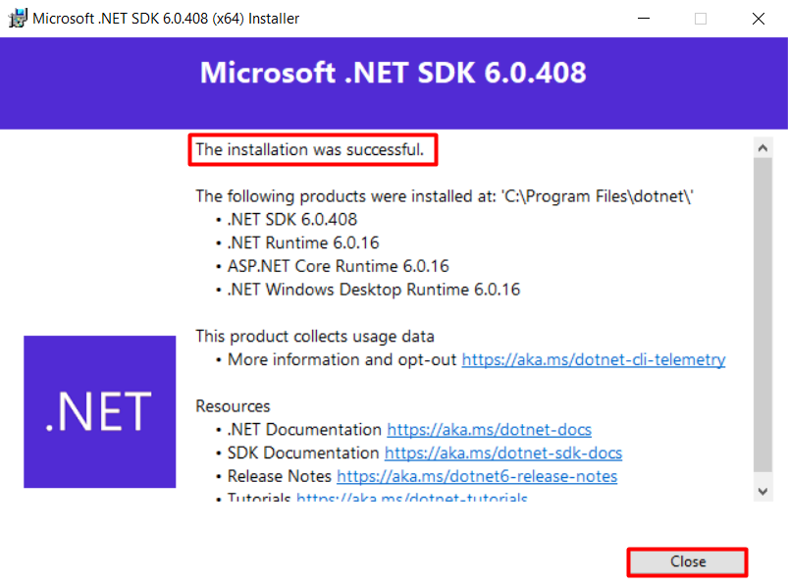

Check .NET version
To check what was installed and its versions, type the following in the Command prompt:
dotnet sdk check
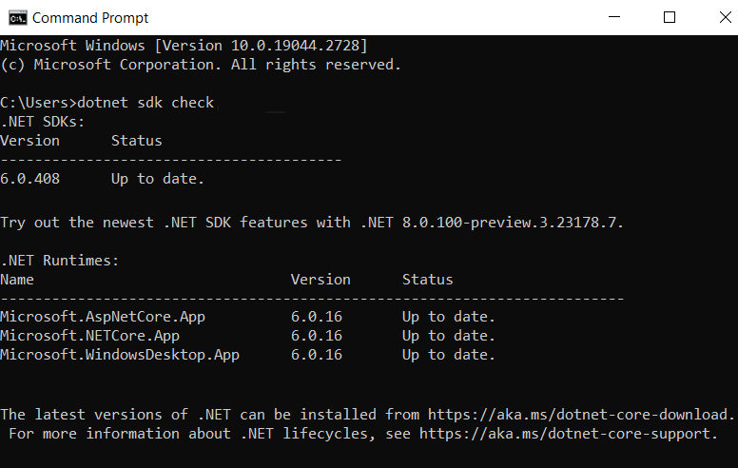

Build and run a simple calculator
We will build a simple calculator program, using .NET6.
You are given a .zip archive named "SimpleCalc". Unzip it and place the folder on your desktop (or a place of your choosing, but keep in mind, that you will have to navigate to it via Command Prompt, so choose an easy for typing path).
The folder contains two files: Program.cs and SimpleCalc.csproj. The first one is the code for our application and the second one is a C# project file that defines a project's settings, dependencies, and build configurations for a .NET application. If you are extremely curious, you can open those with Notepad or Notepad++ to see what's inside, but that is not necessary.
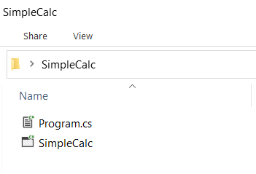

Open the Command Prompt (by default Command Prompt opens in C:\Users\YourUsername) and navigate to the "SimpleCalc" folder. Here we are assuming that the folder is placed on your desktop. Type the following command:
cd desktop\simplecalc

Now we will build our calculator by running the following command:
dotnet build
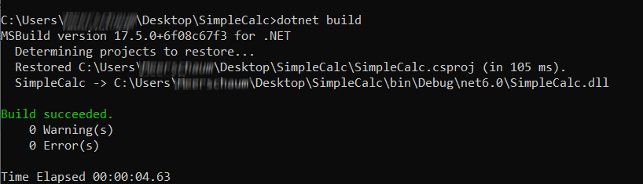
Next, we will run the calculator by typing the following command:
dotnet run
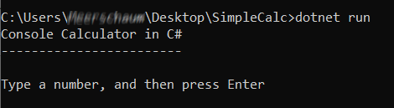
You can see our simple calculator in action.
Type a number. Type a second number. Choose an arithmetic action. Get a result.
