PicturePlay Manual
1 Index:

Page 2: Basic information
- 2.1 Introduction
- 2.2 Program invocation
- 2.3 Options

Page 3: Project
- 3.1 Requirements
- 3.2 Use-Cases
- 3.3 Domain diagram
- 3.4 Project UML Diagram

Page 6: Inner workings

2.1 Introduction

The PicturePlay software is a practice program intended to encode messages inside images using LSB steganography.

This program makes large use of threads, in first place to practice, and also to distribute the encoding/decoding tasks to multiple cores, increasing execution speed.

Following is a small manual describing it’s functions and scope.

2.2 Program invocation

The program is invoked through terminal, and it is compatible with both Linux (tested on Mint) and Windows (tested on Windows 10).

It has been coded in java 11, and a runtime environment of such version (at least) is needed for it to function.

Following is an example of invocation:

java -jar PicturePlay.jar -e Path/of/picture.png “message”

This line will call the program on the defined picture (absolute paths only) and encode the message written between quotes, as defined by the option -e.

The picture will not be moved, it will just be modified and left in the original folder.

2.3 Options

This program allows for 5 different options, these are

- -e: encoding option, its usage is java -jar PicturePlay.jar -e picture-to-encode “message to encode”
- -d: decoding option, its usage is java -jar PicturePlay.jar -d picture-to-decode
- -me: mass encoding with single message option, it’s usage is java -jar PicturePlay.jar -me start-folder maxdepth “message to encode”
- -md: mass decoding, it’s usage is java -jar PicturePlay.jar -de start-folder maxdepth
- -mule mass encoding with multiple message, it’s usage is java -jar PicturePlay.jar -mule start-folder “message1” [“messages from 2 to n”]

(elements in brackets are optional)

3.1 Requirements

- Functional Requirements:
  - In place picture editing: In order not to arouse suspicions of possible encoding, every picture edit must be made without changing the picture’s position in the file system
  - Non-expansive and non-destructive picture editing: In order to avoid suspicion regarding modified picture size, the only allowed operation must be the edit of already present data, without adding more or it, or removing some of it.

- Non-Functional Requirements:
  - Encoding and decoding speed: Due to the possibly high amount of files to work with in order to satisfy the requested service, the program must be able to efficiently utilize the system’s resources so as to reduce said operating time.

3.2 Use-Cases

- Use case 1: Message encoding
Main success scenario:
  - User starts the program using the provided encoding options
  - Program locates the picture or the folder to operate in
  - Program encodes the picture or all pictures found
  - Once the task defined by the option is completed, the program will exit
Alternative scenarios:
  - The user inputs the wrong argument format
    - The program will detect the error in the format
    - The program will exit printing the correct parameter format

- Use case 2: Message decoding
This use case acts the same as the first use case, but instead of encoding it decodes the message embedded in the picture. For the alternative, failure scenario, the same operations will be performed.

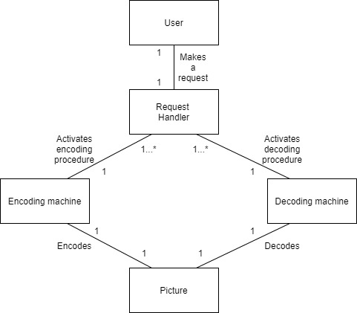
3.3 Domain diagram

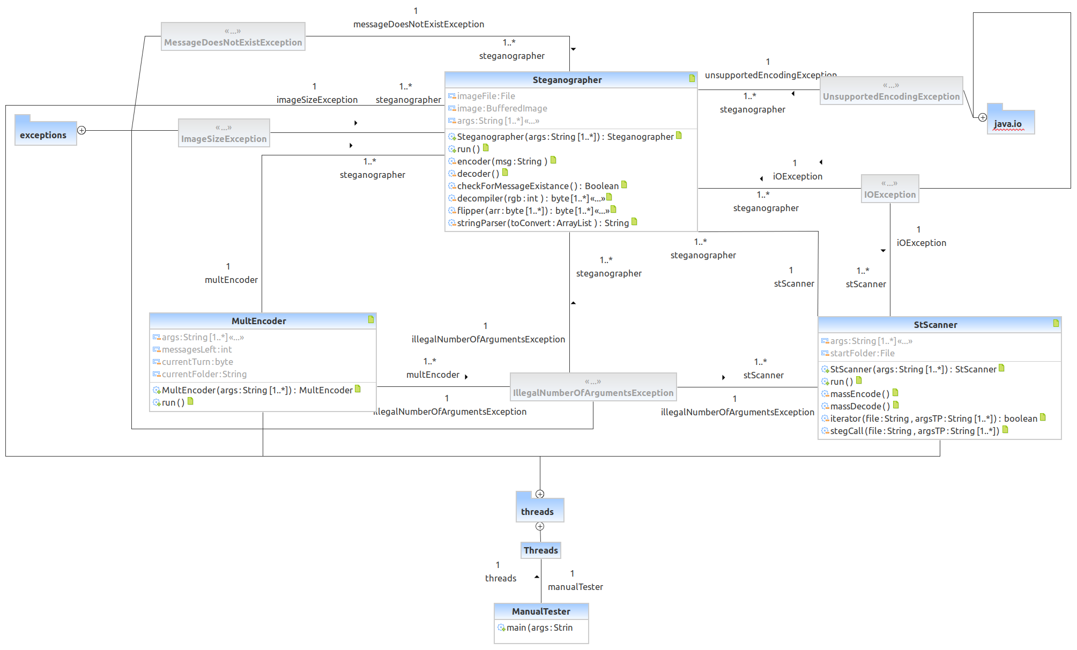
3.4 UML Diagram

4 Inner workings
The program is divided in three main Runnable classes, the first and most important one is the Steganograph one, it provides two functions:

- Encoding: The Steganograph class first verifies that the size of the image passed as argument is big enough to contain the message, since for each character, assuming ASCII encoding, almost 3 bytes are needed in order to encode it, filling an image very quickly. Then it reduces the single characters of the message in their base bits, which are masked into the lowest bits of each RGB color of each pixel, first by clearing them, in order to have a neutral base that reacts properly to a bitwise or operation, then by using said operation to inject them into the picture, which is, once the pixel is ready, updated and saved.
- Decoding: The Steganograph class reverses the operation performed during encoding by filtering the RGB values extracted from the pixel clearing every bit except the left-most one, which will be converted in a single value depending whether the number is read a zero, or as anything else. In order to detect the presence of a message, the decoder first checks the first 8 pixels for the presence of the string “msg”, if it is found, then it proceeds to move through the picture and decode the contained pixels until a string terminator character is decoded. At that point, it stops and prints out the message decoded.

By invoking this class with proper options, the other two classes are able to perform more complex encoding and decoding operations.

The StScanner Class, for example, allows to encode with a single message multiple pictures and decode folder trees by invoking an instance of the Steganograph on each picture found or recursively invoking new instances of itself on folders, with reduced depth.
The depth is used to impose a limit to the StScanner operations, if we interpret the file system as a tree, this input value is used to define how far below the start folder will the program scan and modify.
The StScanner class will stop once it reaches and operates on the leaves of the tree or when the depth reaches 0.
Since the mass encoding and decoding nature of this class, it doesn’t have a proper execution order control, it just starts threads and has them run until they finish their work.

The MultEncoder instead is a class that allows the user to encode different messages in multiple pictures in the same folder or downwards in the folder tree. If enough pictures to encode the messages are contained in the start folder, a series of Steganographs will be instantiated on them, the messages will be encoded and the program will close.
If more pictures are required, the class will activate a DFS-Style algorithm starting on the defined startfolder, which will impose a strict turn lock system on the recursively initiated threads, allowing a modicum of order in the folder exploration and message encoding.

