Pattern Recognition – Coursework 1

Emma Duncanova  Imperial College  ed1615@ic.ac.uk  01087968 | Daniele Olmeda  Imperial College  do915@ic.ac.uk  01114530

Abstract

Introduction
Provided a set which is normalized.

Question 1
PCA invokes the eigenspace method to maximize the scatter of the data set.
- Question 2
- Question 3
While PCA projections allow for image reconstruction from a low dimensional basis, LDA is a necessary extension for class discrimination. Subjecting a data set to both methods in succession can combine the benefits of dimensional reduction and class separation from the eigenface space and Fischer space, respectively.

The LDA method involves optimizing parameter W such that the ratio of the determinant of the between-class scatter matrix (S_{B}) and that of the within-class scatter matrix (S_{W}) is maximized, described by the equation:

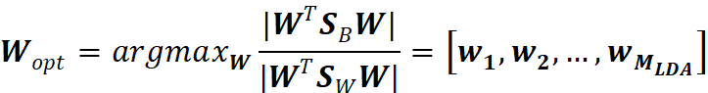

The matrices involved are defined as:
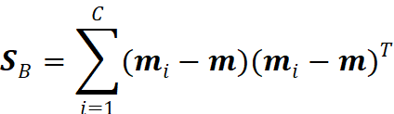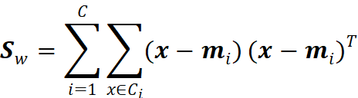

Where m_{i} is the class mean, m is the global mean, and x is the input image data.

To obtain the set of generalized eigenvectors, w_{i,} we collate the eigenvectors corresponding to the M_{LDA} largest eigenvalues obtained from the following relation:

Given the existing definitions of the scatter matrices, the rank of S_{w}ϵℝ^{nxn} has an upper limit of N-c, however the number of images, N, is far lower than the number of pixels per image, n, rendering the matrix singular and the above equation unsolvable.

To solve this, we first conduct PCA and apply LDA to the resulting, low-dimensional eigenface space projected data, represented by ω. This adjusts the S_{W} matrix as follows:
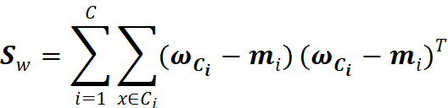
Giving it the dimensions (M_{PCA}, M_{PCA}).

While M_{PCA} is bounded by the rank of S_{W}, N-c, M_{LDA} is limited by the rank of S_{B}, c-1. The plot below shows the effect of varying M_{PCA} and M_{LDA} on recognition accuracy.

The LDA classification subspace is developed through the following relation:

PCA-LDA Ensemble
To improve LDA based facial recognition, individual architectures are developed through varying sampling techniques and parameters, and their outputs are combined to increase confidence in the results.

High dimensionality in the Fischer space leads to overfitting. To compromise between generality and discriminative ability, we combine multiple low dimensional classifiers with either randomly sampled features or randomly sampled training samples.

To produce classifiers using randomly sampled features, we sample M_{PCA}=M₀+M₁ of the N_{train}-1 number of eigenfaces with non-zero eigenvalues. M₀ refers to a fixed set of the largest eigenfaces, while M₁ refers to a set randomly sampled from the remaining N_{train}-1-M₀ eigenfaces. By conducting this K₁ times, we develop K₁ random subspaces.

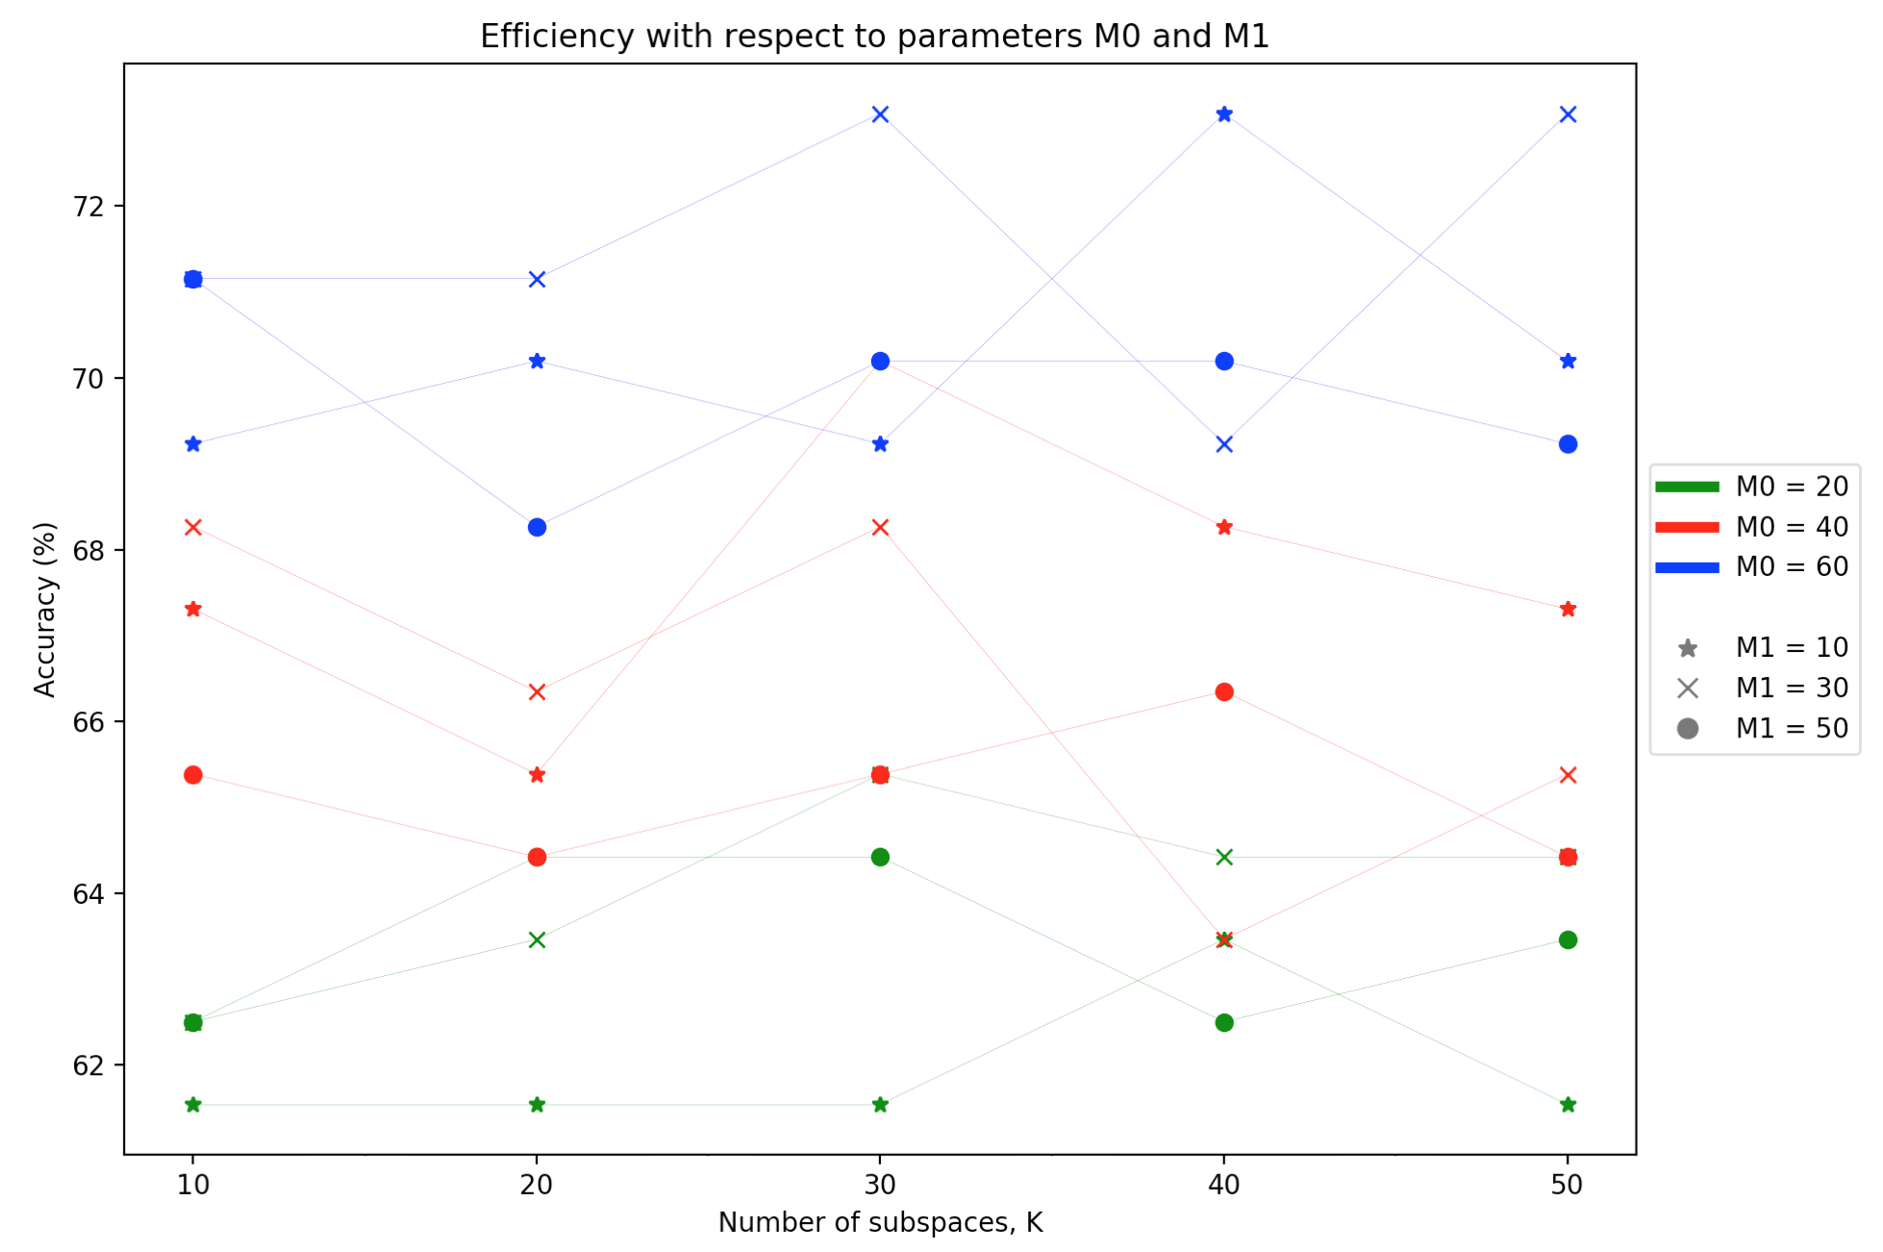
The graph above reveals the general trend that the higher value of M₀, the greater the accuracy of the model. This is justifiable since M₀ retains the most significant structural information of the image, which is why it remains fixed in the during the randomization process.

Random sampling on training samples, known as “bagging”, involves producing smaller samples of the given training set. The procedure involves randomly selecting L classes. Note that only the classes are sampled, rather than the data itself. Conducting this K₂ times develops K₁ random subspaces. The higher the value of K₂, the more likely that the combination of these classifiers uses all class data, while retaining low-dimensionality.

https://cseweb.ucsd.edu/classes/wi14/cse152-a/fisherface-pami97.pdf
Lecture notes
https://cseweb.ucsd.edu/classes/wi14/cse152-a/fisherface-pami97.pdf
http://mmlab.ie.cuhk.edu.hk/pdf/wangTijcv06.pdf?fbclid=IwAR0xOEWtGeHR3IQwrlibOqqO1OnicGVJz7636odvkwDW4qMSG13Us3noaZE
http://mmlab.ie.cuhk.edu.hk/pdf/wangTijcv06.pdf?fbclid=IwAR0xOEWtGeHR3IQwrlibOqqO1OnicGVJz7636odvkwDW4qMSG13Us3noaZE
http://mmlab.ie.cuhk.edu.hk/pdf/wangTijcv06.pdf?fbclid=IwAR0xOEWtGeHR3IQwrlibOqqO1OnicGVJz7636odvkwDW4qMSG13Us3noaZE

