Personal Notes

reference

# Issues with amazon aws instance

the db fires an error

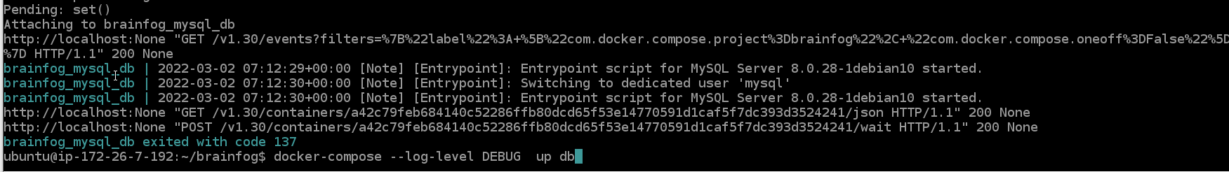

Too less memory on the cloud machine??

docker-compose --log-level DEBUG

docker logs $container_id

docker inspect $container_id

too less memory available on 512 mb of ram, only 62.4 are free

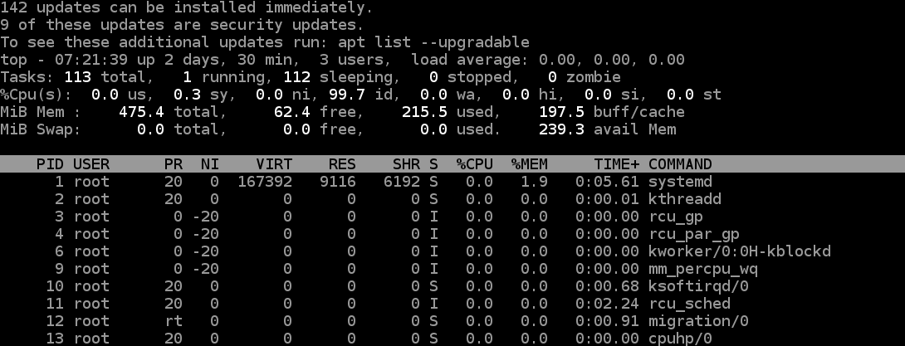

**Maybe try linux alpine??**

Local build stats… 1gb of ram more or less

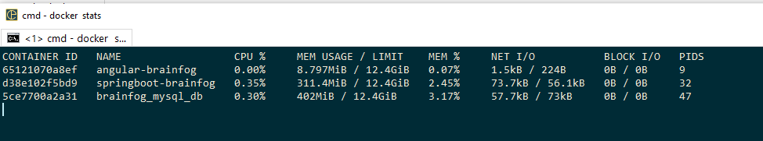

In the end was a memory issue, 512 mb of ram were too less for this kind of application.

# Couldn’t connect to Docker daemon – is it running?

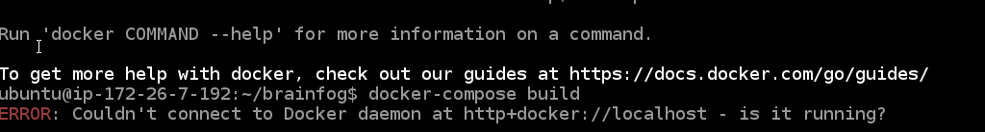

run post installation steps

<https://docs.docker.com/engine/install/linux-postinstall/>