Telemetry Software
Software Architecture Document
Internal structure, data flow, and the reasoning behind the design decisions

1. Purpose and audience
This document describes how the telemetry software is built internally: which parts it is made of, how a sample travels from the vehicle to the screen and to the log file, and why the structural decisions that shape it were taken.
It is written for two readers at once. For a reviewer, it explains the reasoning behind each choice without assuming familiarity with the codebase. For whoever maintains or extends the software next, it names the actual classes, constants and files, so that the description can be followed directly in the source. Class names appear in the form they have in the code.
This is not a user manual: it does not explain how to launch the application or how to read the individual screens. It also does not list the transmitted channels or the field-by-field content of the packets, which are documented separately.

2. What the software does, and under which constraints
The application receives a continuous stream of framed binary packets from the vehicle over a UART link, validates their integrity, converts them into engineering units, displays them in real time and logs them to disk. The same executable also reloads previously recorded sessions and replays them offline. It is a C++20 application built with CMake, using GLFW for the window, Dear ImGui (docking branch) and ImPlot for the interface, and jsoncons for settings persistence. It builds and runs on Windows, Linux and macOS.
Two packet types are transmitted. The fast packet carries vehicle dynamics and powertrain data every 5 ms (200 Hz, 136 bytes in the current layout); the slow packet carries accumulator data every 200 ms (5 Hz, 81 bytes). Sustained payload is therefore about 27.6 kB/s, roughly 276 kbit/s once 8N1 framing is accounted for, against a 500 kbaud link: about 55 % of the available bandwidth.
Four concrete requirements shape almost every decision described later, and are worth stating explicitly:
- Every packet must be logged at the rate it arrives, because the recording is the material the team works on after the session. Dropping rows to make the interface lighter is not acceptable.
- The interface must stay responsive while the stream is at full rate, because it is used at the pit wall during the session. Software that stalls exactly when the car is on track is worthless.
- Recordings produced by previous versions of the vehicle must remain readable, and an ECU that has not been reflashed must keep working with the current build.
- Line noise or lost packets must neither crash the application nor, more importantly, produce plausible but wrong values without anyone noticing.

3. Layered organisation
The code is split into four stacked layers. Each layer only knows the one directly below it and calls into it; data travels back in the opposite direction. The top layer does not know where the numbers it draws come from, and the bottom layer does not know what becomes of them.
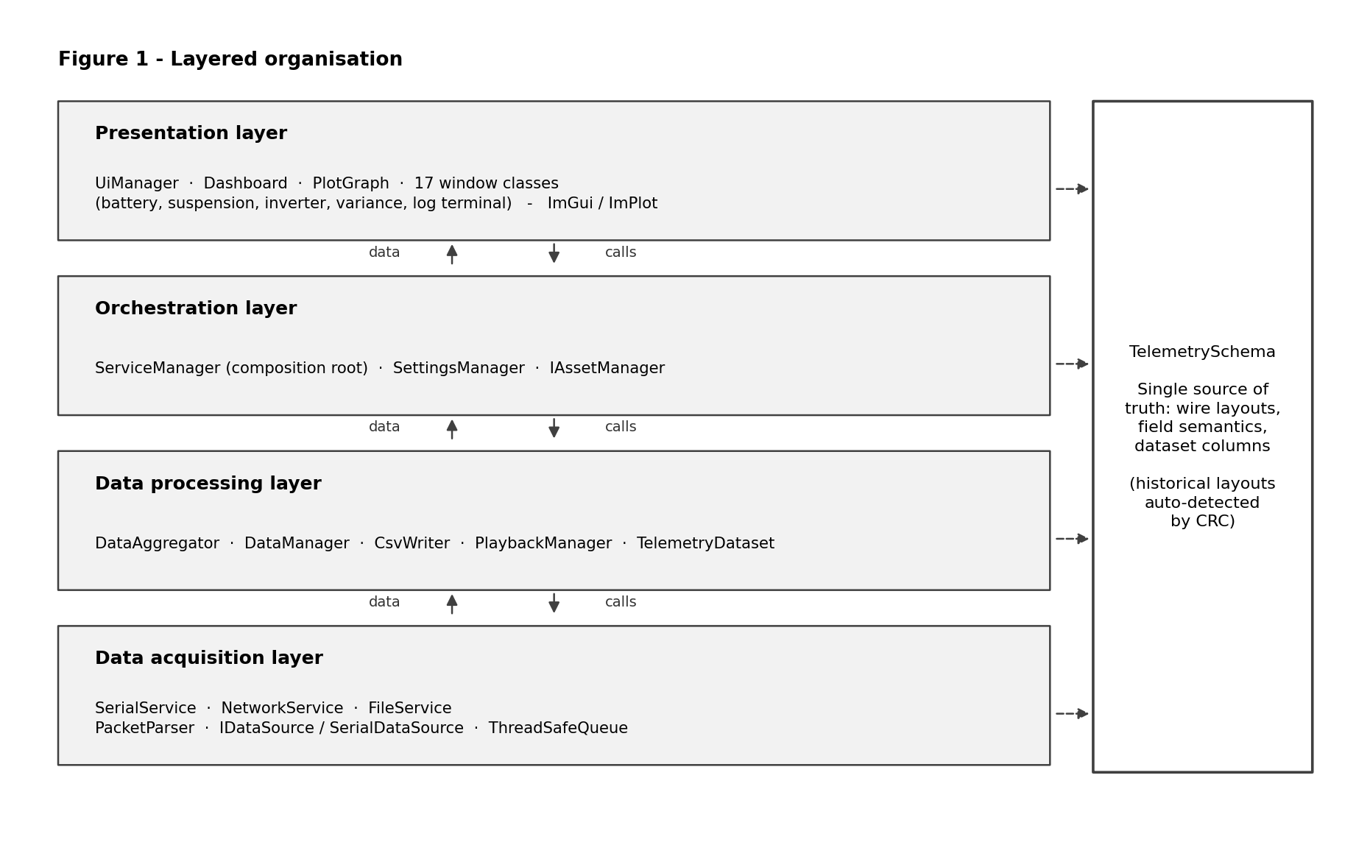
Figure 1 — Layered organisation and the position of the protocol definition.
The reason for this separation is practical rather than formal. The parts that change often are the ones at the top: a window is added, a plot is rearranged. The parts that must stay stable are at the bottom, because touching them risks corrupting recorded data. Keeping dependencies pointing in one direction only means a change to the interface cannot propagate down into the packet decoder.
Beside the four layers, and reachable from all of them, sits TelemetrySchema. It is not a layer but a shared reference; the reason it is drawn separately is explained in section 7.1.

Principal components
Component | Responsibility
ServiceManager | Composition root. Creates every object, wires them together, and governs startup, shutdown and destruction order. The single place where the assembly of the system is decided.
IDataSource | Pure virtual interface for a byte source: enumerate resources, open, read, close. SerialDataSource implements it and confines all Win32 and POSIX serial code.
SerialService | Owns the two live-acquisition threads and the queue that separates them. Consumes raw bytes and produces decoded rows.
ThreadSafeQueue | Mutex and condition-variable queue used to hand byte blocks from the reader to the parser without copying and without busy-waiting.
PacketParser | Locates frames in the byte stream, validates the CRC, locks onto the matching layout and converts fields. Derives lost-packet counts from the tick counters.
TelemetrySchema | Single source of truth: current and frozen wire layouts, field semantics and scaling, canonical dataset column order, value-to-text conversion.
DataAggregator | Computes what the vehicle does not send: mean, variance and standard deviation over a 3 s tumbling window, session max and mean, integrated distance.
DataManager | Fans the completed row out to two subscriber lists: loggers at full rate, interface rate-limited to 10 Hz.
CsvWriter | Appends every received row to the log file in the schema column order, rebasing the timestamp to the start of the recording.
FileService | Loads a recording on a dedicated thread, auto-detecting the .bin layout by CRC or mapping .csv columns by header name.
TelemetryDataset | Column-oriented in-memory storage for a loaded session: one contiguous float buffer plus a parallel double timestamp buffer, with per-column presence flags.
PlaybackManager | Sole owner of the loaded session. Keeps the full-rate copy and a decimated copy for plotting, and runs the cancellable export.
UiManager | Builds and draws the windows, owns the application state machine and the render loop.

4. Wire format handling and data integrity
Both packet types share the same frame structure: two identifying start bytes, a 32-bit tick counter, the payload fields, and a 16-bit checksum. One tick equals 5 ms, so the timestamp published to the rest of the application is the raw counter multiplied by 0.005. The checksum is CRC-16/CCITT-FALSE (polynomial 0x1021, initial value 0xFFFF) computed over every byte of the frame except the checksum itself, and evaluated through a 256-entry lookup table so that validating every packet of a full recording stays cheap.
Framing recovery matters because a serial read returns a block of bytes cut at an arbitrary point: one packet may arrive split across two reads, and two packets may arrive within the same one. PacketParser therefore scans the working buffer for a start-byte pair, and only accepts the frame if the CRC over the candidate length matches. Bytes preceding a valid start pair belong to no known frame and are dropped, with the discarded sequence printed in hexadecimal rather than being interpreted as data.
A frame whose CRC does not match is discarded, never used. This is a deliberate trade: a gap in the recording is preferable to a plausible but wrong value, because the gap is visible and the wrong value is not. The loss does not go unnoticed either. By comparing the tick counters of consecutive frames the parser infers how many are missing — one unit per missing fast packet, forty per missing slow packet — and publishes the running totals as ordinary channels, so whoever is watching knows how much to trust what is on screen.
Backward compatibility is handled by the same mechanism. Past wire layouts are not deleted but kept frozen in TelemetrySchema; three are currently registered for the fast packet (136, 134 and 142 bytes) and two for the slow one (81 and 79 bytes). On each frame the parser first retries the layout that matched last, then the others in order, and locks onto the first whose CRC validates. Since the layouts differ in length, the checksum is computed over a different number of bytes for each candidate and can validate for only one of them. The consequence is that a non-updated ECU keeps being read and an old recording stays openable, with no action required from the operator.

5. Live acquisition data path
When connected to the vehicle, a sample crosses three threads before reaching the screen.
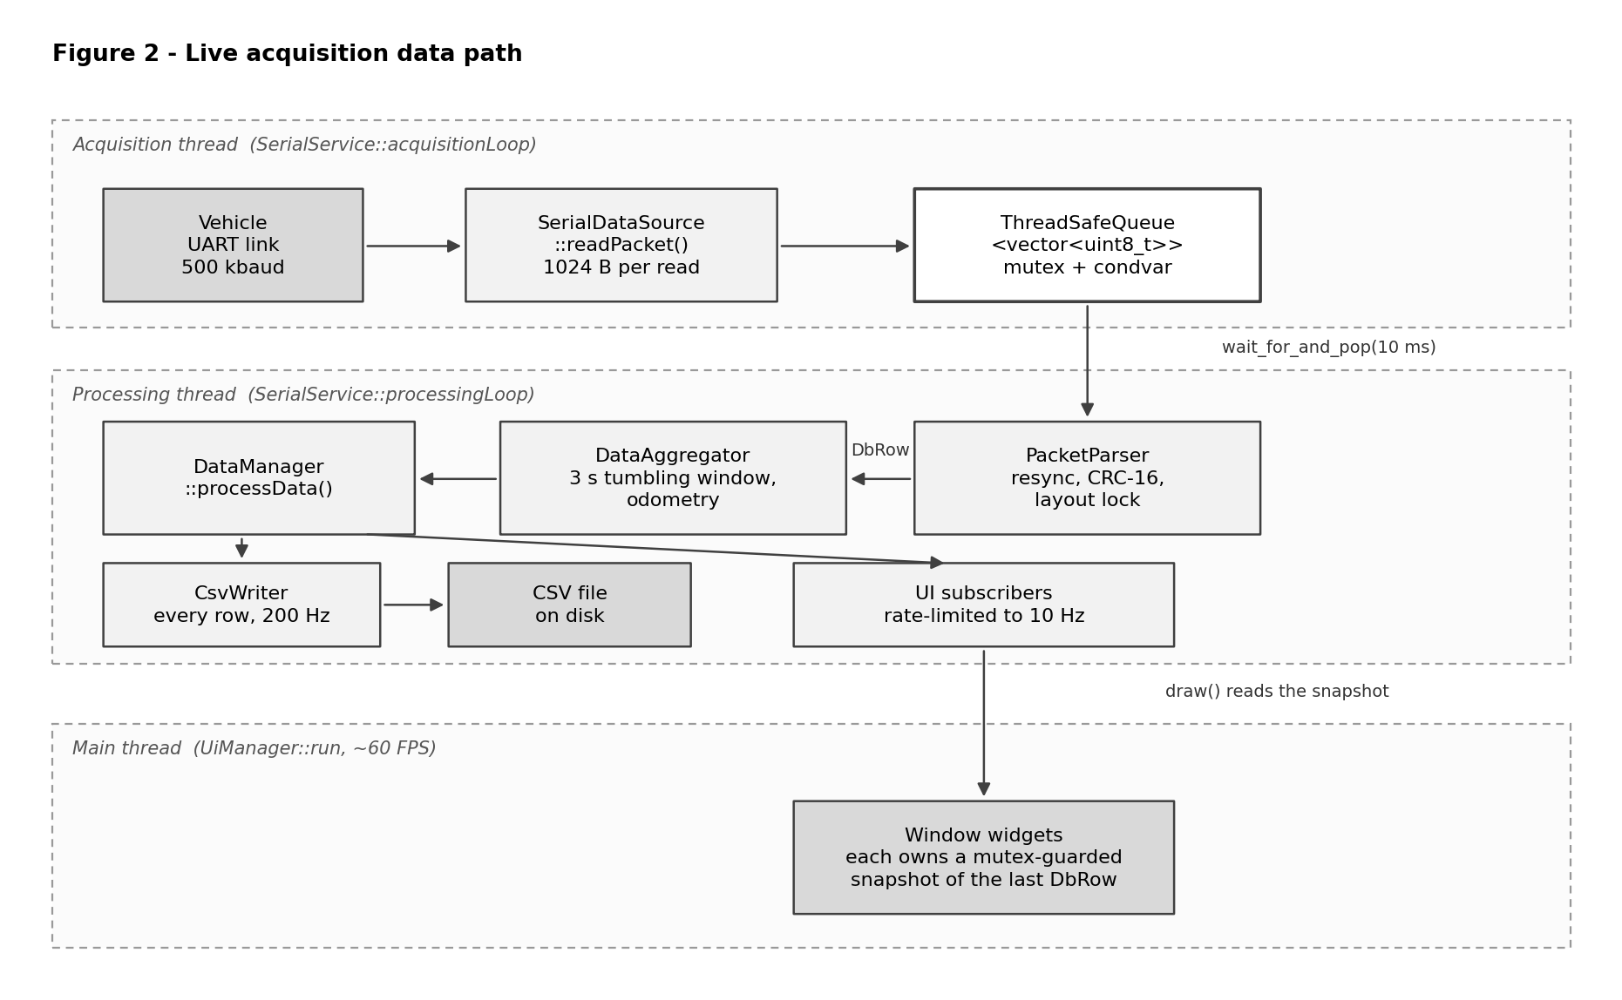
Figure 2 — Live acquisition data path, with the thread boundaries.
The acquisition thread does nothing but read up to 1024 bytes per call from the port and push the block into a ThreadSafeQueue. It does not interpret, validate or convert: its only job is to lose nothing. When a read returns empty it sleeps 1 ms rather than spinning. The processing thread pops blocks with a 10 ms timeout and appends them to a working buffer reserved at 8192 bytes, from which it extracts every complete frame before waiting again.
A subtlety worth noting: when a fast packet is immediately followed by a slow one, the parser decodes the slow packet first and merges its values into the row it is about to emit. Waiting for the two identifying bytes of the following frame is what makes the emitted row independent of where the serial read happened to be cut, so a battery reading is never delayed by one row because of a buffer boundary.
Once a complete row exists it is passed to DataAggregator, which adds the derived quantities, and then to DataManager, which fans it out to two separate subscriber lists: CsvWriter receives every row, the interface receives one every 100 ms. The main thread renders at about 60 FPS and only reads the snapshot each widget keeps.

6. Playback data path
Playback shares the protocol definition and the windows with the live mode, but not the acquisition chain.
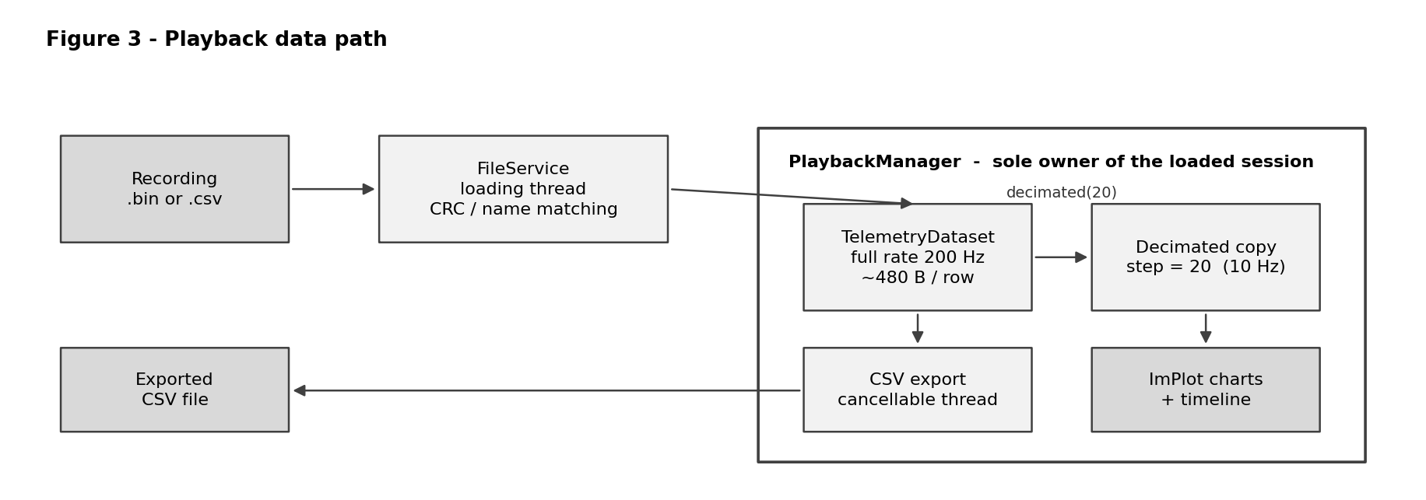
Figure 3 — Loading a recording, the dual in-memory representation, and export.
Loading runs on a dedicated thread because a long session takes several seconds to read and convert, and doing it on the render thread would freeze the window. A .bin is decoded frame by frame with the same CRC-driven layout detection used live; a .csv is matched column by column by header name. Both paths fill a TelemetryDataset and then compute whatever statistic columns the source did not already carry, which is what keeps a bin to csv to bin round trip identical.
The result is handed to PlaybackManager, the sole owner of the loaded session, which keeps two copies. The full-rate copy retains every sample and is the source for export and for any computation; the decimated copy keeps one row out of twenty, bringing 200 Hz down to about 10 Hz, and is what the plots draw. The reason is volume: a twenty-minute endurance run at 200 Hz is roughly 240 000 rows, and asking the plotting library to draw them all on every frame makes timeline navigation unusable, while at screen resolution the visual difference is nil. The full copy stays available, so nothing is lost on export.
Export also runs on its own thread and is cancellable, polling an atomic flag as it writes. Writing a file of several hundred thousand rows is not instantaneous, and the operator must be able to change their mind or close the session without the application blocking.

7. Design decisions and rationale

7.1 A single source of truth for the protocol
The wire layouts, the meaning of each field, its scale and bias, the number of decimals it is rendered with, and the canonical order of the dataset columns are all defined in one place: TelemetrySchema. Live decoding, the dashboard table, the CSV header, the .bin loader and the high-resolution export are all derived from those tables. Adding a channel means appending one entry to one function.
The motivation is that the same information is needed in at least four places. Written four times, sooner or later one copy gets updated and the others do not; the typical symptom is a channel showing one value on screen and a different one in the log, discovered days later during analysis. Concentrating the description in one point makes that class of error impossible by construction.
The same tables also carry the value-to-text conversion in both directions, which is why a number always produces the exact same string whether it is displayed, logged, exported or read back from a CSV.

7.2 Reading and parsing on separate threads
Reading from a serial port and interpreting bytes are different in nature. The first is a wait: the program asks the operating system for data and blocks until it arrives. The second is computation: start-byte search, CRC evaluation, field conversion.
In a single loop, every time parsing takes longer than expected the program is not reading, and the bytes arriving meanwhile accumulate in the driver buffer until it overflows, silently losing data. Split apart, the reader returns to the port immediately and deposits what it read into the queue; the parser takes the time it needs. This is a bounded-latency producer-consumer arrangement in which the queue absorbs bursts and decouples two rates that have no reason to coincide.
ThreadSafeQueue is a std::queue guarded by a std::mutex with a std::condition_variable. The consumer blocks in wait_for with a predicate, so it neither burns CPU in a spin nor acts on a spurious wake-up, and the 10 ms timeout guarantees the loop wakes periodically even with no traffic and can observe that it has been asked to stop. Blocks are transferred with std::move, so a 1024-byte read is never copied.

7.3 Separate rates for logging and display
The logger receives every row; the interface receives ten per second. The distinction lives in a single place, DataManager, which keeps two subscriber lists and timestamps the last UI dispatch with a steady_clock.
The two consumers have opposite requirements. Offline analysis needs everything, because a short transient is often exactly what is being looked for. The eye cannot read two hundred updates per second, and redrawing the widgets at that rate spends the frame budget that keeps the application fluid. Rate-limiting only the display yields a light interface without removing anything from the log.
Having it in one place has a further benefit: no window has to throttle itself, so whoever adds a screen does not need to know the problem exists.

7.4 The data source is an abstraction
The processing chain does not know where the bytes come from. It talks to IDataSource, a pure virtual interface promising four operations: enumerate available resources, open, return data, close. SerialDataSource is one implementation, and it holds all the platform-specific code — a Win32 HANDLE with a DCB and COMMTIMEOUTS on Windows, a POSIX file descriptor with termios on Linux and macOS — behind that single boundary.
The benefit is twofold. Operating-system differences stay confined to one class instead of spreading as conditionals across the program. And adding a different source later, a network link for instance, means writing one new class without touching anything downstream: the dependency points at the interface, not at the concrete type.

7.5 Two data representations for two different jobs
Live, a row is a DbRow, an std::map from channel name to its already-formatted textual value. From file, a session is a TelemetryDataset: one contiguous float buffer laid out row-major, with timestamps kept apart in a parallel double buffer.
These are opposite choices, deliberately. Live, only a few hundred rows per second are handled and flexibility is what matters: a map carries the names of what it contains, tolerates an absent channel, and lets each widget ask for exactly what it needs without anyone keeping indices aligned. At those rates the cost is negligible.
On file the problem is reversed. With 118 dataset columns, a row costs about 480 bytes in the contiguous layout, so a twenty-minute run at 200 Hz occupies roughly 115 MB and scanning one channel is a strided walk over sequential memory — precisely the access pattern the plots need. The same session held as one map per row would mean hundreds of thousands of allocations and string copies, in the order of several gigabytes: it would not fit, and loading would take minutes. The column set is not fixed at compile time but decided when the file is read, which is what lets recordings with different channel sets be handled by the same code. Columns absent from the source are flagged and simply omitted from the generated rows, so widgets show nothing for them rather than a fabricated zero.
Timestamps deserve a note: they are kept as double while values are float. As the ECU tick counter grows during a session, single precision loses the third decimal and with it the ability to distinguish two consecutive samples. Physical values do not need that precision; time does.

7.6 One composition root
Every object is created and wired together in one place, ServiceManager. Windows do not construct services and do not know the processing chain; they ask the manager for what they need. Services are held as std::unique_ptr, so ownership is unambiguous and destruction order is explicit.
This buys three things. A reader finds the answer to how the program is assembled in a single file. The teardown sequence is defined and repeatable, which matters because several objects own threads and must be joined before the objects they use are destroyed. And the link between DataAggregator and DataManager is injected as a std::function at construction time rather than hard-coded inside the classes, so the two remain unaware of each other and can be tested in isolation.

7.7 Deterministic shutdown and restart
Switching session while acquisition is running, or closing the application mid-export, are ordinary situations and must not cause damage. Every object owning a thread stops it and joins it in its own destructor; the export loop polls a std::atomic<bool> cancellation flag. Restart does not reuse the previous objects but replaces them — assigning a fresh unique_ptr destroys the old service, which joins its thread as a side effect — so no residual state from the previous session survives into the new one.
The principle applied throughout is RAII: whoever creates a resource is responsible for releasing it, and the release happens automatically when the owner is destroyed rather than depending on a call someone might forget. It is the simplest way to avoid detached threads, which is the kind of defect that shows up rarely and always at the worst moment.

8. Verification and testing
The software was validated in two complementary ways: against synthetic generators written in Python, and on the vehicle with the real ECU.
The bench tooling lives in two folders of the repository. tester_uart is a small tkinter application, the Telemetry Spammer, which opens a serial port and transmits the real frame format: the fast packet every 5 ms and the slow packet every fortieth tick, that is every 200 ms, exactly as the ECU does. Its sending loop uses a hybrid sleep and busy-wait to hold the 5 ms period with sub-millisecond jitter, and it can drive the port from 9600 baud up to 1 000 000 baud, well beyond the 500 kbaud the vehicle uses. tester_bin_sd uses the same generator to write .bin recordings of arbitrary length, used to exercise the loader.
One detail makes these generators more useful than a simple replay: the CRC routine in Python is an independent implementation, written bit by bit from the algorithm definition, while the C++ side uses a precomputed table. The two agreeing is a genuine cross-check of the checksum, not a tautology.
What the bench setup verifies:
- Framing recovery — the parser reconstructs frames regardless of where the operating system cuts the read blocks, and resynchronises after injected garbage instead of misinterpreting it.
- Layout auto-detection — a generator emitting a past layout is recognised and locked onto, confirming that the frozen tables still decode old traffic.
- Checksum rejection — corrupted frames are discarded rather than published, and the loss counters account for them.
- Sustained throughput — the pipeline holds the full 200 Hz rate, and above it, without the driver buffer overflowing or the interface losing fluidity.
- File paths — .bin and .csv loading, decimation, timeline navigation and high-resolution export on recordings produced by the generator.
On-vehicle testing then covered what a generator cannot reproduce: the behaviour of the real link with the engine bay powered, the effect of electrical noise on packet loss, the actual latency between an event on track and its appearance on screen, and prolonged sessions logging to disk. The loss counters were the main instrument here, since they turn link quality into a number visible during the run rather than a suspicion confirmed afterwards.

9. Reference values
Constants a maintainer is most likely to need, with the file that defines them.
Constant | Value | Defined in
Fast packet period / rate | 5 ms / 200 Hz | ECU firmware, decoded via TelemetrySchema
Slow packet period / rate | 200 ms / 5 Hz | ECU firmware, decoded via TelemetrySchema
Current frame sizes | 136 B (fast), 81 B (slow) | TelemetrySchema.cpp
Registered historical layouts | 3 fast, 2 slow | TelemetrySchema.cpp
Checksum | CRC-16/CCITT-FALSE, 0x1021, init 0xFFFF | TelemetrySchema.cpp
Serial read block | 1024 B | SerialDataSource.cpp
Parser working buffer reserve | 8192 B | SerialService.cpp
Queue pop timeout | 10 ms | SerialService.cpp
Idle sleep when no data | 1 ms | SerialService.cpp
UI dispatch interval | 100 ms (10 Hz) | DataManager.cpp
Statistics window | 3.0 s, tumbling | DataAggregator.hpp
Max distance integration gap | 1.0 s | TelemetrySchema.hpp
Plot decimation step | 20 (200 Hz to 10 Hz) | PlaybackManager.cpp
Dataset columns | 118 | TelemetrySchema.cpp (derived)
Approximate row footprint | ~480 B | TelemetryDataset.hpp
CSV field separator | semicolon | CsvWriter.cpp

10. Known limitations and future work
Reported for completeness, together with the reason each has not been addressed yet.
- Network acquisition exists as an interface but is not implemented: NetworkService returns placeholder values. The serial link has been sufficient so far, and the abstraction means implementing it touches nothing downstream.
- The stop signal for the acquisition threads is a plain bool shared across threads rather than a std::atomic<bool>. It works in practice, but it is formally a data race; the fix is a few lines and is planned.
- CsvWriter writes on the processing thread. If the disk stalls, the delay propagates upstream to the queue. At current volumes the margin is wide, but the natural solution is to move writing onto its own thread with its own queue.
- The queue is unbounded. Under a hypothetical permanent stall of the processing thread it would grow until memory is exhausted, whereas a bounded queue with an explicit overflow policy would fail visibly instead.
- There is no automated test suite. The processing classes were deliberately kept free of any dependency on the graphics layer precisely so that they can be tested in isolation once such a suite is written; the Python generators already provide the input side of it.

