1. **Introduction**
   1. **Purpose**

This document is the Requirements Analysis Specification Document (RASD) for TrackMe’s systems Data4Help, AutomatedSOS and Track4Run. Its purpose is to provide a detailed description of these 3 systems. It is addressed to be read by the customers, users, systems analysts, requirements analysts, developers, programmers, testers and project managers.

Data4Help is designed as a software application used to allow third parties to monitor the location and the health status of individuals. Once registered, third parties can request data both of specific users and of groups of individuals. In the former case, an individual can accept or refuse the request; in the latter case, data will be provided only if they can be properly anonymized by the application. If the request is approved, Data4Help allows third parties to subscribe to new data and to receive them as soon as they are produced.

AutomatedSOS is designed to allow elderly people to receive help if their health parameters, monitored by Data4Help, are below certain thresholds.

Finally, Track4Run is designed to allow people to define paths for specific runs, participants to enroll them and spectator to see the position of all runners.

* + 1. **Goals**

Data4Help:

[G1] - Allows people to make available their position

[G2] - Allows people to make available their health status

[G3] - Allows third parties to request data of some specific individuals

[G4] - Allows third parties to request access to anonymized data of groups of individuals

[G5] - Allows people to choose whether to accept or not the request for sharing data required by third parties

[G6] - Allows third parties to be able to see saved data as soon as a request is approved by the individual.

[G7] - Allows third parties to have access to new data as soon as they are produced.

[G8] - Allows third parties to be notified with the user’s response

AutomatedSOS:

[G9] - Allows users to receive help if their health parameters are below certain thresholds

Track4Run:

[G10] - Allows the organizers to create an event for athletics run

[G11] - Allows participants to enroll to a run

[G12] - Allows spectators to see the position of the runners on the map during a run

* 1. **Scope**

Data4Help is a useful application to monitor individuals’ data. These data are acquired by a smartwatch on which the application is downloaded. Using AutomatedSOS functionalities, one can be sure of receiving help if his/her health parameters go below certain thresholds. Finally, Track4Run provides interesting features for all those interested in a run. Focusing on the relevant phenomena for the system to be developed, it is possible to distinguish the world ones and the shared ones.

* + 1. **World phenomena:**
    2. **Shared phenomena:**
  1. **Definitions, acronyms, abbreviations** 
     1. **Definitions**
* Data: information about health parameters and location of an individual or a group of individuals
* Individuals: people registered on Data4Help, AutomatedSOS and Track4Run that allow the application to acquire their data
* Group: set of individuals
* Users: people registered on Data4Help, AutomatedSOS and Track4Run
* Third parties: people registered on Data4Help that can request data
* Participants: individuals enrolling a run
* Spectators: individuals that see a run
* Organizers: people that organize runs
* Help: ambulance
* Health parameters: pression, heartbeat and quality of sleep
* Devices: electronic device on which Data4Help can be installed
* System: the whole software system to be developed, comprehensive of all its parts and modules
* Node: place from which a run passes
* External partners: operators of a public service for urgent emergencies
  + 1. **Acronyms**
* RASD: Requirements Analysis Specification Document
* GPS: Global Positioning System
  + 1. **Abbreviations**
* [Gn]: n-th goal
* [Dn]: n-th domain assumption
* [Rn]: n-th functional requirement
  1. **Revision History**
  2. **Reference Documents**
* Specification document “Mandatory Project Assignment AY 2018-2019”
* “Requirements Engineering Part II” from Beep
  1. **Overview**

The document is divided in six parts. The first one includes introductory information to give a view of what this document is about. Indeed, it describes the purpose of the 3 systems to be developed by listing its goals and it describes also the scope of the application, by listing the world and the machine phenomena. The second part contains (to be completed). The third part contains (to be completed). The fourth part contains the alloy model

1. **Overall Description**
   1. **Product perspective**

Data4Help is a system designed to provide the functionalities described in section 2.2 Product function. AutomatedSOS uses data provided by Data4Help and relies on external partners to send ambulances when necessary. AlsoTrack4Run uses data provided by Data4Help, furthermore it implements external APIs to offer maps services. To better represent the structure of the system, look at the class diagram shown in the figure below.

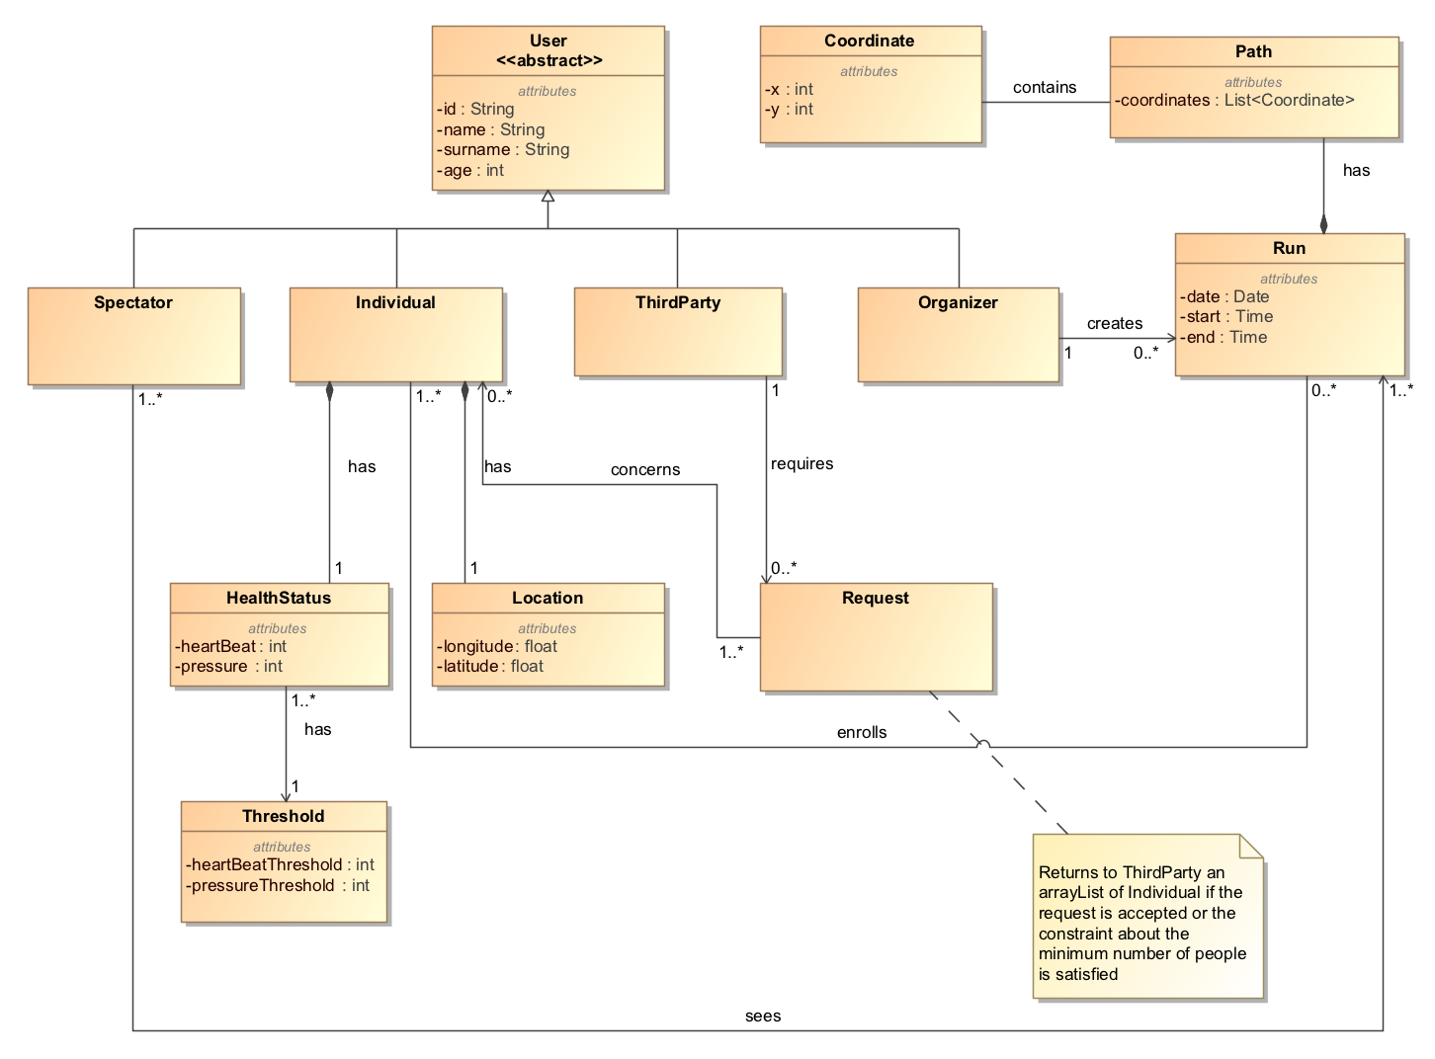

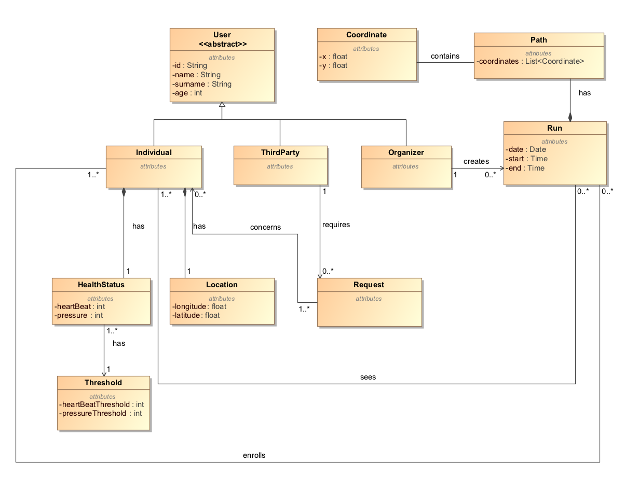

It is possible to see that the system has three types of users. An individual has a location and a health status, and these data can be obtained by third parties through a specific request. Individuals can also enroll a run created by the organizer. Spectators can retrieve information about participants during a run.

The processes of creating a new run and modifying a previously defined run are shown in the state chart below. (secondo me dovremo mettere lo state chart per fare una richiesta, perchè alla fine è il cuore di Data4Help, che è usata da tutte le altre applicaizoni)

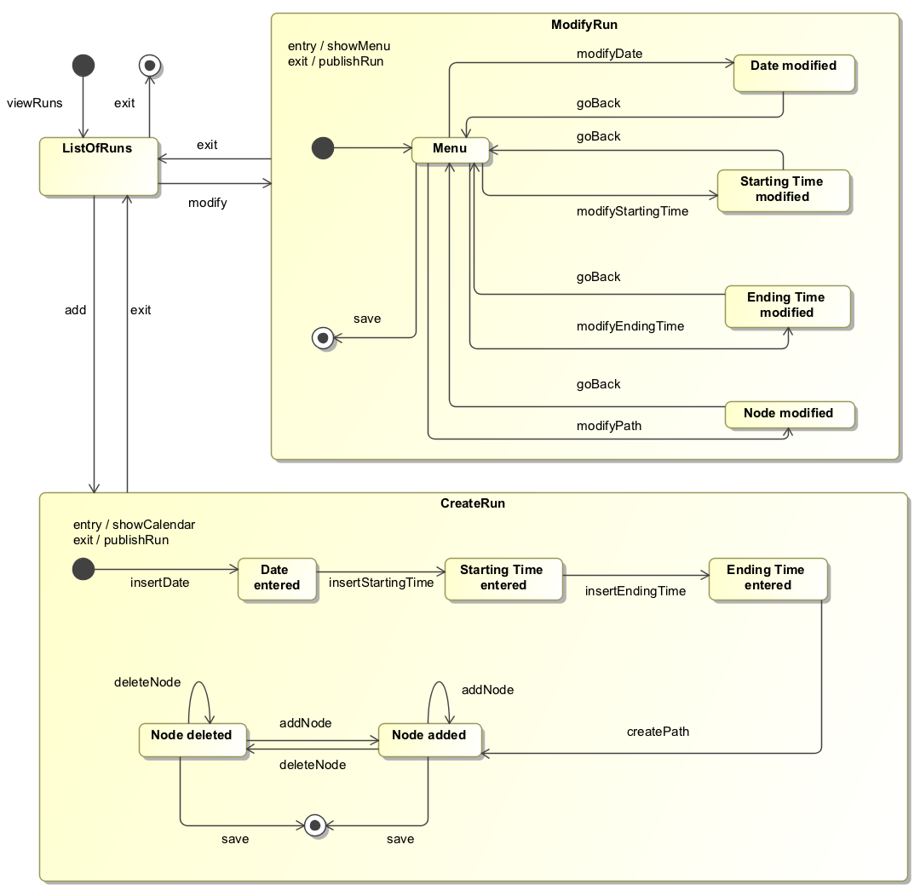

It is possible to see that creating a run implies the definition of the date, the starting time, the ending time and the path of it. Different nodes can be added or deleted during the creation of the path. The organizers can also modify a run they’ve already created.

* 1. Product functions
  2. User characteristics
  3. Assumptions, dependencies and constraints

[D1] - The individuals’ devices are able to measure all the health parameters needed by Data4Help.

[D2] - The individuals’ devices are able to provide an accurate detection of the health parameters.

[D3] - The GPS must be active on the individuals’ devices.

[D4] - The individuals’ devices are able to provide an accurate enough current location.

[D7] - A run present in the list of all runs is actually held

[D8] - The third parties know the ID of the individual they’ve asked data for

[D9] - An internet connection must be active

[D10] - The internet connection is stable

[D11] - The external partner takes charge of the help request

[D12] - An ambulance arrives to the user’s location

[D13] - The individuals are always with the device when they are using Data4Help

1. Specific Requirements