Detection, tracking and location of runways on visual approaches
projeto realizado para o curso "EA979 - INTRODUÇÃO À COMPUTAÇÃO GRÁFICA E AO PROCESSAMENTO DE IMAGEM"
- Daniel Gonçalves Benvenutti 169448
- Matteo Di Fabio 264339
- Renan Sterle 176536
1 Introduction

1.1 Motivation
Both in military aviation as well as in civil aviation, visual flight rules (VFR) remain of great importance nowadays. Particularly in airports and terminals of reduced infrastructure, visual approach and landing procedures account for the majority of cases and such procedures rely on visibility conditions, visual navigational aids and personal performance of the pilot in command. Figure 1 depicts what a final visual approach looks like.
In any type of landing approach, the maintenance of a safe flight envelope is crucial. Therefore, during the final approach leg, parameters such as airspeed, altitude, descent rate, glide slope, ground clearance, as well as location in relation to the runway must be monitored and corrected.
While airspeed, altitude and descent rate are measure by the aircraft, the other parameters can only be determined with the use of external information. In the case of instrument flight rules (IFR), Instrument Landing Systems (ILS), Global Navigation Satellite System (GNSS), inertial navigation systems and radio beacons provide such information, whereas on VFR they are ultimately estimated visually by the pilot.

The idea of this project is to implement a system that:

- Given a picture of an approach, identifies and isolates the runway in question, using image processing filtering and segmentation techniques ;
- Fits the runway image into the expected runway shape by applying perspective and affine transformations ;
- Determines the camera point of view in relation to the runway start. Alignment, lateral offset and distance information are the most important, while relative altitude is of secondary importance;
- Tracks the identified runway in a stream of frames, validating and checking the correlation of the results between different frames of a temporal sequence;
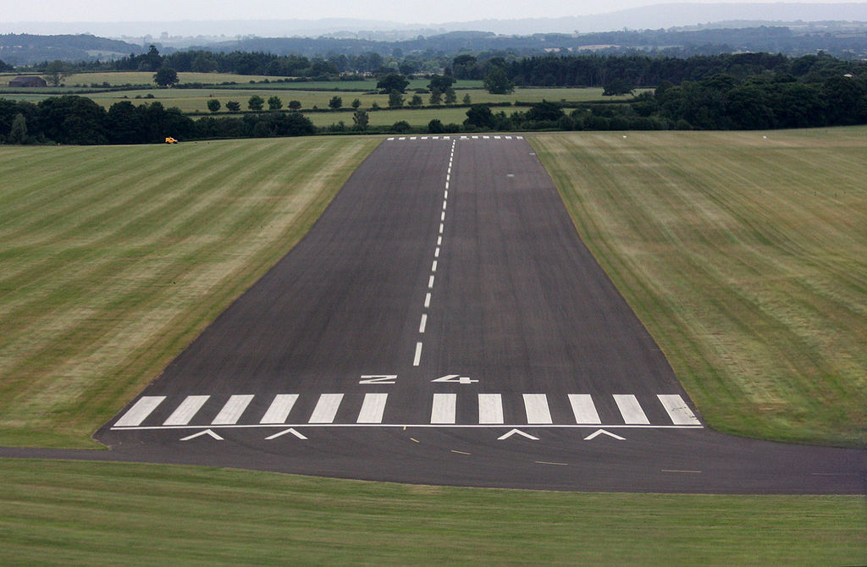

Figure 1: Approach view.

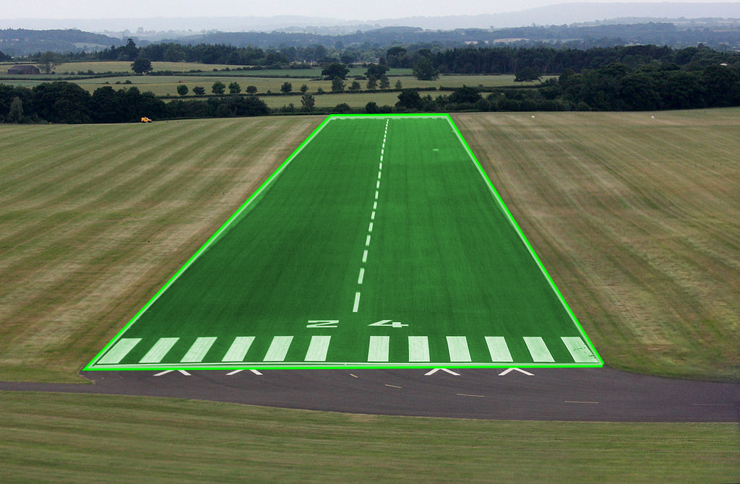
Figure 2: Segmented runway.
1.2 Theoretical Background

Most landing runways are approximately flat. Therefore, when photographed in two dimensions from a different plane in the 3D space, they can be encapsulated within a quadrilateral. This quadrilateral can be mapped to the expected rectangular 2D shape of the runway with perspective and affine transformations as in. Therefore, the coordinates of the camera can be determined in terms of those of the runway, and so can the relevant aeronautical parameters.

1.3 Proposed Development Plan

The project can be developed in several independent fronts simultaneously with a final merge and constitution of the full pipeline. Tasks such as:
- Finding the runway;
- Isolating and correcting projection of runway;
- Given a runway’s bounding quadrilateral in the image, find finding camera’s point of view;
- Given camera’s position, calculating the relevant parameters;
- Validating the obtained parameters by comparison to the sequential temporal series in the case of a video stream;

1.4 Data Source

As data sources, there is plenty of video footage of landings from the cockpit point of view on YouTube and similar platforms. Also, more standardized footage can be generate on purpose and in controlled manner with the use of flight simulators.

1.5 Evaluation

For evaluation purposes, along with qualitative functionality of the system, a few metrics can be defined for a quantitative analysis. For example, one can determine for which visibility conditions the runway is correctly detected, from which distance and with which derivation between frames. Also, data from a flight simulator can be generated so that the real parameters can be known and compared to the calculated ones. Thus, the error margins can be explicitly determined.

2 Our Approach (The code/The processing)
Once the general idea of the project was defined, each member of the group was divided into 3 parts, the work to be done and finally 3 codes were produced.
1) Identify runway
2) Correct
3) calculos
through a main.py these 3 codes are used as libraries to obtain the desired result.

2.1 Identify runway
através do uso da biblioteca openCV e numpy, realizamos as seguintes etapas:

- Contraste -> realça a pista;
- Blur (filtragem bilateral) ->torna homogêneas as áreas com cor similares mantendo as bordas nítidas;
- Canny -> acha as bordas;
- Crop -> corta uma área de cada borda da imagem porque para algumas imagens o canny acha o contorno da imagem e isso atrapalha;
- Dilatação -> funde as bordas encontradas pelo canny e simplifica o processo; Com menos bordas mais grossas a chance de encontras as corretas aumenta.
- Hough -> identifica as retas;
- Filtrar as linhas -> A gente ignora as retas que são muito pouco inclinadas;
- Todas as retas encontradas pelo Hough são desenhadas na imagem -> os segmentos se fundam e se agrupem. (É a mesma idéia da dilatação);
- Hough (de novo) -> encontra as retas que são na verdade o agrupamento e simplificação das retas encontradas pelo primeiro Hough;
- Otimização -> de todas as retas encontradas no 9, encontramos os 4 pontos com quais podemos construir duas retas que melhor sobrepõe as bordas sobrepostas do 8.

0. 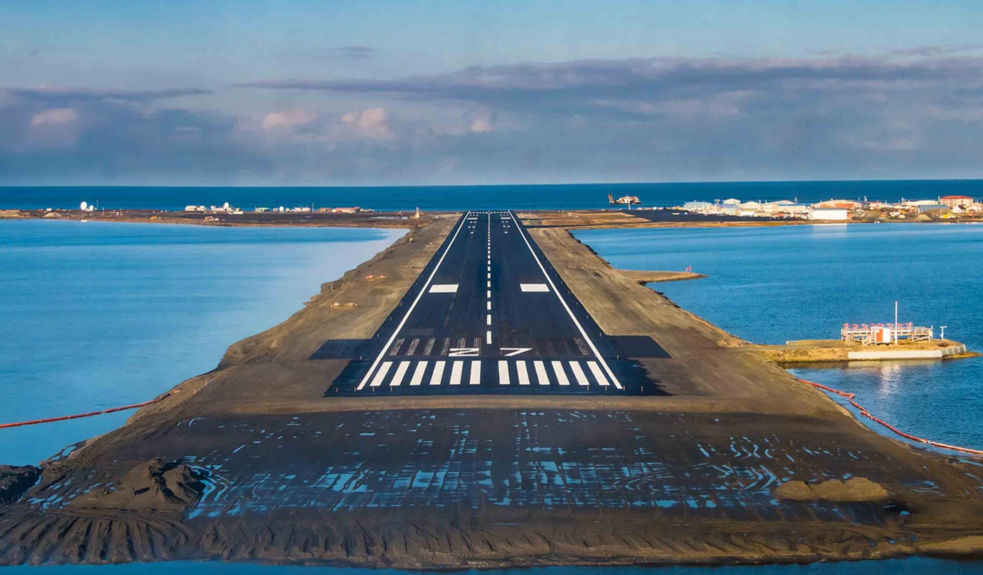 1. 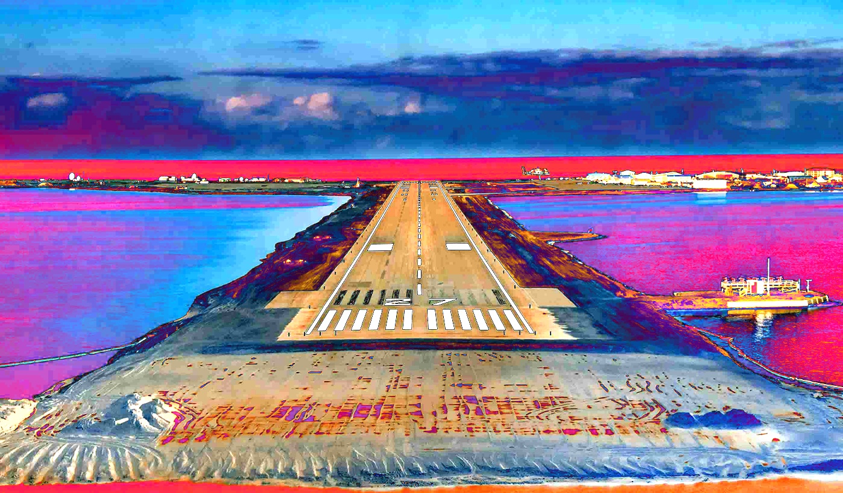
2. 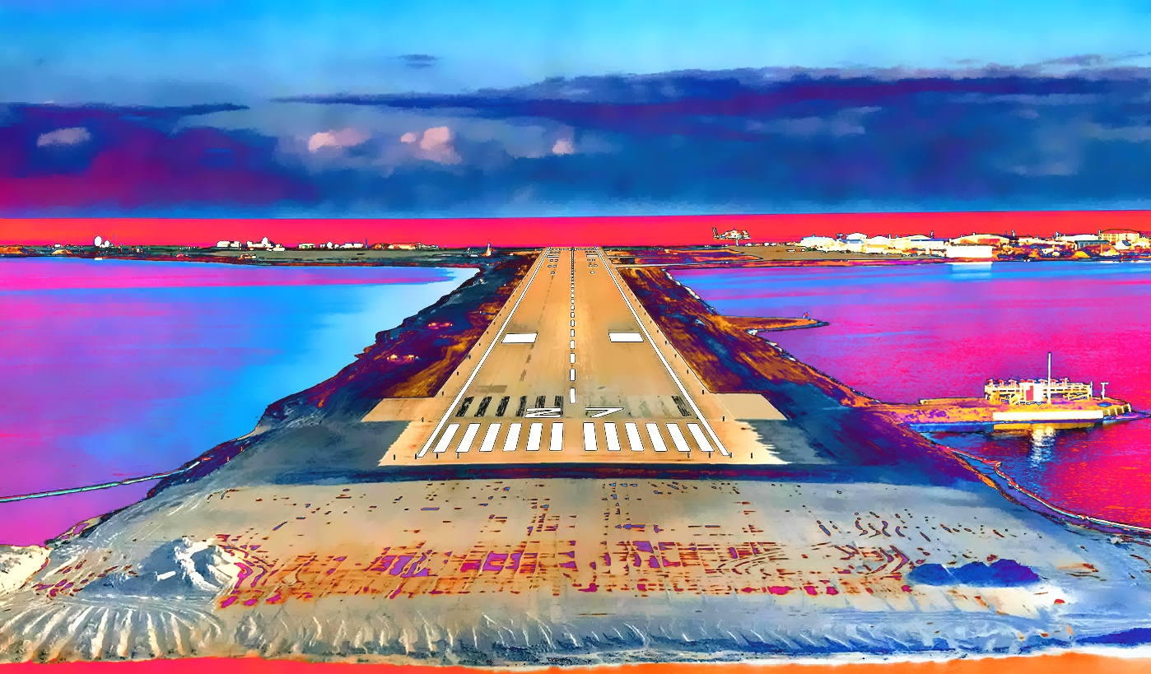 3.4.5. 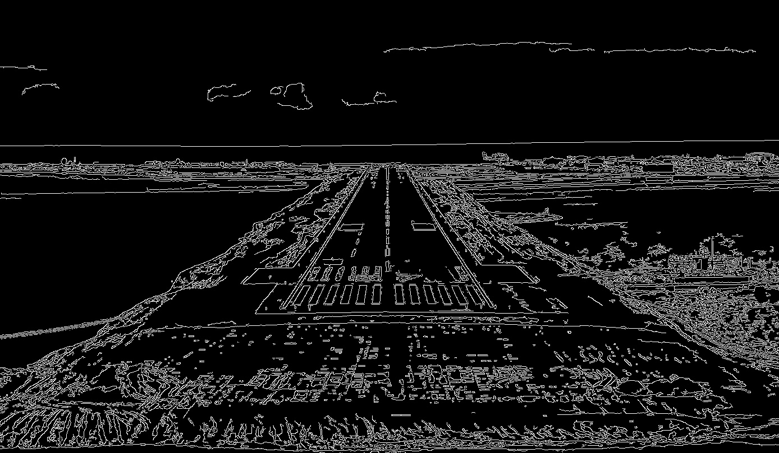
6.7.8.9 .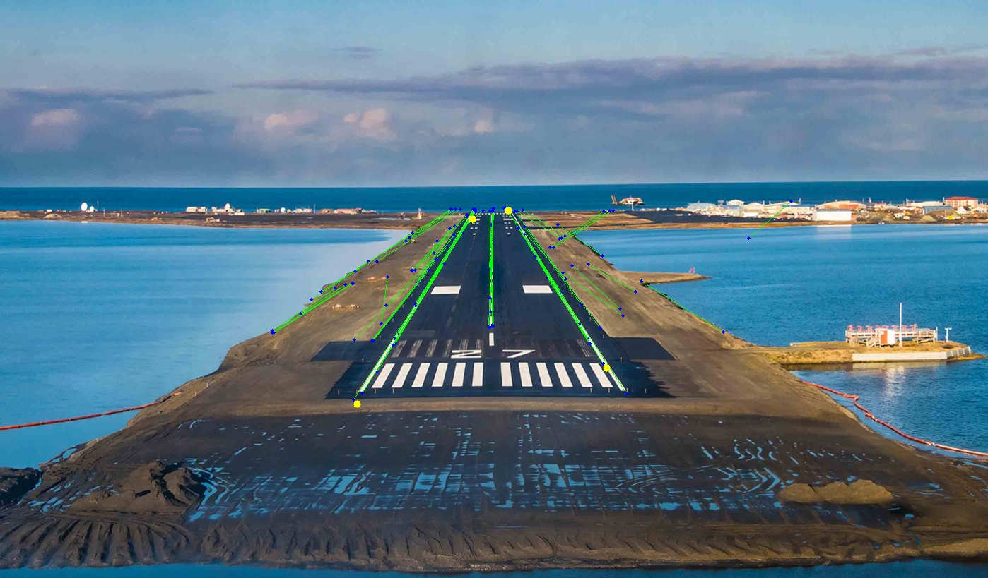 10. 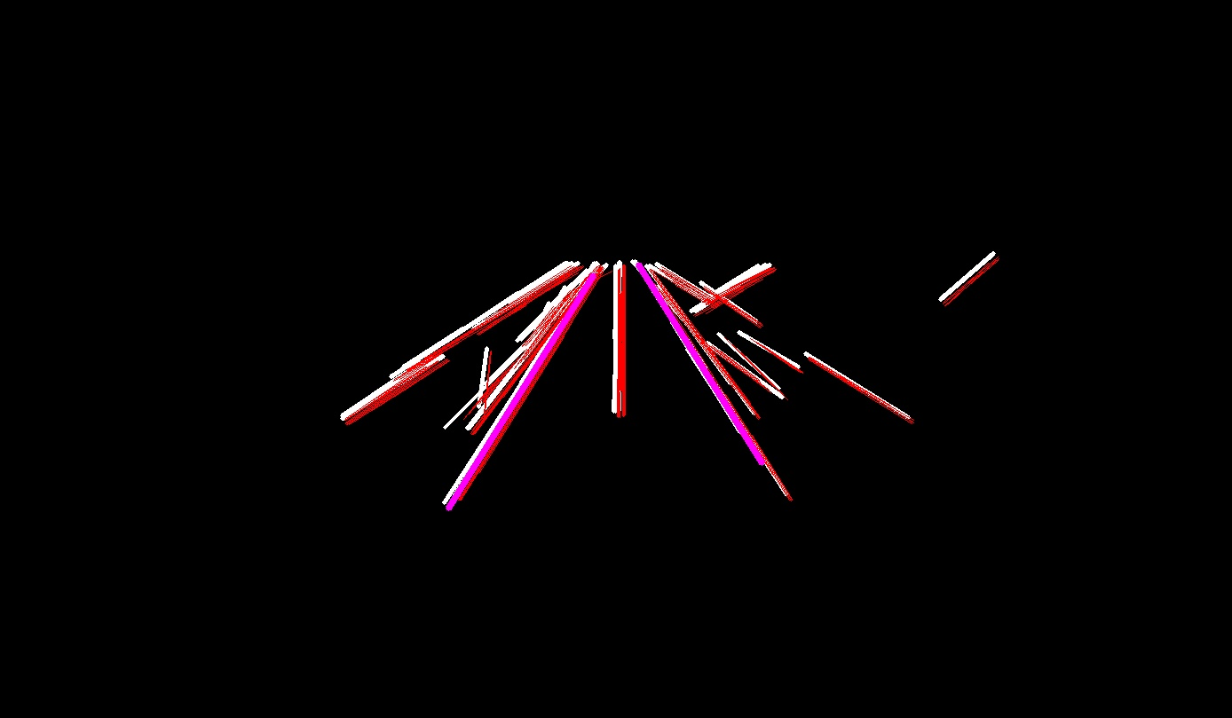
2.2 Correct
2.3 Finding the Plane’s position
A posição do avião é encontrada usando os quatro vertices da pista. No projeto usei uma função do OpenCV chamada calibrateCamera que também executa a função SolvePnP. Para encontrar a posição do avião a função calibrateCamera pega vários pontos com suas coordenadas na imagem e também no mundo real. É possível pegar de várias imagens diferentes. Com isso se obtem a matriz de calibração da câmera em questão. Se várias imagens estiverem dispponíveis podemos inserir essa matriz na função solve PnP e encontrar, junto com os dados dos pontos igual descrito acima, as matrizes tvecs e rvecs de uma imagem. Que são os fatores extrínsecos e também vetores de translação e rotação da imagem e podem ser utilizados para converter coordenadas no espaço da imagem para o espaço do mundo real.
Em seguida fazemos uma operação com esses vetores de acordo com esse artigo na wikipedia https://en.wikipedia.org/wiki/Camera_resectioning#Extrinsic_parameters.

Onde C é a posição da camera em coordenadas do mundo real, R é a matriz de rotação obtida do vetor de rotação com a função rodrigues do openCV e T é o vetor de translação. A qualidade dos valores pode ser melhorada se utilizarmos várias imagens para obtermos a matriz de calibração da câmera. Mas escolhemos não implementar algo que explorasse isso por limitações nas imagens para teste.

3 Results
4 Conclusion

