**git & github tutorial**

commands

First, we should learn a little bit instruction of commands.

ls - To list the files and folders in the current directory.

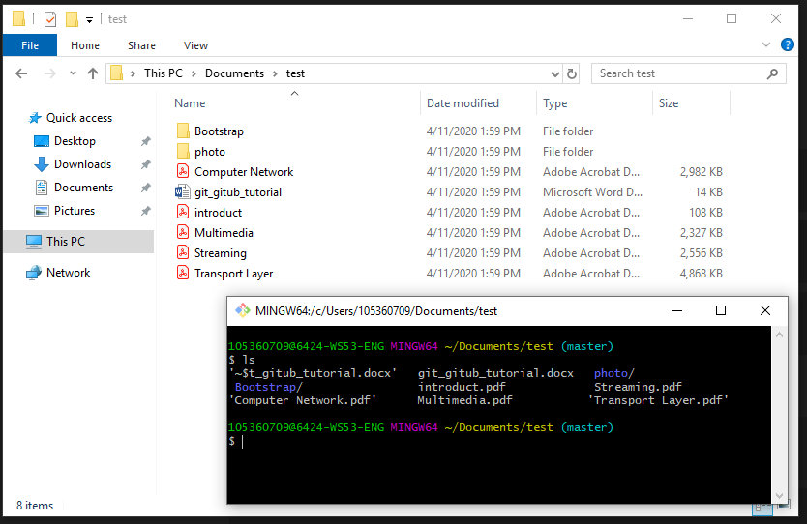

cd - To change your current directory. In other words, it moves you to a new place in the filesystem.

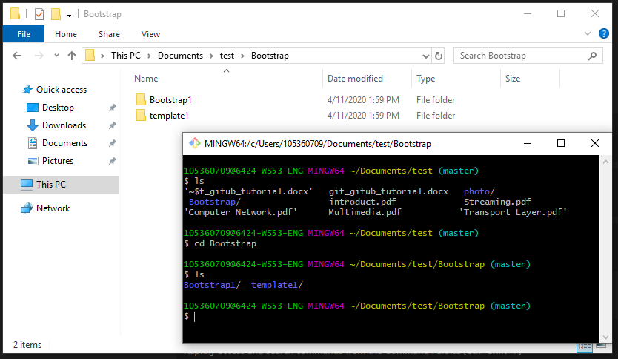

mkdir - To create new directory in the current directory.

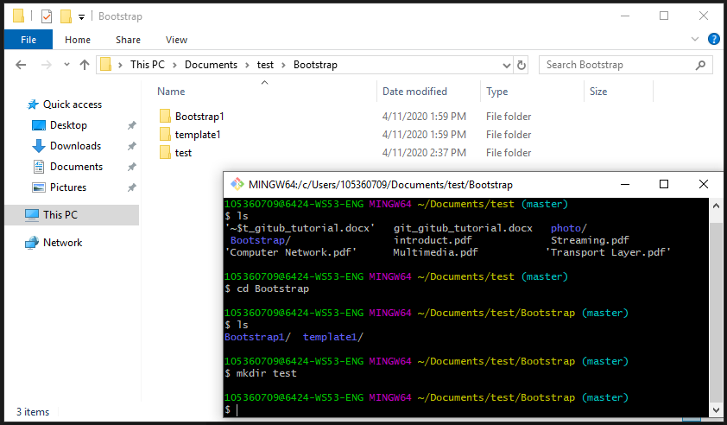

mv - To move files and directories from directory to directory. It also allows you to rename files.

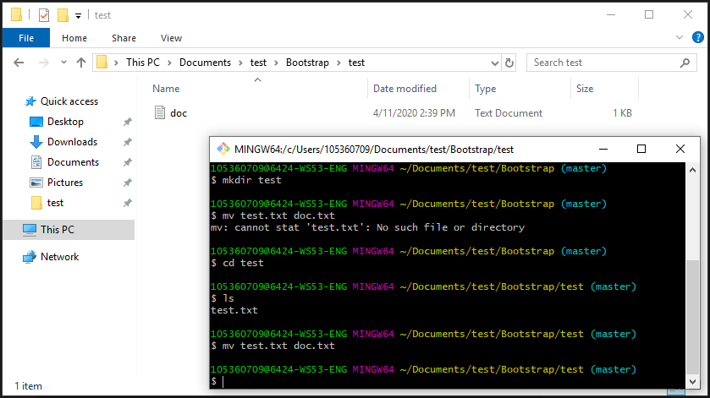

touch - To create a file. It can be anything, from an empty txt file to an empty zip file.

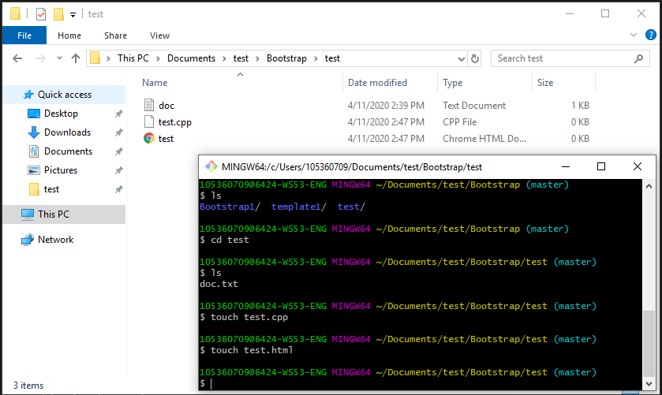

rm - To delete a file.

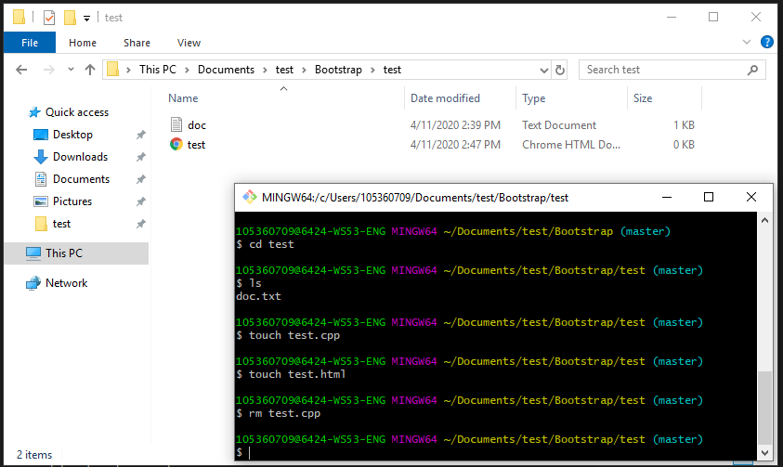

clear - To clear out your existing terminal screen.

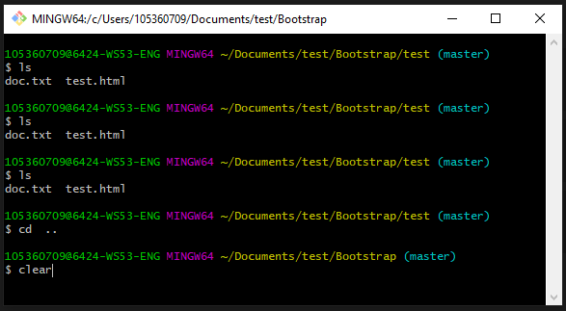

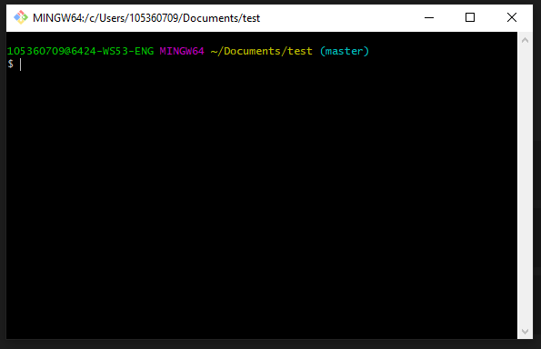

If you want to learn more commands, maybe you can see below:

<https://www.ubuntupit.com/best-linux-commands-to-run-in-the-terminal/>

<https://www.howtogeek.com/412055/37-important-linux-commands-you-should-know/>

Git Commands

First, we will need to download Git.

<https://git-scm.com/>

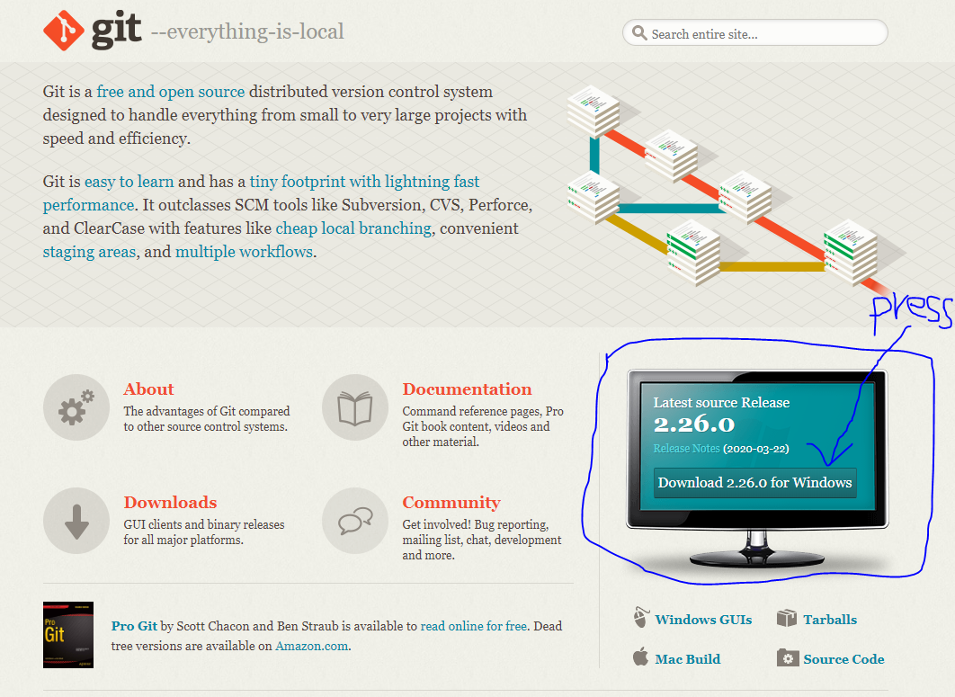

git init : This command is used to start a new repository.

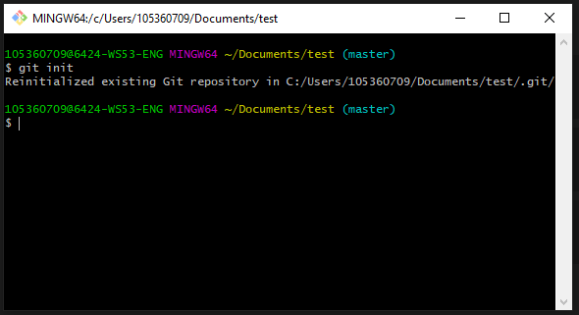

git status : This command lists all the files that have to be committed.

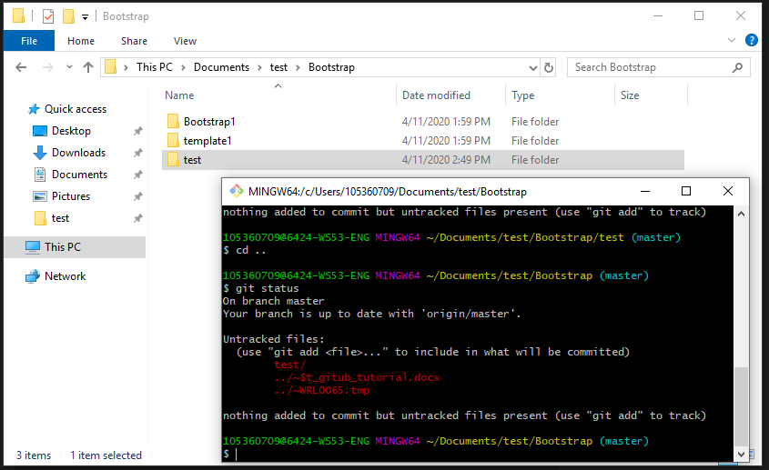

git add : This command adds a file to the staging area.

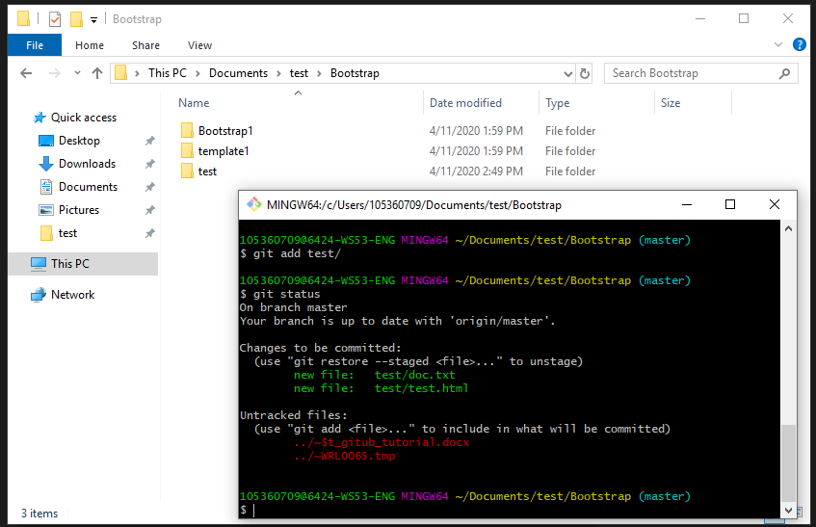

git remote : This command is used to connect your local repository to the remote server.

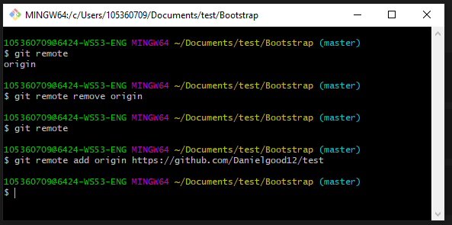

git commit : This command records or snapshots the file permanently in the version history.

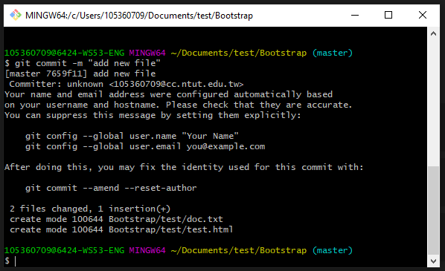

git push : This command sends the committed changes of master branch to your remote repository.

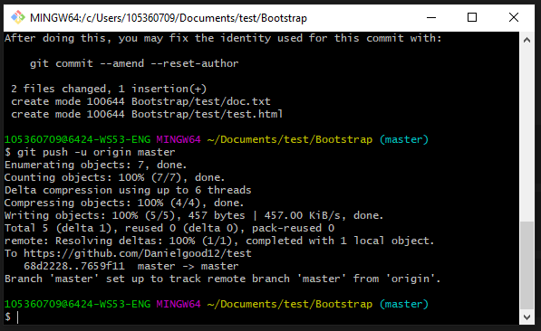

If you want to learn more commands, maybe you can see below:

<https://dzone.com/articles/top-20-git-commands-with-examples>

Lean by doing …

1. creating Repository on Github.

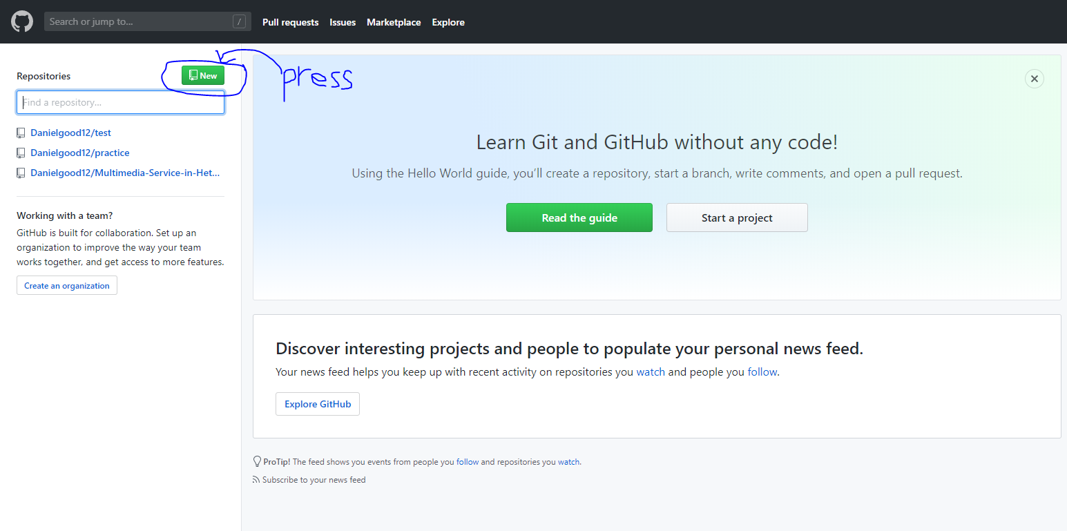

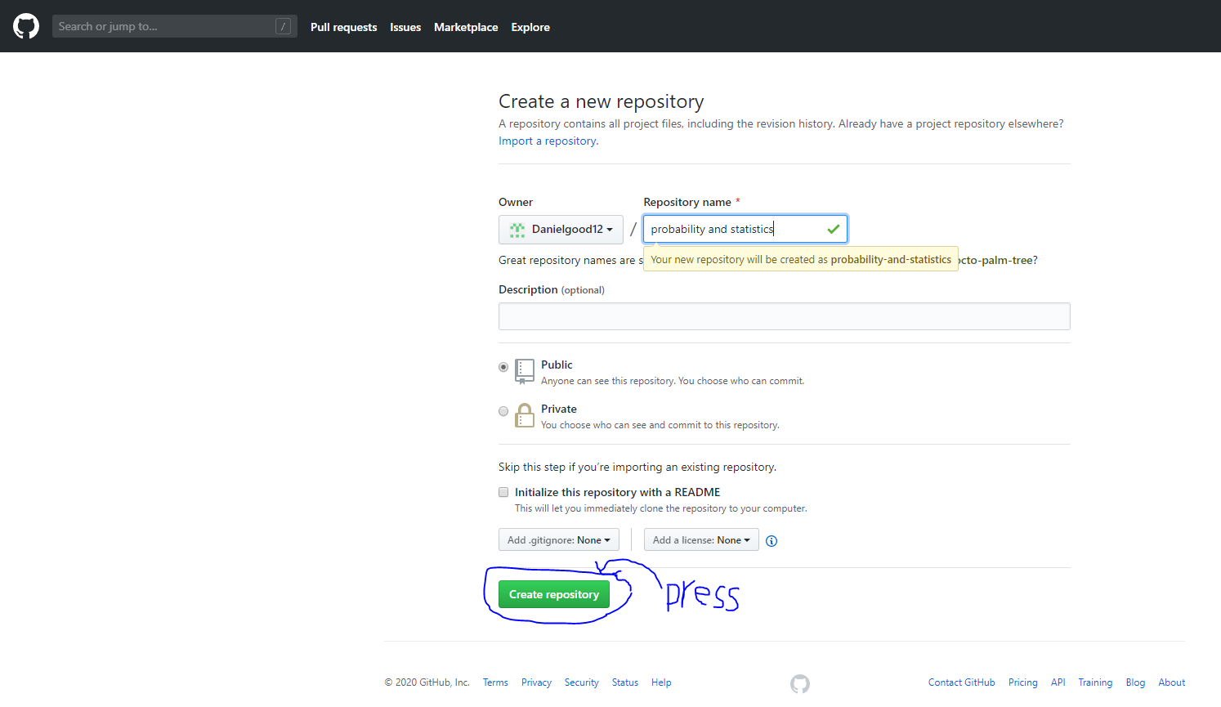

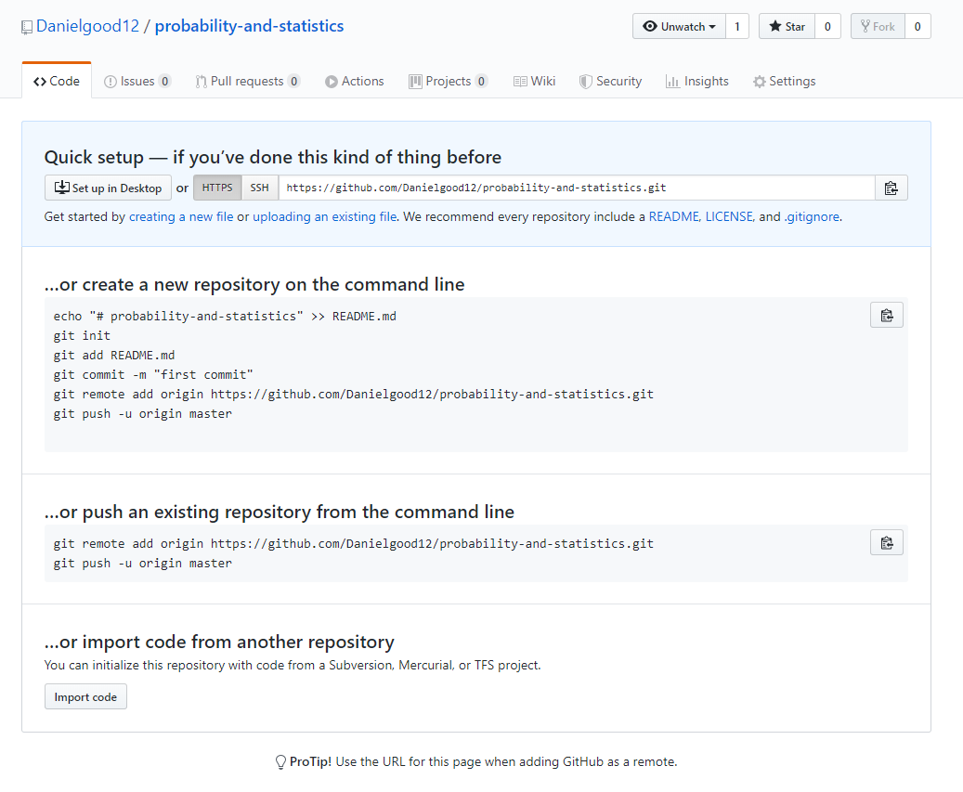

1. creat folder on your computer

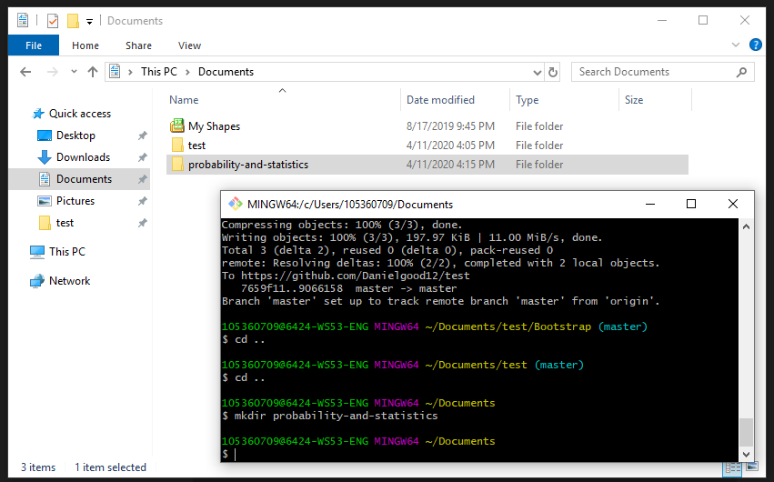

1. continue following bolew …

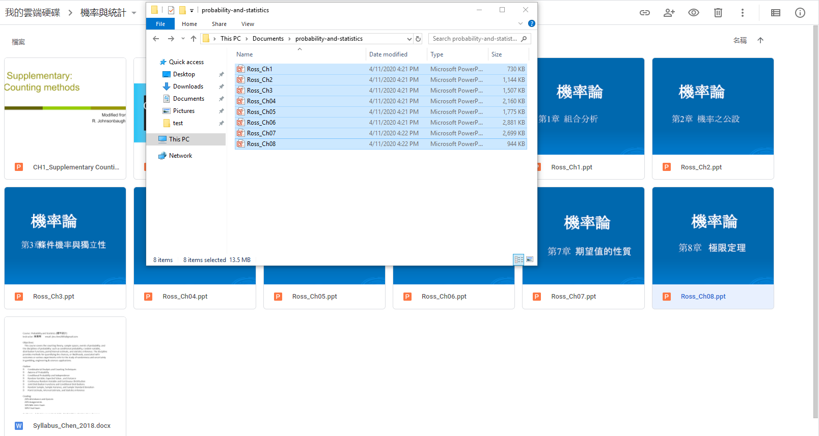

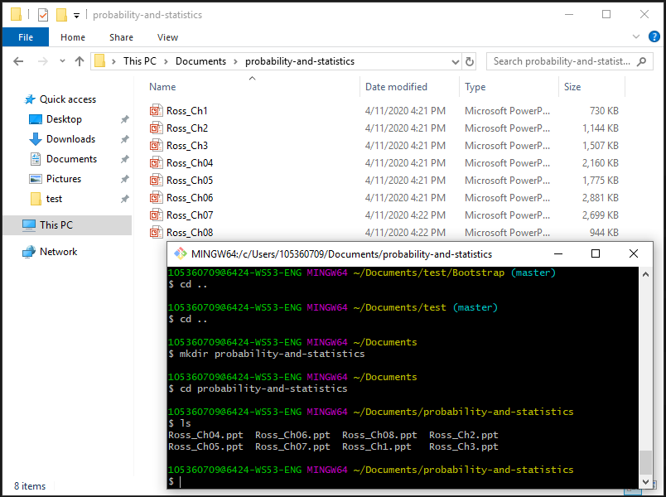

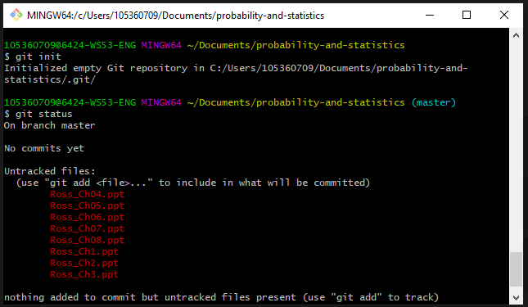

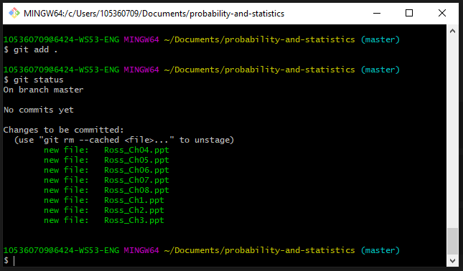

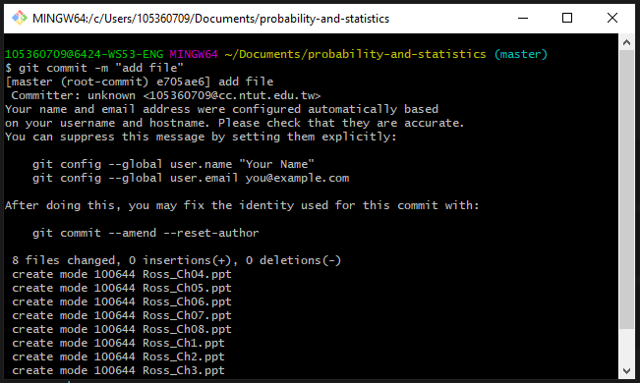

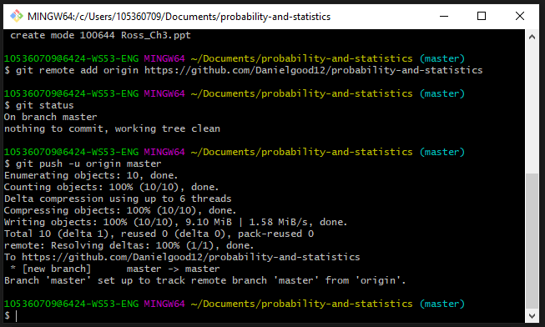

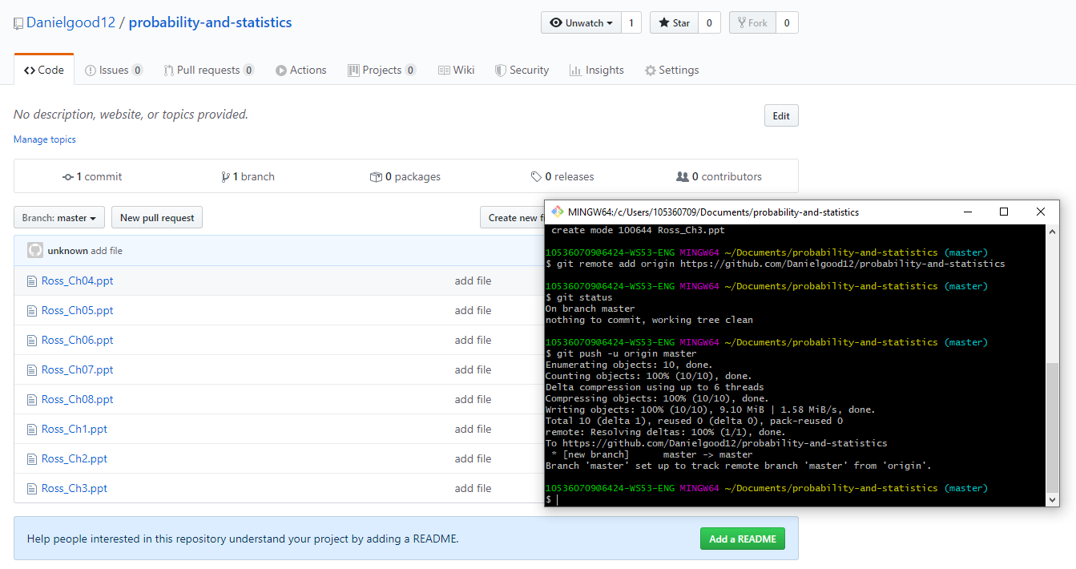

And then, if you want you delete file on Github …

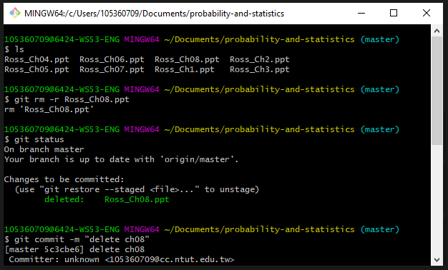

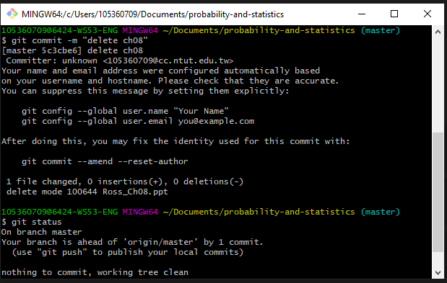

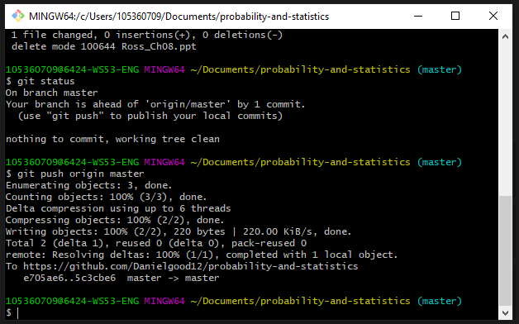

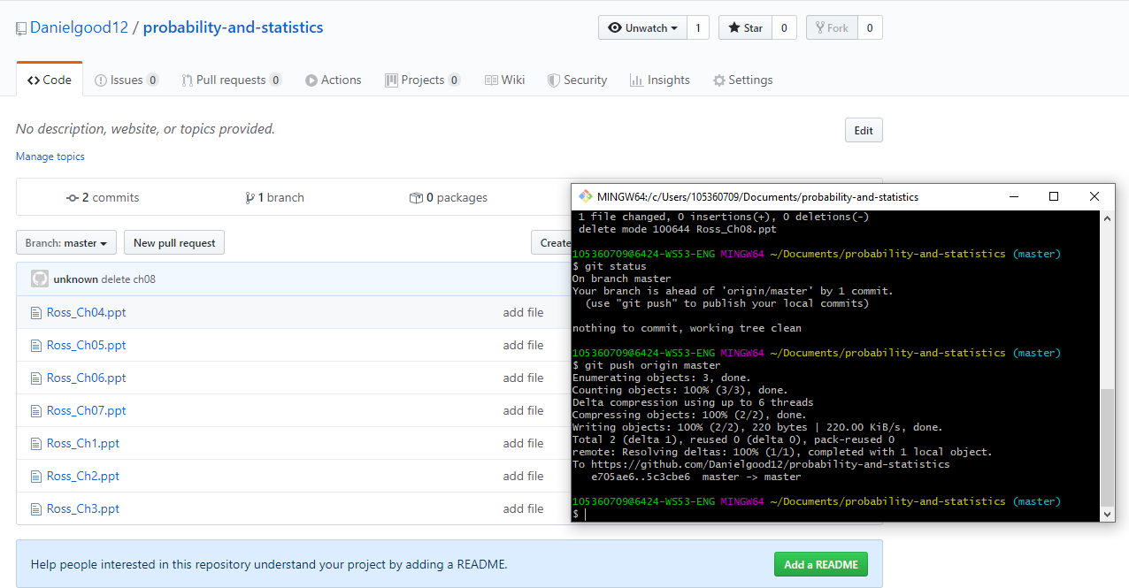

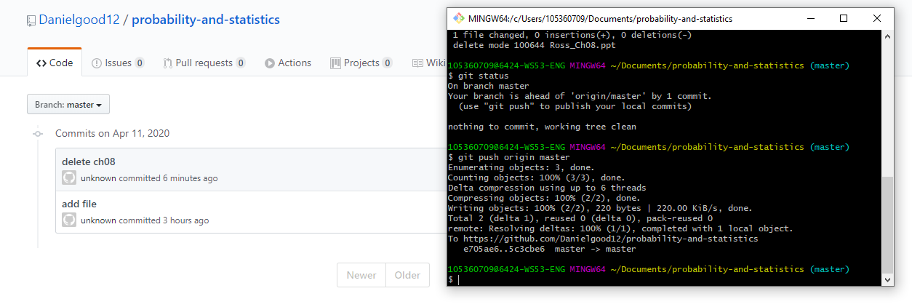

Maybe you met something problem …

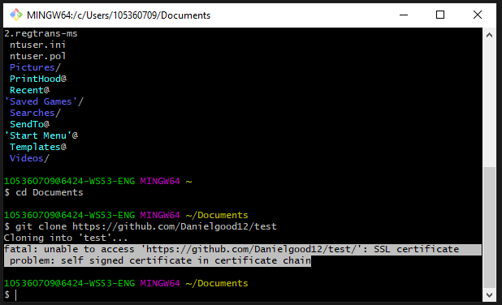

Reference:

<https://devmanna.blogspot.com/2018/06/git-remote-ssl-certification-problem.html>

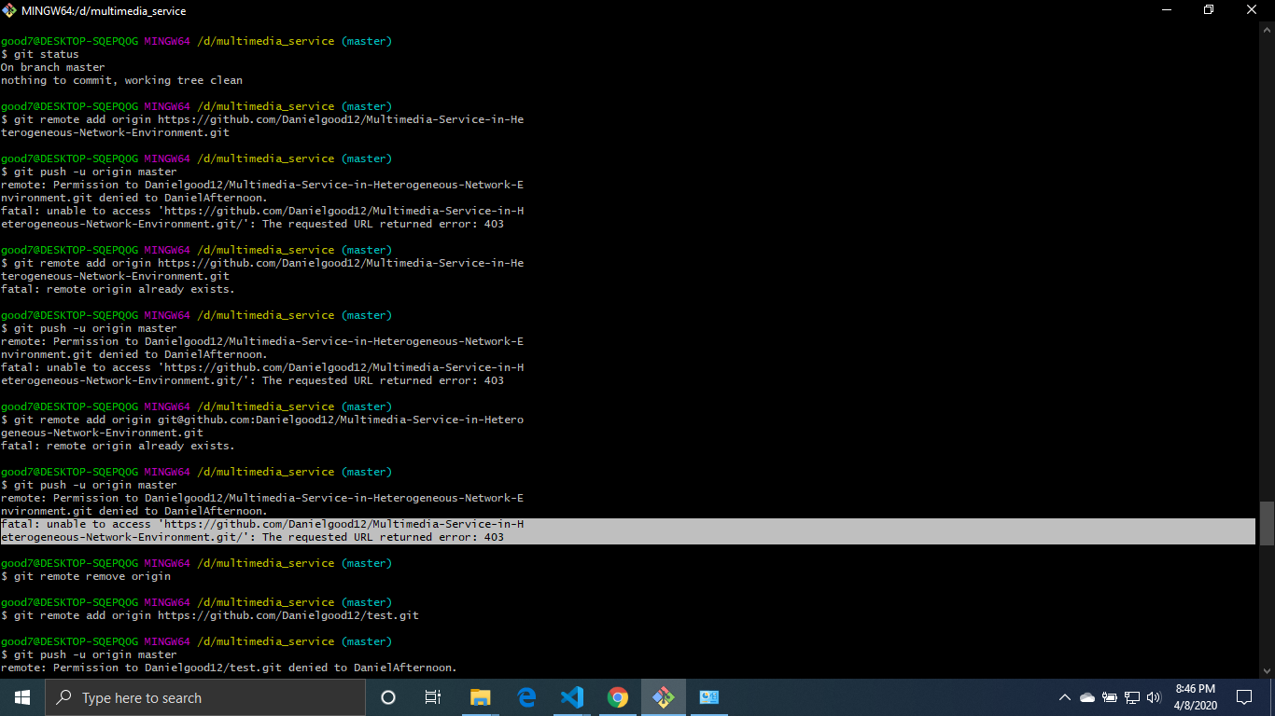

Reference:

<https://hsiangfeng.github.io/git/20190614/391412804/>

* ...end…

If you have any problem, tell me. Maybe we can discuss together.