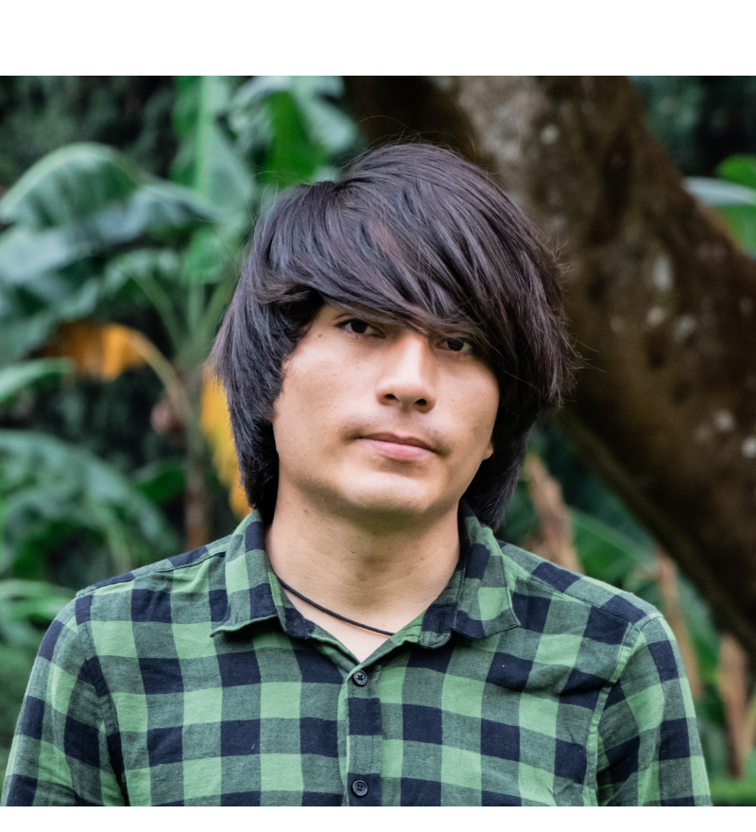 | DANIEL HUMBERTO OREA ARONTES  Journalist & Analyst — International Relations and Public Policy  Cuernavaca, Morelos, Mexico · danielhumberto13@hotmail.com  Byline: Daniel Orea Arontes

PROFESSIONAL PROFILE
Journalist and analyst specializing in international relations, comparative public policy, and the strategic intersections between nations and cultures — exploring how countries connect not only through trade and diplomacy, but through shared narratives, social movements, and creative expression. His reporting for Nación Digital and Mundo Ejecutivo has covered Mexico's agro-export strategy and the modernization of rural policy, including the Plan de Ayala 2.0 and its implications for Latin America–Middle East relations. Beyond journalism, he leads social impact initiatives that translate political and cultural analysis into action, including the International Rap Syndicate, a creative union using hip-hop as a vehicle for social awareness, workers' rights, and cross-border solidarity. His multidisciplinary training in public policy, law, and anthropology grounds his coverage in an analytical, historical, and deeply human perspective.
SELECTED PUBLICATIONS
Mundo Ejecutivo February 27, 2026
"Director de RUMEC presenta plan para tecnificar el campo mexicano y facilitar exportaciones"
English: "RUMEC Director Presents Plan to Modernize Mexican Agriculture and Facilitate Exports"
Nación Digital August 4, 2026
"México apuesta por Emiratos Árabes para exportar alimentos premium"
English: "Mexico Bets on the United Arab Emirates to Export Premium Food"
El Correo del Golfo (United Arab Emirates) Forthcoming
"Article in preparation"
Publication in progress — update title and date once published.
BBC Forthcoming
"Article in preparation"
Section and title to be confirmed — update once published.
RELEVANT EXPERIENCE
RUMEC — Director of Operations ~5 years
- Built profiles of agricultural producers for an international buyer database.
- Led outreach to international markets, with a recent focus on the Middle East.
- Conducted interviews, communications, and institutional relations around the Plan de Ayala 2.0.
LEADERSHIP & SOCIAL IMPACT
International Rap Syndicate — Collaborator and driving force behind a creative union that uses hip-hop as a vehicle for social awareness, workers' rights, and cross-border solidarity, connecting artists and activists across the Americas and beyond.
EDUCATION
Universidad Internacional — Cuernavaca, Morelos, Mexico
RELEVANT CERTIFICATIONS
- U.S. Public Policy: Social, Economic, and Foreign Policies — Harvard University (2020)
- Anthropology — Harvard University: PredictionX, Omens, Oracles, and Prophecies (2020)
- Legal Argumentation — ASPA de México (2022)
- Creative Skills & Critical Thinking Development — Instituto Azteca (2022)
- Introduction to ChatGPT — edX (2024)
SKILLS
Journalistic writing · Public policy & international relations analysis · Institutional relations · Bilingual (English/Spanish) · Applied AI for research and writing · Cross-cultural creative project leadership

