Students:
Name: Daniel Lin
ID:
Name: Hadar Ferber
ID: 209148535

The features we choose:
Collage of moments:

Statistics feature:

Application screenshots:

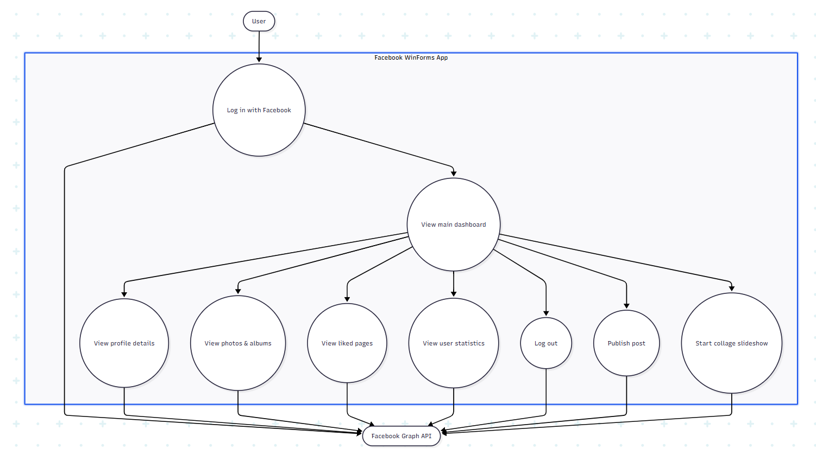
Use Case Diagram:

Collage of moments- Sequence diagram:
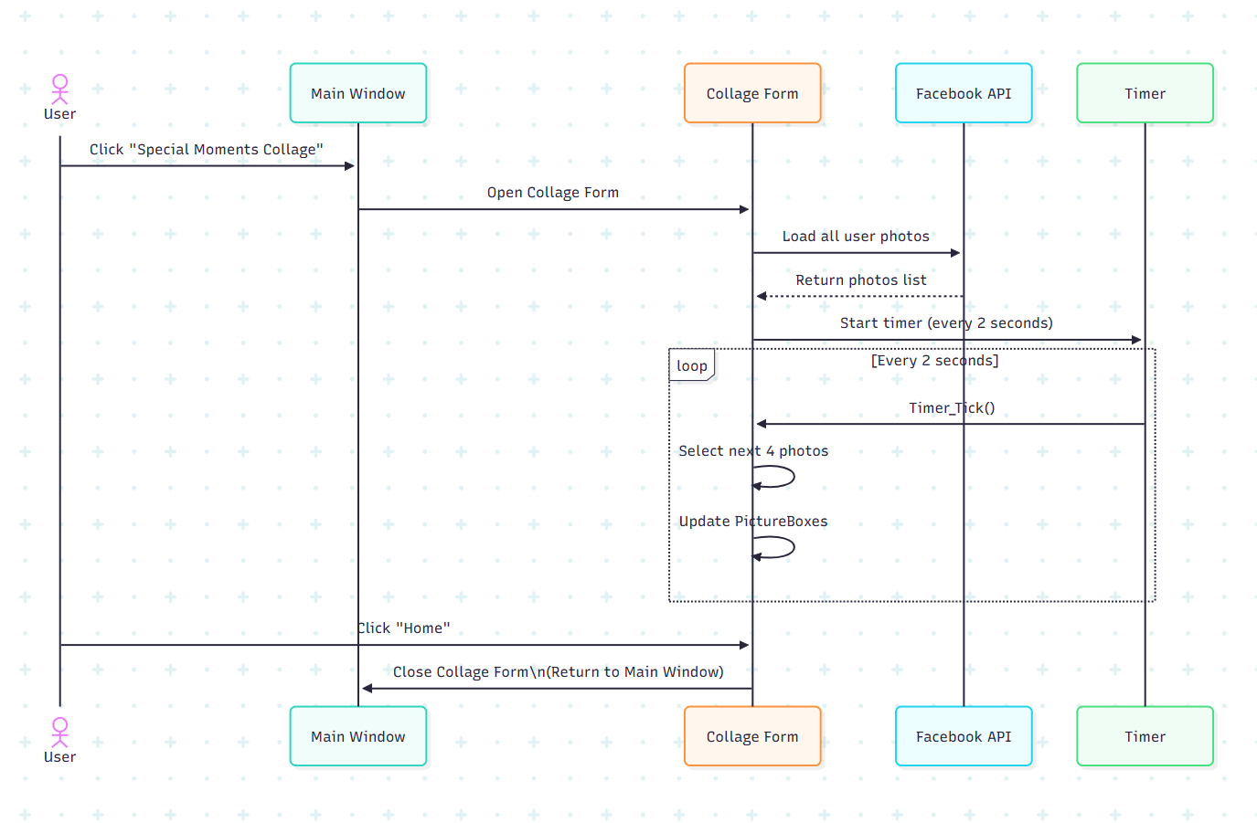

Statistics- Sequence diagram:

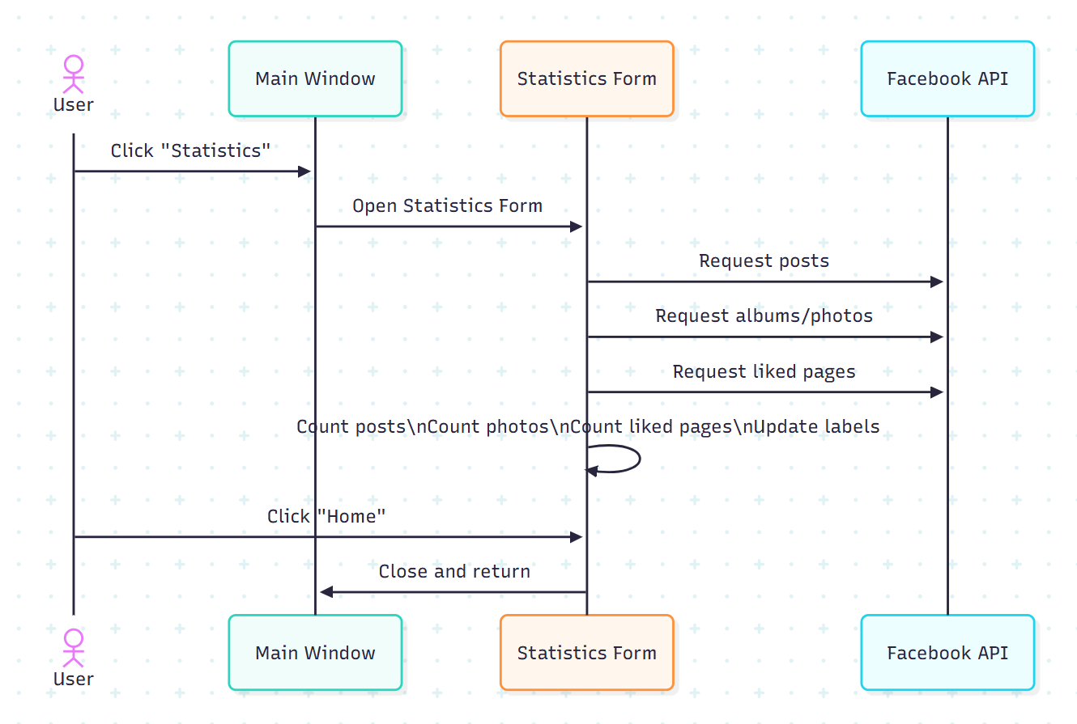

Class diagram:

