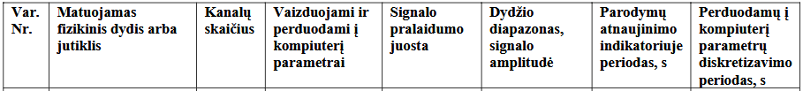
8e-12 adc talpa, 1k switch, 4700*1.01 external. 46ns constant, 230ns 5*tau
32e6/2=16e6 adc clock, 62.5ns T
Reikia bent 3.68 ciklo
Naudojamas 7.5

200 hz nyquist
250 hz sample, 250hz timer
250*0.2=50 samples

SCK max 10mhz, 10mbps. Naudojamas 8 mbps

0.2hz nyquist
5hz dma persiraso, kas 24 perrasymus galima keist pga kanala

