OccupyUC – Room Reservation System

Arcana

Members: Danielle Kritz, Carmen Fortino, Jake Ghaul

October 25, 2016

Introduction

The project is a real-time interactive web application for campus room reservation for students and faculty of the Ursinus community that will take the place of the existing system. It will present a map of campus buildings and display real-time availability of class/study rooms.

Purpose

This project is useful because it will save time and effort for students who are looking for available study spaces. It will prevent frustration and confusion as well as unnecessary wandering. Especially during finals and midterm weeks, the availability of rooms is scarce and often an individual can walk through an entire building only to find that there is no place to study. Furthermore, it has the goal of allowing for a sharing functionality that will help to eliminate one person claiming an entire room that could productivity be used my many more, e.g. Musser Auditorium. It’s an innovative project because it is taking ideas and components of existing application, such as a campus laundry room viewer seen at other universities and the current faculty reservation system, with similar functions and applying them to a personally impactful issue.

Platform

This project will run on any machine with web access, as long as the browser supports the application functionalities. The system requirements include at least a 32-bit processor, 2 GB RAM, 1 GB free hard disk space, and recommended 16-bit color. These requirements are preliminarily based on the requirements of Canvas, since our web application will likely not exceed the memory and speed of the Canvas implementation. Further development of the specifics of our implementation will inform more precise requirements of speed and memory.

Audience

The audience for this project is the Ursinus community including active (currently enrolled, teaching, etc.) faculty and students. It is focused toward student groups, as well as individuals who wish to have a way of obtaining a study room or room for an event. Anyone not a current student or faculty member with a valid UC ID should not be able to access this program. This is not only a safety measure, but a logical limitation for the use of this program.

Team Dynamic

**Meetings & Scheduling**

Preliminarily, group meetings will be held weekly on Tuesday evenings at 9:00 PM in the ACM room (Pfahler 105). Subsequent meeting details regarding place and time will be determined and agreed upon at the end of each meeting. Should anything change over the course of the time between meetings, email will be the primary mode of communication between the members of the group. Carmen will be in charge of the team meeting scheduling and managing what progress in the code should be expected at the following meeting. About 2-3 weeks before the deadline, the team will meet at least twice a week for updates on progress and any issues that arise.

**Configuration Management**

The team will use GitHub as a configuration management tool. Danielle will be the configuration manager tasked with maintaining the Git repository and making sure all code and documentation is merged and committed without conflicts.

Description

**User Interface**

The user interface will be web-based and graphical in nature. A map of the campus academic buildings will be displayed as well as interactive floor plans for the floors of these building. There will be a very brief form for the student/faculty member to fill out to occupy a room and a distinction by color of room status including: available, occupied, and occupied but open to sharing. Images of a sample interface are included below.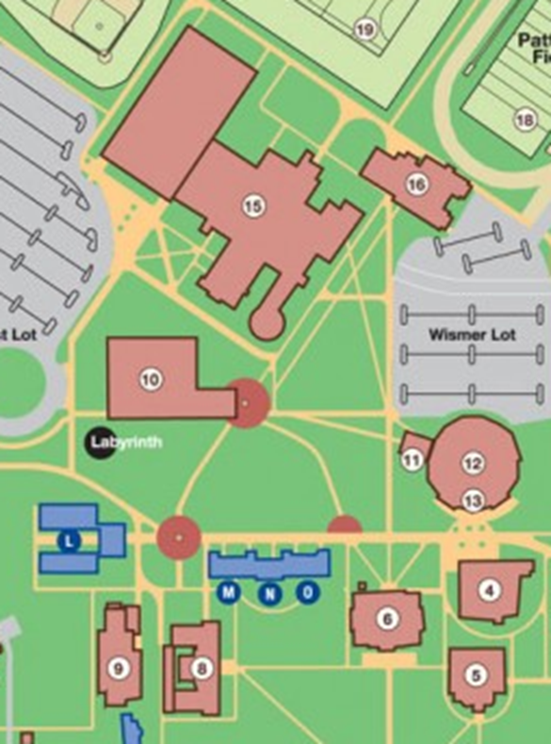



Floor 1

Floor 2

Floor 3

**Pfahler Hall**

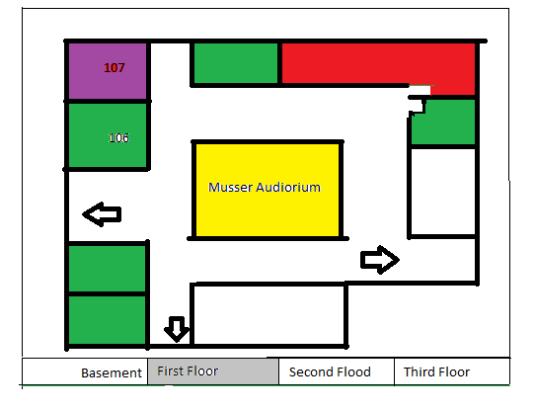

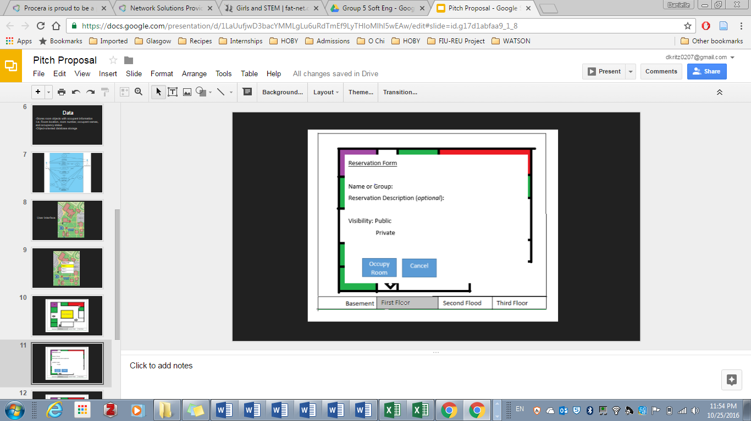

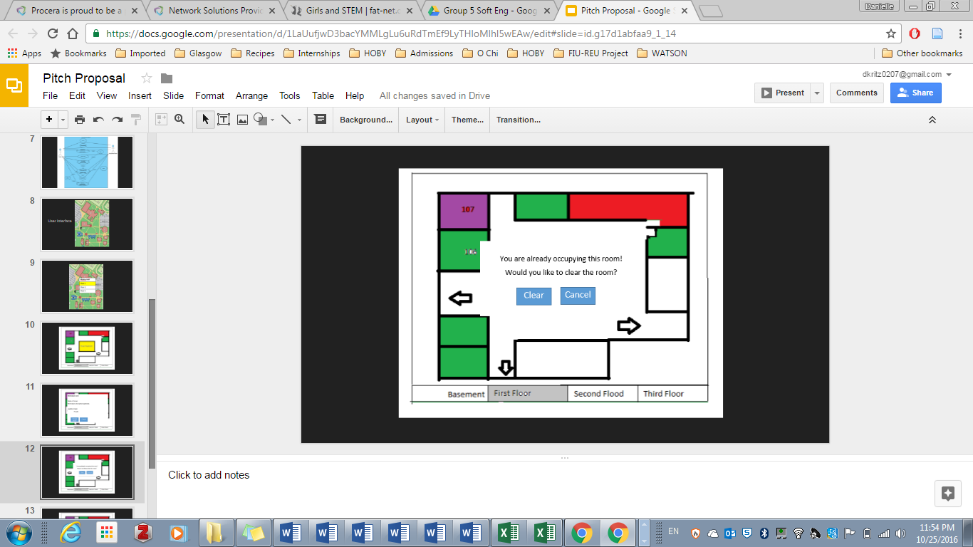

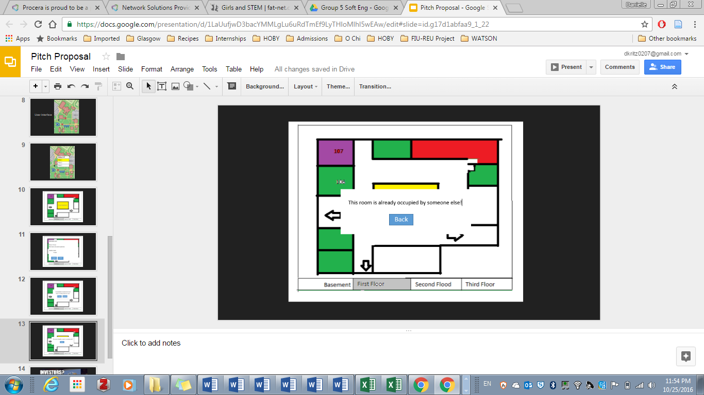

**Processing**

The program will check if the room is occupied and set the color of the room depending on availability (including shareable, reserved, and available). It will also display the occupant data if set to allow other students to see the information. Ideally, this application will be utilized as its own entity, however, should it require interfacing with the legacy system, a better understanding of the existing system is necessary before determining the processing involve. For example, if it has an API that can be used to access the database.

**Data**

The program will store the persistent data relating to the room availability and reservation in a room object. This will include member data such as building, floor, occupant(s), room number, public or private visibility of occupants, etc. The room objects will be stored in an object-oriented database.

**UML Use Case Diagram**

