**Software_Security_Class**

Assignments from class CS305 Software Security.

**Certificate Generator Assignment**

This is assignment we had to generate our own certificates through the command line

**Journal**

• Briefly summarize your client, Artemis Financial, and their software requirements. Who was the client? What issue did they want you to address?

Artemis Financial is a financial consulting agency. They refine savings, retirement, investments, and insurance plans for their clients. They prove to care about their clients by ensuring their system is more secure from external threats.

• What did you do particularly well in identifying their software security vulnerabilities? Why is it important to code securely? What value does software security add to a company’s overall wellbeing?

I believe my thoroughness was key in identifying Artemis Financial’s vulnerabilities within their software security. Placing the Policy of Least Privileges throughout the entire process and application, checking for vulnerabilities in various areas and using different methods of finding them, creating code to prevent as well as handle an attack if it occurs to name a few areas.

Securely coding prevents attacks from happening and protects the sensitive data that is being stored within. This shows that Artemis Financial have genuine regard for their customers. Had an attack occurred, and there was no attempt to uses secure coding techniques, the company could lose the confidence of their consumers.

• What about the process of working through the vulnerability assessment did you find challenging or helpful?

I found it difficult to know which algorithm was best for each task. I did establish that the vulnerability assessment process flow diagram was helpful when looking for vulnerabilities.

• How did you approach the need to increase layers of security? What techniques or strategies would you use in the future to assess vulnerabilities and determine mitigation techniques?

I went through the Vulnerability Assessment Process Flow Diagram and looked for where I felt the application needed more security. In the future, I would use techniques such as sandboxing, run and compile time checking, input validation, and null point referencing. A few other ways to mitigate vulnerabilities in the future are the use of type safe languages, using sage string libraries, and having non-executable sections within the stack.

• How did you ensure the code and software application were functional and secure? After refactoring code, how did you check to see whether you introduced new vulnerabilities?

My strategy for ensuring a secure and functional application was to, periodically, go through the Vulnerability Assessment Process Flow Diagram. I also ran a Maven test and used randomization for the values used with the canaries.

• What resources, tools, or coding practices did you employ that you might find helpful in future assignments or tasks?

The internet helped me greatly. The peer tutoring also helped. Some of the issues I had were simply because the directions were for a PC, and I am working on a Mac and both were instrumental in mitigating issues.

• Employers sometimes ask for examples of work that you have successfully completed to demonstrate your skills, knowledge, and experience. What from this particular assignment might you want to showcase to a future employer?

I believe I presented the Mitigation Plan portion of this assignment with comprehension and effectiveness.

[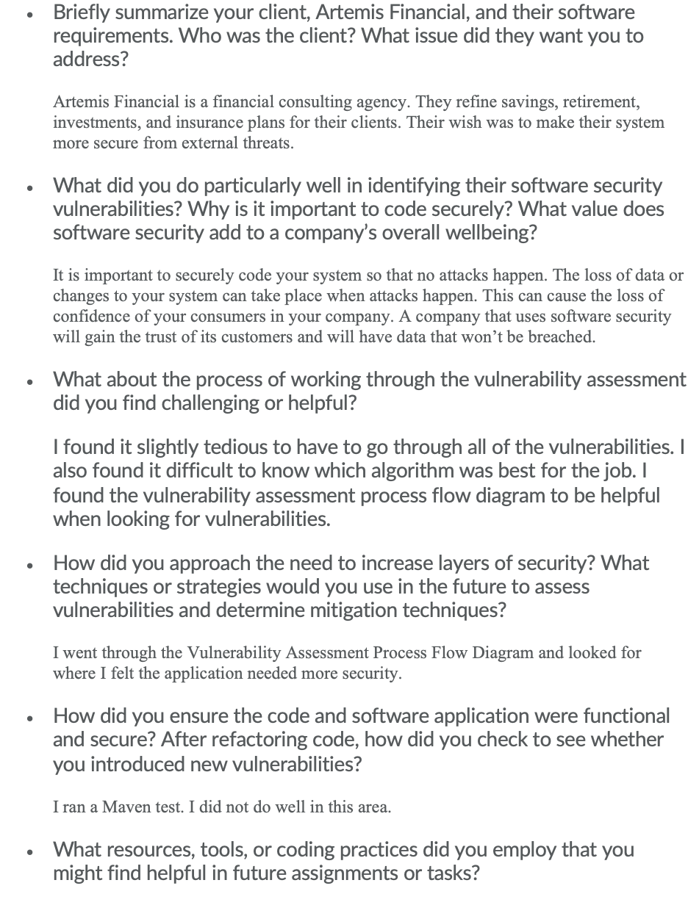](https://user-images.githubusercontent.com/69529948/145108298-32b1551a-111e-42ff-9df3-eec7402ab289.png)