Q1:

1. we use this script:

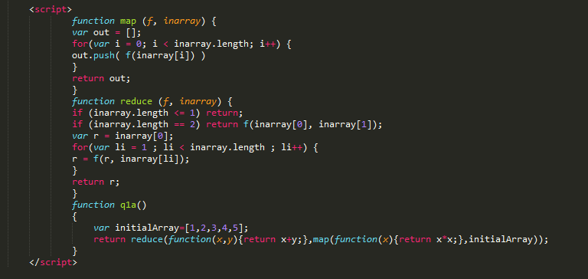

The relevant one line is:

reduce(function(x,y){return x+y;},map(function(x){return x\*x;},initialArray))

Where the first action is map each element to it’s square and the second action is reduce these map output elements to their sum.

1. I used this script:

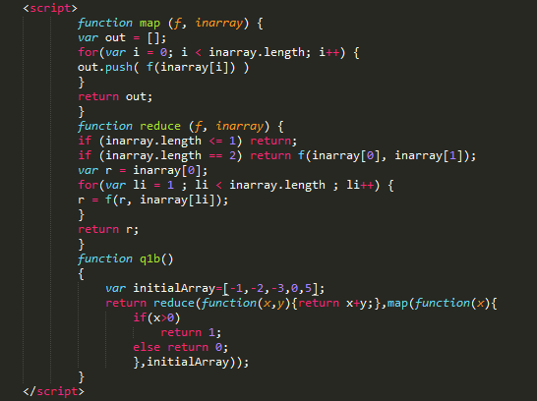

Map each positive number (x>0) to 1 and the other numbers to 0, and then summarize the array with reduce as we did in the first part of this question.

C. I used this script:

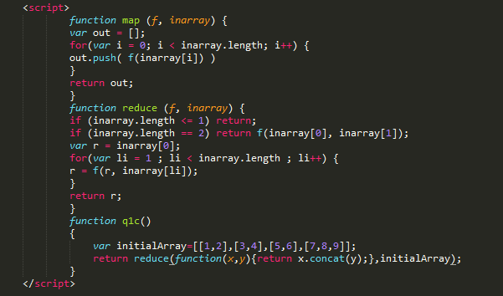

We have to use only reduce function between the elements: the reduce function is concat, which returns a flatten array of two arrays.

Map function is not needed here because the elements are already arrays as required.