
ORT Braude College of Engineering
Department of Software Engineering
Capstone Project — Phase B (61999)
Autonomous Predictive Tracking and Laser
Neutralization System for Flies
Phase B: the predictive motion-modelling component
Project code: 26-1-R-22
By
Daniel Lachmakov · Daniel.lachmakov@e.braude.ac.il
Yaniv Bodaga · Yaniv.bodaga@e.braude.ac.il
Advisors
Dr. Dan Lemberg · Lembergdan@braude.ac.il
Mrs. Elena Kramer · Elenak@braude.ac.il
Project repository — Phase A and Phase B books, full source code, data, results and presentation:
github.com/Danielon05423/Drosophila_Trajectory_Prediction
September 2026

Contents

1. Abstract
An autonomous system that neutralises a fly in flight cannot aim at where the fly is; by the time a sense–decide–actuate loop completes, the target has moved. The whole architecture proposed in Phase A therefore rests on one unproven capability: predicting a fly's position a few tens of milliseconds ahead, more accurately than simply assuming it continues in a straight line. Phase B isolates that question and answers it experimentally.
We use the Kim & Dickinson (2017) free-walking Drosophila dataset — 11 recordings, 326 individually tracked flies, 60 Hz, roughly 70 million frames — and build an end-to-end pipeline from the raw tracking files to a trained predictor. All motion is re-expressed in a body-centred, rotation-invariant frame so that the model learns how a fly turns and accelerates rather than where things happen in one particular arena, and every analysis is restricted to genuine movement bouts, since 68% of raw frames move less than 0.1 mm. A soft-DTW clustering of 4,890 movement segments establishes that fly motion is a continuum rather than a set of separable behaviours, and supplies seven movement types against which the predictor is later stress-tested. The predictor itself is a two-layer LSTM (64 hidden units, ≈ 70k parameters) that maps ten frames of history to the displacement over the next three frames.
Evaluation is deliberately adversarial to our own claim: the 326 flies are split by fly rather than by frame, and every result is reported against two baselines — constant velocity and stopped — computed on identical test windows. At the 50 ms horizon the model reaches a median error of 0.023 mm against 0.122 mm for constant velocity, an 81.2% reduction, and lands closer than physics on 95.3% of individual test moments; the single worst test fly still wins 88.8% of the time. A sweep across five horizons shows this advantage is not an artefact of choosing 50 ms after the fact: it rises from 63% at 17 ms, peaks at 50 ms, and decays to 43% at 500 ms. The improvement holds across all seven movement clusters (73–81%) and across the full range of speeds and turn rates, with the gap widening precisely where the linear-dynamics assumption fails. Four of the five Phase A success criteria are met and measured; the fifth, real-time hardware integration, was not attempted — it requires the physical system, which this component does not touch.

2. Problem Overview and Background

2.1 The problem and why it matters
Flies are a persistent problem in domestic, industrial and laboratory settings. Houseflies and fruit flies move between waste and food surfaces within minutes, and the risk they carry is mechanical transmission rather than nuisance: in food processing, hospital wards and laboratory animal facilities, a single fly landing on a single surface is a contamination event. In research facilities the same insects contaminate controlled experiments, and in agriculture they damage stored produce.
What is striking is that every widely deployed countermeasure is either passive or indiscriminate. Traps wait for the insect to come to them and only work on species attracted to the bait. Sprays treat an entire volume, including surfaces and organisms that should not be treated. A swatter requires a human in the room, watching. None of them can be pointed at one insect on demand, which is what a laboratory or a food line actually needs.
The Phase A proposal is an autonomous system that closes that gap: a camera observes the space, a tracker locates the insect, a safety layer verifies that no person or animal is in the beam path, and a low-power actuator is directed at the target. The engineering difficulty is concentrated in one place. Every stage of that loop — image capture, detection, decision, actuation — costs time, and the total is on the order of tens of milliseconds. A walking Drosophila at 16 mm/s covers its own body length in about 150 ms, and a flying one moves very much faster. A system that aims at the fly's measured position is therefore guaranteed to aim behind it. The only way out is to aim at a prediction.

2.2 What Phase A established
The Phase A report surveyed the system architecture and the relevant literature, and reached two conclusions that frame this phase. The first is that classical tracking filters are the wrong tool for the prediction step. Kalman and particle filters, and simple linear or polynomial extrapolation, are built on the assumption that motion is locally smooth and that the next state is a small perturbation of the current one. That assumption is an excellent description of a fly between turns and a poor one during them — and it is precisely the turns that determine whether the actuator hits or misses. The second is that learning-based sequence models, in particular recurrent (LSTM/GRU) architectures and Transformer-based trajectory predictors, are the natural alternative, because they can represent the dependence of the next step on a longer stretch of history without assuming a functional form for the dynamics.
Phase A specifically identified TrajLearn, a Transformer encoder–decoder for trajectory prediction over discrete spatial cells, as a candidate to adapt. As Section 7.2 describes, that candidate was implemented, evaluated and ultimately set aside for reasons that only became visible once we had the data in hand.

2.3 The research gap and the Phase B question
Phase B narrows the scope from the full system to the single open question the rest of it depends on. It is stated deliberately as a comparison rather than as a capability, because “a neural network can predict fly motion” is not a useful claim — a network can always produce a number, and at a short enough horizon a fly has barely had time to deviate from what it was already doing, so a straight-line guess is very hard to beat. The question this phase answers is therefore:
Can a learned model predict where a fly will be, a fraction of a second ahead, more accurately than assuming it keeps going in a straight line? If so, by how much, over what time horizon, and for which kinds of movement?
Three properties of that question shape everything that follows. It requires a baseline, so constant velocity is computed alongside every prediction we make. It requires a horizon sweep rather than a single number, because the answer is different at 17 ms and at 500 ms. And it requires a breakdown by movement type, because an average improvement could easily be produced by a model that is excellent on straight runs and useless on turns — which would be worthless for the application.

3. General Description
The deliverable of this phase is not an interactive application but a reproducible research pipeline: a set of Python stages that take the raw published tracking files, prepare them, discover the structure of the movement in them, train a predictive model, and evaluate that model against physical baselines with a fixed protocol. Every figure and every number in Section 8 is produced by running that pipeline; nothing is hand-assembled.
Operationally, the system works in six stages:
- The 11 raw CSV recordings are located and parsed. Each file contains three stacked blocks — experimental conditions, an arena table, and the per-frame fly table — so the loader locates the frame table by its header line and reads only that.
- Per-frame motion features are derived, and fly identities are made globally unique across recordings.
- Motion is re-expressed in each fly's own frame of reference, and stretches where the fly is genuinely moving are isolated.
- Branch A clusters short movement segments by shape to establish how many distinguishable kinds of movement the dataset contains.
- Branch C — the main contribution — trains an LSTM to predict the displacement over the next 50 ms from the previous 167 ms, and scores it against the constant-velocity and stopped baselines on flies it has never seen.
- Results are written out as tables, per-fly figures, a horizon sweep and a per-cluster breakdown.
The intended consumers of this component are, first, the laser-actuation subsystem specified in Phase A, which would consume predicted positions as its control signal; and second, ourselves and any subsequent team, who need the accuracy figures and the horizon curve in order to specify the timing and precision budget of the physical system. The pipeline is also written to be reusable by a researcher who wants to run the same comparison on different data: the dataset directory, prediction horizon, history length, cluster range and every training hyper-parameter are configurable through environment variables without editing code, which is documented in Appendix B.
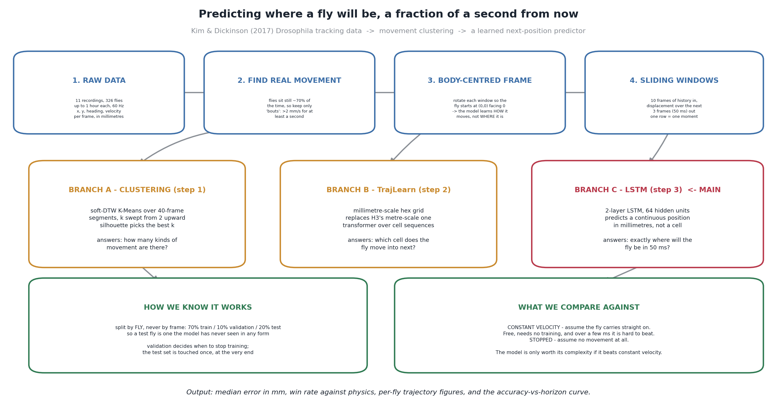
Figure 1. End-to-end pipeline. One shared loading and feature-engineering stage feeds three branches; Branch C answers the project's question, and Branches A and B provide the context against which its result is interpreted.

4. Solution Description — Research Method
This is a research-track component, so the sub-sections below describe the data, the algorithms and the evaluation methodology rather than a deployable software architecture.

4.1 Dataset
All experiments use the free-walking Drosophila melanogaster trajectory dataset published by Kim and Dickinson alongside their 2017 Current Biology paper on idiothetic path integration. It comprises 11 recordings covering 326 individually tracked flies, each followed for up to about an hour at 60 Hz, for roughly 70 million frames and 2.6 GB of raw CSV. The recordings differ systematically in arena size (large or small), in the food drop offered (yeast, sucrose or water), in illumination (white light or dark), and in fly strain — which is useful here, because it means the corpus is not a single homogeneous condition.
The trajectories were produced by the original authors with an automated tracking system and smoothed with a one-dimensional Kalman filter. That matters for interpreting our error figures: the ground truth we measure against is itself a filtered estimate, with a positional noise floor of roughly 0.02 mm (the median frame-to-frame displacement across the raw data, which is dominated by essentially stationary flies).
Table 1. Columns of the per-frame “Fly data” table, and how each is used in this project.
Column | Unit | Content and use
fly | id | Fly index. Zero-based and restarting in every file, so it is remapped to a globally unique, continuous id — without this, flies from different recordings collide.
time(s) | s | Frame timestamp. Sampling is a fixed 60 Hz, so Δt = 16.7 ms throughout.
position_x, position_y | mm | Centroid in arena coordinates. Never used as a model input; only differences of it are, after translation and rotation.
velocity_x, velocity_y | mm/s | Kalman-smoothed velocity. Combined into speed = √(vx² + vy²), and used directly to construct the constant-velocity baseline.
heading(radians) | rad | Body-axis orientation, wrapped to ±π. Unwrapped before use so that it is continuous, which matters both for computing relative headings and for rotating coordinates.
velocity_heading(rad/s) | rad/s | Turn rate. A model input, and the independent variable of the turn-rate robustness analysis in Section 8.5.

4.2 Data preparation and feature representation
Nothing in the raw file is usable as a model input as it stands, and the preparation stage is where most of the project's engineering judgement is concentrated. Six transformations are applied, in order.
- Header discovery. Each recording begins with an experimental-conditions block and an arena table before the per-frame table. The loader scans for the line beginning “fly,time(s)” and starts reading there, which also makes it tolerant of plain CSVs whose header is on the first line.
- Global fly identities. Per-file, zero-based fly indices are offset into a single continuous range, giving 326 distinct flies. Omitting this step would silently merge flies across recordings and corrupt the by-fly train/test split.
- Derived motion features. Speed is computed as the magnitude of the velocity vector; heading is unwrapped so that it never jumps by 2π; turn rate is taken from the recorded heading velocity rather than differentiated from a noisy heading signal.
- Normalisation to a common origin. Every analysis window is translated so that its first frame sits at (0, 0), and then rotated by −heading₀ so that the fly starts facing 0°. Every fly therefore starts at the same point pointing the same way, and two windows can be compared by shape. We deliberately rotate by the measured heading at the window's first frame rather than by an angle estimated from two consecutive position samples, which would be far noisier at this scale.
- Body-centred targets. The model predicts forward and lateral displacement in the fly's own frame at the moment of prediction, not arena x/y. This is the single most important choice in the whole pipeline: an absolute-position target lets the network learn that flies in this arena linger near this wall — true, useful for the benchmark, and worthless for a different camera. A body-centred displacement target forces it to learn how a fly turns and accelerates, which transfers.
- Movement bouts. Measured on the raw data, the median frame-to-frame displacement is about 0.02 mm and roughly 68% of frames move less than 0.1 mm: these flies spend most of their time standing still. Training or evaluating a “where will it be next” model on all frames therefore mostly measures “it is still sitting there”. Every downstream stage instead uses movement bouts — contiguous stretches where a five-frame rolling median of speed stays above 2 mm/s for at least one second — which retains about 27% of frames. Smoothing the speed signal before thresholding prevents a single dip from fragmenting one real bout into many.
The result of this stage is a set of sliding windows: ten frames of history in (≈ 167 ms), the displacement over the next three frames out (50 ms), one row per moment, with a cap of 4,000 windows per fly so that a single long recording cannot dominate the training set.

4.3 Movement clustering
Before building a predictor it is worth asking whether one predictor should be expected to work equally well on every kind of fly movement. To characterise what kinds of movement the dataset contains, movement data was cut into 40-frame segments (≈ 0.67 s), 15 evenly spaced across each fly's recording, giving 4,890 segments in total. Each segment is described by four rotation-invariant features — the sine and cosine of relative heading, speed, and angular velocity — z-scored per segment.
Segments are clustered with soft-DTW time-series K-Means (tslearn), a distance measure suited to comparing motion segments that would not otherwise align frame-to-frame, and the number of clusters k is swept from 2 to 15. Each k is scored by its mean silhouette coefficient on a stratified sample of up to 1,200 segments, for tractability. The sweep peaks at k = 7 with a silhouette of 0.075; clustering the full set at k = 7 gives 0.077, with clusters of 499 to 877 segments each.
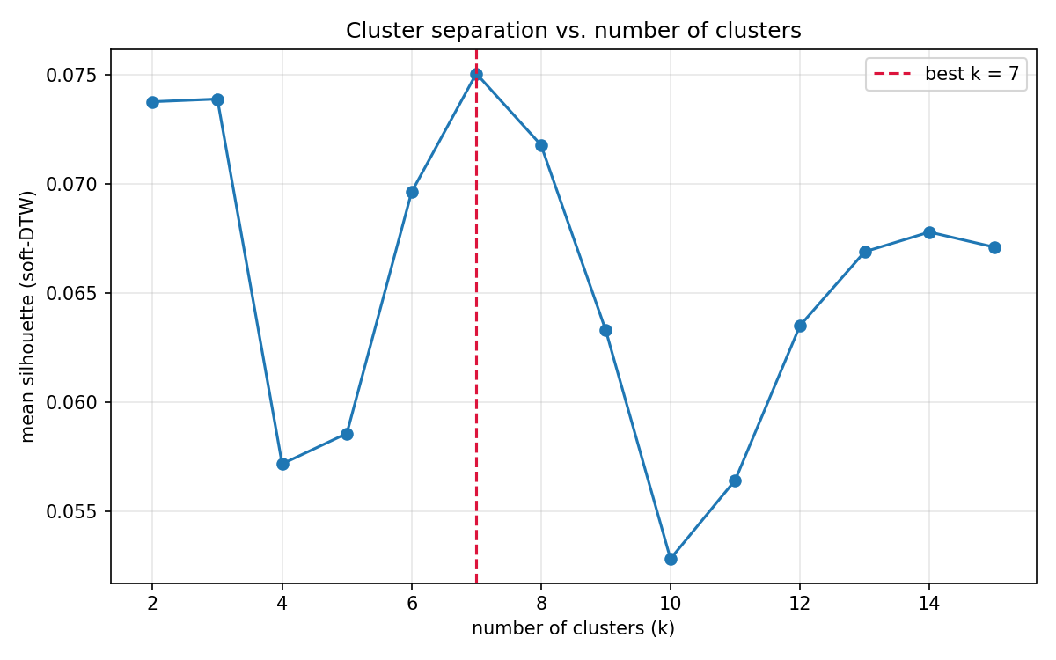
Figure 2. Silhouette score against the number of clusters, over the full 326-fly dataset. The peak is at k = 7.
A silhouette of 0.075 is low in absolute terms, and it is worth being explicit that this is a finding rather than a failure. Silhouette measures how much better a segment fits its own cluster than the nearest alternative; values approaching 1 require genuinely separated groups. Fly movement is a continuum — turns of every sharpness, speeds of every magnitude — so a modest but reproducible peak says that the seven clusters are convenient labels carved out of a continuum, not natural categories. That interpretation is confirmed visually in Figure 3, and it is exactly why the clusters are used in Section 8.4 as a stress test of the predictor rather than as a routing mechanism.
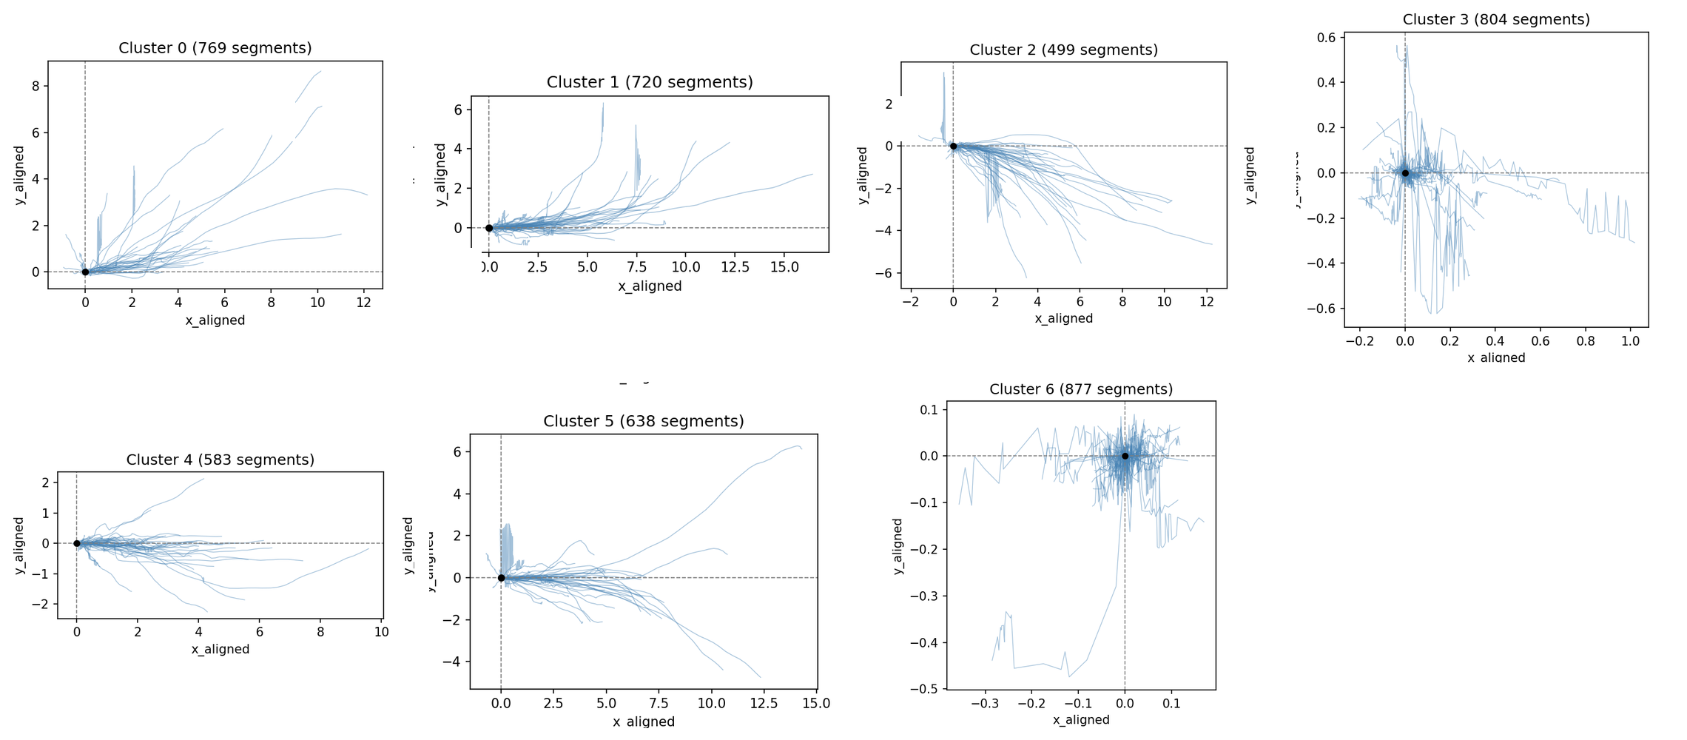
Figure 3. The seven movement types, every segment translated to the origin and rotated to face 0° before plotting. Long straight runs (0, 1, 5), broad sweeping turns (2, 4) and near-stationary jitter (3, 6) — note the differing axis scales.

4.4 The prediction model
The predictive model is a two-layer LSTM with 64 hidden units per layer and dropout of 0.1, followed by a small feed-forward head (64 → 64 → 2 with a ReLU non-linearity), for roughly 70,000 parameters in total. Given the last ten frames it predicts the displacement over the next three frames, expressed in the fly's own reference frame at the end of the window. Each input frame carries five features: forward step, lateral step, speed, angular velocity, and the change in heading since the previous frame. Inputs are standardised using training-set statistics only.
Training uses SmoothL1 loss with beta = 0.1, chosen to match the ≈ 0.1 mm scale of a single step — the default beta of 1.0 would place almost every target inside the quadratic region and effectively reduce the loss to mean squared error at a scale where it is insensitive. The optimiser is AdamW at 1e-3, batches of 512, gradient clipping at 1.0, up to 30 epochs with early stopping after five epochs without validation improvement. The model is snapshotted at epoch 0 (before any training) and every five epochs thereafter, which is what makes the claim in Section 8.3 a measurement rather than an assertion.
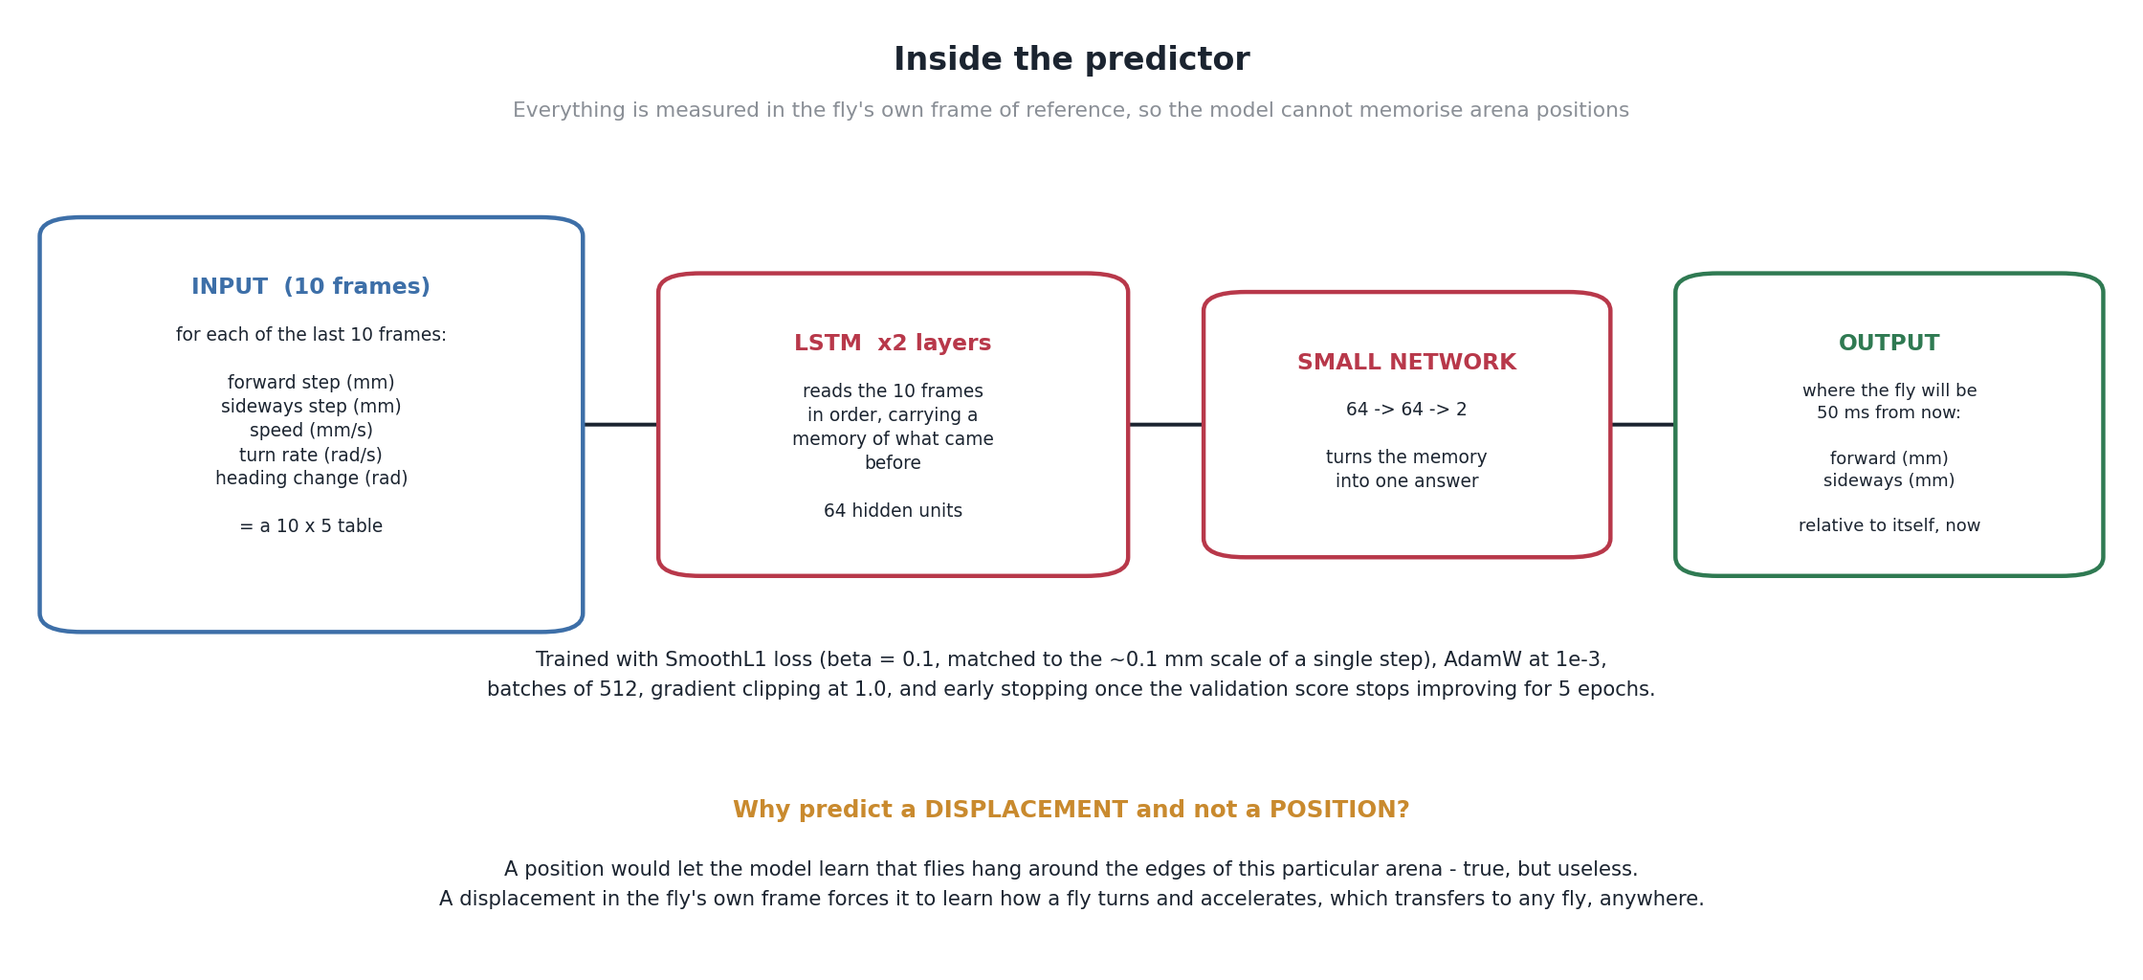
Figure 4. Inside the predictor: inputs, architecture, output, and training configuration.

4.5 Baselines and evaluation methodology
The 326 flies are split by fly, not by frame — 70% train, 10% validation, 20% test, with a fixed random seed — so that no fly's movement appears in more than one set. This is more work to implement than a random split over windows, and it matters: consecutive windows of the same fly overlap heavily, so a frame-level split would place near-duplicate rows on both sides of the boundary and inflate every number in Section 8.
Table 2. Fly-level train / validation / test split (326 flies in total).
Split | Flies | Share | Role
Train | 228 | 69.9% | Gradient updates only.
Validation | 33 | 10.1% | Early stopping and epoch selection. Never used for gradients.
Test | 65 | 19.9% | Touched once, at the end, for every reported figure.

Every model is compared against two baselines computed on identical test windows:
- Constant velocity — assume the fly keeps its current speed and heading for the prediction horizon. This is the honest competitor: it is what a system with no model at all would do, it costs nothing to compute, and at short horizons it is genuinely strong. The learned model is only worth its complexity if it beats this.
- Stopped — assume no movement at all. This is a diagnostic rather than a competitor: it quantifies how much of any method's apparent accuracy is simply the fly being slow.
Two complementary metrics are reported together throughout. Median error in millimetres describes how far off a typical prediction is; the median is used rather than the mean because a handful of extreme moments — a fly making an abrupt turn — would otherwise dominate and could flatter either method depending on which happened to fail. Win rate is the percentage of individual test moments at which the model lands closer to the truth than the baseline; it is reported because a method can have a better median while losing most individual comparisons.

4.6 Success criteria
The criteria below were set in Phase A and are answered, with evidence, in Section 8.8.
- Accurate motion prediction: the learned model must beat the constant-velocity baseline by a clear and consistent margin on held-out flies, not by a margin that only appears on average.
- Robustness and generalisation: the improvement must hold on flies never seen in training, and must not be concentrated in one kind of movement.
- Adaptability to diverse motion: performance must not degrade at high speed or high turn rate, which is where the application needs it most.
- Noise tolerance at the dataset level: the representation must not depend on arena-specific cues, and results must be reported honestly against the measurement noise floor of the source data.
- Real-time hardware integration: not attempted in this work. It is recorded here so that its exclusion is deliberate and visible rather than silent.

5. Research Process
The work proceeded in five stages, each of which changed the design of the next.
- Data engineering. A shared module (fly_common.py) covering raw-CSV parsing, header detection, global fly identity, derived features, window alignment and bout detection was written first. Every later stage imports it, so a change to the definition of a movement bout propagates consistently instead of being reimplemented three times.
- Structure discovery. The clustering sweep followed, partly to characterise the data and partly as a check on the alignment code: if the normalisation were wrong, clusters would be dominated by absolute orientation rather than shape. It is resumable, because a full sweep takes over two hours on the two CPU cores free Colab provides.
- TrajLearn adaptation. The Phase A plan was implemented: a millimetre-scale hex grid replacing TrajLearn's metre-scale one, tokenisation of bouts into cell sequences, and a split-verification routine that replays TrajLearn's own line-order slicing, since a one-line drift would leak a fly across the split. This stage produced the finding that ended the branch (Section 7.2).
- Continuous prediction. The LSTM regressor was built to answer the question directly in millimetres, together with both baselines, the by-fly split, the checkpointing scheme, and the evaluation and figure generation.
- Sweeps and analysis. The model was retrained at five horizons (1, 3, 6, 15 and 30 frames) for the horizon curve, test moments were assigned to their nearest cluster centroid from stage 2 for the per-cluster breakdown, and per-fly figures were generated for all 326 flies so individual behaviour can be inspected, not only aggregates.
There was no external client for this research-track component; the development interface was iterative review with the project advisors, whose feedback shaped two decisions in particular — reporting against an explicit physical baseline rather than in absolute error terms, and reporting a horizon sweep rather than a single headline number.

6. Tools and Technologies
The implementation is entirely in Python 3.10+. NumPy and pandas handle data loading and numerical work; PyTorch implements and trains the LSTM; tslearn provides soft-DTW time-series K-Means and scikit-learn provides the silhouette scoring and supporting metrics; matplotlib and seaborn generate every figure in this report. The two architecture diagrams (Figures 1 and 4) are drawn programmatically from a script that needs no data, so they can be regenerated at any time and cannot drift out of date relative to the code.
Development was done in Visual Studio Code with the pipeline structured as six numbered stages that run in order, plus a Colab notebook (Fly_Project_Colab.ipynb) that wraps the same stages with Google Drive mounting, run-mode presets and per-step timing. Training was performed on Google Colab GPU runtimes, since no local GPU was available; the notebook offers quick, medium and full run modes so that the whole chain can be verified end to end in about ten minutes before committing hours to the full dataset. Source, data and results are versioned in Git, with the large CSV files tracked through Git LFS.

7. Challenges and Solutions

7.1 Choosing the wrong unit of analysis — twice
The first version of the feature set used absolute position and compass heading per frame. The resulting model scored well and was learning the wrong thing: with arena coordinates as inputs it can encode where in this particular arena flies tend to be, which is real structure in the benchmark and useless for a system pointed at a different room. The fix was the body-centred, rotation-invariant representation described in Section 4.2, which costs accuracy on this dataset and is the only version worth reporting.
The second version of the same mistake was evaluating on all frames. With roughly 68% of frames essentially stationary, a model that predicts “no movement” achieves an impressive-looking error, and the aggregate metric mostly measures how often the fly was standing still rather than how well anything was predicted. Restricting every stage to movement bouts made the numbers worse and the experiment meaningful. Both mistakes share a root cause worth recording: a metric improved while the thing we cared about did not, and neither was caught by looking at the metric.

7.2 TrajLearn: a Transformer that scores 95% and predicts nothing
Adapting TrajLearn required two changes. The first was scale: TrajLearn uses the H3 geographic hexagonal grid, whose finest resolutions are still metres across, while our arenas are 65–170 mm; we replaced it with a millimetre-scale hex grid in axial coordinates, matching the vocabulary, neighbour-list and embedding format its preprocessing emits so that its training code runs unmodified. Fixing a cube-rounding bug in that grid, and verifying that every point maps to its genuinely nearest hexagon, took a substantial share of the stage.
The second problem was fatal to the branch. At 60 Hz the fly remains inside the same hexagon for most consecutive frames, so a token model trained on the raw sequence learns to predict “the same cell again”, scores above 95% next-token accuracy, and conveys no information about where the fly is going. Two filters address it — keep only movement bouts, and collapse runs of the same cell so that every token is a genuinely new cell — and with those in place the model answers a legitimate but different question: which cell the fly commits to next. It cannot answer the project's question, because discretising to a hexagon destroys exactly the sub-0.1 mm precision an actuator needs. That is why the continuous LSTM, not the Transformer, is the main result, and why the arithmetic of cell occupancy at a given sampling rate is the check we would now run before committing to any discrete model.

7.3 Evaluating training progress fairly
A loss curve alone does not demonstrate that a model is getting better at the task it is supposed to beat a baseline at; loss can fall while the model remains worse than physics. The solution was to snapshot the full model state at epoch 0 and every five epochs, and score every snapshot on the same held-out test flies with the same metrics. The only variable that changes between those points is how long the model trained, which turns “it improves with training” into a measurement (Section 8.3). The untrained snapshot is also a useful control: it is worse than assuming the fly is stopped, which confirms the pipeline is not accidentally leaking the answer.

7.4 Compute, and a training loop we could not execute locally
Training the model and running the horizon sweep across 326 flies and five horizons are multi-hour jobs, and no local GPU was available. The pipeline was therefore made resumable and configurable through environment variables, with run-mode presets so that correctness could be established on a subset before spending the compute.
A related constraint is worth reporting honestly, because it affects how much verification stands behind which claims. PyTorch could not be installed in the environment used for automated testing, so everything torch-specific was checked by review while everything around it was tested against the real data with a NumPy stand-in predictor. That approach was productive rather than merely defensive: substituting a predictor that is exactly the constant-velocity baseline reproduced the baseline column to machine precision, a random predictor lost on every fly, and a zero predictor stayed put — which validated the window construction, the rotations and the metric code independently of the network. Two real bugs were found this way: inference being attempted over more than a million windows in a single call, and the loss beta being mismatched to the millimetre scale of the targets.

7.5 Reporting a weak result honestly
At the shortest horizon tested, the fly has barely had time to deviate from its current velocity and the physical baseline is close to unbeatable. Early in the project this looked like a failure. It is not: it is a legitimate and informative result, and the correct response was to report the horizon as a variable rather than to search for the setting that made the model look best. That reframing produced Figure 6, which is a stronger and more useful result than any single accuracy number, because it states the timing budget a physical system built on this model would have to hit.

8. Results and Analysis

8.1 Headline result
At the 50 ms horizon (three frames ahead), the LSTM reaches a median error of 0.023 mm on the held-out test flies, against 0.122 mm for the constant-velocity baseline and 0.390 mm for the stopped baseline — an 81.2% reduction in median error relative to physics. Aggregates conceal a great deal, so two distributional figures accompany it: the model is closer than the baseline on 95.3% of individual test moments, and the worst-performing test fly still wins 88.8% of its moments. The result is not carried by a subset of easy flies.
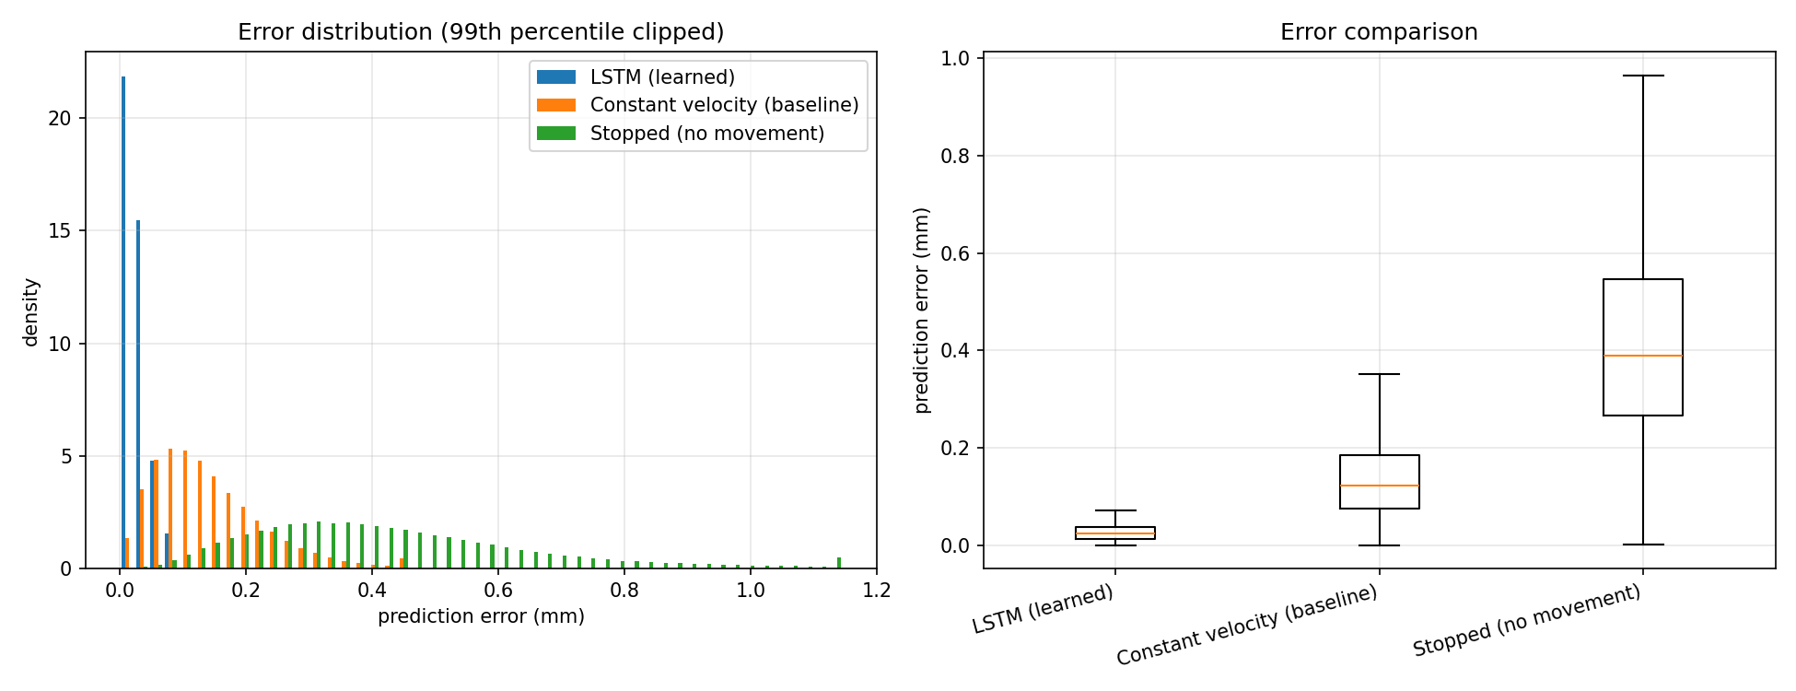
Figure 5. Error distributions on the test set at the 50 ms horizon, clipped at the 99th percentile (left) and as box plots (right). The learned model's whole distribution lies inside the baseline's lower quartile.
For scale: 0.023 mm is roughly a hundredth of a fly's body length, and close to the ≈ 0.02 mm positional noise floor of the source tracking data. This is the appropriate place to state a limitation plainly — at the 50 ms horizon the model is operating near the precision of its own ground truth, so the residual error cannot be attributed entirely to the model, and a meaningfully more precise measurement of it would require better tracking data rather than a better network.

8.2 How far ahead is it worth predicting?
To establish that 50 ms was not selected after the fact, the model was retrained and re-evaluated at five horizons spanning about 17 ms to 500 ms. Predicting further ahead is harder for both methods, but not equally harder: a straight-line assumption degrades much faster than a learned one, so the model's relative advantage rises, peaks and then falls again.
Table 3. Model accuracy against the physics baseline across prediction horizons, full 326-fly test set.
Horizon | LSTM median (mm) | Constant velocity (mm) | Improvement
16.7 ms (1 frame) | 0.013 | 0.035 | 63%
50 ms (3 frames) | 0.023 | 0.122 | 81% (peak)
100 ms (6 frames) | 0.088 | 0.252 | 65%
250 ms (15 frames) | 0.35 | 0.67 | 47%
500 ms (30 frames) | 0.90 | 1.58 | 43%

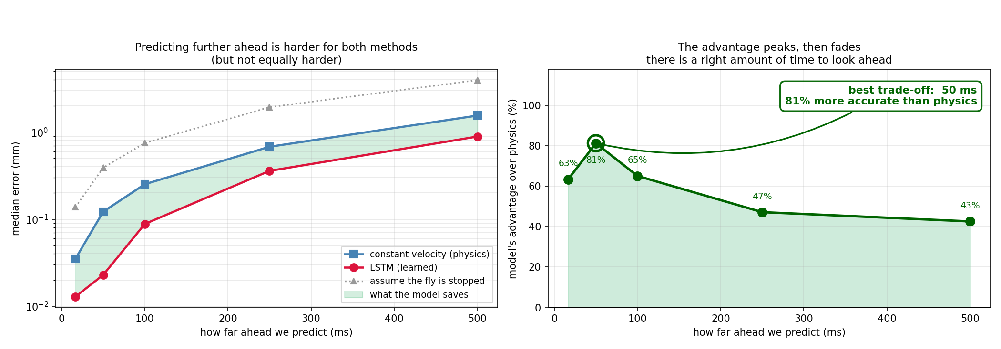
Figure 6. Left: median error against prediction horizon, log scale, with the shaded region showing what the model saves. Right: the model's percentage advantage over physics, peaking at 50 ms.
The shape has a straightforward physical reading. At very short horizons a fly has barely had time to change what it was already doing, so “keep going straight” is close to correct and there is little for a model to add. At long horizons the fly's future depends on decisions it has not yet made, which are not present in the preceding 167 ms of motion, so neither method can see far enough and both degrade. In between there is a window in which the fly's next move is already determined by dynamics visible in its recent history but is no longer a straight continuation of it — and that is where learning pays. For this species, at this sampling rate, that window is centred on 50 ms, which is a concrete design output: it is the latency budget an actuator would have to meet in order to exploit the model at its best.

8.3 Does training actually help?
Figure 7 scores every saved checkpoint on the same held-out test flies. The untrained model (epoch 0) has a median error of 0.509 mm — worse than assuming the fly is stopped, and it beats the baseline on only about 2% of moments. By epoch 5 it is at 0.024 mm and a 95% win rate, and it stays there through epoch 25, with early stopping ending training once validation improvement halts. On the validation set the model overtakes the physics baseline within the first epoch.
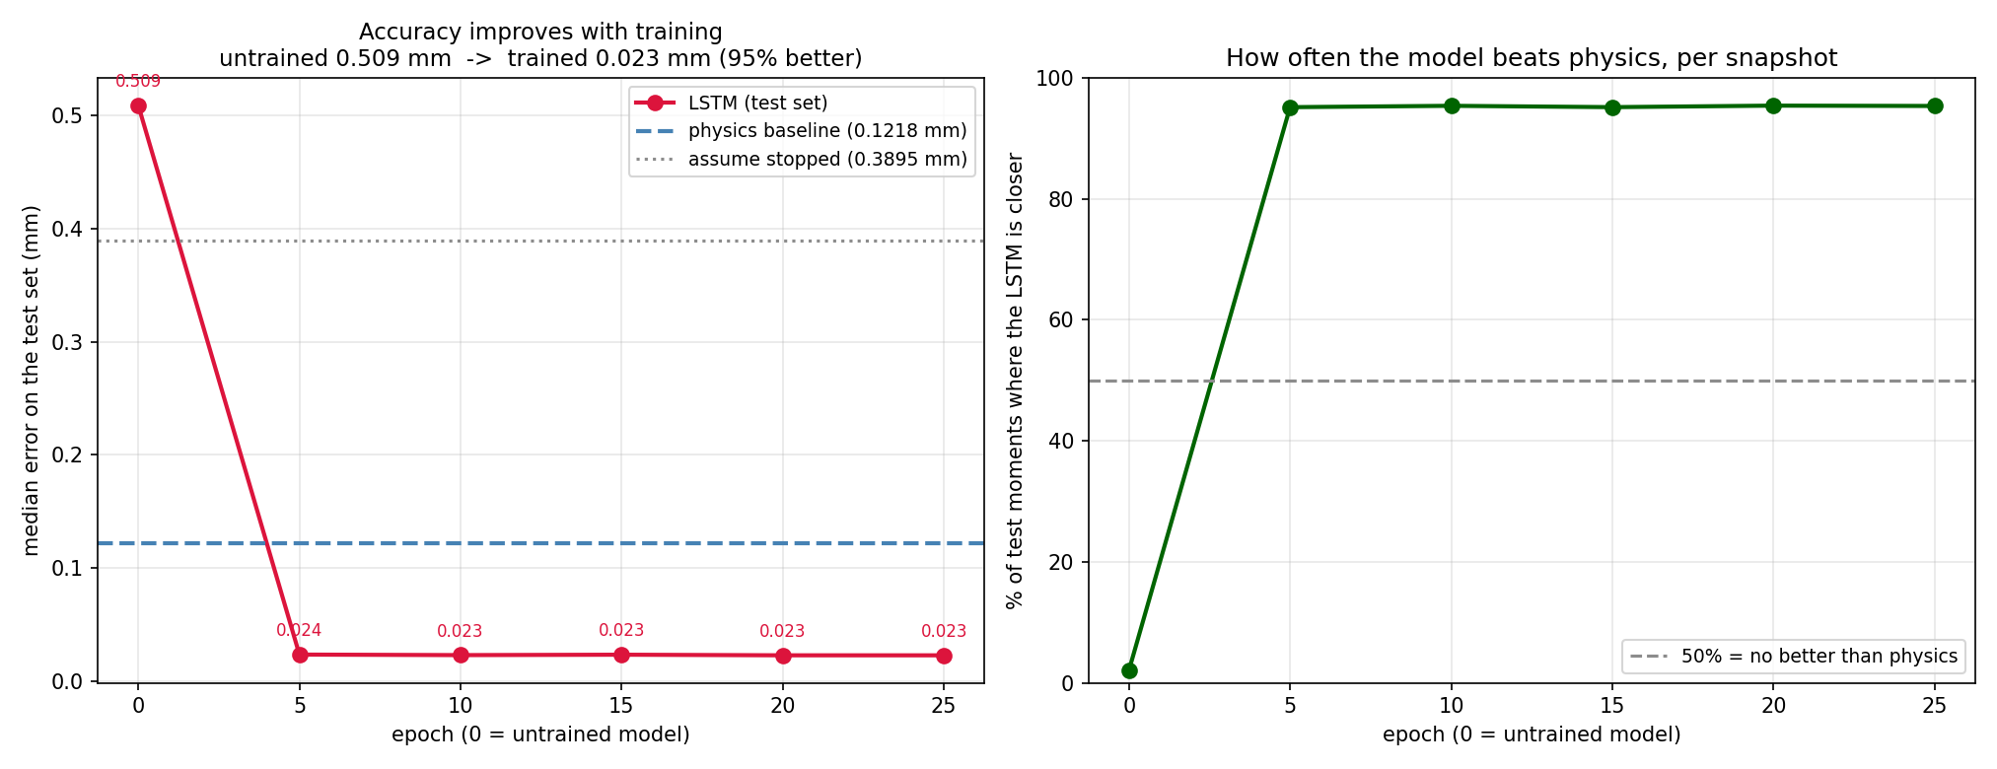
Figure 7. Test-set accuracy at each saved checkpoint (epoch 0 = untrained). Left: median error. Right: win rate against constant velocity. The only variable changing between points is training duration.
Two things are worth drawing out. The first is that the improvement is genuinely attributable to training rather than to the representation: an untrained network with identical inputs performs worse than the trivial baseline. The second is that convergence is very fast — essentially complete within five epochs — which is consistent with a 70,000-parameter model on a large, low-dimensional, highly regular target, and suggests the architecture is not capacity-limited on this data.

8.4 Robustness across movement types
An average improvement could be produced by a model that excels on straight runs and fails on turns, which would be useless for the application. To test this, each test moment is assigned to its nearest soft-DTW cluster centroid from Section 4.3 and scored within its cluster.
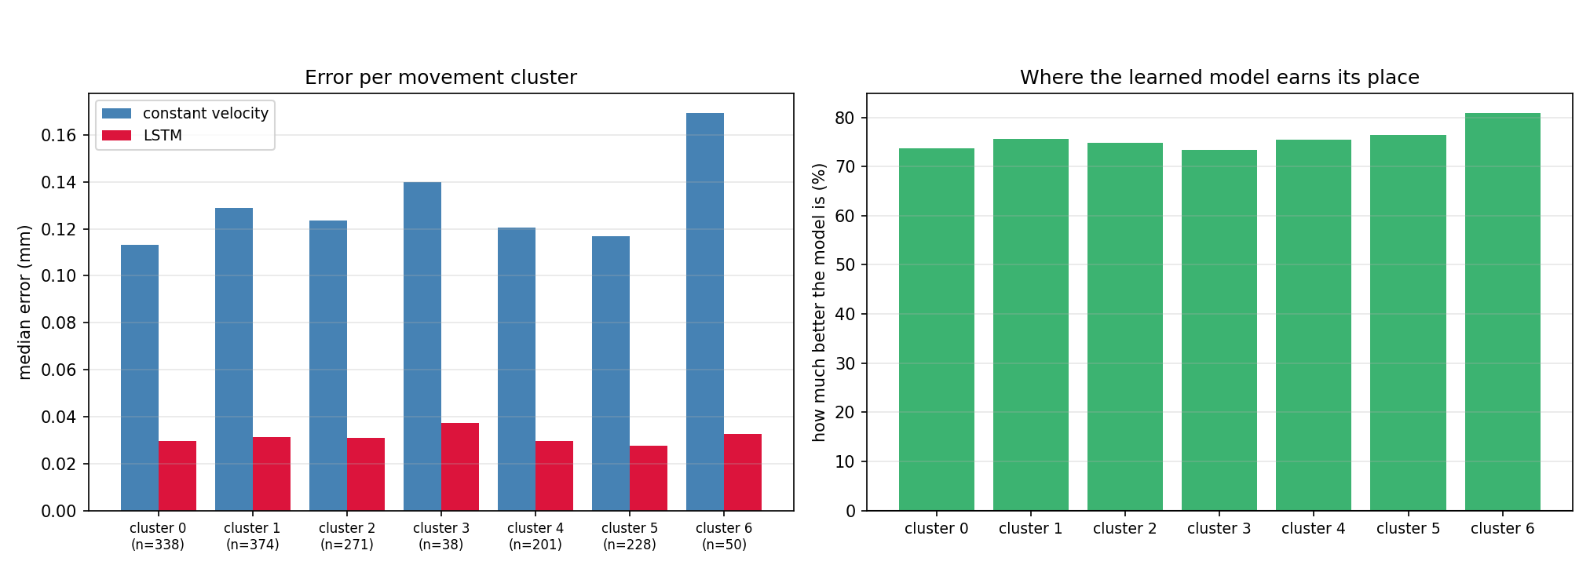
Figure 8. Prediction error by movement cluster on test flies only, at the 50 ms horizon. Left: median error per cluster for both methods. Right: the model's percentage advantage per cluster.
The improvement holds everywhere, ranging from about 73% to about 81% across all seven independently discovered movement types. The baseline's error varies substantially between clusters — roughly 0.11 mm on the easiest to 0.17 mm on the hardest — while the model stays between roughly 0.028 mm and 0.037 mm throughout. In other words, the difficulty that the clusters expose is difficulty for the physical baseline, and the learned model is comparatively indifferent to it. Cluster support is uneven (from 38 to 374 test moments), so the two smallest clusters should be read with corresponding caution; notably, the largest advantage occurs on cluster 6, one of the two smallest and the one whose segments are the most erratic.

8.5 Robustness across speed and turn rate
The cluster breakdown is a categorical view of the same question; Figure 9 gives the continuous one, binning test moments by the fly's instantaneous speed and by the magnitude of its turn rate.
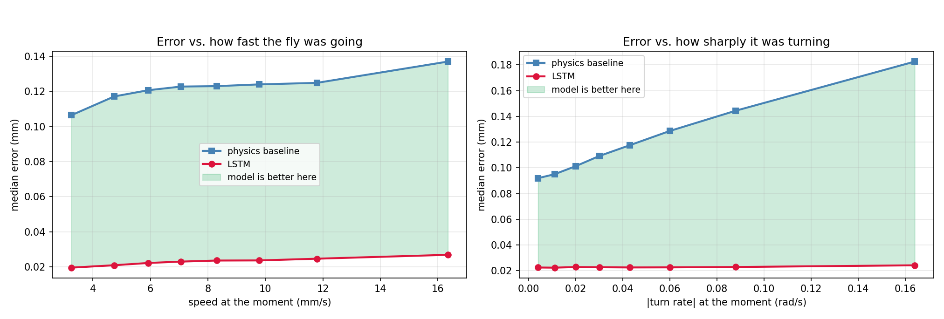
Figure 9. Median error against speed (left) and against absolute turn rate (right), on the test set. The shaded region is the model's margin over the baseline.
This is the clearest single picture of why a learned model earns its place. Across the speed range the baseline degrades gently, from about 0.107 mm to about 0.137 mm, while the model rises only from about 0.020 mm to about 0.027 mm. Across the turn-rate range the divergence is far sharper: the baseline roughly doubles, from about 0.092 mm to about 0.182 mm, while the model stays essentially flat near 0.022 mm. That widening gap is the linear-dynamics assumption failing in exactly the way Section 2.2 predicted it would, and the model absorbing the failure. For the application this is the favourable case, because the moments at which a fly is turning hardest are precisely the moments at which a reactive system misses.

8.6 Individual moments
Aggregate metrics are easier to trust when the underlying events can be inspected. The pipeline draws twelve such moments, ordered from easiest to hardest; Figure 10 reproduces three of them, each one instant from one test fly in that fly's own frame.
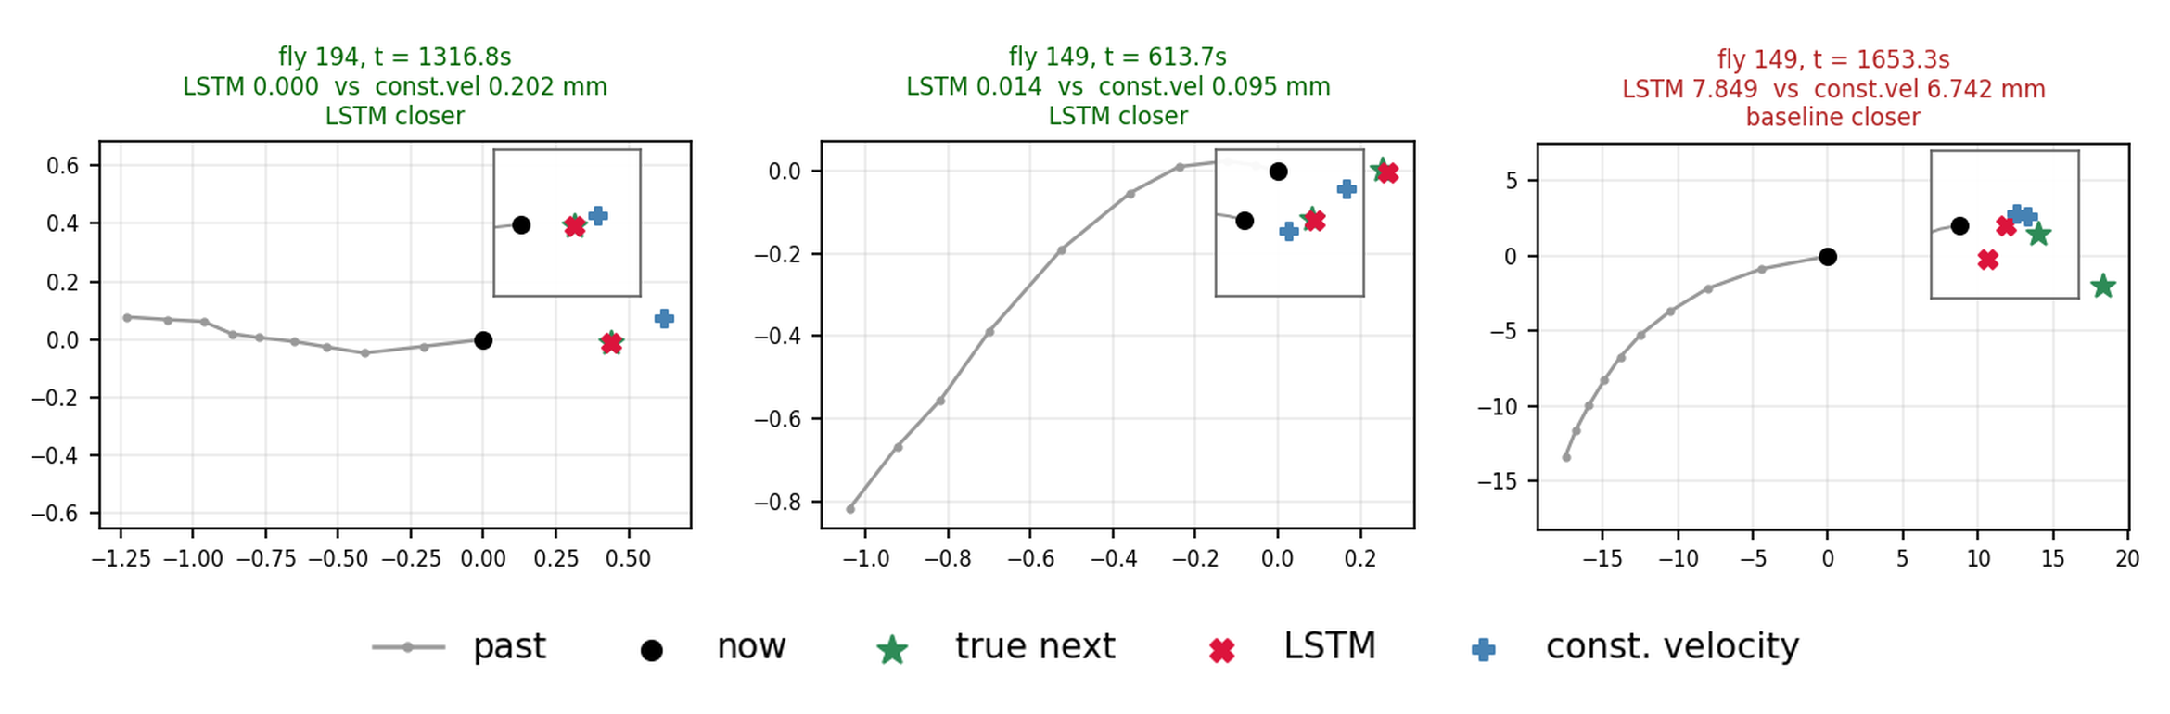
Figure 10. Three individual test moments. Grey is the preceding path; the markers are the true next position and the two predictions. Each panel carries an inset, because at full scale the three markers overlap. The right-hand panel, titled in red, is a moment the baseline wins.
The three panels are chosen to span the range rather than to flatter the model. On the left, fly 194 is moving almost straight: the model lands essentially on the true point (0.000 mm) where constant velocity is 0.202 mm out, which is the easy majority case. In the middle, fly 149 is on a curving path, and this is where the learned model earns its place — the baseline carries the current heading straight on and misses by 0.095 mm while the model follows the bend to within 0.014 mm. On the right is the same fly later in the recording, and a failure: a sharp, sustained turn where the model overshoots by 7.8 mm against the baseline's 6.7 mm. Both are catastrophic in application terms, and the case is characteristic of the residual error — failures are concentrated in high-curvature manoeuvres rather than spread evenly, which is the same conclusion the turn-rate analysis in Section 8.5 reaches from the opposite direction.
The pipeline also generates a two-panel report figure for every one of the 326 flies across all three splits. Figure 11 shows one held-out example: the fly's true path against the baseline and against the model at four training epochs with endpoint drift quoted, and the cumulative distribution of one-step error over the same stretch.
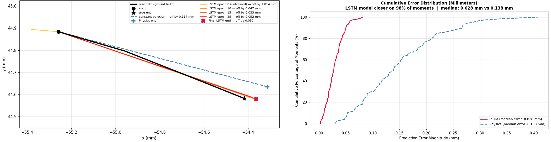
Figure 11. Fly 48, a held-out test fly. Left: the true path (black) against constant velocity (dashed) and the model at epochs 0, 10, 15 and 25. Right: cumulative error distribution for the same fly, model against physics.
The single fly reproduces the aggregate story, and makes the mechanism visible rather than inferred. The untrained model (epoch 0) leaves the path immediately and ends 1.014 mm away, worse than doing nothing; by epoch 25 it ends 0.052 mm from the true endpoint against 0.117 mm for constant velocity, because the baseline holds its initial heading and cuts the corner as the path bends while the model follows the curve. The cumulative distribution makes the same point over every moment rather than only the endpoint: the model reaches 100% of moments by about 0.08 mm of error where the baseline is still climbing at 0.40 mm — a median of 0.028 mm against 0.138 mm, and a win on 98% of moments. This is a representative held-out fly, not a favourable one; the worst test fly still wins 88.8%.

8.7 Would a faster camera have helped?
A recurring question is whether using a published 60 Hz corpus, rather than recording our own with the 815 fps camera considered for the physical rig, limited the result. The comparison below is derived analytically from the 60 Hz statistics — nothing was recorded at 240, 500 or 815 Hz — and makes the trade-off explicit rather than asserting an empirical finding.
Table 4. Sampling-rate comparison, derived from the 60 Hz dataset statistics. Displacement per frame is computed at 7 mm/s, the median speed during a movement bout.
Property | 60 Hz (used) | 240 Hz | 500 Hz | 815 Hz
Frame interval | 16.7 ms | 4.2 ms | 2.0 ms | 1.2 ms
Displacement per frame | 0.117 mm | 0.029 mm | 0.014 mm | 0.009 mm
Against the ≈ 0.02 mm noise floor | 6× above | 1.5× above | below | well below
Frames in a 50 ms horizon | 3 | 12 | 25 | 41
Frames for 167 ms of history | 10 | 40 | 84 | 136
Raw corpus, 326 flies | 2.6 GB | 10 GB | 22 GB | 35 GB
Relative training cost | 1× | 4× | 8× | 14×

The decisive row is the third. Above roughly 250 Hz, the distance a walking fly covers between consecutive frames falls below the positional noise of the tracker itself, so additional frames contribute measurement error rather than information — unless spatial resolution improves in proportion, which is a property of the sensor and optics, not of the frame rate. Meanwhile the cost rises on every axis: to preserve the same 167 ms of context the input sequence grows from 10 frames to 136, raising training cost roughly fourteen-fold, and the corpus grows from 2.6 GB to 35 GB.
The conclusion we draw is that for the modelling question Phase B set out to answer, 60 Hz was not a compromise: it sits comfortably above the noise floor, the 50 ms optimum is three frames rather than a sub-frame interval, and it made a five-horizon sweep across 326 flies affordable on free compute. A high-speed camera becomes worthwhile for a different reason — not better training data, but lower sensing latency once a real-time control loop exists, where 1.2 ms of capture delay against 16.7 ms is a direct and substantial gain against the 50 ms budget identified in Section 8.2. It should be paired with a higher-resolution sensor if the data is also to be used for training.

8.8 Meeting the success criteria
Table 5. Phase A success criteria against the Phase B outcome.
Criterion | Status | Evidence
Accurate motion prediction | Met | 81.2% median-error reduction against constant velocity at the 50 ms horizon; 95.3% win rate over individual moments on held-out flies (Section 8.1).
Robustness and generalisation | Met | By-fly split, so no test fly appears in training in any form; 73–81% improvement across all seven movement clusters; worst individual test fly still wins 88.8% of moments (Sections 8.1, 8.4).
Adaptability to diverse motion | Met | Error essentially flat across the full turn-rate range where the baseline doubles, and near-flat across the speed range (Section 8.5).
Noise tolerance (dataset level) | Met | Body-centred, rotation-invariant features and explicit bout filtering; results reported against the ≈ 0.02 mm noise floor of the Kalman-smoothed source data (Sections 4.2, 8.1).
Real-time hardware integration | Not met | Not attempted. This component predicts motion only and has no connection to camera, safety interlock or actuation.

Four of the five criteria are met and measured. The fifth we did not attempt: it cannot be answered without the physical system, and building that was outside the scope of this work. What we can hand over instead is the specification for it — Section 8.2 gives a 50 ms end-to-end budget, within which the prediction is worth roughly a five-fold reduction in aiming error over a reactive system.

9. Lessons Learned
Architecture choice should follow the shape of the data, not the default of the literature. TrajLearn's discrete, generative, multi-modal design is well matched to problems like vehicle trajectory forecasting, where the state space is naturally discrete and the interesting uncertainty is about which route will be taken. Our problem is the opposite: a single continuous target at sub-millimetre precision, sampled fast enough that discretisation collapses to “the same cell again”. Weeks went into discovering that by implementation. An afternoon of arithmetic on expected cell occupancy at 60 Hz in a 65–170 mm arena would have shown it, and that calculation is now the first thing we would do before adopting any discrete model.
Baselines are not a formality. Reporting every result against constant-velocity and stopped baselines, on the same flies and the same windows, is what turned “the model works” into a specific and falsifiable claim. It also nearly ended the project honestly: at 17 ms the baseline is very hard to beat, and had we reported only that horizon the correct conclusion would have been that a learned model adds little. Having the baseline in place from the start is what made the horizon sweep an obvious next step rather than a rescue attempt.
Splitting by the right unit matters more than it looks. The by-fly split took noticeably more care to implement than a random split over windows, and it changes nothing about the code that trains the model. A frame-level split would have silently inflated every number in Section 8, and — this is the uncomfortable part — nothing in the training or validation curves would have looked wrong.
Fix the evaluation protocol before the modelling, not alongside it. Splits, baselines, metrics and horizons were settled in parallel with architecture work rather than before it, which cost at least one full retraining cycle and a set of figures that had to be discarded. If we repeated this phase, the first week would be spent writing the evaluation harness against a deliberately trivial predictor, and only then would any model be built.
An untestable component does not make its surroundings untestable. PyTorch could not be installed in the test environment, which initially looked like a reason to leave the training path unverified. Substituting analytically known predictors instead — one that is exactly the baseline, one random, one zero — verified the window construction, the rotations, the baseline column and the metrics independently of the network, and found two real bugs (Section 7.4).

10. Conclusion and Future Work

10.1 Conclusion
Phase B set out to determine whether a learned model can predict a fly's short-horizon motion more accurately than a physical baseline, and the answer is yes, by a large and consistent margin, over a well-defined range of horizons. At 50 ms ahead the model reduces median prediction error by 81.2% relative to constant velocity, wins 95.3% of individual moments on flies it has never seen, and retains a 73–81% advantage across every movement type present in the data and across the full range of speeds and turn rates. Critically, its advantage is largest exactly where the reactive alternative is weakest — during sharp turns — which is the condition that determines whether the eventual physical system hits or misses.
Beyond the headline number, two results are more useful to the project than the number itself. The horizon sweep converts an accuracy claim into a design specification: 50 ms is the point of maximum benefit, and therefore the latency budget any real-time control loop built on this model would have to meet. And the sampling-rate analysis establishes that the 60 Hz corpus was sufficient here, and that a high-speed camera would be justified for sensing latency rather than for training data — and only alongside a higher-resolution sensor.
The limitations are equally clear. The model is validated on a single species, a single tracking system and free-walking rather than flying behaviour, so the figures should not be assumed to transfer without re-evaluation. At 50 ms it operates close to the ≈ 0.02 mm noise floor of its own ground truth, so residual error cannot be cleanly separated from measurement error. Convergence within five epochs suggests the architecture is not capacity-limited, making this a lower bound rather than a ceiling. And the component predicts motion only — it has no connection to a camera, a safety system or any actuator.

10.2 Future Work
- Flight, not just walking. The most consequential extension is validating the same protocol on flying Drosophila, whose accelerations and turn rates are an order of magnitude higher. We expect the model's advantage over constant velocity to grow, since Figure 9 shows that advantage increasing with turn rate, but this is a prediction that must be tested rather than assumed.
- Multi-step and uncertainty-aware prediction. The current model emits a single point estimate. A control loop would benefit from a predicted trajectory over the whole horizon and from a calibrated uncertainty, so that the actuator can defer when the model is unsure — which Section 8.6 suggests would correspond closely to high-curvature moments.
- Targeting the residual failure mode. The errors that remain are concentrated in sustained sharp turns rather than spread evenly. Curvature-aware augmentation, a longer history window, or an auxiliary loss on turn-rate prediction are all cheaper avenues than a larger architecture, given that convergence is not capacity-limited.
- Inference cost, measured. The model has about 70,000 parameters and should run comfortably at frame rate, but this was never measured; latency and jitter figures on the target hardware, against the 50 ms budget established here, are needed before any of this could run live. Temporal convolutional networks and small continuous-output Transformers were also not evaluated — and given how quickly the LSTM converges, the interesting comparison is inference cost at equal accuracy, not accuracy itself.
- Closing the loop. Integrating this component with live camera input, the human-detection safety layer and the actuation subsystem specified in Phase A, and measuring end-to-end hit rate rather than prediction error, is the substantive remaining work.

References
[1] I. S. Kim and M. H. Dickinson. Idiothetic Path Integration in the Fruit Fly Drosophila melanogaster. Current Biology, 27(15):2227–2238.e3, 2017. doi:10.1016/j.cub.2017.06.026.
[2] I. Kim and M. Dickinson. Kim_Dickinson_CurrentBiology_2017_Drosophila_Path_Integration. Mendeley Data, V1, 2017. doi:10.17632/3rfdw7p6x6.1. (The trajectory dataset used throughout this report.)
[3] A. Nadiri, J. Li, A. Faraji, G. Abuoda and M. Papagelis. TrajLearn: Trajectory Prediction Learning using Deep Generative Models. arXiv:2501.00184, 2025.
[4] S. Hochreiter and J. Schmidhuber. Long Short-Term Memory. Neural Computation, 9(8):1735–1780, 1997.
[5] M. Cuturi and M. Blondel. Soft-DTW: a Differentiable Loss Function for Time-Series. Proceedings of the 34th International Conference on Machine Learning (ICML), 2017.
[6] P. J. Rousseeuw. Silhouettes: a graphical aid to the interpretation and validation of cluster analysis. Journal of Computational and Applied Mathematics, 20:53–65, 1987.
[7] R. Tavenard et al. tslearn, A Machine Learning Toolkit for Time Series Data. Journal of Machine Learning Research, 21(118):1–6, 2020.
[8] I. Loshchilov and F. Hutter. Decoupled Weight Decay Regularization. International Conference on Learning Representations (ICLR), 2019.
[9] Y. Bodaga and D. Lachmakov. Autonomous Predictive Tracking and Laser Neutralization System for Flies — Capstone Project Phase A. ORT Braude College of Engineering, December 2025. (Full literature review and system design.)

Appendix A — User Guide
This guide describes the normal, successful workflow for reproducing the movement-clustering and motion-prediction analysis in this report. It focuses on the nominal path; error conditions and their handling are covered in Appendix B. It assumes access to the project repository and to the 11 Kim & Dickinson recordings, which are included in the repository under Part_B/data/ via Git LFS.

A.1 What the system does
The system is a six-stage analysis pipeline. Given the raw tracking recordings it produces: a clustering of fly movement into k types with the supporting silhouette sweep; a trained next-position predictor; that predictor's accuracy against two physical baselines on held-out flies; an accuracy-versus-horizon curve; and a per-fly report figure for every fly in the dataset. All output is written to a single configurable folder and nothing is written back into the source data directory.

A.2 Running in Google Colab (recommended)
- Place the project folder — the 11 dataset CSVs and the Python stage scripts (fly_common.py, 01_cluster_ksweep.py, 02_prepare_trajlearn.py, 03_continuous_model.py, 04_report_figures.py, 05_horizon_figure.py, 06_architecture_diagram.py) — in Google Drive.
- Open Fly_Project_Colab.ipynb in Google Colab and set the runtime to GPU (Runtime → Change runtime type → GPU).
- Run the first cell and authorise Drive access when prompted.
- In the Settings cell, point the notebook at the Drive folder from step 1, choose an output folder name, and choose a run mode: quick (a subset of flies, roughly ten minutes, for a sanity check), medium (the whole dataset at reduced sweep resolution), or full (the configuration used for the results in this report).
- Run the cells in order from Step 0 to Step 6. Each step prints its own progress and elapsed time and writes its outputs before the next begins, so the notebook can be interrupted between steps without losing completed work.
- When Step 6 completes, the output folder contains the accuracy tables (prediction_results.csv, epoch_checkpoints.csv, horizon_sweep.csv), the trained weights and snapshots (next_step_lstm.pt), the fly split (fly_split.json), every figure reproduced in Section 8, and per-fly figures for all 326 flies.
Expected wall-clock time for the full run: about two to two and a half hours for the clustering sweep, ten to twenty-five minutes for the TrajLearn preparation stage (dominated by file reading), and ten to twenty minutes for model training on a GPU. The horizon sweep repeats the training stage once per horizon.

A.3 Running locally
- Install the required packages (see Appendix B.1).
- Place the 11 CSV files in a single data folder, and set FLY_DATA_DIR to it (or run from within it — the scripts search recursively from their own folder by default).
- Run, in order: 06_architecture_diagram.py (needs no data), 01_cluster_ksweep.py, 02_prepare_trajlearn.py, 03_continuous_model.py, 04_report_figures.py, 05_horizon_figure.py.
- Outputs are written to outputs/ next to the scripts, or to the folder named by FLY_OUTPUT_DIR.
Order matters in two places: stage 04 needs the weights that stage 03 saves, and stage 05 needs horizon_sweep.csv, which is produced by running stage 03 once at each horizon.

A.4 Reading the results
- prediction_results.csv — median error, mean error and win rate for the model and both baselines on the test set.
- horizon_sweep.csv and horizon_efficiency.png — the accuracy-versus-horizon comparison in Section 8.2.
- epoch_checkpoints.csv and epoch_progression.png — the test-set score of each saved snapshot.
- error_by_cluster.csv / .png and error_by_condition.png — the robustness breakdowns in Sections 8.4 and 8.5.
- per_fly_trajectories/ — one figure per fly, named fly_0042_test.png, fly_0015_train.png and so on; the split label comes from fly_split.json, so held-out flies are identifiable by filename.
- ksweep_silhouette.csv / .png, cluster_meta.json and clusters_plot.png — the clustering results of Section 4.3.
The per-fly figures are the most useful artefact for inspecting individual behaviour rather than aggregates. Each has two panels: the fly's true path over its most active movement bout, drawn against the constant-velocity baseline and against the model at several training epochs with endpoint drift quoted in millimetres; and a cumulative distribution of one-step prediction error over the whole bout, model against physics, with that fly's win rate in the title. Figure 11 in Section 8.6 shows one such figure discussed in full; Figure 12 below is a second held-out fly, for comparison.
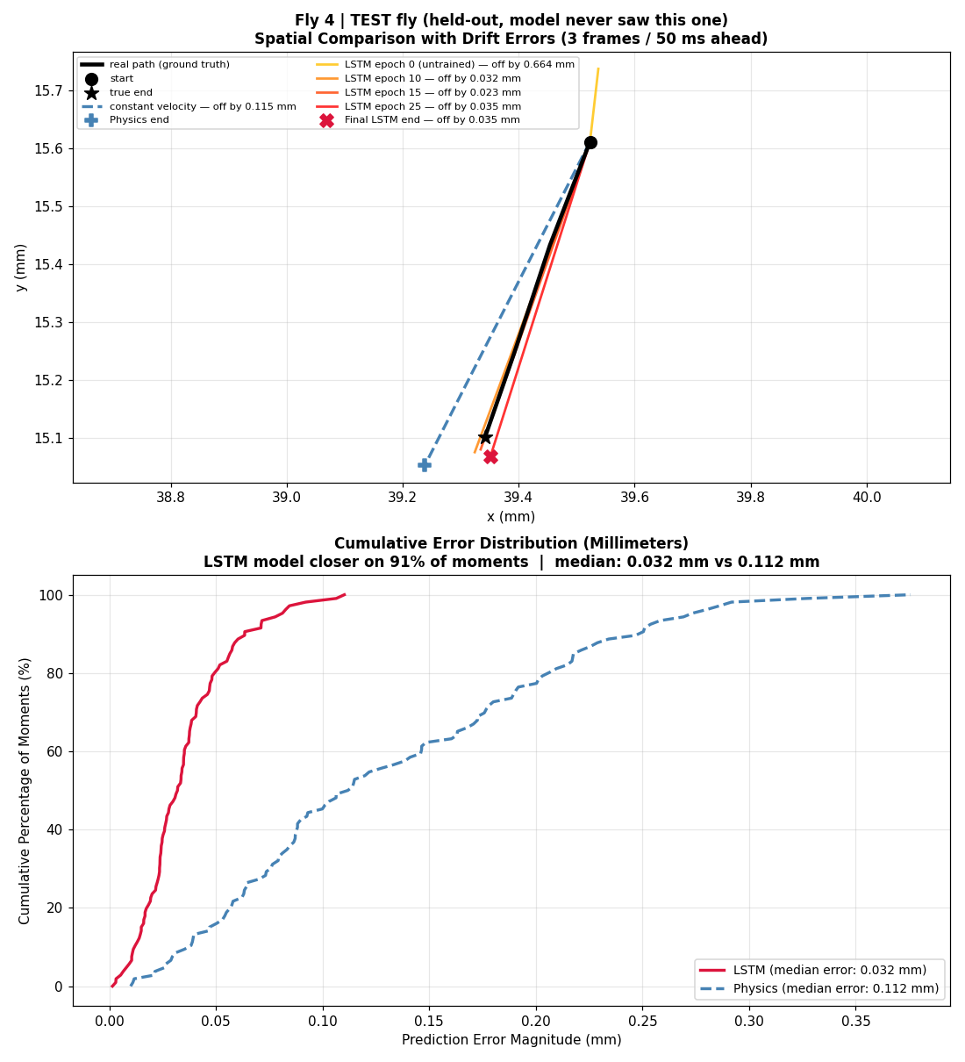
Figure 12. A second per-fly report figure, fly 4, in the layout the pipeline actually writes. Top: spatial comparison over the fly's most active stretch. Bottom: cumulative error distribution for that fly, model against physics.

Appendix B — Maintenance Guide
This guide is addressed to an engineer or researcher continuing the work: extending the pipeline, changing what it measures, or moving it toward the deployable system described in Phase A.

B.1 Operating environment
- Python 3.10 or later.
- Required packages: numpy, pandas, matplotlib, seaborn, torch (2.0+; a CUDA build is strongly recommended), tslearn, scikit-learn. Install with: pip install numpy pandas matplotlib seaborn torch tslearn scikit-learn
- Git LFS is required to retrieve the dataset and result CSVs from the repository; a plain clone yields pointer files rather than data.
- Hardware: a GPU is strongly recommended for 03_continuous_model.py and for 05_horizon_figure.py, which retrains the model once per horizon. Every other stage runs on CPU, although the clustering sweep is CPU-bound and slow. Approximately 8 GB of RAM and 10 GB of free disk are sufficient.
- No infrastructure services (databases, brokers, web servers) are required. The pipeline reads files and writes files.

B.2 Repository layout
- fly_common.py — shared configuration and data handling: frame rate, movement-bout thresholds, raw-CSV parsing and header detection, global fly identity, derived motion features, window alignment, and segment and bout extraction. Every other script imports this, so it is the correct place for any change to how data is interpreted.
- 01_cluster_ksweep.py — soft-DTW K-Means sweep over k and the final clustering. Resumable: results are written after every k and re-running skips completed values. Delete ksweep_silhouette.csv to start over, and do delete it if the sample size changes, so that results from different settings are not mixed.
- 02_prepare_trajlearn.py — millimetre-scale hex-grid tokenisation and TrajLearn input preparation, including the split-verification routine that replays TrajLearn's line-order slicing and aborts on mismatch.
- 03_continuous_model.py — the main result: window construction, the LSTM, both baselines, the by-fly split, checkpointing and evaluation.
- 04_report_figures.py — per-fly report figures for all splits, and the per-cluster breakdown, which requires cluster_centroids.npy from stage 01; without it that one figure is skipped and everything else still runs.
- 05_horizon_figure.py — turns horizon_sweep.csv into the accuracy-versus-horizon figure.
- 06_architecture_diagram.py — the pipeline and model diagrams; data-independent and regenerable at any time.
- Fly_Project_Colab.ipynb — the same stages wrapped for Colab, with Drive mounting, run-mode presets and per-step timing.

B.3 Configuration
Every tunable setting is overridable through an environment variable, which is how the Colab notebook drives the scripts without editing them.
Variable | Meaning | Default
FLY_DATA_DIR | Where to search for the raw CSVs | script folder
FLY_OUTPUT_DIR | Where results are written | ./outputs
FLY_NROWS | Rows read per file (none = all) | all
FLY_K_MIN / FLY_K_MAX | Range of the cluster sweep | 2 / 15
FLY_SWEEP_MAX | Segments used when scoring each k | 1200
FLY_HORIZON | Frames ahead to predict (3 = 50 ms) | 1
FLY_WINDOW | Frames of history fed to the model | 10
FLY_MAX_EPOCHS / FLY_PATIENCE | Training limit and early-stopping patience | 30 / 5
FLY_CHECKPOINT_EVERY | Snapshot the model every N epochs | 5
FLY_MAX_WINDOWS | Cap on training windows per fly | 4000
FLY_HEX_SIZE_MM | Hexagon size for the TrajLearn branch | 1.5

B.4 Extending the system
- Adding more data. Place additional CSVs matching the existing column schema in the data folder. Global fly ids are assigned automatically, so no id renumbering is needed. If the new files lack the three-block structure, the header detector still finds a first-line header.
- Changing the prediction horizon. Set FLY_HORIZON in frames before running stage 03, or use stage 05 to sweep. Note that the horizon changes the target, so checkpoints are not interchangeable between horizons — each horizon has its own output subdirectory.
- Changing the input representation. Feature construction lives in fly_common.py (align_window and add_motion_features) and in the FEATURE_NAMES list in stage 03. Any new feature must be rotation-invariant or body-centred, or it reintroduces the arena-memorisation problem described in Section 7.1.
- Replacing the model. The network, the training loop and the evaluation are separated in stage 03: a replacement need only accept a (batch, window, features) tensor and emit a (batch, 2) displacement for every baseline, metric and figure to continue working unchanged.
- Changing the definition of movement. MIN_SPEED_MM_S, MIN_BOUT_FRAMES and SMOOTH_SPEED_FRAMES in fly_common.py. Changing these invalidates both the clustering and the trained model, so both must be rerun.

B.5 Troubleshooting
- “No CSV files found”. FLY_DATA_DIR is not set or points at the wrong folder; the search is recursive from that folder, and anything inside the output folder is excluded deliberately.
- A recording is skipped with “no fly,time(s) table”. The file has no per-frame table, or is a Git LFS pointer that was never fetched. Check the file size: a pointer is about 130 bytes.
- CUDA out of memory during training. Reduce BATCH_SIZE in stage 03, or FLY_MAX_WINDOWS to cap the number of windows per fly. The model itself is small; memory is dominated by the batched window tensor.
- The cluster sweep appears to restart from scratch. It resumes from ksweep_silhouette.csv in the output folder. If FLY_OUTPUT_DIR changed between runs, the previous results are in the old folder.
- The per-cluster figure is missing. Stage 04 needs cluster_centroids.npy from stage 01 in the same output folder. Every other figure is produced regardless.

B.6 Known limitations
- Validated on a single species and a single tracking system (Drosophila melanogaster, Kim & Dickinson 2017), and on walking rather than flying behaviour. Accuracy figures should not be assumed to transfer without re-evaluation.
- At the 50 ms horizon the model operates close to the source data's own ≈ 0.02 mm positional noise floor, so its residual error cannot be cleanly separated from measurement error.
- The PyTorch training path was developed and validated end to end on Google Colab. It was not verified across every local OS and CUDA combination; everything surrounding it was tested against the real data with analytically known stand-in predictors (Section 7.4).
- This component predicts motion only. It has no connection to a live camera, the human-detection safety system, or laser actuation; integrating them was not attempted in this work.

