

Networks project

Transport Layer

January 29, 2022

daniel Tarek

18P1185



**Functions Implemented:**

A_output (parameters: message), where message is a structure of type msg, containing data to be sent to B. this routine is called when the higher layer on the sending side is approached. This function was implemented with the purpose of making sure that payload section (data) in the message is delivered to the receiving side higher layer in the correct order

A_input (params: packet), where packet is a structure of type pkt. This function will be called whenever a packet sent from B arrives at A. packet, which is possibly corrupted packet, is sent from the B-side.

A_timerinterrupt (), this function will be called when A's timer expires. We need this function to control the retransmission of packets.

A_init () this function will be called before any of your other A-side functions are called. It can be used to do any required initialization and it is called one time only

B_input (params: packet), where packet is a structure of type pkt. This function will be called whenever a packet sent from A (because of a tolayer3 () being done by a A-side procedure) arrives at the B. packet is the (possibly corrupted) packet sent from the A-side.

B_init (), this function will be called before any of your other B-side functions are called. It can be used to do any required initialization and it is called one time only.

**Alternating Bit Protocol**

**A) No loss and no error scenario to demonstrate that the code works under no error case:**

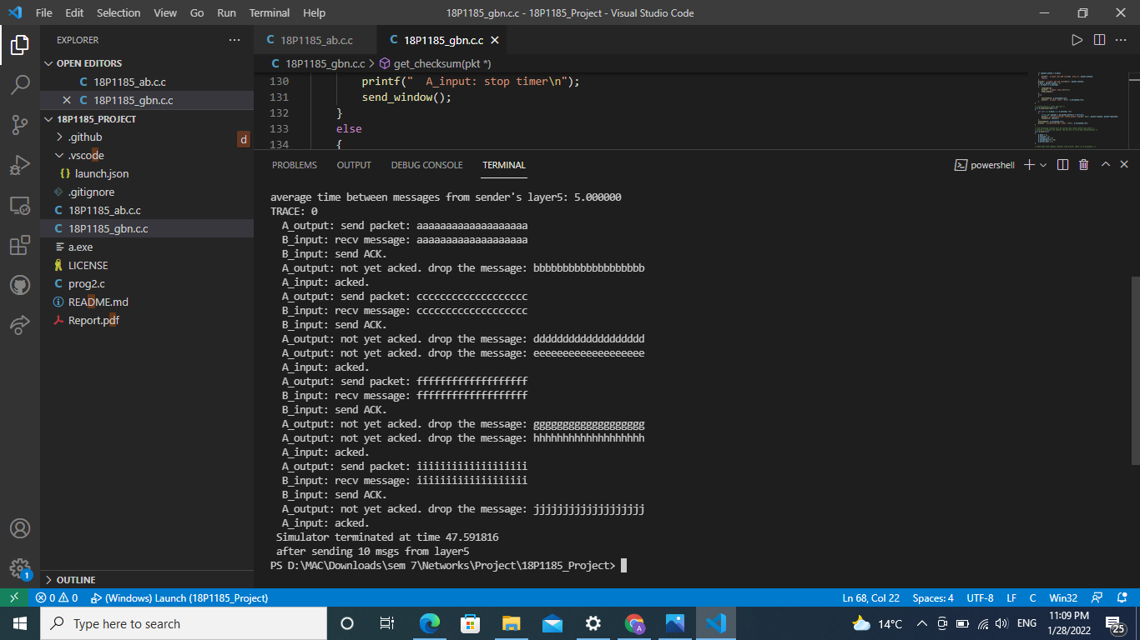

**B) 30 percent loss and no error scenario to demonstrate the code can recover the lossed packets:**

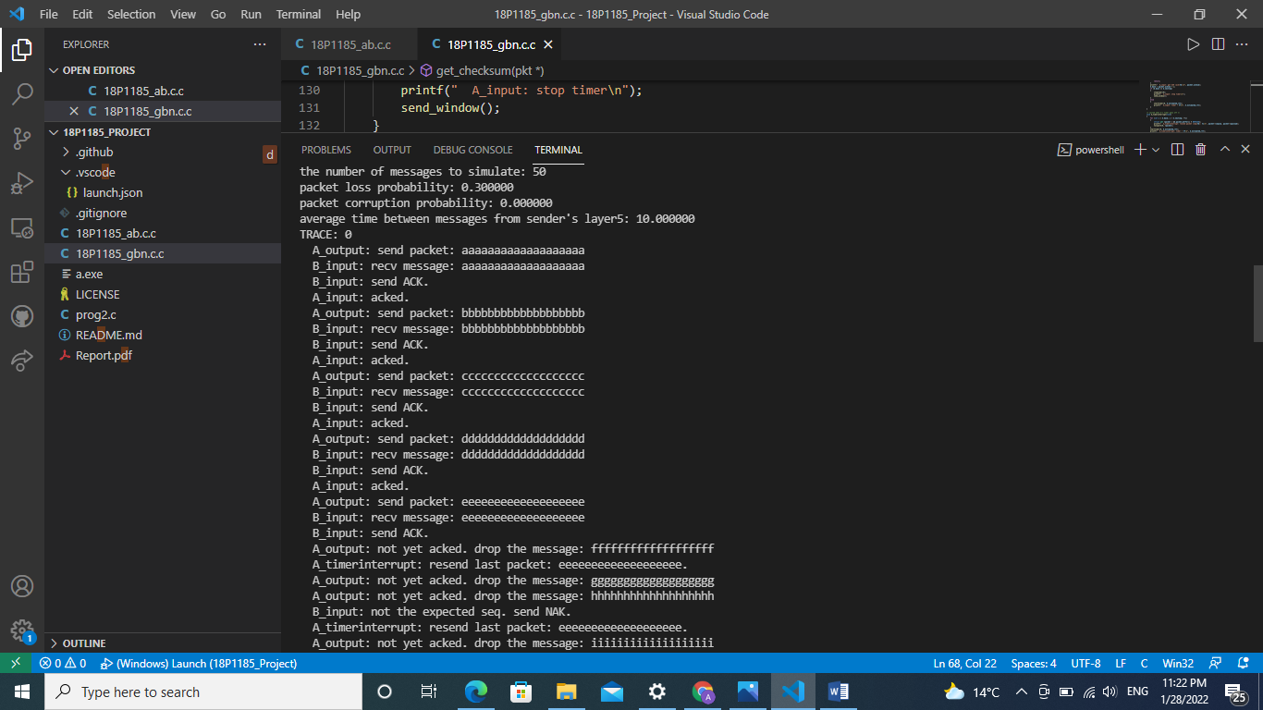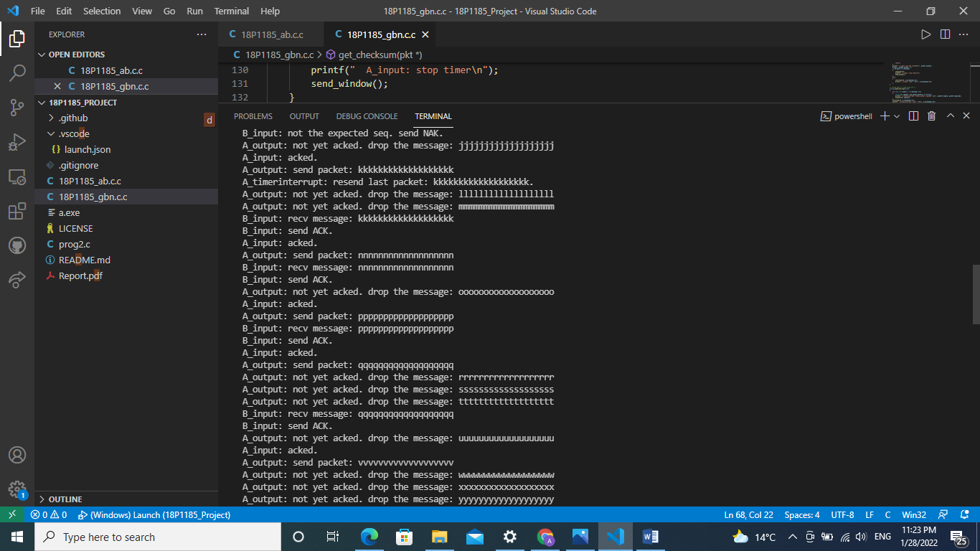

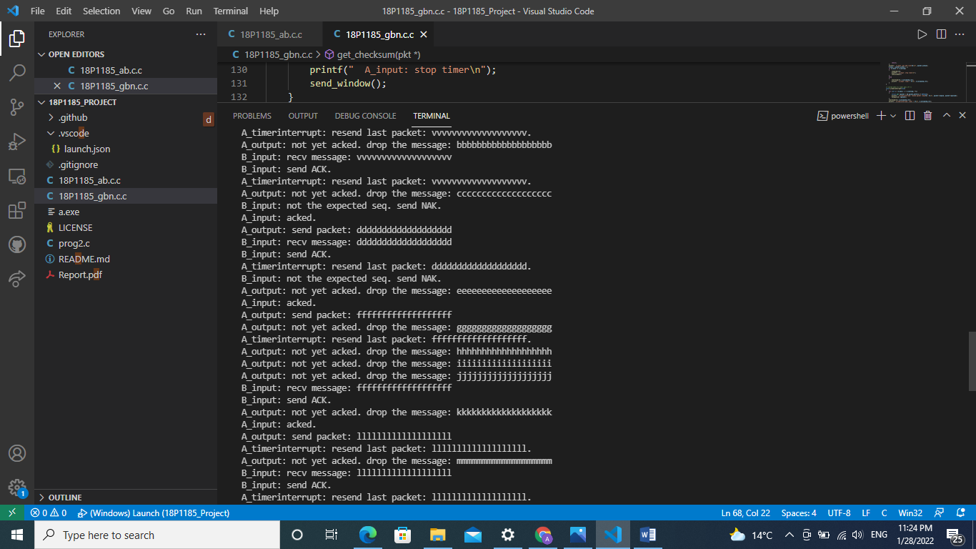

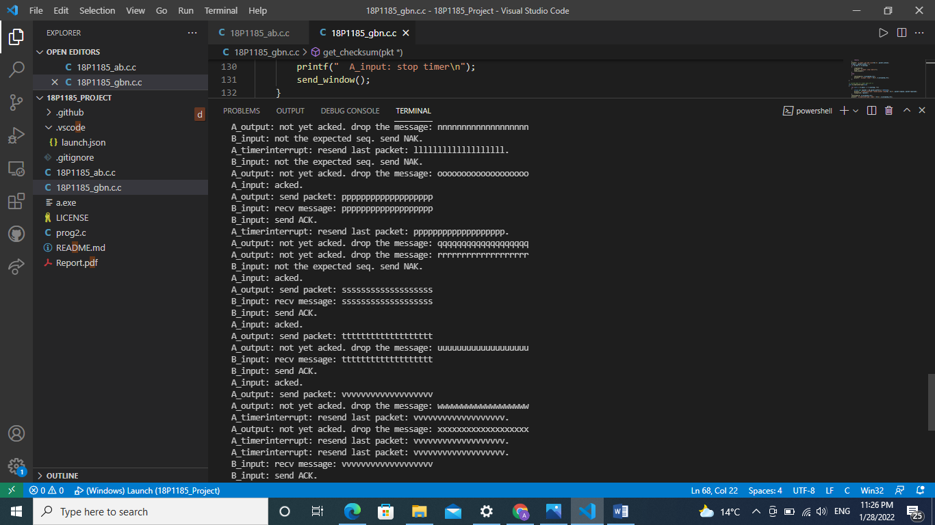

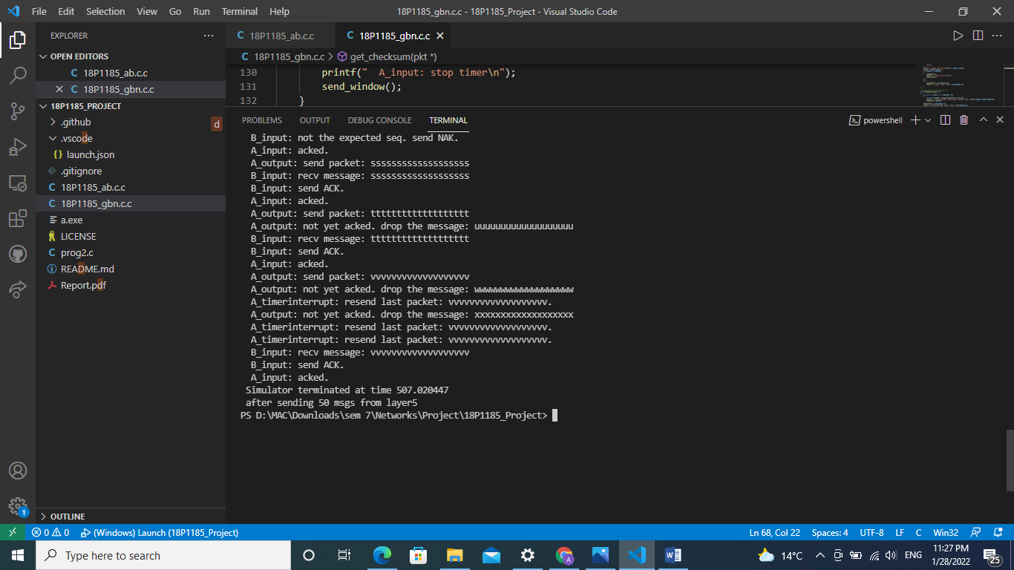

**C) No loss and 30 percent corruption scenario to demonstrate the code can recover the erroneously received packets**

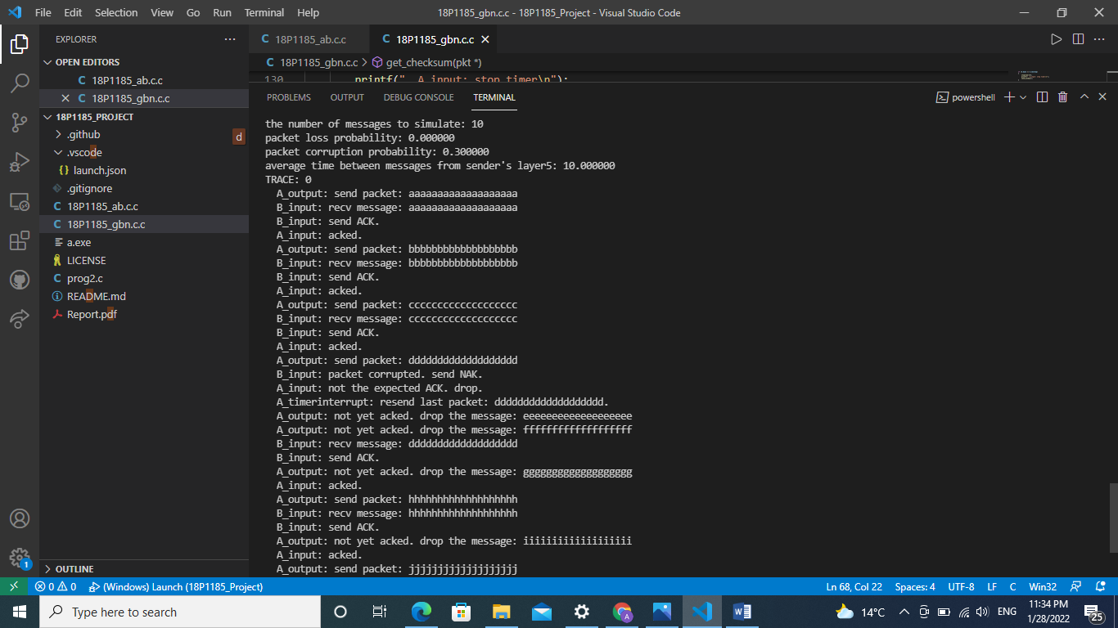

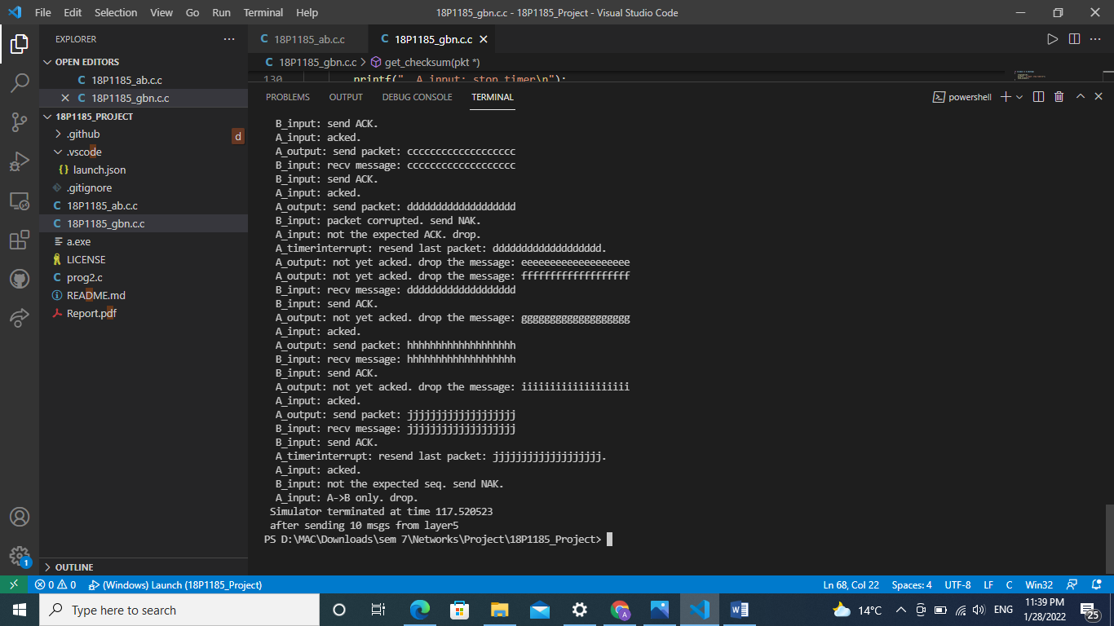

**Go Back N**

**A) No loss and no error scenario to demonstrate that the code works under no error case:**

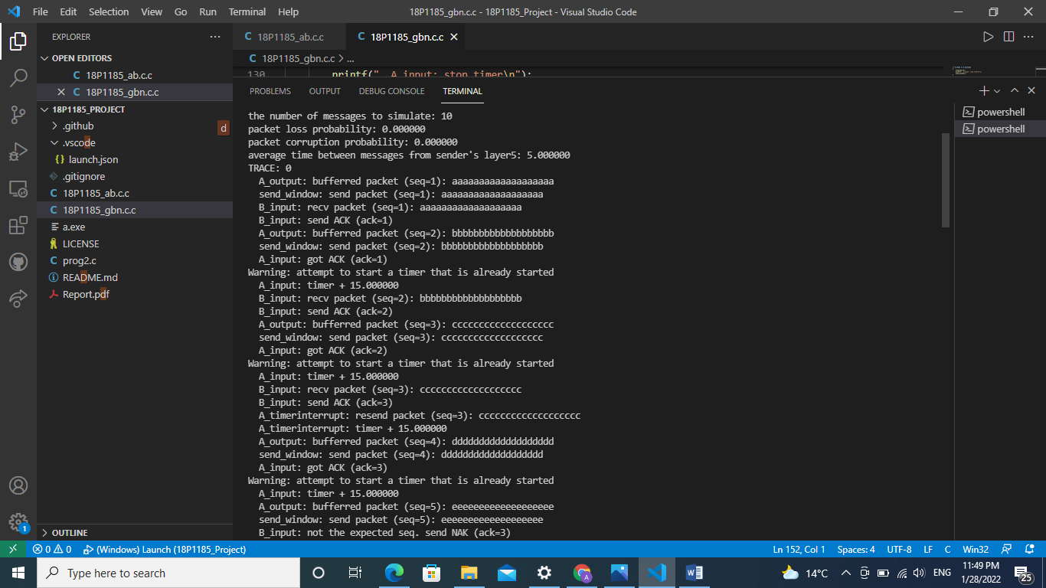

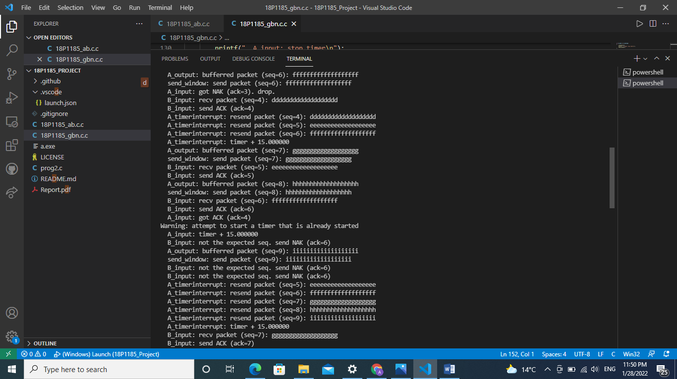

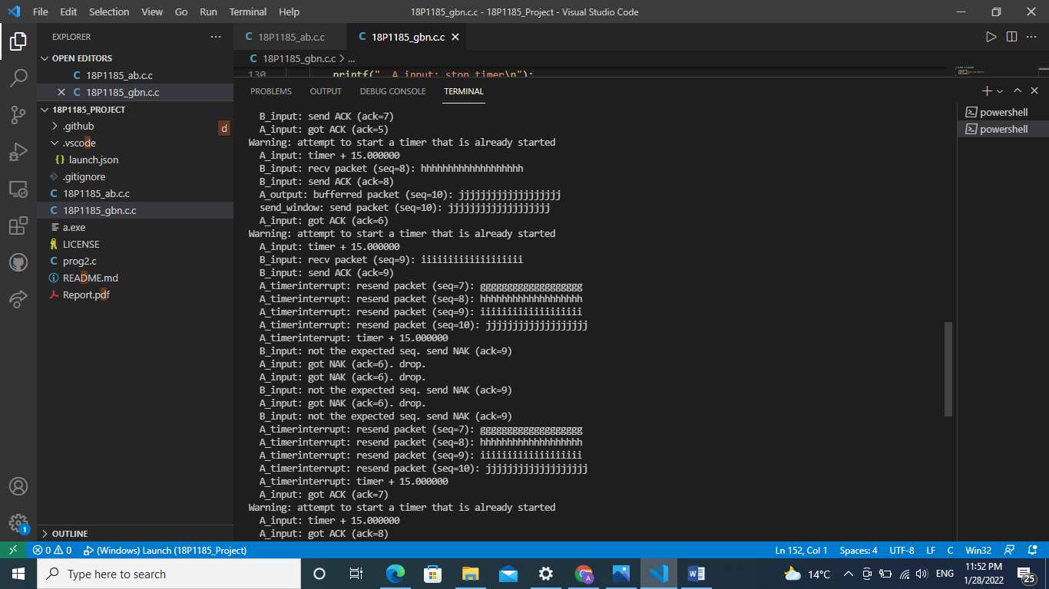

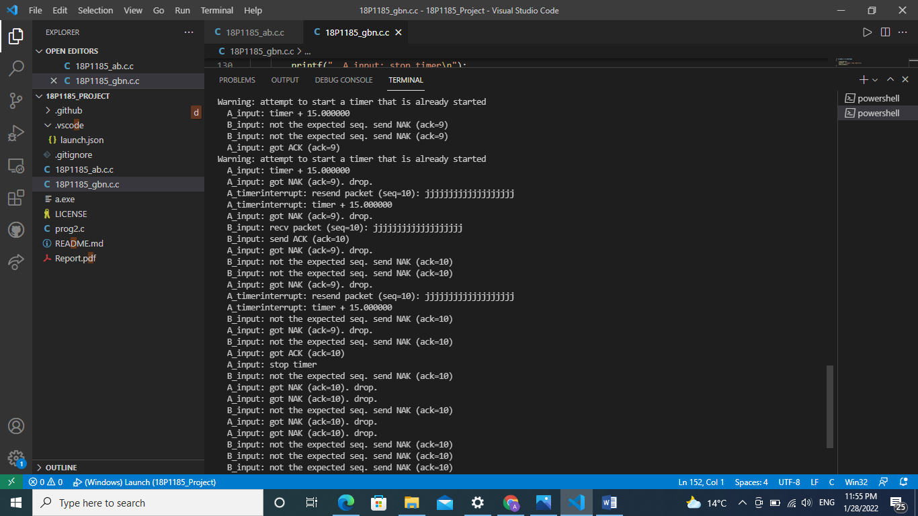

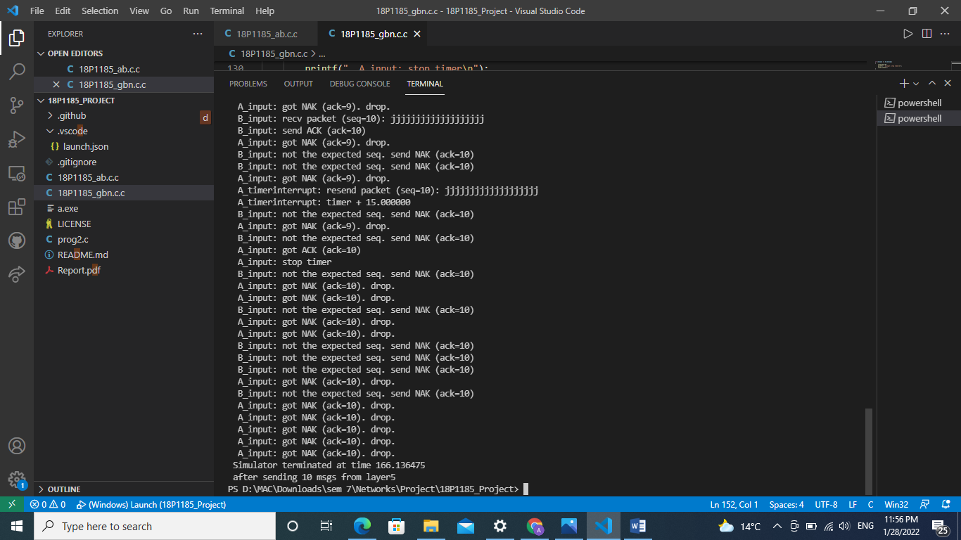

**B) 30 percent loss and no error scenario to demonstrate the code can recover the lossed packets:**

The number of messages to simulate: 50

Packet loss probability: 0.300000

Packet corruption probability: 0.000000

Average time between messages from sender's layer5: 10.000000

TRACE: 0

A_output: bufferred packet (seq=1): aaaaaaaaaaaaaaaaaaa

send_window: send packet (seq=1): aaaaaaaaaaaaaaaaaaa

B_input: recv packet (seq=1): aaaaaaaaaaaaaaaaaaa

B_input: send ACK (ack=1)

A_input: got ACK (ack=1)

A_input: stop timer

A_output: bufferred packet (seq=2): bbbbbbbbbbbbbbbbbbb

send_window: send packet (seq=2): bbbbbbbbbbbbbbbbbbb

B_input: recv packet (seq=2): bbbbbbbbbbbbbbbbbbb

B_input: send ACK (ack=2)

A_input: got ACK (ack=2)

A_input: stop timer

A_output: bufferred packet (seq=3): ccccccccccccccccccc

send_window: send packet (seq=3): ccccccccccccccccccc

B_input: recv packet (seq=3): ccccccccccccccccccc

B_input: send ACK (ack=3)

A_input: got ACK (ack=3)

A_input: stop timer

A_output: bufferred packet (seq=4): ddddddddddddddddddd

send_window: send packet (seq=4): ddddddddddddddddddd

B_input: recv packet (seq=4): ddddddddddddddddddd

B_input: send ACK (ack=4)

A_input: got ACK (ack=4)

A_input: stop timer

A_output: bufferred packet (seq=5): eeeeeeeeeeeeeeeeeee

send_window: send packet (seq=5): eeeeeeeeeeeeeeeeeee

B_input: recv packet (seq=5): eeeeeeeeeeeeeeeeeee

B_input: send ACK (ack=5)

A_output: bufferred packet (seq=6): fffffffffffffffffff

send_window: send packet (seq=6): fffffffffffffffffff

A_timerinterrupt: resend packet (seq=5): eeeeeeeeeeeeeeeeeee

A_timerinterrupt: resend packet (seq=6): fffffffffffffffffff

A_timerinterrupt: timer + 15.000000

B_input: recv packet (seq=6): fffffffffffffffffff

B_input: send ACK (ack=6)

B_input: not the expected seq. send NAK (ack=6)

A_output: bufferred packet (seq=7): ggggggggggggggggggg

send_window: send packet (seq=7): ggggggggggggggggggg

A_input: got ACK (ack=6)

Warning: attempt to start a timer that is already started

A_input: timer + 15.000000

B_input: recv packet (seq=7): ggggggggggggggggggg

B_input: send ACK (ack=7)

A_input: got NAK (ack=6). drop.

A_timerinterrupt: resend packet (seq=7): ggggggggggggggggggg

A_timerinterrupt: timer + 15.000000

A_output: bufferred packet (seq=8): hhhhhhhhhhhhhhhhhhh

send_window: send packet (seq=8): hhhhhhhhhhhhhhhhhhh

B_input: not the expected seq. send NAK (ack=7)

A_input: got ACK (ack=7)

Warning: attempt to start a timer that is already started

A_input: timer + 15.000000

B_input: recv packet (seq=8): hhhhhhhhhhhhhhhhhhh

B_input: send ACK (ack=8)

A_timerinterrupt: resend packet (seq=8): hhhhhhhhhhhhhhhhhhh

A_timerinterrupt: timer + 15.000000

A_output: bufferred packet (seq=9): iiiiiiiiiiiiiiiiiii

send_window: send packet (seq=9): iiiiiiiiiiiiiiiiiii

A_input: got ACK (ack=8)

Warning: attempt to start a timer that is already started

A_input: timer + 15.000000

B_input: not the expected seq. send NAK (ack=8)

A_input: got NAK (ack=8). drop.

A_timerinterrupt: resend packet (seq=9): iiiiiiiiiiiiiiiiiii

A_timerinterrupt: timer + 15.000000

B_input: recv packet (seq=9): iiiiiiiiiiiiiiiiiii

B_input: send ACK (ack=9)

A_output: bufferred packet (seq=10): jjjjjjjjjjjjjjjjjjj

send_window: send packet (seq=10): jjjjjjjjjjjjjjjjjjj

B_input: not the expected seq. send NAK (ack=9)

B_input: recv packet (seq=10): jjjjjjjjjjjjjjjjjjj

B_input: send ACK (ack=10)

A_output: bufferred packet (seq=11): kkkkkkkkkkkkkkkkkkk

send_window: send packet (seq=11): kkkkkkkkkkkkkkkkkkk

B_input: recv packet (seq=11): kkkkkkkkkkkkkkkkkkk

B_input: send ACK (ack=11)

A_output: bufferred packet (seq=12): lllllllllllllllllll

send_window: send packet (seq=12): lllllllllllllllllll

A_input: got ACK (ack=9)

Warning: attempt to start a timer that is already started

A_input: timer + 15.000000

A_output: bufferred packet (seq=13): mmmmmmmmmmmmmmmmmmm

send_window: send packet (seq=13): mmmmmmmmmmmmmmmmmmm

A_timerinterrupt: resend packet (seq=10): jjjjjjjjjjjjjjjjjjj

A_timerinterrupt: resend packet (seq=11): kkkkkkkkkkkkkkkkkkk

A_timerinterrupt: resend packet (seq=12): lllllllllllllllllll

A_timerinterrupt: resend packet (seq=13): mmmmmmmmmmmmmmmmmmm

A_timerinterrupt: timer + 15.000000

B_input: recv packet (seq=12): lllllllllllllllllll

B_input: send ACK (ack=12)

B_input: not the expected seq. send NAK (ack=12)

A_input: got ACK (ack=12)

Warning: attempt to start a timer that is already started

A_input: timer + 15.000000

B_input: not the expected seq. send NAK (ack=12)

A_output: bufferred packet (seq=14): nnnnnnnnnnnnnnnnnnn

send_window: send packet (seq=14): nnnnnnnnnnnnnnnnnnn

A_timerinterrupt: resend packet (seq=13): mmmmmmmmmmmmmmmmmmm

A_timerinterrupt: resend packet (seq=14): nnnnnnnnnnnnnnnnnnn

A_timerinterrupt: timer + 15.000000

B_input: recv packet (seq=13): mmmmmmmmmmmmmmmmmmm

B_input: send ACK (ack=13)

A_input: got NAK (ack=12). drop.

B_input: recv packet (seq=14): nnnnnnnnnnnnnnnnnnn

B_input: send ACK (ack=14)

B_input: not the expected seq. send NAK (ack=14)

A_output: bufferred packet (seq=15): ooooooooooooooooooo

send_window: send packet (seq=15): ooooooooooooooooooo

A_output: bufferred packet (seq=16): ppppppppppppppppppp

send_window: send packet (seq=16): ppppppppppppppppppp

A_input: got ACK (ack=14)

Warning: attempt to start a timer that is already started

A_input: timer + 15.000000

A_timerinterrupt: resend packet (seq=15): ooooooooooooooooooo

A_timerinterrupt: resend packet (seq=16): ppppppppppppppppppp

A_timerinterrupt: timer + 15.000000

B_input: recv packet (seq=15): ooooooooooooooooooo

B_input: send ACK (ack=15)

A_input: got ACK (ack=15)

Warning: attempt to start a timer that is already started

A_input: timer + 15.000000

B_input: recv packet (seq=16): ppppppppppppppppppp

B_input: send ACK (ack=16)

A_input: got ACK (ack=16)

A_input: stop timer

B_input: not the expected seq. send NAK (ack=16)

A_output: bufferred packet (seq=17): qqqqqqqqqqqqqqqqqqq

send_window: send packet (seq=17): qqqqqqqqqqqqqqqqqqq

A_input: got NAK (ack=16). drop.

B_input: recv packet (seq=17): qqqqqqqqqqqqqqqqqqq

B_input: send ACK (ack=17)

A_timerinterrupt: resend packet (seq=17): qqqqqqqqqqqqqqqqqqq

A_timerinterrupt: timer + 15.000000

A_output: bufferred packet (seq=18): rrrrrrrrrrrrrrrrrrr

send_window: send packet (seq=18): rrrrrrrrrrrrrrrrrrr

A_output: bufferred packet (seq=19): sssssssssssssssssss

send_window: send packet (seq=19): sssssssssssssssssss

B_input: not the expected seq. send NAK (ack=17)

A_output: bufferred packet (seq=20): ttttttttttttttttttt

send_window: send packet (seq=20): ttttttttttttttttttt

B_input: recv packet (seq=18): rrrrrrrrrrrrrrrrrrr

B_input: send ACK (ack=18)

A_timerinterrupt: resend packet (seq=17): qqqqqqqqqqqqqqqqqqq

A_timerinterrupt: resend packet (seq=18): rrrrrrrrrrrrrrrrrrr

A_timerinterrupt: resend packet (seq=19): sssssssssssssssssss

A_timerinterrupt: resend packet (seq=20): ttttttttttttttttttt

A_timerinterrupt: timer + 15.000000

A_output: bufferred packet (seq=21): uuuuuuuuuuuuuuuuuuu

send_window: send packet (seq=21): uuuuuuuuuuuuuuuuuuu

B_input: recv packet (seq=19): sssssssssssssssssss

B_input: send ACK (ack=19)

A_input: got ACK (ack=17)

Warning: attempt to start a timer that is already started

A_input: timer + 15.000000

B_input: not the expected seq. send NAK (ack=19)

A_input: got ACK (ack=18)

Warning: attempt to start a timer that is already started

A_input: timer + 15.000000

A_output: bufferred packet (seq=22): vvvvvvvvvvvvvvvvvvv

send_window: send packet (seq=22): vvvvvvvvvvvvvvvvvvv

B_input: not the expected seq. send NAK (ack=19)

A_timerinterrupt: resend packet (seq=19): sssssssssssssssssss

A_timerinterrupt: resend packet (seq=20): ttttttttttttttttttt

A_timerinterrupt: resend packet (seq=21): uuuuuuuuuuuuuuuuuuu

A_timerinterrupt: resend packet (seq=22): vvvvvvvvvvvvvvvvvvv

A_timerinterrupt: timer + 15.000000

B_input: not the expected seq. send NAK (ack=19)

A_input: got ACK (ack=19)

Warning: attempt to start a timer that is already started

A_input: timer + 15.000000

B_input: recv packet (seq=20): ttttttttttttttttttt

B_input: send ACK (ack=20)

A_output: bufferred packet (seq=23): wwwwwwwwwwwwwwwwwww

send_window: send packet (seq=23): wwwwwwwwwwwwwwwwwww

B_input: recv packet (seq=21): uuuuuuuuuuuuuuuuuuu

B_input: send ACK (ack=21)

A_input: got ACK (ack=20)

Warning: attempt to start a timer that is already started

A_input: timer + 15.000000

A_output: bufferred packet (seq=24): xxxxxxxxxxxxxxxxxxx

send_window: send packet (seq=24): xxxxxxxxxxxxxxxxxxx

B_input: recv packet (seq=22): vvvvvvvvvvvvvvvvvvv

B_input: send ACK (ack=22)

A_output: bufferred packet (seq=25): yyyyyyyyyyyyyyyyyyy

send_window: send packet (seq=25): yyyyyyyyyyyyyyyyyyy

A_timerinterrupt: resend packet (seq=21): uuuuuuuuuuuuuuuuuuu

A_timerinterrupt: resend packet (seq=22): vvvvvvvvvvvvvvvvvvv

A_timerinterrupt: resend packet (seq=23): wwwwwwwwwwwwwwwwwww

A_timerinterrupt: resend packet (seq=24): xxxxxxxxxxxxxxxxxxx

A_timerinterrupt: resend packet (seq=25): yyyyyyyyyyyyyyyyyyy

A_timerinterrupt: timer + 15.000000

A_input: got ACK (ack=21)

Warning: attempt to start a timer that is already started

A_input: timer + 15.000000

A_input: got ACK (ack=22)

Warning: attempt to start a timer that is already started

A_input: timer + 15.000000

B_input: not the expected seq. send NAK (ack=22)

A_input: got NAK (ack=22). drop.

A_output: bufferred packet (seq=26): zzzzzzzzzzzzzzzzzzz

send_window: send packet (seq=26): zzzzzzzzzzzzzzzzzzz

A_timerinterrupt: resend packet (seq=23): wwwwwwwwwwwwwwwwwww

A_timerinterrupt: resend packet (seq=24): xxxxxxxxxxxxxxxxxxx

A_timerinterrupt: resend packet (seq=25): yyyyyyyyyyyyyyyyyyy

A_timerinterrupt: resend packet (seq=26): zzzzzzzzzzzzzzzzzzz

A_timerinterrupt: timer + 15.000000

B_input: not the expected seq. send NAK (ack=22)

B_input: not the expected seq. send NAK (ack=22)

A_output: bufferred packet (seq=27): aaaaaaaaaaaaaaaaaaa

send_window: send packet (seq=27): aaaaaaaaaaaaaaaaaaa

A_input: got NAK (ack=22). drop.

B_input: not the expected seq. send NAK (ack=22)

B_input: recv packet (seq=23): wwwwwwwwwwwwwwwwwww

B_input: send ACK (ack=23)

B_input: not the expected seq. send NAK (ack=23)

A_timerinterrupt: resend packet (seq=23): wwwwwwwwwwwwwwwwwww

A_timerinterrupt: resend packet (seq=24): xxxxxxxxxxxxxxxxxxx

A_timerinterrupt: resend packet (seq=25): yyyyyyyyyyyyyyyyyyy

A_timerinterrupt: resend packet (seq=26): zzzzzzzzzzzzzzzzzzz

A_timerinterrupt: resend packet (seq=27): aaaaaaaaaaaaaaaaaaa

A_timerinterrupt: timer + 15.000000

B_input: not the expected seq. send NAK (ack=23)

A_input: got ACK (ack=23)

Warning: attempt to start a timer that is already started

A_input: timer + 15.000000

A_output: bufferred packet (seq=28): bbbbbbbbbbbbbbbbbbb

send_window: send packet (seq=28): bbbbbbbbbbbbbbbbbbb

B_input: not the expected seq. send NAK (ack=23)

B_input: not the expected seq. send NAK (ack=23)

A_output: bufferred packet (seq=29): ccccccccccccccccccc

send_window: send packet (seq=29): ccccccccccccccccccc

A_input: got NAK (ack=23). drop.

A_timerinterrupt: resend packet (seq=24): xxxxxxxxxxxxxxxxxxx

A_timerinterrupt: resend packet (seq=25): yyyyyyyyyyyyyyyyyyy

A_timerinterrupt: resend packet (seq=26): zzzzzzzzzzzzzzzzzzz

A_timerinterrupt: resend packet (seq=27): aaaaaaaaaaaaaaaaaaa

A_timerinterrupt: resend packet (seq=28): bbbbbbbbbbbbbbbbbbb

A_timerinterrupt: resend packet (seq=29): ccccccccccccccccccc

A_timerinterrupt: timer + 15.000000

B_input: not the expected seq. send NAK (ack=23)

B_input: recv packet (seq=24): xxxxxxxxxxxxxxxxxxx

B_input: send ACK (ack=24)

A_input: got NAK (ack=23). drop.

B_input: not the expected seq. send NAK (ack=24)

A_output: bufferred packet (seq=30): ddddddddddddddddddd

send_window: send packet (seq=30): ddddddddddddddddddd

A_timerinterrupt: resend packet (seq=24): xxxxxxxxxxxxxxxxxxx

A_timerinterrupt: resend packet (seq=25): yyyyyyyyyyyyyyyyyyy

A_timerinterrupt: resend packet (seq=26): zzzzzzzzzzzzzzzzzzz

A_timerinterrupt: resend packet (seq=27): aaaaaaaaaaaaaaaaaaa

A_timerinterrupt: resend packet (seq=28): bbbbbbbbbbbbbbbbbbb

A_timerinterrupt: resend packet (seq=29): ccccccccccccccccccc

A_timerinterrupt: resend packet (seq=30): ddddddddddddddddddd

A_timerinterrupt: timer + 15.000000

B_input: not the expected seq. send NAK (ack=24)

A_input: got ACK (ack=24)

Warning: attempt to start a timer that is already started

A_input: timer + 15.000000

B_input: not the expected seq. send NAK (ack=24)

A_input: got NAK (ack=24). drop.

A_input: got NAK (ack=24). drop.

B_input: recv packet (seq=25): yyyyyyyyyyyyyyyyyyy

B_input: send ACK (ack=25)

A_output: bufferred packet (seq=31): eeeeeeeeeeeeeeeeeee

send_window: send packet (seq=31): eeeeeeeeeeeeeeeeeee

A_input: got NAK (ack=24). drop.

A_timerinterrupt: resend packet (seq=25): yyyyyyyyyyyyyyyyyyy

A_timerinterrupt: resend packet (seq=26): zzzzzzzzzzzzzzzzzzz

A_timerinterrupt: resend packet (seq=27): aaaaaaaaaaaaaaaaaaa

A_timerinterrupt: resend packet (seq=28): bbbbbbbbbbbbbbbbbbb

A_timerinterrupt: resend packet (seq=29): ccccccccccccccccccc

A_timerinterrupt: resend packet (seq=30): ddddddddddddddddddd

A_timerinterrupt: resend packet (seq=31): eeeeeeeeeeeeeeeeeee

A_timerinterrupt: timer + 15.000000

B_input: recv packet (seq=26): zzzzzzzzzzzzzzzzzzz

B_input: send ACK (ack=26)

A_input: got ACK (ack=25)

Warning: attempt to start a timer that is already started

A_input: timer + 15.000000

B_input: not the expected seq. send NAK (ack=26)

A_output: bufferred packet (seq=32): fffffffffffffffffff

send_window: send packet (seq=32): fffffffffffffffffff

A_timerinterrupt: resend packet (seq=26): zzzzzzzzzzzzzzzzzzz

A_timerinterrupt: resend packet (seq=27): aaaaaaaaaaaaaaaaaaa

A_timerinterrupt: resend packet (seq=28): bbbbbbbbbbbbbbbbbbb

A_timerinterrupt: resend packet (seq=29): ccccccccccccccccccc

A_timerinterrupt: resend packet (seq=30): ddddddddddddddddddd

A_timerinterrupt: resend packet (seq=31): eeeeeeeeeeeeeeeeeee

A_timerinterrupt: resend packet (seq=32): fffffffffffffffffff

A_timerinterrupt: timer + 15.000000

B_input: not the expected seq. send NAK (ack=26)

A_input: got ACK (ack=26)

Warning: attempt to start a timer that is already started

A_input: timer + 15.000000

A_input: got NAK (ack=26). drop.

B_input: not the expected seq. send NAK (ack=26)

B_input: not the expected seq. send NAK (ack=26)

A_timerinterrupt: resend packet (seq=27): aaaaaaaaaaaaaaaaaaa

A_timerinterrupt: resend packet (seq=28): bbbbbbbbbbbbbbbbbbb

A_timerinterrupt: resend packet (seq=29): ccccccccccccccccccc

A_timerinterrupt: resend packet (seq=30): ddddddddddddddddddd

A_timerinterrupt: resend packet (seq=31): eeeeeeeeeeeeeeeeeee

A_timerinterrupt: resend packet (seq=32): fffffffffffffffffff

A_timerinterrupt: timer + 15.000000

A_output: bufferred packet (seq=33): ggggggggggggggggggg

send_window: send packet (seq=33): ggggggggggggggggggg

B_input: not the expected seq. send NAK (ack=26)

A_input: got NAK (ack=26). drop.

B_input: recv packet (seq=27): aaaaaaaaaaaaaaaaaaa

B_input: send ACK (ack=27)

A_input: got NAK (ack=26). drop.

B_input: not the expected seq. send NAK (ack=27)

A_output: bufferred packet (seq=34): hhhhhhhhhhhhhhhhhhh

send_window: send packet (seq=34): hhhhhhhhhhhhhhhhhhh

A_timerinterrupt: resend packet (seq=27): aaaaaaaaaaaaaaaaaaa

A_timerinterrupt: resend packet (seq=28): bbbbbbbbbbbbbbbbbbb

A_timerinterrupt: resend packet (seq=29): ccccccccccccccccccc

A_timerinterrupt: resend packet (seq=30): ddddddddddddddddddd

A_timerinterrupt: resend packet (seq=31): eeeeeeeeeeeeeeeeeee

A_timerinterrupt: resend packet (seq=32): fffffffffffffffffff

A_timerinterrupt: resend packet (seq=33): ggggggggggggggggggg

A_timerinterrupt: resend packet (seq=34): hhhhhhhhhhhhhhhhhhh

A_timerinterrupt: timer + 15.000000

B_input: not the expected seq. send NAK (ack=27)

B_input: not the expected seq. send NAK (ack=27)

A_output: bufferred packet (seq=35): iiiiiiiiiiiiiiiiiii

A_output: bufferred packet (seq=36): jjjjjjjjjjjjjjjjjjj

B_input: not the expected seq. send NAK (ack=27)

A_output: bufferred packet (seq=37): kkkkkkkkkkkkkkkkkkk

A_input: got ACK (ack=27)

Warning: attempt to start a timer that is already started

A_input: timer + 15.000000

A_timerinterrupt: resend packet (seq=28): bbbbbbbbbbbbbbbbbbb

A_timerinterrupt: resend packet (seq=29): ccccccccccccccccccc

A_timerinterrupt: resend packet (seq=30): ddddddddddddddddddd

A_timerinterrupt: resend packet (seq=31): eeeeeeeeeeeeeeeeeee

A_timerinterrupt: resend packet (seq=32): fffffffffffffffffff

A_timerinterrupt: resend packet (seq=33): ggggggggggggggggggg

A_timerinterrupt: resend packet (seq=34): hhhhhhhhhhhhhhhhhhh

A_timerinterrupt: timer + 15.000000

B_input: recv packet (seq=28): bbbbbbbbbbbbbbbbbbb

B_input: send ACK (ack=28)

A_output: bufferred packet (seq=38): lllllllllllllllllll

send_window: send packet (seq=35): iiiiiiiiiiiiiiiiiii

B_input: recv packet (seq=29): ccccccccccccccccccc

B_input: send ACK (ack=29)

A_input: got ACK (ack=28)

Warning: attempt to start a timer that is already started

A_input: timer + 15.000000

A_output: bufferred packet (seq=39): mmmmmmmmmmmmmmmmmmm

send_window: send packet (seq=36): jjjjjjjjjjjjjjjjjjj

B_input: recv packet (seq=30): ddddddddddddddddddd

B_input: send ACK (ack=30)

A_input: got ACK (ack=29)

Warning: attempt to start a timer that is already started

A_input: timer + 15.000000

A_timerinterrupt: resend packet (seq=30): ddddddddddddddddddd

A_timerinterrupt: resend packet (seq=31): eeeeeeeeeeeeeeeeeee

A_timerinterrupt: resend packet (seq=32): fffffffffffffffffff

A_timerinterrupt: resend packet (seq=33): ggggggggggggggggggg

A_timerinterrupt: resend packet (seq=34): hhhhhhhhhhhhhhhhhhh

A_timerinterrupt: resend packet (seq=35): iiiiiiiiiiiiiiiiiii

A_timerinterrupt: resend packet (seq=36): jjjjjjjjjjjjjjjjjjj

A_timerinterrupt: timer + 15.000000

A_input: got ACK (ack=30)

Warning: attempt to start a timer that is already started

A_input: timer + 15.000000

B_input: recv packet (seq=31): eeeeeeeeeeeeeeeeeee

B_input: send ACK (ack=31)

A_input: got ACK (ack=31)

Warning: attempt to start a timer that is already started

A_input: timer + 15.000000

A_output: bufferred packet (seq=40): nnnnnnnnnnnnnnnnnnn

send_window: send packet (seq=37): kkkkkkkkkkkkkkkkkkk

send_window: send packet (seq=38): lllllllllllllllllll

send_window: send packet (seq=39): mmmmmmmmmmmmmmmmmmm

A_timerinterrupt: resend packet (seq=32): fffffffffffffffffff

A_timerinterrupt: resend packet (seq=33): ggggggggggggggggggg

A_timerinterrupt: resend packet (seq=34): hhhhhhhhhhhhhhhhhhh

A_timerinterrupt: resend packet (seq=35): iiiiiiiiiiiiiiiiiii

A_timerinterrupt: resend packet (seq=36): jjjjjjjjjjjjjjjjjjj

A_timerinterrupt: resend packet (seq=37): kkkkkkkkkkkkkkkkkkk

A_timerinterrupt: resend packet (seq=38): lllllllllllllllllll

A_timerinterrupt: resend packet (seq=39): mmmmmmmmmmmmmmmmmmm

A_timerinterrupt: timer + 15.000000

B_input: not the expected seq. send NAK (ack=31)

B_input: not the expected seq. send NAK (ack=31)

A_input: got NAK (ack=31). drop.

A_input: got NAK (ack=31). drop.

B_input: not the expected seq. send NAK (ack=31)

A_output: bufferred packet (seq=41): ooooooooooooooooooo

B_input: not the expected seq. send NAK (ack=31)

B_input: recv packet (seq=32): fffffffffffffffffff

B_input: send ACK (ack=32)

A_timerinterrupt: resend packet (seq=32): fffffffffffffffffff

A_timerinterrupt: resend packet (seq=33): ggggggggggggggggggg

A_timerinterrupt: resend packet (seq=34): hhhhhhhhhhhhhhhhhhh

A_timerinterrupt: resend packet (seq=35): iiiiiiiiiiiiiiiiiii

A_timerinterrupt: resend packet (seq=36): jjjjjjjjjjjjjjjjjjj

A_timerinterrupt: resend packet (seq=37): kkkkkkkkkkkkkkkkkkk

A_timerinterrupt: resend packet (seq=38): lllllllllllllllllll

A_timerinterrupt: resend packet (seq=39): mmmmmmmmmmmmmmmmmmm

A_timerinterrupt: timer + 15.000000

A_input: got NAK (ack=31). drop.

B_input: not the expected seq. send NAK (ack=32)

B_input: not the expected seq. send NAK (ack=32)

A_input: got ACK (ack=32)

Warning: attempt to start a timer that is already started

A_input: timer + 15.000000

A_output: bufferred packet (seq=42): ppppppppppppppppppp

send_window: send packet (seq=40): nnnnnnnnnnnnnnnnnnn

A_input: got NAK (ack=32). drop.

A_input: got NAK (ack=32). drop.

A_timerinterrupt: resend packet (seq=33): ggggggggggggggggggg

A_timerinterrupt: resend packet (seq=34): hhhhhhhhhhhhhhhhhhh

A_timerinterrupt: resend packet (seq=35): iiiiiiiiiiiiiiiiiii

A_timerinterrupt: resend packet (seq=36): jjjjjjjjjjjjjjjjjjj

A_timerinterrupt: resend packet (seq=37): kkkkkkkkkkkkkkkkkkk

A_timerinterrupt: resend packet (seq=38): lllllllllllllllllll

A_timerinterrupt: resend packet (seq=39): mmmmmmmmmmmmmmmmmmm

A_timerinterrupt: resend packet (seq=40): nnnnnnnnnnnnnnnnnnn

A_timerinterrupt: timer + 15.000000

B_input: not the expected seq. send NAK (ack=32)

A_output: bufferred packet (seq=43): qqqqqqqqqqqqqqqqqqq

A_input: got NAK (ack=32). drop.

B_input: not the expected seq. send NAK (ack=32)

A_timerinterrupt: resend packet (seq=33): ggggggggggggggggggg

A_timerinterrupt: resend packet (seq=34): hhhhhhhhhhhhhhhhhhh

A_timerinterrupt: resend packet (seq=35): iiiiiiiiiiiiiiiiiii

A_timerinterrupt: resend packet (seq=36): jjjjjjjjjjjjjjjjjjj

A_timerinterrupt: resend packet (seq=37): kkkkkkkkkkkkkkkkkkk

A_timerinterrupt: resend packet (seq=38): lllllllllllllllllll

A_timerinterrupt: resend packet (seq=39): mmmmmmmmmmmmmmmmmmm

A_timerinterrupt: resend packet (seq=40): nnnnnnnnnnnnnnnnnnn

A_timerinterrupt: timer + 15.000000

B_input: not the expected seq. send NAK (ack=32)

A_input: got NAK (ack=32). drop.

A_output: bufferred packet (seq=44): rrrrrrrrrrrrrrrrrrr

A_output: bufferred packet (seq=45): sssssssssssssssssss

A_timerinterrupt: resend packet (seq=33): ggggggggggggggggggg

A_timerinterrupt: resend packet (seq=34): hhhhhhhhhhhhhhhhhhh

A_timerinterrupt: resend packet (seq=35): iiiiiiiiiiiiiiiiiii

A_timerinterrupt: resend packet (seq=36): jjjjjjjjjjjjjjjjjjj

A_timerinterrupt: resend packet (seq=37): kkkkkkkkkkkkkkkkkkk

A_timerinterrupt: resend packet (seq=38): lllllllllllllllllll

A_timerinterrupt: resend packet (seq=39): mmmmmmmmmmmmmmmmmmm

A_timerinterrupt: resend packet (seq=40): nnnnnnnnnnnnnnnnnnn

A_timerinterrupt: timer + 15.000000

B_input: not the expected seq. send NAK (ack=32)

B_input: not the expected seq. send NAK (ack=32)

B_input: not the expected seq. send NAK (ack=32)

A_input: got NAK (ack=32). drop.

B_input: not the expected seq. send NAK (ack=32)

A_output: bufferred packet (seq=46): ttttttttttttttttttt

A_input: got NAK (ack=32). drop.

A_input: got NAK (ack=32). drop.

A_timerinterrupt: resend packet (seq=33): ggggggggggggggggggg

A_timerinterrupt: resend packet (seq=34): hhhhhhhhhhhhhhhhhhh

A_timerinterrupt: resend packet (seq=35): iiiiiiiiiiiiiiiiiii

A_timerinterrupt: resend packet (seq=36): jjjjjjjjjjjjjjjjjjj

A_timerinterrupt: resend packet (seq=37): kkkkkkkkkkkkkkkkkkk

A_timerinterrupt: resend packet (seq=38): lllllllllllllllllll

A_timerinterrupt: resend packet (seq=39): mmmmmmmmmmmmmmmmmmm

A_timerinterrupt: resend packet (seq=40): nnnnnnnnnnnnnnnnnnn

A_timerinterrupt: timer + 15.000000

B_input: not the expected seq. send NAK (ack=32)

B_input: not the expected seq. send NAK (ack=32)

A_input: got NAK (ack=32). drop.

B_input: not the expected seq. send NAK (ack=32)

A_output: bufferred packet (seq=47): uuuuuuuuuuuuuuuuuuu

A_timerinterrupt: resend packet (seq=33): ggggggggggggggggggg

A_timerinterrupt: resend packet (seq=34): hhhhhhhhhhhhhhhhhhh

A_timerinterrupt: resend packet (seq=35): iiiiiiiiiiiiiiiiiii

A_timerinterrupt: resend packet (seq=36): jjjjjjjjjjjjjjjjjjj

A_timerinterrupt: resend packet (seq=37): kkkkkkkkkkkkkkkkkkk

A_timerinterrupt: resend packet (seq=38): lllllllllllllllllll

A_timerinterrupt: resend packet (seq=39): mmmmmmmmmmmmmmmmmmm

A_timerinterrupt: resend packet (seq=40): nnnnnnnnnnnnnnnnnnn

A_timerinterrupt: timer + 15.000000

A_input: got NAK (ack=32). drop.

B_input: not the expected seq. send NAK (ack=32)

B_input: not the expected seq. send NAK (ack=32)

A_input: got NAK (ack=32). drop.

B_input: not the expected seq. send NAK (ack=32)

A_input: got NAK (ack=32). drop.

A_timerinterrupt: resend packet (seq=33): ggggggggggggggggggg

A_timerinterrupt: resend packet (seq=34): hhhhhhhhhhhhhhhhhhh

A_timerinterrupt: resend packet (seq=35): iiiiiiiiiiiiiiiiiii

A_timerinterrupt: resend packet (seq=36): jjjjjjjjjjjjjjjjjjj

A_timerinterrupt: resend packet (seq=37): kkkkkkkkkkkkkkkkkkk

A_timerinterrupt: resend packet (seq=38): lllllllllllllllllll

A_timerinterrupt: resend packet (seq=39): mmmmmmmmmmmmmmmmmmm

A_timerinterrupt: resend packet (seq=40): nnnnnnnnnnnnnnnnnnn

A_timerinterrupt: timer + 15.000000

B_input: recv packet (seq=33): ggggggggggggggggggg

B_input: send ACK (ack=33)

A_output: bufferred packet (seq=48): vvvvvvvvvvvvvvvvvvv

A_input: got ACK (ack=33)

Warning: attempt to start a timer that is already started

A_input: timer + 15.000000

B_input: not the expected seq. send NAK (ack=33)

A_output: bufferred packet (seq=49): wwwwwwwwwwwwwwwwwww

send_window: send packet (seq=41): ooooooooooooooooooo

B_input: not the expected seq. send NAK (ack=33)

A_input: got NAK (ack=33). drop.

A_timerinterrupt: resend packet (seq=34): hhhhhhhhhhhhhhhhhhh

A_timerinterrupt: resend packet (seq=35): iiiiiiiiiiiiiiiiiii

A_timerinterrupt: resend packet (seq=36): jjjjjjjjjjjjjjjjjjj

A_timerinterrupt: resend packet (seq=37): kkkkkkkkkkkkkkkkkkk

A_timerinterrupt: resend packet (seq=38): lllllllllllllllllll

A_timerinterrupt: resend packet (seq=39): mmmmmmmmmmmmmmmmmmm

A_timerinterrupt: resend packet (seq=40): nnnnnnnnnnnnnnnnnnn

A_timerinterrupt: resend packet (seq=41): ooooooooooooooooooo

A_timerinterrupt: timer + 15.000000

A_input: got NAK (ack=33). drop.

B_input: not the expected seq. send NAK (ack=33)

A_output: bufferred packet (seq=50): xxxxxxxxxxxxxxxxxxx

B_input: recv packet (seq=34): hhhhhhhhhhhhhhhhhhh

B_input: send ACK (ack=34)

A_timerinterrupt: resend packet (seq=34): hhhhhhhhhhhhhhhhhhh

A_timerinterrupt: resend packet (seq=35): iiiiiiiiiiiiiiiiiii

A_timerinterrupt: resend packet (seq=36): jjjjjjjjjjjjjjjjjjj

A_timerinterrupt: resend packet (seq=37): kkkkkkkkkkkkkkkkkkk

A_timerinterrupt: resend packet (seq=38): lllllllllllllllllll

A_timerinterrupt: resend packet (seq=39): mmmmmmmmmmmmmmmmmmm

A_timerinterrupt: resend packet (seq=40): nnnnnnnnnnnnnnnnnnn

A_timerinterrupt: resend packet (seq=41): ooooooooooooooooooo

A_timerinterrupt: timer + 15.000000

B_input: not the expected seq. send NAK (ack=34)

B_input: not the expected seq. send NAK (ack=34)

A_input: got ACK (ack=34)

Warning: attempt to start a timer that is already started

A_input: timer + 15.000000

B_input: not the expected seq. send NAK (ack=34)

B_input: not the expected seq. send NAK (ack=34)

A_timerinterrupt: resend packet (seq=35): iiiiiiiiiiiiiiiiiii

A_timerinterrupt: resend packet (seq=36): jjjjjjjjjjjjjjjjjjj

A_timerinterrupt: resend packet (seq=37): kkkkkkkkkkkkkkkkkkk

A_timerinterrupt: resend packet (seq=38): lllllllllllllllllll

A_timerinterrupt: resend packet (seq=39): mmmmmmmmmmmmmmmmmmm

A_timerinterrupt: resend packet (seq=40): nnnnnnnnnnnnnnnnnnn

A_timerinterrupt: resend packet (seq=41): ooooooooooooooooooo

A_timerinterrupt: timer + 15.000000

A_input: got NAK (ack=34). drop.

B_input: not the expected seq. send NAK (ack=34)

A_input: got NAK (ack=34). drop.

B_input: not the expected seq. send NAK (ack=34)

A_input: got NAK (ack=34). drop.

B_input: not the expected seq. send NAK (ack=34)

A_timerinterrupt: resend packet (seq=35): iiiiiiiiiiiiiiiiiii

A_timerinterrupt: resend packet (seq=36): jjjjjjjjjjjjjjjjjjj

A_timerinterrupt: resend packet (seq=37): kkkkkkkkkkkkkkkkkkk

A_timerinterrupt: resend packet (seq=38): lllllllllllllllllll

A_timerinterrupt: resend packet (seq=39): mmmmmmmmmmmmmmmmmmm

A_timerinterrupt: resend packet (seq=40): nnnnnnnnnnnnnnnnnnn

A_timerinterrupt: resend packet (seq=41): ooooooooooooooooooo

A_timerinterrupt: timer + 15.000000

A_input: got NAK (ack=34). drop.

B_input: not the expected seq. send NAK (ack=34)

A_timerinterrupt: resend packet (seq=35): iiiiiiiiiiiiiiiiiii

A_timerinterrupt: resend packet (seq=36): jjjjjjjjjjjjjjjjjjj

A_timerinterrupt: resend packet (seq=37): kkkkkkkkkkkkkkkkkkk

A_timerinterrupt: resend packet (seq=38): lllllllllllllllllll

A_timerinterrupt: resend packet (seq=39): mmmmmmmmmmmmmmmmmmm

A_timerinterrupt: resend packet (seq=40): nnnnnnnnnnnnnnnnnnn

A_timerinterrupt: resend packet (seq=41): ooooooooooooooooooo

A_timerinterrupt: timer + 15.000000

B_input: not the expected seq. send NAK (ack=34)

A_input: got NAK (ack=34). drop.

B_input: not the expected seq. send NAK (ack=34)

A_input: got NAK (ack=34). drop.

A_timerinterrupt: resend packet (seq=35): iiiiiiiiiiiiiiiiiii

A_timerinterrupt: resend packet (seq=36): jjjjjjjjjjjjjjjjjjj

A_timerinterrupt: resend packet (seq=37): kkkkkkkkkkkkkkkkkkk

A_timerinterrupt: resend packet (seq=38): lllllllllllllllllll

A_timerinterrupt: resend packet (seq=39): mmmmmmmmmmmmmmmmmmm

A_timerinterrupt: resend packet (seq=40): nnnnnnnnnnnnnnnnnnn

A_timerinterrupt: resend packet (seq=41): ooooooooooooooooooo

A_timerinterrupt: timer + 15.000000

B_input: not the expected seq. send NAK (ack=34)

B_input: not the expected seq. send NAK (ack=34)

B_input: not the expected seq. send NAK (ack=34)

A_input: got NAK (ack=34). drop.

B_input: not the expected seq. send NAK (ack=34)

A_input: got NAK (ack=34). drop.

A_timerinterrupt: resend packet (seq=35): iiiiiiiiiiiiiiiiiii

A_timerinterrupt: resend packet (seq=36): jjjjjjjjjjjjjjjjjjj

A_timerinterrupt: resend packet (seq=37): kkkkkkkkkkkkkkkkkkk

A_timerinterrupt: resend packet (seq=38): lllllllllllllllllll

A_timerinterrupt: resend packet (seq=39): mmmmmmmmmmmmmmmmmmm

A_timerinterrupt: resend packet (seq=40): nnnnnnnnnnnnnnnnnnn

A_timerinterrupt: resend packet (seq=41): ooooooooooooooooooo

A_timerinterrupt: timer + 15.000000

B_input: not the expected seq. send NAK (ack=34)

B_input: not the expected seq. send NAK (ack=34)

A_input: got NAK (ack=34). drop.

B_input: not the expected seq. send NAK (ack=34)

A_input: got NAK (ack=34). drop.

B_input: not the expected seq. send NAK (ack=34)

A_timerinterrupt: resend packet (seq=35): iiiiiiiiiiiiiiiiiii

A_timerinterrupt: resend packet (seq=36): jjjjjjjjjjjjjjjjjjj

A_timerinterrupt: resend packet (seq=37): kkkkkkkkkkkkkkkkkkk

A_timerinterrupt: resend packet (seq=38): lllllllllllllllllll

A_timerinterrupt: resend packet (seq=39): mmmmmmmmmmmmmmmmmmm

A_timerinterrupt: resend packet (seq=40): nnnnnnnnnnnnnnnnnnn

A_timerinterrupt: resend packet (seq=41): ooooooooooooooooooo

A_timerinterrupt: timer + 15.000000

A_input: got NAK (ack=34). drop.

B_input: not the expected seq. send NAK (ack=34)

A_input: got NAK (ack=34). drop.

A_input: got NAK (ack=34). drop.

B_input: not the expected seq. send NAK (ack=34)

A_timerinterrupt: resend packet (seq=35): iiiiiiiiiiiiiiiiiii

A_timerinterrupt: resend packet (seq=36): jjjjjjjjjjjjjjjjjjj

A_timerinterrupt: resend packet (seq=37): kkkkkkkkkkkkkkkkkkk

A_timerinterrupt: resend packet (seq=38): lllllllllllllllllll

A_timerinterrupt: resend packet (seq=39): mmmmmmmmmmmmmmmmmmm

A_timerinterrupt: resend packet (seq=40): nnnnnnnnnnnnnnnnnnn

A_timerinterrupt: resend packet (seq=41): ooooooooooooooooooo

A_timerinterrupt: timer + 15.000000

A_input: got NAK (ack=34). drop.

B_input: not the expected seq. send NAK (ack=34)

A_input: got NAK (ack=34). drop.

B_input: not the expected seq. send NAK (ack=34)

A_timerinterrupt: resend packet (seq=35): iiiiiiiiiiiiiiiiiii

A_timerinterrupt: resend packet (seq=36): jjjjjjjjjjjjjjjjjjj

A_timerinterrupt: resend packet (seq=37): kkkkkkkkkkkkkkkkkkk

A_timerinterrupt: resend packet (seq=38): lllllllllllllllllll

A_timerinterrupt: resend packet (seq=39): mmmmmmmmmmmmmmmmmmm

A_timerinterrupt: resend packet (seq=40): nnnnnnnnnnnnnnnnnnn

A_timerinterrupt: resend packet (seq=41): ooooooooooooooooooo

A_timerinterrupt: timer + 15.000000

B_input: not the expected seq. send NAK (ack=34)

A_input: got NAK (ack=34). drop.

B_input: not the expected seq. send NAK (ack=34)

A_input: got NAK (ack=34). drop.

A_timerinterrupt: resend packet (seq=35): iiiiiiiiiiiiiiiiiii

A_timerinterrupt: resend packet (seq=36): jjjjjjjjjjjjjjjjjjj

A_timerinterrupt: resend packet (seq=37): kkkkkkkkkkkkkkkkkkk

A_timerinterrupt: resend packet (seq=38): lllllllllllllllllll

A_timerinterrupt: resend packet (seq=39): mmmmmmmmmmmmmmmmmmm

A_timerinterrupt: resend packet (seq=40): nnnnnnnnnnnnnnnnnnn

A_timerinterrupt: resend packet (seq=41): ooooooooooooooooooo

A_timerinterrupt: timer + 15.000000

B_input: not the expected seq. send NAK (ack=34)

A_input: got NAK (ack=34). drop.

A_input: got NAK (ack=34). drop.

B_input: not the expected seq. send NAK (ack=34)

A_timerinterrupt: resend packet (seq=35): iiiiiiiiiiiiiiiiiii

A_timerinterrupt: resend packet (seq=36): jjjjjjjjjjjjjjjjjjj

A_timerinterrupt: resend packet (seq=37): kkkkkkkkkkkkkkkkkkk

A_timerinterrupt: resend packet (seq=38): lllllllllllllllllll

A_timerinterrupt: resend packet (seq=39): mmmmmmmmmmmmmmmmmmm

A_timerinterrupt: resend packet (seq=40): nnnnnnnnnnnnnnnnnnn

A_timerinterrupt: resend packet (seq=41): ooooooooooooooooooo

A_timerinterrupt: timer + 15.000000

B_input: not the expected seq. send NAK (ack=34)

A_input: got NAK (ack=34). drop.

B_input: not the expected seq. send NAK (ack=34)

B_input: not the expected seq. send NAK (ack=34)

A_timerinterrupt: resend packet (seq=35): iiiiiiiiiiiiiiiiiii

A_timerinterrupt: resend packet (seq=36): jjjjjjjjjjjjjjjjjjj

A_timerinterrupt: resend packet (seq=37): kkkkkkkkkkkkkkkkkkk

A_timerinterrupt: resend packet (seq=38): lllllllllllllllllll

A_timerinterrupt: resend packet (seq=39): mmmmmmmmmmmmmmmmmmm

A_timerinterrupt: resend packet (seq=40): nnnnnnnnnnnnnnnnnnn

A_timerinterrupt: resend packet (seq=41): ooooooooooooooooooo

A_timerinterrupt: timer + 15.000000

A_input: got NAK (ack=34). drop.

A_input: got NAK (ack=34). drop.

B_input: not the expected seq. send NAK (ack=34)

A_timerinterrupt: resend packet (seq=35): iiiiiiiiiiiiiiiiiii

A_timerinterrupt: resend packet (seq=36): jjjjjjjjjjjjjjjjjjj

A_timerinterrupt: resend packet (seq=37): kkkkkkkkkkkkkkkkkkk

A_timerinterrupt: resend packet (seq=38): lllllllllllllllllll

A_timerinterrupt: resend packet (seq=39): mmmmmmmmmmmmmmmmmmm

A_timerinterrupt: resend packet (seq=40): nnnnnnnnnnnnnnnnnnn

A_timerinterrupt: resend packet (seq=41): ooooooooooooooooooo

A_timerinterrupt: timer + 15.000000

B_input: not the expected seq. send NAK (ack=34)

A_input: got NAK (ack=34). drop.

B_input: not the expected seq. send NAK (ack=34)

B_input: not the expected seq. send NAK (ack=34)

A_timerinterrupt: resend packet (seq=35): iiiiiiiiiiiiiiiiiii

A_timerinterrupt: resend packet (seq=36): jjjjjjjjjjjjjjjjjjj

A_timerinterrupt: resend packet (seq=37): kkkkkkkkkkkkkkkkkkk

A_timerinterrupt: resend packet (seq=38): lllllllllllllllllll

A_timerinterrupt: resend packet (seq=39): mmmmmmmmmmmmmmmmmmm

A_timerinterrupt: resend packet (seq=40): nnnnnnnnnnnnnnnnnnn

A_timerinterrupt: resend packet (seq=41): ooooooooooooooooooo

A_timerinterrupt: timer + 15.000000

A_input: got NAK (ack=34). drop.

B_input: recv packet (seq=35): iiiiiiiiiiiiiiiiiii

B_input: send ACK (ack=35)

A_input: got ACK (ack=35)

Warning: attempt to start a timer that is already started

A_input: timer + 15.000000

B_input: recv packet (seq=36): jjjjjjjjjjjjjjjjjjj

B_input: send ACK (ack=36)

B_input: recv packet (seq=37): kkkkkkkkkkkkkkkkkkk

B_input: send ACK (ack=37)

A_timerinterrupt: resend packet (seq=36): jjjjjjjjjjjjjjjjjjj

A_timerinterrupt: resend packet (seq=37): kkkkkkkkkkkkkkkkkkk

A_timerinterrupt: resend packet (seq=38): lllllllllllllllllll

A_timerinterrupt: resend packet (seq=39): mmmmmmmmmmmmmmmmmmm

A_timerinterrupt: resend packet (seq=40): nnnnnnnnnnnnnnnnnnn

A_timerinterrupt: resend packet (seq=41): ooooooooooooooooooo

A_timerinterrupt: timer + 15.000000

A_input: got ACK (ack=36)

Warning: attempt to start a timer that is already started

A_input: timer + 15.000000

B_input: recv packet (seq=38): lllllllllllllllllll

B_input: send ACK (ack=38)

B_input: recv packet (seq=39): mmmmmmmmmmmmmmmmmmm

B_input: send ACK (ack=39)

A_timerinterrupt: resend packet (seq=37): kkkkkkkkkkkkkkkkkkk

A_timerinterrupt: resend packet (seq=38): lllllllllllllllllll

A_timerinterrupt: resend packet (seq=39): mmmmmmmmmmmmmmmmmmm

A_timerinterrupt: resend packet (seq=40): nnnnnnnnnnnnnnnnnnn

A_timerinterrupt: resend packet (seq=41): ooooooooooooooooooo

A_timerinterrupt: timer + 15.000000

A_input: got ACK (ack=37)

Warning: attempt to start a timer that is already started

A_input: timer + 15.000000

A_input: got ACK (ack=38)

Warning: attempt to start a timer that is already started

A_input: timer + 15.000000

B_input: recv packet (seq=40): nnnnnnnnnnnnnnnnnnn

B_input: send ACK (ack=40)

A_input: got ACK (ack=39)

Warning: attempt to start a timer that is already started

A_input: timer + 15.000000

B_input: not the expected seq. send NAK (ack=40)

A_timerinterrupt: resend packet (seq=40): nnnnnnnnnnnnnnnnnnn

A_timerinterrupt: resend packet (seq=41): ooooooooooooooooooo

A_timerinterrupt: timer + 15.000000

A_input: got ACK (ack=40)

Warning: attempt to start a timer that is already started

A_input: timer + 15.000000

B_input: not the expected seq. send NAK (ack=40)

B_input: not the expected seq. send NAK (ack=40)

A_input: got NAK (ack=40). drop.

A_input: got NAK (ack=40). drop.

A_timerinterrupt: resend packet (seq=41): ooooooooooooooooooo

A_timerinterrupt: timer + 15.000000

B_input: not the expected seq. send NAK (ack=40)

A_input: got NAK (ack=40). drop.

B_input: not the expected seq. send NAK (ack=40)

A_timerinterrupt: resend packet (seq=41): ooooooooooooooooooo

A_timerinterrupt: timer + 15.000000

B_input: not the expected seq. send NAK (ack=40)

A_input: got NAK (ack=40). drop.

B_input: not the expected seq. send NAK (ack=40)

A_timerinterrupt: resend packet (seq=41): ooooooooooooooooooo

A_timerinterrupt: timer + 15.000000

A_input: got NAK (ack=40). drop.

B_input: not the expected seq. send NAK (ack=40)

B_input: not the expected seq. send NAK (ack=40)

A_input: got NAK (ack=40). drop.

B_input: not the expected seq. send NAK (ack=40)

A_input: got NAK (ack=40). drop.

B_input: not the expected seq. send NAK (ack=40)

A_timerinterrupt: resend packet (seq=41): ooooooooooooooooooo

A_timerinterrupt: timer + 15.000000

B_input: not the expected seq. send NAK (ack=40)

B_input: not the expected seq. send NAK (ack=40)

A_input: got NAK (ack=40). drop.

A_timerinterrupt: resend packet (seq=41): ooooooooooooooooooo

A_timerinterrupt: timer + 15.000000

A_input: got NAK (ack=40). drop.

B_input: not the expected seq. send NAK (ack=40)

A_input: got NAK (ack=40). drop.

B_input: not the expected seq. send NAK (ack=40)

A_input: got NAK (ack=40). drop.

B_input: not the expected seq. send NAK (ack=40)

A_input: got NAK (ack=40). drop.

B_input: recv packet (seq=41): ooooooooooooooooooo

B_input: send ACK (ack=41)

A_input: got NAK (ack=40). drop.

A_timerinterrupt: resend packet (seq=41): ooooooooooooooooooo

A_timerinterrupt: timer + 15.000000

B_input: not the expected seq. send NAK (ack=41)

A_input: got ACK (ack=41)

A_input: stop timer

send_window: send packet (seq=42): ppppppppppppppppppp

send_window: send packet (seq=43): qqqqqqqqqqqqqqqqqqq

send_window: send packet (seq=44): rrrrrrrrrrrrrrrrrrr

send_window: send packet (seq=45): sssssssssssssssssss

send_window: send packet (seq=46): ttttttttttttttttttt

send_window: send packet (seq=47): uuuuuuuuuuuuuuuuuuu

send_window: send packet (seq=48): vvvvvvvvvvvvvvvvvvv

send_window: send packet (seq=49): wwwwwwwwwwwwwwwwwww

B_input: not the expected seq. send NAK (ack=41)

B_input: not the expected seq. send NAK (ack=41)

A_timerinterrupt: resend packet (seq=42): ppppppppppppppppppp

A_timerinterrupt: resend packet (seq=43): qqqqqqqqqqqqqqqqqqq

A_timerinterrupt: resend packet (seq=44): rrrrrrrrrrrrrrrrrrr

A_timerinterrupt: resend packet (seq=45): sssssssssssssssssss

A_timerinterrupt: resend packet (seq=46): ttttttttttttttttttt

A_timerinterrupt: resend packet (seq=47): uuuuuuuuuuuuuuuuuuu

A_timerinterrupt: resend packet (seq=48): vvvvvvvvvvvvvvvvvvv

A_timerinterrupt: resend packet (seq=49): wwwwwwwwwwwwwwwwwww

A_timerinterrupt: timer + 15.000000

B_input: not the expected seq. send NAK (ack=41)

B_input: not the expected seq. send NAK (ack=41)

B_input: not the expected seq. send NAK (ack=41)

A_input: got NAK (ack=41). drop.

B_input: not the expected seq. send NAK (ack=41)

B_input: not the expected seq. send NAK (ack=41)

A_input: got NAK (ack=41). drop.

A_timerinterrupt: resend packet (seq=42): ppppppppppppppppppp

A_timerinterrupt: resend packet (seq=43): qqqqqqqqqqqqqqqqqqq

A_timerinterrupt: resend packet (seq=44): rrrrrrrrrrrrrrrrrrr

A_timerinterrupt: resend packet (seq=45): sssssssssssssssssss

A_timerinterrupt: resend packet (seq=46): ttttttttttttttttttt

A_timerinterrupt: resend packet (seq=47): uuuuuuuuuuuuuuuuuuu

A_timerinterrupt: resend packet (seq=48): vvvvvvvvvvvvvvvvvvv

A_timerinterrupt: resend packet (seq=49): wwwwwwwwwwwwwwwwwww

A_timerinterrupt: timer + 15.000000

B_input: not the expected seq. send NAK (ack=41)

A_input: got NAK (ack=41). drop.

B_input: not the expected seq. send NAK (ack=41)

B_input: not the expected seq. send NAK (ack=41)

B_input: not the expected seq. send NAK (ack=41)

A_timerinterrupt: resend packet (seq=42): ppppppppppppppppppp

A_timerinterrupt: resend packet (seq=43): qqqqqqqqqqqqqqqqqqq

A_timerinterrupt: resend packet (seq=44): rrrrrrrrrrrrrrrrrrr

A_timerinterrupt: resend packet (seq=45): sssssssssssssssssss

A_timerinterrupt: resend packet (seq=46): ttttttttttttttttttt

A_timerinterrupt: resend packet (seq=47): uuuuuuuuuuuuuuuuuuu

A_timerinterrupt: resend packet (seq=48): vvvvvvvvvvvvvvvvvvv

A_timerinterrupt: resend packet (seq=49): wwwwwwwwwwwwwwwwwww

A_timerinterrupt: timer + 15.000000

A_input: got NAK (ack=41). drop.

B_input: not the expected seq. send NAK (ack=41)

B_input: not the expected seq. send NAK (ack=41)

A_input: got NAK (ack=41). drop.

A_input: got NAK (ack=41). drop.

B_input: not the expected seq. send NAK (ack=41)

A_timerinterrupt: resend packet (seq=42): ppppppppppppppppppp

A_timerinterrupt: resend packet (seq=43): qqqqqqqqqqqqqqqqqqq

A_timerinterrupt: resend packet (seq=44): rrrrrrrrrrrrrrrrrrr

A_timerinterrupt: resend packet (seq=45): sssssssssssssssssss

A_timerinterrupt: resend packet (seq=46): ttttttttttttttttttt

A_timerinterrupt: resend packet (seq=47): uuuuuuuuuuuuuuuuuuu

A_timerinterrupt: resend packet (seq=48): vvvvvvvvvvvvvvvvvvv

A_timerinterrupt: resend packet (seq=49): wwwwwwwwwwwwwwwwwww

A_timerinterrupt: timer + 15.000000

A_input: got NAK (ack=41). drop.

B_input: not the expected seq. send NAK (ack=41)

B_input: not the expected seq. send NAK (ack=41)

A_input: got NAK (ack=41). drop.

A_timerinterrupt: resend packet (seq=42): ppppppppppppppppppp

A_timerinterrupt: resend packet (seq=43): qqqqqqqqqqqqqqqqqqq

A_timerinterrupt: resend packet (seq=44): rrrrrrrrrrrrrrrrrrr

A_timerinterrupt: resend packet (seq=45): sssssssssssssssssss

A_timerinterrupt: resend packet (seq=46): ttttttttttttttttttt

A_timerinterrupt: resend packet (seq=47): uuuuuuuuuuuuuuuuuuu

A_timerinterrupt: resend packet (seq=48): vvvvvvvvvvvvvvvvvvv

A_timerinterrupt: resend packet (seq=49): wwwwwwwwwwwwwwwwwww

A_timerinterrupt: timer + 15.000000

A_input: got NAK (ack=41). drop.

B_input: not the expected seq. send NAK (ack=41)

B_input: not the expected seq. send NAK (ack=41)

A_input: got NAK (ack=41). drop.

B_input: not the expected seq. send NAK (ack=41)

A_timerinterrupt: resend packet (seq=42): ppppppppppppppppppp

A_timerinterrupt: resend packet (seq=43): qqqqqqqqqqqqqqqqqqq

A_timerinterrupt: resend packet (seq=44): rrrrrrrrrrrrrrrrrrr

A_timerinterrupt: resend packet (seq=45): sssssssssssssssssss

A_timerinterrupt: resend packet (seq=46): ttttttttttttttttttt

A_timerinterrupt: resend packet (seq=47): uuuuuuuuuuuuuuuuuuu

A_timerinterrupt: resend packet (seq=48): vvvvvvvvvvvvvvvvvvv

A_timerinterrupt: resend packet (seq=49): wwwwwwwwwwwwwwwwwww

A_timerinterrupt: timer + 15.000000

A_input: got NAK (ack=41). drop.

B_input: not the expected seq. send NAK (ack=41)

A_input: got NAK (ack=41). drop.

B_input: not the expected seq. send NAK (ack=41)

A_input: got NAK (ack=41). drop.

B_input: not the expected seq. send NAK (ack=41)

A_input: got NAK (ack=41). drop.

A_timerinterrupt: resend packet (seq=42): ppppppppppppppppppp

A_timerinterrupt: resend packet (seq=43): qqqqqqqqqqqqqqqqqqq

A_timerinterrupt: resend packet (seq=44): rrrrrrrrrrrrrrrrrrr

A_timerinterrupt: resend packet (seq=45): sssssssssssssssssss

A_timerinterrupt: resend packet (seq=46): ttttttttttttttttttt

A_timerinterrupt: resend packet (seq=47): uuuuuuuuuuuuuuuuuuu

A_timerinterrupt: resend packet (seq=48): vvvvvvvvvvvvvvvvvvv

A_timerinterrupt: resend packet (seq=49): wwwwwwwwwwwwwwwwwww

A_timerinterrupt: timer + 15.000000

B_input: not the expected seq. send NAK (ack=41)

A_input: got NAK (ack=41). drop.

B_input: not the expected seq. send NAK (ack=41)

A_input: got NAK (ack=41). drop.

B_input: not the expected seq. send NAK (ack=41)

A_timerinterrupt: resend packet (seq=42): ppppppppppppppppppp

A_timerinterrupt: resend packet (seq=43): qqqqqqqqqqqqqqqqqqq

A_timerinterrupt: resend packet (seq=44): rrrrrrrrrrrrrrrrrrr

A_timerinterrupt: resend packet (seq=45): sssssssssssssssssss

A_timerinterrupt: resend packet (seq=46): ttttttttttttttttttt

A_timerinterrupt: resend packet (seq=47): uuuuuuuuuuuuuuuuuuu

A_timerinterrupt: resend packet (seq=48): vvvvvvvvvvvvvvvvvvv

A_timerinterrupt: resend packet (seq=49): wwwwwwwwwwwwwwwwwww

A_timerinterrupt: timer + 15.000000

A_input: got NAK (ack=41). drop.

B_input: not the expected seq. send NAK (ack=41)

B_input: not the expected seq. send NAK (ack=41)

B_input: not the expected seq. send NAK (ack=41)

A_timerinterrupt: resend packet (seq=42): ppppppppppppppppppp

A_timerinterrupt: resend packet (seq=43): qqqqqqqqqqqqqqqqqqq

A_timerinterrupt: resend packet (seq=44): rrrrrrrrrrrrrrrrrrr

A_timerinterrupt: resend packet (seq=45): sssssssssssssssssss

A_timerinterrupt: resend packet (seq=46): ttttttttttttttttttt

A_timerinterrupt: resend packet (seq=47): uuuuuuuuuuuuuuuuuuu

A_timerinterrupt: resend packet (seq=48): vvvvvvvvvvvvvvvvvvv

A_timerinterrupt: resend packet (seq=49): wwwwwwwwwwwwwwwwwww

A_timerinterrupt: timer + 15.000000

A_input: got NAK (ack=41). drop.

B_input: not the expected seq. send NAK (ack=41)

B_input: not the expected seq. send NAK (ack=41)

A_timerinterrupt: resend packet (seq=42): ppppppppppppppppppp

A_timerinterrupt: resend packet (seq=43): qqqqqqqqqqqqqqqqqqq

A_timerinterrupt: resend packet (seq=44): rrrrrrrrrrrrrrrrrrr

A_timerinterrupt: resend packet (seq=45): sssssssssssssssssss

A_timerinterrupt: resend packet (seq=46): ttttttttttttttttttt

A_timerinterrupt: resend packet (seq=47): uuuuuuuuuuuuuuuuuuu

A_timerinterrupt: resend packet (seq=48): vvvvvvvvvvvvvvvvvvv

A_timerinterrupt: resend packet (seq=49): wwwwwwwwwwwwwwwwwww

A_timerinterrupt: timer + 15.000000

A_input: got NAK (ack=41). drop.

B_input: not the expected seq. send NAK (ack=41)

A_input: got NAK (ack=41). drop.

B_input: not the expected seq. send NAK (ack=41)

A_timerinterrupt: resend packet (seq=42): ppppppppppppppppppp

A_timerinterrupt: resend packet (seq=43): qqqqqqqqqqqqqqqqqqq

A_timerinterrupt: resend packet (seq=44): rrrrrrrrrrrrrrrrrrr

A_timerinterrupt: resend packet (seq=45): sssssssssssssssssss

A_timerinterrupt: resend packet (seq=46): ttttttttttttttttttt

A_timerinterrupt: resend packet (seq=47): uuuuuuuuuuuuuuuuuuu

A_timerinterrupt: resend packet (seq=48): vvvvvvvvvvvvvvvvvvv

A_timerinterrupt: resend packet (seq=49): wwwwwwwwwwwwwwwwwww

A_timerinterrupt: timer + 15.000000

A_input: got NAK (ack=41). drop.

B_input: not the expected seq. send NAK (ack=41)

A_input: got NAK (ack=41). drop.

A_input: got NAK (ack=41). drop.

A_timerinterrupt: resend packet (seq=42): ppppppppppppppppppp

A_timerinterrupt: resend packet (seq=43): qqqqqqqqqqqqqqqqqqq

A_timerinterrupt: resend packet (seq=44): rrrrrrrrrrrrrrrrrrr

A_timerinterrupt: resend packet (seq=45): sssssssssssssssssss

A_timerinterrupt: resend packet (seq=46): ttttttttttttttttttt

A_timerinterrupt: resend packet (seq=47): uuuuuuuuuuuuuuuuuuu

A_timerinterrupt: resend packet (seq=48): vvvvvvvvvvvvvvvvvvv

A_timerinterrupt: resend packet (seq=49): wwwwwwwwwwwwwwwwwww

A_timerinterrupt: timer + 15.000000

B_input: not the expected seq. send NAK (ack=41)

B_input: not the expected seq. send NAK (ack=41)

A_input: got NAK (ack=41). drop.

B_input: not the expected seq. send NAK (ack=41)

A_timerinterrupt: resend packet (seq=42): ppppppppppppppppppp

A_timerinterrupt: resend packet (seq=43): qqqqqqqqqqqqqqqqqqq

A_timerinterrupt: resend packet (seq=44): rrrrrrrrrrrrrrrrrrr

A_timerinterrupt: resend packet (seq=45): sssssssssssssssssss

A_timerinterrupt: resend packet (seq=46): ttttttttttttttttttt

A_timerinterrupt: resend packet (seq=47): uuuuuuuuuuuuuuuuuuu

A_timerinterrupt: resend packet (seq=48): vvvvvvvvvvvvvvvvvvv

A_timerinterrupt: resend packet (seq=49): wwwwwwwwwwwwwwwwwww

A_timerinterrupt: timer + 15.000000

A_input: got NAK (ack=41). drop.

B_input: not the expected seq. send NAK (ack=41)

B_input: not the expected seq. send NAK (ack=41)

B_input: not the expected seq. send NAK (ack=41)

A_timerinterrupt: resend packet (seq=42): ppppppppppppppppppp

A_timerinterrupt: resend packet (seq=43): qqqqqqqqqqqqqqqqqqq

A_timerinterrupt: resend packet (seq=44): rrrrrrrrrrrrrrrrrrr

A_timerinterrupt: resend packet (seq=45): sssssssssssssssssss

A_timerinterrupt: resend packet (seq=46): ttttttttttttttttttt

A_timerinterrupt: resend packet (seq=47): uuuuuuuuuuuuuuuuuuu

A_timerinterrupt: resend packet (seq=48): vvvvvvvvvvvvvvvvvvv

A_timerinterrupt: resend packet (seq=49): wwwwwwwwwwwwwwwwwww

A_timerinterrupt: timer + 15.000000

A_input: got NAK (ack=41). drop.

A_input: got NAK (ack=41). drop.

B_input: not the expected seq. send NAK (ack=41)

A_input: got NAK (ack=41). drop.

B_input: not the expected seq. send NAK (ack=41)

A_timerinterrupt: resend packet (seq=42): ppppppppppppppppppp

A_timerinterrupt: resend packet (seq=43): qqqqqqqqqqqqqqqqqqq

A_timerinterrupt: resend packet (seq=44): rrrrrrrrrrrrrrrrrrr

A_timerinterrupt: resend packet (seq=45): sssssssssssssssssss

A_timerinterrupt: resend packet (seq=46): ttttttttttttttttttt

A_timerinterrupt: resend packet (seq=47): uuuuuuuuuuuuuuuuuuu

A_timerinterrupt: resend packet (seq=48): vvvvvvvvvvvvvvvvvvv

A_timerinterrupt: resend packet (seq=49): wwwwwwwwwwwwwwwwwww

A_timerinterrupt: timer + 15.000000

A_input: got NAK (ack=41). drop.

B_input: not the expected seq. send NAK (ack=41)

B_input: not the expected seq. send NAK (ack=41)

A_timerinterrupt: resend packet (seq=42): ppppppppppppppppppp

A_timerinterrupt: resend packet (seq=43): qqqqqqqqqqqqqqqqqqq

A_timerinterrupt: resend packet (seq=44): rrrrrrrrrrrrrrrrrrr

A_timerinterrupt: resend packet (seq=45): sssssssssssssssssss

A_timerinterrupt: resend packet (seq=46): ttttttttttttttttttt

A_timerinterrupt: resend packet (seq=47): uuuuuuuuuuuuuuuuuuu

A_timerinterrupt: resend packet (seq=48): vvvvvvvvvvvvvvvvvvv

A_timerinterrupt: resend packet (seq=49): wwwwwwwwwwwwwwwwwww

A_timerinterrupt: timer + 15.000000

A_input: got NAK (ack=41). drop.

B_input: not the expected seq. send NAK (ack=41)

B_input: not the expected seq. send NAK (ack=41)

B_input: not the expected seq. send NAK (ack=41)

A_input: got NAK (ack=41). drop.

A_timerinterrupt: resend packet (seq=42): ppppppppppppppppppp

A_timerinterrupt: resend packet (seq=43): qqqqqqqqqqqqqqqqqqq

A_timerinterrupt: resend packet (seq=44): rrrrrrrrrrrrrrrrrrr

A_timerinterrupt: resend packet (seq=45): sssssssssssssssssss

A_timerinterrupt: resend packet (seq=46): ttttttttttttttttttt

A_timerinterrupt: resend packet (seq=47): uuuuuuuuuuuuuuuuuuu

A_timerinterrupt: resend packet (seq=48): vvvvvvvvvvvvvvvvvvv

A_timerinterrupt: resend packet (seq=49): wwwwwwwwwwwwwwwwwww

A_timerinterrupt: timer + 15.000000

B_input: not the expected seq. send NAK (ack=41)

A_input: got NAK (ack=41). drop.

B_input: not the expected seq. send NAK (ack=41)

A_input: got NAK (ack=41). drop.

B_input: not the expected seq. send NAK (ack=41)

A_input: got NAK (ack=41). drop.

A_timerinterrupt: resend packet (seq=42): ppppppppppppppppppp

A_timerinterrupt: resend packet (seq=43): qqqqqqqqqqqqqqqqqqq

A_timerinterrupt: resend packet (seq=44): rrrrrrrrrrrrrrrrrrr

A_timerinterrupt: resend packet (seq=45): sssssssssssssssssss

A_timerinterrupt: resend packet (seq=46): ttttttttttttttttttt

A_timerinterrupt: resend packet (seq=47): uuuuuuuuuuuuuuuuuuu

A_timerinterrupt: resend packet (seq=48): vvvvvvvvvvvvvvvvvvv

A_timerinterrupt: resend packet (seq=49): wwwwwwwwwwwwwwwwwww

A_timerinterrupt: timer + 15.000000

B_input: not the expected seq. send NAK (ack=41)

B_input: not the expected seq. send NAK (ack=41)

A_input: got NAK (ack=41). drop.

A_input: got NAK (ack=41). drop.

A_input: got NAK (ack=41). drop.

B_input: not the expected seq. send NAK (ack=41)

B_input: not the expected seq. send NAK (ack=41)

A_input: got NAK (ack=41). drop.

A_timerinterrupt: resend packet (seq=42): ppppppppppppppppppp

A_timerinterrupt: resend packet (seq=43): qqqqqqqqqqqqqqqqqqq

A_timerinterrupt: resend packet (seq=44): rrrrrrrrrrrrrrrrrrr

A_timerinterrupt: resend packet (seq=45): sssssssssssssssssss

A_timerinterrupt: resend packet (seq=46): ttttttttttttttttttt

A_timerinterrupt: resend packet (seq=47): uuuuuuuuuuuuuuuuuuu

A_timerinterrupt: resend packet (seq=48): vvvvvvvvvvvvvvvvvvv

A_timerinterrupt: resend packet (seq=49): wwwwwwwwwwwwwwwwwww

A_timerinterrupt: timer + 15.000000

A_input: got NAK (ack=41). drop.

B_input: not the expected seq. send NAK (ack=41)

B_input: not the expected seq. send NAK (ack=41)

A_input: got NAK (ack=41). drop.

A_timerinterrupt: resend packet (seq=42): ppppppppppppppppppp

A_timerinterrupt: resend packet (seq=43): qqqqqqqqqqqqqqqqqqq

A_timerinterrupt: resend packet (seq=44): rrrrrrrrrrrrrrrrrrr

A_timerinterrupt: resend packet (seq=45): sssssssssssssssssss

A_timerinterrupt: resend packet (seq=46): ttttttttttttttttttt

A_timerinterrupt: resend packet (seq=47): uuuuuuuuuuuuuuuuuuu

A_timerinterrupt: resend packet (seq=48): vvvvvvvvvvvvvvvvvvv

A_timerinterrupt: resend packet (seq=49): wwwwwwwwwwwwwwwwwww

A_timerinterrupt: timer + 15.000000

A_input: got NAK (ack=41). drop.

B_input: not the expected seq. send NAK (ack=41)

B_input: not the expected seq. send NAK (ack=41)

A_input: got NAK (ack=41). drop.

A_timerinterrupt: resend packet (seq=42): ppppppppppppppppppp

A_timerinterrupt: resend packet (seq=43): qqqqqqqqqqqqqqqqqqq

A_timerinterrupt: resend packet (seq=44): rrrrrrrrrrrrrrrrrrr

A_timerinterrupt: resend packet (seq=45): sssssssssssssssssss

A_timerinterrupt: resend packet (seq=46): ttttttttttttttttttt

A_timerinterrupt: resend packet (seq=47): uuuuuuuuuuuuuuuuuuu

A_timerinterrupt: resend packet (seq=48): vvvvvvvvvvvvvvvvvvv

A_timerinterrupt: resend packet (seq=49): wwwwwwwwwwwwwwwwwww

A_timerinterrupt: timer + 15.000000

A_input: got NAK (ack=41). drop.

B_input: not the expected seq. send NAK (ack=41)

B_input: not the expected seq. send NAK (ack=41)

A_input: got NAK (ack=41). drop.

A_timerinterrupt: resend packet (seq=42): ppppppppppppppppppp

A_timerinterrupt: resend packet (seq=43): qqqqqqqqqqqqqqqqqqq

A_timerinterrupt: resend packet (seq=44): rrrrrrrrrrrrrrrrrrr

A_timerinterrupt: resend packet (seq=45): sssssssssssssssssss

A_timerinterrupt: resend packet (seq=46): ttttttttttttttttttt

A_timerinterrupt: resend packet (seq=47): uuuuuuuuuuuuuuuuuuu

A_timerinterrupt: resend packet (seq=48): vvvvvvvvvvvvvvvvvvv

A_timerinterrupt: resend packet (seq=49): wwwwwwwwwwwwwwwwwww

A_timerinterrupt: timer + 15.000000

B_input: not the expected seq. send NAK (ack=41)

A_input: got NAK (ack=41). drop.

B_input: not the expected seq. send NAK (ack=41)

A_timerinterrupt: resend packet (seq=42): ppppppppppppppppppp

A_timerinterrupt: resend packet (seq=43): qqqqqqqqqqqqqqqqqqq

A_timerinterrupt: resend packet (seq=44): rrrrrrrrrrrrrrrrrrr

A_timerinterrupt: resend packet (seq=45): sssssssssssssssssss

A_timerinterrupt: resend packet (seq=46): ttttttttttttttttttt

A_timerinterrupt: resend packet (seq=47): uuuuuuuuuuuuuuuuuuu

A_timerinterrupt: resend packet (seq=48): vvvvvvvvvvvvvvvvvvv

A_timerinterrupt: resend packet (seq=49): wwwwwwwwwwwwwwwwwww

A_timerinterrupt: timer + 15.000000

B_input: not the expected seq. send NAK (ack=41)

A_input: got NAK (ack=41). drop.

B_input: not the expected seq. send NAK (ack=41)

B_input: not the expected seq. send NAK (ack=41)

A_input: got NAK (ack=41). drop.

B_input: not the expected seq. send NAK (ack=41)

A_timerinterrupt: resend packet (seq=42): ppppppppppppppppppp

A_timerinterrupt: resend packet (seq=43): qqqqqqqqqqqqqqqqqqq

A_timerinterrupt: resend packet (seq=44): rrrrrrrrrrrrrrrrrrr

A_timerinterrupt: resend packet (seq=45): sssssssssssssssssss

A_timerinterrupt: resend packet (seq=46): ttttttttttttttttttt

A_timerinterrupt: resend packet (seq=47): uuuuuuuuuuuuuuuuuuu

A_timerinterrupt: resend packet (seq=48): vvvvvvvvvvvvvvvvvvv

A_timerinterrupt: resend packet (seq=49): wwwwwwwwwwwwwwwwwww

A_timerinterrupt: timer + 15.000000

A_input: got NAK (ack=41). drop.

B_input: not the expected seq. send NAK (ack=41)

A_timerinterrupt: resend packet (seq=42): ppppppppppppppppppp

A_timerinterrupt: resend packet (seq=43): qqqqqqqqqqqqqqqqqqq

A_timerinterrupt: resend packet (seq=44): rrrrrrrrrrrrrrrrrrr

A_timerinterrupt: resend packet (seq=45): sssssssssssssssssss

A_timerinterrupt: resend packet (seq=46): ttttttttttttttttttt

A_timerinterrupt: resend packet (seq=47): uuuuuuuuuuuuuuuuuuu

A_timerinterrupt: resend packet (seq=48): vvvvvvvvvvvvvvvvvvv

A_timerinterrupt: resend packet (seq=49): wwwwwwwwwwwwwwwwwww

A_timerinterrupt: timer + 15.000000

B_input: not the expected seq. send NAK (ack=41)

B_input: not the expected seq. send NAK (ack=41)

B_input: not the expected seq. send NAK (ack=41)

A_input: got NAK (ack=41). drop.

B_input: not the expected seq. send NAK (ack=41)

A_timerinterrupt: resend packet (seq=42): ppppppppppppppppppp

A_timerinterrupt: resend packet (seq=43): qqqqqqqqqqqqqqqqqqq

A_timerinterrupt: resend packet (seq=44): rrrrrrrrrrrrrrrrrrr

A_timerinterrupt: resend packet (seq=45): sssssssssssssssssss

A_timerinterrupt: resend packet (seq=46): ttttttttttttttttttt

A_timerinterrupt: resend packet (seq=47): uuuuuuuuuuuuuuuuuuu

A_timerinterrupt: resend packet (seq=48): vvvvvvvvvvvvvvvvvvv

A_timerinterrupt: resend packet (seq=49): wwwwwwwwwwwwwwwwwww

A_timerinterrupt: timer + 15.000000

A_input: got NAK (ack=41). drop.

A_input: got NAK (ack=41). drop.

B_input: not the expected seq. send NAK (ack=41)

A_input: got NAK (ack=41). drop.

B_input: not the expected seq. send NAK (ack=41)

B_input: not the expected seq. send NAK (ack=41)

A_timerinterrupt: resend packet (seq=42): ppppppppppppppppppp

A_timerinterrupt: resend packet (seq=43): qqqqqqqqqqqqqqqqqqq

A_timerinterrupt: resend packet (seq=44): rrrrrrrrrrrrrrrrrrr

A_timerinterrupt: resend packet (seq=45): sssssssssssssssssss

A_timerinterrupt: resend packet (seq=46): ttttttttttttttttttt

A_timerinterrupt: resend packet (seq=47): uuuuuuuuuuuuuuuuuuu

A_timerinterrupt: resend packet (seq=48): vvvvvvvvvvvvvvvvvvv

A_timerinterrupt: resend packet (seq=49): wwwwwwwwwwwwwwwwwww

A_timerinterrupt: timer + 15.000000

A_input: got NAK (ack=41). drop.

A_input: got NAK (ack=41). drop.

B_input: not the expected seq. send NAK (ack=41)

A_timerinterrupt: resend packet (seq=42): ppppppppppppppppppp

A_timerinterrupt: resend packet (seq=43): qqqqqqqqqqqqqqqqqqq

A_timerinterrupt: resend packet (seq=44): rrrrrrrrrrrrrrrrrrr

A_timerinterrupt: resend packet (seq=45): sssssssssssssssssss

A_timerinterrupt: resend packet (seq=46): ttttttttttttttttttt

A_timerinterrupt: resend packet (seq=47): uuuuuuuuuuuuuuuuuuu

A_timerinterrupt: resend packet (seq=48): vvvvvvvvvvvvvvvvvvv

A_timerinterrupt: resend packet (seq=49): wwwwwwwwwwwwwwwwwww

A_timerinterrupt: timer + 15.000000

A_input: got NAK (ack=41). drop.

B_input: not the expected seq. send NAK (ack=41)

A_input: got NAK (ack=41). drop.

B_input: not the expected seq. send NAK (ack=41)

B_input: not the expected seq. send NAK (ack=41)

A_timerinterrupt: resend packet (seq=42): ppppppppppppppppppp

A_timerinterrupt: resend packet (seq=43): qqqqqqqqqqqqqqqqqqq

A_timerinterrupt: resend packet (seq=44): rrrrrrrrrrrrrrrrrrr

A_timerinterrupt: resend packet (seq=45): sssssssssssssssssss

A_timerinterrupt: resend packet (seq=46): ttttttttttttttttttt

A_timerinterrupt: resend packet (seq=47): uuuuuuuuuuuuuuuuuuu

A_timerinterrupt: resend packet (seq=48): vvvvvvvvvvvvvvvvvvv

A_timerinterrupt: resend packet (seq=49): wwwwwwwwwwwwwwwwwww

A_timerinterrupt: timer + 15.000000

A_input: got NAK (ack=41). drop.

B_input: recv packet (seq=42): ppppppppppppppppppp

B_input: send ACK (ack=42)

A_timerinterrupt: resend packet (seq=42): ppppppppppppppppppp

A_timerinterrupt: resend packet (seq=43): qqqqqqqqqqqqqqqqqqq

A_timerinterrupt: resend packet (seq=44): rrrrrrrrrrrrrrrrrrr

A_timerinterrupt: resend packet (seq=45): sssssssssssssssssss

A_timerinterrupt: resend packet (seq=46): ttttttttttttttttttt

A_timerinterrupt: resend packet (seq=47): uuuuuuuuuuuuuuuuuuu

A_timerinterrupt: resend packet (seq=48): vvvvvvvvvvvvvvvvvvv

A_timerinterrupt: resend packet (seq=49): wwwwwwwwwwwwwwwwwww

A_timerinterrupt: timer + 15.000000

B_input: not the expected seq. send NAK (ack=42)

A_input: got ACK (ack=42)

Warning: attempt to start a timer that is already started

A_input: timer + 15.000000

B_input: not the expected seq. send NAK (ack=42)

B_input: not the expected seq. send NAK (ack=42)

A_timerinterrupt: resend packet (seq=43): qqqqqqqqqqqqqqqqqqq

A_timerinterrupt: resend packet (seq=44): rrrrrrrrrrrrrrrrrrr

A_timerinterrupt: resend packet (seq=45): sssssssssssssssssss

A_timerinterrupt: resend packet (seq=46): ttttttttttttttttttt

A_timerinterrupt: resend packet (seq=47): uuuuuuuuuuuuuuuuuuu

A_timerinterrupt: resend packet (seq=48): vvvvvvvvvvvvvvvvvvv

A_timerinterrupt: resend packet (seq=49): wwwwwwwwwwwwwwwwwww

A_timerinterrupt: timer + 15.000000

B_input: not the expected seq. send NAK (ack=42)

A_input: got NAK (ack=42). drop.

A_input: got NAK (ack=42). drop.

B_input: recv packet (seq=43): qqqqqqqqqqqqqqqqqqq

B_input: send ACK (ack=43)

B_input: recv packet (seq=44): rrrrrrrrrrrrrrrrrrr

B_input: send ACK (ack=44)

A_timerinterrupt: resend packet (seq=43): qqqqqqqqqqqqqqqqqqq

A_timerinterrupt: resend packet (seq=44): rrrrrrrrrrrrrrrrrrr

A_timerinterrupt: resend packet (seq=45): sssssssssssssssssss

A_timerinterrupt: resend packet (seq=46): ttttttttttttttttttt

A_timerinterrupt: resend packet (seq=47): uuuuuuuuuuuuuuuuuuu

A_timerinterrupt: resend packet (seq=48): vvvvvvvvvvvvvvvvvvv

A_timerinterrupt: resend packet (seq=49): wwwwwwwwwwwwwwwwwww

A_timerinterrupt: timer + 15.000000

B_input: not the expected seq. send NAK (ack=44)

A_input: got ACK (ack=43)

Warning: attempt to start a timer that is already started

A_input: timer + 15.000000

A_input: got ACK (ack=44)

Warning: attempt to start a timer that is already started

A_input: timer + 15.000000

B_input: not the expected seq. send NAK (ack=44)

A_timerinterrupt: resend packet (seq=45): sssssssssssssssssss

A_timerinterrupt: resend packet (seq=46): ttttttttttttttttttt

A_timerinterrupt: resend packet (seq=47): uuuuuuuuuuuuuuuuuuu

A_timerinterrupt: resend packet (seq=48): vvvvvvvvvvvvvvvvvvv

A_timerinterrupt: resend packet (seq=49): wwwwwwwwwwwwwwwwwww

A_timerinterrupt: timer + 15.000000

B_input: not the expected seq. send NAK (ack=44)

A_input: got NAK (ack=44). drop.

B_input: not the expected seq. send NAK (ack=44)

B_input: not the expected seq. send NAK (ack=44)

A_timerinterrupt: resend packet (seq=45): sssssssssssssssssss

A_timerinterrupt: resend packet (seq=46): ttttttttttttttttttt

A_timerinterrupt: resend packet (seq=47): uuuuuuuuuuuuuuuuuuu

A_timerinterrupt: resend packet (seq=48): vvvvvvvvvvvvvvvvvvv

A_timerinterrupt: resend packet (seq=49): wwwwwwwwwwwwwwwwwww

A_timerinterrupt: timer + 15.000000

A_input: got NAK (ack=44). drop.

B_input: recv packet (seq=45): sssssssssssssssssss

B_input: send ACK (ack=45)

A_input: got NAK (ack=44). drop.

A_input: got ACK (ack=45)

Warning: attempt to start a timer that is already started

A_input: timer + 15.000000

B_input: recv packet (seq=46): ttttttttttttttttttt

B_input: send ACK (ack=46)

B_input: recv packet (seq=47): uuuuuuuuuuuuuuuuuuu

B_input: send ACK (ack=47)

A_timerinterrupt: resend packet (seq=46): ttttttttttttttttttt

A_timerinterrupt: resend packet (seq=47): uuuuuuuuuuuuuuuuuuu

A_timerinterrupt: resend packet (seq=48): vvvvvvvvvvvvvvvvvvv

A_timerinterrupt: resend packet (seq=49): wwwwwwwwwwwwwwwwwww

A_timerinterrupt: timer + 15.000000

B_input: recv packet (seq=48): vvvvvvvvvvvvvvvvvvv

B_input: send ACK (ack=48)

A_input: got ACK (ack=46)

Warning: attempt to start a timer that is already started

A_input: timer + 15.000000

A_input: got ACK (ack=47)

Warning: attempt to start a timer that is already started

A_input: timer + 15.000000

B_input: recv packet (seq=49): wwwwwwwwwwwwwwwwwww

B_input: send ACK (ack=49)

A_timerinterrupt: resend packet (seq=48): vvvvvvvvvvvvvvvvvvv

A_timerinterrupt: resend packet (seq=49): wwwwwwwwwwwwwwwwwww

A_timerinterrupt: timer + 15.000000

B_input: not the expected seq. send NAK (ack=49)

A_input: got ACK (ack=48)

Warning: attempt to start a timer that is already started

A_input: timer + 15.000000

B_input: not the expected seq. send NAK (ack=49)

A_input: got ACK (ack=49)

A_input: stop timer

send_window: send packet (seq=50): xxxxxxxxxxxxxxxxxxx

B_input: not the expected seq. send NAK (ack=49)

B_input: not the expected seq. send NAK (ack=49)

A_input: got NAK (ack=49). drop.

B_input: not the expected seq. send NAK (ack=49)

A_input: got NAK (ack=49). drop.

A_timerinterrupt: resend packet (seq=50): xxxxxxxxxxxxxxxxxxx

A_timerinterrupt: timer + 15.000000

A_input: got NAK (ack=49). drop.

B_input: not the expected seq. send NAK (ack=49)

B_input: not the expected seq. send NAK (ack=49)

A_input: got NAK (ack=49). drop.

A_timerinterrupt: resend packet (seq=50): xxxxxxxxxxxxxxxxxxx

A_timerinterrupt: timer + 15.000000

B_input: not the expected seq. send NAK (ack=49)

B_input: not the expected seq. send NAK (ack=49)

A_timerinterrupt: resend packet (seq=50): xxxxxxxxxxxxxxxxxxx

A_timerinterrupt: timer + 15.000000

B_input: not the expected seq. send NAK (ack=49)

A_input: got NAK (ack=49). drop.

B_input: not the expected seq. send NAK (ack=49)

A_input: got NAK (ack=49). drop.

B_input: not the expected seq. send NAK (ack=49)

A_timerinterrupt: resend packet (seq=50): xxxxxxxxxxxxxxxxxxx

A_timerinterrupt: timer + 15.000000

B_input: not the expected seq. send NAK (ack=49)

B_input: not the expected seq. send NAK (ack=49)

A_input: got NAK (ack=49). drop.

B_input: not the expected seq. send NAK (ack=49)

B_input: not the expected seq. send NAK (ack=49)

A_timerinterrupt: resend packet (seq=50): xxxxxxxxxxxxxxxxxxx

A_timerinterrupt: timer + 15.000000

A_input: got NAK (ack=49). drop.

B_input: not the expected seq. send NAK (ack=49)

B_input: not the expected seq. send NAK (ack=49)

A_input: got NAK (ack=49). drop.

B_input: not the expected seq. send NAK (ack=49)

A_timerinterrupt: resend packet (seq=50): xxxxxxxxxxxxxxxxxxx

A_timerinterrupt: timer + 15.000000

A_input: got NAK (ack=49). drop.

B_input: not the expected seq. send NAK (ack=49)

A_input: got NAK (ack=49). drop.

A_input: got NAK (ack=49). drop.

B_input: not the expected seq. send NAK (ack=49)

A_timerinterrupt: resend packet (seq=50): xxxxxxxxxxxxxxxxxxx

A_timerinterrupt: timer + 15.000000

B_input: not the expected seq. send NAK (ack=49)

A_input: got NAK (ack=49). drop.

A_input: got NAK (ack=49). drop.

B_input: not the expected seq. send NAK (ack=49)

B_input: not the expected seq. send NAK (ack=49)

A_timerinterrupt: resend packet (seq=50): xxxxxxxxxxxxxxxxxxx

A_timerinterrupt: timer + 15.000000

B_input: not the expected seq. send NAK (ack=49)

B_input: not the expected seq. send NAK (ack=49)

A_input: got NAK (ack=49). drop.

B_input: not the expected seq. send NAK (ack=49)

B_input: not the expected seq. send NAK (ack=49)

A_timerinterrupt: resend packet (seq=50): xxxxxxxxxxxxxxxxxxx

A_timerinterrupt: timer + 15.000000

A_input: got NAK (ack=49). drop.

B_input: not the expected seq. send NAK (ack=49)

A_input: got NAK (ack=49). drop.

B_input: not the expected seq. send NAK (ack=49)

A_input: got NAK (ack=49). drop.

B_input: not the expected seq. send NAK (ack=49)

A_input: got NAK (ack=49). drop.

A_timerinterrupt: resend packet (seq=50): xxxxxxxxxxxxxxxxxxx

A_timerinterrupt: timer + 15.000000

B_input: not the expected seq. send NAK (ack=49)

B_input: not the expected seq. send NAK (ack=49)

A_input: got NAK (ack=49). drop.

A_input: got NAK (ack=49). drop.

B_input: not the expected seq. send NAK (ack=49)

B_input: not the expected seq. send NAK (ack=49)

A_timerinterrupt: resend packet (seq=50): xxxxxxxxxxxxxxxxxxx

A_timerinterrupt: timer + 15.000000

B_input: not the expected seq. send NAK (ack=49)

A_input: got NAK (ack=49). drop.

B_input: not the expected seq. send NAK (ack=49)

A_input: got NAK (ack=49). drop.

B_input: not the expected seq. send NAK (ack=49)

A_timerinterrupt: resend packet (seq=50): xxxxxxxxxxxxxxxxxxx

A_timerinterrupt: timer + 15.000000

A_input: got NAK (ack=49). drop.

B_input: not the expected seq. send NAK (ack=49)

B_input: not the expected seq. send NAK (ack=49)

A_input: got NAK (ack=49). drop.

B_input: not the expected seq. send NAK (ack=49)

A_input: got NAK (ack=49). drop.

A_timerinterrupt: resend packet (seq=50): xxxxxxxxxxxxxxxxxxx

A_timerinterrupt: timer + 15.000000

B_input: not the expected seq. send NAK (ack=49)

A_input: got NAK (ack=49). drop.

B_input: not the expected seq. send NAK (ack=49)

A_input: got NAK (ack=49). drop.

A_input: got NAK (ack=49). drop.

A_input: got NAK (ack=49). drop.

B_input: not the expected seq. send NAK (ack=49)

A_timerinterrupt: resend packet (seq=50): xxxxxxxxxxxxxxxxxxx

A_timerinterrupt: timer + 15.000000

A_input: got NAK (ack=49). drop.

B_input: not the expected seq. send NAK (ack=49)

B_input: not the expected seq. send NAK (ack=49)

A_input: got NAK (ack=49). drop.

B_input: not the expected seq. send NAK (ack=49)

A_timerinterrupt: resend packet (seq=50): xxxxxxxxxxxxxxxxxxx

A_timerinterrupt: timer + 15.000000

A_input: got NAK (ack=49). drop.

A_input: got NAK (ack=49). drop.

B_input: not the expected seq. send NAK (ack=49)

A_input: got NAK (ack=49). drop.

B_input: not the expected seq. send NAK (ack=49)

A_timerinterrupt: resend packet (seq=50): xxxxxxxxxxxxxxxxxxx

A_timerinterrupt: timer + 15.000000

B_input: not the expected seq. send NAK (ack=49)

A_input: got NAK (ack=49). drop.

A_timerinterrupt: resend packet (seq=50): xxxxxxxxxxxxxxxxxxx

A_timerinterrupt: timer + 15.000000

B_input: not the expected seq. send NAK (ack=49)

B_input: not the expected seq. send NAK (ack=49)

B_input: not the expected seq. send NAK (ack=49)

A_input: got NAK (ack=49). drop.

A_timerinterrupt: resend packet (seq=50): xxxxxxxxxxxxxxxxxxx

A_timerinterrupt: timer + 15.000000

B_input: not the expected seq. send NAK (ack=49)

A_input: got NAK (ack=49). drop.

B_input: not the expected seq. send NAK (ack=49)

B_input: not the expected seq. send NAK (ack=49)

A_timerinterrupt: resend packet (seq=50): xxxxxxxxxxxxxxxxxxx

A_timerinterrupt: timer + 15.000000

B_input: not the expected seq. send NAK (ack=49)

A_input: got NAK (ack=49). drop.

B_input: not the expected seq. send NAK (ack=49)

A_input: got NAK (ack=49). drop.

A_timerinterrupt: resend packet (seq=50): xxxxxxxxxxxxxxxxxxx

A_timerinterrupt: timer + 15.000000

B_input: not the expected seq. send NAK (ack=49)

B_input: not the expected seq. send NAK (ack=49)

A_input: got NAK (ack=49). drop.

B_input: not the expected seq. send NAK (ack=49)

A_input: got NAK (ack=49). drop.

B_input: not the expected seq. send NAK (ack=49)

A_timerinterrupt: resend packet (seq=50): xxxxxxxxxxxxxxxxxxx

A_timerinterrupt: timer + 15.000000

B_input: not the expected seq. send NAK (ack=49)

B_input: not the expected seq. send NAK (ack=49)

B_input: not the expected seq. send NAK (ack=49)

A_input: got NAK (ack=49). drop.

A_timerinterrupt: resend packet (seq=50): xxxxxxxxxxxxxxxxxxx

A_timerinterrupt: timer + 15.000000

B_input: not the expected seq. send NAK (ack=49)

B_input: not the expected seq. send NAK (ack=49)

A_input: got NAK (ack=49). drop.

B_input: not the expected seq. send NAK (ack=49)

A_input: got NAK (ack=49). drop.

A_input: got NAK (ack=49). drop.

B_input: not the expected seq. send NAK (ack=49)

A_timerinterrupt: resend packet (seq=50): xxxxxxxxxxxxxxxxxxx

A_timerinterrupt: timer + 15.000000

A_input: got NAK (ack=49). drop.

B_input: not the expected seq. send NAK (ack=49)

B_input: not the expected seq. send NAK (ack=49)

A_input: got NAK (ack=49). drop.

A_input: got NAK (ack=49). drop.

A_timerinterrupt: resend packet (seq=50): xxxxxxxxxxxxxxxxxxx

A_timerinterrupt: timer + 15.000000

B_input: not the expected seq. send NAK (ack=49)

A_input: got NAK (ack=49). drop.

B_input: not the expected seq. send NAK (ack=49)

A_timerinterrupt: resend packet (seq=50): xxxxxxxxxxxxxxxxxxx

A_timerinterrupt: timer + 15.000000

B_input: not the expected seq. send NAK (ack=49)

A_input: got NAK (ack=49). drop.

B_input: not the expected seq. send NAK (ack=49)

A_input: got NAK (ack=49). drop.

A_timerinterrupt: resend packet (seq=50): xxxxxxxxxxxxxxxxxxx

A_timerinterrupt: timer + 15.000000

B_input: not the expected seq. send NAK (ack=49)

B_input: not the expected seq. send NAK (ack=49)

A_input: got NAK (ack=49). drop.

A_timerinterrupt: resend packet (seq=50): xxxxxxxxxxxxxxxxxxx

A_timerinterrupt: timer + 15.000000

A_input: got NAK (ack=49). drop.

B_input: not the expected seq. send NAK (ack=49)

A_input: got NAK (ack=49). drop.

B_input: not the expected seq. send NAK (ack=49)

A_timerinterrupt: resend packet (seq=50): xxxxxxxxxxxxxxxxxxx

A_timerinterrupt: timer + 15.000000

B_input: not the expected seq. send NAK (ack=49)

A_input: got NAK (ack=49). drop.

B_input: not the expected seq. send NAK (ack=49)

B_input: not the expected seq. send NAK (ack=49)

A_input: got NAK (ack=49). drop.

A_timerinterrupt: resend packet (seq=50): xxxxxxxxxxxxxxxxxxx

A_timerinterrupt: timer + 15.000000

B_input: not the expected seq. send NAK (ack=49)

A_input: got NAK (ack=49). drop.

A_input: got NAK (ack=49). drop.

B_input: not the expected seq. send NAK (ack=49)

A_timerinterrupt: resend packet (seq=50): xxxxxxxxxxxxxxxxxxx

A_timerinterrupt: timer + 15.000000

B_input: not the expected seq. send NAK (ack=49)

A_input: got NAK (ack=49). drop.

B_input: not the expected seq. send NAK (ack=49)

A_timerinterrupt: resend packet (seq=50): xxxxxxxxxxxxxxxxxxx

A_timerinterrupt: timer + 15.000000

B_input: not the expected seq. send NAK (ack=49)

A_input: got NAK (ack=49). drop.

B_input: not the expected seq. send NAK (ack=49)

A_input: got NAK (ack=49). drop.

B_input: not the expected seq. send NAK (ack=49)

B_input: not the expected seq. send NAK (ack=49)

A_input: got NAK (ack=49). drop.

B_input: not the expected seq. send NAK (ack=49)

A_timerinterrupt: resend packet (seq=50): xxxxxxxxxxxxxxxxxxx

A_timerinterrupt: timer + 15.000000

B_input: not the expected seq. send NAK (ack=49)

B_input: not the expected seq. send NAK (ack=49)

A_input: got NAK (ack=49). drop.

A_input: got NAK (ack=49). drop.

B_input: not the expected seq. send NAK (ack=49)

A_timerinterrupt: resend packet (seq=50): xxxxxxxxxxxxxxxxxxx

A_timerinterrupt: timer + 15.000000

A_input: got NAK (ack=49). drop.

B_input: not the expected seq. send NAK (ack=49)

A_input: got NAK (ack=49). drop.

A_input: got NAK (ack=49). drop.

A_input: got NAK (ack=49). drop.

B_input: not the expected seq. send NAK (ack=49)

A_timerinterrupt: resend packet (seq=50): xxxxxxxxxxxxxxxxxxx

A_timerinterrupt: timer + 15.000000

B_input: not the expected seq. send NAK (ack=49)

A_input: got NAK (ack=49). drop.

B_input: not the expected seq. send NAK (ack=49)

A_timerinterrupt: resend packet (seq=50): xxxxxxxxxxxxxxxxxxx

A_timerinterrupt: timer + 15.000000

A_input: got NAK (ack=49). drop.

B_input: not the expected seq. send NAK (ack=49)

A_input: got NAK (ack=49). drop.

B_input: not the expected seq. send NAK (ack=49)

B_input: not the expected seq. send NAK (ack=49)

A_input: got NAK (ack=49). drop.

B_input: not the expected seq. send NAK (ack=49)

B_input: not the expected seq. send NAK (ack=49)

A_timerinterrupt: resend packet (seq=50): xxxxxxxxxxxxxxxxxxx

A_timerinterrupt: timer + 15.000000

A_input: got NAK (ack=49). drop.

B_input: not the expected seq. send NAK (ack=49)

B_input: not the expected seq. send NAK (ack=49)

A_input: got NAK (ack=49). drop.

A_timerinterrupt: resend packet (seq=50): xxxxxxxxxxxxxxxxxxx

A_timerinterrupt: timer + 15.000000

A_input: got NAK (ack=49). drop.

B_input: not the expected seq. send NAK (ack=49)

B_input: not the expected seq. send NAK (ack=49)

A_input: got NAK (ack=49). drop.

B_input: not the expected seq. send NAK (ack=49)

A_input: got NAK (ack=49). drop.

A_timerinterrupt: resend packet (seq=50): xxxxxxxxxxxxxxxxxxx

A_timerinterrupt: timer + 15.000000

A_input: got NAK (ack=49). drop.

B_input: not the expected seq. send NAK (ack=49)

A_input: got NAK (ack=49). drop.

A_input: got NAK (ack=49). drop.

B_input: not the expected seq. send NAK (ack=49)

A_input: got NAK (ack=49). drop.

A_timerinterrupt: resend packet (seq=50): xxxxxxxxxxxxxxxxxxx

A_timerinterrupt: timer + 15.000000

B_input: not the expected seq. send NAK (ack=49)

A_input: got NAK (ack=49). drop.

B_input: not the expected seq. send NAK (ack=49)

B_input: not the expected seq. send NAK (ack=49)

A_timerinterrupt: resend packet (seq=50): xxxxxxxxxxxxxxxxxxx

A_timerinterrupt: timer + 15.000000

A_input: got NAK (ack=49). drop.

B_input: not the expected seq. send NAK (ack=49)

A_input: got NAK (ack=49). drop.

B_input: not the expected seq. send NAK (ack=49)

A_input: got NAK (ack=49). drop.

A_timerinterrupt: resend packet (seq=50): xxxxxxxxxxxxxxxxxxx

A_timerinterrupt: timer + 15.000000

B_input: not the expected seq. send NAK (ack=49)

B_input: not the expected seq. send NAK (ack=49)

A_input: got NAK (ack=49). drop.

A_timerinterrupt: resend packet (seq=50): xxxxxxxxxxxxxxxxxxx

A_timerinterrupt: timer + 15.000000

B_input: not the expected seq. send NAK (ack=49)

B_input: not the expected seq. send NAK (ack=49)

A_input: got NAK (ack=49). drop.

A_input: got NAK (ack=49). drop.

A_timerinterrupt: resend packet (seq=50): xxxxxxxxxxxxxxxxxxx

A_timerinterrupt: timer + 15.000000

B_input: not the expected seq. send NAK (ack=49)

A_input: got NAK (ack=49). drop.

B_input: not the expected seq. send NAK (ack=49)

B_input: not the expected seq. send NAK (ack=49)

A_timerinterrupt: resend packet (seq=50): xxxxxxxxxxxxxxxxxxx

A_timerinterrupt: timer + 15.000000

B_input: not the expected seq. send NAK (ack=49)

A_input: got NAK (ack=49). drop.

B_input: not the expected seq. send NAK (ack=49)

A_timerinterrupt: resend packet (seq=50): xxxxxxxxxxxxxxxxxxx

A_timerinterrupt: timer + 15.000000

B_input: not the expected seq. send NAK (ack=49)

A_input: got NAK (ack=49). drop.

B_input: not the expected seq. send NAK (ack=49)

A_input: got NAK (ack=49). drop.

B_input: not the expected seq. send NAK (ack=49)

A_input: got NAK (ack=49). drop.

A_timerinterrupt: resend packet (seq=50): xxxxxxxxxxxxxxxxxxx

A_timerinterrupt: timer + 15.000000

B_input: not the expected seq. send NAK (ack=49)

B_input: not the expected seq. send NAK (ack=49)

A_input: got NAK (ack=49). drop.

B_input: not the expected seq. send NAK (ack=49)

A_timerinterrupt: resend packet (seq=50): xxxxxxxxxxxxxxxxxxx

A_timerinterrupt: timer + 15.000000

A_input: got NAK (ack=49). drop.

B_input: not the expected seq. send NAK (ack=49)

B_input: not the expected seq. send NAK (ack=49)

A_timerinterrupt: resend packet (seq=50): xxxxxxxxxxxxxxxxxxx

A_timerinterrupt: timer + 15.000000

B_input: not the expected seq. send NAK (ack=49)

A_input: got NAK (ack=49). drop.

B_input: not the expected seq. send NAK (ack=49)

A_input: got NAK (ack=49). drop.

B_input: not the expected seq. send NAK (ack=49)

A_timerinterrupt: resend packet (seq=50): xxxxxxxxxxxxxxxxxxx

A_timerinterrupt: timer + 15.000000

B_input: not the expected seq. send NAK (ack=49)

B_input: not the expected seq. send NAK (ack=49)

B_input: not the expected seq. send NAK (ack=49)

A_timerinterrupt: resend packet (seq=50): xxxxxxxxxxxxxxxxxxx

A_timerinterrupt: timer + 15.000000

A_input: got NAK (ack=49). drop.

B_input: not the expected seq. send NAK (ack=49)

A_input: got NAK (ack=49). drop.

B_input: not the expected seq. send NAK (ack=49)

B_input: not the expected seq. send NAK (ack=49)

A_timerinterrupt: resend packet (seq=50): xxxxxxxxxxxxxxxxxxx

A_timerinterrupt: timer + 15.000000

A_input: got NAK (ack=49). drop.

B_input: not the expected seq. send NAK (ack=49)

A_input: got NAK (ack=49). drop.

A_input: got NAK (ack=49). drop.

B_input: not the expected seq. send NAK (ack=49)

A_timerinterrupt: resend packet (seq=50): xxxxxxxxxxxxxxxxxxx

A_timerinterrupt: timer + 15.000000

A_input: got NAK (ack=49). drop.

B_input: not the expected seq. send NAK (ack=49)

B_input: not the expected seq. send NAK (ack=49)

A_timerinterrupt: resend packet (seq=50): xxxxxxxxxxxxxxxxxxx

A_timerinterrupt: timer + 15.000000

A_input: got NAK (ack=49). drop.

B_input: not the expected seq. send NAK (ack=49)

B_input: not the expected seq. send NAK (ack=49)

B_input: not the expected seq. send NAK (ack=49)

B_input: not the expected seq. send NAK (ack=49)

A_timerinterrupt: resend packet (seq=50): xxxxxxxxxxxxxxxxxxx

A_timerinterrupt: timer + 15.000000

A_input: got NAK (ack=49). drop.

B_input: not the expected seq. send NAK (ack=49)

A_input: got NAK (ack=49). drop.

B_input: not the expected seq. send NAK (ack=49)

B_input: not the expected seq. send NAK (ack=49)

A_timerinterrupt: resend packet (seq=50): xxxxxxxxxxxxxxxxxxx

A_timerinterrupt: timer + 15.000000

B_input: not the expected seq. send NAK (ack=49)

A_input: got NAK (ack=49). drop.

B_input: not the expected seq. send NAK (ack=49)

A_input: got NAK (ack=49). drop.

B_input: not the expected seq. send NAK (ack=49)

B_input: not the expected seq. send NAK (ack=49)

A_timerinterrupt: resend packet (seq=50): xxxxxxxxxxxxxxxxxxx

A_timerinterrupt: timer + 15.000000

A_input: got NAK (ack=49). drop.

B_input: not the expected seq. send NAK (ack=49)

A_input: got NAK (ack=49). drop.

A_input: got NAK (ack=49). drop.

B_input: not the expected seq. send NAK (ack=49)

A_input: got NAK (ack=49). drop.

B_input: not the expected seq. send NAK (ack=49)

A_timerinterrupt: resend packet (seq=50): xxxxxxxxxxxxxxxxxxx

A_timerinterrupt: timer + 15.000000

B_input: not the expected seq. send NAK (ack=49)

B_input: not the expected seq. send NAK (ack=49)

A_input: got NAK (ack=49). drop.

A_timerinterrupt: resend packet (seq=50): xxxxxxxxxxxxxxxxxxx

A_timerinterrupt: timer + 15.000000

A_input: got NAK (ack=49). drop.

B_input: recv packet (seq=50): xxxxxxxxxxxxxxxxxxx

B_input: send ACK (ack=50)

B_input: not the expected seq. send NAK (ack=50)

A_timerinterrupt: resend packet (seq=50): xxxxxxxxxxxxxxxxxxx

A_timerinterrupt: timer + 15.000000

B_input: not the expected seq. send NAK (ack=50)

B_input: not the expected seq. send NAK (ack=50)

A_input: got ACK (ack=50)

A_input: stop timer

B_input: not the expected seq. send NAK (ack=50)

A_input: got NAK (ack=50). drop.

B_input: not the expected seq. send NAK (ack=50)

A_input: got NAK (ack=50). drop.

B_input: not the expected seq. send NAK (ack=50)

B_input: not the expected seq. send NAK (ack=50)

B_input: not the expected seq. send NAK (ack=50)

B_input: not the expected seq. send NAK (ack=50)

B_input: not the expected seq. send NAK (ack=50)

A_input: got NAK (ack=50). drop.

B_input: not the expected seq. send NAK (ack=50)

B_input: not the expected seq. send NAK (ack=50)

A_input: got NAK (ack=50). drop.

B_input: not the expected seq. send NAK (ack=50)

A_input: got NAK (ack=50). drop.

B_input: not the expected seq. send NAK (ack=50)

A_input: got NAK (ack=50). drop.

B_input: not the expected seq. send NAK (ack=50)

A_input: got NAK (ack=50). drop.

A_input: got NAK (ack=50). drop.

B_input: not the expected seq. send NAK (ack=50)

B_input: not the expected seq. send NAK (ack=50)

A_input: got NAK (ack=50). drop.

B_input: not the expected seq. send NAK (ack=50)

A_input: got NAK (ack=50). drop.

B_input: not the expected seq. send NAK (ack=50)

B_input: not the expected seq. send NAK (ack=50)

A_input: got NAK (ack=50). drop.

B_input: not the expected seq. send NAK (ack=50)

B_input: not the expected seq. send NAK (ack=50)

A_input: got NAK (ack=50). drop.

B_input: not the expected seq. send NAK (ack=50)

A_input: got NAK (ack=50). drop.

B_input: not the expected seq. send NAK (ack=50)

A_input: got NAK (ack=50). drop.

B_input: not the expected seq. send NAK (ack=50)

B_input: not the expected seq. send NAK (ack=50)

B_input: not the expected seq. send NAK (ack=50)

A_input: got NAK (ack=50). drop.

B_input: not the expected seq. send NAK (ack=50)

A_input: got NAK (ack=50). drop.

B_input: not the expected seq. send NAK (ack=50)

B_input: not the expected seq. send NAK (ack=50)

A_input: got NAK (ack=50). drop.

A_input: got NAK (ack=50). drop.

A_input: got NAK (ack=50). drop.

B_input: not the expected seq. send NAK (ack=50)

B_input: not the expected seq. send NAK (ack=50)

B_input: not the expected seq. send NAK (ack=50)

A_input: got NAK (ack=50). drop.

B_input: not the expected seq. send NAK (ack=50)

B_input: not the expected seq. send NAK (ack=50)

A_input: got NAK (ack=50). drop.

B_input: not the expected seq. send NAK (ack=50)

A_input: got NAK (ack=50). drop.

B_input: not the expected seq. send NAK (ack=50)

A_input: got NAK (ack=50). drop.

B_input: not the expected seq. send NAK (ack=50)

A_input: got NAK (ack=50). drop.

A_input: got NAK (ack=50). drop.

Simulator terminated at time 2516.320557

after sending 50 msgs from layer5

**C) No loss and 30 percent corruption scenario to demonstrate the code can recover the erroneously received packets**

the number of messages to simulate: 10

packet loss probability: 0.000000

packet corruption probability: 0.300000

average time between messages from sender's layer5: 10.000000

TRACE: 0

A_output: bufferred packet (seq=1): aaaaaaaaaaaaaaaaaaa

send_window: send packet (seq=1): aaaaaaaaaaaaaaaaaaa

B_input: recv packet (seq=1): aaaaaaaaaaaaaaaaaaa

B_input: send ACK (ack=1)

A_input: got ACK (ack=1)

A_input: stop timer

A_output: bufferred packet (seq=2): bbbbbbbbbbbbbbbbbbb

send_window: send packet (seq=2): bbbbbbbbbbbbbbbbbbb

B_input: recv packet (seq=2): bbbbbbbbbbbbbbbbbbb

B_input: send ACK (ack=2)

A_input: got ACK (ack=2)

A_input: stop timer

A_output: bufferred packet (seq=3): ccccccccccccccccccc

send_window: send packet (seq=3): ccccccccccccccccccc

B_input: recv packet (seq=3): ccccccccccccccccccc

B_input: send ACK (ack=3)

A_input: got ACK (ack=3)

A_input: stop timer

A_output: bufferred packet (seq=4): ddddddddddddddddddd

send_window: send packet (seq=4): ddddddddddddddddddd

B_input: packet corrupted. send NAK (ack=3)

A_input: got NAK (ack=3). drop.

A_timerinterrupt: resend packet (seq=4): ddddddddddddddddddd

A_timerinterrupt: timer + 15.000000

A_output: bufferred packet (seq=5): eeeeeeeeeeeeeeeeeee

send_window: send packet (seq=5): eeeeeeeeeeeeeeeeeee

A_output: bufferred packet (seq=6): fffffffffffffffffff

send_window: send packet (seq=6): fffffffffffffffffff

B_input: recv packet (seq=4): ddddddddddddddddddd

B_input: send ACK (ack=4)

A_input: packet corrupted. drop.

A_output: bufferred packet (seq=7): ggggggggggggggggggg

send_window: send packet (seq=7): ggggggggggggggggggg

B_input: recv packet (seq=5): eeeeeeeeeeeeeeeeeee

B_input: send ACK (ack=5)

A_timerinterrupt: resend packet (seq=4): ddddddddddddddddddd

A_timerinterrupt: resend packet (seq=5): eeeeeeeeeeeeeeeeeee

A_timerinterrupt: resend packet (seq=6): fffffffffffffffffff

A_timerinterrupt: resend packet (seq=7): ggggggggggggggggggg

A_timerinterrupt: timer + 15.000000

B_input: packet corrupted. send NAK (ack=5)

A_input: got ACK (ack=5)

Warning: attempt to start a timer that is already started

A_input: timer + 15.000000

B_input: not the expected seq. send NAK (ack=5)

A_input: got NAK (ack=5). drop.

B_input: not the expected seq. send NAK (ack=5)

A_output: bufferred packet (seq=8): hhhhhhhhhhhhhhhhhhh

send_window: send packet (seq=8): hhhhhhhhhhhhhhhhhhh

A_timerinterrupt: resend packet (seq=6): fffffffffffffffffff

A_timerinterrupt: resend packet (seq=7): ggggggggggggggggggg

A_timerinterrupt: resend packet (seq=8): hhhhhhhhhhhhhhhhhhh

A_timerinterrupt: timer + 15.000000

A_output: bufferred packet (seq=9): iiiiiiiiiiiiiiiiiii

send_window: send packet (seq=9): iiiiiiiiiiiiiiiiiii

B_input: not the expected seq. send NAK (ack=5)

A_input: got NAK (ack=5). drop.

B_input: recv packet (seq=6): fffffffffffffffffff

B_input: send ACK (ack=6)

A_input: got NAK (ack=5). drop.

B_input: recv packet (seq=7): ggggggggggggggggggg

B_input: send ACK (ack=7)

A_timerinterrupt: resend packet (seq=6): fffffffffffffffffff

A_timerinterrupt: resend packet (seq=7): ggggggggggggggggggg

A_timerinterrupt: resend packet (seq=8): hhhhhhhhhhhhhhhhhhh

A_timerinterrupt: resend packet (seq=9): iiiiiiiiiiiiiiiiiii

A_timerinterrupt: timer + 15.000000

A_input: got NAK (ack=5). drop.

A_input: got ACK (ack=6)

Warning: attempt to start a timer that is already started

A_input: timer + 15.000000

A_output: bufferred packet (seq=10): jjjjjjjjjjjjjjjjjjj

send_window: send packet (seq=10): jjjjjjjjjjjjjjjjjjj

B_input: packet corrupted. send NAK (ack=7)

B_input: not the expected seq. send NAK (ack=7)

A_input: got ACK (ack=7)

Warning: attempt to start a timer that is already started

A_input: timer + 15.000000

A_timerinterrupt: resend packet (seq=8): hhhhhhhhhhhhhhhhhhh

A_timerinterrupt: resend packet (seq=9): iiiiiiiiiiiiiiiiiii

A_timerinterrupt: resend packet (seq=10): jjjjjjjjjjjjjjjjjjj

A_timerinterrupt: timer + 15.000000

B_input: not the expected seq. send NAK (ack=7)

B_input: packet corrupted. send NAK (ack=7)

A_input: packet corrupted. drop.

A_input: got NAK (ack=7). drop.

B_input: packet corrupted. send NAK (ack=7)

B_input: packet corrupted. send NAK (ack=7)

A_timerinterrupt: resend packet (seq=8): hhhhhhhhhhhhhhhhhhh

A_timerinterrupt: resend packet (seq=9): iiiiiiiiiiiiiiiiiii

A_timerinterrupt: resend packet (seq=10): jjjjjjjjjjjjjjjjjjj

A_timerinterrupt: timer + 15.000000

A_input: got NAK (ack=7). drop.

B_input: not the expected seq. send NAK (ack=7)

A_input: packet corrupted. drop.

B_input: packet corrupted. send NAK (ack=7)

A_input: got NAK (ack=7). drop.

A_timerinterrupt: resend packet (seq=8): hhhhhhhhhhhhhhhhhhh

A_timerinterrupt: resend packet (seq=9): iiiiiiiiiiiiiiiiiii

A_timerinterrupt: resend packet (seq=10): jjjjjjjjjjjjjjjjjjj

A_timerinterrupt: timer + 15.000000

A_input: packet corrupted. drop.

A_input: got NAK (ack=7). drop.

B_input: not the expected seq. send NAK (ack=7)

B_input: packet corrupted. send NAK (ack=7)

B_input: recv packet (seq=8): hhhhhhhhhhhhhhhhhhh

B_input: send ACK (ack=8)

A_input: packet corrupted. drop.

B_input: recv packet (seq=9): iiiiiiiiiiiiiiiiiii

B_input: send ACK (ack=9)

B_input: recv packet (seq=10): jjjjjjjjjjjjjjjjjjj

B_input: send ACK (ack=10)

A_input: got NAK (ack=7). drop.

A_timerinterrupt: resend packet (seq=8): hhhhhhhhhhhhhhhhhhh

A_timerinterrupt: resend packet (seq=9): iiiiiiiiiiiiiiiiiii

A_timerinterrupt: resend packet (seq=10): jjjjjjjjjjjjjjjjjjj

A_timerinterrupt: timer + 15.000000

A_input: got NAK (ack=7). drop.

A_input: got ACK (ack=8)

Warning: attempt to start a timer that is already started

A_input: timer + 15.000000

B_input: not the expected seq. send NAK (ack=10)

A_input: packet corrupted. drop.

B_input: not the expected seq. send NAK (ack=10)

A_timerinterrupt: resend packet (seq=9): iiiiiiiiiiiiiiiiiii

A_timerinterrupt: resend packet (seq=10): jjjjjjjjjjjjjjjjjjj

A_timerinterrupt: timer + 15.000000

B_input: not the expected seq. send NAK (ack=10)

A_input: got ACK (ack=10)

A_input: stop timer

A_input: got NAK (ack=10). drop.

B_input: packet corrupted. send NAK (ack=10)

A_input: got NAK (ack=10). drop.

B_input: not the expected seq. send NAK (ack=10)

B_input: packet corrupted. send NAK (ack=10)

A_input: got NAK (ack=10). drop.

B_input: not the expected seq. send NAK (ack=10)

A_input: packet corrupted. drop.

B_input: not the expected seq. send NAK (ack=10)

A_input: got NAK (ack=10). drop.

B_input: not the expected seq. send NAK (ack=10)

B_input: packet corrupted. send NAK (ack=10)

B_input: packet corrupted. send NAK (ack=10)

A_input: packet corrupted. drop.

A_input: packet corrupted. drop.

A_input: packet corrupted. drop.

A_input: got NAK (ack=10). drop.

A_input: got NAK (ack=10). drop.

A_input: got NAK (ack=10). drop.

Simulator terminated at time 227.009552

after sending 10 msgs from layer5

**Screenshot from the terminal window for part c**

