Worksheet: Laying paths and patios
Many gardens have paths or patios. Take a close look at these five different patterns.
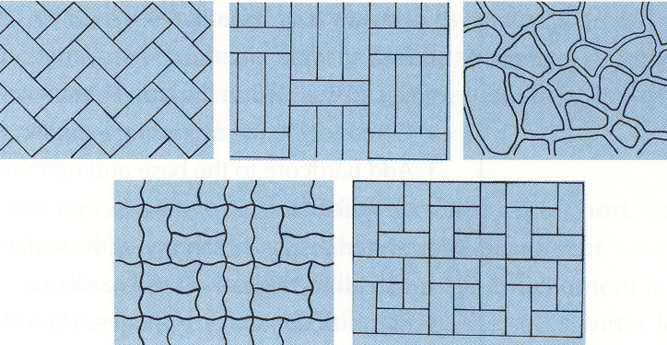
Decide which one has a

a) herringbone pattern

b) squared pattern

c) fishtail pattern

d) cane-weave pattern

e) crazy-paving pattern

Read the description of the laying process below. Match the descriptions with the correct drawing. Make sure you understand the text. If necessary, consult your dictionary.
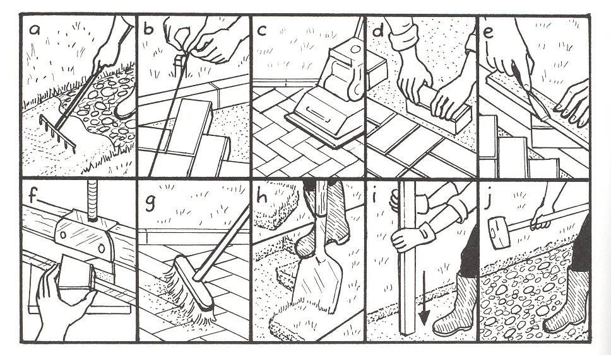
1) Begin by placing string lines along the path area. Then dig out the topsoil within the string lines. ___
2) Compact the base by using a garden roller or a timber post. ___
3) Add hardcore to the base and ram this down with a roller or a sledgehammer. ___
4) Spread a layer of sand onto the surface with a garden rake. This will fill the hollows in the hardcore. ___
5) Place blocks along the edges. Then lay the central blocks in the chosen pattern. ___
6) Set up string lines across the paving as a guide to laying the blocks symmetrically, especially if you are creating a diagonal effect. ___
7) Mark blocks for cutting using a chisel against a straight edge. ___
8) Cut the blocks using a hydraulic stone splitter. Place the block in the jaws along the mark, and pull the handle to cut. ___
9) Vibrate the blocks into the sand bed with a compacting machine. ___
10) Brush sand into the joints between blocks and vibrate the surface again with the compacting machine. ___

