Source Data Mapping Approach to CDMV5.3

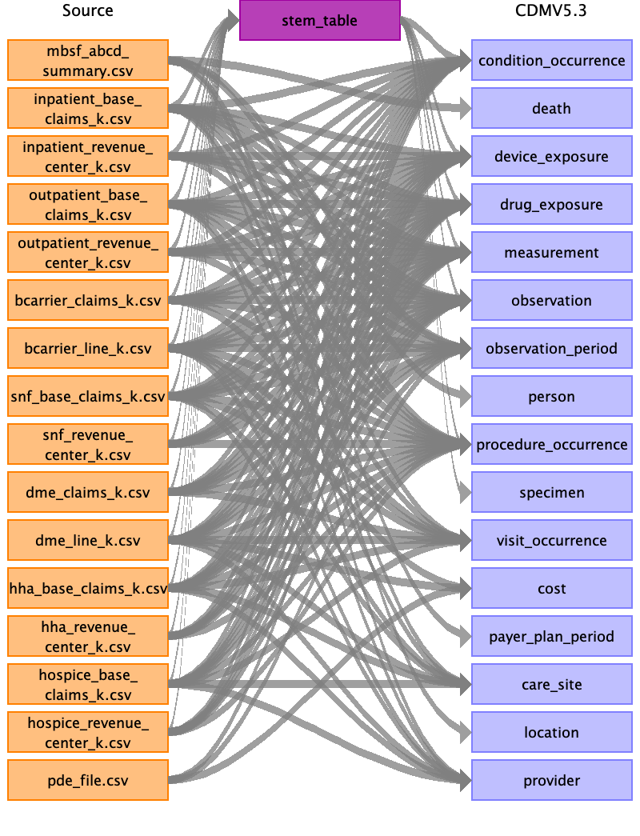

Table name: stem_table

Reading from inpatient_base_claims_k.csv

Generated

|  |  |  |  |
| --- | --- | --- | --- |
| Destination Field | Source Field | Logic | Comment |
| domain_id |  |  |  |
| person_id |  |  |  |
| visit_occurrence_id |  |  |  |
| visit_detail_id |  |  |  |
| provider_id |  |  |  |
| id |  |  |  |
| concept_id |  |  |  |
| source_value |  |  |  |
| source_concept_id |  |  |  |
| type_concept_id |  |  |  |
| start_date |  |  |  |
| start_datetime |  |  |  |
| end_date |  |  |  |
| end_datetime |  |  |  |
| verbatim_end_date |  |  |  |
| days_supply |  |  |  |
| dose_unit_source_value |  |  |  |
| lot_number |  |  |  |
| modifier_concept_id |  |  |  |
| modifier_source_value |  |  |  |
| operator_concept_id |  |  |  |
| quantity |  |  |  |
| range_high |  |  |  |
| range_low |  |  |  |
| refills |  |  |  |
| route_concept_id |  |  |  |
| route_source_value |  |  |  |
| sig |  |  |  |
| stop_reason |  |  |  |
| unique_device_id |  |  |  |
| unit_concept_id |  |  |  |
| unit_source_value |  |  |  |
| value_as_concept_id |  |  |  |
| value_as_number |  |  |  |
| value_as_string |  |  |  |
| value_source_value |  |  |  |
| anatomic_site_concept_id |  |  |  |
| disease_status_concept_id |  |  |  |
| specimen_source_id |  |  |  |
| anatomic_site_source_value |  |  |  |
| disease_status_source_value |  |  |  |
| condition_status_concept_id |  |  |  |
| condition_status_source_value |  |  |  |
| qualifier_concept_id |  |  |  |
| qualifier_source_value |  |  |  |
| measurement_time |  |  |  |

Reading from inpatient_revenue_center_k.csv

Generated

|  |  |  |  |
| --- | --- | --- | --- |
| Destination Field | Source Field | Logic | Comment |
| domain_id |  |  |  |
| person_id |  |  |  |
| visit_occurrence_id |  |  |  |
| visit_detail_id |  |  |  |
| provider_id |  |  |  |
| id |  |  |  |
| concept_id |  |  |  |
| source_value |  |  |  |
| source_concept_id |  |  |  |
| type_concept_id |  |  |  |
| start_date |  |  |  |
| start_datetime |  |  |  |
| end_date |  |  |  |
| end_datetime |  |  |  |
| verbatim_end_date |  |  |  |
| days_supply |  |  |  |
| dose_unit_source_value |  |  |  |
| lot_number |  |  |  |
| modifier_concept_id |  |  |  |
| modifier_source_value |  |  |  |
| operator_concept_id |  |  |  |
| quantity |  |  |  |
| range_high |  |  |  |
| range_low |  |  |  |
| refills |  |  |  |
| route_concept_id |  |  |  |
| route_source_value |  |  |  |
| sig |  |  |  |
| stop_reason |  |  |  |
| unique_device_id |  |  |  |
| unit_concept_id |  |  |  |
| unit_source_value |  |  |  |
| value_as_concept_id |  |  |  |
| value_as_number |  |  |  |
| value_as_string |  |  |  |
| value_source_value |  |  |  |
| anatomic_site_concept_id |  |  |  |
| disease_status_concept_id |  |  |  |
| specimen_source_id |  |  |  |
| anatomic_site_source_value |  |  |  |
| disease_status_source_value |  |  |  |
| condition_status_concept_id |  |  |  |
| condition_status_source_value |  |  |  |
| qualifier_concept_id |  |  |  |
| qualifier_source_value |  |  |  |
| measurement_time |  |  |  |

Reading from outpatient_base_claims_k.csv

Generated

|  |  |  |  |
| --- | --- | --- | --- |
| Destination Field | Source Field | Logic | Comment |
| domain_id |  |  |  |
| person_id |  |  |  |
| visit_occurrence_id |  |  |  |
| visit_detail_id |  |  |  |
| provider_id |  |  |  |
| id |  |  |  |
| concept_id |  |  |  |
| source_value |  |  |  |
| source_concept_id |  |  |  |
| type_concept_id |  |  |  |
| start_date |  |  |  |
| start_datetime |  |  |  |
| end_date |  |  |  |
| end_datetime |  |  |  |
| verbatim_end_date |  |  |  |
| days_supply |  |  |  |
| dose_unit_source_value |  |  |  |
| lot_number |  |  |  |
| modifier_concept_id |  |  |  |
| modifier_source_value |  |  |  |
| operator_concept_id |  |  |  |
| quantity |  |  |  |
| range_high |  |  |  |
| range_low |  |  |  |
| refills |  |  |  |
| route_concept_id |  |  |  |
| route_source_value |  |  |  |
| sig |  |  |  |
| stop_reason |  |  |  |
| unique_device_id |  |  |  |
| unit_concept_id |  |  |  |
| unit_source_value |  |  |  |
| value_as_concept_id |  |  |  |
| value_as_number |  |  |  |
| value_as_string |  |  |  |
| value_source_value |  |  |  |
| anatomic_site_concept_id |  |  |  |
| disease_status_concept_id |  |  |  |
| specimen_source_id |  |  |  |
| anatomic_site_source_value |  |  |  |
| disease_status_source_value |  |  |  |
| condition_status_concept_id |  |  |  |
| condition_status_source_value |  |  |  |
| qualifier_concept_id |  |  |  |
| qualifier_source_value |  |  |  |
| measurement_time |  |  |  |

Reading from snf_base_claims_k.csv

Generated

|  |  |  |  |
| --- | --- | --- | --- |
| Destination Field | Source Field | Logic | Comment |
| domain_id |  |  |  |
| person_id |  |  |  |
| visit_occurrence_id |  |  |  |
| visit_detail_id |  |  |  |
| provider_id |  |  |  |
| id |  |  |  |
| concept_id |  |  |  |
| source_value |  |  |  |
| source_concept_id |  |  |  |
| type_concept_id |  |  |  |
| start_date |  |  |  |
| start_datetime |  |  |  |
| end_date |  |  |  |
| end_datetime |  |  |  |
| verbatim_end_date |  |  |  |
| days_supply |  |  |  |
| dose_unit_source_value |  |  |  |
| lot_number |  |  |  |
| modifier_concept_id |  |  |  |
| modifier_source_value |  |  |  |
| operator_concept_id |  |  |  |
| quantity |  |  |  |
| range_high |  |  |  |
| range_low |  |  |  |
| refills |  |  |  |
| route_concept_id |  |  |  |
| route_source_value |  |  |  |
| sig |  |  |  |
| stop_reason |  |  |  |
| unique_device_id |  |  |  |
| unit_concept_id |  |  |  |
| unit_source_value |  |  |  |
| value_as_concept_id |  |  |  |
| value_as_number |  |  |  |
| value_as_string |  |  |  |
| value_source_value |  |  |  |
| anatomic_site_concept_id |  |  |  |
| disease_status_concept_id |  |  |  |
| specimen_source_id |  |  |  |
| anatomic_site_source_value |  |  |  |
| disease_status_source_value |  |  |  |
| condition_status_concept_id |  |  |  |
| condition_status_source_value |  |  |  |
| qualifier_concept_id |  |  |  |
| qualifier_source_value |  |  |  |
| measurement_time |  |  |  |

Reading from hha_base_claims_k.csv

Generated

|  |  |  |  |
| --- | --- | --- | --- |
| Destination Field | Source Field | Logic | Comment |
| domain_id |  |  |  |
| person_id |  |  |  |
| visit_occurrence_id |  |  |  |
| visit_detail_id |  |  |  |
| provider_id |  |  |  |
| id |  |  |  |
| concept_id |  |  |  |
| source_value |  |  |  |
| source_concept_id |  |  |  |
| type_concept_id |  |  |  |
| start_date |  |  |  |
| start_datetime |  |  |  |
| end_date |  |  |  |
| end_datetime |  |  |  |
| verbatim_end_date |  |  |  |
| days_supply |  |  |  |
| dose_unit_source_value |  |  |  |
| lot_number |  |  |  |
| modifier_concept_id |  |  |  |
| modifier_source_value |  |  |  |
| operator_concept_id |  |  |  |
| quantity |  |  |  |
| range_high |  |  |  |
| range_low |  |  |  |
| refills |  |  |  |
| route_concept_id |  |  |  |
| route_source_value |  |  |  |
| sig |  |  |  |
| stop_reason |  |  |  |
| unique_device_id |  |  |  |
| unit_concept_id |  |  |  |
| unit_source_value |  |  |  |
| value_as_concept_id |  |  |  |
| value_as_number |  |  |  |
| value_as_string |  |  |  |
| value_source_value |  |  |  |
| anatomic_site_concept_id |  |  |  |
| disease_status_concept_id |  |  |  |
| specimen_source_id |  |  |  |
| anatomic_site_source_value |  |  |  |
| disease_status_source_value |  |  |  |
| condition_status_concept_id |  |  |  |
| condition_status_source_value |  |  |  |
| qualifier_concept_id |  |  |  |
| qualifier_source_value |  |  |  |
| measurement_time |  |  |  |

Reading from hospice_base_claims_k.csv

Generated

|  |  |  |  |
| --- | --- | --- | --- |
| Destination Field | Source Field | Logic | Comment |
| domain_id |  |  |  |
| person_id |  |  |  |
| visit_occurrence_id |  |  |  |
| visit_detail_id |  |  |  |
| provider_id |  |  |  |
| id |  |  |  |
| concept_id |  |  |  |
| source_value |  |  |  |
| source_concept_id |  |  |  |
| type_concept_id |  |  |  |
| start_date |  |  |  |
| start_datetime |  |  |  |
| end_date |  |  |  |
| end_datetime |  |  |  |
| verbatim_end_date |  |  |  |
| days_supply |  |  |  |
| dose_unit_source_value |  |  |  |
| lot_number |  |  |  |
| modifier_concept_id |  |  |  |
| modifier_source_value |  |  |  |
| operator_concept_id |  |  |  |
| quantity |  |  |  |
| range_high |  |  |  |
| range_low |  |  |  |
| refills |  |  |  |
| route_concept_id |  |  |  |
| route_source_value |  |  |  |
| sig |  |  |  |
| stop_reason |  |  |  |
| unique_device_id |  |  |  |
| unit_concept_id |  |  |  |
| unit_source_value |  |  |  |
| value_as_concept_id |  |  |  |
| value_as_number |  |  |  |
| value_as_string |  |  |  |
| value_source_value |  |  |  |
| anatomic_site_concept_id |  |  |  |
| disease_status_concept_id |  |  |  |
| specimen_source_id |  |  |  |
| anatomic_site_source_value |  |  |  |
| disease_status_source_value |  |  |  |
| condition_status_concept_id |  |  |  |
| condition_status_source_value |  |  |  |
| qualifier_concept_id |  |  |  |
| qualifier_source_value |  |  |  |
| measurement_time |  |  |  |

Reading from bcarrier_claims_k.csv

Generated

|  |  |  |  |
| --- | --- | --- | --- |
| Destination Field | Source Field | Logic | Comment |
| domain_id |  |  |  |
| person_id |  |  |  |
| visit_occurrence_id |  |  |  |
| visit_detail_id |  |  |  |
| provider_id |  |  |  |
| id |  |  |  |
| concept_id |  |  |  |
| source_value |  |  |  |
| source_concept_id |  |  |  |
| type_concept_id |  |  |  |
| start_date |  |  |  |
| start_datetime |  |  |  |
| end_date |  |  |  |
| end_datetime |  |  |  |
| verbatim_end_date |  |  |  |
| days_supply |  |  |  |
| dose_unit_source_value |  |  |  |
| lot_number |  |  |  |
| modifier_concept_id |  |  |  |
| modifier_source_value |  |  |  |
| operator_concept_id |  |  |  |
| quantity |  |  |  |
| range_high |  |  |  |
| range_low |  |  |  |
| refills |  |  |  |
| route_concept_id |  |  |  |
| route_source_value |  |  |  |
| sig |  |  |  |
| stop_reason |  |  |  |
| unique_device_id |  |  |  |
| unit_concept_id |  |  |  |
| unit_source_value |  |  |  |
| value_as_concept_id |  |  |  |
| value_as_number |  |  |  |
| value_as_string |  |  |  |
| value_source_value |  |  |  |
| anatomic_site_concept_id |  |  |  |
| disease_status_concept_id |  |  |  |
| specimen_source_id |  |  |  |
| anatomic_site_source_value |  |  |  |
| disease_status_source_value |  |  |  |
| condition_status_concept_id |  |  |  |
| condition_status_source_value |  |  |  |
| qualifier_concept_id |  |  |  |
| qualifier_source_value |  |  |  |
| measurement_time |  |  |  |

Reading from dme_claims_k.csv

Generated

|  |  |  |  |
| --- | --- | --- | --- |
| Destination Field | Source Field | Logic | Comment |
| domain_id |  |  |  |
| person_id |  |  |  |
| visit_occurrence_id |  |  |  |
| visit_detail_id |  |  |  |
| provider_id |  |  |  |
| id |  |  |  |
| concept_id |  |  |  |
| source_value |  |  |  |
| source_concept_id |  |  |  |
| type_concept_id |  |  |  |
| start_date |  |  |  |
| start_datetime |  |  |  |
| end_date |  |  |  |
| end_datetime |  |  |  |
| verbatim_end_date |  |  |  |
| days_supply |  |  |  |
| dose_unit_source_value |  |  |  |
| lot_number |  |  |  |
| modifier_concept_id |  |  |  |
| modifier_source_value |  |  |  |
| operator_concept_id |  |  |  |
| quantity |  |  |  |
| range_high |  |  |  |
| range_low |  |  |  |
| refills |  |  |  |
| route_concept_id |  |  |  |
| route_source_value |  |  |  |
| sig |  |  |  |
| stop_reason |  |  |  |
| unique_device_id |  |  |  |
| unit_concept_id |  |  |  |
| unit_source_value |  |  |  |
| value_as_concept_id |  |  |  |
| value_as_number |  |  |  |
| value_as_string |  |  |  |
| value_source_value |  |  |  |
| anatomic_site_concept_id |  |  |  |
| disease_status_concept_id |  |  |  |
| specimen_source_id |  |  |  |
| anatomic_site_source_value |  |  |  |
| disease_status_source_value |  |  |  |
| condition_status_concept_id |  |  |  |
| condition_status_source_value |  |  |  |
| qualifier_concept_id |  |  |  |
| qualifier_source_value |  |  |  |
| measurement_time |  |  |  |

Reading from bcarrier_line_k.csv

Generated

|  |  |  |  |
| --- | --- | --- | --- |
| Destination Field | Source Field | Logic | Comment |
| domain_id |  |  |  |
| person_id |  |  |  |
| visit_occurrence_id |  |  |  |
| visit_detail_id |  |  |  |
| provider_id |  |  |  |
| id |  |  |  |
| concept_id |  |  |  |
| source_value |  |  |  |
| source_concept_id |  |  |  |
| type_concept_id |  |  |  |
| start_date |  |  |  |
| start_datetime |  |  |  |
| end_date |  |  |  |
| end_datetime |  |  |  |
| verbatim_end_date |  |  |  |
| days_supply |  |  |  |
| dose_unit_source_value |  |  |  |
| lot_number |  |  |  |
| modifier_concept_id |  |  |  |
| modifier_source_value |  |  |  |
| operator_concept_id |  |  |  |
| quantity |  |  |  |
| range_high |  |  |  |
| range_low |  |  |  |
| refills |  |  |  |
| route_concept_id |  |  |  |
| route_source_value |  |  |  |
| sig |  |  |  |
| stop_reason |  |  |  |
| unique_device_id |  |  |  |
| unit_concept_id |  |  |  |
| unit_source_value |  |  |  |
| value_as_concept_id |  |  |  |
| value_as_number |  |  |  |
| value_as_string |  |  |  |
| value_source_value |  |  |  |
| anatomic_site_concept_id |  |  |  |
| disease_status_concept_id |  |  |  |
| specimen_source_id |  |  |  |
| anatomic_site_source_value |  |  |  |
| disease_status_source_value |  |  |  |
| condition_status_concept_id |  |  |  |
| condition_status_source_value |  |  |  |
| qualifier_concept_id |  |  |  |
| qualifier_source_value |  |  |  |
| measurement_time |  |  |  |

Reading from dme_line_k.csv

Generated

|  |  |  |  |
| --- | --- | --- | --- |
| Destination Field | Source Field | Logic | Comment |
| domain_id |  |  |  |
| person_id |  |  |  |
| visit_occurrence_id |  |  |  |
| visit_detail_id |  |  |  |
| provider_id |  |  |  |
| id |  |  |  |
| concept_id |  |  |  |
| source_value |  |  |  |
| source_concept_id |  |  |  |
| type_concept_id |  |  |  |
| start_date |  |  |  |
| start_datetime |  |  |  |
| end_date |  |  |  |
| end_datetime |  |  |  |
| verbatim_end_date |  |  |  |
| days_supply |  |  |  |
| dose_unit_source_value |  |  |  |
| lot_number |  |  |  |
| modifier_concept_id |  |  |  |
| modifier_source_value |  |  |  |
| operator_concept_id |  |  |  |
| quantity |  |  |  |
| range_high |  |  |  |
| range_low |  |  |  |
| refills |  |  |  |
| route_concept_id |  |  |  |
| route_source_value |  |  |  |
| sig |  |  |  |
| stop_reason |  |  |  |
| unique_device_id |  |  |  |
| unit_concept_id |  |  |  |
| unit_source_value |  |  |  |
| value_as_concept_id |  |  |  |
| value_as_number |  |  |  |
| value_as_string |  |  |  |
| value_source_value |  |  |  |
| anatomic_site_concept_id |  |  |  |
| disease_status_concept_id |  |  |  |
| specimen_source_id |  |  |  |
| anatomic_site_source_value |  |  |  |
| disease_status_source_value |  |  |  |
| condition_status_concept_id |  |  |  |
| condition_status_source_value |  |  |  |
| qualifier_concept_id |  |  |  |
| qualifier_source_value |  |  |  |
| measurement_time |  |  |  |

Reading from outpatient_revenue_center_k.csv

Generated

|  |  |  |  |
| --- | --- | --- | --- |
| Destination Field | Source Field | Logic | Comment |
| domain_id |  |  |  |
| person_id |  |  |  |
| visit_occurrence_id |  |  |  |
| visit_detail_id |  |  |  |
| provider_id |  |  |  |
| id |  |  |  |
| concept_id |  |  |  |
| source_value |  |  |  |
| source_concept_id |  |  |  |
| type_concept_id |  |  |  |
| start_date |  |  |  |
| start_datetime |  |  |  |
| end_date |  |  |  |
| end_datetime |  |  |  |
| verbatim_end_date |  |  |  |
| days_supply |  |  |  |
| dose_unit_source_value |  |  |  |
| lot_number |  |  |  |
| modifier_concept_id |  |  |  |
| modifier_source_value |  |  |  |
| operator_concept_id |  |  |  |
| quantity |  |  |  |
| range_high |  |  |  |
| range_low |  |  |  |
| refills |  |  |  |
| route_concept_id |  |  |  |
| route_source_value |  |  |  |
| sig |  |  |  |
| stop_reason |  |  |  |
| unique_device_id |  |  |  |
| unit_concept_id |  |  |  |
| unit_source_value |  |  |  |
| value_as_concept_id |  |  |  |
| value_as_number |  |  |  |
| value_as_string |  |  |  |
| value_source_value |  |  |  |
| anatomic_site_concept_id |  |  |  |
| disease_status_concept_id |  |  |  |
| specimen_source_id |  |  |  |
| anatomic_site_source_value |  |  |  |
| disease_status_source_value |  |  |  |
| condition_status_concept_id |  |  |  |
| condition_status_source_value |  |  |  |
| qualifier_concept_id |  |  |  |
| qualifier_source_value |  |  |  |
| measurement_time |  |  |  |

Reading from snf_revenue_center_k.csv

Generated

|  |  |  |  |
| --- | --- | --- | --- |
| Destination Field | Source Field | Logic | Comment |
| domain_id |  |  |  |
| person_id |  |  |  |
| visit_occurrence_id |  |  |  |
| visit_detail_id |  |  |  |
| provider_id |  |  |  |
| id |  |  |  |
| concept_id |  |  |  |
| source_value |  |  |  |
| source_concept_id |  |  |  |
| type_concept_id |  |  |  |
| start_date |  |  |  |
| start_datetime |  |  |  |
| end_date |  |  |  |
| end_datetime |  |  |  |
| verbatim_end_date |  |  |  |
| days_supply |  |  |  |
| dose_unit_source_value |  |  |  |
| lot_number |  |  |  |
| modifier_concept_id |  |  |  |
| modifier_source_value |  |  |  |
| operator_concept_id |  |  |  |
| quantity |  |  |  |
| range_high |  |  |  |
| range_low |  |  |  |
| refills |  |  |  |
| route_concept_id |  |  |  |
| route_source_value |  |  |  |
| sig |  |  |  |
| stop_reason |  |  |  |
| unique_device_id |  |  |  |
| unit_concept_id |  |  |  |
| unit_source_value |  |  |  |
| value_as_concept_id |  |  |  |
| value_as_number |  |  |  |
| value_as_string |  |  |  |
| value_source_value |  |  |  |
| anatomic_site_concept_id |  |  |  |
| disease_status_concept_id |  |  |  |
| specimen_source_id |  |  |  |
| anatomic_site_source_value |  |  |  |
| disease_status_source_value |  |  |  |
| condition_status_concept_id |  |  |  |
| condition_status_source_value |  |  |  |
| qualifier_concept_id |  |  |  |
| qualifier_source_value |  |  |  |
| measurement_time |  |  |  |

Reading from hha_revenue_center_k.csv

Generated

|  |  |  |  |
| --- | --- | --- | --- |
| Destination Field | Source Field | Logic | Comment |
| domain_id |  |  |  |
| person_id |  |  |  |
| visit_occurrence_id |  |  |  |
| visit_detail_id |  |  |  |
| provider_id |  |  |  |
| id |  |  |  |
| concept_id |  |  |  |
| source_value |  |  |  |
| source_concept_id |  |  |  |
| type_concept_id |  |  |  |
| start_date |  |  |  |
| start_datetime |  |  |  |
| end_date |  |  |  |
| end_datetime |  |  |  |
| verbatim_end_date |  |  |  |
| days_supply |  |  |  |
| dose_unit_source_value |  |  |  |
| lot_number |  |  |  |
| modifier_concept_id |  |  |  |
| modifier_source_value |  |  |  |
| operator_concept_id |  |  |  |
| quantity |  |  |  |
| range_high |  |  |  |
| range_low |  |  |  |
| refills |  |  |  |
| route_concept_id |  |  |  |
| route_source_value |  |  |  |
| sig |  |  |  |
| stop_reason |  |  |  |
| unique_device_id |  |  |  |
| unit_concept_id |  |  |  |
| unit_source_value |  |  |  |
| value_as_concept_id |  |  |  |
| value_as_number |  |  |  |
| value_as_string |  |  |  |
| value_source_value |  |  |  |
| anatomic_site_concept_id |  |  |  |
| disease_status_concept_id |  |  |  |
| specimen_source_id |  |  |  |
| anatomic_site_source_value |  |  |  |
| disease_status_source_value |  |  |  |
| condition_status_concept_id |  |  |  |
| condition_status_source_value |  |  |  |
| qualifier_concept_id |  |  |  |
| qualifier_source_value |  |  |  |
| measurement_time |  |  |  |

Reading from hospice_revenue_center_k.csv

Generated

|  |  |  |  |
| --- | --- | --- | --- |
| Destination Field | Source Field | Logic | Comment |
| domain_id |  |  |  |
| person_id |  |  |  |
| visit_occurrence_id |  |  |  |
| visit_detail_id |  |  |  |
| provider_id |  |  |  |
| id |  |  |  |
| concept_id |  |  |  |
| source_value |  |  |  |
| source_concept_id |  |  |  |
| type_concept_id |  |  |  |
| start_date |  |  |  |
| start_datetime |  |  |  |
| end_date |  |  |  |
| end_datetime |  |  |  |
| verbatim_end_date |  |  |  |
| days_supply |  |  |  |
| dose_unit_source_value |  |  |  |
| lot_number |  |  |  |
| modifier_concept_id |  |  |  |
| modifier_source_value |  |  |  |
| operator_concept_id |  |  |  |
| quantity |  |  |  |
| range_high |  |  |  |
| range_low |  |  |  |
| refills |  |  |  |
| route_concept_id |  |  |  |
| route_source_value |  |  |  |
| sig |  |  |  |
| stop_reason |  |  |  |
| unique_device_id |  |  |  |
| unit_concept_id |  |  |  |
| unit_source_value |  |  |  |
| value_as_concept_id |  |  |  |
| value_as_number |  |  |  |
| value_as_string |  |  |  |
| value_source_value |  |  |  |
| anatomic_site_concept_id |  |  |  |
| disease_status_concept_id |  |  |  |
| specimen_source_id |  |  |  |
| anatomic_site_source_value |  |  |  |
| disease_status_source_value |  |  |  |
| condition_status_concept_id |  |  |  |
| condition_status_source_value |  |  |  |
| qualifier_concept_id |  |  |  |
| qualifier_source_value |  |  |  |
| measurement_time |  |  |  |

Table name: condition_occurrence

Reading from inpatient_base_claims_k.csv

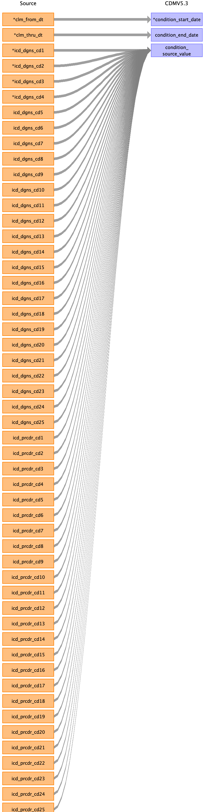

|  |  |  |  |
| --- | --- | --- | --- |
| Destination Field | Source Field | Logic | Comment |
| condition_occurrence_id |  |  | Add when new and unique condition exists. |
| person_id |  |  | Linked to PERSON table |
| condition_concept_id |  |  | OMOP CONCEPT MAPPING |
| condition_start_date | clm_from_dt |  |  |
| condition_start_datetime |  |  |  |
| condition_end_date | clm_thru_dt |  |  |
| condition_end_datetime |  |  |  |
| condition_type_concept_id |  |  | 32853 Inpatient claim  32859 Outpatient claim  32810 Carrier: Claim  32844 SNF: Facility claim  32810 DME: Claim  32844 HHA: Facility claim  32844 Hospice: Facility claim |
| stop_reason |  |  |  |
| provider_id |  |  | Linked to PROVIDER table |
| visit_occurrence_id |  |  | Linked to VISIT_OCCURRENCE table |
| visit_detail_id |  |  |  |
| condition_source_value | icd_dgns_cd1  icd_dgns_cd2  icd_dgns_cd3  icd_dgns_cd4  icd_dgns_cd5  icd_dgns_cd6  icd_dgns_cd7  icd_dgns_cd8  icd_dgns_cd9  icd_dgns_cd10  icd_dgns_cd11  icd_dgns_cd12  icd_dgns_cd13  icd_dgns_cd14  icd_dgns_cd15  icd_dgns_cd16  icd_dgns_cd17  icd_dgns_cd18  icd_dgns_cd19  icd_dgns_cd20  icd_dgns_cd21  icd_dgns_cd22  icd_dgns_cd23  icd_dgns_cd24  icd_dgns_cd25  icd_prcdr_cd1  icd_prcdr_cd2  icd_prcdr_cd3  icd_prcdr_cd4  icd_prcdr_cd5  icd_prcdr_cd6  icd_prcdr_cd7  icd_prcdr_cd8  icd_prcdr_cd9  icd_prcdr_cd10  icd_prcdr_cd11  icd_prcdr_cd12  icd_prcdr_cd13  icd_prcdr_cd14  icd_prcdr_cd15  icd_prcdr_cd16  icd_prcdr_cd17  icd_prcdr_cd18  icd_prcdr_cd19  icd_prcdr_cd20  icd_prcdr_cd21  icd_prcdr_cd22  icd_prcdr_cd23  icd_prcdr_cd24  icd_prcdr_cd25 |  |  |
| condition_source_concept_id |  |  | OMOP CONCEPT MAPPING |
| condition_status_source_value |  |  |  |
| condition_status_concept_id |  |  |  |

Reading from inpatient_revenue_center_k.csv

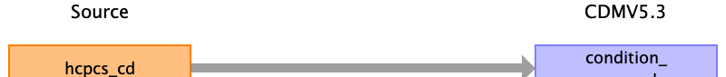

|  |  |  |  |
| --- | --- | --- | --- |
| Destination Field | Source Field | Logic | Comment |
| condition_occurrence_id |  |  | Add when new and unique condition exists. |
| person_id |  |  | Linked to PERSON table |
| condition_concept_id |  |  | OMOP CONCEPT MAPPING |
| condition_start_date |  |  |  |
| condition_start_datetime |  |  |  |
| condition_end_date |  |  |  |
| condition_end_datetime |  |  |  |
| condition_type_concept_id |  |  | 32853 Inpatient claim  32859 Outpatient claim  32810 Carrier: Claim  32844 SNF: Facility claim  32810 DME: Claim  32844 HHA: Facility claim  32844 Hospice: Facility claim |
| stop_reason |  |  |  |
| provider_id |  |  | Linked to PROVIDER table |
| visit_occurrence_id |  |  | Linked to VISIT_OCCURRENCE table |
| visit_detail_id |  |  |  |
| condition_source_value | hcpcs_cd |  |  |
| condition_source_concept_id |  |  | OMOP CONCEPT MAPPING |
| condition_status_source_value |  |  |  |
| condition_status_concept_id |  |  |  |

Reading from outpatient_base_claims_k.csv

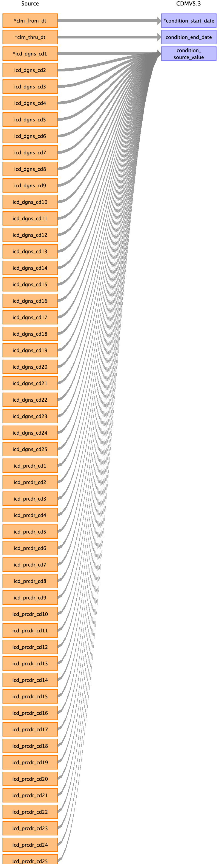

|  |  |  |  |
| --- | --- | --- | --- |
| Destination Field | Source Field | Logic | Comment |
| condition_occurrence_id |  |  | Add when new and unique condition exists. |
| person_id |  |  | Linked to PERSON table |
| condition_concept_id |  |  | OMOP CONCEPT MAPPING |
| condition_start_date | clm_from_dt |  |  |
| condition_start_datetime |  |  |  |
| condition_end_date | clm_thru_dt |  |  |
| condition_end_datetime |  |  |  |
| condition_type_concept_id |  |  | 32853 Inpatient claim  32859 Outpatient claim  32810 Carrier: Claim  32844 SNF: Facility claim  32810 DME: Claim  32844 HHA: Facility claim  32844 Hospice: Facility claim |
| stop_reason |  |  |  |
| provider_id |  |  | Linked to PROVIDER table |
| visit_occurrence_id |  |  | Linked to VISIT_OCCURRENCE table |
| visit_detail_id |  |  |  |
| condition_source_value | icd_dgns_cd1  icd_dgns_cd2  icd_dgns_cd3  icd_dgns_cd4  icd_dgns_cd5  icd_dgns_cd6  icd_dgns_cd7  icd_dgns_cd8  icd_dgns_cd9  icd_dgns_cd10  icd_dgns_cd11  icd_dgns_cd12  icd_dgns_cd13  icd_dgns_cd14  icd_dgns_cd15  icd_dgns_cd16  icd_dgns_cd17  icd_dgns_cd18  icd_dgns_cd19  icd_dgns_cd20  icd_dgns_cd21  icd_dgns_cd22  icd_dgns_cd23  icd_dgns_cd24  icd_dgns_cd25  icd_prcdr_cd1  icd_prcdr_cd2  icd_prcdr_cd3  icd_prcdr_cd4  icd_prcdr_cd5  icd_prcdr_cd6  icd_prcdr_cd7  icd_prcdr_cd8  icd_prcdr_cd9  icd_prcdr_cd10  icd_prcdr_cd11  icd_prcdr_cd12  icd_prcdr_cd13  icd_prcdr_cd14  icd_prcdr_cd15  icd_prcdr_cd16  icd_prcdr_cd17  icd_prcdr_cd18  icd_prcdr_cd19  icd_prcdr_cd20  icd_prcdr_cd21  icd_prcdr_cd22  icd_prcdr_cd23  icd_prcdr_cd24  icd_prcdr_cd25 |  |  |
| condition_source_concept_id |  |  | OMOP CONCEPT MAPPING |
| condition_status_source_value |  |  |  |
| condition_status_concept_id |  |  |  |

Reading from outpatient_revenue_center_k.csv



|  |  |  |  |
| --- | --- | --- | --- |
| Destination Field | Source Field | Logic | Comment |
| condition_occurrence_id |  |  | Add when new and unique condition exists. |
| person_id |  |  | Linked to PERSON table |
| condition_concept_id |  |  | OMOP CONCEPT MAPPING |
| condition_start_date |  |  |  |
| condition_start_datetime |  |  |  |
| condition_end_date |  |  |  |
| condition_end_datetime |  |  |  |
| condition_type_concept_id |  |  | 32853 Inpatient claim  32859 Outpatient claim  32810 Carrier: Claim  32844 SNF: Facility claim  32810 DME: Claim  32844 HHA: Facility claim  32844 Hospice: Facility claim |
| stop_reason |  |  |  |
| provider_id |  |  | Linked to PROVIDER table |
| visit_occurrence_id |  |  | Linked to VISIT_OCCURRENCE table |
| visit_detail_id |  |  |  |
| condition_source_value | hcpcs_cd |  |  |
| condition_source_concept_id |  |  | OMOP CONCEPT MAPPING |
| condition_status_source_value |  |  |  |
| condition_status_concept_id |  |  |  |

Reading from bcarrier_claims_k.csv

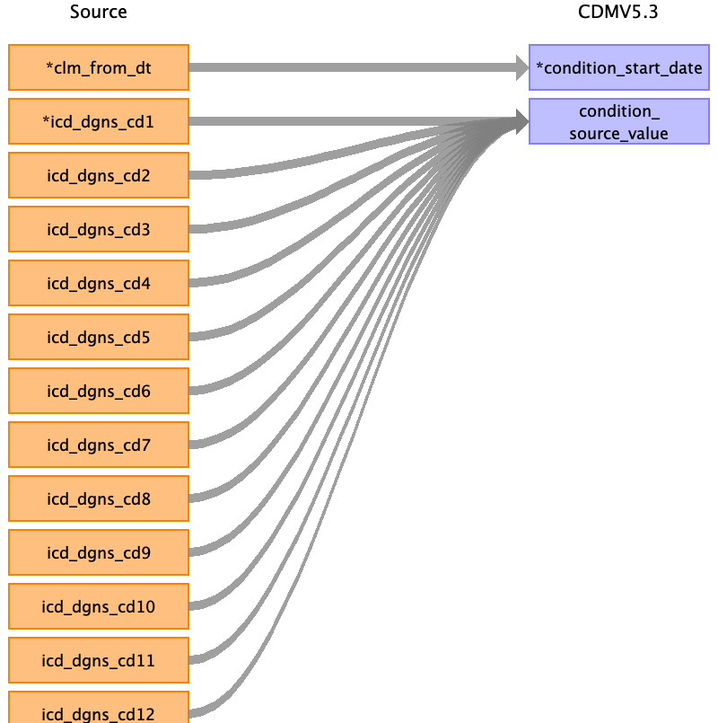

|  |  |  |  |
| --- | --- | --- | --- |
| Destination Field | Source Field | Logic | Comment |
| condition_occurrence_id |  |  | Add when new and unique condition exists. |
| person_id |  |  | Linked to PERSON table |
| condition_concept_id |  |  | OMOP CONCEPT MAPPING |
| condition_start_date | clm_from_dt |  |  |
| condition_start_datetime |  |  |  |
| condition_end_date |  |  |  |
| condition_end_datetime |  |  |  |
| condition_type_concept_id |  |  | 32853 Inpatient claim  32859 Outpatient claim  32810 Carrier: Claim  32844 SNF: Facility claim  32810 DME: Claim  32844 HHA: Facility claim  32844 Hospice: Facility claim |
| stop_reason |  |  |  |
| provider_id |  |  | Linked to PROVIDER table |
| visit_occurrence_id |  |  | Linked to VISIT_OCCURRENCE table |
| visit_detail_id |  |  |  |
| condition_source_value | icd_dgns_cd1  icd_dgns_cd2  icd_dgns_cd3  icd_dgns_cd4  icd_dgns_cd5  icd_dgns_cd6  icd_dgns_cd7  icd_dgns_cd8  icd_dgns_cd9  icd_dgns_cd10  icd_dgns_cd11  icd_dgns_cd12 |  |  |
| condition_source_concept_id |  |  | OMOP CONCEPT MAPPING |
| condition_status_source_value |  |  |  |
| condition_status_concept_id |  |  |  |

Reading from bcarrier_line_k.csv

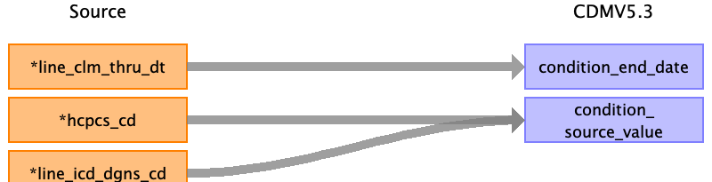

|  |  |  |  |
| --- | --- | --- | --- |
| Destination Field | Source Field | Logic | Comment |
| condition_occurrence_id |  |  | Add when new and unique condition exists. |
| person_id |  |  | Linked to PERSON table |
| condition_concept_id |  |  | OMOP CONCEPT MAPPING |
| condition_start_date |  |  |  |
| condition_start_datetime |  |  |  |
| condition_end_date | line_clm_thru_dt |  |  |
| condition_end_datetime |  |  |  |
| condition_type_concept_id |  |  | 32853 Inpatient claim  32859 Outpatient claim  32810 Carrier: Claim  32844 SNF: Facility claim  32810 DME: Claim  32844 HHA: Facility claim  32844 Hospice: Facility claim |
| stop_reason |  |  |  |
| provider_id |  |  | Linked to PROVIDER table |
| visit_occurrence_id |  |  | Linked to VISIT_OCCURRENCE table |
| visit_detail_id |  |  |  |
| condition_source_value | hcpcs_cd  line_icd_dgns_cd |  |  |
| condition_source_concept_id |  |  | OMOP CONCEPT MAPPING |
| condition_status_source_value |  |  |  |
| condition_status_concept_id |  |  |  |

Reading from snf_base_claims_k.csv

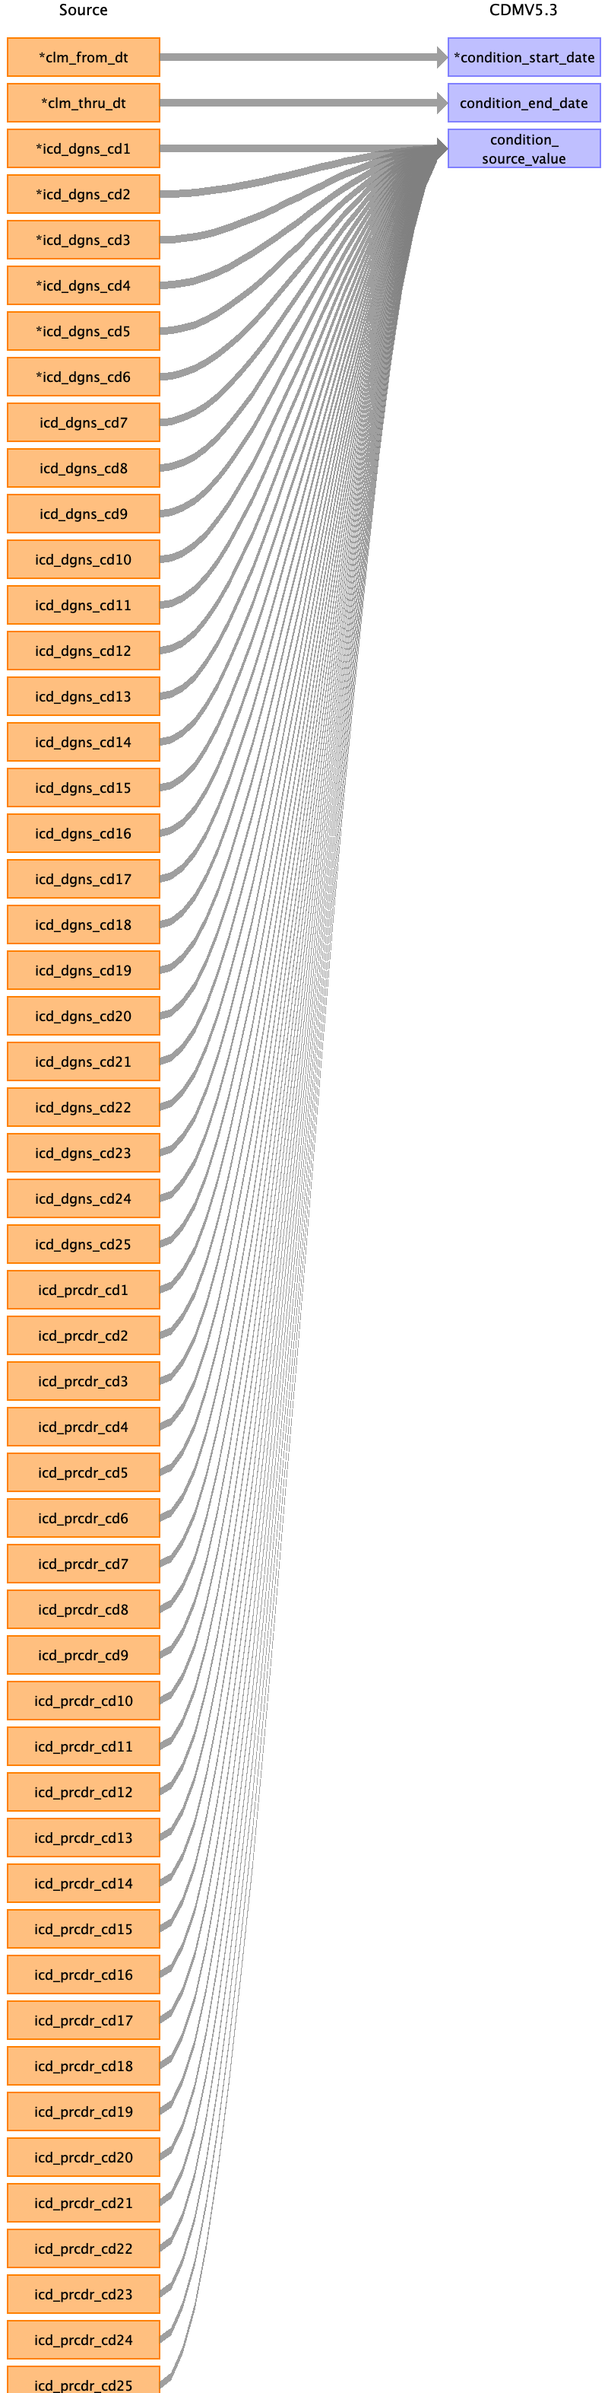

|  |  |  |  |
| --- | --- | --- | --- |
| Destination Field | Source Field | Logic | Comment |
| condition_occurrence_id |  |  | Add when new and unique condition exists. |
| person_id |  |  | Linked to PERSON table |
| condition_concept_id |  |  | OMOP CONCEPT MAPPING |
| condition_start_date | clm_from_dt |  |  |
| condition_start_datetime |  |  |  |
| condition_end_date | clm_thru_dt |  |  |
| condition_end_datetime |  |  |  |
| condition_type_concept_id |  |  | 32853 Inpatient claim  32859 Outpatient claim  32810 Carrier: Claim  32844 SNF: Facility claim  32810 DME: Claim  32844 HHA: Facility claim  32844 Hospice: Facility claim |
| stop_reason |  |  |  |
| provider_id |  |  | Linked to PROVIDER table |
| visit_occurrence_id |  |  | Linked to VISIT_OCCURRENCE table |
| visit_detail_id |  |  |  |
| condition_source_value | icd_dgns_cd1  icd_dgns_cd2  icd_dgns_cd3  icd_dgns_cd4  icd_dgns_cd5  icd_dgns_cd6  icd_dgns_cd7  icd_dgns_cd8  icd_dgns_cd9  icd_dgns_cd10  icd_dgns_cd11  icd_dgns_cd12  icd_dgns_cd13  icd_dgns_cd14  icd_dgns_cd15  icd_dgns_cd16  icd_dgns_cd17  icd_dgns_cd18  icd_dgns_cd19  icd_dgns_cd20  icd_dgns_cd21  icd_dgns_cd22  icd_dgns_cd23  icd_dgns_cd24  icd_dgns_cd25  icd_prcdr_cd1  icd_prcdr_cd2  icd_prcdr_cd3  icd_prcdr_cd4  icd_prcdr_cd5  icd_prcdr_cd6  icd_prcdr_cd7  icd_prcdr_cd8  icd_prcdr_cd9  icd_prcdr_cd10  icd_prcdr_cd11  icd_prcdr_cd12  icd_prcdr_cd13  icd_prcdr_cd14  icd_prcdr_cd15  icd_prcdr_cd16  icd_prcdr_cd17  icd_prcdr_cd18  icd_prcdr_cd19  icd_prcdr_cd20  icd_prcdr_cd21  icd_prcdr_cd22  icd_prcdr_cd23  icd_prcdr_cd24  icd_prcdr_cd25 |  |  |
| condition_source_concept_id |  |  | OMOP CONCEPT MAPPING |
| condition_status_source_value |  |  |  |
| condition_status_concept_id |  |  |  |

Reading from snf_revenue_center_k.csv



|  |  |  |  |
| --- | --- | --- | --- |
| Destination Field | Source Field | Logic | Comment |
| condition_occurrence_id |  |  | Add when new and unique condition exists. |
| person_id |  |  | Linked to PERSON table |
| condition_concept_id |  |  | OMOP CONCEPT MAPPING |
| condition_start_date |  |  |  |
| condition_start_datetime |  |  |  |
| condition_end_date |  |  |  |
| condition_end_datetime |  |  |  |
| condition_type_concept_id |  |  | 32853 Inpatient claim  32859 Outpatient claim  32810 Carrier: Claim  32844 SNF: Facility claim  32810 DME: Claim  32844 HHA: Facility claim  32844 Hospice: Facility claim |
| stop_reason |  |  |  |
| provider_id |  |  | Linked to PROVIDER table |
| visit_occurrence_id |  |  | Linked to VISIT_OCCURRENCE table |
| visit_detail_id |  |  |  |
| condition_source_value | hcpcs_cd |  |  |
| condition_source_concept_id |  |  | OMOP CONCEPT MAPPING |
| condition_status_source_value |  |  |  |
| condition_status_concept_id |  |  |  |

Reading from dme_claims_k.csv



|  |  |  |  |
| --- | --- | --- | --- |
| Destination Field | Source Field | Logic | Comment |
| condition_occurrence_id |  |  | Add when new and unique condition exists. |
| person_id |  |  | Linked to PERSON table |
| condition_concept_id |  |  | OMOP CONCEPT MAPPING |
| condition_start_date | clm_from_dt |  |  |
| condition_start_datetime |  |  |  |
| condition_end_date |  |  |  |
| condition_end_datetime |  |  |  |
| condition_type_concept_id |  |  | 32853 Inpatient claim  32859 Outpatient claim  32810 Carrier: Claim  32844 SNF: Facility claim  32810 DME: Claim  32844 HHA: Facility claim  32844 Hospice: Facility claim |
| stop_reason |  |  |  |
| provider_id |  |  | Linked to PROVIDER table |
| visit_occurrence_id |  |  | Linked to VISIT_OCCURRENCE table |
| visit_detail_id |  |  |  |
| condition_source_value | icd_dgns_cd1  icd_dgns_cd2  icd_dgns_cd3  icd_dgns_cd4  icd_dgns_cd5  icd_dgns_cd6  icd_dgns_cd7  icd_dgns_cd8  icd_dgns_cd9  icd_dgns_cd10  icd_dgns_cd11  icd_dgns_cd12 |  |  |
| condition_source_concept_id |  |  | OMOP CONCEPT MAPPING |
| condition_status_source_value |  |  |  |
| condition_status_concept_id |  |  |  |

Reading from dme_line_k.csv



|  |  |  |  |
| --- | --- | --- | --- |
| Destination Field | Source Field | Logic | Comment |
| condition_occurrence_id |  |  | Add when new and unique condition exists. |
| person_id |  |  | Linked to PERSON table |
| condition_concept_id |  |  | OMOP CONCEPT MAPPING |
| condition_start_date |  |  |  |
| condition_start_datetime |  |  |  |
| condition_end_date | line_clm_thru_dt |  |  |
| condition_end_datetime |  |  |  |
| condition_type_concept_id |  |  | 32853 Inpatient claim  32859 Outpatient claim  32810 Carrier: Claim  32844 SNF: Facility claim  32810 DME: Claim  32844 HHA: Facility claim  32844 Hospice: Facility claim |
| stop_reason |  |  |  |
| provider_id |  |  | Linked to PROVIDER table |
| visit_occurrence_id |  |  | Linked to VISIT_OCCURRENCE table |
| visit_detail_id |  |  |  |
| condition_source_value | hcpcs_cd  line_icd_dgns_cd |  |  |
| condition_source_concept_id |  |  | OMOP CONCEPT MAPPING |
| condition_status_source_value |  |  |  |
| condition_status_concept_id |  |  |  |

Reading from hha_base_claims_k.csv

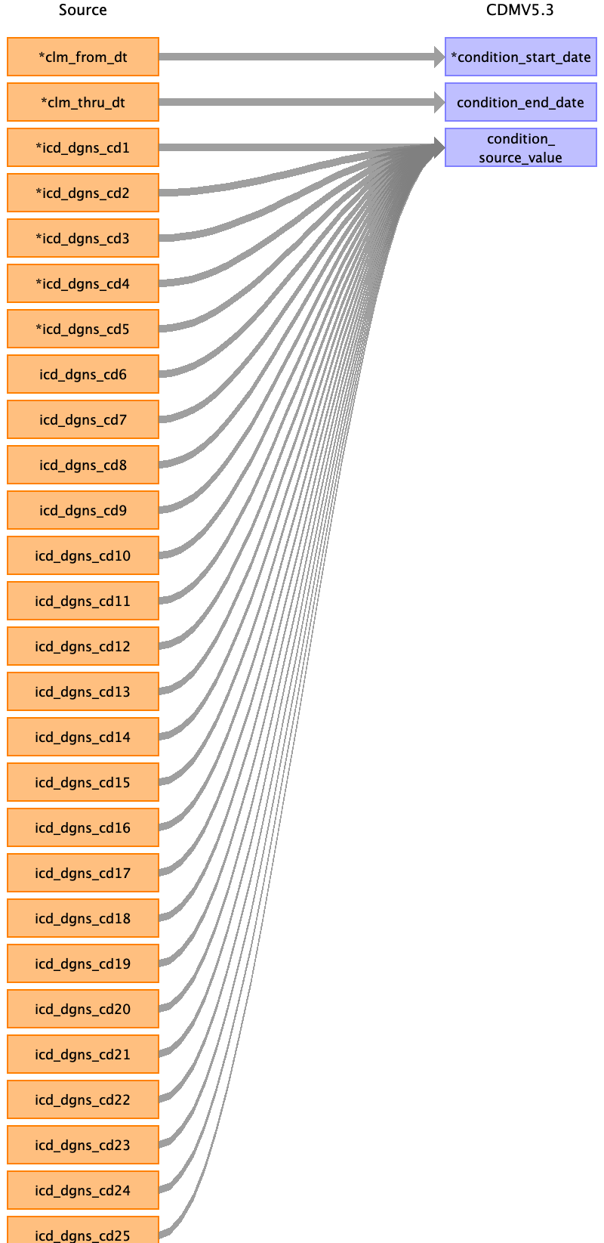

|  |  |  |  |
| --- | --- | --- | --- |
| Destination Field | Source Field | Logic | Comment |
| condition_occurrence_id |  |  | Add when new and unique condition exists. |
| person_id |  |  | Linked to PERSON table |
| condition_concept_id |  |  | OMOP CONCEPT MAPPING |
| condition_start_date | clm_from_dt |  |  |
| condition_start_datetime |  |  |  |
| condition_end_date | clm_thru_dt |  |  |
| condition_end_datetime |  |  |  |
| condition_type_concept_id |  |  | 32853 Inpatient claim  32859 Outpatient claim  32810 Carrier: Claim  32844 SNF: Facility claim  32810 DME: Claim  32844 HHA: Facility claim  32844 Hospice: Facility claim |
| stop_reason |  |  |  |
| provider_id |  |  | Linked to PROVIDER table |
| visit_occurrence_id |  |  | Linked to VISIT_OCCURRENCE table |
| visit_detail_id |  |  |  |
| condition_source_value | icd_dgns_cd1  icd_dgns_cd2  icd_dgns_cd3  icd_dgns_cd4  icd_dgns_cd5  icd_dgns_cd6  icd_dgns_cd7  icd_dgns_cd8  icd_dgns_cd9  icd_dgns_cd10  icd_dgns_cd11  icd_dgns_cd12  icd_dgns_cd13  icd_dgns_cd14  icd_dgns_cd15  icd_dgns_cd16  icd_dgns_cd17  icd_dgns_cd18  icd_dgns_cd19  icd_dgns_cd20  icd_dgns_cd21  icd_dgns_cd22  icd_dgns_cd23  icd_dgns_cd24  icd_dgns_cd25 |  |  |
| condition_source_concept_id |  |  | OMOP CONCEPT MAPPING |
| condition_status_source_value |  |  |  |
| condition_status_concept_id |  |  |  |

Reading from hha_revenue_center_k.csv



|  |  |  |  |
| --- | --- | --- | --- |
| Destination Field | Source Field | Logic | Comment |
| condition_occurrence_id |  |  | Add when new and unique condition exists. |
| person_id |  |  | Linked to PERSON table |
| condition_concept_id |  |  | OMOP CONCEPT MAPPING |
| condition_start_date |  |  |  |
| condition_start_datetime |  |  |  |
| condition_end_date |  |  |  |
| condition_end_datetime |  |  |  |
| condition_type_concept_id |  |  | 32853 Inpatient claim  32859 Outpatient claim  32810 Carrier: Claim  32844 SNF: Facility claim  32810 DME: Claim  32844 HHA: Facility claim  32844 Hospice: Facility claim |
| stop_reason |  |  |  |
| provider_id |  |  | Linked to PROVIDER table |
| visit_occurrence_id |  |  | Linked to VISIT_OCCURRENCE table |
| visit_detail_id |  |  |  |
| condition_source_value | hcpcs_cd |  |  |
| condition_source_concept_id |  |  | OMOP CONCEPT MAPPING |
| condition_status_source_value |  |  |  |
| condition_status_concept_id |  |  |  |

Reading from hospice_base_claims_k.csv

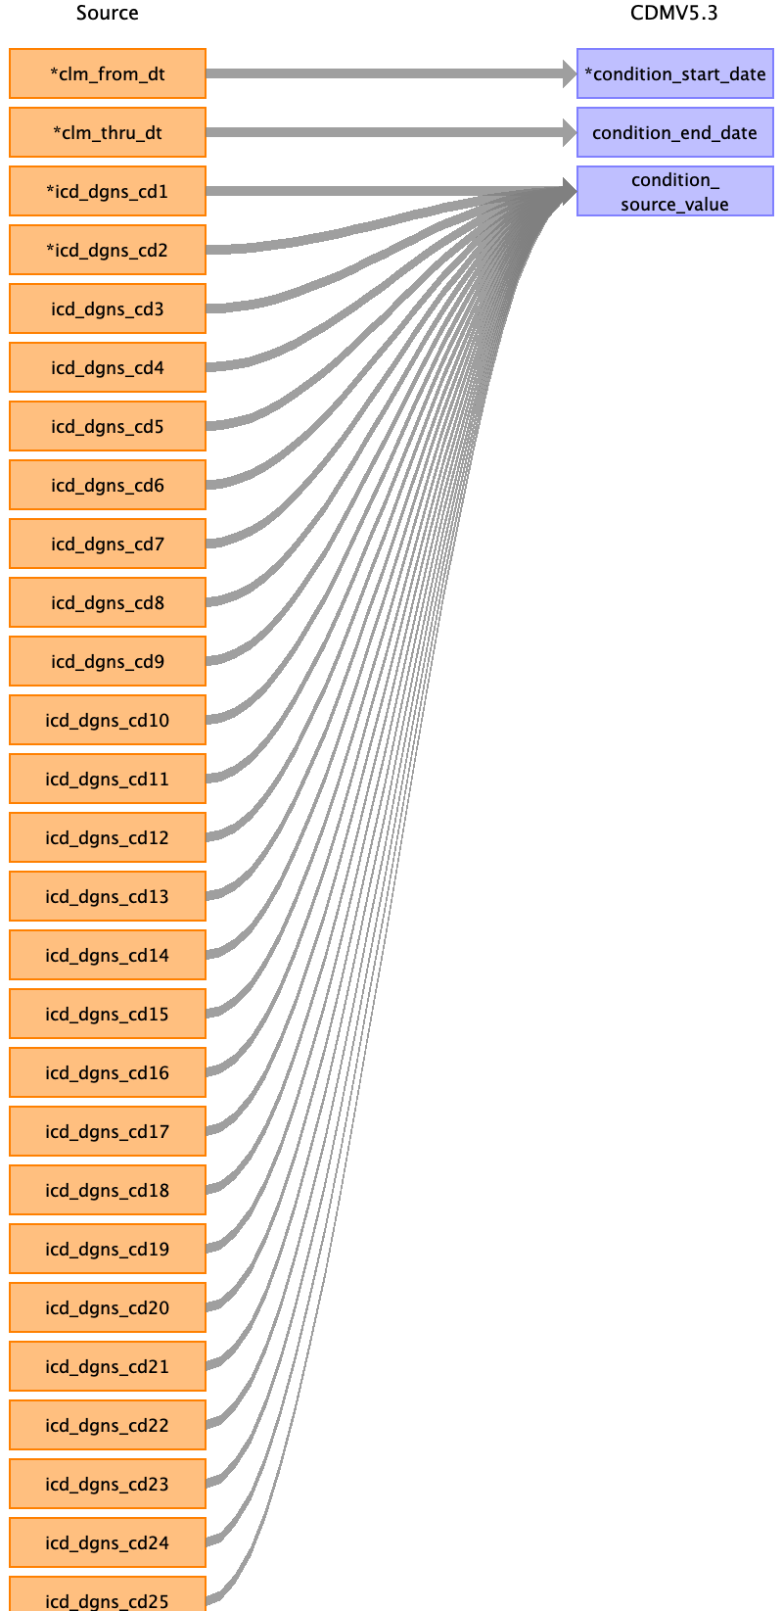

|  |  |  |  |
| --- | --- | --- | --- |
| Destination Field | Source Field | Logic | Comment |
| condition_occurrence_id |  |  | Add when new and unique condition exists. |
| person_id |  |  | Linked to PERSON table |
| condition_concept_id |  |  | OMOP CONCEPT MAPPING |
| condition_start_date | clm_from_dt |  |  |
| condition_start_datetime |  |  |  |
| condition_end_date | clm_thru_dt |  |  |
| condition_end_datetime |  |  |  |
| condition_type_concept_id |  |  | 32853 Inpatient claim  32859 Outpatient claim  32810 Carrier: Claim  32844 SNF: Facility claim  32810 DME: Claim  32844 HHA: Facility claim  32844 Hospice: Facility claim |
| stop_reason |  |  |  |
| provider_id |  |  | Linked to PROVIDER table |
| visit_occurrence_id |  |  | Linked to VISIT_OCCURRENCE table |
| visit_detail_id |  |  |  |
| condition_source_value | icd_dgns_cd1  icd_dgns_cd2  icd_dgns_cd3  icd_dgns_cd4  icd_dgns_cd5  icd_dgns_cd6  icd_dgns_cd7  icd_dgns_cd8  icd_dgns_cd9  icd_dgns_cd10  icd_dgns_cd11  icd_dgns_cd12  icd_dgns_cd13  icd_dgns_cd14  icd_dgns_cd15  icd_dgns_cd16  icd_dgns_cd17  icd_dgns_cd18  icd_dgns_cd19  icd_dgns_cd20  icd_dgns_cd21  icd_dgns_cd22  icd_dgns_cd23  icd_dgns_cd24  icd_dgns_cd25 |  |  |
| condition_source_concept_id |  |  | OMOP CONCEPT MAPPING |
| condition_status_source_value |  |  |  |
| condition_status_concept_id |  |  |  |

Reading from hospice_revenue_center_k.csv



|  |  |  |  |
| --- | --- | --- | --- |
| Destination Field | Source Field | Logic | Comment |
| condition_occurrence_id |  |  | Add when new and unique condition exists. |
| person_id |  |  | Linked to PERSON table |
| condition_concept_id |  |  | OMOP CONCEPT MAPPING |
| condition_start_date |  |  |  |
| condition_start_datetime |  |  |  |
| condition_end_date |  |  |  |
| condition_end_datetime |  |  |  |
| condition_type_concept_id |  |  | 32853 Inpatient claim  32859 Outpatient claim  32810 Carrier: Claim  32844 SNF: Facility claim  32810 DME: Claim  32844 HHA: Facility claim  32844 Hospice: Facility claim |
| stop_reason |  |  |  |
| provider_id |  |  | Linked to PROVIDER table |
| visit_occurrence_id |  |  | Linked to VISIT_OCCURRENCE table |
| visit_detail_id |  |  |  |
| condition_source_value | hcpcs_cd |  |  |
| condition_source_concept_id |  |  | OMOP CONCEPT MAPPING |
| condition_status_source_value |  |  |  |
| condition_status_concept_id |  |  |  |

Reading from stem_table

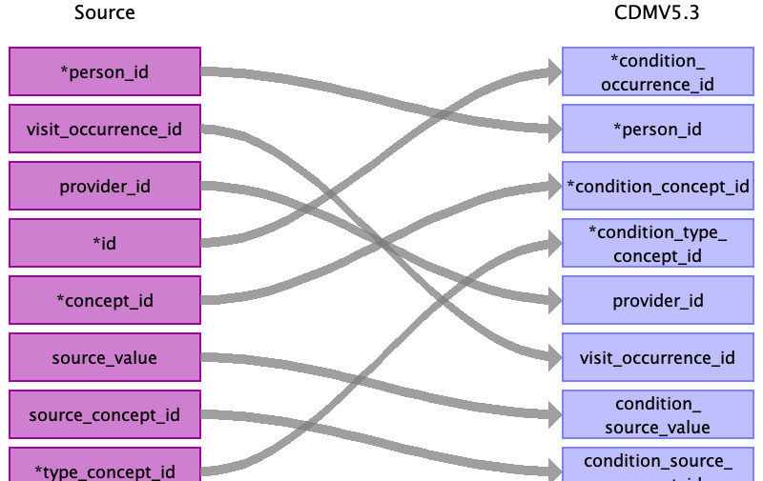

|  |  |  |  |
| --- | --- | --- | --- |
| Destination Field | Source Field | Logic | Comment |
| condition_occurrence_id | id |  | Add when new and unique condition exists. |
| person_id | person_id |  | Linked to PERSON table |
| condition_concept_id | concept_id |  | OMOP CONCEPT MAPPING |
| condition_start_date |  |  |  |
| condition_start_datetime |  |  |  |
| condition_end_date |  |  |  |
| condition_end_datetime |  |  |  |
| condition_type_concept_id | type_concept_id |  | 32853 Inpatient claim  32859 Outpatient claim  32810 Carrier: Claim  32844 SNF: Facility claim  32810 DME: Claim  32844 HHA: Facility claim  32844 Hospice: Facility claim |
| stop_reason |  |  |  |
| provider_id | provider_id |  | Linked to PROVIDER table |
| visit_occurrence_id | visit_occurrence_id |  | Linked to VISIT_OCCURRENCE table |
| visit_detail_id |  |  |  |
| condition_source_value | source_value |  |  |
| condition_source_concept_id | source_concept_id |  | OMOP CONCEPT MAPPING |
| condition_status_source_value |  |  |  |
| condition_status_concept_id |  |  |  |

Table name: death

Reading from mbsf_abcd_summary.csv

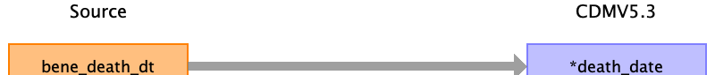

|  |  |  |  |
| --- | --- | --- | --- |
| Destination Field | Source Field | Logic | Comment |
| person_id |  |  | Linked to PERSON table |
| death_date | bene_death_dt |  |  |
| death_datetime |  |  |  |
| death_type_concept_id |  |  | 32813 Claim enrolment record |
| cause_concept_id |  |  |  |
| cause_source_value |  |  |  |
| cause_source_concept_id |  |  |  |

Table name: device_exposure

Reading from stem_table

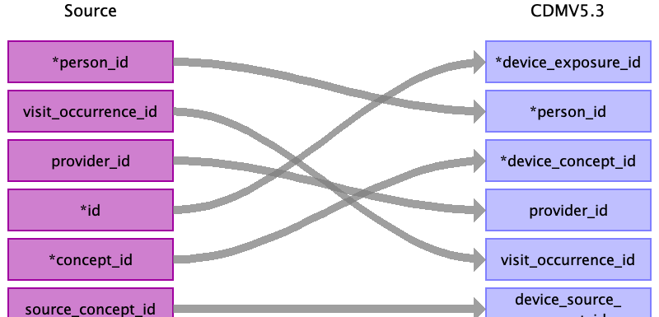

|  |  |  |  |
| --- | --- | --- | --- |
| Destination Field | Source Field | Logic | Comment |
| device_exposure_id | id |  | Add when new and unique code in device domain exists. |
| person_id | person_id |  | Linked to PERSON table |
| device_concept_id | concept_id |  | OMOP CONCEPT MAPPING |
| device_exposure_start_date |  |  |  |
| device_exposure_start_datetime |  |  |  |
| device_exposure_end_date |  |  |  |
| device_exposure_end_datetime |  |  |  |
| device_type_concept_id |  |  | 32810 Claim |
| unique_device_id |  |  |  |
| quantity |  |  |  |
| provider_id | provider_id |  | Linked to PROVIDER table |
| visit_occurrence_id | visit_occurrence_id |  | Linked to VISIT_OCCURRENCE table |
| visit_detail_id |  |  |  |
| device_source_value |  |  |  |
| device_source_concept_id | source_concept_id |  | OMOP CONCEPT MAPPING table |

Reading from inpatient_base_claims_k.csv

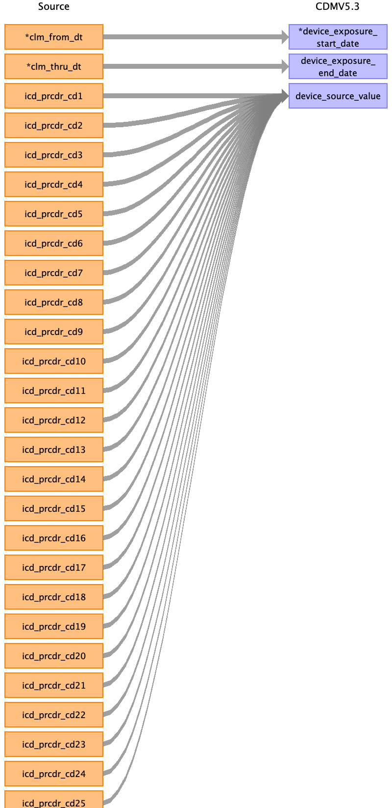

|  |  |  |  |
| --- | --- | --- | --- |
| Destination Field | Source Field | Logic | Comment |
| device_exposure_id |  |  | Add when new and unique code in device domain exists. |
| person_id |  |  | Linked to PERSON table |
| device_concept_id |  |  | OMOP CONCEPT MAPPING |
| device_exposure_start_date | clm_from_dt |  |  |
| device_exposure_start_datetime |  |  |  |
| device_exposure_end_date | clm_thru_dt |  |  |
| device_exposure_end_datetime |  |  |  |
| device_type_concept_id |  |  | 32810 Claim |
| unique_device_id |  |  |  |
| quantity |  |  |  |
| provider_id |  |  | Linked to PROVIDER table |
| visit_occurrence_id |  |  | Linked to VISIT_OCCURRENCE table |
| visit_detail_id |  |  |  |
| device_source_value | icd_prcdr_cd1  icd_prcdr_cd2  icd_prcdr_cd3  icd_prcdr_cd4  icd_prcdr_cd5  icd_prcdr_cd6  icd_prcdr_cd7  icd_prcdr_cd8  icd_prcdr_cd9  icd_prcdr_cd10  icd_prcdr_cd11  icd_prcdr_cd12  icd_prcdr_cd13  icd_prcdr_cd14  icd_prcdr_cd15  icd_prcdr_cd16  icd_prcdr_cd17  icd_prcdr_cd18  icd_prcdr_cd19  icd_prcdr_cd20  icd_prcdr_cd21  icd_prcdr_cd22  icd_prcdr_cd23  icd_prcdr_cd24  icd_prcdr_cd25 |  |  |
| device_source_concept_id |  |  | OMOP CONCEPT MAPPING table |

Reading from outpatient_base_claims_k.csv



|  |  |  |  |
| --- | --- | --- | --- |
| Destination Field | Source Field | Logic | Comment |
| device_exposure_id |  |  | Add when new and unique code in device domain exists. |
| person_id |  |  | Linked to PERSON table |
| device_concept_id |  |  | OMOP CONCEPT MAPPING |
| device_exposure_start_date | clm_from_dt |  |  |
| device_exposure_start_datetime |  |  |  |
| device_exposure_end_date | clm_thru_dt |  |  |
| device_exposure_end_datetime |  |  |  |
| device_type_concept_id |  |  | 32810 Claim |
| unique_device_id |  |  |  |
| quantity |  |  |  |
| provider_id |  |  | Linked to PROVIDER table |
| visit_occurrence_id |  |  | Linked to VISIT_OCCURRENCE table |
| visit_detail_id |  |  |  |
| device_source_value | icd_prcdr_cd1  icd_prcdr_cd2  icd_prcdr_cd3  icd_prcdr_cd4  icd_prcdr_cd5  icd_prcdr_cd6  icd_prcdr_cd7  icd_prcdr_cd8  icd_prcdr_cd9  icd_prcdr_cd10  icd_prcdr_cd11  icd_prcdr_cd12  icd_prcdr_cd13  icd_prcdr_cd14  icd_prcdr_cd15  icd_prcdr_cd16  icd_prcdr_cd17  icd_prcdr_cd18  icd_prcdr_cd19  icd_prcdr_cd20  icd_prcdr_cd21  icd_prcdr_cd22  icd_prcdr_cd23  icd_prcdr_cd24  icd_prcdr_cd25 |  |  |
| device_source_concept_id |  |  | OMOP CONCEPT MAPPING table |

Reading from bcarrier_claims_k.csv

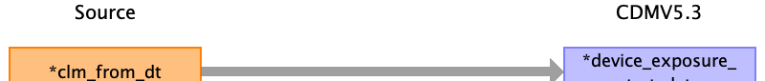

|  |  |  |  |
| --- | --- | --- | --- |
| Destination Field | Source Field | Logic | Comment |
| device_exposure_id |  |  | Add when new and unique code in device domain exists. |
| person_id |  |  | Linked to PERSON table |
| device_concept_id |  |  | OMOP CONCEPT MAPPING |
| device_exposure_start_date | clm_from_dt |  |  |
| device_exposure_start_datetime |  |  |  |
| device_exposure_end_date |  |  |  |
| device_exposure_end_datetime |  |  |  |
| device_type_concept_id |  |  | 32810 Claim |
| unique_device_id |  |  |  |
| quantity |  |  |  |
| provider_id |  |  | Linked to PROVIDER table |
| visit_occurrence_id |  |  | Linked to VISIT_OCCURRENCE table |
| visit_detail_id |  |  |  |
| device_source_value |  |  |  |
| device_source_concept_id |  |  | OMOP CONCEPT MAPPING table |

Reading from snf_base_claims_k.csv



|  |  |  |  |
| --- | --- | --- | --- |
| Destination Field | Source Field | Logic | Comment |
| device_exposure_id |  |  | Add when new and unique code in device domain exists. |
| person_id |  |  | Linked to PERSON table |
| device_concept_id |  |  | OMOP CONCEPT MAPPING |
| device_exposure_start_date | clm_from_dt |  |  |
| device_exposure_start_datetime |  |  |  |
| device_exposure_end_date | clm_thru_dt |  |  |
| device_exposure_end_datetime |  |  |  |
| device_type_concept_id |  |  | 32810 Claim |
| unique_device_id |  |  |  |
| quantity |  |  |  |
| provider_id |  |  | Linked to PROVIDER table |
| visit_occurrence_id |  |  | Linked to VISIT_OCCURRENCE table |
| visit_detail_id |  |  |  |
| device_source_value | icd_prcdr_cd1  icd_prcdr_cd2  icd_prcdr_cd3  icd_prcdr_cd4  icd_prcdr_cd5  icd_prcdr_cd6  icd_prcdr_cd7  icd_prcdr_cd8  icd_prcdr_cd9  icd_prcdr_cd10  icd_prcdr_cd11  icd_prcdr_cd12  icd_prcdr_cd13  icd_prcdr_cd14  icd_prcdr_cd15  icd_prcdr_cd16  icd_prcdr_cd17  icd_prcdr_cd18  icd_prcdr_cd19  icd_prcdr_cd20  icd_prcdr_cd21  icd_prcdr_cd22  icd_prcdr_cd23  icd_prcdr_cd24  icd_prcdr_cd25 |  |  |
| device_source_concept_id |  |  | OMOP CONCEPT MAPPING table |

Reading from dme_claims_k.csv



|  |  |  |  |
| --- | --- | --- | --- |
| Destination Field | Source Field | Logic | Comment |
| device_exposure_id |  |  | Add when new and unique code in device domain exists. |
| person_id |  |  | Linked to PERSON table |
| device_concept_id |  |  | OMOP CONCEPT MAPPING |
| device_exposure_start_date | clm_from_dt |  |  |
| device_exposure_start_datetime |  |  |  |
| device_exposure_end_date |  |  |  |
| device_exposure_end_datetime |  |  |  |
| device_type_concept_id |  |  | 32810 Claim |
| unique_device_id |  |  |  |
| quantity |  |  |  |
| provider_id |  |  | Linked to PROVIDER table |
| visit_occurrence_id |  |  | Linked to VISIT_OCCURRENCE table |
| visit_detail_id |  |  |  |
| device_source_value |  |  |  |
| device_source_concept_id |  |  | OMOP CONCEPT MAPPING table |

Reading from hha_base_claims_k.csv

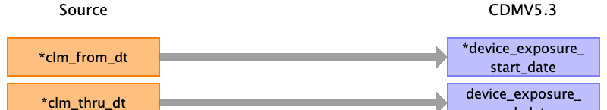

|  |  |  |  |
| --- | --- | --- | --- |
| Destination Field | Source Field | Logic | Comment |
| device_exposure_id |  |  | Add when new and unique code in device domain exists. |
| person_id |  |  | Linked to PERSON table |
| device_concept_id |  |  | OMOP CONCEPT MAPPING |
| device_exposure_start_date | clm_from_dt |  |  |
| device_exposure_start_datetime |  |  |  |
| device_exposure_end_date | clm_thru_dt |  |  |
| device_exposure_end_datetime |  |  |  |
| device_type_concept_id |  |  | 32810 Claim |
| unique_device_id |  |  |  |
| quantity |  |  |  |
| provider_id |  |  | Linked to PROVIDER table |
| visit_occurrence_id |  |  | Linked to VISIT_OCCURRENCE table |
| visit_detail_id |  |  |  |
| device_source_value |  |  |  |
| device_source_concept_id |  |  | OMOP CONCEPT MAPPING table |

Reading from hospice_base_claims_k.csv



|  |  |  |  |
| --- | --- | --- | --- |
| Destination Field | Source Field | Logic | Comment |
| device_exposure_id |  |  | Add when new and unique code in device domain exists. |
| person_id |  |  | Linked to PERSON table |
| device_concept_id |  |  | OMOP CONCEPT MAPPING |
| device_exposure_start_date | clm_from_dt |  |  |
| device_exposure_start_datetime |  |  |  |
| device_exposure_end_date | clm_thru_dt |  |  |
| device_exposure_end_datetime |  |  |  |
| device_type_concept_id |  |  | 32810 Claim |
| unique_device_id |  |  |  |
| quantity |  |  |  |
| provider_id |  |  | Linked to PROVIDER table |
| visit_occurrence_id |  |  | Linked to VISIT_OCCURRENCE table |
| visit_detail_id |  |  |  |
| device_source_value |  |  |  |
| device_source_concept_id |  |  | OMOP CONCEPT MAPPING table |

Reading from inpatient_revenue_center_k.csv

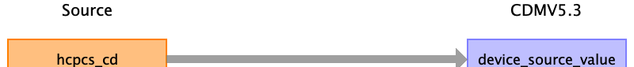

|  |  |  |  |
| --- | --- | --- | --- |
| Destination Field | Source Field | Logic | Comment |
| device_exposure_id |  |  | Add when new and unique code in device domain exists. |
| person_id |  |  | Linked to PERSON table |
| device_concept_id |  |  | OMOP CONCEPT MAPPING |
| device_exposure_start_date |  |  |  |
| device_exposure_start_datetime |  |  |  |
| device_exposure_end_date |  |  |  |
| device_exposure_end_datetime |  |  |  |
| device_type_concept_id |  |  | 32810 Claim |
| unique_device_id |  |  |  |
| quantity |  |  |  |
| provider_id |  |  | Linked to PROVIDER table |
| visit_occurrence_id |  |  | Linked to VISIT_OCCURRENCE table |
| visit_detail_id |  |  |  |
| device_source_value | hcpcs_cd |  |  |
| device_source_concept_id |  |  | OMOP CONCEPT MAPPING table |

Reading from outpatient_revenue_center_k.csv



|  |  |  |  |
| --- | --- | --- | --- |
| Destination Field | Source Field | Logic | Comment |
| device_exposure_id |  |  | Add when new and unique code in device domain exists. |
| person_id |  |  | Linked to PERSON table |
| device_concept_id |  |  | OMOP CONCEPT MAPPING |
| device_exposure_start_date |  |  |  |
| device_exposure_start_datetime |  |  |  |
| device_exposure_end_date |  |  |  |
| device_exposure_end_datetime |  |  |  |
| device_type_concept_id |  |  | 32810 Claim |
| unique_device_id |  |  |  |
| quantity |  |  |  |
| provider_id |  |  | Linked to PROVIDER table |
| visit_occurrence_id |  |  | Linked to VISIT_OCCURRENCE table |
| visit_detail_id |  |  |  |
| device_source_value | hcpcs_cd |  |  |
| device_source_concept_id |  |  | OMOP CONCEPT MAPPING table |

Reading from snf_revenue_center_k.csv



|  |  |  |  |
| --- | --- | --- | --- |
| Destination Field | Source Field | Logic | Comment |
| device_exposure_id |  |  | Add when new and unique code in device domain exists. |
| person_id |  |  | Linked to PERSON table |
| device_concept_id |  |  | OMOP CONCEPT MAPPING |
| device_exposure_start_date |  |  |  |
| device_exposure_start_datetime |  |  |  |
| device_exposure_end_date |  |  |  |
| device_exposure_end_datetime |  |  |  |
| device_type_concept_id |  |  | 32810 Claim |
| unique_device_id |  |  |  |
| quantity |  |  |  |
| provider_id |  |  | Linked to PROVIDER table |
| visit_occurrence_id |  |  | Linked to VISIT_OCCURRENCE table |
| visit_detail_id |  |  |  |
| device_source_value | hcpcs_cd |  |  |
| device_source_concept_id |  |  | OMOP CONCEPT MAPPING table |

Reading from hha_revenue_center_k.csv



|  |  |  |  |
| --- | --- | --- | --- |
| Destination Field | Source Field | Logic | Comment |
| device_exposure_id |  |  | Add when new and unique code in device domain exists. |
| person_id |  |  | Linked to PERSON table |
| device_concept_id |  |  | OMOP CONCEPT MAPPING |
| device_exposure_start_date |  |  |  |
| device_exposure_start_datetime |  |  |  |
| device_exposure_end_date |  |  |  |
| device_exposure_end_datetime |  |  |  |
| device_type_concept_id |  |  | 32810 Claim |
| unique_device_id |  |  |  |
| quantity |  |  |  |
| provider_id |  |  | Linked to PROVIDER table |
| visit_occurrence_id |  |  | Linked to VISIT_OCCURRENCE table |
| visit_detail_id |  |  |  |
| device_source_value | hcpcs_cd |  |  |
| device_source_concept_id |  |  | OMOP CONCEPT MAPPING table |

Reading from hospice_revenue_center_k.csv



|  |  |  |  |
| --- | --- | --- | --- |
| Destination Field | Source Field | Logic | Comment |
| device_exposure_id |  |  | Add when new and unique code in device domain exists. |
| person_id |  |  | Linked to PERSON table |
| device_concept_id |  |  | OMOP CONCEPT MAPPING |
| device_exposure_start_date |  |  |  |
| device_exposure_start_datetime |  |  |  |
| device_exposure_end_date |  |  |  |
| device_exposure_end_datetime |  |  |  |
| device_type_concept_id |  |  | 32810 Claim |
| unique_device_id |  |  |  |
| quantity |  |  |  |
| provider_id |  |  | Linked to PROVIDER table |
| visit_occurrence_id |  |  | Linked to VISIT_OCCURRENCE table |
| visit_detail_id |  |  |  |
| device_source_value | hcpcs_cd |  |  |
| device_source_concept_id |  |  | OMOP CONCEPT MAPPING table |

Reading from bcarrier_line_k.csv

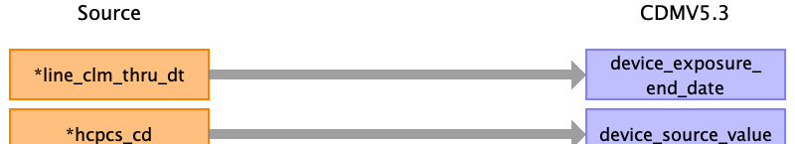

|  |  |  |  |
| --- | --- | --- | --- |
| Destination Field | Source Field | Logic | Comment |
| device_exposure_id |  |  | Add when new and unique code in device domain exists. |
| person_id |  |  | Linked to PERSON table |
| device_concept_id |  |  | OMOP CONCEPT MAPPING |
| device_exposure_start_date |  |  |  |
| device_exposure_start_datetime |  |  |  |
| device_exposure_end_date | line_clm_thru_dt |  |  |
| device_exposure_end_datetime |  |  |  |
| device_type_concept_id |  |  | 32810 Claim |
| unique_device_id |  |  |  |
| quantity |  |  |  |
| provider_id |  |  | Linked to PROVIDER table |
| visit_occurrence_id |  |  | Linked to VISIT_OCCURRENCE table |
| visit_detail_id |  |  |  |
| device_source_value | hcpcs_cd |  |  |
| device_source_concept_id |  |  | OMOP CONCEPT MAPPING table |

Reading from dme_line_k.csv



|  |  |  |  |
| --- | --- | --- | --- |
| Destination Field | Source Field | Logic | Comment |
| device_exposure_id |  |  | Add when new and unique code in device domain exists. |
| person_id |  |  | Linked to PERSON table |
| device_concept_id |  |  | OMOP CONCEPT MAPPING |
| device_exposure_start_date |  |  |  |
| device_exposure_start_datetime |  |  |  |
| device_exposure_end_date | line_clm_thru_dt |  |  |
| device_exposure_end_datetime |  |  |  |
| device_type_concept_id |  |  | 32810 Claim |
| unique_device_id |  |  |  |
| quantity |  |  |  |
| provider_id |  |  | Linked to PROVIDER table |
| visit_occurrence_id |  |  | Linked to VISIT_OCCURRENCE table |
| visit_detail_id |  |  |  |
| device_source_value | hcpcs_cd |  |  |
| device_source_concept_id |  |  | OMOP CONCEPT MAPPING table |

Table name: drug_exposure

Reading from stem_table

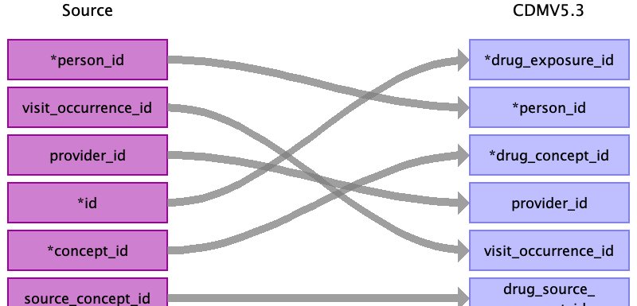

|  |  |  |  |
| --- | --- | --- | --- |
| Destination Field | Source Field | Logic | Comment |
| drug_exposure_id | id |  | Add when new and unique medication record exists. |
| person_id | person_id |  | Linked to PERSON table |
| drug_concept_id | concept_id |  | OMOP CONCEPT MAPPING table |
| drug_exposure_start_date |  |  |  |
| drug_exposure_start_datetime |  |  |  |
| drug_exposure_end_date |  |  |  |
| drug_exposure_end_datetime |  |  |  |
| verbatim_end_date |  |  |  |
| drug_type_concept_id |  |  | 32838 EHR prescription |
| stop_reason |  |  |  |
| refills |  |  |  |
| quantity |  |  | only pde has |
| days_supply |  |  | only pde has |
| sig |  |  |  |
| route_concept_id |  |  |  |
| lot_number |  |  |  |
| provider_id | provider_id |  | Linked to PROVIDER table |
| visit_occurrence_id | visit_occurrence_id |  | Linked to VISIT_OCCURRENCE table |
| visit_detail_id |  |  |  |
| drug_source_value |  |  |  |
| drug_source_concept_id | source_concept_id |  | OMOP CONCEPT MAPPING table |
| route_source_value |  |  |  |
| dose_unit_source_value |  |  |  |

Reading from pde_file.csv

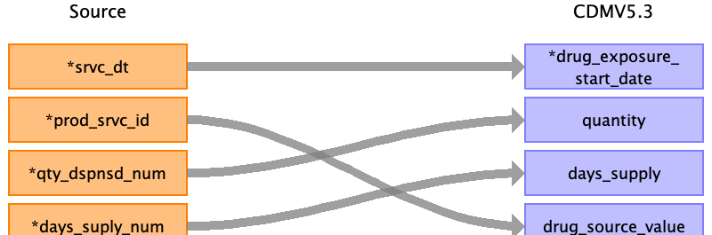

|  |  |  |  |
| --- | --- | --- | --- |
| Destination Field | Source Field | Logic | Comment |
| drug_exposure_id |  |  | Add when new and unique medication record exists. |
| person_id |  |  | Linked to PERSON table |
| drug_concept_id |  |  | OMOP CONCEPT MAPPING table |
| drug_exposure_start_date | srvc_dt |  |  |
| drug_exposure_start_datetime |  |  |  |
| drug_exposure_end_date |  |  |  |
| drug_exposure_end_datetime |  |  |  |
| verbatim_end_date |  |  |  |
| drug_type_concept_id |  |  | 32838 EHR prescription |
| stop_reason |  |  |  |
| refills |  |  |  |
| quantity | qty_dspnsd_num |  | only pde has |
| days_supply | days_suply_num |  | only pde has |
| sig |  |  |  |
| route_concept_id |  |  |  |
| lot_number |  |  |  |
| provider_id |  |  | Linked to PROVIDER table |
| visit_occurrence_id |  |  | Linked to VISIT_OCCURRENCE table |
| visit_detail_id |  |  |  |
| drug_source_value | prod_srvc_id |  |  |
| drug_source_concept_id |  |  | OMOP CONCEPT MAPPING table |
| route_source_value |  |  |  |
| dose_unit_source_value |  |  |  |

Reading from inpatient_base_claims_k.csv

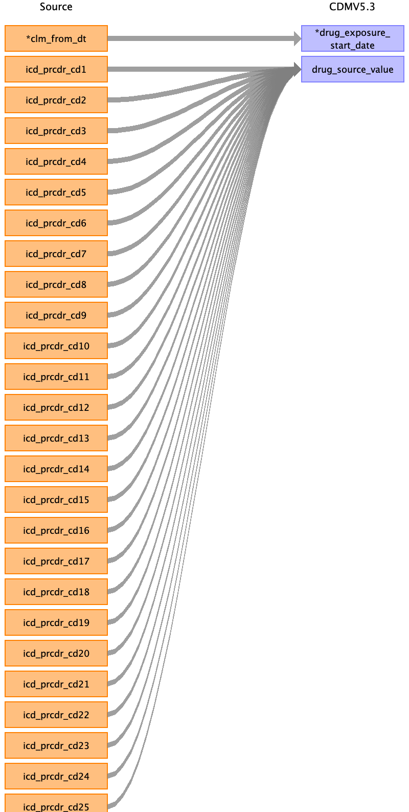

|  |  |  |  |
| --- | --- | --- | --- |
| Destination Field | Source Field | Logic | Comment |
| drug_exposure_id |  |  | Add when new and unique medication record exists. |
| person_id |  |  | Linked to PERSON table |
| drug_concept_id |  |  | OMOP CONCEPT MAPPING table |
| drug_exposure_start_date | clm_from_dt |  |  |
| drug_exposure_start_datetime |  |  |  |
| drug_exposure_end_date |  |  |  |
| drug_exposure_end_datetime |  |  |  |
| verbatim_end_date |  |  |  |
| drug_type_concept_id |  |  | 32838 EHR prescription |
| stop_reason |  |  |  |
| refills |  |  |  |
| quantity |  |  | only pde has |
| days_supply |  |  | only pde has |
| sig |  |  |  |
| route_concept_id |  |  |  |
| lot_number |  |  |  |
| provider_id |  |  | Linked to PROVIDER table |
| visit_occurrence_id |  |  | Linked to VISIT_OCCURRENCE table |
| visit_detail_id |  |  |  |
| drug_source_value | icd_prcdr_cd1  icd_prcdr_cd2  icd_prcdr_cd3  icd_prcdr_cd4  icd_prcdr_cd5  icd_prcdr_cd6  icd_prcdr_cd7  icd_prcdr_cd8  icd_prcdr_cd9  icd_prcdr_cd10  icd_prcdr_cd11  icd_prcdr_cd12  icd_prcdr_cd13  icd_prcdr_cd14  icd_prcdr_cd15  icd_prcdr_cd16  icd_prcdr_cd17  icd_prcdr_cd18  icd_prcdr_cd19  icd_prcdr_cd20  icd_prcdr_cd21  icd_prcdr_cd22  icd_prcdr_cd23  icd_prcdr_cd24  icd_prcdr_cd25 |  |  |
| drug_source_concept_id |  |  | OMOP CONCEPT MAPPING table |
| route_source_value |  |  |  |
| dose_unit_source_value |  |  |  |

Reading from outpatient_base_claims_k.csv



|  |  |  |  |
| --- | --- | --- | --- |
| Destination Field | Source Field | Logic | Comment |
| drug_exposure_id |  |  | Add when new and unique medication record exists. |
| person_id |  |  | Linked to PERSON table |
| drug_concept_id |  |  | OMOP CONCEPT MAPPING table |
| drug_exposure_start_date | clm_from_dt |  |  |
| drug_exposure_start_datetime |  |  |  |
| drug_exposure_end_date |  |  |  |
| drug_exposure_end_datetime |  |  |  |
| verbatim_end_date |  |  |  |
| drug_type_concept_id |  |  | 32838 EHR prescription |
| stop_reason |  |  |  |
| refills |  |  |  |
| quantity |  |  | only pde has |
| days_supply |  |  | only pde has |
| sig |  |  |  |
| route_concept_id |  |  |  |
| lot_number |  |  |  |
| provider_id |  |  | Linked to PROVIDER table |
| visit_occurrence_id |  |  | Linked to VISIT_OCCURRENCE table |
| visit_detail_id |  |  |  |
| drug_source_value | icd_prcdr_cd1  icd_prcdr_cd2  icd_prcdr_cd3  icd_prcdr_cd4  icd_prcdr_cd5  icd_prcdr_cd6  icd_prcdr_cd7  icd_prcdr_cd8  icd_prcdr_cd9  icd_prcdr_cd10  icd_prcdr_cd11  icd_prcdr_cd12  icd_prcdr_cd13  icd_prcdr_cd14  icd_prcdr_cd15  icd_prcdr_cd16  icd_prcdr_cd17  icd_prcdr_cd18  icd_prcdr_cd19  icd_prcdr_cd20  icd_prcdr_cd21  icd_prcdr_cd22  icd_prcdr_cd23  icd_prcdr_cd24  icd_prcdr_cd25 |  |  |
| drug_source_concept_id |  |  | OMOP CONCEPT MAPPING table |
| route_source_value |  |  |  |
| dose_unit_source_value |  |  |  |

Reading from snf_base_claims_k.csv



|  |  |  |  |
| --- | --- | --- | --- |
| Destination Field | Source Field | Logic | Comment |
| drug_exposure_id |  |  | Add when new and unique medication record exists. |
| person_id |  |  | Linked to PERSON table |
| drug_concept_id |  |  | OMOP CONCEPT MAPPING table |
| drug_exposure_start_date | clm_from_dt |  |  |
| drug_exposure_start_datetime |  |  |  |
| drug_exposure_end_date |  |  |  |
| drug_exposure_end_datetime |  |  |  |
| verbatim_end_date |  |  |  |
| drug_type_concept_id |  |  | 32838 EHR prescription |
| stop_reason |  |  |  |
| refills |  |  |  |
| quantity |  |  | only pde has |
| days_supply |  |  | only pde has |
| sig |  |  |  |
| route_concept_id |  |  |  |
| lot_number |  |  |  |
| provider_id |  |  | Linked to PROVIDER table |
| visit_occurrence_id |  |  | Linked to VISIT_OCCURRENCE table |
| visit_detail_id |  |  |  |
| drug_source_value | icd_prcdr_cd1  icd_prcdr_cd2  icd_prcdr_cd3  icd_prcdr_cd4  icd_prcdr_cd5  icd_prcdr_cd6  icd_prcdr_cd7  icd_prcdr_cd8  icd_prcdr_cd9  icd_prcdr_cd10  icd_prcdr_cd11  icd_prcdr_cd12  icd_prcdr_cd13  icd_prcdr_cd14  icd_prcdr_cd15  icd_prcdr_cd16  icd_prcdr_cd17  icd_prcdr_cd18  icd_prcdr_cd19  icd_prcdr_cd20  icd_prcdr_cd21  icd_prcdr_cd22  icd_prcdr_cd23  icd_prcdr_cd24  icd_prcdr_cd25 |  |  |
| drug_source_concept_id |  |  | OMOP CONCEPT MAPPING table |
| route_source_value |  |  |  |
| dose_unit_source_value |  |  |  |

Reading from hha_base_claims_k.csv

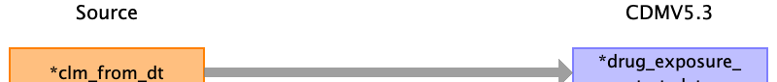

|  |  |  |  |
| --- | --- | --- | --- |
| Destination Field | Source Field | Logic | Comment |
| drug_exposure_id |  |  | Add when new and unique medication record exists. |
| person_id |  |  | Linked to PERSON table |
| drug_concept_id |  |  | OMOP CONCEPT MAPPING table |
| drug_exposure_start_date | clm_from_dt |  |  |
| drug_exposure_start_datetime |  |  |  |
| drug_exposure_end_date |  |  |  |
| drug_exposure_end_datetime |  |  |  |
| verbatim_end_date |  |  |  |
| drug_type_concept_id |  |  | 32838 EHR prescription |
| stop_reason |  |  |  |
| refills |  |  |  |
| quantity |  |  | only pde has |
| days_supply |  |  | only pde has |
| sig |  |  |  |
| route_concept_id |  |  |  |
| lot_number |  |  |  |
| provider_id |  |  | Linked to PROVIDER table |
| visit_occurrence_id |  |  | Linked to VISIT_OCCURRENCE table |
| visit_detail_id |  |  |  |
| drug_source_value |  |  |  |
| drug_source_concept_id |  |  | OMOP CONCEPT MAPPING table |
| route_source_value |  |  |  |
| dose_unit_source_value |  |  |  |

Reading from hospice_base_claims_k.csv



|  |  |  |  |
| --- | --- | --- | --- |
| Destination Field | Source Field | Logic | Comment |
| drug_exposure_id |  |  | Add when new and unique medication record exists. |
| person_id |  |  | Linked to PERSON table |
| drug_concept_id |  |  | OMOP CONCEPT MAPPING table |
| drug_exposure_start_date | clm_from_dt |  |  |
| drug_exposure_start_datetime |  |  |  |
| drug_exposure_end_date |  |  |  |
| drug_exposure_end_datetime |  |  |  |
| verbatim_end_date |  |  |  |
| drug_type_concept_id |  |  | 32838 EHR prescription |
| stop_reason |  |  |  |
| refills |  |  |  |
| quantity |  |  | only pde has |
| days_supply |  |  | only pde has |
| sig |  |  |  |
| route_concept_id |  |  |  |
| lot_number |  |  |  |
| provider_id |  |  | Linked to PROVIDER table |
| visit_occurrence_id |  |  | Linked to VISIT_OCCURRENCE table |
| visit_detail_id |  |  |  |
| drug_source_value |  |  |  |
| drug_source_concept_id |  |  | OMOP CONCEPT MAPPING table |
| route_source_value |  |  |  |
| dose_unit_source_value |  |  |  |

Reading from dme_claims_k.csv



|  |  |  |  |
| --- | --- | --- | --- |
| Destination Field | Source Field | Logic | Comment |
| drug_exposure_id |  |  | Add when new and unique medication record exists. |
| person_id |  |  | Linked to PERSON table |
| drug_concept_id |  |  | OMOP CONCEPT MAPPING table |
| drug_exposure_start_date | clm_from_dt |  |  |
| drug_exposure_start_datetime |  |  |  |
| drug_exposure_end_date |  |  |  |
| drug_exposure_end_datetime |  |  |  |
| verbatim_end_date |  |  |  |
| drug_type_concept_id |  |  | 32838 EHR prescription |
| stop_reason |  |  |  |
| refills |  |  |  |
| quantity |  |  | only pde has |
| days_supply |  |  | only pde has |
| sig |  |  |  |
| route_concept_id |  |  |  |
| lot_number |  |  |  |
| provider_id |  |  | Linked to PROVIDER table |
| visit_occurrence_id |  |  | Linked to VISIT_OCCURRENCE table |
| visit_detail_id |  |  |  |
| drug_source_value |  |  |  |
| drug_source_concept_id |  |  | OMOP CONCEPT MAPPING table |
| route_source_value |  |  |  |
| dose_unit_source_value |  |  |  |

Reading from bcarrier_line_k.csv

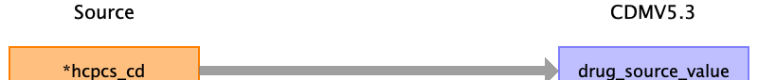

|  |  |  |  |
| --- | --- | --- | --- |
| Destination Field | Source Field | Logic | Comment |
| drug_exposure_id |  |  | Add when new and unique medication record exists. |
| person_id |  |  | Linked to PERSON table |
| drug_concept_id |  |  | OMOP CONCEPT MAPPING table |
| drug_exposure_start_date |  |  |  |
| drug_exposure_start_datetime |  |  |  |
| drug_exposure_end_date |  |  |  |
| drug_exposure_end_datetime |  |  |  |
| verbatim_end_date |  |  |  |
| drug_type_concept_id |  |  | 32838 EHR prescription |
| stop_reason |  |  |  |
| refills |  |  |  |
| quantity |  |  | only pde has |
| days_supply |  |  | only pde has |
| sig |  |  |  |
| route_concept_id |  |  |  |
| lot_number |  |  |  |
| provider_id |  |  | Linked to PROVIDER table |
| visit_occurrence_id |  |  | Linked to VISIT_OCCURRENCE table |
| visit_detail_id |  |  |  |
| drug_source_value | hcpcs_cd |  |  |
| drug_source_concept_id |  |  | OMOP CONCEPT MAPPING table |
| route_source_value |  |  |  |
| dose_unit_source_value |  |  |  |

Reading from dme_line_k.csv



|  |  |  |  |
| --- | --- | --- | --- |
| Destination Field | Source Field | Logic | Comment |
| drug_exposure_id |  |  | Add when new and unique medication record exists. |
| person_id |  |  | Linked to PERSON table |
| drug_concept_id |  |  | OMOP CONCEPT MAPPING table |
| drug_exposure_start_date |  |  |  |
| drug_exposure_start_datetime |  |  |  |
| drug_exposure_end_date |  |  |  |
| drug_exposure_end_datetime |  |  |  |
| verbatim_end_date |  |  |  |
| drug_type_concept_id |  |  | 32838 EHR prescription |
| stop_reason |  |  |  |
| refills |  |  |  |
| quantity |  |  | only pde has |
| days_supply |  |  | only pde has |
| sig |  |  |  |
| route_concept_id |  |  |  |
| lot_number |  |  |  |
| provider_id |  |  | Linked to PROVIDER table |
| visit_occurrence_id |  |  | Linked to VISIT_OCCURRENCE table |
| visit_detail_id |  |  |  |
| drug_source_value | hcpcs_cd |  |  |
| drug_source_concept_id |  |  | OMOP CONCEPT MAPPING table |
| route_source_value |  |  |  |
| dose_unit_source_value |  |  |  |

Reading from inpatient_revenue_center_k.csv

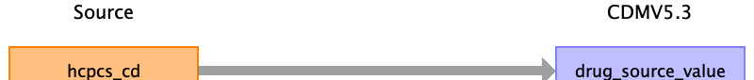

|  |  |  |  |
| --- | --- | --- | --- |
| Destination Field | Source Field | Logic | Comment |
| drug_exposure_id |  |  | Add when new and unique medication record exists. |
| person_id |  |  | Linked to PERSON table |
| drug_concept_id |  |  | OMOP CONCEPT MAPPING table |
| drug_exposure_start_date |  |  |  |
| drug_exposure_start_datetime |  |  |  |
| drug_exposure_end_date |  |  |  |
| drug_exposure_end_datetime |  |  |  |
| verbatim_end_date |  |  |  |
| drug_type_concept_id |  |  | 32838 EHR prescription |
| stop_reason |  |  |  |
| refills |  |  |  |
| quantity |  |  | only pde has |
| days_supply |  |  | only pde has |
| sig |  |  |  |
| route_concept_id |  |  |  |
| lot_number |  |  |  |
| provider_id |  |  | Linked to PROVIDER table |
| visit_occurrence_id |  |  | Linked to VISIT_OCCURRENCE table |
| visit_detail_id |  |  |  |
| drug_source_value | hcpcs_cd |  |  |
| drug_source_concept_id |  |  | OMOP CONCEPT MAPPING table |
| route_source_value |  |  |  |
| dose_unit_source_value |  |  |  |

Reading from outpatient_revenue_center_k.csv



|  |  |  |  |
| --- | --- | --- | --- |
| Destination Field | Source Field | Logic | Comment |
| drug_exposure_id |  |  | Add when new and unique medication record exists. |
| person_id |  |  | Linked to PERSON table |
| drug_concept_id |  |  | OMOP CONCEPT MAPPING table |
| drug_exposure_start_date |  |  |  |
| drug_exposure_start_datetime |  |  |  |
| drug_exposure_end_date |  |  |  |
| drug_exposure_end_datetime |  |  |  |
| verbatim_end_date |  |  |  |
| drug_type_concept_id |  |  | 32838 EHR prescription |
| stop_reason |  |  |  |
| refills |  |  |  |
| quantity |  |  | only pde has |
| days_supply |  |  | only pde has |
| sig |  |  |  |
| route_concept_id |  |  |  |
| lot_number |  |  |  |
| provider_id |  |  | Linked to PROVIDER table |
| visit_occurrence_id |  |  | Linked to VISIT_OCCURRENCE table |
| visit_detail_id |  |  |  |
| drug_source_value | hcpcs_cd |  |  |
| drug_source_concept_id |  |  | OMOP CONCEPT MAPPING table |
| route_source_value |  |  |  |
| dose_unit_source_value |  |  |  |

Reading from bcarrier_claims_k.csv



|  |  |  |  |
| --- | --- | --- | --- |
| Destination Field | Source Field | Logic | Comment |
| drug_exposure_id |  |  | Add when new and unique medication record exists. |
| person_id |  |  | Linked to PERSON table |
| drug_concept_id |  |  | OMOP CONCEPT MAPPING table |
| drug_exposure_start_date | clm_from_dt |  |  |
| drug_exposure_start_datetime |  |  |  |
| drug_exposure_end_date |  |  |  |
| drug_exposure_end_datetime |  |  |  |
| verbatim_end_date |  |  |  |
| drug_type_concept_id |  |  | 32838 EHR prescription |
| stop_reason |  |  |  |
| refills |  |  |  |
| quantity |  |  | only pde has |
| days_supply |  |  | only pde has |
| sig |  |  |  |
| route_concept_id |  |  |  |
| lot_number |  |  |  |
| provider_id |  |  | Linked to PROVIDER table |
| visit_occurrence_id |  |  | Linked to VISIT_OCCURRENCE table |
| visit_detail_id |  |  |  |
| drug_source_value |  |  |  |
| drug_source_concept_id |  |  | OMOP CONCEPT MAPPING table |
| route_source_value |  |  |  |
| dose_unit_source_value |  |  |  |

Reading from snf_revenue_center_k.csv



|  |  |  |  |
| --- | --- | --- | --- |
| Destination Field | Source Field | Logic | Comment |
| drug_exposure_id |  |  | Add when new and unique medication record exists. |
| person_id |  |  | Linked to PERSON table |
| drug_concept_id |  |  | OMOP CONCEPT MAPPING table |
| drug_exposure_start_date |  |  |  |
| drug_exposure_start_datetime |  |  |  |
| drug_exposure_end_date |  |  |  |
| drug_exposure_end_datetime |  |  |  |
| verbatim_end_date |  |  |  |
| drug_type_concept_id |  |  | 32838 EHR prescription |
| stop_reason |  |  |  |
| refills |  |  |  |
| quantity |  |  | only pde has |
| days_supply |  |  | only pde has |
| sig |  |  |  |
| route_concept_id |  |  |  |
| lot_number |  |  |  |
| provider_id |  |  | Linked to PROVIDER table |
| visit_occurrence_id |  |  | Linked to VISIT_OCCURRENCE table |
| visit_detail_id |  |  |  |
| drug_source_value | hcpcs_cd |  |  |
| drug_source_concept_id |  |  | OMOP CONCEPT MAPPING table |
| route_source_value |  |  |  |
| dose_unit_source_value |  |  |  |

Reading from hha_revenue_center_k.csv



|  |  |  |  |
| --- | --- | --- | --- |
| Destination Field | Source Field | Logic | Comment |
| drug_exposure_id |  |  | Add when new and unique medication record exists. |
| person_id |  |  | Linked to PERSON table |
| drug_concept_id |  |  | OMOP CONCEPT MAPPING table |
| drug_exposure_start_date |  |  |  |
| drug_exposure_start_datetime |  |  |  |
| drug_exposure_end_date |  |  |  |
| drug_exposure_end_datetime |  |  |  |
| verbatim_end_date |  |  |  |
| drug_type_concept_id |  |  | 32838 EHR prescription |
| stop_reason |  |  |  |
| refills |  |  |  |
| quantity |  |  | only pde has |
| days_supply |  |  | only pde has |
| sig |  |  |  |
| route_concept_id |  |  |  |
| lot_number |  |  |  |
| provider_id |  |  | Linked to PROVIDER table |
| visit_occurrence_id |  |  | Linked to VISIT_OCCURRENCE table |
| visit_detail_id |  |  |  |
| drug_source_value | hcpcs_cd |  |  |
| drug_source_concept_id |  |  | OMOP CONCEPT MAPPING table |
| route_source_value |  |  |  |
| dose_unit_source_value |  |  |  |

Reading from hospice_revenue_center_k.csv



|  |  |  |  |
| --- | --- | --- | --- |
| Destination Field | Source Field | Logic | Comment |
| drug_exposure_id |  |  | Add when new and unique medication record exists. |
| person_id |  |  | Linked to PERSON table |
| drug_concept_id |  |  | OMOP CONCEPT MAPPING table |
| drug_exposure_start_date |  |  |  |
| drug_exposure_start_datetime |  |  |  |
| drug_exposure_end_date |  |  |  |
| drug_exposure_end_datetime |  |  |  |
| verbatim_end_date |  |  |  |
| drug_type_concept_id |  |  | 32838 EHR prescription |
| stop_reason |  |  |  |
| refills |  |  |  |
| quantity |  |  | only pde has |
| days_supply |  |  | only pde has |
| sig |  |  |  |
| route_concept_id |  |  |  |
| lot_number |  |  |  |
| provider_id |  |  | Linked to PROVIDER table |
| visit_occurrence_id |  |  | Linked to VISIT_OCCURRENCE table |
| visit_detail_id |  |  |  |
| drug_source_value | hcpcs_cd |  |  |
| drug_source_concept_id |  |  | OMOP CONCEPT MAPPING table |
| route_source_value |  |  |  |
| dose_unit_source_value |  |  |  |

Table name: fact_relationship

NOT USING

Table name: measurement

Reading from stem_table

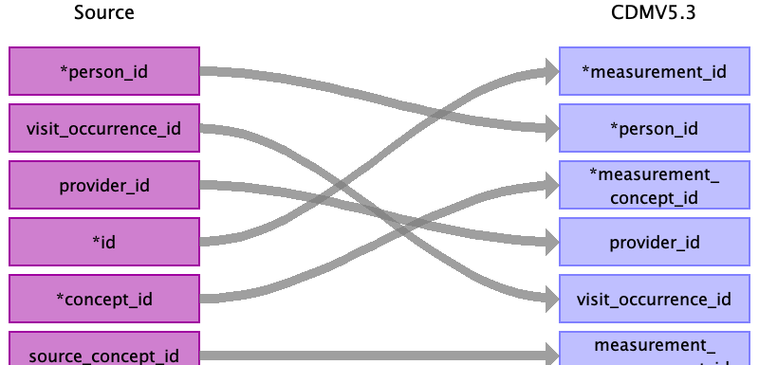

|  |  |  |  |
| --- | --- | --- | --- |
| Destination Field | Source Field | Logic | Comment |
| measurement_id | id |  | Add when new and unique measurement exists. |
| person_id | person_id |  | Linked to PERSON table |
| measurement_concept_id | concept_id |  | OMOP CONCEPT MAPPING table |
| measurement_date |  |  |  |
| measurement_datetime |  |  |  |
| measurement_time |  |  |  |
| measurement_type_concept_id |  |  | 32810 Claim |
| operator_concept_id |  |  |  |
| value_as_number |  |  |  |
| value_as_concept_id |  |  |  |
| unit_concept_id |  |  |  |
| range_low |  |  |  |
| range_high |  |  |  |
| provider_id | provider_id |  | Linked to PROVIDER table |
| visit_occurrence_id | visit_occurrence_id |  | Linked to VISIT_OCCURRENCE table |
| visit_detail_id |  |  |  |
| measurement_source_value |  |  |  |
| measurement_source_concept_id | source_concept_id |  | OMOP CONCEPT MAPPING table |
| unit_source_value |  |  |  |
| value_source_value |  |  |  |

Reading from inpatient_base_claims_k.csv

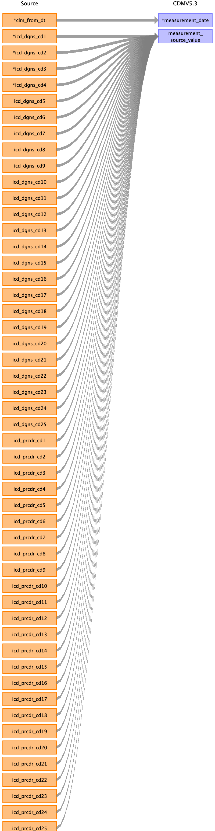

|  |  |  |  |
| --- | --- | --- | --- |
| Destination Field | Source Field | Logic | Comment |
| measurement_id |  |  | Add when new and unique measurement exists. |
| person_id |  |  | Linked to PERSON table |
| measurement_concept_id |  |  | OMOP CONCEPT MAPPING table |
| measurement_date | clm_from_dt |  |  |
| measurement_datetime |  |  |  |
| measurement_time |  |  |  |
| measurement_type_concept_id |  |  | 32810 Claim |
| operator_concept_id |  |  |  |
| value_as_number |  |  |  |
| value_as_concept_id |  |  |  |
| unit_concept_id |  |  |  |
| range_low |  |  |  |
| range_high |  |  |  |
| provider_id |  |  | Linked to PROVIDER table |
| visit_occurrence_id |  |  | Linked to VISIT_OCCURRENCE table |
| visit_detail_id |  |  |  |
| measurement_source_value | icd_dgns_cd1  icd_dgns_cd2  icd_dgns_cd3  icd_dgns_cd4  icd_dgns_cd5  icd_dgns_cd6  icd_dgns_cd7  icd_dgns_cd8  icd_dgns_cd9  icd_dgns_cd10  icd_dgns_cd11  icd_dgns_cd12  icd_dgns_cd13  icd_dgns_cd14  icd_dgns_cd15  icd_dgns_cd16  icd_dgns_cd17  icd_dgns_cd18  icd_dgns_cd19  icd_dgns_cd20  icd_dgns_cd21  icd_dgns_cd22  icd_dgns_cd23  icd_dgns_cd24  icd_dgns_cd25  icd_prcdr_cd1  icd_prcdr_cd2  icd_prcdr_cd3  icd_prcdr_cd4  icd_prcdr_cd5  icd_prcdr_cd6  icd_prcdr_cd7  icd_prcdr_cd8  icd_prcdr_cd9  icd_prcdr_cd10  icd_prcdr_cd11  icd_prcdr_cd12  icd_prcdr_cd13  icd_prcdr_cd14  icd_prcdr_cd15  icd_prcdr_cd16  icd_prcdr_cd17  icd_prcdr_cd18  icd_prcdr_cd19  icd_prcdr_cd20  icd_prcdr_cd21  icd_prcdr_cd22  icd_prcdr_cd23  icd_prcdr_cd24  icd_prcdr_cd25 |  |  |
| measurement_source_concept_id |  |  | OMOP CONCEPT MAPPING table |
| unit_source_value |  |  |  |
| value_source_value |  |  |  |

Reading from outpatient_base_claims_k.csv

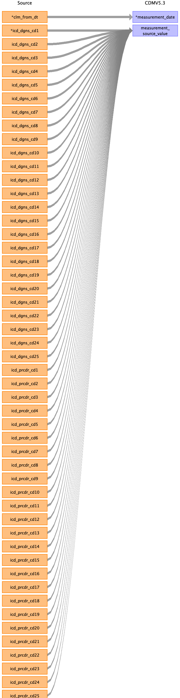

|  |  |  |  |
| --- | --- | --- | --- |
| Destination Field | Source Field | Logic | Comment |
| measurement_id |  |  | Add when new and unique measurement exists. |
| person_id |  |  | Linked to PERSON table |
| measurement_concept_id |  |  | OMOP CONCEPT MAPPING table |
| measurement_date | clm_from_dt |  |  |
| measurement_datetime |  |  |  |
| measurement_time |  |  |  |
| measurement_type_concept_id |  |  | 32810 Claim |
| operator_concept_id |  |  |  |
| value_as_number |  |  |  |
| value_as_concept_id |  |  |  |
| unit_concept_id |  |  |  |
| range_low |  |  |  |
| range_high |  |  |  |
| provider_id |  |  | Linked to PROVIDER table |
| visit_occurrence_id |  |  | Linked to VISIT_OCCURRENCE table |
| visit_detail_id |  |  |  |
| measurement_source_value | icd_dgns_cd1  icd_dgns_cd2  icd_dgns_cd3  icd_dgns_cd4  icd_dgns_cd5  icd_dgns_cd6  icd_dgns_cd7  icd_dgns_cd8  icd_dgns_cd9  icd_dgns_cd10  icd_dgns_cd11  icd_dgns_cd12  icd_dgns_cd13  icd_dgns_cd14  icd_dgns_cd15  icd_dgns_cd16  icd_dgns_cd17  icd_dgns_cd18  icd_dgns_cd19  icd_dgns_cd20  icd_dgns_cd21  icd_dgns_cd22  icd_dgns_cd23  icd_dgns_cd24  icd_dgns_cd25  icd_prcdr_cd1  icd_prcdr_cd2  icd_prcdr_cd3  icd_prcdr_cd4  icd_prcdr_cd5  icd_prcdr_cd6  icd_prcdr_cd7  icd_prcdr_cd8  icd_prcdr_cd9  icd_prcdr_cd10  icd_prcdr_cd11  icd_prcdr_cd12  icd_prcdr_cd13  icd_prcdr_cd14  icd_prcdr_cd15  icd_prcdr_cd16  icd_prcdr_cd17  icd_prcdr_cd18  icd_prcdr_cd19  icd_prcdr_cd20  icd_prcdr_cd21  icd_prcdr_cd22  icd_prcdr_cd23  icd_prcdr_cd24  icd_prcdr_cd25 |  |  |
| measurement_source_concept_id |  |  | OMOP CONCEPT MAPPING table |
| unit_source_value |  |  |  |
| value_source_value |  |  |  |

Reading from bcarrier_claims_k.csv

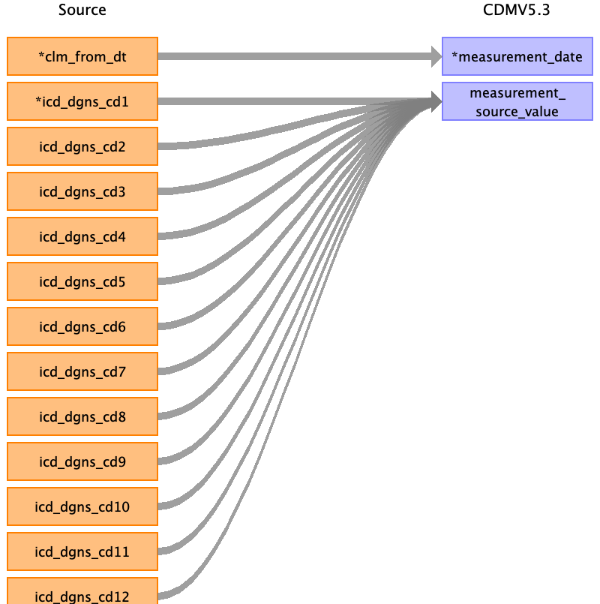

|  |  |  |  |
| --- | --- | --- | --- |
| Destination Field | Source Field | Logic | Comment |
| measurement_id |  |  | Add when new and unique measurement exists. |
| person_id |  |  | Linked to PERSON table |
| measurement_concept_id |  |  | OMOP CONCEPT MAPPING table |
| measurement_date | clm_from_dt |  |  |
| measurement_datetime |  |  |  |
| measurement_time |  |  |  |
| measurement_type_concept_id |  |  | 32810 Claim |
| operator_concept_id |  |  |  |
| value_as_number |  |  |  |
| value_as_concept_id |  |  |  |
| unit_concept_id |  |  |  |
| range_low |  |  |  |
| range_high |  |  |  |
| provider_id |  |  | Linked to PROVIDER table |
| visit_occurrence_id |  |  | Linked to VISIT_OCCURRENCE table |
| visit_detail_id |  |  |  |
| measurement_source_value | icd_dgns_cd1  icd_dgns_cd2  icd_dgns_cd3  icd_dgns_cd4  icd_dgns_cd5  icd_dgns_cd6  icd_dgns_cd7  icd_dgns_cd8  icd_dgns_cd9  icd_dgns_cd10  icd_dgns_cd11  icd_dgns_cd12 |  |  |
| measurement_source_concept_id |  |  | OMOP CONCEPT MAPPING table |
| unit_source_value |  |  |  |
| value_source_value |  |  |  |

Reading from snf_base_claims_k.csv

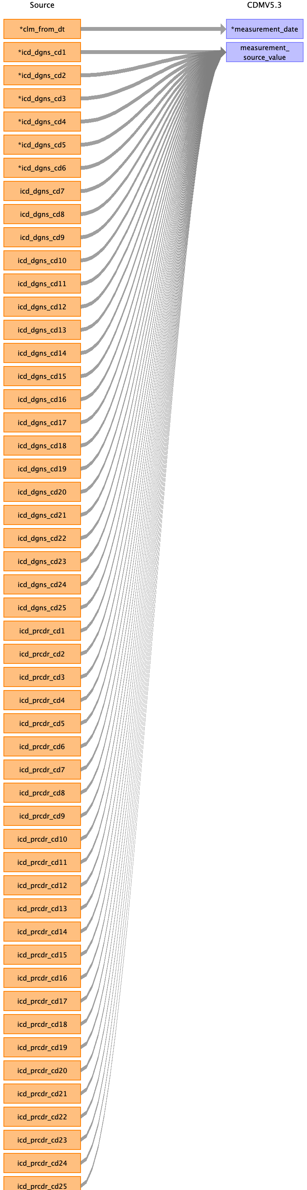

|  |  |  |  |
| --- | --- | --- | --- |
| Destination Field | Source Field | Logic | Comment |
| measurement_id |  |  | Add when new and unique measurement exists. |
| person_id |  |  | Linked to PERSON table |
| measurement_concept_id |  |  | OMOP CONCEPT MAPPING table |
| measurement_date | clm_from_dt |  |  |
| measurement_datetime |  |  |  |
| measurement_time |  |  |  |
| measurement_type_concept_id |  |  | 32810 Claim |
| operator_concept_id |  |  |  |
| value_as_number |  |  |  |
| value_as_concept_id |  |  |  |
| unit_concept_id |  |  |  |
| range_low |  |  |  |
| range_high |  |  |  |
| provider_id |  |  | Linked to PROVIDER table |
| visit_occurrence_id |  |  | Linked to VISIT_OCCURRENCE table |
| visit_detail_id |  |  |  |
| measurement_source_value | icd_dgns_cd1  icd_dgns_cd2  icd_dgns_cd3  icd_dgns_cd4  icd_dgns_cd5  icd_dgns_cd6  icd_dgns_cd7  icd_dgns_cd8  icd_dgns_cd9  icd_dgns_cd10  icd_dgns_cd11  icd_dgns_cd12  icd_dgns_cd13  icd_dgns_cd14  icd_dgns_cd15  icd_dgns_cd16  icd_dgns_cd17  icd_dgns_cd18  icd_dgns_cd19  icd_dgns_cd20  icd_dgns_cd21  icd_dgns_cd22  icd_dgns_cd23  icd_dgns_cd24  icd_dgns_cd25  icd_prcdr_cd1  icd_prcdr_cd2  icd_prcdr_cd3  icd_prcdr_cd4  icd_prcdr_cd5  icd_prcdr_cd6  icd_prcdr_cd7  icd_prcdr_cd8  icd_prcdr_cd9  icd_prcdr_cd10  icd_prcdr_cd11  icd_prcdr_cd12  icd_prcdr_cd13  icd_prcdr_cd14  icd_prcdr_cd15  icd_prcdr_cd16  icd_prcdr_cd17  icd_prcdr_cd18  icd_prcdr_cd19  icd_prcdr_cd20  icd_prcdr_cd21  icd_prcdr_cd22  icd_prcdr_cd23  icd_prcdr_cd24  icd_prcdr_cd25 |  |  |
| measurement_source_concept_id |  |  | OMOP CONCEPT MAPPING table |
| unit_source_value |  |  |  |
| value_source_value |  |  |  |

Reading from dme_claims_k.csv



|  |  |  |  |
| --- | --- | --- | --- |
| Destination Field | Source Field | Logic | Comment |
| measurement_id |  |  | Add when new and unique measurement exists. |
| person_id |  |  | Linked to PERSON table |
| measurement_concept_id |  |  | OMOP CONCEPT MAPPING table |
| measurement_date | clm_from_dt |  |  |
| measurement_datetime |  |  |  |
| measurement_time |  |  |  |
| measurement_type_concept_id |  |  | 32810 Claim |
| operator_concept_id |  |  |  |
| value_as_number |  |  |  |
| value_as_concept_id |  |  |  |
| unit_concept_id |  |  |  |
| range_low |  |  |  |
| range_high |  |  |  |
| provider_id |  |  | Linked to PROVIDER table |
| visit_occurrence_id |  |  | Linked to VISIT_OCCURRENCE table |
| visit_detail_id |  |  |  |
| measurement_source_value | icd_dgns_cd1  icd_dgns_cd2  icd_dgns_cd3  icd_dgns_cd4  icd_dgns_cd5  icd_dgns_cd6  icd_dgns_cd7  icd_dgns_cd8  icd_dgns_cd9  icd_dgns_cd10  icd_dgns_cd11  icd_dgns_cd12 |  |  |
| measurement_source_concept_id |  |  | OMOP CONCEPT MAPPING table |
| unit_source_value |  |  |  |
| value_source_value |  |  |  |

Reading from hha_base_claims_k.csv

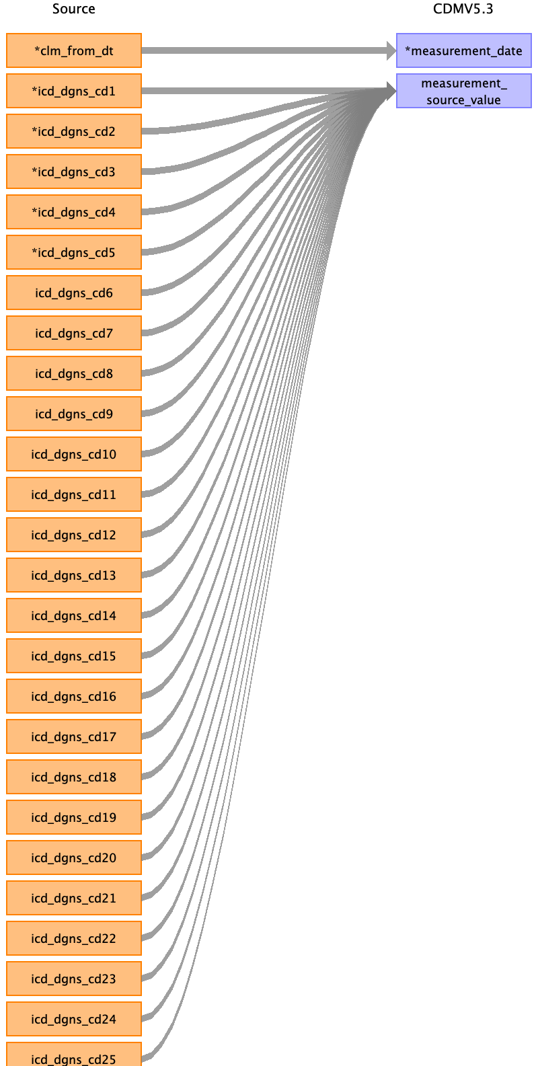

|  |  |  |  |
| --- | --- | --- | --- |
| Destination Field | Source Field | Logic | Comment |
| measurement_id |  |  | Add when new and unique measurement exists. |
| person_id |  |  | Linked to PERSON table |
| measurement_concept_id |  |  | OMOP CONCEPT MAPPING table |
| measurement_date | clm_from_dt |  |  |
| measurement_datetime |  |  |  |
| measurement_time |  |  |  |
| measurement_type_concept_id |  |  | 32810 Claim |
| operator_concept_id |  |  |  |
| value_as_number |  |  |  |
| value_as_concept_id |  |  |  |
| unit_concept_id |  |  |  |
| range_low |  |  |  |
| range_high |  |  |  |
| provider_id |  |  | Linked to PROVIDER table |
| visit_occurrence_id |  |  | Linked to VISIT_OCCURRENCE table |
| visit_detail_id |  |  |  |
| measurement_source_value | icd_dgns_cd1  icd_dgns_cd2  icd_dgns_cd3  icd_dgns_cd4  icd_dgns_cd5  icd_dgns_cd6  icd_dgns_cd7  icd_dgns_cd8  icd_dgns_cd9  icd_dgns_cd10  icd_dgns_cd11  icd_dgns_cd12  icd_dgns_cd13  icd_dgns_cd14  icd_dgns_cd15  icd_dgns_cd16  icd_dgns_cd17  icd_dgns_cd18  icd_dgns_cd19  icd_dgns_cd20  icd_dgns_cd21  icd_dgns_cd22  icd_dgns_cd23  icd_dgns_cd24  icd_dgns_cd25 |  |  |
| measurement_source_concept_id |  |  | OMOP CONCEPT MAPPING table |
| unit_source_value |  |  |  |
| value_source_value |  |  |  |

Reading from hospice_base_claims_k.csv

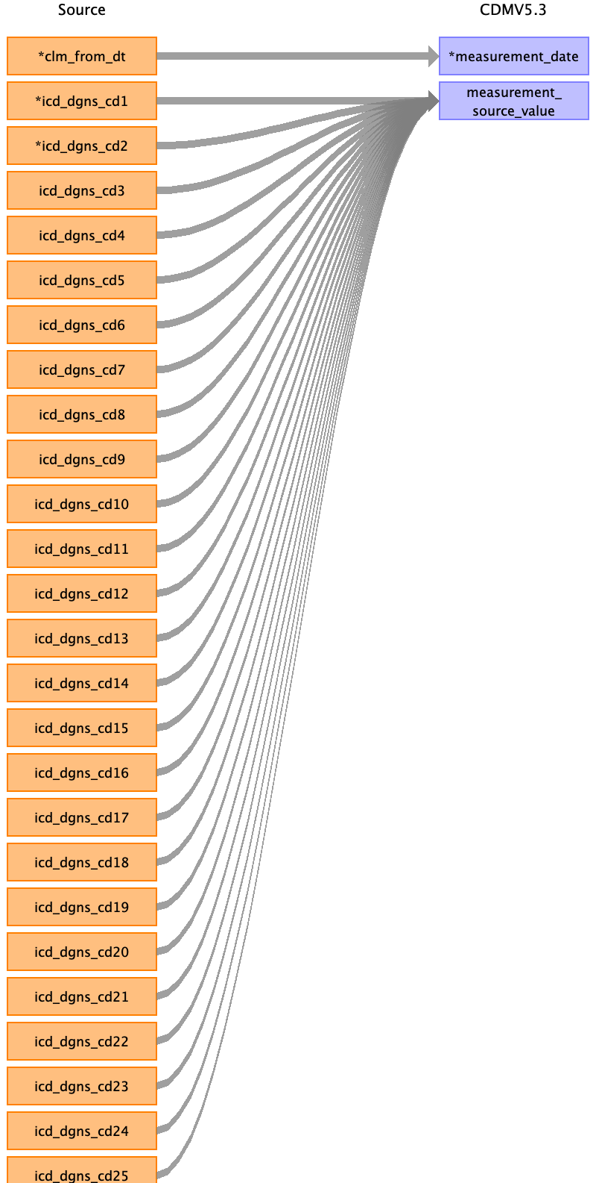

|  |  |  |  |
| --- | --- | --- | --- |
| Destination Field | Source Field | Logic | Comment |
| measurement_id |  |  | Add when new and unique measurement exists. |
| person_id |  |  | Linked to PERSON table |
| measurement_concept_id |  |  | OMOP CONCEPT MAPPING table |
| measurement_date | clm_from_dt |  |  |
| measurement_datetime |  |  |  |
| measurement_time |  |  |  |
| measurement_type_concept_id |  |  | 32810 Claim |
| operator_concept_id |  |  |  |
| value_as_number |  |  |  |
| value_as_concept_id |  |  |  |
| unit_concept_id |  |  |  |
| range_low |  |  |  |
| range_high |  |  |  |
| provider_id |  |  | Linked to PROVIDER table |
| visit_occurrence_id |  |  | Linked to VISIT_OCCURRENCE table |
| visit_detail_id |  |  |  |
| measurement_source_value | icd_dgns_cd1  icd_dgns_cd2  icd_dgns_cd3  icd_dgns_cd4  icd_dgns_cd5  icd_dgns_cd6  icd_dgns_cd7  icd_dgns_cd8  icd_dgns_cd9  icd_dgns_cd10  icd_dgns_cd11  icd_dgns_cd12  icd_dgns_cd13  icd_dgns_cd14  icd_dgns_cd15  icd_dgns_cd16  icd_dgns_cd17  icd_dgns_cd18  icd_dgns_cd19  icd_dgns_cd20  icd_dgns_cd21  icd_dgns_cd22  icd_dgns_cd23  icd_dgns_cd24  icd_dgns_cd25 |  |  |
| measurement_source_concept_id |  |  | OMOP CONCEPT MAPPING table |
| unit_source_value |  |  |  |
| value_source_value |  |  |  |

Reading from bcarrier_line_k.csv

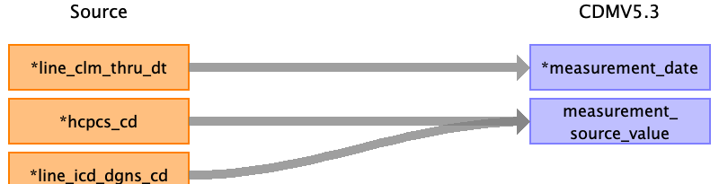

|  |  |  |  |
| --- | --- | --- | --- |
| Destination Field | Source Field | Logic | Comment |
| measurement_id |  |  | Add when new and unique measurement exists. |
| person_id |  |  | Linked to PERSON table |
| measurement_concept_id |  |  | OMOP CONCEPT MAPPING table |
| measurement_date | line_clm_thru_dt |  |  |
| measurement_datetime |  |  |  |
| measurement_time |  |  |  |
| measurement_type_concept_id |  |  | 32810 Claim |
| operator_concept_id |  |  |  |
| value_as_number |  |  |  |
| value_as_concept_id |  |  |  |
| unit_concept_id |  |  |  |
| range_low |  |  |  |
| range_high |  |  |  |
| provider_id |  |  | Linked to PROVIDER table |
| visit_occurrence_id |  |  | Linked to VISIT_OCCURRENCE table |
| visit_detail_id |  |  |  |
| measurement_source_value | line_icd_dgns_cd  hcpcs_cd |  |  |
| measurement_source_concept_id |  |  | OMOP CONCEPT MAPPING table |
| unit_source_value |  |  |  |
| value_source_value |  |  |  |

Reading from dme_line_k.csv



|  |  |  |  |
| --- | --- | --- | --- |
| Destination Field | Source Field | Logic | Comment |
| measurement_id |  |  | Add when new and unique measurement exists. |
| person_id |  |  | Linked to PERSON table |
| measurement_concept_id |  |  | OMOP CONCEPT MAPPING table |
| measurement_date | line_clm_thru_dt |  |  |
| measurement_datetime |  |  |  |
| measurement_time |  |  |  |
| measurement_type_concept_id |  |  | 32810 Claim |
| operator_concept_id |  |  |  |
| value_as_number |  |  |  |
| value_as_concept_id |  |  |  |
| unit_concept_id |  |  |  |
| range_low |  |  |  |
| range_high |  |  |  |
| provider_id |  |  | Linked to PROVIDER table |
| visit_occurrence_id |  |  | Linked to VISIT_OCCURRENCE table |
| visit_detail_id |  |  |  |
| measurement_source_value | line_icd_dgns_cd  hcpcs_cd |  |  |
| measurement_source_concept_id |  |  | OMOP CONCEPT MAPPING table |
| unit_source_value |  |  |  |
| value_source_value |  |  |  |

Reading from inpatient_revenue_center_k.csv

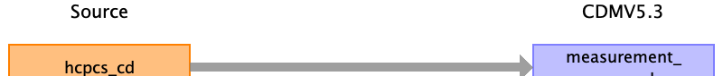

|  |  |  |  |
| --- | --- | --- | --- |
| Destination Field | Source Field | Logic | Comment |
| measurement_id |  |  | Add when new and unique measurement exists. |
| person_id |  |  | Linked to PERSON table |
| measurement_concept_id |  |  | OMOP CONCEPT MAPPING table |
| measurement_date |  |  |  |
| measurement_datetime |  |  |  |
| measurement_time |  |  |  |
| measurement_type_concept_id |  |  | 32810 Claim |
| operator_concept_id |  |  |  |
| value_as_number |  |  |  |
| value_as_concept_id |  |  |  |
| unit_concept_id |  |  |  |
| range_low |  |  |  |
| range_high |  |  |  |
| provider_id |  |  | Linked to PROVIDER table |
| visit_occurrence_id |  |  | Linked to VISIT_OCCURRENCE table |
| visit_detail_id |  |  |  |
| measurement_source_value | hcpcs_cd |  |  |
| measurement_source_concept_id |  |  | OMOP CONCEPT MAPPING table |
| unit_source_value |  |  |  |
| value_source_value |  |  |  |

Reading from outpatient_revenue_center_k.csv



|  |  |  |  |
| --- | --- | --- | --- |
| Destination Field | Source Field | Logic | Comment |
| measurement_id |  |  | Add when new and unique measurement exists. |
| person_id |  |  | Linked to PERSON table |
| measurement_concept_id |  |  | OMOP CONCEPT MAPPING table |
| measurement_date |  |  |  |
| measurement_datetime |  |  |  |
| measurement_time |  |  |  |
| measurement_type_concept_id |  |  | 32810 Claim |
| operator_concept_id |  |  |  |
| value_as_number |  |  |  |
| value_as_concept_id |  |  |  |
| unit_concept_id |  |  |  |
| range_low |  |  |  |
| range_high |  |  |  |
| provider_id |  |  | Linked to PROVIDER table |
| visit_occurrence_id |  |  | Linked to VISIT_OCCURRENCE table |
| visit_detail_id |  |  |  |
| measurement_source_value | hcpcs_cd |  |  |
| measurement_source_concept_id |  |  | OMOP CONCEPT MAPPING table |
| unit_source_value |  |  |  |
| value_source_value |  |  |  |

Reading from snf_revenue_center_k.csv



|  |  |  |  |
| --- | --- | --- | --- |
| Destination Field | Source Field | Logic | Comment |
| measurement_id |  |  | Add when new and unique measurement exists. |
| person_id |  |  | Linked to PERSON table |
| measurement_concept_id |  |  | OMOP CONCEPT MAPPING table |
| measurement_date |  |  |  |
| measurement_datetime |  |  |  |
| measurement_time |  |  |  |
| measurement_type_concept_id |  |  | 32810 Claim |
| operator_concept_id |  |  |  |
| value_as_number |  |  |  |
| value_as_concept_id |  |  |  |
| unit_concept_id |  |  |  |
| range_low |  |  |  |
| range_high |  |  |  |
| provider_id |  |  | Linked to PROVIDER table |
| visit_occurrence_id |  |  | Linked to VISIT_OCCURRENCE table |
| visit_detail_id |  |  |  |
| measurement_source_value | hcpcs_cd |  |  |
| measurement_source_concept_id |  |  | OMOP CONCEPT MAPPING table |
| unit_source_value |  |  |  |
| value_source_value |  |  |  |

Reading from hha_revenue_center_k.csv



|  |  |  |  |
| --- | --- | --- | --- |
| Destination Field | Source Field | Logic | Comment |
| measurement_id |  |  | Add when new and unique measurement exists. |
| person_id |  |  | Linked to PERSON table |
| measurement_concept_id |  |  | OMOP CONCEPT MAPPING table |
| measurement_date |  |  |  |
| measurement_datetime |  |  |  |
| measurement_time |  |  |  |
| measurement_type_concept_id |  |  | 32810 Claim |
| operator_concept_id |  |  |  |
| value_as_number |  |  |  |
| value_as_concept_id |  |  |  |
| unit_concept_id |  |  |  |
| range_low |  |  |  |
| range_high |  |  |  |
| provider_id |  |  | Linked to PROVIDER table |
| visit_occurrence_id |  |  | Linked to VISIT_OCCURRENCE table |
| visit_detail_id |  |  |  |
| measurement_source_value | hcpcs_cd |  |  |
| measurement_source_concept_id |  |  | OMOP CONCEPT MAPPING table |
| unit_source_value |  |  |  |
| value_source_value |  |  |  |

Reading from hospice_revenue_center_k.csv



|  |  |  |  |
| --- | --- | --- | --- |
| Destination Field | Source Field | Logic | Comment |
| measurement_id |  |  | Add when new and unique measurement exists. |
| person_id |  |  | Linked to PERSON table |
| measurement_concept_id |  |  | OMOP CONCEPT MAPPING table |
| measurement_date |  |  |  |
| measurement_datetime |  |  |  |
| measurement_time |  |  |  |
| measurement_type_concept_id |  |  | 32810 Claim |
| operator_concept_id |  |  |  |
| value_as_number |  |  |  |
| value_as_concept_id |  |  |  |
| unit_concept_id |  |  |  |
| range_low |  |  |  |
| range_high |  |  |  |
| provider_id |  |  | Linked to PROVIDER table |
| visit_occurrence_id |  |  | Linked to VISIT_OCCURRENCE table |
| visit_detail_id |  |  |  |
| measurement_source_value | hcpcs_cd |  |  |
| measurement_source_concept_id |  |  | OMOP CONCEPT MAPPING table |
| unit_source_value |  |  |  |
| value_source_value |  |  |  |

Table name: note

NOT USING

Table name: note_nlp

NOT USING

Table name: observation

Reading from stem_table

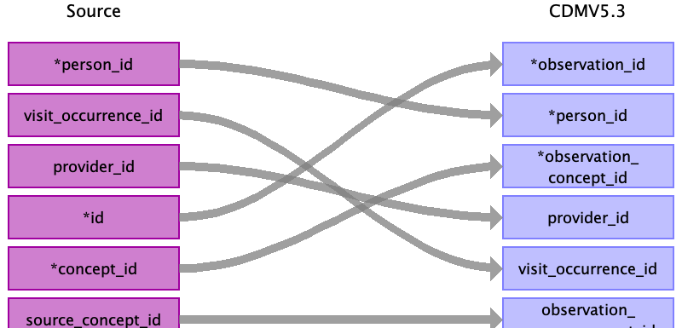

|  |  |  |  |
| --- | --- | --- | --- |
| Destination Field | Source Field | Logic | Comment |
| observation_id | id |  | Add when new and unique observation code exists. |
| person_id | person_id |  | Linked to PERSON table |
| observation_concept_id | concept_id |  | OMOP CONCEPT MAPPING table |
| observation_date |  |  |  |
| observation_datetime |  |  |  |
| observation_type_concept_id |  |  | 32810 Claim |
| value_as_number |  |  |  |
| value_as_string |  |  |  |
| value_as_concept_id |  |  |  |
| qualifier_concept_id |  |  |  |
| unit_concept_id |  |  |  |
| provider_id | provider_id |  | Linked to PROVIDER table |
| visit_occurrence_id | visit_occurrence_id |  | Linked to VISIT_OCCURRENCE table |
| visit_detail_id |  |  |  |
| observation_source_value |  |  |  |
| observation_source_concept_id | source_concept_id |  | OMOP CONCEPT MAPPING table |
| unit_source_value |  |  |  |
| qualifier_source_value |  |  |  |

Reading from inpatient_base_claims_k.csv

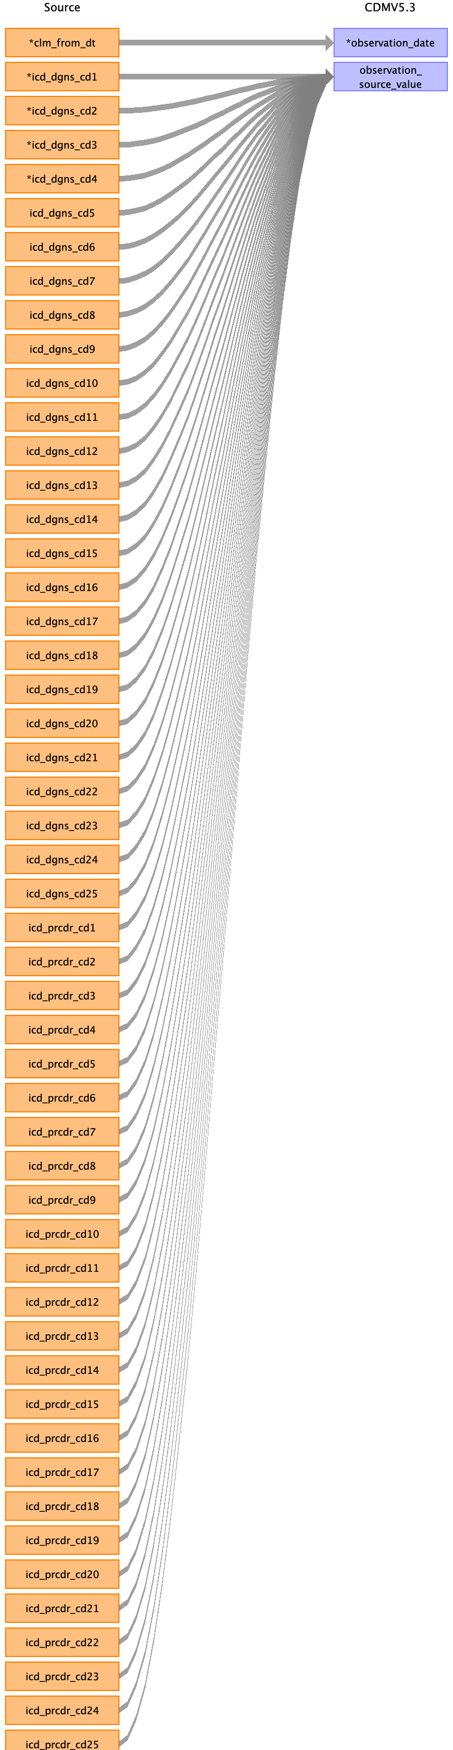

|  |  |  |  |
| --- | --- | --- | --- |
| Destination Field | Source Field | Logic | Comment |
| observation_id |  |  | Add when new and unique observation code exists. |
| person_id |  |  | Linked to PERSON table |
| observation_concept_id |  |  | OMOP CONCEPT MAPPING table |
| observation_date | clm_from_dt |  |  |
| observation_datetime |  |  |  |
| observation_type_concept_id |  |  | 32810 Claim |
| value_as_number |  |  |  |
| value_as_string |  |  |  |
| value_as_concept_id |  |  |  |
| qualifier_concept_id |  |  |  |
| unit_concept_id |  |  |  |
| provider_id |  |  | Linked to PROVIDER table |
| visit_occurrence_id |  |  | Linked to VISIT_OCCURRENCE table |
| visit_detail_id |  |  |  |
| observation_source_value | icd_dgns_cd1  icd_dgns_cd2  icd_dgns_cd3  icd_dgns_cd4  icd_dgns_cd5  icd_dgns_cd6  icd_dgns_cd7  icd_dgns_cd8  icd_dgns_cd9  icd_dgns_cd10  icd_dgns_cd11  icd_dgns_cd12  icd_dgns_cd13  icd_dgns_cd14  icd_dgns_cd15  icd_dgns_cd16  icd_dgns_cd17  icd_dgns_cd18  icd_dgns_cd19  icd_dgns_cd20  icd_dgns_cd21  icd_dgns_cd22  icd_dgns_cd23  icd_dgns_cd24  icd_dgns_cd25  icd_prcdr_cd1  icd_prcdr_cd2  icd_prcdr_cd3  icd_prcdr_cd4  icd_prcdr_cd5  icd_prcdr_cd6  icd_prcdr_cd7  icd_prcdr_cd8  icd_prcdr_cd9  icd_prcdr_cd10  icd_prcdr_cd11  icd_prcdr_cd12  icd_prcdr_cd13  icd_prcdr_cd14  icd_prcdr_cd15  icd_prcdr_cd16  icd_prcdr_cd17  icd_prcdr_cd18  icd_prcdr_cd19  icd_prcdr_cd20  icd_prcdr_cd21  icd_prcdr_cd22  icd_prcdr_cd23  icd_prcdr_cd24  icd_prcdr_cd25 |  |  |
| observation_source_concept_id |  |  | OMOP CONCEPT MAPPING table |
| unit_source_value |  |  |  |
| qualifier_source_value |  |  |  |

Reading from outpatient_base_claims_k.csv

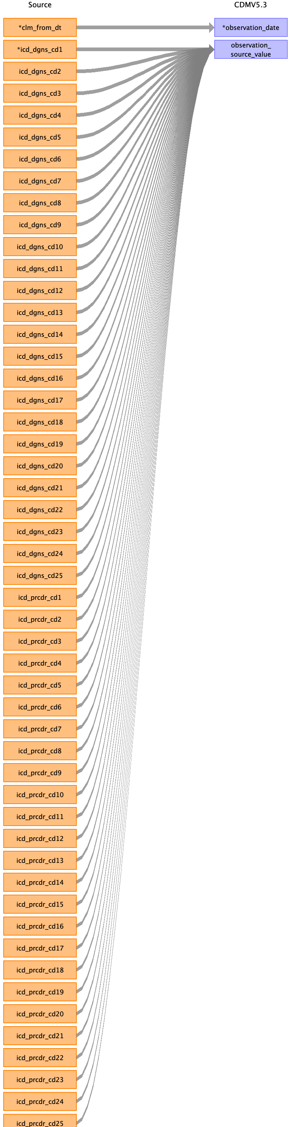

|  |  |  |  |
| --- | --- | --- | --- |
| Destination Field | Source Field | Logic | Comment |
| observation_id |  |  | Add when new and unique observation code exists. |
| person_id |  |  | Linked to PERSON table |
| observation_concept_id |  |  | OMOP CONCEPT MAPPING table |
| observation_date | clm_from_dt |  |  |
| observation_datetime |  |  |  |
| observation_type_concept_id |  |  | 32810 Claim |
| value_as_number |  |  |  |
| value_as_string |  |  |  |
| value_as_concept_id |  |  |  |
| qualifier_concept_id |  |  |  |
| unit_concept_id |  |  |  |
| provider_id |  |  | Linked to PROVIDER table |
| visit_occurrence_id |  |  | Linked to VISIT_OCCURRENCE table |
| visit_detail_id |  |  |  |
| observation_source_value | icd_dgns_cd1  icd_dgns_cd2  icd_dgns_cd3  icd_dgns_cd4  icd_dgns_cd5  icd_dgns_cd6  icd_dgns_cd7  icd_dgns_cd8  icd_dgns_cd9  icd_dgns_cd10  icd_dgns_cd11  icd_dgns_cd12  icd_dgns_cd13  icd_dgns_cd14  icd_dgns_cd15  icd_dgns_cd16  icd_dgns_cd17  icd_dgns_cd18  icd_dgns_cd19  icd_dgns_cd20  icd_dgns_cd21  icd_dgns_cd22  icd_dgns_cd23  icd_dgns_cd24  icd_dgns_cd25  icd_prcdr_cd1  icd_prcdr_cd2  icd_prcdr_cd3  icd_prcdr_cd4  icd_prcdr_cd5  icd_prcdr_cd6  icd_prcdr_cd7  icd_prcdr_cd8  icd_prcdr_cd9  icd_prcdr_cd10  icd_prcdr_cd11  icd_prcdr_cd12  icd_prcdr_cd13  icd_prcdr_cd14  icd_prcdr_cd15  icd_prcdr_cd16  icd_prcdr_cd17  icd_prcdr_cd18  icd_prcdr_cd19  icd_prcdr_cd20  icd_prcdr_cd21  icd_prcdr_cd22  icd_prcdr_cd23  icd_prcdr_cd24  icd_prcdr_cd25 |  |  |
| observation_source_concept_id |  |  | OMOP CONCEPT MAPPING table |
| unit_source_value |  |  |  |
| qualifier_source_value |  |  |  |

Reading from bcarrier_claims_k.csv

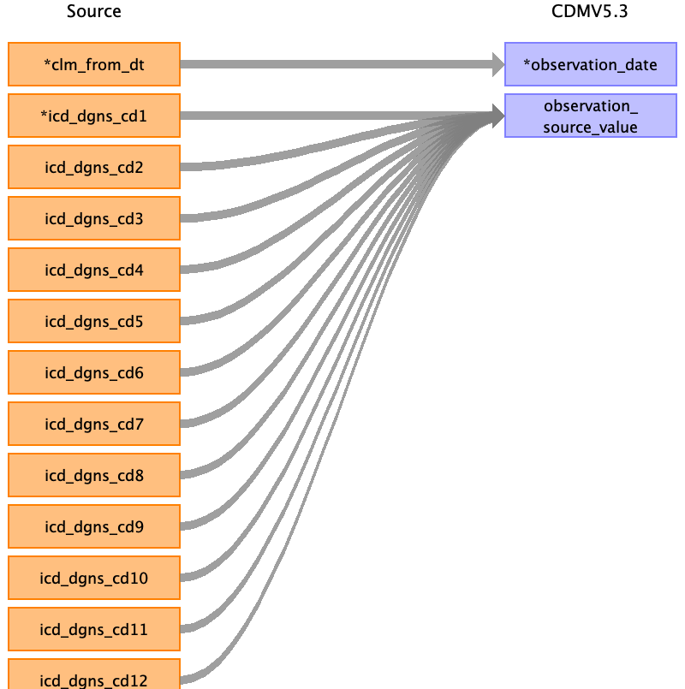

|  |  |  |  |
| --- | --- | --- | --- |
| Destination Field | Source Field | Logic | Comment |
| observation_id |  |  | Add when new and unique observation code exists. |
| person_id |  |  | Linked to PERSON table |
| observation_concept_id |  |  | OMOP CONCEPT MAPPING table |
| observation_date | clm_from_dt |  |  |
| observation_datetime |  |  |  |
| observation_type_concept_id |  |  | 32810 Claim |
| value_as_number |  |  |  |
| value_as_string |  |  |  |
| value_as_concept_id |  |  |  |
| qualifier_concept_id |  |  |  |
| unit_concept_id |  |  |  |
| provider_id |  |  | Linked to PROVIDER table |
| visit_occurrence_id |  |  | Linked to VISIT_OCCURRENCE table |
| visit_detail_id |  |  |  |
| observation_source_value | icd_dgns_cd1  icd_dgns_cd2  icd_dgns_cd3  icd_dgns_cd4  icd_dgns_cd5  icd_dgns_cd6  icd_dgns_cd7  icd_dgns_cd8  icd_dgns_cd9  icd_dgns_cd10  icd_dgns_cd11  icd_dgns_cd12 |  |  |
| observation_source_concept_id |  |  | OMOP CONCEPT MAPPING table |
| unit_source_value |  |  |  |
| qualifier_source_value |  |  |  |

Reading from snf_base_claims_k.csv

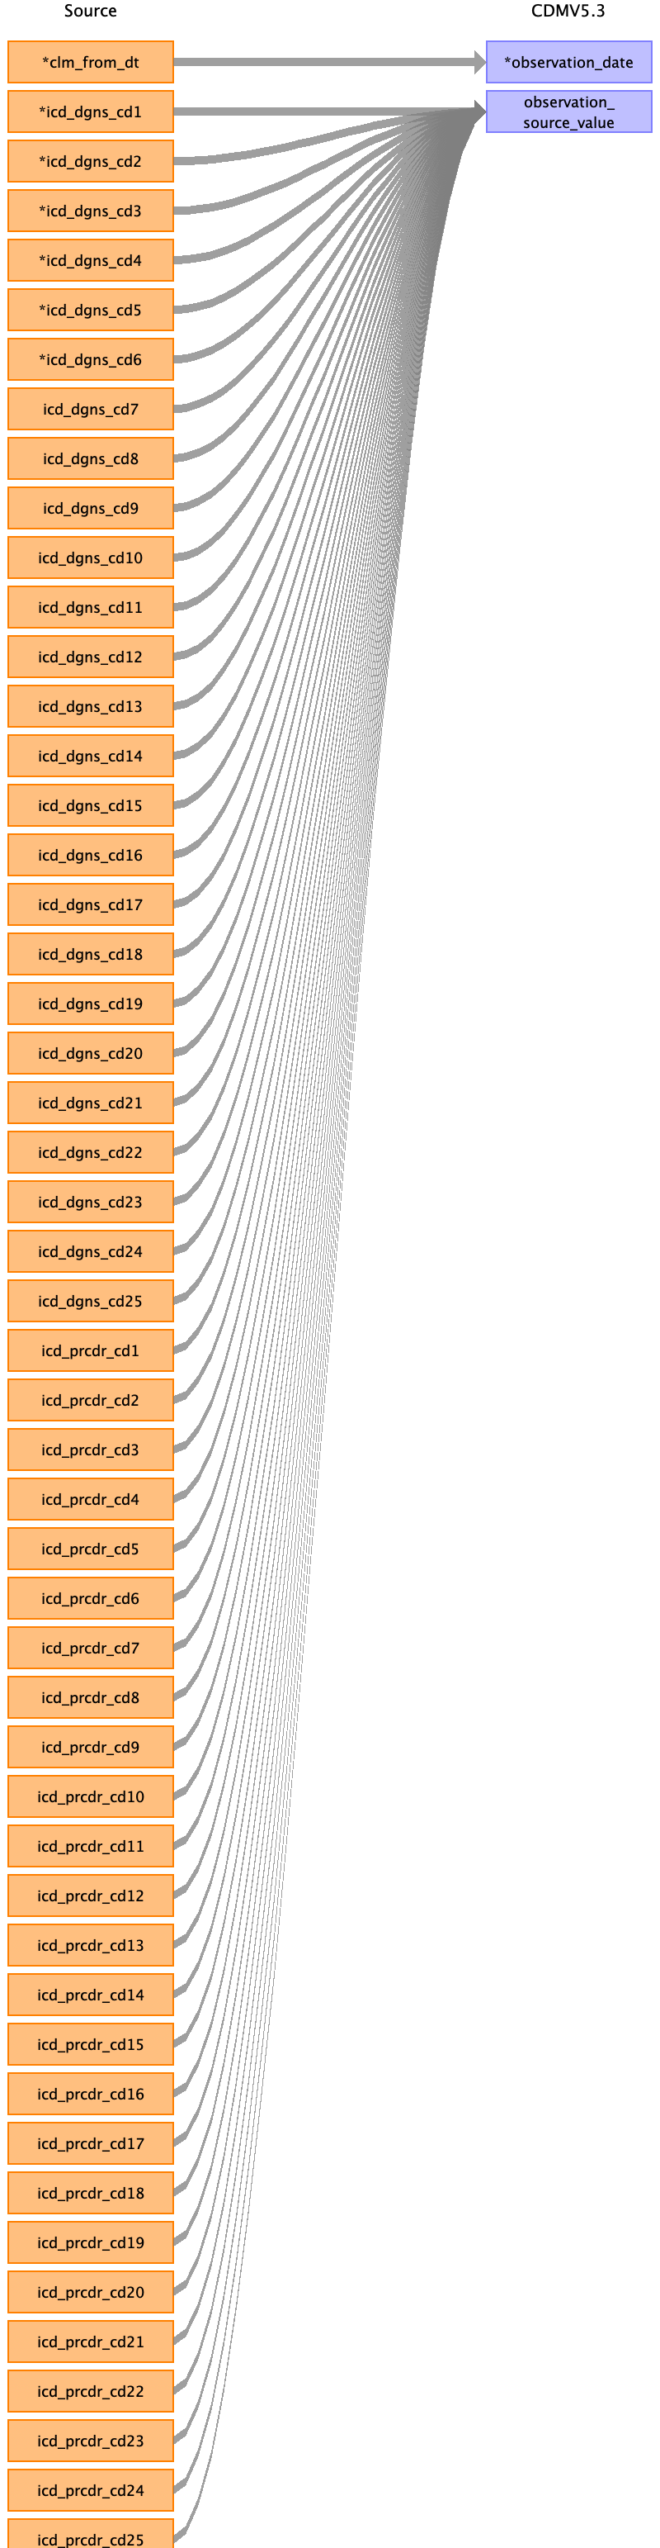

|  |  |  |  |
| --- | --- | --- | --- |
| Destination Field | Source Field | Logic | Comment |
| observation_id |  |  | Add when new and unique observation code exists. |
| person_id |  |  | Linked to PERSON table |
| observation_concept_id |  |  | OMOP CONCEPT MAPPING table |
| observation_date | clm_from_dt |  |  |
| observation_datetime |  |  |  |
| observation_type_concept_id |  |  | 32810 Claim |
| value_as_number |  |  |  |
| value_as_string |  |  |  |
| value_as_concept_id |  |  |  |
| qualifier_concept_id |  |  |  |
| unit_concept_id |  |  |  |
| provider_id |  |  | Linked to PROVIDER table |
| visit_occurrence_id |  |  | Linked to VISIT_OCCURRENCE table |
| visit_detail_id |  |  |  |
| observation_source_value | icd_dgns_cd1  icd_dgns_cd2  icd_dgns_cd3  icd_dgns_cd4  icd_dgns_cd5  icd_dgns_cd6  icd_dgns_cd7  icd_dgns_cd8  icd_dgns_cd9  icd_dgns_cd10  icd_dgns_cd11  icd_dgns_cd12  icd_dgns_cd13  icd_dgns_cd14  icd_dgns_cd15  icd_dgns_cd16  icd_dgns_cd17  icd_dgns_cd18  icd_dgns_cd19  icd_dgns_cd20  icd_dgns_cd21  icd_dgns_cd22  icd_dgns_cd23  icd_dgns_cd24  icd_dgns_cd25  icd_prcdr_cd1  icd_prcdr_cd2  icd_prcdr_cd3  icd_prcdr_cd4  icd_prcdr_cd5  icd_prcdr_cd6  icd_prcdr_cd7  icd_prcdr_cd8  icd_prcdr_cd9  icd_prcdr_cd10  icd_prcdr_cd11  icd_prcdr_cd12  icd_prcdr_cd13  icd_prcdr_cd14  icd_prcdr_cd15  icd_prcdr_cd16  icd_prcdr_cd17  icd_prcdr_cd18  icd_prcdr_cd19  icd_prcdr_cd20  icd_prcdr_cd21  icd_prcdr_cd22  icd_prcdr_cd23  icd_prcdr_cd24  icd_prcdr_cd25 |  |  |
| observation_source_concept_id |  |  | OMOP CONCEPT MAPPING table |
| unit_source_value |  |  |  |
| qualifier_source_value |  |  |  |

Reading from dme_claims_k.csv



|  |  |  |  |
| --- | --- | --- | --- |
| Destination Field | Source Field | Logic | Comment |
| observation_id |  |  | Add when new and unique observation code exists. |
| person_id |  |  | Linked to PERSON table |
| observation_concept_id |  |  | OMOP CONCEPT MAPPING table |
| observation_date | clm_from_dt |  |  |
| observation_datetime |  |  |  |
| observation_type_concept_id |  |  | 32810 Claim |
| value_as_number |  |  |  |
| value_as_string |  |  |  |
| value_as_concept_id |  |  |  |
| qualifier_concept_id |  |  |  |
| unit_concept_id |  |  |  |
| provider_id |  |  | Linked to PROVIDER table |
| visit_occurrence_id |  |  | Linked to VISIT_OCCURRENCE table |
| visit_detail_id |  |  |  |
| observation_source_value | icd_dgns_cd1  icd_dgns_cd2  icd_dgns_cd3  icd_dgns_cd4  icd_dgns_cd5  icd_dgns_cd6  icd_dgns_cd7  icd_dgns_cd8  icd_dgns_cd9  icd_dgns_cd10  icd_dgns_cd11  icd_dgns_cd12 |  |  |
| observation_source_concept_id |  |  | OMOP CONCEPT MAPPING table |
| unit_source_value |  |  |  |
| qualifier_source_value |  |  |  |

Reading from hha_base_claims_k.csv

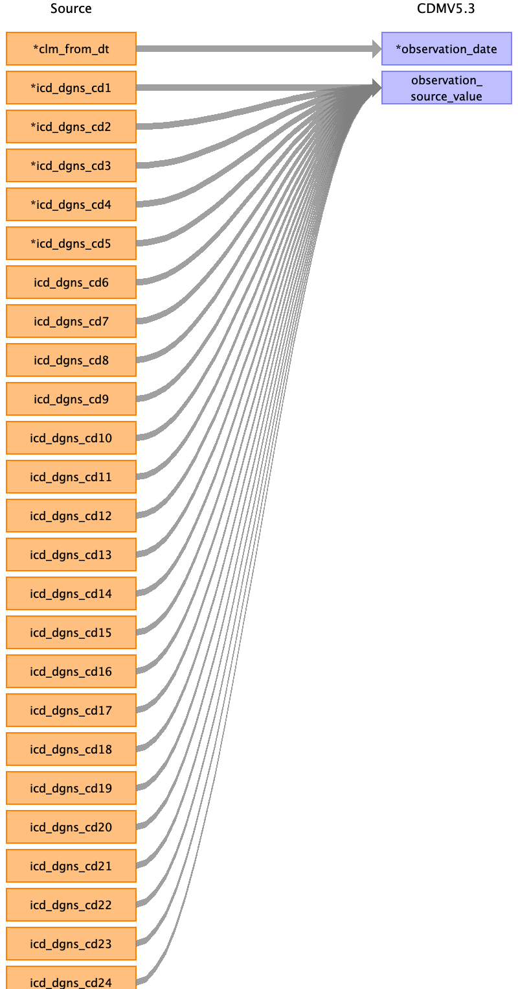

|  |  |  |  |
| --- | --- | --- | --- |
| Destination Field | Source Field | Logic | Comment |
| observation_id |  |  | Add when new and unique observation code exists. |
| person_id |  |  | Linked to PERSON table |
| observation_concept_id |  |  | OMOP CONCEPT MAPPING table |
| observation_date | clm_from_dt |  |  |
| observation_datetime |  |  |  |
| observation_type_concept_id |  |  | 32810 Claim |
| value_as_number |  |  |  |
| value_as_string |  |  |  |
| value_as_concept_id |  |  |  |
| qualifier_concept_id |  |  |  |
| unit_concept_id |  |  |  |
| provider_id |  |  | Linked to PROVIDER table |
| visit_occurrence_id |  |  | Linked to VISIT_OCCURRENCE table |
| visit_detail_id |  |  |  |
| observation_source_value | icd_dgns_cd1  icd_dgns_cd2  icd_dgns_cd3  icd_dgns_cd4  icd_dgns_cd5  icd_dgns_cd6  icd_dgns_cd7  icd_dgns_cd8  icd_dgns_cd9  icd_dgns_cd10  icd_dgns_cd11  icd_dgns_cd12  icd_dgns_cd13  icd_dgns_cd14  icd_dgns_cd15  icd_dgns_cd16  icd_dgns_cd17  icd_dgns_cd18  icd_dgns_cd19  icd_dgns_cd20  icd_dgns_cd21  icd_dgns_cd22  icd_dgns_cd23  icd_dgns_cd24 |  |  |
| observation_source_concept_id |  |  | OMOP CONCEPT MAPPING table |
| unit_source_value |  |  |  |
| qualifier_source_value |  |  |  |

Reading from hospice_base_claims_k.csv

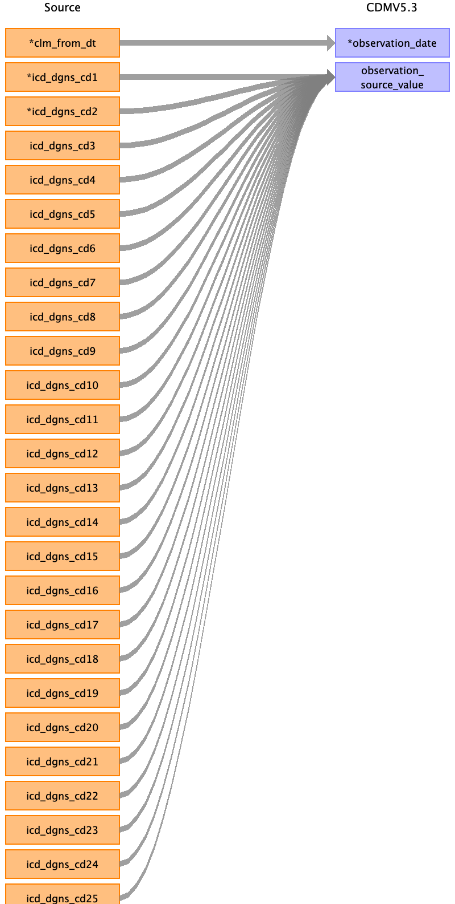

|  |  |  |  |
| --- | --- | --- | --- |
| Destination Field | Source Field | Logic | Comment |
| observation_id |  |  | Add when new and unique observation code exists. |
| person_id |  |  | Linked to PERSON table |
| observation_concept_id |  |  | OMOP CONCEPT MAPPING table |
| observation_date | clm_from_dt |  |  |
| observation_datetime |  |  |  |
| observation_type_concept_id |  |  | 32810 Claim |
| value_as_number |  |  |  |
| value_as_string |  |  |  |
| value_as_concept_id |  |  |  |
| qualifier_concept_id |  |  |  |
| unit_concept_id |  |  |  |
| provider_id |  |  | Linked to PROVIDER table |
| visit_occurrence_id |  |  | Linked to VISIT_OCCURRENCE table |
| visit_detail_id |  |  |  |
| observation_source_value | icd_dgns_cd1  icd_dgns_cd2  icd_dgns_cd3  icd_dgns_cd4  icd_dgns_cd5  icd_dgns_cd6  icd_dgns_cd7  icd_dgns_cd8  icd_dgns_cd9  icd_dgns_cd10  icd_dgns_cd11  icd_dgns_cd12  icd_dgns_cd13  icd_dgns_cd14  icd_dgns_cd15  icd_dgns_cd16  icd_dgns_cd17  icd_dgns_cd18  icd_dgns_cd19  icd_dgns_cd20  icd_dgns_cd21  icd_dgns_cd22  icd_dgns_cd23  icd_dgns_cd24  icd_dgns_cd25 |  |  |
| observation_source_concept_id |  |  | OMOP CONCEPT MAPPING table |
| unit_source_value |  |  |  |
| qualifier_source_value |  |  |  |

Reading from bcarrier_line_k.csv

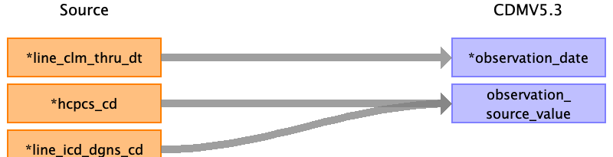

|  |  |  |  |
| --- | --- | --- | --- |
| Destination Field | Source Field | Logic | Comment |
| observation_id |  |  | Add when new and unique observation code exists. |
| person_id |  |  | Linked to PERSON table |
| observation_concept_id |  |  | OMOP CONCEPT MAPPING table |
| observation_date | line_clm_thru_dt |  |  |
| observation_datetime |  |  |  |
| observation_type_concept_id |  |  | 32810 Claim |
| value_as_number |  |  |  |
| value_as_string |  |  |  |
| value_as_concept_id |  |  |  |
| qualifier_concept_id |  |  |  |
| unit_concept_id |  |  |  |
| provider_id |  |  | Linked to PROVIDER table |
| visit_occurrence_id |  |  | Linked to VISIT_OCCURRENCE table |
| visit_detail_id |  |  |  |
| observation_source_value | line_icd_dgns_cd  hcpcs_cd |  |  |
| observation_source_concept_id |  |  | OMOP CONCEPT MAPPING table |
| unit_source_value |  |  |  |
| qualifier_source_value |  |  |  |

Reading from dme_line_k.csv



|  |  |  |  |
| --- | --- | --- | --- |
| Destination Field | Source Field | Logic | Comment |
| observation_id |  |  | Add when new and unique observation code exists. |
| person_id |  |  | Linked to PERSON table |
| observation_concept_id |  |  | OMOP CONCEPT MAPPING table |
| observation_date | line_clm_thru_dt |  |  |
| observation_datetime |  |  |  |
| observation_type_concept_id |  |  | 32810 Claim |
| value_as_number |  |  |  |
| value_as_string |  |  |  |
| value_as_concept_id |  |  |  |
| qualifier_concept_id |  |  |  |
| unit_concept_id |  |  |  |
| provider_id |  |  | Linked to PROVIDER table |
| visit_occurrence_id |  |  | Linked to VISIT_OCCURRENCE table |
| visit_detail_id |  |  |  |
| observation_source_value | hcpcs_cd  line_icd_dgns_cd |  |  |
| observation_source_concept_id |  |  | OMOP CONCEPT MAPPING table |
| unit_source_value |  |  |  |
| qualifier_source_value |  |  |  |

Reading from inpatient_revenue_center_k.csv

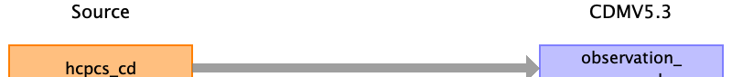

|  |  |  |  |
| --- | --- | --- | --- |
| Destination Field | Source Field | Logic | Comment |
| observation_id |  |  | Add when new and unique observation code exists. |
| person_id |  |  | Linked to PERSON table |
| observation_concept_id |  |  | OMOP CONCEPT MAPPING table |
| observation_date |  |  |  |
| observation_datetime |  |  |  |
| observation_type_concept_id |  |  | 32810 Claim |
| value_as_number |  |  |  |
| value_as_string |  |  |  |
| value_as_concept_id |  |  |  |
| qualifier_concept_id |  |  |  |
| unit_concept_id |  |  |  |
| provider_id |  |  | Linked to PROVIDER table |
| visit_occurrence_id |  |  | Linked to VISIT_OCCURRENCE table |
| visit_detail_id |  |  |  |
| observation_source_value | hcpcs_cd |  |  |
| observation_source_concept_id |  |  | OMOP CONCEPT MAPPING table |
| unit_source_value |  |  |  |
| qualifier_source_value |  |  |  |

Reading from outpatient_revenue_center_k.csv



|  |  |  |  |
| --- | --- | --- | --- |
| Destination Field | Source Field | Logic | Comment |
| observation_id |  |  | Add when new and unique observation code exists. |
| person_id |  |  | Linked to PERSON table |
| observation_concept_id |  |  | OMOP CONCEPT MAPPING table |
| observation_date |  |  |  |
| observation_datetime |  |  |  |
| observation_type_concept_id |  |  | 32810 Claim |
| value_as_number |  |  |  |
| value_as_string |  |  |  |
| value_as_concept_id |  |  |  |
| qualifier_concept_id |  |  |  |
| unit_concept_id |  |  |  |
| provider_id |  |  | Linked to PROVIDER table |
| visit_occurrence_id |  |  | Linked to VISIT_OCCURRENCE table |
| visit_detail_id |  |  |  |
| observation_source_value | hcpcs_cd |  |  |
| observation_source_concept_id |  |  | OMOP CONCEPT MAPPING table |
| unit_source_value |  |  |  |
| qualifier_source_value |  |  |  |

Reading from snf_revenue_center_k.csv



|  |  |  |  |
| --- | --- | --- | --- |
| Destination Field | Source Field | Logic | Comment |
| observation_id |  |  | Add when new and unique observation code exists. |
| person_id |  |  | Linked to PERSON table |
| observation_concept_id |  |  | OMOP CONCEPT MAPPING table |
| observation_date |  |  |  |
| observation_datetime |  |  |  |
| observation_type_concept_id |  |  | 32810 Claim |
| value_as_number |  |  |  |
| value_as_string |  |  |  |
| value_as_concept_id |  |  |  |
| qualifier_concept_id |  |  |  |
| unit_concept_id |  |  |  |
| provider_id |  |  | Linked to PROVIDER table |
| visit_occurrence_id |  |  | Linked to VISIT_OCCURRENCE table |
| visit_detail_id |  |  |  |
| observation_source_value | hcpcs_cd |  |  |
| observation_source_concept_id |  |  | OMOP CONCEPT MAPPING table |
| unit_source_value |  |  |  |
| qualifier_source_value |  |  |  |

Reading from hha_revenue_center_k.csv



|  |  |  |  |
| --- | --- | --- | --- |
| Destination Field | Source Field | Logic | Comment |
| observation_id |  |  | Add when new and unique observation code exists. |
| person_id |  |  | Linked to PERSON table |
| observation_concept_id |  |  | OMOP CONCEPT MAPPING table |
| observation_date |  |  |  |
| observation_datetime |  |  |  |
| observation_type_concept_id |  |  | 32810 Claim |
| value_as_number |  |  |  |
| value_as_string |  |  |  |
| value_as_concept_id |  |  |  |
| qualifier_concept_id |  |  |  |
| unit_concept_id |  |  |  |
| provider_id |  |  | Linked to PROVIDER table |
| visit_occurrence_id |  |  | Linked to VISIT_OCCURRENCE table |
| visit_detail_id |  |  |  |
| observation_source_value | hcpcs_cd |  |  |
| observation_source_concept_id |  |  | OMOP CONCEPT MAPPING table |
| unit_source_value |  |  |  |
| qualifier_source_value |  |  |  |

Reading from hospice_revenue_center_k.csv



|  |  |  |  |
| --- | --- | --- | --- |
| Destination Field | Source Field | Logic | Comment |
| observation_id |  |  | Add when new and unique observation code exists. |
| person_id |  |  | Linked to PERSON table |
| observation_concept_id |  |  | OMOP CONCEPT MAPPING table |
| observation_date |  |  |  |
| observation_datetime |  |  |  |
| observation_type_concept_id |  |  | 32810 Claim |
| value_as_number |  |  |  |
| value_as_string |  |  |  |
| value_as_concept_id |  |  |  |
| qualifier_concept_id |  |  |  |
| unit_concept_id |  |  |  |
| provider_id |  |  | Linked to PROVIDER table |
| visit_occurrence_id |  |  | Linked to VISIT_OCCURRENCE table |
| visit_detail_id |  |  |  |
| observation_source_value | hcpcs_cd |  |  |
| observation_source_concept_id |  |  | OMOP CONCEPT MAPPING table |
| unit_source_value |  |  |  |
| qualifier_source_value |  |  |  |

Table name: observation_period

Reading from mbsf_abcd_summary.csv

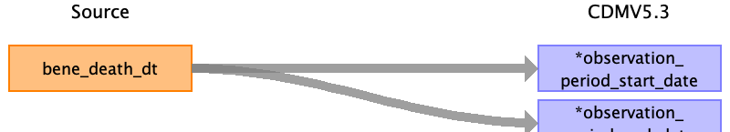

|  |  |  |  |
| --- | --- | --- | --- |
| Destination Field | Source Field | Logic | Comment |
| observation_period_id |  |  | Add when new and unique observation period exists. |
| person_id |  |  | Linked to PERSON table. |
| observation_period_start_date | bene_death_dt |  |  |
| observation_period_end_date | bene_death_dt |  |  |
| period_type_concept_id |  |  | 32813 |

Reading from inpatient_base_claims_k.csv

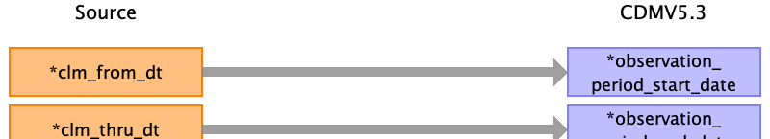

|  |  |  |  |
| --- | --- | --- | --- |
| Destination Field | Source Field | Logic | Comment |
| observation_period_id |  |  | Add when new and unique observation period exists. |
| person_id |  |  | Linked to PERSON table. |
| observation_period_start_date | clm_from_dt |  |  |
| observation_period_end_date | clm_thru_dt |  |  |
| period_type_concept_id |  |  | 32813 |

Reading from outpatient_base_claims_k.csv



|  |  |  |  |
| --- | --- | --- | --- |
| Destination Field | Source Field | Logic | Comment |
| observation_period_id |  |  | Add when new and unique observation period exists. |
| person_id |  |  | Linked to PERSON table. |
| observation_period_start_date | clm_from_dt |  |  |
| observation_period_end_date | clm_thru_dt |  |  |
| period_type_concept_id |  |  | 32813 |

Reading from bcarrier_claims_k.csv

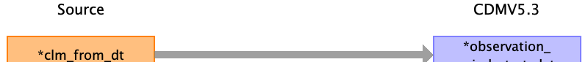

|  |  |  |  |
| --- | --- | --- | --- |
| Destination Field | Source Field | Logic | Comment |
| observation_period_id |  |  | Add when new and unique observation period exists. |
| person_id |  |  | Linked to PERSON table. |
| observation_period_start_date | clm_from_dt |  |  |
| observation_period_end_date |  |  |  |
| period_type_concept_id |  |  | 32813 |

Reading from bcarrier_line_k.csv

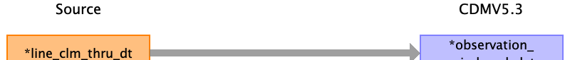

|  |  |  |  |
| --- | --- | --- | --- |
| Destination Field | Source Field | Logic | Comment |
| observation_period_id |  |  | Add when new and unique observation period exists. |
| person_id |  |  | Linked to PERSON table. |
| observation_period_start_date |  |  |  |
| observation_period_end_date | line_clm_thru_dt |  |  |
| period_type_concept_id |  |  | 32813 |

Reading from snf_base_claims_k.csv



|  |  |  |  |
| --- | --- | --- | --- |
| Destination Field | Source Field | Logic | Comment |
| observation_period_id |  |  | Add when new and unique observation period exists. |
| person_id |  |  | Linked to PERSON table. |
| observation_period_start_date | clm_from_dt |  |  |
| observation_period_end_date | clm_thru_dt |  |  |
| period_type_concept_id |  |  | 32813 |

Reading from dme_claims_k.csv



|  |  |  |  |
| --- | --- | --- | --- |
| Destination Field | Source Field | Logic | Comment |
| observation_period_id |  |  | Add when new and unique observation period exists. |
| person_id |  |  | Linked to PERSON table. |
| observation_period_start_date | clm_from_dt |  |  |
| observation_period_end_date |  |  |  |
| period_type_concept_id |  |  | 32813 |

Reading from dme_line_k.csv



|  |  |  |  |
| --- | --- | --- | --- |
| Destination Field | Source Field | Logic | Comment |
| observation_period_id |  |  | Add when new and unique observation period exists. |
| person_id |  |  | Linked to PERSON table. |
| observation_period_start_date |  |  |  |
| observation_period_end_date | line_clm_thru_dt |  |  |
| period_type_concept_id |  |  | 32813 |

Reading from hha_base_claims_k.csv



|  |  |  |  |
| --- | --- | --- | --- |
| Destination Field | Source Field | Logic | Comment |
| observation_period_id |  |  | Add when new and unique observation period exists. |
| person_id |  |  | Linked to PERSON table. |
| observation_period_start_date | clm_from_dt |  |  |
| observation_period_end_date | clm_thru_dt |  |  |
| period_type_concept_id |  |  | 32813 |

Reading from hospice_base_claims_k.csv



|  |  |  |  |
| --- | --- | --- | --- |
| Destination Field | Source Field | Logic | Comment |
| observation_period_id |  |  | Add when new and unique observation period exists. |
| person_id |  |  | Linked to PERSON table. |
| observation_period_start_date | clm_from_dt |  |  |
| observation_period_end_date | clm_thru_dt |  |  |
| period_type_concept_id |  |  | 32813 |

Reading from pde_file.csv

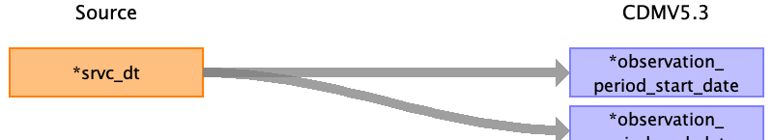

|  |  |  |  |
| --- | --- | --- | --- |
| Destination Field | Source Field | Logic | Comment |
| observation_period_id |  |  | Add when new and unique observation period exists. |
| person_id |  |  | Linked to PERSON table. |
| observation_period_start_date | srvc_dt |  |  |
| observation_period_end_date | srvc_dt |  |  |
| period_type_concept_id |  |  | 32813 |

Table name: person

Reading from mbsf_abcd_summary.csv

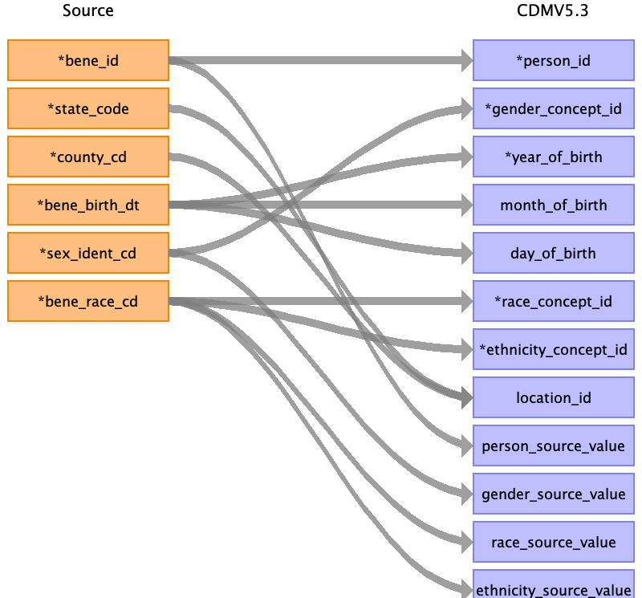

|  |  |  |  |
| --- | --- | --- | --- |
| Destination Field | Source Field | Logic | Comment |
| person_id | bene_id |  |  |
| gender_concept_id | sex_ident_cd |  |  |
| year_of_birth | bene_birth_dt |  |  |
| month_of_birth | bene_birth_dt |  |  |
| day_of_birth | bene_birth_dt |  |  |
| birth_datetime |  |  |  |
| race_concept_id | bene_race_cd |  |  |
| ethnicity_concept_id | bene_race_cd |  |  |
| location_id | state_code  county_cd |  |  |
| provider_id |  |  |  |
| care_site_id |  |  |  |
| person_source_value | bene_id |  |  |
| gender_source_value | sex_ident_cd |  |  |
| gender_source_concept_id |  |  |  |
| race_source_value | bene_race_cd |  |  |
| race_source_concept_id |  |  |  |
| ethnicity_source_value | bene_race_cd |  |  |
| ethnicity_source_concept_id |  |  |  |

Table name: procedure_occurrence

Reading from stem_table

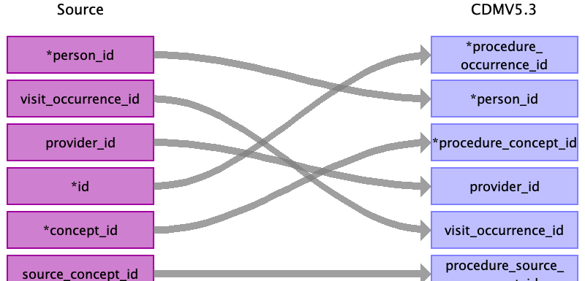

|  |  |  |  |
| --- | --- | --- | --- |
| Destination Field | Source Field | Logic | Comment |
| procedure_occurrence_id | id |  | Add when new and unique procedure code exists. |
| person_id | person_id |  | Linked PERSON table |
| procedure_concept_id | concept_id |  | OMOP CONCEPT MAPPING |
| procedure_date |  |  |  |
| procedure_datetime |  |  |  |
| procedure_type_concept_id |  |  | 32853 Inpatient claim  32859 Outpatient claim  32810 Carrier: Claim  32844 SNF: Facility claim  32810 DME: Claim  32844 HHA: Facility claim  32844 Hospice: Facility claim |
| modifier_concept_id |  |  | 0 |
| quantity |  |  |  |
| provider_id | provider_id |  | Linked to PROVIDER table |
| visit_occurrence_id | visit_occurrence_id |  | Linked to VISIT_OCCURRENCE table |
| visit_detail_id |  |  |  |
| procedure_source_value |  |  |  |
| procedure_source_concept_id | source_concept_id |  | OMOP CONCEPT MAPPING |
| modifier_source_value |  |  |  |

Reading from inpatient_base_claims_k.csv

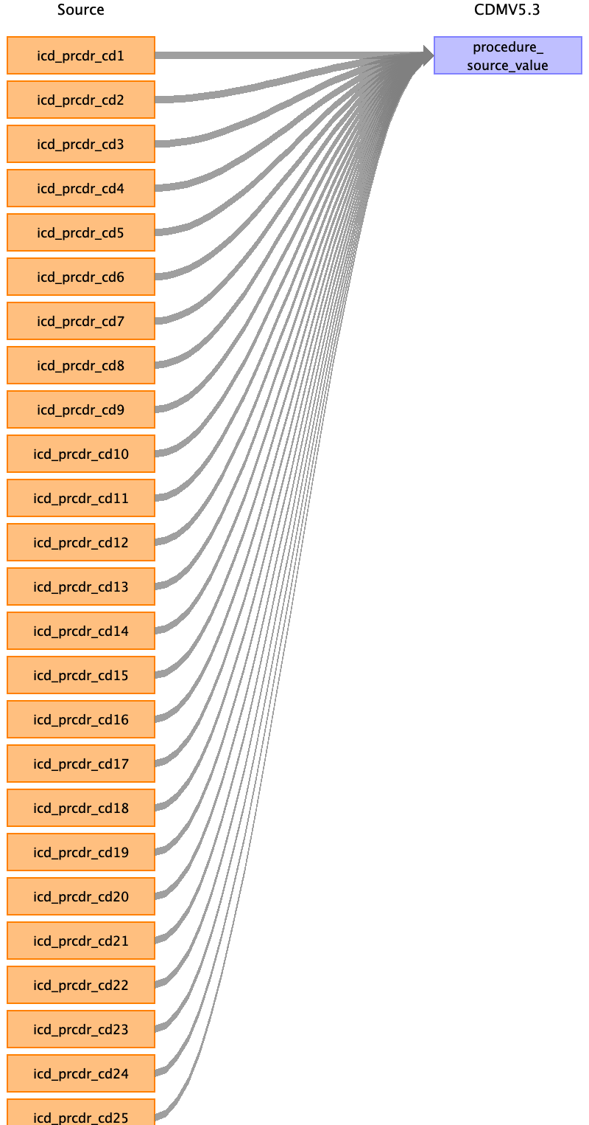

|  |  |  |  |
| --- | --- | --- | --- |
| Destination Field | Source Field | Logic | Comment |
| procedure_occurrence_id |  |  | Add when new and unique procedure code exists. |
| person_id |  |  | Linked PERSON table |
| procedure_concept_id |  |  | OMOP CONCEPT MAPPING |
| procedure_date |  |  |  |
| procedure_datetime |  |  |  |
| procedure_type_concept_id |  |  | 32853 Inpatient claim  32859 Outpatient claim  32810 Carrier: Claim  32844 SNF: Facility claim  32810 DME: Claim  32844 HHA: Facility claim  32844 Hospice: Facility claim |
| modifier_concept_id |  |  | 0 |
| quantity |  |  |  |
| provider_id |  |  | Linked to PROVIDER table |
| visit_occurrence_id |  |  | Linked to VISIT_OCCURRENCE table |
| visit_detail_id |  |  |  |
| procedure_source_value | icd_prcdr_cd1  icd_prcdr_cd2  icd_prcdr_cd3  icd_prcdr_cd4  icd_prcdr_cd5  icd_prcdr_cd6  icd_prcdr_cd7  icd_prcdr_cd8  icd_prcdr_cd9  icd_prcdr_cd10  icd_prcdr_cd11  icd_prcdr_cd12  icd_prcdr_cd13  icd_prcdr_cd14  icd_prcdr_cd15  icd_prcdr_cd16  icd_prcdr_cd17  icd_prcdr_cd18  icd_prcdr_cd19  icd_prcdr_cd20  icd_prcdr_cd21  icd_prcdr_cd22  icd_prcdr_cd23  icd_prcdr_cd24  icd_prcdr_cd25 |  |  |
| procedure_source_concept_id |  |  | OMOP CONCEPT MAPPING |
| modifier_source_value |  |  |  |

Reading from outpatient_base_claims_k.csv

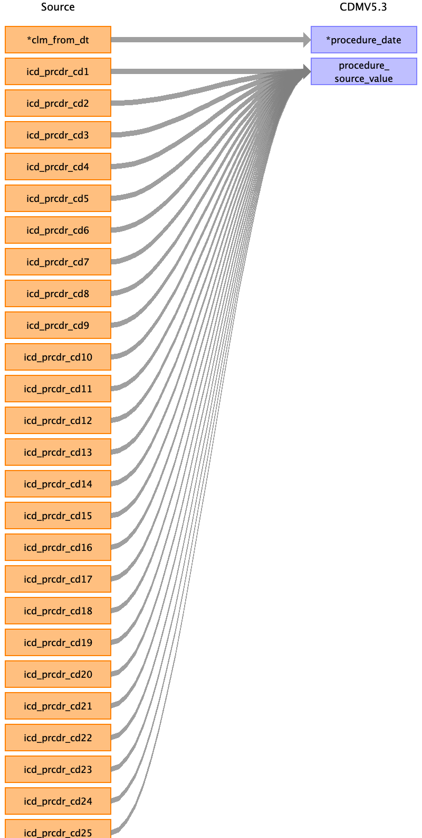

|  |  |  |  |
| --- | --- | --- | --- |
| Destination Field | Source Field | Logic | Comment |
| procedure_occurrence_id |  |  | Add when new and unique procedure code exists. |
| person_id |  |  | Linked PERSON table |
| procedure_concept_id |  |  | OMOP CONCEPT MAPPING |
| procedure_date | clm_from_dt |  |  |
| procedure_datetime |  |  |  |
| procedure_type_concept_id |  |  | 32853 Inpatient claim  32859 Outpatient claim  32810 Carrier: Claim  32844 SNF: Facility claim  32810 DME: Claim  32844 HHA: Facility claim  32844 Hospice: Facility claim |
| modifier_concept_id |  |  | 0 |
| quantity |  |  |  |
| provider_id |  |  | Linked to PROVIDER table |
| visit_occurrence_id |  |  | Linked to VISIT_OCCURRENCE table |
| visit_detail_id |  |  |  |
| procedure_source_value | icd_prcdr_cd1  icd_prcdr_cd2  icd_prcdr_cd3  icd_prcdr_cd4  icd_prcdr_cd5  icd_prcdr_cd6  icd_prcdr_cd7  icd_prcdr_cd8  icd_prcdr_cd9  icd_prcdr_cd10  icd_prcdr_cd11  icd_prcdr_cd12  icd_prcdr_cd13  icd_prcdr_cd14  icd_prcdr_cd15  icd_prcdr_cd16  icd_prcdr_cd17  icd_prcdr_cd18  icd_prcdr_cd19  icd_prcdr_cd20  icd_prcdr_cd21  icd_prcdr_cd22  icd_prcdr_cd23  icd_prcdr_cd24  icd_prcdr_cd25 |  |  |
| procedure_source_concept_id |  |  | OMOP CONCEPT MAPPING |
| modifier_source_value |  |  |  |

Reading from bcarrier_claims_k.csv

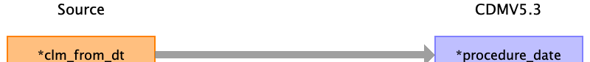

|  |  |  |  |
| --- | --- | --- | --- |
| Destination Field | Source Field | Logic | Comment |
| procedure_occurrence_id |  |  | Add when new and unique procedure code exists. |
| person_id |  |  | Linked PERSON table |
| procedure_concept_id |  |  | OMOP CONCEPT MAPPING |
| procedure_date | clm_from_dt |  |  |
| procedure_datetime |  |  |  |
| procedure_type_concept_id |  |  | 32853 Inpatient claim  32859 Outpatient claim  32810 Carrier: Claim  32844 SNF: Facility claim  32810 DME: Claim  32844 HHA: Facility claim  32844 Hospice: Facility claim |
| modifier_concept_id |  |  | 0 |
| quantity |  |  |  |
| provider_id |  |  | Linked to PROVIDER table |
| visit_occurrence_id |  |  | Linked to VISIT_OCCURRENCE table |
| visit_detail_id |  |  |  |
| procedure_source_value |  |  |  |
| procedure_source_concept_id |  |  | OMOP CONCEPT MAPPING |
| modifier_source_value |  |  |  |

Reading from snf_base_claims_k.csv



|  |  |  |  |
| --- | --- | --- | --- |
| Destination Field | Source Field | Logic | Comment |
| procedure_occurrence_id |  |  | Add when new and unique procedure code exists. |
| person_id |  |  | Linked PERSON table |
| procedure_concept_id |  |  | OMOP CONCEPT MAPPING |
| procedure_date | clm_from_dt |  |  |
| procedure_datetime |  |  |  |
| procedure_type_concept_id |  |  | 32853 Inpatient claim  32859 Outpatient claim  32810 Carrier: Claim  32844 SNF: Facility claim  32810 DME: Claim  32844 HHA: Facility claim  32844 Hospice: Facility claim |
| modifier_concept_id |  |  | 0 |
| quantity |  |  |  |
| provider_id |  |  | Linked to PROVIDER table |
| visit_occurrence_id |  |  | Linked to VISIT_OCCURRENCE table |
| visit_detail_id |  |  |  |
| procedure_source_value | icd_prcdr_cd1  icd_prcdr_cd2  icd_prcdr_cd3  icd_prcdr_cd4  icd_prcdr_cd5  icd_prcdr_cd6  icd_prcdr_cd7  icd_prcdr_cd8  icd_prcdr_cd9  icd_prcdr_cd10  icd_prcdr_cd11  icd_prcdr_cd12  icd_prcdr_cd13  icd_prcdr_cd14  icd_prcdr_cd15  icd_prcdr_cd16  icd_prcdr_cd17  icd_prcdr_cd18  icd_prcdr_cd19  icd_prcdr_cd20  icd_prcdr_cd21  icd_prcdr_cd22  icd_prcdr_cd23  icd_prcdr_cd24  icd_prcdr_cd25 |  |  |
| procedure_source_concept_id |  |  | OMOP CONCEPT MAPPING |
| modifier_source_value |  |  |  |

Reading from dme_claims_k.csv



|  |  |  |  |
| --- | --- | --- | --- |
| Destination Field | Source Field | Logic | Comment |
| procedure_occurrence_id |  |  | Add when new and unique procedure code exists. |
| person_id |  |  | Linked PERSON table |
| procedure_concept_id |  |  | OMOP CONCEPT MAPPING |
| procedure_date | clm_from_dt |  |  |
| procedure_datetime |  |  |  |
| procedure_type_concept_id |  |  | 32853 Inpatient claim  32859 Outpatient claim  32810 Carrier: Claim  32844 SNF: Facility claim  32810 DME: Claim  32844 HHA: Facility claim  32844 Hospice: Facility claim |
| modifier_concept_id |  |  | 0 |
| quantity |  |  |  |
| provider_id |  |  | Linked to PROVIDER table |
| visit_occurrence_id |  |  | Linked to VISIT_OCCURRENCE table |
| visit_detail_id |  |  |  |
| procedure_source_value |  |  |  |
| procedure_source_concept_id |  |  | OMOP CONCEPT MAPPING |
| modifier_source_value |  |  |  |

Reading from hha_base_claims_k.csv



|  |  |  |  |
| --- | --- | --- | --- |
| Destination Field | Source Field | Logic | Comment |
| procedure_occurrence_id |  |  | Add when new and unique procedure code exists. |
| person_id |  |  | Linked PERSON table |
| procedure_concept_id |  |  | OMOP CONCEPT MAPPING |
| procedure_date | clm_from_dt |  |  |
| procedure_datetime |  |  |  |
| procedure_type_concept_id |  |  | 32853 Inpatient claim  32859 Outpatient claim  32810 Carrier: Claim  32844 SNF: Facility claim  32810 DME: Claim  32844 HHA: Facility claim  32844 Hospice: Facility claim |
| modifier_concept_id |  |  | 0 |
| quantity |  |  |  |
| provider_id |  |  | Linked to PROVIDER table |
| visit_occurrence_id |  |  | Linked to VISIT_OCCURRENCE table |
| visit_detail_id |  |  |  |
| procedure_source_value |  |  |  |
| procedure_source_concept_id |  |  | OMOP CONCEPT MAPPING |
| modifier_source_value |  |  |  |

Reading from hospice_base_claims_k.csv



|  |  |  |  |
| --- | --- | --- | --- |
| Destination Field | Source Field | Logic | Comment |
| procedure_occurrence_id |  |  | Add when new and unique procedure code exists. |
| person_id |  |  | Linked PERSON table |
| procedure_concept_id |  |  | OMOP CONCEPT MAPPING |
| procedure_date | clm_from_dt |  |  |
| procedure_datetime |  |  |  |
| procedure_type_concept_id |  |  | 32853 Inpatient claim  32859 Outpatient claim  32810 Carrier: Claim  32844 SNF: Facility claim  32810 DME: Claim  32844 HHA: Facility claim  32844 Hospice: Facility claim |
| modifier_concept_id |  |  | 0 |
| quantity |  |  |  |
| provider_id |  |  | Linked to PROVIDER table |
| visit_occurrence_id |  |  | Linked to VISIT_OCCURRENCE table |
| visit_detail_id |  |  |  |
| procedure_source_value |  |  |  |
| procedure_source_concept_id |  |  | OMOP CONCEPT MAPPING |
| modifier_source_value |  |  |  |

Reading from inpatient_revenue_center_k.csv

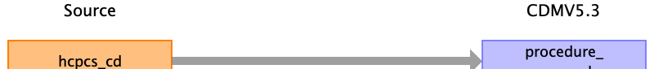

|  |  |  |  |
| --- | --- | --- | --- |
| Destination Field | Source Field | Logic | Comment |
| procedure_occurrence_id |  |  | Add when new and unique procedure code exists. |
| person_id |  |  | Linked PERSON table |
| procedure_concept_id |  |  | OMOP CONCEPT MAPPING |
| procedure_date |  |  |  |
| procedure_datetime |  |  |  |
| procedure_type_concept_id |  |  | 32853 Inpatient claim  32859 Outpatient claim  32810 Carrier: Claim  32844 SNF: Facility claim  32810 DME: Claim  32844 HHA: Facility claim  32844 Hospice: Facility claim |
| modifier_concept_id |  |  | 0 |
| quantity |  |  |  |
| provider_id |  |  | Linked to PROVIDER table |
| visit_occurrence_id |  |  | Linked to VISIT_OCCURRENCE table |
| visit_detail_id |  |  |  |
| procedure_source_value | hcpcs_cd |  |  |
| procedure_source_concept_id |  |  | OMOP CONCEPT MAPPING |
| modifier_source_value |  |  |  |

Reading from outpatient_revenue_center_k.csv



|  |  |  |  |
| --- | --- | --- | --- |
| Destination Field | Source Field | Logic | Comment |
| procedure_occurrence_id |  |  | Add when new and unique procedure code exists. |
| person_id |  |  | Linked PERSON table |
| procedure_concept_id |  |  | OMOP CONCEPT MAPPING |
| procedure_date |  |  |  |
| procedure_datetime |  |  |  |
| procedure_type_concept_id |  |  | 32853 Inpatient claim  32859 Outpatient claim  32810 Carrier: Claim  32844 SNF: Facility claim  32810 DME: Claim  32844 HHA: Facility claim  32844 Hospice: Facility claim |
| modifier_concept_id |  |  | 0 |
| quantity |  |  |  |
| provider_id |  |  | Linked to PROVIDER table |
| visit_occurrence_id |  |  | Linked to VISIT_OCCURRENCE table |
| visit_detail_id |  |  |  |
| procedure_source_value | hcpcs_cd |  |  |
| procedure_source_concept_id |  |  | OMOP CONCEPT MAPPING |
| modifier_source_value |  |  |  |

Reading from snf_revenue_center_k.csv



|  |  |  |  |
| --- | --- | --- | --- |
| Destination Field | Source Field | Logic | Comment |
| procedure_occurrence_id |  |  | Add when new and unique procedure code exists. |
| person_id |  |  | Linked PERSON table |
| procedure_concept_id |  |  | OMOP CONCEPT MAPPING |
| procedure_date |  |  |  |
| procedure_datetime |  |  |  |
| procedure_type_concept_id |  |  | 32853 Inpatient claim  32859 Outpatient claim  32810 Carrier: Claim  32844 SNF: Facility claim  32810 DME: Claim  32844 HHA: Facility claim  32844 Hospice: Facility claim |
| modifier_concept_id |  |  | 0 |
| quantity |  |  |  |
| provider_id |  |  | Linked to PROVIDER table |
| visit_occurrence_id |  |  | Linked to VISIT_OCCURRENCE table |
| visit_detail_id |  |  |  |
| procedure_source_value | hcpcs_cd |  |  |
| procedure_source_concept_id |  |  | OMOP CONCEPT MAPPING |
| modifier_source_value |  |  |  |

Reading from hha_revenue_center_k.csv



|  |  |  |  |
| --- | --- | --- | --- |
| Destination Field | Source Field | Logic | Comment |
| procedure_occurrence_id |  |  | Add when new and unique procedure code exists. |
| person_id |  |  | Linked PERSON table |
| procedure_concept_id |  |  | OMOP CONCEPT MAPPING |
| procedure_date |  |  |  |
| procedure_datetime |  |  |  |
| procedure_type_concept_id |  |  | 32853 Inpatient claim  32859 Outpatient claim  32810 Carrier: Claim  32844 SNF: Facility claim  32810 DME: Claim  32844 HHA: Facility claim  32844 Hospice: Facility claim |
| modifier_concept_id |  |  | 0 |
| quantity |  |  |  |
| provider_id |  |  | Linked to PROVIDER table |
| visit_occurrence_id |  |  | Linked to VISIT_OCCURRENCE table |
| visit_detail_id |  |  |  |
| procedure_source_value | hcpcs_cd |  |  |
| procedure_source_concept_id |  |  | OMOP CONCEPT MAPPING |
| modifier_source_value |  |  |  |

Reading from hospice_revenue_center_k.csv



|  |  |  |  |
| --- | --- | --- | --- |
| Destination Field | Source Field | Logic | Comment |
| procedure_occurrence_id |  |  | Add when new and unique procedure code exists. |
| person_id |  |  | Linked PERSON table |
| procedure_concept_id |  |  | OMOP CONCEPT MAPPING |
| procedure_date |  |  |  |
| procedure_datetime |  |  |  |
| procedure_type_concept_id |  |  | 32853 Inpatient claim  32859 Outpatient claim  32810 Carrier: Claim  32844 SNF: Facility claim  32810 DME: Claim  32844 HHA: Facility claim  32844 Hospice: Facility claim |
| modifier_concept_id |  |  | 0 |
| quantity |  |  |  |
| provider_id |  |  | Linked to PROVIDER table |
| visit_occurrence_id |  |  | Linked to VISIT_OCCURRENCE table |
| visit_detail_id |  |  |  |
| procedure_source_value | hcpcs_cd |  |  |
| procedure_source_concept_id |  |  | OMOP CONCEPT MAPPING |
| modifier_source_value |  |  |  |

Reading from bcarrier_line_k.csv

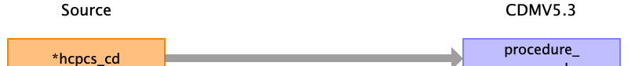

|  |  |  |  |
| --- | --- | --- | --- |
| Destination Field | Source Field | Logic | Comment |
| procedure_occurrence_id |  |  | Add when new and unique procedure code exists. |
| person_id |  |  | Linked PERSON table |
| procedure_concept_id |  |  | OMOP CONCEPT MAPPING |
| procedure_date |  |  |  |
| procedure_datetime |  |  |  |
| procedure_type_concept_id |  |  | 32853 Inpatient claim  32859 Outpatient claim  32810 Carrier: Claim  32844 SNF: Facility claim  32810 DME: Claim  32844 HHA: Facility claim  32844 Hospice: Facility claim |
| modifier_concept_id |  |  | 0 |
| quantity |  |  |  |
| provider_id |  |  | Linked to PROVIDER table |
| visit_occurrence_id |  |  | Linked to VISIT_OCCURRENCE table |
| visit_detail_id |  |  |  |
| procedure_source_value | hcpcs_cd |  |  |
| procedure_source_concept_id |  |  | OMOP CONCEPT MAPPING |
| modifier_source_value |  |  |  |

Reading from dme_line_k.csv



|  |  |  |  |
| --- | --- | --- | --- |
| Destination Field | Source Field | Logic | Comment |
| procedure_occurrence_id |  |  | Add when new and unique procedure code exists. |
| person_id |  |  | Linked PERSON table |
| procedure_concept_id |  |  | OMOP CONCEPT MAPPING |
| procedure_date |  |  |  |
| procedure_datetime |  |  |  |
| procedure_type_concept_id |  |  | 32853 Inpatient claim  32859 Outpatient claim  32810 Carrier: Claim  32844 SNF: Facility claim  32810 DME: Claim  32844 HHA: Facility claim  32844 Hospice: Facility claim |
| modifier_concept_id |  |  | 0 |
| quantity |  |  |  |
| provider_id |  |  | Linked to PROVIDER table |
| visit_occurrence_id |  |  | Linked to VISIT_OCCURRENCE table |
| visit_detail_id |  |  |  |
| procedure_source_value | hcpcs_cd |  |  |
| procedure_source_concept_id |  |  | OMOP CONCEPT MAPPING |
| modifier_source_value |  |  |  |

Table name: specimen

NOT USING

Reading from stem_table

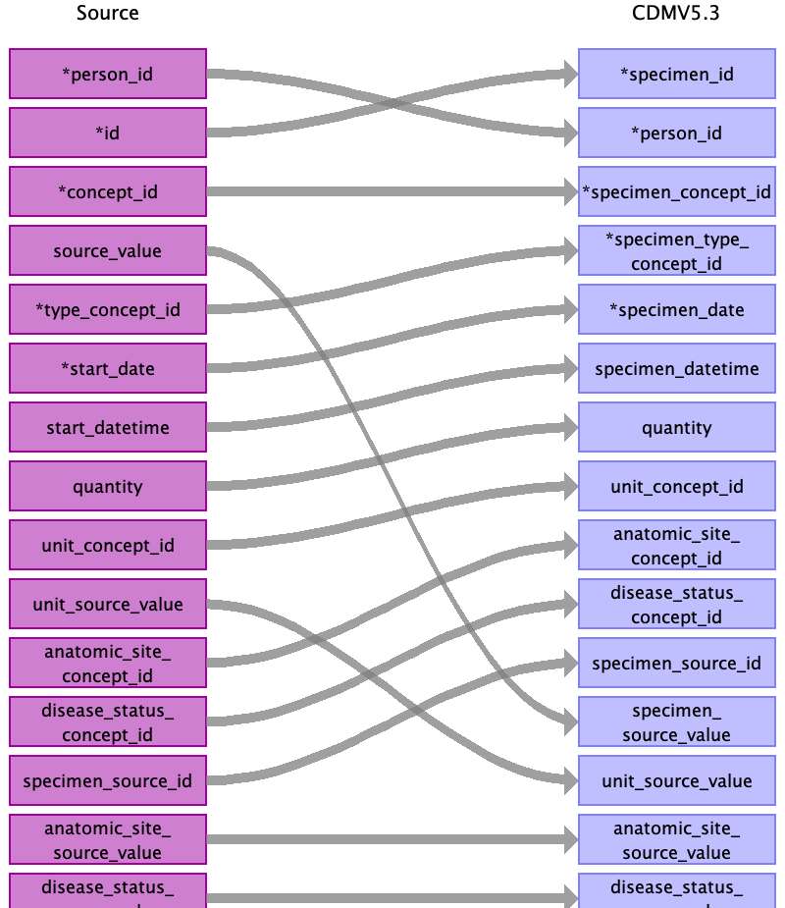

|  |  |  |  |
| --- | --- | --- | --- |
| Destination Field | Source Field | Logic | Comment |
| specimen_id | id |  |  |
| person_id | person_id |  |  |
| specimen_concept_id | concept_id |  |  |
| specimen_type_concept_id | type_concept_id |  |  |
| specimen_date | start_date |  |  |
| specimen_datetime | start_datetime |  |  |
| quantity | quantity |  |  |
| unit_concept_id | unit_concept_id |  |  |
| anatomic_site_concept_id | anatomic_site_concept_id |  |  |
| disease_status_concept_id | disease_status_concept_id |  |  |
| specimen_source_id | specimen_source_id |  |  |
| specimen_source_value | source_value |  |  |
| unit_source_value | unit_source_value |  |  |
| anatomic_site_source_value | anatomic_site_source_value |  |  |
| disease_status_source_value | disease_status_source_value |  |  |

Table name: visit_detail

NOT USING

Table name: visit_occurrence

Reading from inpatient_base_claims_k.csv

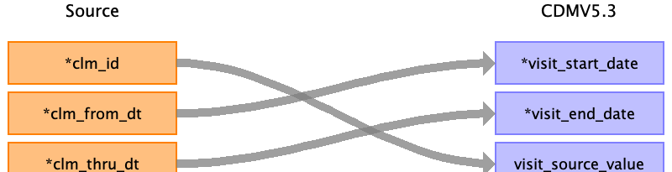

|  |  |  |  |
| --- | --- | --- | --- |
| Destination Field | Source Field | Logic | Comment |
| visit_occurrence_id |  |  | Add when new and unique visit exists. |
| person_id |  |  | Linked to PERSON table |
| visit_concept_id |  |  | 9201 Inpatient Visit  9202 Outpatient Visit  0 Carrier  8863 Skilled Nursing Facility  38004327 Durable Medical Equipment Supplier  38004519 Home Health Agency  8546 Hospice |
| visit_start_date | clm_from_dt |  |  |
| visit_start_datetime |  |  |  |
| visit_end_date | clm_thru_dt |  |  |
| visit_end_datetime |  |  |  |
| visit_type_concept_id |  |  | 32853 Inpatient claim  32859 Outpatient claim  32810 Claim  32844 SNF: Facility claim  0 DME: Not Sure  32844 HHA: Facility claim  32844 FHospice: acility claim |
| provider_id |  |  | Linked to PROVIDER table |
| care_site_id |  |  | Linked to CARE_SITE table |
| visit_source_value | clm_id |  |  |
| visit_source_concept_id |  |  |  |
| admitting_source_concept_id |  |  |  |
| admitting_source_value |  |  |  |
| discharge_to_concept_id |  |  |  |
| discharge_to_source_value |  |  |  |
| preceding_visit_occurrence_id |  |  |  |

Reading from outpatient_base_claims_k.csv



|  |  |  |  |
| --- | --- | --- | --- |
| Destination Field | Source Field | Logic | Comment |
| visit_occurrence_id |  |  | Add when new and unique visit exists. |
| person_id |  |  | Linked to PERSON table |
| visit_concept_id |  |  | 9201 Inpatient Visit  9202 Outpatient Visit  0 Carrier  8863 Skilled Nursing Facility  38004327 Durable Medical Equipment Supplier  38004519 Home Health Agency  8546 Hospice |
| visit_start_date | clm_from_dt |  |  |
| visit_start_datetime |  |  |  |
| visit_end_date | clm_thru_dt |  |  |
| visit_end_datetime |  |  |  |
| visit_type_concept_id |  |  | 32853 Inpatient claim  32859 Outpatient claim  32810 Claim  32844 SNF: Facility claim  0 DME: Not Sure  32844 HHA: Facility claim  32844 FHospice: acility claim |
| provider_id |  |  | Linked to PROVIDER table |
| care_site_id |  |  | Linked to CARE_SITE table |
| visit_source_value | clm_id |  |  |
| visit_source_concept_id |  |  |  |
| admitting_source_concept_id |  |  |  |
| admitting_source_value |  |  |  |
| discharge_to_concept_id |  |  |  |
| discharge_to_source_value |  |  |  |
| preceding_visit_occurrence_id |  |  |  |

Reading from bcarrier_claims_k.csv

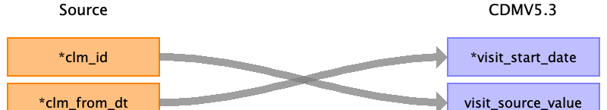

|  |  |  |  |
| --- | --- | --- | --- |
| Destination Field | Source Field | Logic | Comment |
| visit_occurrence_id |  |  | Add when new and unique visit exists. |
| person_id |  |  | Linked to PERSON table |
| visit_concept_id |  |  | 9201 Inpatient Visit  9202 Outpatient Visit  0 Carrier  8863 Skilled Nursing Facility  38004327 Durable Medical Equipment Supplier  38004519 Home Health Agency  8546 Hospice |
| visit_start_date | clm_from_dt |  |  |
| visit_start_datetime |  |  |  |
| visit_end_date |  |  |  |
| visit_end_datetime |  |  |  |
| visit_type_concept_id |  |  | 32853 Inpatient claim  32859 Outpatient claim  32810 Claim  32844 SNF: Facility claim  0 DME: Not Sure  32844 HHA: Facility claim  32844 FHospice: acility claim |
| provider_id |  |  | Linked to PROVIDER table |
| care_site_id |  |  | Linked to CARE_SITE table |
| visit_source_value | clm_id |  |  |
| visit_source_concept_id |  |  |  |
| admitting_source_concept_id |  |  |  |
| admitting_source_value |  |  |  |
| discharge_to_concept_id |  |  |  |
| discharge_to_source_value |  |  |  |
| preceding_visit_occurrence_id |  |  |  |

Reading from bcarrier_line_k.csv

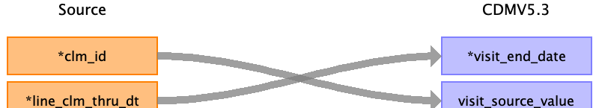

|  |  |  |  |
| --- | --- | --- | --- |
| Destination Field | Source Field | Logic | Comment |
| visit_occurrence_id |  |  | Add when new and unique visit exists. |
| person_id |  |  | Linked to PERSON table |
| visit_concept_id |  |  | 9201 Inpatient Visit  9202 Outpatient Visit  0 Carrier  8863 Skilled Nursing Facility  38004327 Durable Medical Equipment Supplier  38004519 Home Health Agency  8546 Hospice |
| visit_start_date |  |  |  |
| visit_start_datetime |  |  |  |
| visit_end_date | line_clm_thru_dt |  |  |
| visit_end_datetime |  |  |  |
| visit_type_concept_id |  |  | 32853 Inpatient claim  32859 Outpatient claim  32810 Claim  32844 SNF: Facility claim  0 DME: Not Sure  32844 HHA: Facility claim  32844 FHospice: acility claim |
| provider_id |  |  | Linked to PROVIDER table |
| care_site_id |  |  | Linked to CARE_SITE table |
| visit_source_value | clm_id |  |  |
| visit_source_concept_id |  |  |  |
| admitting_source_concept_id |  |  |  |
| admitting_source_value |  |  |  |
| discharge_to_concept_id |  |  |  |
| discharge_to_source_value |  |  |  |
| preceding_visit_occurrence_id |  |  |  |

Reading from snf_base_claims_k.csv



|  |  |  |  |
| --- | --- | --- | --- |
| Destination Field | Source Field | Logic | Comment |
| visit_occurrence_id |  |  | Add when new and unique visit exists. |
| person_id |  |  | Linked to PERSON table |
| visit_concept_id |  |  | 9201 Inpatient Visit  9202 Outpatient Visit  0 Carrier  8863 Skilled Nursing Facility  38004327 Durable Medical Equipment Supplier  38004519 Home Health Agency  8546 Hospice |
| visit_start_date | clm_from_dt |  |  |
| visit_start_datetime |  |  |  |
| visit_end_date | clm_thru_dt |  |  |
| visit_end_datetime |  |  |  |
| visit_type_concept_id |  |  | 32853 Inpatient claim  32859 Outpatient claim  32810 Claim  32844 SNF: Facility claim  0 DME: Not Sure  32844 HHA: Facility claim  32844 FHospice: acility claim |
| provider_id |  |  | Linked to PROVIDER table |
| care_site_id |  |  | Linked to CARE_SITE table |
| visit_source_value | clm_id |  |  |
| visit_source_concept_id |  |  |  |
| admitting_source_concept_id |  |  |  |
| admitting_source_value |  |  |  |
| discharge_to_concept_id |  |  |  |
| discharge_to_source_value |  |  |  |
| preceding_visit_occurrence_id |  |  |  |

Reading from dme_claims_k.csv



|  |  |  |  |
| --- | --- | --- | --- |
| Destination Field | Source Field | Logic | Comment |
| visit_occurrence_id |  |  | Add when new and unique visit exists. |
| person_id |  |  | Linked to PERSON table |
| visit_concept_id |  |  | 9201 Inpatient Visit  9202 Outpatient Visit  0 Carrier  8863 Skilled Nursing Facility  38004327 Durable Medical Equipment Supplier  38004519 Home Health Agency  8546 Hospice |
| visit_start_date | clm_from_dt |  |  |
| visit_start_datetime |  |  |  |
| visit_end_date |  |  |  |
| visit_end_datetime |  |  |  |
| visit_type_concept_id |  |  | 32853 Inpatient claim  32859 Outpatient claim  32810 Claim  32844 SNF: Facility claim  0 DME: Not Sure  32844 HHA: Facility claim  32844 FHospice: acility claim |
| provider_id |  |  | Linked to PROVIDER table |
| care_site_id |  |  | Linked to CARE_SITE table |
| visit_source_value | clm_id |  |  |
| visit_source_concept_id |  |  |  |
| admitting_source_concept_id |  |  |  |
| admitting_source_value |  |  |  |
| discharge_to_concept_id |  |  |  |
| discharge_to_source_value |  |  |  |
| preceding_visit_occurrence_id |  |  |  |

Reading from dme_line_k.csv



|  |  |  |  |
| --- | --- | --- | --- |
| Destination Field | Source Field | Logic | Comment |
| visit_occurrence_id |  |  | Add when new and unique visit exists. |
| person_id |  |  | Linked to PERSON table |
| visit_concept_id |  |  | 9201 Inpatient Visit  9202 Outpatient Visit  0 Carrier  8863 Skilled Nursing Facility  38004327 Durable Medical Equipment Supplier  38004519 Home Health Agency  8546 Hospice |
| visit_start_date |  |  |  |
| visit_start_datetime |  |  |  |
| visit_end_date | line_clm_thru_dt |  |  |
| visit_end_datetime |  |  |  |
| visit_type_concept_id |  |  | 32853 Inpatient claim  32859 Outpatient claim  32810 Claim  32844 SNF: Facility claim  0 DME: Not Sure  32844 HHA: Facility claim  32844 FHospice: acility claim |
| provider_id |  |  | Linked to PROVIDER table |
| care_site_id |  |  | Linked to CARE_SITE table |
| visit_source_value | clm_id |  |  |
| visit_source_concept_id |  |  |  |
| admitting_source_concept_id |  |  |  |
| admitting_source_value |  |  |  |
| discharge_to_concept_id |  |  |  |
| discharge_to_source_value |  |  |  |
| preceding_visit_occurrence_id |  |  |  |

Reading from hha_base_claims_k.csv



|  |  |  |  |
| --- | --- | --- | --- |
| Destination Field | Source Field | Logic | Comment |
| visit_occurrence_id |  |  | Add when new and unique visit exists. |
| person_id |  |  | Linked to PERSON table |
| visit_concept_id |  |  | 9201 Inpatient Visit  9202 Outpatient Visit  0 Carrier  8863 Skilled Nursing Facility  38004327 Durable Medical Equipment Supplier  38004519 Home Health Agency  8546 Hospice |
| visit_start_date | clm_from_dt |  |  |
| visit_start_datetime |  |  |  |
| visit_end_date | clm_thru_dt |  |  |
| visit_end_datetime |  |  |  |
| visit_type_concept_id |  |  | 32853 Inpatient claim  32859 Outpatient claim  32810 Claim  32844 SNF: Facility claim  0 DME: Not Sure  32844 HHA: Facility claim  32844 FHospice: acility claim |
| provider_id |  |  | Linked to PROVIDER table |
| care_site_id |  |  | Linked to CARE_SITE table |
| visit_source_value | clm_id |  |  |
| visit_source_concept_id |  |  |  |
| admitting_source_concept_id |  |  |  |
| admitting_source_value |  |  |  |
| discharge_to_concept_id |  |  |  |
| discharge_to_source_value |  |  |  |
| preceding_visit_occurrence_id |  |  |  |

Reading from hospice_base_claims_k.csv



|  |  |  |  |
| --- | --- | --- | --- |
| Destination Field | Source Field | Logic | Comment |
| visit_occurrence_id |  |  | Add when new and unique visit exists. |
| person_id |  |  | Linked to PERSON table |
| visit_concept_id |  |  | 9201 Inpatient Visit  9202 Outpatient Visit  0 Carrier  8863 Skilled Nursing Facility  38004327 Durable Medical Equipment Supplier  38004519 Home Health Agency  8546 Hospice |
| visit_start_date | clm_from_dt |  |  |
| visit_start_datetime |  |  |  |
| visit_end_date | clm_thru_dt |  |  |
| visit_end_datetime |  |  |  |
| visit_type_concept_id |  |  | 32853 Inpatient claim  32859 Outpatient claim  32810 Claim  32844 SNF: Facility claim  0 DME: Not Sure  32844 HHA: Facility claim  32844 FHospice: acility claim |
| provider_id |  |  | Linked to PROVIDER table |
| care_site_id |  |  | Linked to CARE_SITE table |
| visit_source_value | clm_id |  |  |
| visit_source_concept_id |  |  |  |
| admitting_source_concept_id |  |  |  |
| admitting_source_value |  |  |  |
| discharge_to_concept_id |  |  |  |
| discharge_to_source_value |  |  |  |
| preceding_visit_occurrence_id |  |  |  |

Table name: cohort

NOT USING

Table name: cohort_attribute

NOT USING

Table name: condition_era

NOT USING

Table name: dose_era

NOT USING

Table name: drug_era

NOT USING

Table name: cost

Reading from pde_file.csv

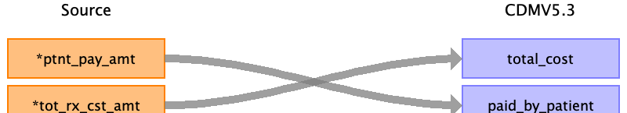

|  |  |  |  |
| --- | --- | --- | --- |
| Destination Field | Source Field | Logic | Comment |
| cost_id |  |  | Add when new and unique cost exists. |
| cost_event_id |  |  | Linked to DRUG_EXPOSURE for drug_exposure_id  Linked to PROCEDURE_OCCURRENCE for procedure_occurrence_id |
| cost_domain_id |  |  |  |
| cost_type_concept_id |  |  |  |
| currency_concept_id |  |  | CURRENCY_US_DOLLAR = "44818668" |
| total_charge |  |  |  |
| total_cost | tot_rx_cst_amt |  |  |
| total_paid |  |  |  |
| paid_by_payer |  |  |  |
| paid_by_patient | ptnt_pay_amt |  |  |
| paid_patient_copay |  |  |  |
| paid_patient_coinsurance |  |  |  |
| paid_patient_deductible |  |  |  |
| paid_by_primary |  |  |  |
| paid_ingredient_cost |  |  |  |
| paid_dispensing_fee |  |  |  |
| payer_plan_period_id |  |  |  |
| amount_allowed |  |  |  |
| revenue_code_concept_id |  |  |  |
| revenue_code_source_value |  |  |  |
| drg_concept_id |  |  |  |
| drg_source_value |  |  |  |

Reading from bcarrier_line_k.csv

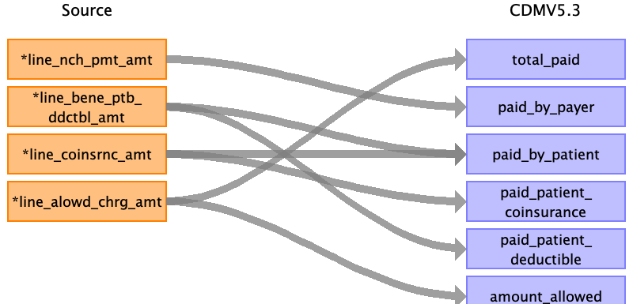

|  |  |  |  |
| --- | --- | --- | --- |
| Destination Field | Source Field | Logic | Comment |
| cost_id |  |  | Add when new and unique cost exists. |
| cost_event_id |  |  | Linked to DRUG_EXPOSURE for drug_exposure_id  Linked to PROCEDURE_OCCURRENCE for procedure_occurrence_id |
| cost_domain_id |  |  |  |
| cost_type_concept_id |  |  |  |
| currency_concept_id |  |  | CURRENCY_US_DOLLAR = "44818668" |
| total_charge |  |  |  |
| total_cost |  |  |  |
| total_paid | line_alowd_chrg_amt |  |  |
| paid_by_payer | line_nch_pmt_amt |  |  |
| paid_by_patient | line_coinsrnc_amt  line_bene_ptb_ddctbl_amt |  |  |
| paid_patient_copay |  |  |  |
| paid_patient_coinsurance | line_coinsrnc_amt |  |  |
| paid_patient_deductible | line_bene_ptb_ddctbl_amt |  |  |
| paid_by_primary |  |  |  |
| paid_ingredient_cost |  |  |  |
| paid_dispensing_fee |  |  |  |
| payer_plan_period_id |  |  |  |
| amount_allowed | line_alowd_chrg_amt |  |  |
| revenue_code_concept_id |  |  |  |
| revenue_code_source_value |  |  |  |
| drg_concept_id |  |  |  |
| drg_source_value |  |  |  |

Reading from dme_line_k.csv

Generated

|  |  |  |  |
| --- | --- | --- | --- |
| Destination Field | Source Field | Logic | Comment |
| cost_id |  |  | Add when new and unique cost exists. |
| cost_event_id |  |  | Linked to DRUG_EXPOSURE for drug_exposure_id  Linked to PROCEDURE_OCCURRENCE for procedure_occurrence_id |
| cost_domain_id |  |  |  |
| cost_type_concept_id |  |  |  |
| currency_concept_id |  |  | CURRENCY_US_DOLLAR = "44818668" |
| total_charge |  |  |  |
| total_cost |  |  |  |
| total_paid |  |  |  |
| paid_by_payer |  |  |  |
| paid_by_patient |  |  |  |
| paid_patient_copay |  |  |  |
| paid_patient_coinsurance |  |  |  |
| paid_patient_deductible |  |  |  |
| paid_by_primary |  |  |  |
| paid_ingredient_cost |  |  |  |
| paid_dispensing_fee |  |  |  |
| payer_plan_period_id |  |  |  |
| amount_allowed |  |  |  |
| revenue_code_concept_id |  |  |  |
| revenue_code_source_value |  |  |  |
| drg_concept_id |  |  |  |
| drg_source_value |  |  |  |

Table name: payer_plan_period

Reading from mbsf_abcd_summary.csv

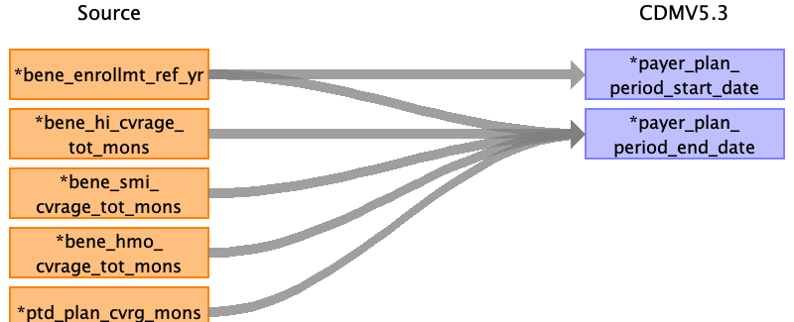

|  |  |  |  |
| --- | --- | --- | --- |
| Destination Field | Source Field | Logic | Comment |
| payer_plan_period_id |  |  | Add when new and unique plan exists. |
| person_id |  |  | Linked to PERSON table |
| payer_plan_period_start_date | bene_enrollmt_ref_yr |  |  |
| payer_plan_period_end_date | bene_enrollmt_ref_yr  bene_hi_cvrage_tot_mons  bene_smi_cvrage_tot_mons  bene_hmo_cvrage_tot_mons  ptd_plan_cvrg_mons |  | end_date = start_date + number of months. |
| payer_concept_id |  |  |  |
| payer_source_value |  |  | Medicare Part A, Medicare Part B, HMO, Medicare Part D |
| payer_source_concept_id |  |  |  |
| plan_concept_id |  |  |  |
| plan_source_value |  |  |  |
| plan_source_concept_id |  |  |  |
| sponsor_concept_id |  |  |  |
| sponsor_source_value |  |  |  |
| sponsor_source_concept_id |  |  |  |
| family_source_value |  |  |  |
| stop_reason_concept_id |  |  |  |
| stop_reason_source_value |  |  |  |
| stop_reason_source_concept_id |  |  |  |

Table name: care_site

Reading from inpatient_base_claims_k.csv

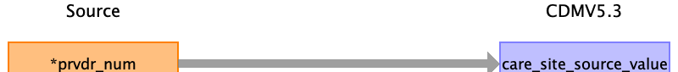

|  |  |  |  |
| --- | --- | --- | --- |
| Destination Field | Source Field | Logic | Comment |
| care_site_id |  |  | Add when new an unique care_site and its related provider/tax number exists |
| care_site_name |  |  |  |
| place_of_service_concept_id |  |  | INPATIENT_PLACE_OF_SERVICE = 8717 # Inpatient Hospital  OUTPATIENT_PLACE_OF_SERVICE = 8756 # Outpatient Hospital  CARRIER_CLAIMS_PLACE_OF_SERVICE = 581477 # Office  SNF_PLACE_OF_SERVICE = 8863 # Skilled Nursing Facility  DME_PLACE_OF_SERVICE = 38004327 # Durable Medical Equipment  HHA_CLAIMS_PLACE_OF_SERVICE = 38004519 # Home Health Agency  HOSPICE_CLAIMS_PLACE_OF_SERVICE = 8546 |
| location_id |  |  | Linked to LOCATION table |
| care_site_source_value | prvdr_num |  |  |
| place_of_service_source_value |  |  | "Inpatient Facility"  "Outpatient Facility"  " "  "Skilled Nursing Facility"  "Durable Medical Equipment Supplier"  "Home Health Agency Facility"  "Hospice Facility" |

Reading from outpatient_base_claims_k.csv



|  |  |  |  |
| --- | --- | --- | --- |
| Destination Field | Source Field | Logic | Comment |
| care_site_id |  |  | Add when new an unique care_site and its related provider/tax number exists |
| care_site_name |  |  |  |
| place_of_service_concept_id |  |  | INPATIENT_PLACE_OF_SERVICE = 8717 # Inpatient Hospital  OUTPATIENT_PLACE_OF_SERVICE = 8756 # Outpatient Hospital  CARRIER_CLAIMS_PLACE_OF_SERVICE = 581477 # Office  SNF_PLACE_OF_SERVICE = 8863 # Skilled Nursing Facility  DME_PLACE_OF_SERVICE = 38004327 # Durable Medical Equipment  HHA_CLAIMS_PLACE_OF_SERVICE = 38004519 # Home Health Agency  HOSPICE_CLAIMS_PLACE_OF_SERVICE = 8546 |
| location_id |  |  | Linked to LOCATION table |
| care_site_source_value | prvdr_num |  |  |
| place_of_service_source_value |  |  | "Inpatient Facility"  "Outpatient Facility"  " "  "Skilled Nursing Facility"  "Durable Medical Equipment Supplier"  "Home Health Agency Facility"  "Hospice Facility" |

Reading from snf_base_claims_k.csv



|  |  |  |  |
| --- | --- | --- | --- |
| Destination Field | Source Field | Logic | Comment |
| care_site_id |  |  | Add when new an unique care_site and its related provider/tax number exists |
| care_site_name |  |  |  |
| place_of_service_concept_id |  |  | INPATIENT_PLACE_OF_SERVICE = 8717 # Inpatient Hospital  OUTPATIENT_PLACE_OF_SERVICE = 8756 # Outpatient Hospital  CARRIER_CLAIMS_PLACE_OF_SERVICE = 581477 # Office  SNF_PLACE_OF_SERVICE = 8863 # Skilled Nursing Facility  DME_PLACE_OF_SERVICE = 38004327 # Durable Medical Equipment  HHA_CLAIMS_PLACE_OF_SERVICE = 38004519 # Home Health Agency  HOSPICE_CLAIMS_PLACE_OF_SERVICE = 8546 |
| location_id |  |  | Linked to LOCATION table |
| care_site_source_value | prvdr_num |  |  |
| place_of_service_source_value |  |  | "Inpatient Facility"  "Outpatient Facility"  " "  "Skilled Nursing Facility"  "Durable Medical Equipment Supplier"  "Home Health Agency Facility"  "Hospice Facility" |

Reading from hha_base_claims_k.csv



|  |  |  |  |
| --- | --- | --- | --- |
| Destination Field | Source Field | Logic | Comment |
| care_site_id |  |  | Add when new an unique care_site and its related provider/tax number exists |
| care_site_name |  |  |  |
| place_of_service_concept_id |  |  | INPATIENT_PLACE_OF_SERVICE = 8717 # Inpatient Hospital  OUTPATIENT_PLACE_OF_SERVICE = 8756 # Outpatient Hospital  CARRIER_CLAIMS_PLACE_OF_SERVICE = 581477 # Office  SNF_PLACE_OF_SERVICE = 8863 # Skilled Nursing Facility  DME_PLACE_OF_SERVICE = 38004327 # Durable Medical Equipment  HHA_CLAIMS_PLACE_OF_SERVICE = 38004519 # Home Health Agency  HOSPICE_CLAIMS_PLACE_OF_SERVICE = 8546 |
| location_id |  |  | Linked to LOCATION table |
| care_site_source_value | prvdr_num |  |  |
| place_of_service_source_value |  |  | "Inpatient Facility"  "Outpatient Facility"  " "  "Skilled Nursing Facility"  "Durable Medical Equipment Supplier"  "Home Health Agency Facility"  "Hospice Facility" |

Reading from hospice_base_claims_k.csv



|  |  |  |  |
| --- | --- | --- | --- |
| Destination Field | Source Field | Logic | Comment |
| care_site_id |  |  | Add when new an unique care_site and its related provider/tax number exists |
| care_site_name |  |  |  |
| place_of_service_concept_id |  |  | INPATIENT_PLACE_OF_SERVICE = 8717 # Inpatient Hospital  OUTPATIENT_PLACE_OF_SERVICE = 8756 # Outpatient Hospital  CARRIER_CLAIMS_PLACE_OF_SERVICE = 581477 # Office  SNF_PLACE_OF_SERVICE = 8863 # Skilled Nursing Facility  DME_PLACE_OF_SERVICE = 38004327 # Durable Medical Equipment  HHA_CLAIMS_PLACE_OF_SERVICE = 38004519 # Home Health Agency  HOSPICE_CLAIMS_PLACE_OF_SERVICE = 8546 |
| location_id |  |  | Linked to LOCATION table |
| care_site_source_value | prvdr_num |  |  |
| place_of_service_source_value |  |  | "Inpatient Facility"  "Outpatient Facility"  " "  "Skilled Nursing Facility"  "Durable Medical Equipment Supplier"  "Home Health Agency Facility"  "Hospice Facility" |

Reading from bcarrier_line_k.csv

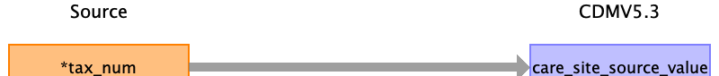

|  |  |  |  |
| --- | --- | --- | --- |
| Destination Field | Source Field | Logic | Comment |
| care_site_id |  |  | Add when new an unique care_site and its related provider/tax number exists |
| care_site_name |  |  |  |
| place_of_service_concept_id |  |  | INPATIENT_PLACE_OF_SERVICE = 8717 # Inpatient Hospital  OUTPATIENT_PLACE_OF_SERVICE = 8756 # Outpatient Hospital  CARRIER_CLAIMS_PLACE_OF_SERVICE = 581477 # Office  SNF_PLACE_OF_SERVICE = 8863 # Skilled Nursing Facility  DME_PLACE_OF_SERVICE = 38004327 # Durable Medical Equipment  HHA_CLAIMS_PLACE_OF_SERVICE = 38004519 # Home Health Agency  HOSPICE_CLAIMS_PLACE_OF_SERVICE = 8546 |
| location_id |  |  | Linked to LOCATION table |
| care_site_source_value | tax_num |  |  |
| place_of_service_source_value |  |  | "Inpatient Facility"  "Outpatient Facility"  " "  "Skilled Nursing Facility"  "Durable Medical Equipment Supplier"  "Home Health Agency Facility"  "Hospice Facility" |

Reading from dme_line_k.csv



|  |  |  |  |
| --- | --- | --- | --- |
| Destination Field | Source Field | Logic | Comment |
| care_site_id |  |  | Add when new an unique care_site and its related provider/tax number exists |
| care_site_name |  |  |  |
| place_of_service_concept_id |  |  | INPATIENT_PLACE_OF_SERVICE = 8717 # Inpatient Hospital  OUTPATIENT_PLACE_OF_SERVICE = 8756 # Outpatient Hospital  CARRIER_CLAIMS_PLACE_OF_SERVICE = 581477 # Office  SNF_PLACE_OF_SERVICE = 8863 # Skilled Nursing Facility  DME_PLACE_OF_SERVICE = 38004327 # Durable Medical Equipment  HHA_CLAIMS_PLACE_OF_SERVICE = 38004519 # Home Health Agency  HOSPICE_CLAIMS_PLACE_OF_SERVICE = 8546 |
| location_id |  |  | Linked to LOCATION table |
| care_site_source_value | tax_num |  |  |
| place_of_service_source_value |  |  | "Inpatient Facility"  "Outpatient Facility"  " "  "Skilled Nursing Facility"  "Durable Medical Equipment Supplier"  "Home Health Agency Facility"  "Hospice Facility" |

Table name: location

Reading from mbsf_abcd_summary.csv

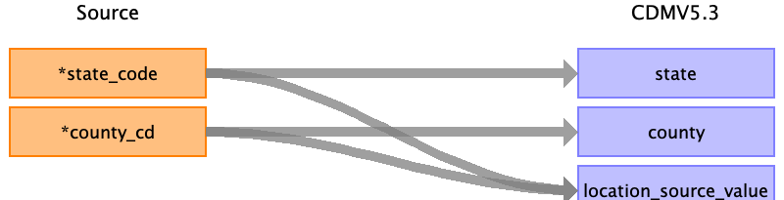

|  |  |  |  |
| --- | --- | --- | --- |
| Destination Field | Source Field | Logic | Comment |
| location_id |  |  | Add when new and unique location information exists. |
| address_1 |  |  |  |
| address_2 |  |  |  |
| city |  |  |  |
| state | state_code |  |  |
| zip |  |  |  |
| county | county_cd |  |  |
| location_source_value | state_code  county_cd |  |  |

Table name: provider

Reading from inpatient_base_claims_k.csv

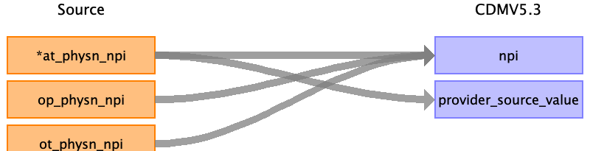

|  |  |  |  |
| --- | --- | --- | --- |
| Destination Field | Source Field | Logic | Comment |
| provider_id |  |  | Ass when new and unique provider and its related npi number exists. |
| provider_name |  |  |  |
| npi | at_physn_npi  op_physn_npi  ot_physn_npi |  |  |
| dea |  |  |  |
| specialty_concept_id |  |  |  |
| care_site_id |  |  | Linked to CARE_SITE table |
| year_of_birth |  |  |  |
| gender_concept_id |  |  |  |
| provider_source_value | at_physn_npi |  | OHDSI team tend to select AT_PHYSN_NPI to represent it. Unsure the reason. |
| specialty_source_value |  |  |  |
| specialty_source_concept_id |  |  |  |
| gender_source_value |  |  |  |
| gender_source_concept_id |  |  |  |

Reading from outpatient_base_claims_k.csv



|  |  |  |  |
| --- | --- | --- | --- |
| Destination Field | Source Field | Logic | Comment |
| provider_id |  |  | Ass when new and unique provider and its related npi number exists. |
| provider_name |  |  |  |
| npi | at_physn_npi  op_physn_npi  ot_physn_npi |  |  |
| dea |  |  |  |
| specialty_concept_id |  |  |  |
| care_site_id |  |  | Linked to CARE_SITE table |
| year_of_birth |  |  |  |
| gender_concept_id |  |  |  |
| provider_source_value | at_physn_npi |  | OHDSI team tend to select AT_PHYSN_NPI to represent it. Unsure the reason. |
| specialty_source_value |  |  |  |
| specialty_source_concept_id |  |  |  |
| gender_source_value |  |  |  |
| gender_source_concept_id |  |  |  |

Reading from snf_base_claims_k.csv



|  |  |  |  |
| --- | --- | --- | --- |
| Destination Field | Source Field | Logic | Comment |
| provider_id |  |  | Ass when new and unique provider and its related npi number exists. |
| provider_name |  |  |  |
| npi | at_physn_npi  op_physn_npi  ot_physn_npi |  |  |
| dea |  |  |  |
| specialty_concept_id |  |  |  |
| care_site_id |  |  | Linked to CARE_SITE table |
| year_of_birth |  |  |  |
| gender_concept_id |  |  |  |
| provider_source_value | at_physn_npi |  | OHDSI team tend to select AT_PHYSN_NPI to represent it. Unsure the reason. |
| specialty_source_value |  |  |  |
| specialty_source_concept_id |  |  |  |
| gender_source_value |  |  |  |
| gender_source_concept_id |  |  |  |

Reading from hha_base_claims_k.csv



|  |  |  |  |
| --- | --- | --- | --- |
| Destination Field | Source Field | Logic | Comment |
| provider_id |  |  | Ass when new and unique provider and its related npi number exists. |
| provider_name |  |  |  |
| npi | at_physn_npi  op_physn_npi  ot_physn_npi |  |  |
| dea |  |  |  |
| specialty_concept_id |  |  |  |
| care_site_id |  |  | Linked to CARE_SITE table |
| year_of_birth |  |  |  |
| gender_concept_id |  |  |  |
| provider_source_value | at_physn_npi |  | OHDSI team tend to select AT_PHYSN_NPI to represent it. Unsure the reason. |
| specialty_source_value |  |  |  |
| specialty_source_concept_id |  |  |  |
| gender_source_value |  |  |  |
| gender_source_concept_id |  |  |  |

Reading from hospice_base_claims_k.csv



|  |  |  |  |
| --- | --- | --- | --- |
| Destination Field | Source Field | Logic | Comment |
| provider_id |  |  | Ass when new and unique provider and its related npi number exists. |
| provider_name |  |  |  |
| npi | at_physn_npi  op_physn_npi  ot_physn_npi |  |  |
| dea |  |  |  |
| specialty_concept_id |  |  |  |
| care_site_id |  |  | Linked to CARE_SITE table |
| year_of_birth |  |  |  |
| gender_concept_id |  |  |  |
| provider_source_value | at_physn_npi |  | OHDSI team tend to select AT_PHYSN_NPI to represent it. Unsure the reason. |
| specialty_source_value |  |  |  |
| specialty_source_concept_id |  |  |  |
| gender_source_value |  |  |  |
| gender_source_concept_id |  |  |  |

Reading from bcarrier_line_k.csv

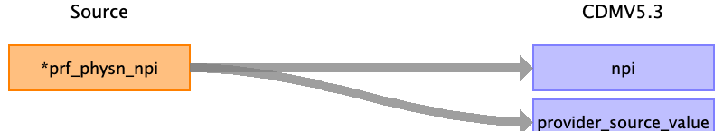

|  |  |  |  |
| --- | --- | --- | --- |
| Destination Field | Source Field | Logic | Comment |
| provider_id |  |  | Ass when new and unique provider and its related npi number exists. |
| provider_name |  |  |  |
| npi | prf_physn_npi |  |  |
| dea |  |  |  |
| specialty_concept_id |  |  |  |
| care_site_id |  |  | Linked to CARE_SITE table |
| year_of_birth |  |  |  |
| gender_concept_id |  |  |  |
| provider_source_value | prf_physn_npi |  | OHDSI team tend to select AT_PHYSN_NPI to represent it. Unsure the reason. |
| specialty_source_value |  |  |  |
| specialty_source_concept_id |  |  |  |
| gender_source_value |  |  |  |
| gender_source_concept_id |  |  |  |

Reading from dme_line_k.csv

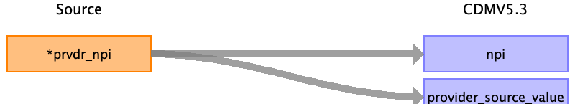

|  |  |  |  |
| --- | --- | --- | --- |
| Destination Field | Source Field | Logic | Comment |
| provider_id |  |  | Ass when new and unique provider and its related npi number exists. |
| provider_name |  |  |  |
| npi | prvdr_npi |  |  |
| dea |  |  |  |
| specialty_concept_id |  |  |  |
| care_site_id |  |  | Linked to CARE_SITE table |
| year_of_birth |  |  |  |
| gender_concept_id |  |  |  |
| provider_source_value | prvdr_npi |  | OHDSI team tend to select AT_PHYSN_NPI to represent it. Unsure the reason. |
| specialty_source_value |  |  |  |
| specialty_source_concept_id |  |  |  |
| gender_source_value |  |  |  |
| gender_source_concept_id |  |  |  |

Table name: cdm_source

NOT USING

Table name: metadata

NOT USING

Table name: attribute_definition

NOT USING

Table name: cohort_definition

NOT USING

Appendix: source tables

Table: stem_table

|  |  |  |  |
| --- | --- | --- | --- |
| Field | Type | Most freq. value | Comment |
| domain_id | CHARACTER VARYING |  |  |
| person_id | INTEGER |  |  |
| visit_occurrence_id | INTEGER |  |  |
| visit_detail_id | INTEGER |  |  |
| provider_id | INTEGER |  |  |
| id | INTEGER |  |  |
| concept_id | INTEGER |  |  |
| source_value | CHARACTER VARYING |  |  |
| source_concept_id | INTEGER |  |  |
| type_concept_id | INTEGER |  |  |
| start_date | DATE |  |  |
| start_datetime | DATETIME |  |  |
| end_date | DATE |  |  |
| end_datetime | DATETIME |  |  |
| verbatim_end_date | DATE |  |  |
| days_supply | INTEGER |  |  |
| dose_unit_source_value | CHARACTER VARYING |  |  |
| lot_number | CHARACTER VARYING |  |  |
| modifier_concept_id | INTEGER |  |  |
| modifier_source_value | CHARACTER VARYING |  |  |
| operator_concept_id | INTEGER |  |  |
| quantity | INTEGER |  |  |
| range_high | FLOAT |  |  |
| range_low | FLOAT |  |  |
| refills | INTEGER |  |  |
| route_concept_id | INTEGER |  |  |
| route_source_value | CHARACTER VARYING |  |  |
| sig | CHARACTER VARYING |  |  |
| stop_reason | CHARACTER VARYING |  |  |
| unique_device_id | CHARACTER VARYING |  |  |
| unit_concept_id | INTEGER |  |  |
| unit_source_value | CHARACTER VARYING |  |  |
| value_as_concept_id | INTEGER |  |  |
| value_as_number | DECIMAL |  |  |
| value_as_string | CHARACTER VARYING |  |  |
| value_source_value | CHARACTER VARYING |  |  |
| anatomic_site_concept_id | INTEGER |  |  |
| disease_status_concept_id | INTEGER |  |  |
| specimen_source_id | INTEGER |  |  |
| anatomic_site_source_value | CHARACTER VARYING |  |  |
| disease_status_source_value | CHARACTER VARYING |  |  |
| condition_status_concept_id | CHARACTER VARYING |  |  |
| condition_status_source_value | INTEGER |  |  |
| qualifier_concept_id | INTEGER |  |  |
| qualifier_source_value | CHARACTER VARYING |  |  |
| measurement_time | CHARACTER VARYING |  |  |

Table: mbsf_abcd_summary.csv

|  |  |  |  |
| --- | --- | --- | --- |
| Field | Type | Most freq. value | Comment |
| bene_id | VARCHAR |  |  |
| bene_enrollmt_ref_yr | REAL | 2018.0 |  |
| enrl_src | VARCHAR | CME |  |
| sample_group | INT | 15 |  |
| enhanced_five_percent_flag | VARCHAR |  |  |
| crnt_bic_cd | VARCHAR | A |  |
| state_code | INT | 30 |  |
| county_cd | INT | 060 |  |
| zip_cd | INT | 03301 |  |
| state_cnty_fips_cd_01 | INT | 33013 |  |
| state_cnty_fips_cd_02 | INT | 33013 |  |
| state_cnty_fips_cd_03 | INT | 33013 |  |
| state_cnty_fips_cd_04 | INT | 33013 |  |
| state_cnty_fips_cd_05 | INT | 33013 |  |
| state_cnty_fips_cd_06 | INT | 33013 |  |
| state_cnty_fips_cd_07 | INT | 33013 |  |
| state_cnty_fips_cd_08 | INT | 33013 |  |
| state_cnty_fips_cd_09 | INT | 33013 |  |
| state_cnty_fips_cd_10 | INT | 33013 |  |
| state_cnty_fips_cd_11 | INT | 33013 |  |
| state_cnty_fips_cd_12 | INT | 33013 |  |
| age_at_end_ref_yr | REAL | 96.0 |  |
| bene_birth_dt | DATE |  |  |
| valid_death_dt_sw | VARCHAR |  |  |
| bene_death_dt | DATE |  |  |
| sex_ident_cd | INT | 2 |  |
| bene_race_cd | INT | 1 |  |
| rti_race_cd | INT | 1 |  |
| covstart | DATE | 1973-07-01 |  |
| entlmt_rsn_orig | INT | 0 |  |
| entlmt_rsn_curr | INT | 0 |  |
| esrd_ind | INT | 0 |  |
| mdcr_status_code_01 | INT | 10 |  |
| mdcr_status_code_02 | INT | 10 |  |
| mdcr_status_code_03 | INT | 10 |  |
| mdcr_status_code_04 | INT | 10 |  |
| mdcr_status_code_05 | INT | 10 |  |
| mdcr_status_code_06 | INT | 10 |  |
| mdcr_status_code_07 | INT | 10 |  |
| mdcr_status_code_08 | INT | 10 |  |
| mdcr_status_code_09 | INT | 10 |  |
| mdcr_status_code_10 | INT | 10 |  |
| mdcr_status_code_11 | INT | 10 |  |
| mdcr_status_code_12 | INT | 10 |  |
| bene_pta_trmntn_cd | INT | 0 |  |
| bene_ptb_trmntn_cd | INT | 0 |  |
| bene_hi_cvrage_tot_mons | REAL | 12.0 |  |
| bene_smi_cvrage_tot_mons | REAL | 12.0 |  |
| bene_state_buyin_tot_mons | REAL | 0.0 |  |
| bene_hmo_cvrage_tot_mons | REAL | 0.0 |  |
| ptd_plan_cvrg_mons | REAL | 12.0 |  |
| rds_cvrg_mons | REAL | 0.0 |  |
| dual_elgbl_mons | REAL | 0.0 |  |
| mdcr_entlmt_buyin_ind_01 | VARCHAR | 3 |  |
| mdcr_entlmt_buyin_ind_02 | VARCHAR | 3 |  |
| mdcr_entlmt_buyin_ind_03 | VARCHAR | 3 |  |
| mdcr_entlmt_buyin_ind_04 | VARCHAR | 3 |  |
| mdcr_entlmt_buyin_ind_05 | VARCHAR | 3 |  |
| mdcr_entlmt_buyin_ind_06 | VARCHAR | 3 |  |
| mdcr_entlmt_buyin_ind_07 | VARCHAR | 3 |  |
| mdcr_entlmt_buyin_ind_08 | VARCHAR | 3 |  |
| mdcr_entlmt_buyin_ind_09 | VARCHAR | 3 |  |
| mdcr_entlmt_buyin_ind_10 | VARCHAR | 3 |  |
| mdcr_entlmt_buyin_ind_11 | VARCHAR | 3 |  |
| mdcr_entlmt_buyin_ind_12 | VARCHAR | 3 |  |
| hmo_ind_01 | VARCHAR | 0 |  |
| hmo_ind_02 | VARCHAR | 0 |  |
| hmo_ind_03 | VARCHAR | 0 |  |
| hmo_ind_04 | VARCHAR | 0 |  |
| hmo_ind_05 | VARCHAR | 0 |  |
| hmo_ind_06 | VARCHAR | 0 |  |
| hmo_ind_07 | VARCHAR | 0 |  |
| hmo_ind_08 | VARCHAR | 0 |  |
| hmo_ind_09 | VARCHAR | 0 |  |
| hmo_ind_10 | INT | 0 |  |
| hmo_ind_11 | INT | 0 |  |
| hmo_ind_12 | INT | 0 |  |
| ptc_cntrct_id_01 | VARCHAR | N |  |
| ptc_cntrct_id_02 | VARCHAR | N |  |
| ptc_cntrct_id_03 | VARCHAR | N |  |
| ptc_cntrct_id_04 | VARCHAR | N |  |
| ptc_cntrct_id_05 | VARCHAR | N |  |
| ptc_cntrct_id_06 | VARCHAR | N |  |
| ptc_cntrct_id_07 | VARCHAR | N |  |
| ptc_cntrct_id_08 | VARCHAR | N |  |
| ptc_cntrct_id_09 | VARCHAR | N |  |
| ptc_cntrct_id_10 | VARCHAR | N |  |
| ptc_cntrct_id_11 | VARCHAR | N |  |
| ptc_cntrct_id_12 | VARCHAR | N |  |
| ptc_pbp_id_01 | INT |  |  |
| ptc_pbp_id_02 | INT |  |  |
| ptc_pbp_id_03 | INT |  |  |
| ptc_pbp_id_04 | INT |  |  |
| ptc_pbp_id_05 | INT |  |  |
| ptc_pbp_id_06 | INT |  |  |
| ptc_pbp_id_07 | INT |  |  |
| ptc_pbp_id_08 | INT |  |  |
| ptc_pbp_id_09 | INT |  |  |
| ptc_pbp_id_10 | EMPTY |  |  |
| ptc_pbp_id_11 | EMPTY |  |  |
| ptc_pbp_id_12 | EMPTY |  |  |
| ptc_plan_type_cd_01 | INT |  |  |
| ptc_plan_type_cd_02 | INT |  |  |
| ptc_plan_type_cd_03 | INT |  |  |
| ptc_plan_type_cd_04 | INT |  |  |
| ptc_plan_type_cd_05 | INT |  |  |
| ptc_plan_type_cd_06 | INT |  |  |
| ptc_plan_type_cd_07 | INT |  |  |
| ptc_plan_type_cd_08 | INT |  |  |
| ptc_plan_type_cd_09 | INT |  |  |
| ptc_plan_type_cd_10 | EMPTY |  |  |
| ptc_plan_type_cd_11 | EMPTY |  |  |
| ptc_plan_type_cd_12 | EMPTY |  |  |
| ptd_cntrct_id_01 | VARCHAR | S5884 |  |
| ptd_cntrct_id_02 | VARCHAR | S5884 |  |
| ptd_cntrct_id_03 | VARCHAR | S5884 |  |
| ptd_cntrct_id_04 | VARCHAR | S5884 |  |
| ptd_cntrct_id_05 | VARCHAR | S5884 |  |
| ptd_cntrct_id_06 | VARCHAR | S5884 |  |
| ptd_cntrct_id_07 | VARCHAR | S5884 |  |
| ptd_cntrct_id_08 | VARCHAR | S5884 |  |
| ptd_cntrct_id_09 | VARCHAR | S5884 |  |
| ptd_cntrct_id_10 | VARCHAR | S5884 |  |
| ptd_cntrct_id_11 | VARCHAR | S5884 |  |
| ptd_cntrct_id_12 | VARCHAR | S5884 |  |
| ptd_pbp_id_01 | INT | 022 |  |
| ptd_pbp_id_02 | INT | 022 |  |
| ptd_pbp_id_03 | INT | 022 |  |
| ptd_pbp_id_04 | INT | 022 |  |
| ptd_pbp_id_05 | INT | 022 |  |
| ptd_pbp_id_06 | INT | 022 |  |
| ptd_pbp_id_07 | INT | 022 |  |
| ptd_pbp_id_08 | INT | 022 |  |
| ptd_pbp_id_09 | INT | 022 |  |
| ptd_pbp_id_10 | INT | 022 |  |
| ptd_pbp_id_11 | INT | 022 |  |
| ptd_pbp_id_12 | INT | 022 |  |
| ptd_sgmt_id_01 | INT | 000 |  |
| ptd_sgmt_id_02 | INT | 000 |  |
| ptd_sgmt_id_03 | INT | 000 |  |
| ptd_sgmt_id_04 | INT | 000 |  |
| ptd_sgmt_id_05 | INT | 000 |  |
| ptd_sgmt_id_06 | INT | 000 |  |
| ptd_sgmt_id_07 | INT | 000 |  |
| ptd_sgmt_id_08 | INT | 000 |  |
| ptd_sgmt_id_09 | INT | 000 |  |
| ptd_sgmt_id_10 | INT | 000 |  |
| ptd_sgmt_id_11 | INT | 000 |  |
| ptd_sgmt_id_12 | INT | 000 |  |
| rds_ind_01 | VARCHAR | N |  |
| rds_ind_02 | VARCHAR | N |  |
| rds_ind_03 | VARCHAR | N |  |
| rds_ind_04 | VARCHAR | N |  |
| rds_ind_05 | VARCHAR | N |  |
| rds_ind_06 | VARCHAR | N |  |
| rds_ind_07 | VARCHAR | N |  |
| rds_ind_08 | VARCHAR | N |  |
| rds_ind_09 | VARCHAR | N |  |
| rds_ind_10 | VARCHAR | N |  |
| rds_ind_11 | VARCHAR | N |  |
| rds_ind_12 | VARCHAR | N |  |
| dual_stus_cd_01 | VARCHAR | NA |  |
| dual_stus_cd_02 | VARCHAR | NA |  |
| dual_stus_cd_03 | VARCHAR | NA |  |
| dual_stus_cd_04 | VARCHAR | NA |  |
| dual_stus_cd_05 | VARCHAR | NA |  |
| dual_stus_cd_06 | VARCHAR | NA |  |
| dual_stus_cd_07 | VARCHAR | NA |  |
| dual_stus_cd_08 | VARCHAR | NA |  |
| dual_stus_cd_09 | VARCHAR | NA |  |
| dual_stus_cd_10 | VARCHAR | NA |  |
| dual_stus_cd_11 | VARCHAR | NA |  |
| dual_stus_cd_12 | VARCHAR | NA |  |
| cst_shr_grp_cd_01 | INT | 09 |  |
| cst_shr_grp_cd_02 | INT | 09 |  |
| cst_shr_grp_cd_03 | INT | 09 |  |
| cst_shr_grp_cd_04 | INT | 09 |  |
| cst_shr_grp_cd_05 | INT | 09 |  |
| cst_shr_grp_cd_06 | INT | 01 |  |
| cst_shr_grp_cd_07 | INT | 09 |  |
| cst_shr_grp_cd_08 | INT | 09 |  |
| cst_shr_grp_cd_09 | INT | 01 |  |
| cst_shr_grp_cd_10 | INT | 01 |  |
| cst_shr_grp_cd_11 | INT | 01 |  |
| cst_shr_grp_cd_12 | INT | 01 |  |

Table: mbsf_cc_summary.csv

|  |  |  |  |
| --- | --- | --- | --- |
| Field | Type | Most freq. value | Comment |
| bene_id | VARCHAR |  |  |
| bene_enrollmt_ref_yr | REAL | 2018.0 |  |
| enrl_src | VARCHAR | CME |  |
| ami | REAL | 2.0 |  |
| ami_mid | REAL | 2.0 |  |
| ami_ever | DATE |  |  |
| alzh | REAL | 2.0 |  |
| alzh_mid | REAL | 2.0 |  |
| alzh_ever | DATE |  |  |
| alzh_demen | REAL | 2.0 |  |
| alzh_demen_mid | REAL | 2.0 |  |
| alzh_demen_ever | DATE |  |  |
| atrial_fib | REAL | 2.0 |  |
| atrial_fib_mid | REAL | 2.0 |  |
| atrial_fib_ever | DATE |  |  |
| cataract | REAL | 2.0 |  |
| cataract_mid | REAL | 2.0 |  |
| cataract_ever | DATE |  |  |
| chronickidney | REAL | 2.0 |  |
| chronickidney_mid | REAL | 2.0 |  |
| chronickidney_ever | DATE |  |  |
| copd | REAL | 2.0 |  |
| copd_mid | REAL | 2.0 |  |
| copd_ever | DATE |  |  |
| chf | REAL | 2.0 |  |
| chf_mid | REAL | 2.0 |  |
| chf_ever | DATE |  |  |
| diabetes | REAL | 2.0 |  |
| diabetes_mid | REAL | 2.0 |  |
| diabetes_ever | DATE |  |  |
| glaucoma | REAL | 2.0 |  |
| glaucoma_mid | REAL | 2.0 |  |
| glaucoma_ever | DATE |  |  |
| hip_fracture | REAL | 2.0 |  |
| hip_fracture_mid | REAL | 2.0 |  |
| hip_fracture_ever | DATE |  |  |
| ischemicheart | REAL | 2.0 |  |
| ischemicheart_mid | REAL | 2.0 |  |
| ischemicheart_ever | DATE |  |  |
| depression | REAL | 2.0 |  |
| depression_mid | REAL | 2.0 |  |
| depression_ever | DATE |  |  |
| osteoporosis | REAL | 2.0 |  |
| osteoporosis_mid | REAL | 2.0 |  |
| osteoporosis_ever | DATE |  |  |
| ra_oa | REAL | 2.0 |  |
| ra_oa_mid | REAL | 2.0 |  |
| ra_oa_ever | DATE |  |  |
| stroke_tia | REAL | 2.0 |  |
| stroke_tia_mid | REAL | 2.0 |  |
| stroke_tia_ever | DATE |  |  |
| cancer_breast | REAL | 2.0 |  |
| cancer_breast_mid | REAL | 2.0 |  |
| cancer_breast_ever | DATE |  |  |
| cancer_colorectal | REAL | 2.0 |  |
| cancer_colorectal_mid | REAL | 2.0 |  |
| cancer_colorectal_ever | DATE |  |  |
| cancer_prostate | REAL | 2.0 |  |
| cancer_prostate_mid | REAL | 2.0 |  |
| cancer_prostate_ever | DATE |  |  |
| cancer_lung | REAL | 2.0 |  |
| cancer_lung_mid | REAL | 2.0 |  |
| cancer_lung_ever | DATE |  |  |
| cancer_endometrial | REAL | 2.0 |  |
| cancer_endometrial_mid | REAL | 2.0 |  |
| cancer_endometrial_ever | DATE |  |  |
| anemia | REAL | 2.0 |  |
| anemia_mid | REAL | 2.0 |  |
| anemia_ever | DATE |  |  |
| asthma | REAL | 2.0 |  |
| asthma_mid | REAL | 2.0 |  |
| asthma_ever | DATE |  |  |
| hyperl | REAL | 2.0 |  |
| hyperl_mid | REAL | 3.0 |  |
| hyperl_ever | DATE |  |  |
| hyperp | REAL | 2.0 |  |
| hyperp_mid | REAL | 2.0 |  |
| hyperp_ever | DATE |  |  |
| hypert | REAL | 3.0 |  |
| hypert_mid | REAL | 3.0 |  |
| hypert_ever | DATE |  |  |
| hypoth | REAL | 2.0 |  |
| hypoth_mid | REAL | 2.0 |  |
| hypoth_ever | DATE |  |  |

Table: inpatient_base_claims_k.csv

|  |  |  |  |
| --- | --- | --- | --- |
| Field | Type | Most freq. value | Comment |
| bene_id | VARCHAR |  |  |
| clm_id | VARCHAR |  |  |
| nch_near_line_rec_ident_cd | VARCHAR | V |  |
| nch_clm_type_cd | INT | 60 |  |
| clm_from_dt | DATE |  |  |
| clm_thru_dt | DATE |  |  |
| nch_wkly_proc_dt | DATE |  |  |
| fi_clm_proc_dt | DATE |  |  |
| claim_query_code | INT | 3 |  |
| prvdr_num | INT |  |  |
| clm_fac_type_cd | INT | 1 |  |
| clm_srvc_clsfctn_type_cd | INT | 1 |  |
| clm_freq_cd | VARCHAR | 1 |  |
| fi_num | INT | 09101 |  |
| clm_mdcr_non_pmt_rsn_cd | VARCHAR |  |  |
| clm_pmt_amt | REAL |  |  |
| nch_prmry_pyr_clm_pd_amt | REAL | 0.0 |  |
| nch_prmry_pyr_cd | EMPTY |  |  |
| fi_clm_actn_cd | INT | 1 |  |
| prvdr_state_cd | INT | 10 |  |
| org_npi_num | INT |  |  |
| at_physn_upin | EMPTY |  |  |
| at_physn_npi | INT |  |  |
| at_physn_spclty_cd | EMPTY |  |  |
| op_physn_upin | EMPTY |  |  |
| op_physn_npi | INT |  |  |
| op_physn_spclty_cd | EMPTY |  |  |
| ot_physn_upin | EMPTY |  |  |
| ot_physn_npi | EMPTY |  |  |
| ot_physn_spclty_cd | EMPTY |  |  |
| rndrng_physn_npi | EMPTY |  |  |
| rndrng_physn_spclty_cd | EMPTY |  |  |
| clm_mco_pd_sw | EMPTY |  |  |
| ptnt_dschrg_stus_cd | INT | 03 |  |
| clm_pps_ind_cd | INT | 2 |  |
| clm_tot_chrg_amt | REAL |  |  |
| clm_admsn_dt | DATE |  |  |
| clm_ip_admsn_type_cd | INT | 1 |  |
| clm_src_ip_admsn_cd | INT | 1 |  |
| nch_ptnt_status_ind_cd | VARCHAR | A |  |
| clm_pass_thru_per_diem_amt | REAL | 0.0 |  |
| nch_bene_ip_ddctbl_amt | REAL | 1340.0 |  |
| nch_bene_pta_coinsrnc_lblty_am | REAL | 0.0 |  |
| nch_bene_blood_ddctbl_lblty_am | REAL | 0.0 |  |
| nch_profnl_cmpnt_chrg_amt | REAL | 0.0 |  |
| nch_ip_ncvrd_chrg_amt | REAL | 0.0 |  |
| nch_ip_tot_ddctn_amt | REAL | 1340.0 |  |
| clm_tot_pps_cptl_amt | REAL | 0.0 |  |
| clm_pps_cptl_fsp_amt | REAL | 0.0 |  |
| clm_pps_cptl_outlier_amt | REAL | 0.0 |  |
| clm_pps_cptl_dsprprtnt_shr_amt | REAL | 0.0 |  |
| clm_pps_cptl_ime_amt | REAL | 0.0 |  |
| clm_pps_cptl_excptn_amt | REAL | 0.0 |  |
| clm_pps_old_cptl_hld_hrmls_amt | REAL | 0.0 |  |
| clm_pps_cptl_drg_wt_num | REAL | 0.0 |  |
| clm_utlztn_day_cnt | REAL | 3.0 |  |
| bene_tot_coinsrnc_days_cnt | REAL | 0.0 |  |
| bene_lrd_used_cnt | REAL | 0.0 |  |
| clm_non_utlztn_days_cnt | REAL | 0.0 |  |
| nch_blood_pnts_frnshd_qty | REAL | 0.0 |  |
| nch_vrfd_ncvrd_stay_from_dt | EMPTY |  |  |
| nch_vrfd_ncvrd_stay_thru_dt | EMPTY |  |  |
| nch_actv_or_cvrd_lvl_care_thru | EMPTY |  |  |
| nch_bene_mdcr_bnfts_exhtd_dt_i | EMPTY |  |  |
| nch_bene_dschrg_dt | DATE |  |  |
| clm_drg_cd | INT |  |  |
| clm_drg_outlier_stay_cd | INT | 0 |  |
| nch_drg_outlier_aprvd_pmt_amt | REAL | 0.0 |  |
| admtg_dgns_cd | VARCHAR |  |  |
| prncpal_dgns_cd | VARCHAR |  |  |
| icd_dgns_cd1 | VARCHAR |  |  |
| clm_poa_ind_sw1 | VARCHAR | Y |  |
| icd_dgns_cd2 | VARCHAR |  |  |
| clm_poa_ind_sw2 | VARCHAR | Y |  |
| icd_dgns_cd3 | VARCHAR |  |  |
| clm_poa_ind_sw3 | VARCHAR | Y |  |
| icd_dgns_cd4 | VARCHAR |  |  |
| clm_poa_ind_sw4 | VARCHAR | Y |  |
| icd_dgns_cd5 | VARCHAR |  |  |
| clm_poa_ind_sw5 | VARCHAR | Y |  |
| icd_dgns_cd6 | VARCHAR |  |  |
| clm_poa_ind_sw6 | VARCHAR | Y |  |
| icd_dgns_cd7 | VARCHAR |  |  |
| clm_poa_ind_sw7 | VARCHAR | Y |  |
| icd_dgns_cd8 | VARCHAR |  |  |
| clm_poa_ind_sw8 | VARCHAR | Y |  |
| icd_dgns_cd9 | VARCHAR |  |  |
| clm_poa_ind_sw9 | VARCHAR | Y |  |
| icd_dgns_cd10 | VARCHAR |  |  |
| clm_poa_ind_sw10 | VARCHAR | Y |  |
| icd_dgns_cd11 | VARCHAR |  |  |
| clm_poa_ind_sw11 | VARCHAR |  |  |
| icd_dgns_cd12 | VARCHAR |  |  |
| clm_poa_ind_sw12 | VARCHAR |  |  |
| icd_dgns_cd13 | VARCHAR |  |  |
| clm_poa_ind_sw13 | VARCHAR |  |  |
| icd_dgns_cd14 | VARCHAR |  |  |
| clm_poa_ind_sw14 | VARCHAR |  |  |
| icd_dgns_cd15 | VARCHAR |  |  |
| clm_poa_ind_sw15 | VARCHAR |  |  |
| icd_dgns_cd16 | VARCHAR |  |  |
| clm_poa_ind_sw16 | VARCHAR |  |  |
| icd_dgns_cd17 | VARCHAR |  |  |
| clm_poa_ind_sw17 | VARCHAR |  |  |
| icd_dgns_cd18 | VARCHAR |  |  |
| clm_poa_ind_sw18 | VARCHAR |  |  |
| icd_dgns_cd19 | VARCHAR |  |  |
| clm_poa_ind_sw19 | VARCHAR |  |  |
| icd_dgns_cd20 | VARCHAR |  |  |
| clm_poa_ind_sw20 | VARCHAR |  |  |
| icd_dgns_cd21 | VARCHAR |  |  |
| clm_poa_ind_sw21 | VARCHAR |  |  |
| icd_dgns_cd22 | VARCHAR |  |  |
| clm_poa_ind_sw22 | VARCHAR |  |  |
| icd_dgns_cd23 | VARCHAR |  |  |
| clm_poa_ind_sw23 | VARCHAR |  |  |
| icd_dgns_cd24 | VARCHAR |  |  |
| clm_poa_ind_sw24 | INT |  |  |
| icd_dgns_cd25 | VARCHAR |  |  |
| clm_poa_ind_sw25 | INT |  |  |
| fst_dgns_e_cd | VARCHAR |  |  |
| icd_dgns_e_cd1 | VARCHAR |  |  |
| clm_e_poa_ind_sw1 | INT |  |  |
| icd_dgns_e_cd2 | EMPTY |  |  |
| clm_e_poa_ind_sw2 | EMPTY |  |  |
| icd_dgns_e_cd3 | EMPTY |  |  |
| clm_e_poa_ind_sw3 | EMPTY |  |  |
| icd_dgns_e_cd4 | EMPTY |  |  |
| clm_e_poa_ind_sw4 | EMPTY |  |  |
| icd_dgns_e_cd5 | EMPTY |  |  |
| clm_e_poa_ind_sw5 | EMPTY |  |  |
| icd_dgns_e_cd6 | EMPTY |  |  |
| clm_e_poa_ind_sw6 | EMPTY |  |  |
| icd_dgns_e_cd7 | EMPTY |  |  |
| clm_e_poa_ind_sw7 | EMPTY |  |  |
| icd_dgns_e_cd8 | EMPTY |  |  |
| clm_e_poa_ind_sw8 | EMPTY |  |  |
| icd_dgns_e_cd9 | EMPTY |  |  |
| clm_e_poa_ind_sw9 | EMPTY |  |  |
| icd_dgns_e_cd10 | EMPTY |  |  |
| clm_e_poa_ind_sw10 | EMPTY |  |  |
| icd_dgns_e_cd11 | EMPTY |  |  |
| clm_e_poa_ind_sw11 | EMPTY |  |  |
| icd_dgns_e_cd12 | EMPTY |  |  |
| clm_e_poa_ind_sw12 | EMPTY |  |  |
| icd_prcdr_cd1 | VARCHAR |  |  |
| prcdr_dt1 | DATE |  |  |
| icd_prcdr_cd2 | VARCHAR |  |  |
| prcdr_dt2 | DATE |  |  |
| icd_prcdr_cd3 | VARCHAR |  |  |
| prcdr_dt3 | DATE |  |  |
| icd_prcdr_cd4 | EMPTY |  |  |
| prcdr_dt4 | EMPTY |  |  |
| icd_prcdr_cd5 | EMPTY |  |  |
| prcdr_dt5 | EMPTY |  |  |
| icd_prcdr_cd6 | EMPTY |  |  |
| prcdr_dt6 | EMPTY |  |  |
| icd_prcdr_cd7 | EMPTY |  |  |
| prcdr_dt7 | EMPTY |  |  |
| icd_prcdr_cd8 | EMPTY |  |  |
| prcdr_dt8 | EMPTY |  |  |
| icd_prcdr_cd9 | EMPTY |  |  |
| prcdr_dt9 | EMPTY |  |  |
| icd_prcdr_cd10 | EMPTY |  |  |
| prcdr_dt10 | EMPTY |  |  |
| icd_prcdr_cd11 | EMPTY |  |  |
| prcdr_dt11 | EMPTY |  |  |
| icd_prcdr_cd12 | EMPTY |  |  |
| prcdr_dt12 | EMPTY |  |  |
| icd_prcdr_cd13 | EMPTY |  |  |
| prcdr_dt13 | EMPTY |  |  |
| icd_prcdr_cd14 | EMPTY |  |  |
| prcdr_dt14 | EMPTY |  |  |
| icd_prcdr_cd15 | EMPTY |  |  |
| prcdr_dt15 | EMPTY |  |  |
| icd_prcdr_cd16 | EMPTY |  |  |
| prcdr_dt16 | EMPTY |  |  |
| icd_prcdr_cd17 | EMPTY |  |  |
| prcdr_dt17 | EMPTY |  |  |
| icd_prcdr_cd18 | EMPTY |  |  |
| prcdr_dt18 | EMPTY |  |  |
| icd_prcdr_cd19 | EMPTY |  |  |
| prcdr_dt19 | EMPTY |  |  |
| icd_prcdr_cd20 | EMPTY |  |  |
| prcdr_dt20 | EMPTY |  |  |
| icd_prcdr_cd21 | EMPTY |  |  |
| prcdr_dt21 | EMPTY |  |  |
| icd_prcdr_cd22 | EMPTY |  |  |
| prcdr_dt22 | EMPTY |  |  |
| icd_prcdr_cd23 | EMPTY |  |  |
| prcdr_dt23 | EMPTY |  |  |
| icd_prcdr_cd24 | EMPTY |  |  |
| prcdr_dt24 | EMPTY |  |  |
| icd_prcdr_cd25 | EMPTY |  |  |
| prcdr_dt25 | EMPTY |  |  |
| ime_op_clm_val_amt | REAL |  |  |
| dsh_op_clm_val_amt | REAL |  |  |
| dob_dt | DATE |  |  |
| gndr_cd | INT | 2 |  |
| bene_race_cd | INT | 1 |  |
| bene_cnty_cd | INT |  |  |
| bene_state_cd | INT | 10 |  |
| bene_mlg_cntct_zip_cd | INT |  |  |
| clm_mdcl_rec | EMPTY |  |  |
| clm_trtmt_authrztn_num | EMPTY |  |  |
| clm_prcr_rtrn_cd | INT | 14 |  |
| clm_srvc_fac_zip_cd | INT |  |  |
| clm_ip_low_vol_pmt_amt | REAL | 0.0 |  |
| clm_care_imprvmt_model_cd1 | EMPTY |  |  |
| clm_care_imprvmt_model_cd2 | INT |  |  |
| clm_care_imprvmt_model_cd3 | EMPTY |  |  |
| clm_care_imprvmt_model_cd4 | EMPTY |  |  |
| clm_bndld_model_1_dscnt_pct | REAL | 0.0 |  |
| clm_base_oprtg_drg_amt | REAL | 0.0 |  |
| clm_vbp_prtcpnt_ind_cd | VARCHAR | Y |  |
| clm_vbp_adjstmt_pct | REAL | 0.0 |  |
| clm_hrr_prtcpnt_ind_cd | INT | 1 |  |
| clm_hrr_adjstmt_pct | REAL | 0.0 |  |
| clm_model_4_readmsn_ind_cd | EMPTY |  |  |
| clm_uncompd_care_pmt_amt | REAL | 0.0 |  |
| clm_bndld_adjstmt_pmt_amt | REAL | 0.0 |  |
| clm_vbp_adjstmt_pmt_amt | REAL | 0.0 |  |
| clm_hrr_adjstmt_pmt_amt | REAL | 0.0 |  |
| ehr_pymt_adjstmt_amt | REAL | 0.0 |  |
| pps_std_val_pymt_amt | REAL | 0.0 |  |
| finl_std_amt | REAL | 0.0 |  |
| hac_pgm_rdctn_ind_sw | EMPTY |  |  |
| ehr_pgm_rdctn_ind_sw | EMPTY |  |  |
| clm_site_ntrl_pymt_cst_amt | REAL | 0.0 |  |
| clm_site_ntrl_pymt_ipps_amt | REAL | 0.0 |  |
| clm_full_std_pymt_amt | REAL | 0.0 |  |
| clm_ss_outlier_std_pymt_amt | REAL | 0.0 |  |
| clm_next_gnrtn_aco_ind_cd1 | EMPTY |  |  |
| clm_next_gnrtn_aco_ind_cd2 | EMPTY |  |  |
| clm_next_gnrtn_aco_ind_cd3 | EMPTY |  |  |
| clm_next_gnrtn_aco_ind_cd4 | EMPTY |  |  |
| clm_next_gnrtn_aco_ind_cd5 | EMPTY |  |  |
| aco_id_num | EMPTY |  |  |
| clm_bene_id_type_cd | VARCHAR | H |  |
| clm_rsdl_pymt_ind_cd | EMPTY |  |  |
| clm_rp_ind_cd | EMPTY |  |  |
| prvdr_vldtn_type_cd | EMPTY |  |  |
| rr_brd_exclsn_ind_sw | EMPTY |  |  |
| clm_ip_initl_ms_drg_cd | EMPTY |  |  |
| clm_model_reimbrsmt_amt | EMPTY |  |  |

Table: inpatient_revenue_center_k.csv

|  |  |  |  |
| --- | --- | --- | --- |
| Field | Type | Most freq. value | Comment |
| bene_id | VARCHAR | BBBBBBBBBBB747p |  |
| clm_id | VARCHAR | BBBBBs884KBIpB2 |  |
| clm_thru_dt | DATE | 2018-03-03 |  |
| clm_line_num | REAL | 1.0 |  |
| nch_clm_type_cd | INT | 60 |  |
| rev_cntr | INT | 0001 |  |
| hcpcs_cd | VARCHAR |  |  |
| hcpcs_1st_mdfr_cd | EMPTY |  |  |
| hcpcs_2nd_mdfr_cd | EMPTY |  |  |
| hcpcs_3rd_mdfr_cd | EMPTY |  |  |
| rev_cntr_unit_cnt | REAL | 1.0 |  |
| rev_cntr_rate_amt | REAL | 0.0 |  |
| rev_cntr_tot_chrg_amt | REAL |  |  |
| rev_cntr_ncvrd_chrg_amt | REAL | 0.0 |  |
| rev_cntr_ddctbl_coinsrnc_cd | EMPTY |  |  |
| rev_cntr_ndc_qty | REAL | 0.0 |  |
| rev_cntr_ndc_qty_qlfr_cd | VARCHAR |  |  |
| rndrng_physn_upin | EMPTY |  |  |
| rndrng_physn_npi | EMPTY |  |  |
| rndrng_physn_spclty_cd | EMPTY |  |  |
| rev_cntr_ide_ndc_upc_num | INT |  |  |
| rev_cntr_prcng_ind_cd | VARCHAR |  |  |
| thrpy_cap_ind_cd1 | EMPTY |  |  |
| thrpy_cap_ind_cd2 | EMPTY |  |  |
| rc_model_reimbrsmt_amt | EMPTY |  |  |

Table: inpatient_condition_codes.csv

|  |  |  |  |
| --- | --- | --- | --- |
| Field | Type | Most freq. value | Comment |
| bene_id | VARCHAR |  |  |
| clm_id | VARCHAR |  |  |
| nch_clm_type_cd | INT | 60 |  |
| rlt_cond_cd_seq | INT | 01 |  |
| clm_rlt_cond_cd | VARCHAR | 09 |  |

Table: inpatient_occurrnce_codes.csv

|  |  |  |  |
| --- | --- | --- | --- |
| Field | Type | Most freq. value | Comment |
| bene_id | VARCHAR | BBBBBBBBBBq88s4 |  |
| clm_id | VARCHAR | BBBBBs8IK4qIqKq |  |
| nch_clm_type_cd | INT | 60 |  |
| rlt_ocrnc_cd_seq | INT | 01 |  |
| clm_rlt_ocrnc_cd | VARCHAR | 18 |  |
| clm_rlt_ocrnc_dt | DATE |  |  |

Table: inpatient_span_codes.csv

|  |  |  |  |
| --- | --- | --- | --- |
| Field | Type | Most freq. value | Comment |
| bene_id | VARCHAR |  |  |
| clm_id | VARCHAR |  |  |
| nch_clm_type_cd | INT | 60 |  |
| rlt_span_cd_seq | INT | 01 |  |
| clm_span_cd | VARCHAR |  |  |
| clm_span_from_dt | DATE |  |  |
| clm_span_thru_dt | DATE |  |  |

Table: inpatient_value_codes.csv

|  |  |  |  |
| --- | --- | --- | --- |
| Field | Type | Most freq. value | Comment |
| bene_id | VARCHAR | BBBBBBBBBBB84pI |  |
| clm_id | VARCHAR | BBBBBs87pK8psKK |  |
| nch_clm_type_cd | INT | 60 |  |
| rlt_val_cd_seq | INT | 01 |  |
| clm_val_cd | VARCHAR | 73 |  |
| clm_val_amt | REAL | 1340.0 |  |

Table: inpatient_demo_codes.csv

|  |  |  |  |
| --- | --- | --- | --- |
| Field | Type | Most freq. value | Comment |
| bene_id | VARCHAR |  |  |
| clm_id | VARCHAR |  |  |
| nch_clm_type_cd | INT |  |  |
| demo_id_sqnc_num | REAL |  |  |
| demo_id_num | INT |  |  |
| demo_info_txt | EMPTY |  |  |

Table: outpatient_base_claims_k.csv

|  |  |  |  |
| --- | --- | --- | --- |
| Field | Type | Most freq. value | Comment |
| bene_id | VARCHAR | BBBBBBBBBBq82Is |  |
| clm_id | VARCHAR |  |  |
| nch_near_line_rec_ident_cd | VARCHAR | W |  |
| nch_clm_type_cd | INT | 40 |  |
| clm_from_dt | DATE | 2018-03-01 |  |
| clm_thru_dt | DATE | 2018-03-01 |  |
| nch_wkly_proc_dt | DATE | 2018-03-16 |  |
| fi_clm_proc_dt | DATE | 2018-01-30 |  |
| claim_query_code | INT | 3 |  |
| prvdr_num | INT | 301310 |  |
| clm_fac_type_cd | INT | 1 |  |
| clm_srvc_clsfctn_type_cd | INT | 3 |  |
| clm_freq_cd | INT | 1 |  |
| fi_num | INT | 14311 |  |
| clm_mdcr_non_pmt_rsn_cd | EMPTY |  |  |
| clm_pmt_amt | REAL | 133.34 |  |
| nch_prmry_pyr_clm_pd_amt | REAL | 0.0 |  |
| nch_prmry_pyr_cd | EMPTY |  |  |
| prvdr_state_cd | INT | 30 |  |
| org_npi_num | INT | 1386680593 |  |
| srvc_loc_npi_num | INT |  |  |
| at_physn_upin | EMPTY |  |  |
| at_physn_npi | INT | 1497002174 |  |
| at_physn_spclty_cd | INT | 11 |  |
| op_physn_upin | EMPTY |  |  |
| op_physn_npi | INT |  |  |
| op_physn_spclty_cd | INT |  |  |
| ot_physn_upin | EMPTY |  |  |
| ot_physn_npi | EMPTY |  |  |
| ot_physn_spclty_cd | EMPTY |  |  |
| rndrng_physn_npi | INT |  |  |
| rndrng_physn_spclty_cd | INT |  |  |
| rfr_physn_npi | EMPTY |  |  |
| rfr_physn_spclty_cd | EMPTY |  |  |
| clm_mco_pd_sw | EMPTY |  |  |
| ptnt_dschrg_stus_cd | INT | 01 |  |
| clm_tot_chrg_amt | REAL |  |  |
| nch_bene_blood_ddctbl_lblty_am | REAL | 0.0 |  |
| nch_profnl_cmpnt_chrg_amt | REAL |  |  |
| prncpal_dgns_cd | VARCHAR | M6281 |  |
| icd_dgns_cd1 | VARCHAR | M6281 |  |
| icd_dgns_cd2 | VARCHAR |  |  |
| icd_dgns_cd3 | VARCHAR |  |  |
| icd_dgns_cd4 | VARCHAR |  |  |
| icd_dgns_cd5 | VARCHAR |  |  |
| icd_dgns_cd6 | VARCHAR |  |  |
| icd_dgns_cd7 | VARCHAR |  |  |
| icd_dgns_cd8 | VARCHAR |  |  |
| icd_dgns_cd9 | VARCHAR |  |  |
| icd_dgns_cd10 | VARCHAR |  |  |
| icd_dgns_cd11 | VARCHAR |  |  |
| icd_dgns_cd12 | VARCHAR |  |  |
| icd_dgns_cd13 | VARCHAR |  |  |
| icd_dgns_cd14 | VARCHAR |  |  |
| icd_dgns_cd15 | VARCHAR |  |  |
| icd_dgns_cd16 | VARCHAR |  |  |
| icd_dgns_cd17 | VARCHAR |  |  |
| icd_dgns_cd18 | VARCHAR |  |  |
| icd_dgns_cd19 | VARCHAR |  |  |
| icd_dgns_cd20 | EMPTY |  |  |
| icd_dgns_cd21 | EMPTY |  |  |
| icd_dgns_cd22 | EMPTY |  |  |
| icd_dgns_cd23 | EMPTY |  |  |
| icd_dgns_cd24 | EMPTY |  |  |
| icd_dgns_cd25 | EMPTY |  |  |
| fst_dgns_e_cd | VARCHAR |  |  |
| icd_dgns_e_cd1 | VARCHAR |  |  |
| icd_dgns_e_cd2 | EMPTY |  |  |
| icd_dgns_e_cd3 | EMPTY |  |  |
| icd_dgns_e_cd4 | EMPTY |  |  |
| icd_dgns_e_cd5 | EMPTY |  |  |
| icd_dgns_e_cd6 | EMPTY |  |  |
| icd_dgns_e_cd7 | EMPTY |  |  |
| icd_dgns_e_cd8 | EMPTY |  |  |
| icd_dgns_e_cd9 | EMPTY |  |  |
| icd_dgns_e_cd10 | EMPTY |  |  |
| icd_dgns_e_cd11 | EMPTY |  |  |
| icd_dgns_e_cd12 | EMPTY |  |  |
| icd_prcdr_cd1 | EMPTY |  |  |
| prcdr_dt1 | EMPTY |  |  |
| icd_prcdr_cd2 | EMPTY |  |  |
| prcdr_dt2 | EMPTY |  |  |
| icd_prcdr_cd3 | EMPTY |  |  |
| prcdr_dt3 | EMPTY |  |  |
| icd_prcdr_cd4 | EMPTY |  |  |
| prcdr_dt4 | EMPTY |  |  |
| icd_prcdr_cd5 | EMPTY |  |  |
| prcdr_dt5 | EMPTY |  |  |
| icd_prcdr_cd6 | EMPTY |  |  |
| prcdr_dt6 | EMPTY |  |  |
| icd_prcdr_cd7 | EMPTY |  |  |
| prcdr_dt7 | EMPTY |  |  |
| icd_prcdr_cd8 | EMPTY |  |  |
| prcdr_dt8 | EMPTY |  |  |
| icd_prcdr_cd9 | EMPTY |  |  |
| prcdr_dt9 | EMPTY |  |  |
| icd_prcdr_cd10 | EMPTY |  |  |
| prcdr_dt10 | EMPTY |  |  |
| icd_prcdr_cd11 | EMPTY |  |  |
| prcdr_dt11 | EMPTY |  |  |
| icd_prcdr_cd12 | EMPTY |  |  |
| prcdr_dt12 | EMPTY |  |  |
| icd_prcdr_cd13 | EMPTY |  |  |
| prcdr_dt13 | EMPTY |  |  |
| icd_prcdr_cd14 | EMPTY |  |  |
| prcdr_dt14 | EMPTY |  |  |
| icd_prcdr_cd15 | EMPTY |  |  |
| prcdr_dt15 | EMPTY |  |  |
| icd_prcdr_cd16 | EMPTY |  |  |
| prcdr_dt16 | EMPTY |  |  |
| icd_prcdr_cd17 | EMPTY |  |  |
| prcdr_dt17 | EMPTY |  |  |
| icd_prcdr_cd18 | EMPTY |  |  |
| prcdr_dt18 | EMPTY |  |  |
| icd_prcdr_cd19 | EMPTY |  |  |
| prcdr_dt19 | EMPTY |  |  |
| icd_prcdr_cd20 | EMPTY |  |  |
| prcdr_dt20 | EMPTY |  |  |
| icd_prcdr_cd21 | EMPTY |  |  |
| prcdr_dt21 | EMPTY |  |  |
| icd_prcdr_cd22 | EMPTY |  |  |
| prcdr_dt22 | EMPTY |  |  |
| icd_prcdr_cd23 | EMPTY |  |  |
| prcdr_dt23 | EMPTY |  |  |
| icd_prcdr_cd24 | EMPTY |  |  |
| prcdr_dt24 | EMPTY |  |  |
| icd_prcdr_cd25 | EMPTY |  |  |
| prcdr_dt25 | EMPTY |  |  |
| rsn_visit_cd1 | VARCHAR |  |  |
| rsn_visit_cd2 | VARCHAR |  |  |
| rsn_visit_cd3 | VARCHAR |  |  |
| nch_bene_ptb_ddctbl_amt | REAL | 0.0 |  |
| nch_bene_ptb_coinsrnc_amt | REAL | 0.0 |  |
| clm_op_prvdr_pmt_amt | REAL | 133.34 |  |
| clm_op_bene_pmt_amt | REAL | 0.0 |  |
| dob_dt | DATE | 1928-08-03 |  |
| gndr_cd | INT | 2 |  |
| bene_race_cd | INT | 1 |  |
| bene_cnty_cd | INT | 030 |  |
| bene_state_cd | INT | 30 |  |
| bene_mlg_cntct_zip_cd | INT | 035980000 |  |
| clm_mdcl_rec | EMPTY |  |  |
| fi_clm_actn_cd | INT | 1 |  |
| nch_blood_pnts_frnshd_qty | REAL | 0.0 |  |
| clm_trtmt_authrztn_num | EMPTY |  |  |
| clm_prcr_rtrn_cd | INT | 00 |  |
| clm_srvc_fac_zip_cd | INT | 035843556 |  |
| clm_op_trans_type_cd | VARCHAR | C |  |
| clm_op_esrd_mthd_cd | INT | 0 |  |
| clm_next_gnrtn_aco_ind_cd1 | EMPTY |  |  |
| clm_next_gnrtn_aco_ind_cd2 | EMPTY |  |  |
| clm_next_gnrtn_aco_ind_cd3 | EMPTY |  |  |
| clm_next_gnrtn_aco_ind_cd4 | EMPTY |  |  |
| clm_next_gnrtn_aco_ind_cd5 | EMPTY |  |  |
| aco_id_num | EMPTY |  |  |
| clm_bene_id_type_cd | EMPTY |  |  |
| clm_rsdl_pymt_ind_cd | EMPTY |  |  |
| prvdr_vldtn_type_cd | EMPTY |  |  |
| rr_brd_exclsn_ind_sw | EMPTY |  |  |
| clm_model_reimbrsmt_amt | EMPTY |  |  |

Table: outpatient_revenue_center_k.csv

|  |  |  |  |
| --- | --- | --- | --- |
| Field | Type | Most freq. value | Comment |
| bene_id | VARCHAR | BBBBBBBBBBq8sq8 |  |
| clm_id | VARCHAR | BBBBBsq2B84K848 |  |
| clm_thru_dt | DATE | 2018-01-08 |  |
| clm_line_num | REAL | 1.0 |  |
| nch_clm_type_cd | INT | 40 |  |
| rev_cntr | INT | 0001 |  |
| rev_cntr_dt | DATE |  |  |
| rev_cntr_1st_ansi_cd | VARCHAR |  |  |
| rev_cntr_2nd_ansi_cd | EMPTY |  |  |
| rev_cntr_3rd_ansi_cd | EMPTY |  |  |
| rev_cntr_4th_ansi_cd | EMPTY |  |  |
| rev_cntr_apc_hipps_cd | INT | 00000 |  |
| hcpcs_cd | VARCHAR |  |  |
| hcpcs_1st_mdfr_cd | VARCHAR |  |  |
| hcpcs_2nd_mdfr_cd | VARCHAR |  |  |
| hcpcs_3rd_mdfr_cd | EMPTY |  |  |
| hcpcs_4th_mdfr_cd | EMPTY |  |  |
| rev_cntr_pmt_mthd_ind_cd | INT | 2 |  |
| rev_cntr_dscnt_ind_cd | INT | 1 |  |
| rev_cntr_packg_ind_cd | INT | 0 |  |
| rev_cntr_otaf_pmt_cd | EMPTY |  |  |
| rev_cntr_ide_ndc_upc_num | INT |  |  |
| rev_cntr_unit_cnt | REAL | 1.0 |  |
| rev_cntr_rate_amt | REAL | 0.0 |  |
| rev_cntr_blood_ddctbl_amt | REAL | 0.0 |  |
| rev_cntr_cash_ddctbl_amt | REAL | 0.0 |  |
| rev_cntr_coinsrnc_wge_adjstd_c | REAL | 0.0 |  |
| rev_cntr_rdcd_coinsrnc_amt | REAL | 0.0 |  |
| rev_cntr_1st_msp_pd_amt | REAL | 0.0 |  |
| rev_cntr_2nd_msp_pd_amt | REAL | 0.0 |  |
| rev_cntr_prvdr_pmt_amt | REAL | 0.0 |  |
| rev_cntr_bene_pmt_amt | REAL | 0.0 |  |
| rev_cntr_ptnt_rspnsblty_pmt | REAL | 0.0 |  |
| rev_cntr_pmt_amt_amt | REAL | 0.0 |  |
| rev_cntr_tot_chrg_amt | REAL | 0.01 |  |
| rev_cntr_ncvrd_chrg_amt | REAL | 0.0 |  |
| rev_cntr_stus_ind_cd | VARCHAR | A |  |
| rev_cntr_ndc_qty | REAL | 0.0 |  |
| rev_cntr_ndc_qty_qlfr_cd | VARCHAR |  |  |
| rndrng_physn_upin | EMPTY |  |  |
| rndrng_physn_npi | INT |  |  |
| rndrng_physn_spclty_cd | INT |  |  |
| rev_cntr_ddctbl_coinsrnc_cd | INT |  |  |
| rev_cntr_prcng_ind_cd | VARCHAR |  |  |
| thrpy_cap_ind_cd1 | EMPTY |  |  |
| thrpy_cap_ind_cd2 | EMPTY |  |  |
| rc_ptnt_add_on_pymt_amt | REAL | 0.0 |  |
| trnstnl_drug_add_on_pymt_amt | REAL | 0.0 |  |
| rev_cntr_rp_ind_cd | EMPTY |  |  |
| rc_model_reimbrsmt_amt | EMPTY |  |  |

Table: outpatient_condition_codes.csv

|  |  |  |  |
| --- | --- | --- | --- |
| Field | Type | Most freq. value | Comment |
| bene_id | VARCHAR | BBBBBBBBBBBqKsq |  |
| clm_id | VARCHAR |  |  |
| nch_clm_type_cd | INT | 40 |  |
| rlt_cond_cd_seq | INT | 01 |  |
| clm_rlt_cond_cd | VARCHAR | 09 |  |

Table: outpatient_occurrnce_codes.csv

|  |  |  |  |
| --- | --- | --- | --- |
| Field | Type | Most freq. value | Comment |
| bene_id | VARCHAR | BBBBBBBBBBq82Is |  |
| clm_id | VARCHAR |  |  |
| nch_clm_type_cd | INT | 40 |  |
| rlt_ocrnc_cd_seq | INT | 01 |  |
| clm_rlt_ocrnc_cd | VARCHAR | 18 |  |
| clm_rlt_ocrnc_dt | DATE | 2017-11-29 |  |

Table: outpatient_span_codes.csv

|  |  |  |  |
| --- | --- | --- | --- |
| Field | Type | Most freq. value | Comment |
| bene_id | VARCHAR | BBBBBBBps7psq4K |  |
| clm_id | VARCHAR | BBBBBs22s48I4B2 |  |
| nch_clm_type_cd | INT | 40 |  |
| rlt_span_cd_seq | INT | 01 |  |
| clm_span_cd | VARCHAR | 72 |  |
| clm_span_from_dt | DATE | 2018-12-03 |  |
| clm_span_thru_dt | DATE | 2018-11-29 |  |

Table: outpatient_value_codes.csv

|  |  |  |  |
| --- | --- | --- | --- |
| Field | Type | Most freq. value | Comment |
| bene_id | VARCHAR | BBBBBBBBBBq8sq8 |  |
| clm_id | VARCHAR | BBBBBsqpsII8B87 |  |
| nch_clm_type_cd | INT | 40 |  |
| rlt_val_cd_seq | INT | 01 |  |
| clm_val_cd | VARCHAR | 73 |  |
| clm_val_amt | REAL | 357035.42 |  |

Table: outpatient_demo_codes.csv

|  |  |  |  |
| --- | --- | --- | --- |
| Field | Type | Most freq. value | Comment |
| bene_id | VARCHAR | BBBBBBBBBBB7p4B |  |
| clm_id | VARCHAR |  |  |
| nch_clm_type_cd | INT | 40 |  |
| demo_id_sqnc_num | REAL | 1.0 |  |
| demo_id_num | INT | 74 |  |
| demo_info_txt | EMPTY |  |  |

Table: bcarrier_claims_k.csv

|  |  |  |  |
| --- | --- | --- | --- |
| Field | Type | Most freq. value | Comment |
| bene_id | VARCHAR | BBBBBBBBBBBq777 |  |
| clm_id | VARCHAR |  |  |
| nch_near_line_rec_ident_cd | VARCHAR | O |  |
| nch_clm_type_cd | INT | 71 |  |
| clm_from_dt | DATE | 2018-10-25 |  |
| clm_thru_dt | DATE | 2018-10-25 |  |
| nch_wkly_proc_dt | DATE | 2018-11-09 |  |
| carr_clm_entry_cd | INT | 1 |  |
| clm_disp_cd | INT | 01 |  |
| carr_num | INT | 09102 |  |
| carr_clm_pmt_dnl_cd | INT | 1 |  |
| clm_pmt_amt | REAL |  |  |
| carr_clm_prmry_pyr_pd_amt | REAL | 0.0 |  |
| rfr_physn_upin | VARCHAR |  |  |
| rfr_physn_npi | INT | 1558329607 |  |
| carr_clm_prvdr_asgnmt_ind_sw | VARCHAR | A |  |
| nch_clm_prvdr_pmt_amt | REAL |  |  |
| nch_clm_bene_pmt_amt | REAL | 0.0 |  |
| nch_carr_clm_sbmtd_chrg_amt | REAL |  |  |
| nch_carr_clm_alowd_amt | REAL |  |  |
| carr_clm_cash_ddctbl_apld_amt | REAL | 0.0 |  |
| carr_clm_hcpcs_yr_cd | INT | 8 |  |
| carr_clm_rfrng_pin_num | VARCHAR | 04582Z |  |
| prncpal_dgns_cd | VARCHAR | G801 |  |
| prncpal_dgns_vrsn_cd | INT | 0 |  |
| icd_dgns_cd1 | VARCHAR | G801 |  |
| icd_dgns_vrsn_cd1 | INT | 0 |  |
| icd_dgns_cd2 | VARCHAR |  |  |
| icd_dgns_vrsn_cd2 | INT | 0 |  |
| icd_dgns_cd3 | VARCHAR |  |  |
| icd_dgns_vrsn_cd3 | INT |  |  |
| icd_dgns_cd4 | VARCHAR |  |  |
| icd_dgns_vrsn_cd4 | INT |  |  |
| icd_dgns_cd5 | VARCHAR |  |  |
| icd_dgns_vrsn_cd5 | INT |  |  |
| icd_dgns_cd6 | VARCHAR |  |  |
| icd_dgns_vrsn_cd6 | INT |  |  |
| icd_dgns_cd7 | VARCHAR |  |  |
| icd_dgns_vrsn_cd7 | INT |  |  |
| icd_dgns_cd8 | VARCHAR |  |  |
| icd_dgns_vrsn_cd8 | INT |  |  |
| icd_dgns_cd9 | VARCHAR |  |  |
| icd_dgns_vrsn_cd9 | INT |  |  |
| icd_dgns_cd10 | VARCHAR |  |  |
| icd_dgns_vrsn_cd10 | INT |  |  |
| icd_dgns_cd11 | EMPTY |  |  |
| icd_dgns_vrsn_cd11 | EMPTY |  |  |
| icd_dgns_cd12 | EMPTY |  |  |
| icd_dgns_vrsn_cd12 | EMPTY |  |  |
| clm_clncl_tril_num | INT | 00000000 |  |
| dob_dt | DATE | 1937-04-07 |  |
| gndr_cd | INT | 2 |  |
| bene_race_cd | INT | 1 |  |
| bene_cnty_cd | INT | 040 |  |
| bene_state_cd | INT | 10 |  |
| bene_mlg_cntct_zip_cd | INT | 329530000 |  |
| clm_bene_pd_amt | REAL | 0.0 |  |
| cpo_prvdr_num | EMPTY |  |  |
| cpo_org_npi_num | EMPTY |  |  |
| carr_clm_blg_npi_num | INT | 1851663348 |  |
| aco_id_num | EMPTY |  |  |
| carr_clm_sos_npi_num | INT |  |  |
| clm_bene_id_type_cd | VARCHAR | H |  |
| clm_rsdl_pymt_ind_cd | EMPTY |  |  |
| prvdr_vldtn_type_cd | EMPTY |  |  |

Table: bcarrier_line_k.csv

|  |  |  |  |
| --- | --- | --- | --- |
| Field | Type | Most freq. value | Comment |
| bene_id | VARCHAR | BBBBBBBBBBBq777 |  |
| clm_id | VARCHAR | BBBB8s2s4qBBqIq |  |
| line_num | REAL | 1.0 |  |
| nch_clm_type_cd | INT | 71 |  |
| line_clm_thru_dt | DATE | 2018-04-12 |  |
| carr_prfrng_pin_num | VARCHAR | 04582Z |  |
| prf_physn_upin | EMPTY |  |  |
| prf_physn_npi | INT | 1558329607 |  |
| org_npi_num | EMPTY |  |  |
| carr_line_prvdr_type_cd | INT | 1 |  |
| tax_num | INT | 592855683 |  |
| prvdr_state_cd | INT | 10 |  |
| prvdr_zip | INT | 329524868 |  |
| prvdr_spclty | INT | 08 |  |
| prtcptng_ind_cd | INT | 1 |  |
| carr_line_rdcd_pmt_phys_astn_c | INT | 0 |  |
| line_srvc_cnt | REAL | 1.0 |  |
| line_cms_type_srvc_cd | VARCHAR | 1 |  |
| line_place_of_srvc_cd | INT | 11 |  |
| carr_line_prcng_lclty_cd | VARCHAR | 99 |  |
| line_1st_expns_dt | DATE | 2018-04-12 |  |
| line_last_expns_dt | DATE | 2018-04-12 |  |
| hcpcs_cd | VARCHAR | 99213 |  |
| hcpcs_1st_mdfr_cd | INT |  |  |
| hcpcs_2nd_mdfr_cd | EMPTY |  |  |
| betos_cd | VARCHAR | M1B |  |
| line_nch_pmt_amt | REAL | 0.0 |  |
| line_bene_pmt_amt | REAL | 0.0 |  |
| line_prvdr_pmt_amt | REAL | 0.0 |  |
| line_bene_ptb_ddctbl_amt | REAL | 0.0 |  |
| line_bene_prmry_pyr_cd | EMPTY |  |  |
| line_bene_prmry_pyr_pd_amt | REAL | 0.0 |  |
| line_coinsrnc_amt | REAL | 0.0 |  |
| line_sbmtd_chrg_amt | REAL | 120.0 |  |
| line_alowd_chrg_amt | REAL | 0.0 |  |
| line_prcsg_ind_cd | VARCHAR | A |  |
| line_pmt_80_100_cd | INT | 0 |  |
| line_service_deductible | INT | 0 |  |
| carr_line_mtus_cnt | REAL | 1.0 |  |
| carr_line_mtus_cd | INT | 3 |  |
| line_icd_dgns_cd | VARCHAR | D510 |  |
| line_icd_dgns_vrsn_cd | INT | 0 |  |
| hpsa_scrcty_ind_cd | EMPTY |  |  |
| carr_line_rx_num | EMPTY |  |  |
| line_hct_hgb_rslt_num | REAL | 0.0 |  |
| line_hct_hgb_type_cd | EMPTY |  |  |
| line_ndc_cd | EMPTY |  |  |
| carr_line_clia_lab_num | VARCHAR | 10D0276236 |  |
| carr_line_ansthsa_unit_cnt | REAL | 0.0 |  |
| carr_line_cl_chrg_amt | REAL | 0.0 |  |
| physn_zip_cd | INT | 329524868 |  |
| line_othr_apld_ind_cd1 | VARCHAR | H |  |
| line_othr_apld_ind_cd2 | VARCHAR | N |  |
| line_othr_apld_ind_cd3 | VARCHAR | N |  |
| line_othr_apld_ind_cd4 | VARCHAR | N |  |
| line_othr_apld_ind_cd5 | VARCHAR | N |  |
| line_othr_apld_ind_cd6 | VARCHAR | N |  |
| line_othr_apld_ind_cd7 | VARCHAR | N |  |
| line_othr_apld_amt1 | REAL | 0.0 |  |
| line_othr_apld_amt2 | REAL | 0.0 |  |
| line_othr_apld_amt3 | REAL | 0.0 |  |
| line_othr_apld_amt4 | REAL | 0.0 |  |
| line_othr_apld_amt5 | REAL | 0.0 |  |
| line_othr_apld_amt6 | REAL | 0.0 |  |
| line_othr_apld_amt7 | REAL | 0.0 |  |
| thrpy_cap_ind_cd1 | EMPTY |  |  |
| thrpy_cap_ind_cd2 | EMPTY |  |  |
| thrpy_cap_ind_cd3 | EMPTY |  |  |
| thrpy_cap_ind_cd4 | EMPTY |  |  |
| thrpy_cap_ind_cd5 | EMPTY |  |  |
| clm_next_gnrtn_aco_ind_cd1 | EMPTY |  |  |
| clm_next_gnrtn_aco_ind_cd2 | EMPTY |  |  |
| clm_next_gnrtn_aco_ind_cd3 | EMPTY |  |  |
| clm_next_gnrtn_aco_ind_cd4 | EMPTY |  |  |
| clm_next_gnrtn_aco_ind_cd5 | EMPTY |  |  |
| carr_line_mdpp_npi_num | EMPTY |  |  |
| line_rsdl_pymt_ind_cd | EMPTY |  |  |
| line_rp_ind_cd | EMPTY |  |  |
| line_prvdr_vldtn_type_cd | EMPTY |  |  |

Table: bcarrier_demo_codes.csv

|  |  |  |  |
| --- | --- | --- | --- |
| Field | Type | Most freq. value | Comment |
| bene_id | VARCHAR | BBBBBB8KB2K24Ip |  |
| clm_id | VARCHAR |  |  |
| nch_clm_type_cd | INT | 71 |  |
| demo_id_sqnc_num | REAL | 1.0 |  |
| demo_id_num | INT | 74 |  |
| demo_info_txt | EMPTY |  |  |

Table: snf_base_claims_k.csv

|  |  |  |  |
| --- | --- | --- | --- |
| Field | Type | Most freq. value | Comment |
| bene_id | VARCHAR | BBBBBBBBBBqpq7s |  |
| clm_id | VARCHAR |  |  |
| nch_near_line_rec_ident_cd | VARCHAR | V |  |
| nch_clm_type_cd | INT | 20 |  |
| clm_from_dt | DATE |  |  |
| clm_thru_dt | DATE |  |  |
| nch_wkly_proc_dt | DATE |  |  |
| fi_clm_proc_dt | DATE |  |  |
| claim_query_code | INT | 1 |  |
| prvdr_num | VARCHAR | 305030 |  |
| clm_fac_type_cd | INT | 2 |  |
| clm_srvc_clsfctn_type_cd | INT | 1 |  |
| clm_freq_cd | INT | 0 |  |
| fi_num | INT | 14311 |  |
| clm_mdcr_non_pmt_rsn_cd | VARCHAR |  |  |
| clm_pmt_amt | REAL | 0.0 |  |
| nch_prmry_pyr_clm_pd_amt | REAL | 0.0 |  |
| nch_prmry_pyr_cd | EMPTY |  |  |
| fi_clm_actn_cd | INT | 1 |  |
| prvdr_state_cd | INT | 30 |  |
| org_npi_num | INT | 1588944896 |  |
| at_physn_upin | EMPTY |  |  |
| at_physn_npi | INT | 1275508988 |  |
| at_physn_spclty_cd | EMPTY |  |  |
| op_physn_upin | EMPTY |  |  |
| op_physn_npi | EMPTY |  |  |
| op_physn_spclty_cd | EMPTY |  |  |
| ot_physn_upin | EMPTY |  |  |
| ot_physn_npi | EMPTY |  |  |
| ot_physn_spclty_cd | EMPTY |  |  |
| rndrng_physn_npi | EMPTY |  |  |
| rndrng_physn_spclty_cd | EMPTY |  |  |
| clm_mco_pd_sw | EMPTY |  |  |
| ptnt_dschrg_stus_cd | INT | 30 |  |
| clm_pps_ind_cd | INT | 2 |  |
| clm_tot_chrg_amt | REAL | 11470.0 |  |
| clm_admsn_dt | DATE | 2017-09-27 |  |
| clm_ip_admsn_type_cd | INT | 3 |  |
| clm_src_ip_admsn_cd | INT | 4 |  |
| nch_ptnt_status_ind_cd | VARCHAR | C |  |
| nch_bene_ip_ddctbl_amt | REAL | 0.0 |  |
| nch_bene_pta_coinsrnc_lblty_am | REAL | 0.0 |  |
| nch_bene_blood_ddctbl_lblty_am | REAL | 0.0 |  |
| nch_ip_ncvrd_chrg_amt | REAL | 0.0 |  |
| nch_ip_tot_ddctn_amt | REAL | 0.0 |  |
| clm_pps_cptl_fsp_amt | REAL | 0.0 |  |
| clm_pps_cptl_outlier_amt | REAL | 0.0 |  |
| clm_pps_cptl_dsprprtnt_shr_amt | REAL | 0.0 |  |
| clm_pps_cptl_ime_amt | REAL | 0.0 |  |
| clm_pps_cptl_excptn_amt | REAL | 0.0 |  |
| clm_pps_old_cptl_hld_hrmls_amt | REAL | 0.0 |  |
| clm_utlztn_day_cnt | REAL | 0.0 |  |
| bene_tot_coinsrnc_days_cnt | REAL | 0.0 |  |
| clm_non_utlztn_days_cnt | REAL | 0.0 |  |
| nch_blood_pnts_frnshd_qty | REAL | 0.0 |  |
| nch_qlfyd_stay_from_dt | DATE | 2017-09-18 |  |
| nch_qlfyd_stay_thru_dt | DATE | 2017-09-27 |  |
| nch_vrfd_ncvrd_stay_from_dt | EMPTY |  |  |
| nch_vrfd_ncvrd_stay_thru_dt | EMPTY |  |  |
| nch_actv_or_cvrd_lvl_care_thru | DATE |  |  |
| nch_bene_mdcr_bnfts_exhtd_dt_i | EMPTY |  |  |
| nch_bene_dschrg_dt | DATE |  |  |
| clm_drg_cd | INT | 000 |  |
| admtg_dgns_cd | VARCHAR | R339 |  |
| prncpal_dgns_cd | VARCHAR | G309 |  |
| icd_dgns_cd1 | VARCHAR | G309 |  |
| icd_dgns_cd2 | VARCHAR | F0390 |  |
| icd_dgns_cd3 | VARCHAR | F209 |  |
| icd_dgns_cd4 | VARCHAR | F419 |  |
| icd_dgns_cd5 | VARCHAR | F329 |  |
| icd_dgns_cd6 | VARCHAR | G4700 |  |
| icd_dgns_cd7 | VARCHAR | M1990 |  |
| icd_dgns_cd8 | VARCHAR | I10 |  |
| icd_dgns_cd9 | VARCHAR | E785 |  |
| icd_dgns_cd10 | VARCHAR |  |  |
| icd_dgns_cd11 | VARCHAR |  |  |
| icd_dgns_cd12 | VARCHAR |  |  |
| icd_dgns_cd13 | VARCHAR |  |  |
| icd_dgns_cd14 | VARCHAR |  |  |
| icd_dgns_cd15 | VARCHAR |  |  |
| icd_dgns_cd16 | VARCHAR |  |  |
| icd_dgns_cd17 | VARCHAR |  |  |
| icd_dgns_cd18 | VARCHAR |  |  |
| icd_dgns_cd19 | VARCHAR |  |  |
| icd_dgns_cd20 | VARCHAR |  |  |
| icd_dgns_cd21 | VARCHAR |  |  |
| icd_dgns_cd22 | VARCHAR |  |  |
| icd_dgns_cd23 | VARCHAR |  |  |
| icd_dgns_cd24 | VARCHAR |  |  |
| icd_dgns_cd25 | VARCHAR |  |  |
| fst_dgns_e_cd | VARCHAR |  |  |
| icd_dgns_e_cd1 | VARCHAR |  |  |
| icd_dgns_e_cd2 | EMPTY |  |  |
| icd_dgns_e_cd3 | EMPTY |  |  |
| icd_dgns_e_cd4 | EMPTY |  |  |
| icd_dgns_e_cd5 | EMPTY |  |  |
| icd_dgns_e_cd6 | EMPTY |  |  |
| icd_dgns_e_cd7 | EMPTY |  |  |
| icd_dgns_e_cd8 | EMPTY |  |  |
| icd_dgns_e_cd9 | EMPTY |  |  |
| icd_dgns_e_cd10 | EMPTY |  |  |
| icd_dgns_e_cd11 | EMPTY |  |  |
| icd_dgns_e_cd12 | EMPTY |  |  |
| icd_prcdr_cd1 | EMPTY |  |  |
| prcdr_dt1 | EMPTY |  |  |
| icd_prcdr_cd2 | EMPTY |  |  |
| prcdr_dt2 | EMPTY |  |  |
| icd_prcdr_cd3 | EMPTY |  |  |
| prcdr_dt3 | EMPTY |  |  |
| icd_prcdr_cd4 | EMPTY |  |  |
| prcdr_dt4 | EMPTY |  |  |
| icd_prcdr_cd5 | EMPTY |  |  |
| prcdr_dt5 | EMPTY |  |  |
| icd_prcdr_cd6 | EMPTY |  |  |
| prcdr_dt6 | EMPTY |  |  |
| icd_prcdr_cd7 | EMPTY |  |  |
| prcdr_dt7 | EMPTY |  |  |
| icd_prcdr_cd8 | EMPTY |  |  |
| prcdr_dt8 | EMPTY |  |  |
| icd_prcdr_cd9 | EMPTY |  |  |
| prcdr_dt9 | EMPTY |  |  |
| icd_prcdr_cd10 | EMPTY |  |  |
| prcdr_dt10 | EMPTY |  |  |
| icd_prcdr_cd11 | EMPTY |  |  |
| prcdr_dt11 | EMPTY |  |  |
| icd_prcdr_cd12 | EMPTY |  |  |
| prcdr_dt12 | EMPTY |  |  |
| icd_prcdr_cd13 | EMPTY |  |  |
| prcdr_dt13 | EMPTY |  |  |
| icd_prcdr_cd14 | EMPTY |  |  |
| prcdr_dt14 | EMPTY |  |  |
| icd_prcdr_cd15 | EMPTY |  |  |
| prcdr_dt15 | EMPTY |  |  |
| icd_prcdr_cd16 | EMPTY |  |  |
| prcdr_dt16 | EMPTY |  |  |
| icd_prcdr_cd17 | EMPTY |  |  |
| prcdr_dt17 | EMPTY |  |  |
| icd_prcdr_cd18 | EMPTY |  |  |
| prcdr_dt18 | EMPTY |  |  |
| icd_prcdr_cd19 | EMPTY |  |  |
| prcdr_dt19 | EMPTY |  |  |
| icd_prcdr_cd20 | EMPTY |  |  |
| prcdr_dt20 | EMPTY |  |  |
| icd_prcdr_cd21 | EMPTY |  |  |
| prcdr_dt21 | EMPTY |  |  |
| icd_prcdr_cd22 | EMPTY |  |  |
| prcdr_dt22 | EMPTY |  |  |
| icd_prcdr_cd23 | EMPTY |  |  |
| prcdr_dt23 | EMPTY |  |  |
| icd_prcdr_cd24 | EMPTY |  |  |
| prcdr_dt24 | EMPTY |  |  |
| icd_prcdr_cd25 | EMPTY |  |  |
| prcdr_dt25 | EMPTY |  |  |
| dob_dt | DATE | 1926-03-28 |  |
| gndr_cd | INT | 2 |  |
| bene_race_cd | INT | 1 |  |
| bene_cnty_cd | INT | 050 |  |
| bene_state_cd | INT | 30 |  |
| bene_mlg_cntct_zip_cd | INT | 031040000 |  |
| clm_mdcl_rec | EMPTY |  |  |
| clm_trtmt_authrztn_num | EMPTY |  |  |
| clm_prcr_rtrn_cd | INT | 00 |  |
| clm_srvc_fac_zip_cd | INT | 031044357 |  |
| nch_profnl_cmpnt_chrg_amt | REAL | 0.0 |  |
| clm_next_gnrtn_aco_ind_cd1 | EMPTY |  |  |
| clm_next_gnrtn_aco_ind_cd2 | EMPTY |  |  |
| clm_next_gnrtn_aco_ind_cd3 | EMPTY |  |  |
| clm_next_gnrtn_aco_ind_cd4 | EMPTY |  |  |
| clm_next_gnrtn_aco_ind_cd5 | EMPTY |  |  |
| aco_id_num | EMPTY |  |  |
| clm_bene_id_type_cd | VARCHAR | H |  |
| clm_rsdl_pymt_ind_cd | EMPTY |  |  |
| prvdr_vldtn_type_cd | EMPTY |  |  |
| rr_brd_exclsn_ind_sw | EMPTY |  |  |
| clm_model_reimbrsmt_amt | EMPTY |  |  |

Table: snf_revenue_center_k.csv

|  |  |  |  |
| --- | --- | --- | --- |
| Field | Type | Most freq. value | Comment |
| bene_id | VARCHAR | BBBBBBBBBBBsqss |  |
| clm_id | VARCHAR | BBBBBspBp27Ip2K |  |
| clm_thru_dt | DATE | 2018-06-30 |  |
| clm_line_num | REAL | 1.0 |  |
| nch_clm_type_cd | INT | 20 |  |
| rev_cntr | INT | 0120 |  |
| hcpcs_cd | VARCHAR |  |  |
| hcpcs_1st_mdfr_cd | EMPTY |  |  |
| hcpcs_2nd_mdfr_cd | EMPTY |  |  |
| hcpcs_3rd_mdfr_cd | EMPTY |  |  |
| rev_cntr_unit_cnt | REAL | 0.0 |  |
| rev_cntr_rate_amt | REAL | 0.0 |  |
| rev_cntr_tot_chrg_amt | REAL | 0.0 |  |
| rev_cntr_ncvrd_chrg_amt | REAL | 0.0 |  |
| rev_cntr_ddctbl_coinsrnc_cd | EMPTY |  |  |
| rev_cntr_ndc_qty | REAL | 0.0 |  |
| rev_cntr_ndc_qty_qlfr_cd | VARCHAR |  |  |
| rndrng_physn_upin | EMPTY |  |  |
| rndrng_physn_npi | EMPTY |  |  |
| rndrng_physn_spclty_cd | EMPTY |  |  |
| rev_cntr_ide_ndc_upc_num | INT |  |  |
| rev_cntr_prcng_ind_cd | VARCHAR |  |  |
| thrpy_cap_ind_cd1 | EMPTY |  |  |
| thrpy_cap_ind_cd2 | EMPTY |  |  |
| rev_cntr_rp_ind_cd | EMPTY |  |  |
| rc_model_reimbrsmt_amt | EMPTY |  |  |

Table: snf_condition_codes.csv

|  |  |  |  |
| --- | --- | --- | --- |
| Field | Type | Most freq. value | Comment |
| bene_id | VARCHAR | BBBBBBBBBBqpq7s |  |
| clm_id | VARCHAR |  |  |
| nch_clm_type_cd | INT | 20 |  |
| rlt_cond_cd_seq | INT | 01 |  |
| clm_rlt_cond_cd | INT | 21 |  |

Table: snf_occurrnce_codes.csv

|  |  |  |  |
| --- | --- | --- | --- |
| Field | Type | Most freq. value | Comment |
| bene_id | VARCHAR | BBBBBBBBBBBsqss |  |
| clm_id | VARCHAR |  |  |
| nch_clm_type_cd | INT | 20 |  |
| rlt_ocrnc_cd_seq | INT | 01 |  |
| clm_rlt_ocrnc_cd | INT | 50 |  |
| clm_rlt_ocrnc_dt | DATE |  |  |

Table: snf_span_codes.csv

|  |  |  |  |
| --- | --- | --- | --- |
| Field | Type | Most freq. value | Comment |
| bene_id | VARCHAR | BBBBBBBBBBqpq7s |  |
| clm_id | VARCHAR |  |  |
| nch_clm_type_cd | INT | 20 |  |
| rlt_span_cd_seq | INT | 01 |  |
| clm_span_cd | INT | 70 |  |
| clm_span_from_dt | DATE | 2017-09-18 |  |
| clm_span_thru_dt | DATE | 2017-09-27 |  |

Table: snf_value_codes.csv

|  |  |  |  |
| --- | --- | --- | --- |
| Field | Type | Most freq. value | Comment |
| bene_id | VARCHAR | BBBBBBBBBBBsqss |  |
| clm_id | VARCHAR |  |  |
| nch_clm_type_cd | INT | 20 |  |
| rlt_val_cd_seq | INT | 01 |  |
| clm_val_cd | VARCHAR | 73 |  |
| clm_val_amt | REAL | 31.0 |  |

Table: snf_demo_codes.csv

|  |  |  |  |
| --- | --- | --- | --- |
| Field | Type | Most freq. value | Comment |
| bene_id | VARCHAR | BBBBBBB88qsIBK8 |  |
| clm_id | VARCHAR |  |  |
| nch_clm_type_cd | INT | 20 |  |
| demo_id_sqnc_num | REAL | 1.0 |  |
| demo_id_num | INT | 74 |  |
| demo_info_txt | VARCHAR |  |  |

Table: dme_claims_k.csv

|  |  |  |  |
| --- | --- | --- | --- |
| Field | Type | Most freq. value | Comment |
| bene_id | VARCHAR | BBBBBBBBBBq8p47 |  |
| clm_id | VARCHAR |  |  |
| nch_near_line_rec_ident_cd | VARCHAR | M |  |
| nch_clm_type_cd | INT | 82 |  |
| clm_from_dt | DATE |  |  |
| clm_thru_dt | DATE |  |  |
| nch_wkly_proc_dt | DATE | 2018-06-08 |  |
| carr_clm_entry_cd | INT | 1 |  |
| clm_disp_cd | INT | 01 |  |
| carr_num | INT | 18003 |  |
| carr_clm_pmt_dnl_cd | INT | 1 |  |
| clm_pmt_amt | REAL | 79.18 |  |
| carr_clm_prmry_pyr_pd_amt | REAL | 0.0 |  |
| carr_clm_prvdr_asgnmt_ind_sw | VARCHAR | A |  |
| nch_clm_prvdr_pmt_amt | REAL | 79.18 |  |
| nch_clm_bene_pmt_amt | REAL | 0.0 |  |
| nch_carr_clm_sbmtd_chrg_amt | REAL | 412.36 |  |
| nch_carr_clm_alowd_amt | REAL | 101.0 |  |
| carr_clm_cash_ddctbl_apld_amt | REAL | 0.0 |  |
| carr_clm_hcpcs_yr_cd | INT | 8 |  |
| prncpal_dgns_cd | VARCHAR | R270 |  |
| prncpal_dgns_vrsn_cd | INT | 0 |  |
| icd_dgns_cd1 | VARCHAR | R270 |  |
| icd_dgns_vrsn_cd1 | INT | 0 |  |
| icd_dgns_cd2 | VARCHAR |  |  |
| icd_dgns_vrsn_cd2 | INT |  |  |
| icd_dgns_cd3 | VARCHAR |  |  |
| icd_dgns_vrsn_cd3 | INT |  |  |
| icd_dgns_cd4 | VARCHAR |  |  |
| icd_dgns_vrsn_cd4 | INT |  |  |
| icd_dgns_cd5 | EMPTY |  |  |
| icd_dgns_vrsn_cd5 | EMPTY |  |  |
| icd_dgns_cd6 | EMPTY |  |  |
| icd_dgns_vrsn_cd6 | EMPTY |  |  |
| icd_dgns_cd7 | EMPTY |  |  |
| icd_dgns_vrsn_cd7 | EMPTY |  |  |
| icd_dgns_cd8 | EMPTY |  |  |
| icd_dgns_vrsn_cd8 | EMPTY |  |  |
| icd_dgns_cd9 | EMPTY |  |  |
| icd_dgns_vrsn_cd9 | EMPTY |  |  |
| icd_dgns_cd10 | EMPTY |  |  |
| icd_dgns_vrsn_cd10 | EMPTY |  |  |
| icd_dgns_cd11 | EMPTY |  |  |
| icd_dgns_vrsn_cd11 | EMPTY |  |  |
| icd_dgns_cd12 | EMPTY |  |  |
| icd_dgns_vrsn_cd12 | EMPTY |  |  |
| rfr_physn_upin | VARCHAR | E22073 |  |
| rfr_physn_npi | INT | 1093712176 |  |
| clm_clncl_tril_num | INT | 00000000 |  |
| dob_dt | DATE | 1963-02-05 |  |
| gndr_cd | INT | 2 |  |
| bene_race_cd | INT | 1 |  |
| bene_cnty_cd | INT | 510 |  |
| bene_state_cd | INT | 10 |  |
| bene_mlg_cntct_zip_cd | INT | 337820000 |  |
| clm_bene_pd_amt | REAL | 0.0 |  |
| aco_id_num | EMPTY |  |  |
| clm_bene_id_type_cd | VARCHAR | H |  |
| clm_rsdl_pymt_ind_cd | EMPTY |  |  |

Table: dme_line_k.csv

|  |  |  |  |
| --- | --- | --- | --- |
| Field | Type | Most freq. value | Comment |
| bene_id | VARCHAR | BBBBBBBBBBBK8qI |  |
| clm_id | VARCHAR | BBBB8s2Ks2KB7Kp |  |
| line_num | REAL | 1.0 |  |
| nch_clm_type_cd | INT | 82 |  |
| line_clm_thru_dt | DATE | 2018-05-31 |  |
| tax_num | INT | 5915332063 |  |
| prvdr_spclty | VARCHAR | 54 |  |
| prtcptng_ind_cd | INT | 3 |  |
| line_srvc_cnt | REAL | 1.0 |  |
| line_cms_type_srvc_cd | VARCHAR | P |  |
| line_place_of_srvc_cd | INT | 12 |  |
| line_1st_expns_dt | DATE | 2018-05-31 |  |
| line_last_expns_dt | DATE | 2018-05-31 |  |
| hcpcs_cd | VARCHAR | E0442 |  |
| hcpcs_1st_mdfr_cd | VARCHAR |  |  |
| hcpcs_2nd_mdfr_cd | VARCHAR |  |  |
| betos_cd | VARCHAR | D1F |  |
| line_nch_pmt_amt | REAL | 0.0 |  |
| line_bene_pmt_amt | REAL | 0.0 |  |
| line_prvdr_pmt_amt | REAL | 0.0 |  |
| line_bene_ptb_ddctbl_amt | REAL | 0.0 |  |
| line_bene_prmry_pyr_cd | EMPTY |  |  |
| line_bene_prmry_pyr_pd_amt | REAL | 0.0 |  |
| line_coinsrnc_amt | REAL | 0.0 |  |
| line_prmry_alowd_chrg_amt | REAL | 0.0 |  |
| line_sbmtd_chrg_amt | REAL | 299.59 |  |
| line_alowd_chrg_amt | REAL | 0.0 |  |
| line_prcsg_ind_cd | VARCHAR | A |  |
| line_pmt_80_100_cd | INT | 0 |  |
| line_service_deductible | INT | 0 |  |
| line_icd_dgns_cd | VARCHAR | J449 |  |
| line_icd_dgns_vrsn_cd | INT | 0 |  |
| line_dme_prchs_price_amt | REAL | 0.0 |  |
| prvdr_num | INT | 0193100002 |  |
| prvdr_npi | INT | 1184085193 |  |
| dmerc_line_prcng_state_cd | INT | 10 |  |
| prvdr_state_cd | INT | 10 |  |
| dmerc_line_supplr_type_cd | INT | 3 |  |
| hcpcs_3rd_mdfr_cd | VARCHAR |  |  |
| hcpcs_4th_mdfr_cd | VARCHAR |  |  |
| dmerc_line_scrn_svgs_amt | REAL | 0.0 |  |
| dmerc_line_mtus_cnt | REAL | 1.0 |  |
| dmerc_line_mtus_cd | INT | 3 |  |
| line_hct_hgb_rslt_num | REAL | 0.0 |  |
| line_hct_hgb_type_cd | EMPTY |  |  |
| line_ndc_cd | EMPTY |  |  |
| line_othr_apld_ind_cd1 | VARCHAR | H |  |
| line_othr_apld_ind_cd2 | VARCHAR | N |  |
| line_othr_apld_ind_cd3 | VARCHAR | N |  |
| line_othr_apld_ind_cd4 | VARCHAR | N |  |
| line_othr_apld_ind_cd5 | VARCHAR | N |  |
| line_othr_apld_ind_cd6 | VARCHAR | N |  |
| line_othr_apld_ind_cd7 | VARCHAR | N |  |
| line_othr_apld_amt1 | REAL | 0.0 |  |
| line_othr_apld_amt2 | REAL | 0.0 |  |
| line_othr_apld_amt3 | REAL | 0.0 |  |
| line_othr_apld_amt4 | REAL | 0.0 |  |
| line_othr_apld_amt5 | REAL | 0.0 |  |
| line_othr_apld_amt6 | REAL | 0.0 |  |
| line_othr_apld_amt7 | REAL | 0.0 |  |
| line_rsdl_pymt_ind_cd | EMPTY |  |  |
| line_rp_ind_cd | EMPTY |  |  |
| dmerc_line_frgn_adr_ind | EMPTY |  |  |
| line_rr_brd_exclsn_ind_sw | EMPTY |  |  |

Table: dme_demo_codes.csv

|  |  |  |  |
| --- | --- | --- | --- |
| Field | Type | Most freq. value | Comment |
| bene_id | VARCHAR | BBBBBBBqK7q4KIp |  |
| clm_id | VARCHAR |  |  |
| nch_clm_type_cd | INT | 82 |  |
| demo_id_sqnc_num | REAL | 1.0 |  |
| demo_id_num | INT | 60 |  |
| demo_info_txt | EMPTY |  |  |

Table: hha_base_claims_k.csv

|  |  |  |  |
| --- | --- | --- | --- |
| Field | Type | Most freq. value | Comment |
| bene_id | VARCHAR | BBBBBBBBBBq8p84 |  |
| clm_id | VARCHAR |  |  |
| nch_near_line_rec_ident_cd | VARCHAR | W |  |
| nch_clm_type_cd | INT | 10 |  |
| clm_from_dt | DATE |  |  |
| clm_thru_dt | DATE |  |  |
| nch_wkly_proc_dt | DATE |  |  |
| prvdr_num | INT |  |  |
| fi_clm_proc_dt | DATE |  |  |
| clm_fac_type_cd | INT | 3 |  |
| clm_srvc_clsfctn_type_cd | INT | 2 |  |
| clm_freq_cd | VARCHAR | 9 |  |
| fi_num | INT | 11004 |  |
| clm_mdcr_non_pmt_rsn_cd | EMPTY |  |  |
| clm_pmt_amt | REAL |  |  |
| nch_prmry_pyr_clm_pd_amt | REAL | 0.0 |  |
| nch_prmry_pyr_cd | EMPTY |  |  |
| prvdr_state_cd | INT | 10 |  |
| org_npi_num | INT |  |  |
| srvc_loc_npi_num | INT |  |  |
| at_physn_upin | EMPTY |  |  |
| at_physn_npi | INT | 1932201282 |  |
| at_physn_spclty_cd | INT | 11 |  |
| op_physn_npi | INT |  |  |
| op_physn_spclty_cd | INT |  |  |
| ot_physn_npi | EMPTY |  |  |
| ot_physn_spclty_cd | EMPTY |  |  |
| rndrng_physn_npi | EMPTY |  |  |
| rndrng_physn_spclty_cd | EMPTY |  |  |
| rfr_physn_npi | INT |  |  |
| rfr_physn_spclty_cd | VARCHAR |  |  |
| ptnt_dschrg_stus_cd | INT | 01 |  |
| clm_pps_ind_cd | INT | 2 |  |
| clm_tot_chrg_amt | REAL |  |  |
| prncpal_dgns_cd | VARCHAR |  |  |
| icd_dgns_cd1 | VARCHAR |  |  |
| icd_dgns_cd2 | VARCHAR |  |  |
| icd_dgns_cd3 | VARCHAR |  |  |
| icd_dgns_cd4 | VARCHAR |  |  |
| icd_dgns_cd5 | VARCHAR |  |  |
| icd_dgns_cd6 | VARCHAR |  |  |
| icd_dgns_cd7 | VARCHAR |  |  |
| icd_dgns_cd8 | VARCHAR |  |  |
| icd_dgns_cd9 | VARCHAR |  |  |
| icd_dgns_cd10 | VARCHAR |  |  |
| icd_dgns_cd11 | VARCHAR |  |  |
| icd_dgns_cd12 | VARCHAR |  |  |
| icd_dgns_cd13 | VARCHAR |  |  |
| icd_dgns_cd14 | VARCHAR |  |  |
| icd_dgns_cd15 | VARCHAR |  |  |
| icd_dgns_cd16 | VARCHAR |  |  |
| icd_dgns_cd17 | EMPTY |  |  |
| icd_dgns_cd18 | EMPTY |  |  |
| icd_dgns_cd19 | EMPTY |  |  |
| icd_dgns_cd20 | EMPTY |  |  |
| icd_dgns_cd21 | EMPTY |  |  |
| icd_dgns_cd22 | EMPTY |  |  |
| icd_dgns_cd23 | EMPTY |  |  |
| icd_dgns_cd24 | EMPTY |  |  |
| icd_dgns_cd25 | EMPTY |  |  |
| fst_dgns_e_cd | EMPTY |  |  |
| icd_dgns_e_cd1 | EMPTY |  |  |
| icd_dgns_e_cd2 | EMPTY |  |  |
| icd_dgns_e_cd3 | EMPTY |  |  |
| icd_dgns_e_cd4 | EMPTY |  |  |
| icd_dgns_e_cd5 | EMPTY |  |  |
| icd_dgns_e_cd6 | EMPTY |  |  |
| icd_dgns_e_cd7 | EMPTY |  |  |
| icd_dgns_e_cd8 | EMPTY |  |  |
| icd_dgns_e_cd9 | EMPTY |  |  |
| icd_dgns_e_cd10 | EMPTY |  |  |
| icd_dgns_e_cd11 | EMPTY |  |  |
| icd_dgns_e_cd12 | EMPTY |  |  |
| clm_hha_lupa_ind_cd | VARCHAR |  |  |
| clm_hha_rfrl_cd | INT | 1 |  |
| clm_hha_tot_visit_cnt | REAL |  |  |
| clm_admsn_dt | DATE |  |  |
| dob_dt | DATE | 1921-11-21 |  |
| gndr_cd | INT | 2 |  |
| bene_race_cd | INT | 1 |  |
| bene_cnty_cd | INT | 400 |  |
| bene_state_cd | INT | 10 |  |
| bene_mlg_cntct_zip_cd | INT |  |  |
| clm_mdcl_rec | EMPTY |  |  |
| claim_query_code | INT | 5 |  |
| fi_clm_actn_cd | INT | 5 |  |
| clm_mco_pd_sw | EMPTY |  |  |
| nch_bene_dschrg_dt | DATE |  |  |
| clm_trtmt_authrztn_num | VARCHAR |  |  |
| clm_prcr_rtrn_cd | INT | 00 |  |
| clm_srvc_fac_zip_cd | INT |  |  |
| clm_next_gnrtn_aco_ind_cd1 | INT |  |  |
| clm_next_gnrtn_aco_ind_cd2 | EMPTY |  |  |
| clm_next_gnrtn_aco_ind_cd3 | EMPTY |  |  |
| clm_next_gnrtn_aco_ind_cd4 | EMPTY |  |  |
| clm_next_gnrtn_aco_ind_cd5 | EMPTY |  |  |
| aco_id_num | VARCHAR |  |  |
| finl_std_amt | REAL | 0.0 |  |
| clm_bene_id_type_cd | VARCHAR | H |  |
| clm_rsdl_pymt_ind_cd | EMPTY |  |  |
| prvdr_vldtn_type_cd | EMPTY |  |  |
| rr_brd_exclsn_ind_sw | EMPTY |  |  |
| pps_std_val_pymt_amt | REAL | 0.0 |  |
| clm_model_reimbrsmt_amt | EMPTY |  |  |

Table: hha_revenue_center_k.csv

|  |  |  |  |
| --- | --- | --- | --- |
| Field | Type | Most freq. value | Comment |
| bene_id | VARCHAR | BBBBBBBBBBq8p84 |  |
| clm_id | VARCHAR | BBBBBs8884K2p2s |  |
| clm_thru_dt | DATE | 2018-04-01 |  |
| clm_line_num | REAL | 1.0 |  |
| nch_clm_type_cd | INT | 10 |  |
| rev_cntr | INT | 0421 |  |
| rev_cntr_dt | DATE |  |  |
| rev_cntr_1st_ansi_cd | VARCHAR |  |  |
| rev_cntr_apc_hipps_cd | VARCHAR | 00000 |  |
| hcpcs_cd | VARCHAR | G0151 |  |
| hcpcs_1st_mdfr_cd | EMPTY |  |  |
| hcpcs_2nd_mdfr_cd | EMPTY |  |  |
| hcpcs_3rd_mdfr_cd | EMPTY |  |  |
| rev_cntr_pmt_mthd_ind_cd | INT | 3 |  |
| rev_cntr_unit_cnt | REAL | 3.0 |  |
| rev_cntr_rate_amt | REAL | 0.0 |  |
| rev_cntr_pmt_amt_amt | REAL | 0.0 |  |
| rev_cntr_tot_chrg_amt | REAL | 200.0 |  |
| rev_cntr_ncvrd_chrg_amt | REAL | 0.0 |  |
| rev_cntr_ddctbl_coinsrnc_cd | INT |  |  |
| rev_cntr_stus_ind_cd | VARCHAR | B |  |
| rev_cntr_ndc_qty | REAL | 0.0 |  |
| rev_cntr_ndc_qty_qlfr_cd | EMPTY |  |  |
| rndrng_physn_upin | EMPTY |  |  |
| rndrng_physn_npi | EMPTY |  |  |
| rndrng_physn_spclty_cd | EMPTY |  |  |
| rev_cntr_dscnt_ind_cd | INT | 1 |  |
| rev_cntr_ide_ndc_upc_num | EMPTY |  |  |
| rev_cntr_prvdr_pmt_amt | REAL | 0.0 |  |
| rev_cntr_ptnt_rspnsblty_pmt | REAL | 0.0 |  |
| rev_cntr_prcng_ind_cd | VARCHAR | A |  |
| thrpy_cap_ind_cd1 | EMPTY |  |  |
| thrpy_cap_ind_cd2 | EMPTY |  |  |
| rev_cntr_rp_ind_cd | EMPTY |  |  |
| rc_model_reimbrsmt_amt | EMPTY |  |  |

Table: hha_condition_codes.csv

|  |  |  |  |
| --- | --- | --- | --- |
| Field | Type | Most freq. value | Comment |
| bene_id | VARCHAR |  |  |
| clm_id | VARCHAR |  |  |
| nch_clm_type_cd | INT |  |  |
| rlt_cond_cd_seq | INT |  |  |
| clm_rlt_cond_cd | INT |  |  |

Table: hha_occurrnce_codes.csv

|  |  |  |  |
| --- | --- | --- | --- |
| Field | Type | Most freq. value | Comment |
| bene_id | VARCHAR | BBBBBBBIB7828IK |  |
| clm_id | VARCHAR | BBBBBs2KI2BsssB |  |
| nch_clm_type_cd | INT | 10 |  |
| rlt_ocrnc_cd_seq | INT | 01 |  |
| clm_rlt_ocrnc_cd | VARCHAR | 55 |  |
| clm_rlt_ocrnc_dt | DATE | 2000-01-01 |  |

Table: hha_span_codes.csv

|  |  |  |  |
| --- | --- | --- | --- |
| Field | Type | Most freq. value | Comment |
| bene_id | VARCHAR | BBBBBBB747Bp47p |  |
| clm_id | VARCHAR |  |  |
| nch_clm_type_cd | INT | 10 |  |
| rlt_span_cd_seq | INT | 01 |  |
| clm_span_cd | INT | 74 |  |
| clm_span_from_dt | DATE |  |  |
| clm_span_thru_dt | DATE |  |  |

Table: hha_value_codes.csv

|  |  |  |  |
| --- | --- | --- | --- |
| Field | Type | Most freq. value | Comment |
| bene_id | VARCHAR | BBBBBBBBBBq8p84 |  |
| clm_id | VARCHAR | BBBBBsqI8BKp2K2 |  |
| nch_clm_type_cd | INT | 10 |  |
| rlt_val_cd_seq | INT | 01 |  |
| clm_val_cd | VARCHAR | 61 |  |
| clm_val_amt | REAL | 6.0 |  |

Table: hha_demo_codes.csv

|  |  |  |  |
| --- | --- | --- | --- |
| Field | Type | Most freq. value | Comment |
| bene_id | VARCHAR | BBBBBB84KsI4I48 |  |
| clm_id | VARCHAR |  |  |
| nch_clm_type_cd | INT | 10 |  |
| demo_id_sqnc_num | REAL | 1.0 |  |
| demo_id_num | INT | 74 |  |
| demo_info_txt | EMPTY |  |  |

Table: hospice_base_claims_k.csv

|  |  |  |  |
| --- | --- | --- | --- |
| Field | Type | Most freq. value | Comment |
| bene_id | VARCHAR | BBBBBBBBBBB482B |  |
| clm_id | VARCHAR |  |  |
| nch_near_line_rec_ident_cd | VARCHAR | V |  |
| nch_clm_type_cd | INT | 50 |  |
| clm_from_dt | DATE |  |  |
| clm_thru_dt | DATE |  |  |
| nch_wkly_proc_dt | DATE |  |  |
| fi_clm_proc_dt | DATE |  |  |
| prvdr_num | INT | 421582 |  |
| clm_fac_type_cd | INT | 8 |  |
| clm_srvc_clsfctn_type_cd | INT | 1 |  |
| clm_freq_cd | INT | 3 |  |
| fi_num | INT | 11004 |  |
| clm_mdcr_non_pmt_rsn_cd | VARCHAR |  |  |
| clm_pmt_amt | REAL | 4402.31 |  |
| nch_prmry_pyr_clm_pd_amt | REAL | 0.0 |  |
| nch_prmry_pyr_cd | EMPTY |  |  |
| prvdr_state_cd | INT | 42 |  |
| org_npi_num | INT | 1063728533 |  |
| srvc_loc_npi_num | INT | 1245669654 |  |
| at_physn_upin | EMPTY |  |  |
| at_physn_npi | INT | 1346259280 |  |
| at_physn_spclty_cd | INT | 11 |  |
| op_physn_npi | INT |  |  |
| op_physn_spclty_cd | INT |  |  |
| ot_physn_npi | EMPTY |  |  |
| ot_physn_spclty_cd | EMPTY |  |  |
| rndrng_physn_npi | EMPTY |  |  |
| rndrng_physn_spclty_cd | EMPTY |  |  |
| rfr_physn_npi | INT | 1780690503 |  |
| rfr_physn_spclty_cd | INT | 08 |  |
| ptnt_dschrg_stus_cd | INT | 30 |  |
| clm_tot_chrg_amt | REAL |  |  |
| nch_ptnt_status_ind_cd | VARCHAR | C |  |
| clm_utlztn_day_cnt | REAL | 31.0 |  |
| nch_bene_dschrg_dt | DATE |  |  |
| prncpal_dgns_cd | VARCHAR | G301 |  |
| icd_dgns_cd1 | VARCHAR | G301 |  |
| icd_dgns_cd2 | VARCHAR | F0281 |  |
| icd_dgns_cd3 | VARCHAR | E785 |  |
| icd_dgns_cd4 | VARCHAR | N189 |  |
| icd_dgns_cd5 | VARCHAR |  |  |
| icd_dgns_cd6 | VARCHAR |  |  |
| icd_dgns_cd7 | VARCHAR |  |  |
| icd_dgns_cd8 | VARCHAR |  |  |
| icd_dgns_cd9 | VARCHAR |  |  |
| icd_dgns_cd10 | VARCHAR |  |  |
| icd_dgns_cd11 | VARCHAR |  |  |
| icd_dgns_cd12 | VARCHAR |  |  |
| icd_dgns_cd13 | VARCHAR |  |  |
| icd_dgns_cd14 | VARCHAR |  |  |
| icd_dgns_cd15 | VARCHAR |  |  |
| icd_dgns_cd16 | VARCHAR |  |  |
| icd_dgns_cd17 | VARCHAR |  |  |
| icd_dgns_cd18 | VARCHAR |  |  |
| icd_dgns_cd19 | EMPTY |  |  |
| icd_dgns_cd20 | EMPTY |  |  |
| icd_dgns_cd21 | EMPTY |  |  |
| icd_dgns_cd22 | EMPTY |  |  |
| icd_dgns_cd23 | EMPTY |  |  |
| icd_dgns_cd24 | EMPTY |  |  |
| icd_dgns_cd25 | EMPTY |  |  |
| fst_dgns_e_cd | EMPTY |  |  |
| icd_dgns_e_cd1 | EMPTY |  |  |
| icd_dgns_e_cd2 | EMPTY |  |  |
| icd_dgns_e_cd3 | EMPTY |  |  |
| icd_dgns_e_cd4 | EMPTY |  |  |
| icd_dgns_e_cd5 | EMPTY |  |  |
| icd_dgns_e_cd6 | EMPTY |  |  |
| icd_dgns_e_cd7 | EMPTY |  |  |
| icd_dgns_e_cd8 | EMPTY |  |  |
| icd_dgns_e_cd9 | EMPTY |  |  |
| icd_dgns_e_cd10 | EMPTY |  |  |
| icd_dgns_e_cd11 | EMPTY |  |  |
| icd_dgns_e_cd12 | EMPTY |  |  |
| clm_hospc_start_dt_id | DATE |  |  |
| bene_hospc_prd_cnt | REAL | 3.0 |  |
| dob_dt | DATE | 1920-10-30 |  |
| gndr_cd | INT | 2 |  |
| bene_race_cd | INT | 1 |  |
| bene_cnty_cd | INT | 410 |  |
| bene_state_cd | INT | 42 |  |
| bene_mlg_cntct_zip_cd | INT | 293220000 |  |
| clm_mdcl_rec | EMPTY |  |  |
| claim_query_code | INT | 1 |  |
| fi_clm_actn_cd | INT | 1 |  |
| clm_trtmt_authrztn_num | EMPTY |  |  |
| clm_prcr_rtrn_cd | INT | 73 |  |
| clm_srvc_fac_zip_cd | INT | 296153532 |  |
| clm_next_gnrtn_aco_ind_cd1 | EMPTY |  |  |
| clm_next_gnrtn_aco_ind_cd2 | EMPTY |  |  |
| clm_next_gnrtn_aco_ind_cd3 | EMPTY |  |  |
| clm_next_gnrtn_aco_ind_cd4 | EMPTY |  |  |
| clm_next_gnrtn_aco_ind_cd5 | EMPTY |  |  |
| aco_id_num | EMPTY |  |  |
| clm_bene_id_type_cd | VARCHAR | H |  |
| clm_rsdl_pymt_ind_cd | EMPTY |  |  |
| prvdr_vldtn_type_cd | EMPTY |  |  |
| rr_brd_exclsn_ind_sw | EMPTY |  |  |
| clm_model_reimbrsmt_amt | EMPTY |  |  |

Table: hospice_revenue_center_k.csv

|  |  |  |  |
| --- | --- | --- | --- |
| Field | Type | Most freq. value | Comment |
| bene_id | VARCHAR | BBBBBBBBBBB482B |  |
| clm_id | VARCHAR | BBBBBs87KspB7pK |  |
| clm_thru_dt | DATE | 2018-07-31 |  |
| clm_line_num | REAL | 1.0 |  |
| nch_clm_type_cd | INT | 50 |  |
| rev_cntr | INT | 0571 |  |
| rev_cntr_dt | DATE |  |  |
| hcpcs_cd | VARCHAR | G0156 |  |
| hcpcs_1st_mdfr_cd | VARCHAR |  |  |
| hcpcs_2nd_mdfr_cd | EMPTY |  |  |
| hcpcs_3rd_mdfr_cd | EMPTY |  |  |
| rev_cntr_unit_cnt | REAL | 1.0 |  |
| rev_cntr_rate_amt | REAL | 0.0 |  |
| rev_cntr_prvdr_pmt_amt | REAL | 0.0 |  |
| rev_cntr_bene_pmt_amt | REAL | 0.0 |  |
| rev_cntr_pmt_amt_amt | REAL | 0.0 |  |
| rev_cntr_tot_chrg_amt | REAL | 50.0 |  |
| rev_cntr_ncvrd_chrg_amt | REAL | 0.0 |  |
| rev_cntr_ddctbl_coinsrnc_cd | INT | 3 |  |
| rev_cntr_ndc_qty | REAL | 0.0 |  |
| rev_cntr_ndc_qty_qlfr_cd | VARCHAR |  |  |
| rndrng_physn_upin | EMPTY |  |  |
| rndrng_physn_npi | EMPTY |  |  |
| rndrng_physn_spclty_cd | EMPTY |  |  |
| rev_cntr_ide_ndc_upc_num | INT |  |  |
| rev_cntr_stus_ind_cd | VARCHAR | B |  |
| rev_cntr_prcng_ind_cd | VARCHAR | A |  |
| thrpy_cap_ind_cd1 | EMPTY |  |  |
| thrpy_cap_ind_cd2 | EMPTY |  |  |
| rev_cntr_rp_ind_cd | EMPTY |  |  |
| rc_model_reimbrsmt_amt | EMPTY |  |  |

Table: hospice_condition_codes.csv

|  |  |  |  |
| --- | --- | --- | --- |
| Field | Type | Most freq. value | Comment |
| bene_id | VARCHAR |  |  |
| clm_id | VARCHAR |  |  |
| nch_clm_type_cd | INT | 50 |  |
| rlt_cond_cd_seq | INT | 01 |  |
| clm_rlt_cond_cd | VARCHAR |  |  |

Table: hospice_occurrnce_codes.csv

|  |  |  |  |
| --- | --- | --- | --- |
| Field | Type | Most freq. value | Comment |
| bene_id | VARCHAR | BBBBBBBBBBB482B |  |
| clm_id | VARCHAR |  |  |
| nch_clm_type_cd | INT | 50 |  |
| rlt_ocrnc_cd_seq | INT | 01 |  |
| clm_rlt_ocrnc_cd | INT | 27 |  |
| clm_rlt_ocrnc_dt | DATE |  |  |

Table: hospice_span_codes.csv

|  |  |  |  |
| --- | --- | --- | --- |
| Field | Type | Most freq. value | Comment |
| bene_id | VARCHAR | BBBBBBBBs2qBII4 |  |
| clm_id | VARCHAR | BBBBBs2q4IIK7Bq |  |
| nch_clm_type_cd | INT | 50 |  |
| rlt_span_cd_seq | INT | 01 |  |
| clm_span_cd | VARCHAR | 77 |  |
| clm_span_from_dt | DATE | 2018-01-01 |  |
| clm_span_thru_dt | DATE | 2018-10-31 |  |

Table: hospice_value_codes.csv

|  |  |  |  |
| --- | --- | --- | --- |
| Field | Type | Most freq. value | Comment |
| bene_id | VARCHAR | BBBBBBBBBBB482B |  |
| clm_id | VARCHAR | BBBBBs28KBsIpKq |  |
| nch_clm_type_cd | INT | 50 |  |
| rlt_val_cd_seq | INT | 01 |  |
| clm_val_cd | VARCHAR | 61 |  |
| clm_val_amt | REAL | 24860.0 |  |

Table: hospice_demo_codes.csv

|  |  |  |  |
| --- | --- | --- | --- |
| Field | Type | Most freq. value | Comment |
| bene_id | VARCHAR | BBBBBBBBsI8BBBI |  |
| clm_id | VARCHAR |  |  |
| nch_clm_type_cd | INT | 50 |  |
| demo_id_sqnc_num | REAL | 1.0 |  |
| demo_id_num | INT | 74 |  |
| demo_info_txt | EMPTY |  |  |

Table: pde_file.csv

|  |  |  |  |
| --- | --- | --- | --- |
| Field | Type | Most freq. value | Comment |
| pde_id | VARCHAR |  |  |
| bene_id | VARCHAR | BBBBBBBBBBBIp77 |  |
| srvc_dt | DATE |  |  |
| pd_dt | EMPTY |  |  |
| srvc_prvdr_id_qlfyr_cd | INT | 01 |  |
| srvc_prvdr_id | INT | 1487687059 |  |
| prscrbr_id_qlfyr_cd | INT | 01 |  |
| prscrbr_id | INT | 1609865609 |  |
| prod_srvc_id | INT | 00003089321 |  |
| plan_cntrct_rec_id | VARCHAR | S5820 |  |
| plan_pbp_rec_num | INT | 010 |  |
| cmpnd_cd | REAL | 1.0 |  |
| daw_prod_slctn_cd | INT | 0 |  |
| qty_dspnsd_num | REAL | 28.0 |  |
| days_suply_num | REAL | 30.0 |  |
| fill_num | REAL | 0.0 |  |
| dspnsng_stus_cd | EMPTY |  |  |
| drug_cvrg_stus_cd | VARCHAR | C |  |
| adjstmt_dltn_cd | VARCHAR |  |  |
| prcng_excptn_cd | EMPTY |  |  |
| ctstrphc_cvrg_cd | VARCHAR |  |  |
| gdc_blw_oopt_amt | REAL | 0.0 |  |
| gdc_abv_oopt_amt | REAL | 0.0 |  |
| ptnt_pay_amt | REAL | 0.0 |  |
| othr_troop_amt | REAL | 0.0 |  |
| lics_amt | REAL | 0.0 |  |
| plro_amt | REAL | 0.0 |  |
| cvrd_d_plan_pd_amt | REAL | 204.93 |  |
| ncvrd_plan_pd_amt | REAL | 0.0 |  |
| tot_rx_cst_amt | REAL | 210.75 |  |
| benefit_phase | VARCHAR | PP |  |
| formulary_id | INT | 00018039 |  |
| frmlry_rx_id | INT | 00009374 |  |
| rx_orgn_cd | INT | 3 |  |
| rptd_gap_dscnt_num | REAL | 0.0 |  |
| brnd_gnrc_cd | VARCHAR | B |  |
| phrmcy_srvc_type_cd | INT | 05 |  |
| ptnt_rsdnc_cd | INT | 03 |  |
| submsn_clr_cd | INT |  |  |
| bn | VARCHAR | ELIQUIS |  |
| gnn | VARCHAR | APIXABAN |  |
| str | VARCHAR | 2.5 MG |  |
| gcdf | VARCHAR | TA |  |
| gcdf_desc | VARCHAR | TABLET |  |