1st attemp

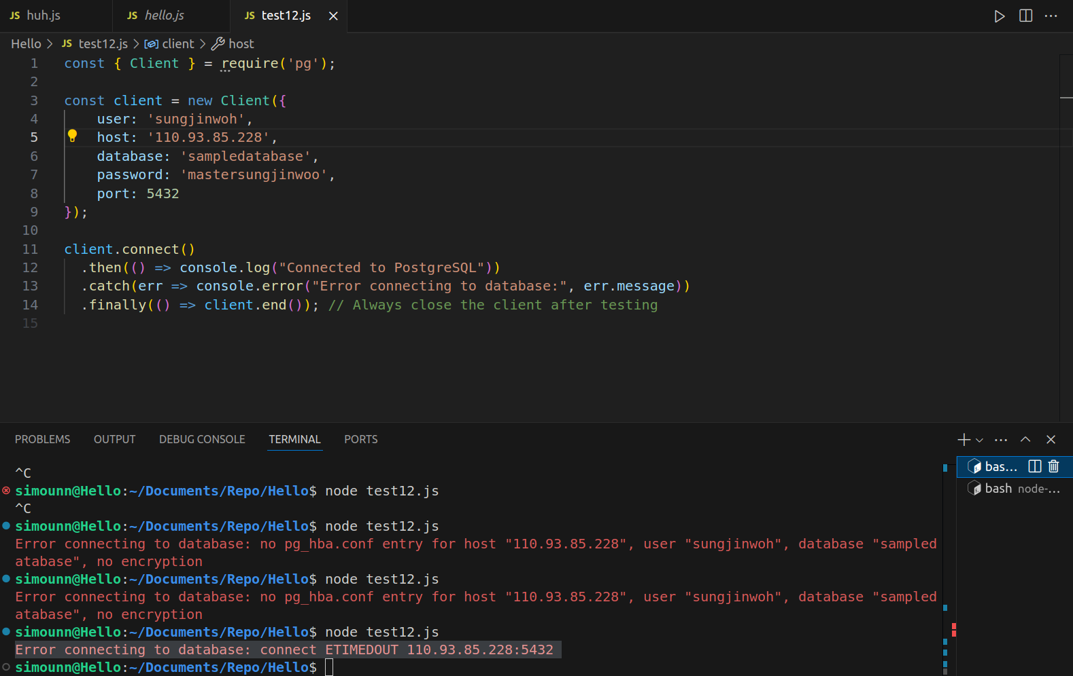

Error connecting to database: connect ETIMEDOUT 110.93.85.228:5432

2nd attemp

direct connection

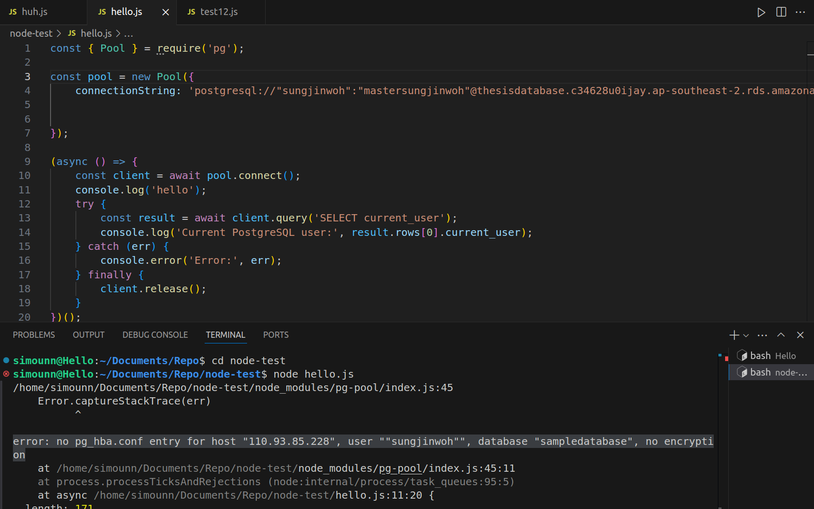

error: no pg_hba.conf entry for host "110.93.85.228", user ""sungjinwoh"", database "sampledatabase", no encryption

3rd attempt

using dotenv

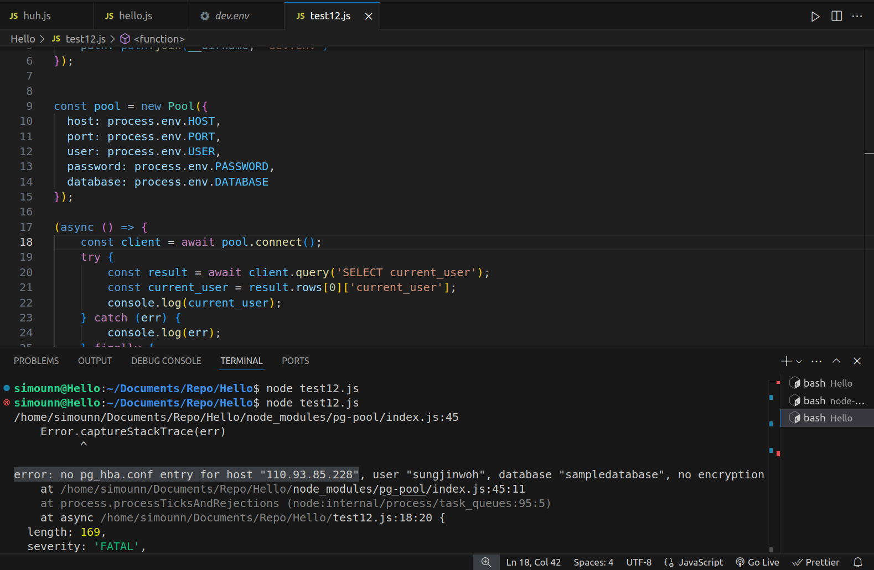

error: no pg_hba.conf entry for host "110.93.85.228"

Edited the

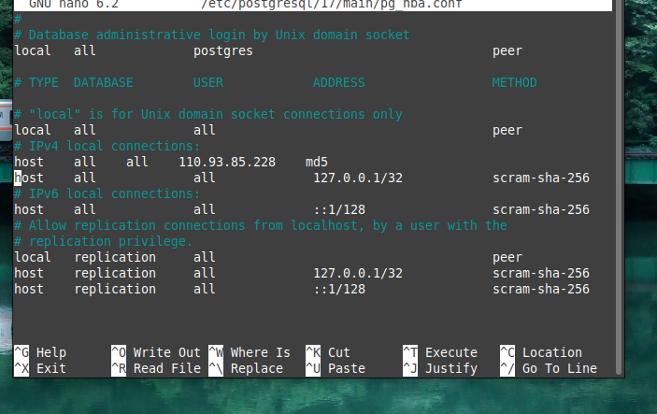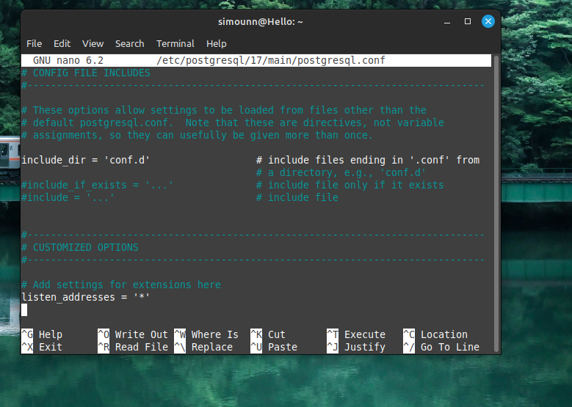host all all 110.93.85.228 md5

sudo systemctl restart postgresql

sudo service postgresql restart  
  
try to run again encounter the same problem