Faculty of Computer Technology and Cybersecurity
Department of Computer Engineering
ARCHITECTURE AND ORGANIZATION OF COMPUTER SYSTEMS
LABORATORY WORK - 1

Instructor: Dr. Mohsin Farhad, PhD, Professor
Points: 0.90
Date: 05.09.2026
Full Name: Daniil Kalts
Group: IT2-2404SE

PROGRESS OF WORK
1) Start the Atmel Studio.
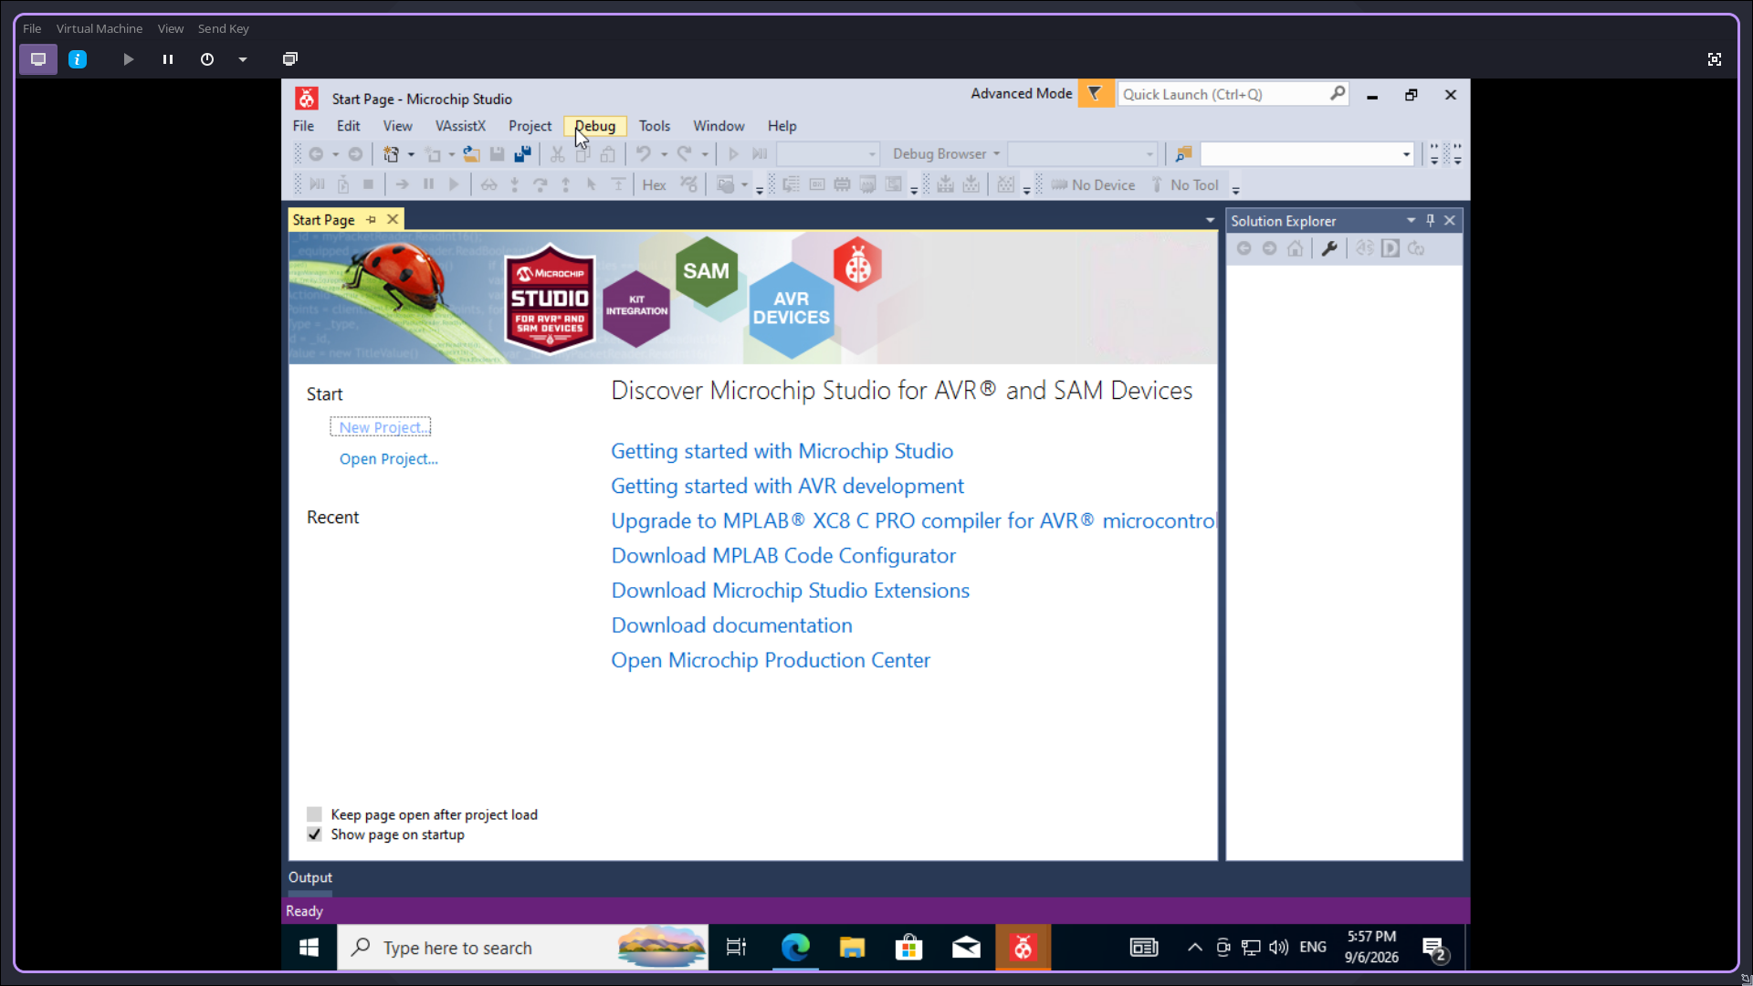

2) Create a new GCC C Executable project.
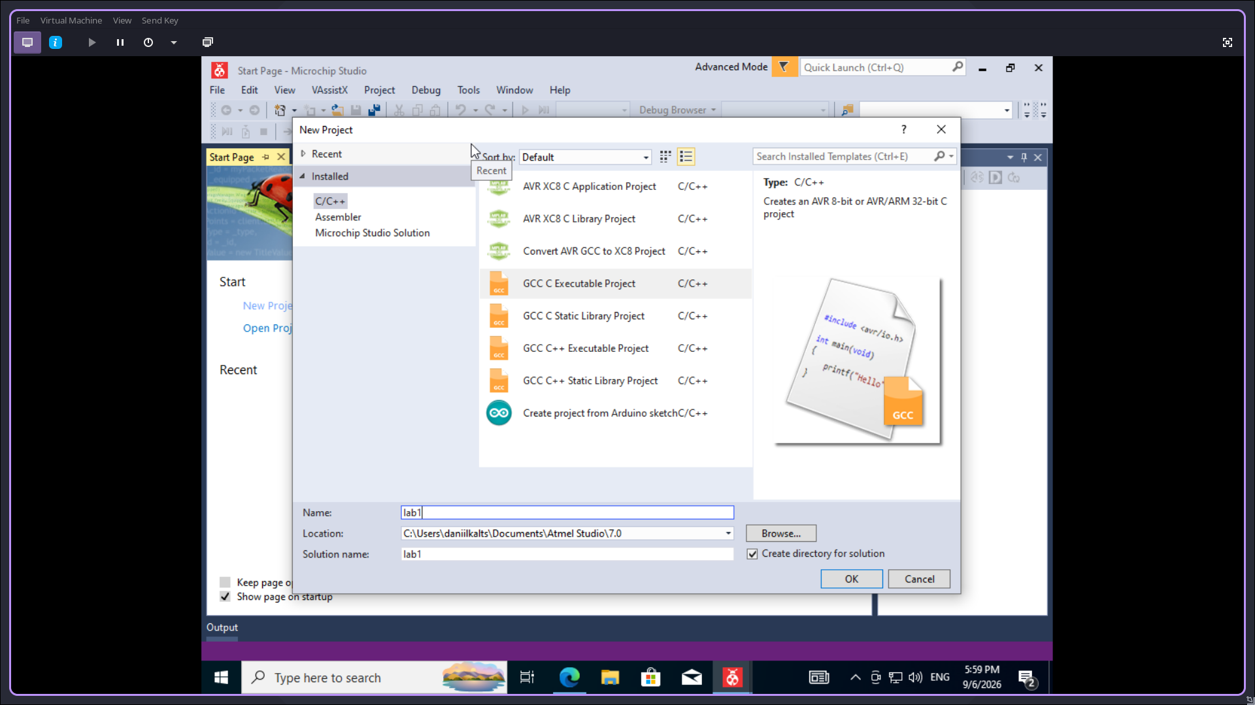

3) Select the device (in this work — ATmega2561.
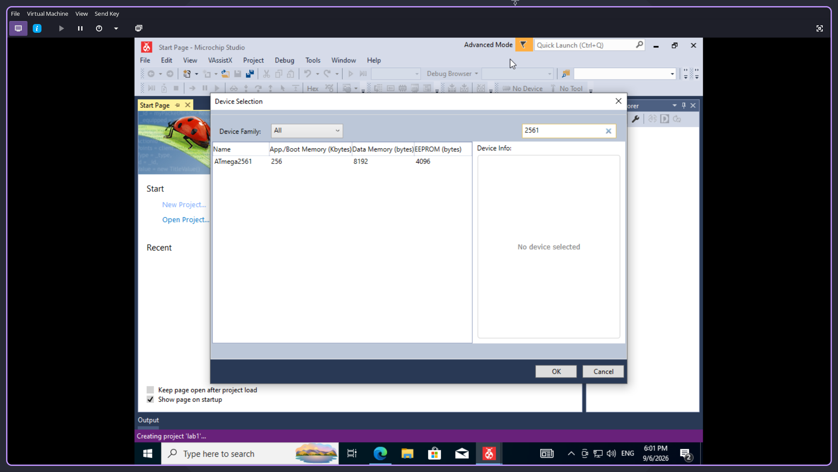

4) Write the program implementing Morse code signals (dot(), dashe() and pause()
functions) and the main() function that initializes port B and, in an endless loop, outputs
the first letters of the first name in Morse code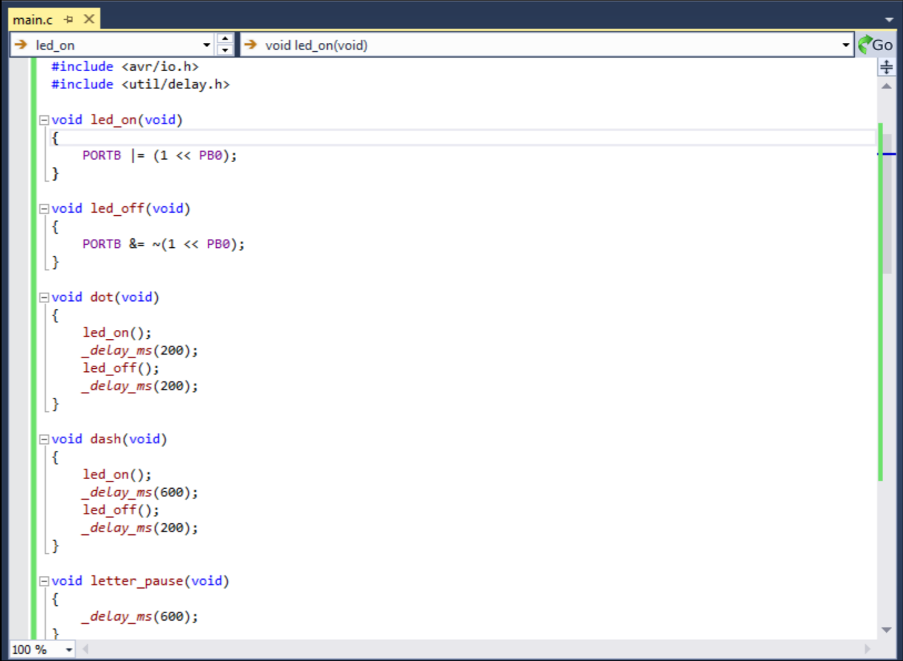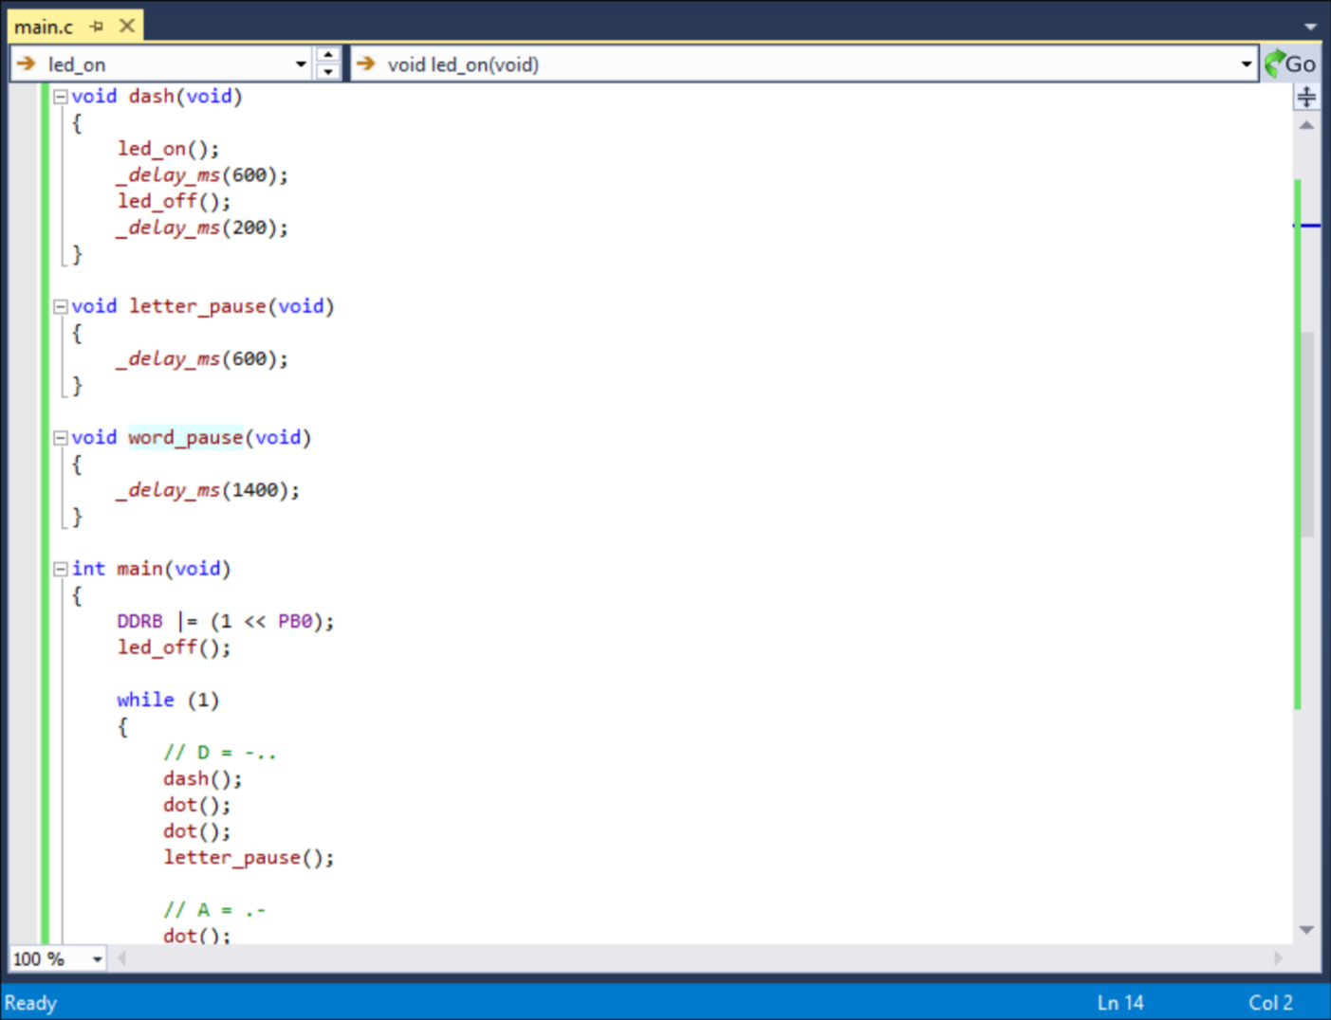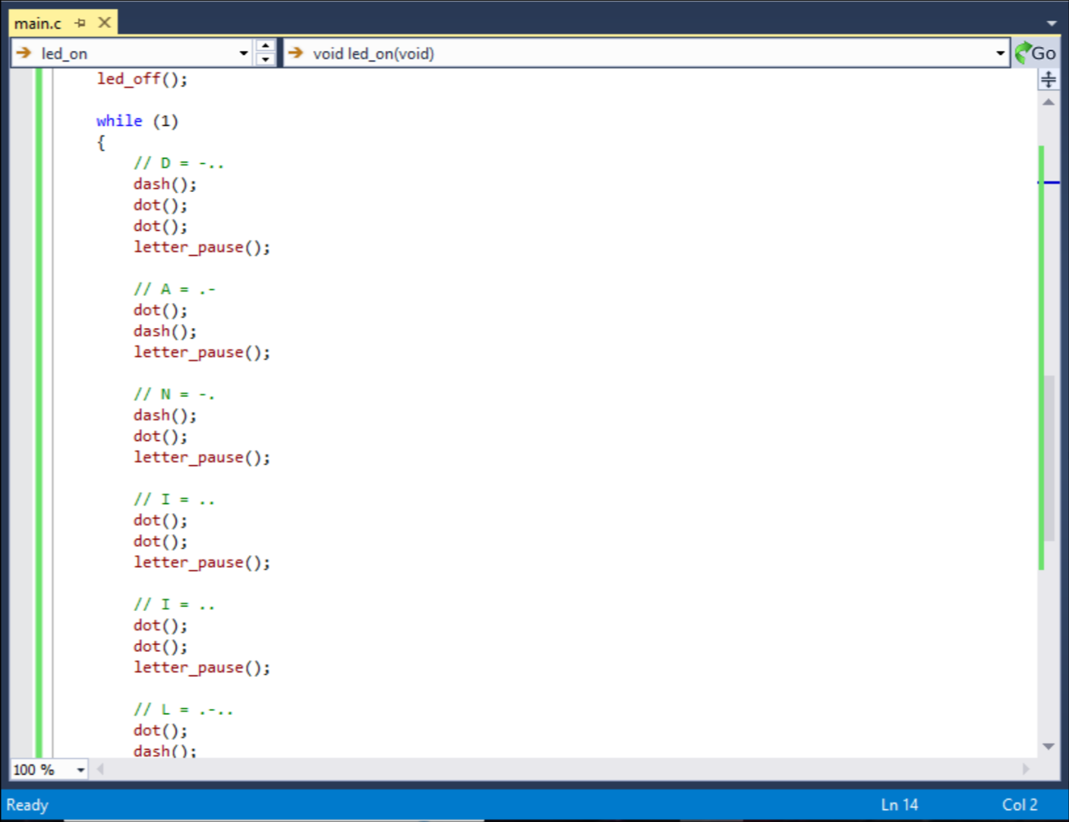

5. Compile the project and obtain the .hex file.
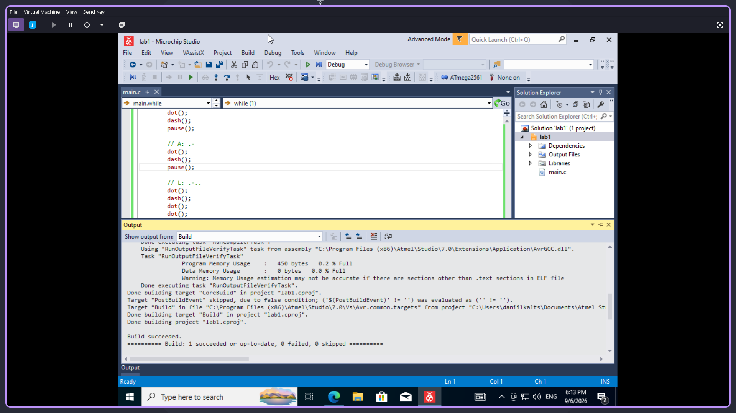

6. Open Proteus (ISIS Professional) and pick the ATmega2561 and LED components.
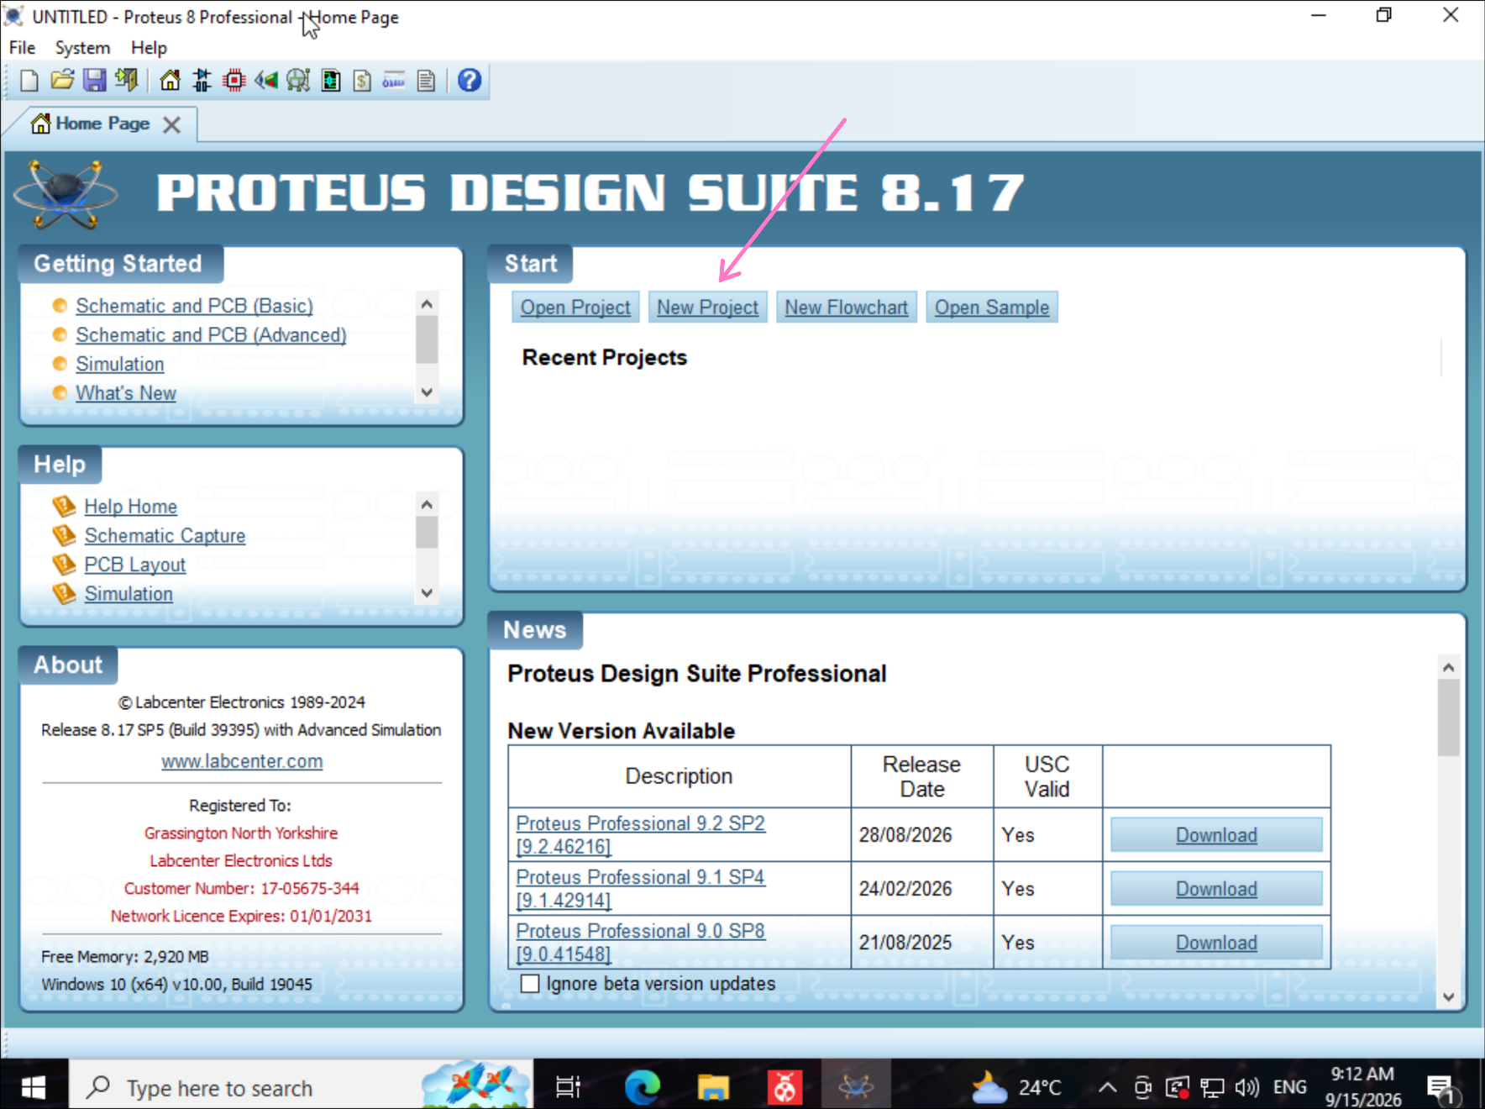
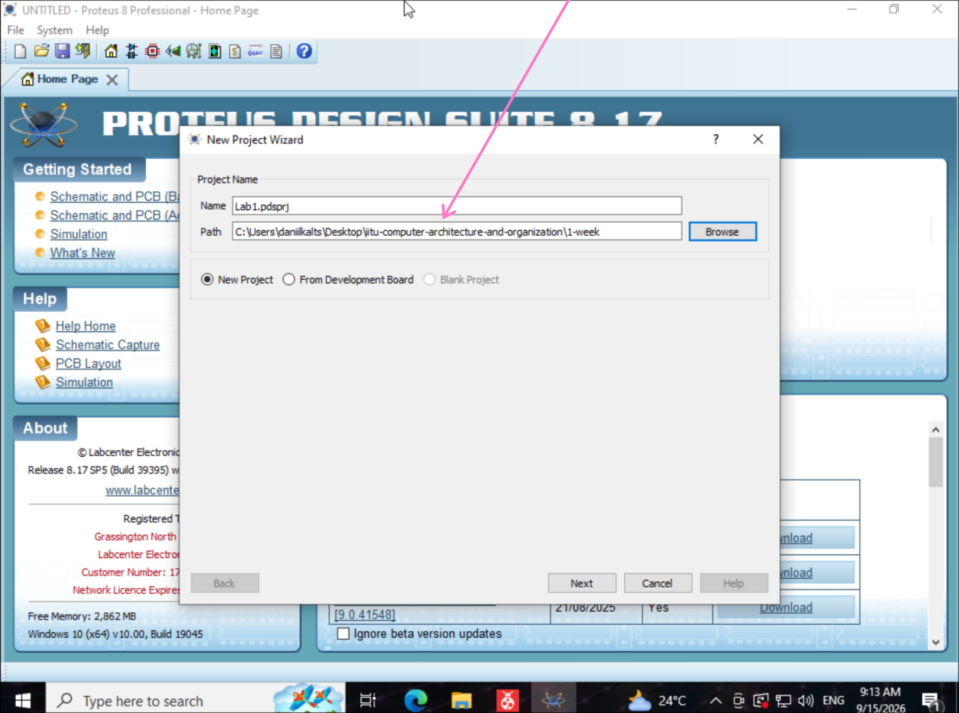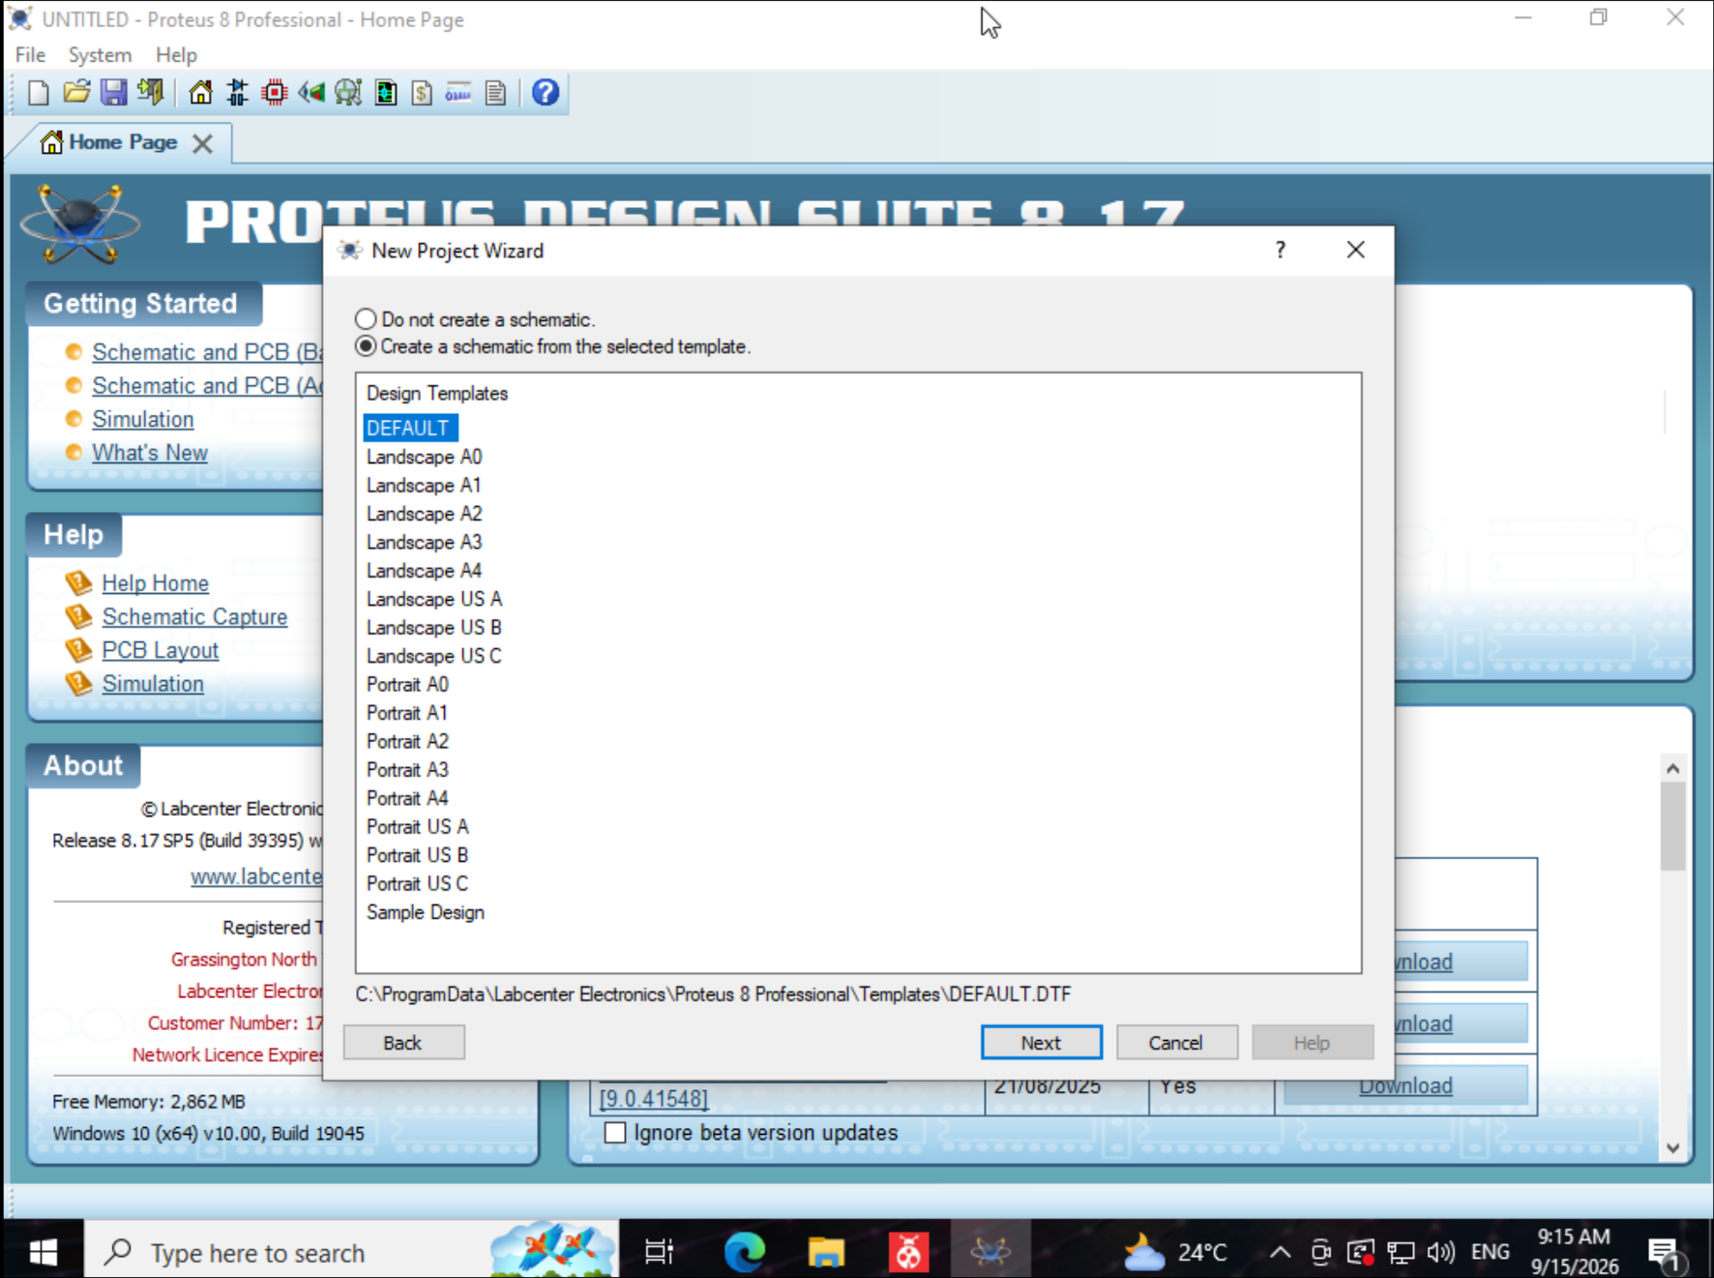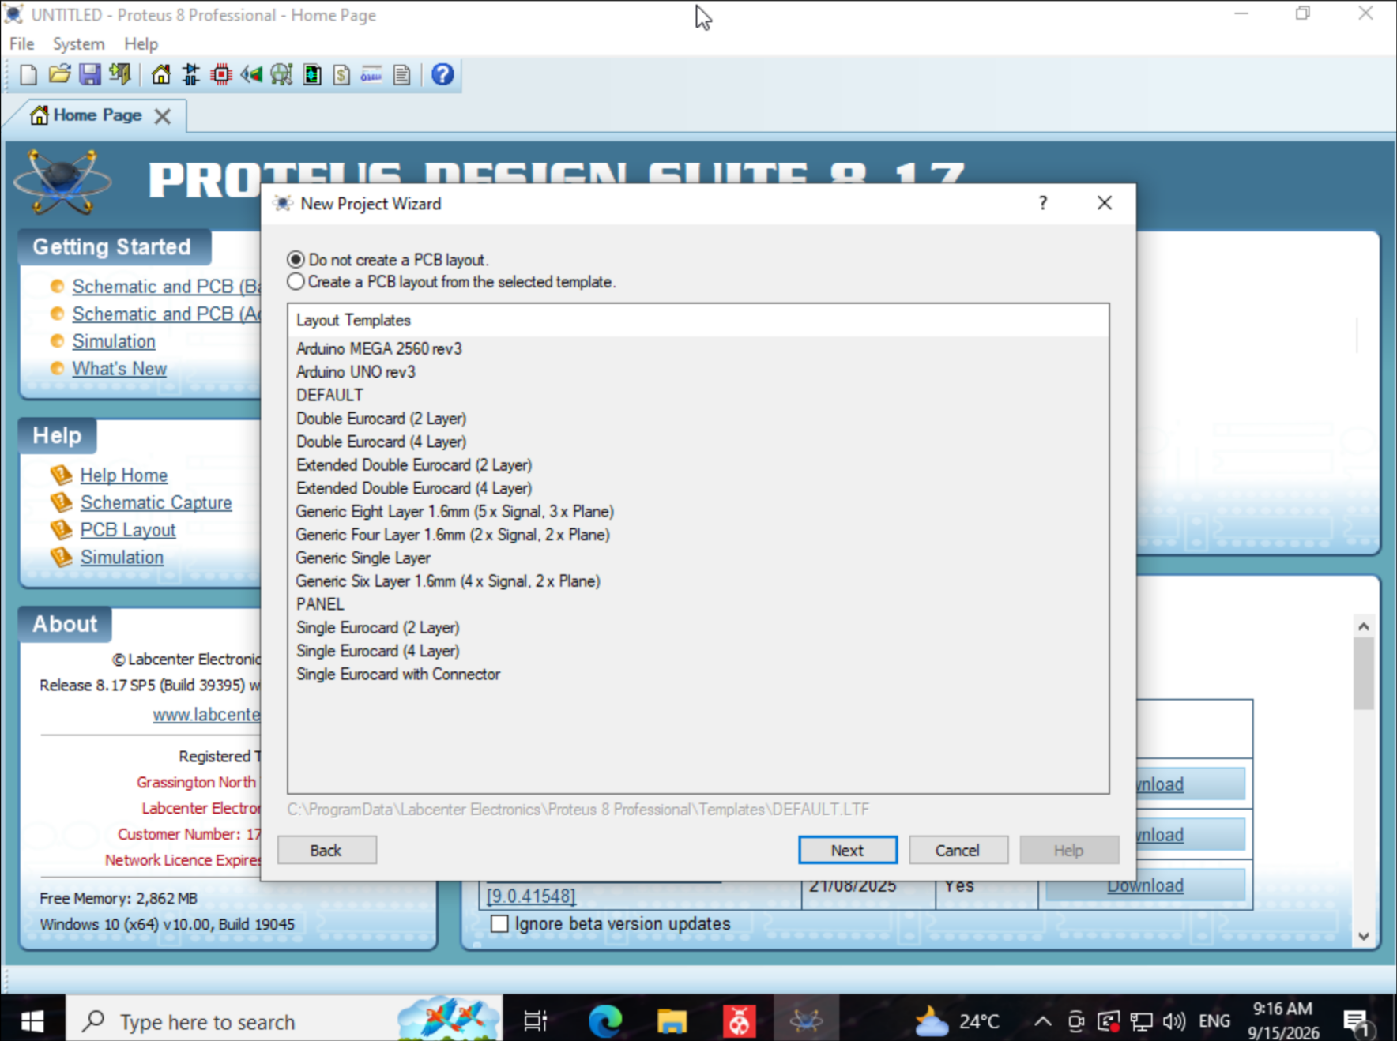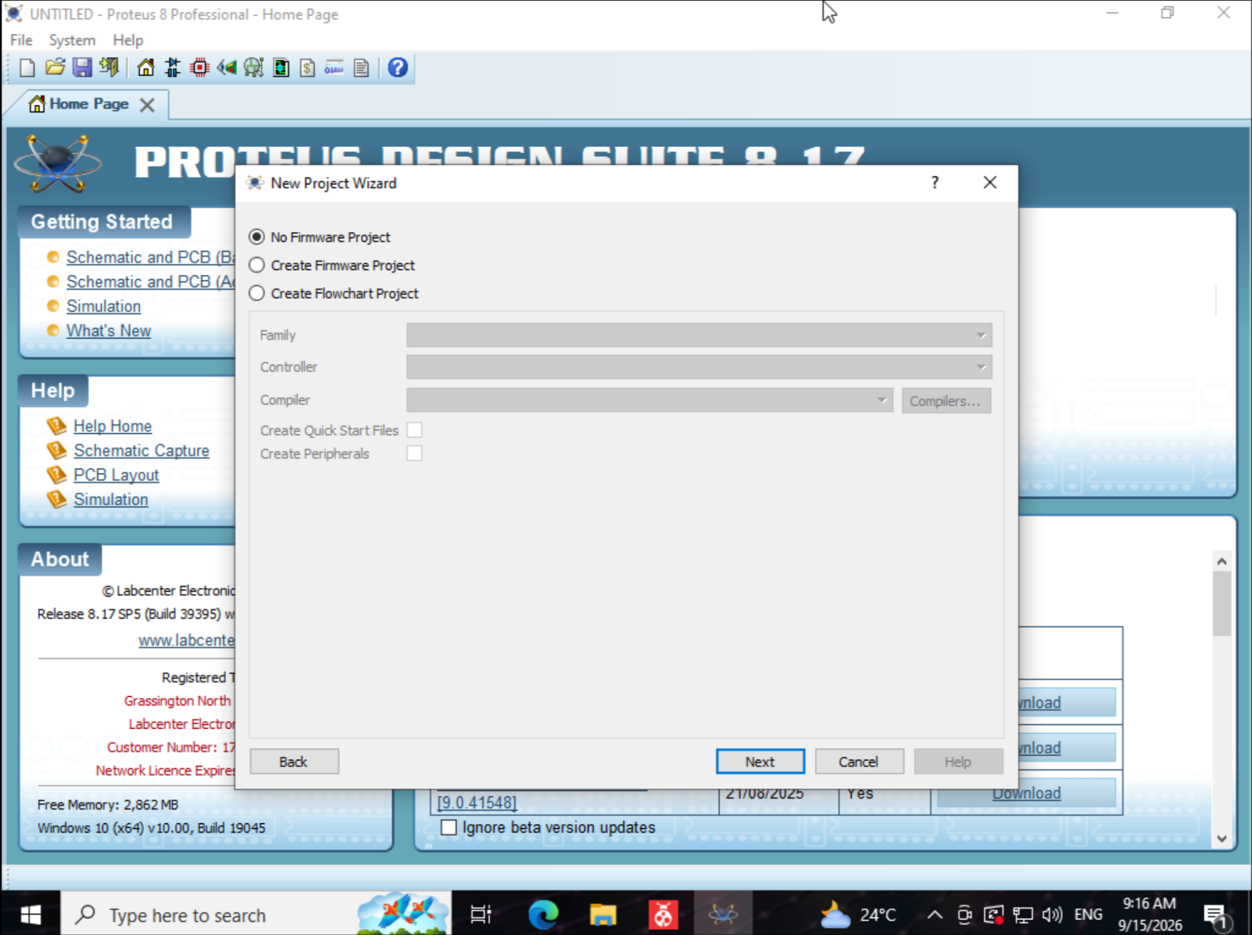

7. Build the circuit: place the microcontroller and the LED on the schematic sheet and
connect the pins.
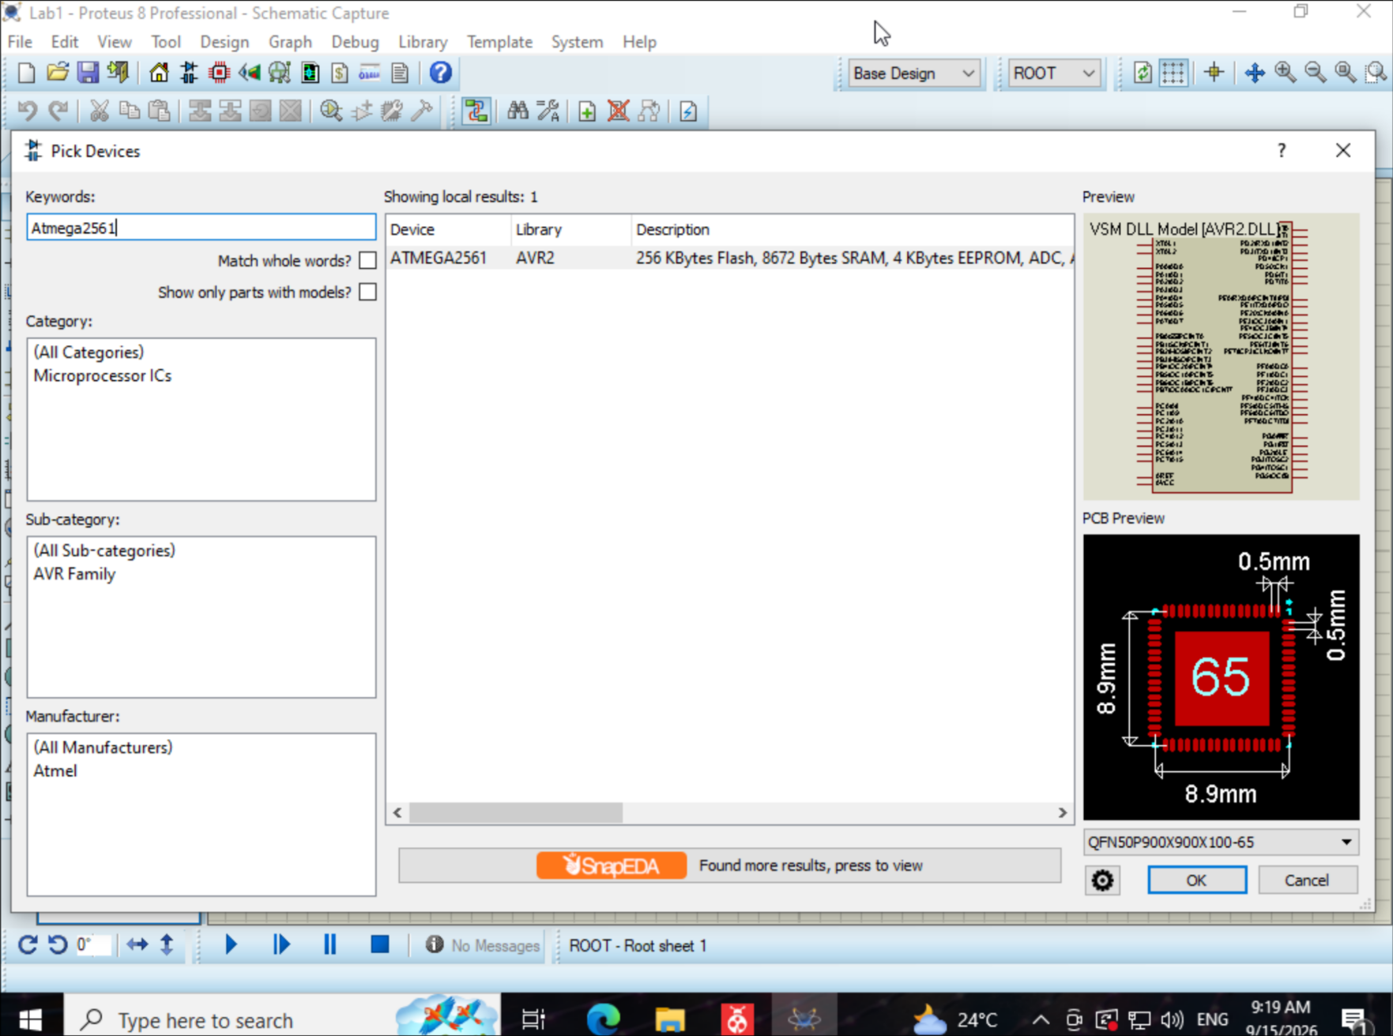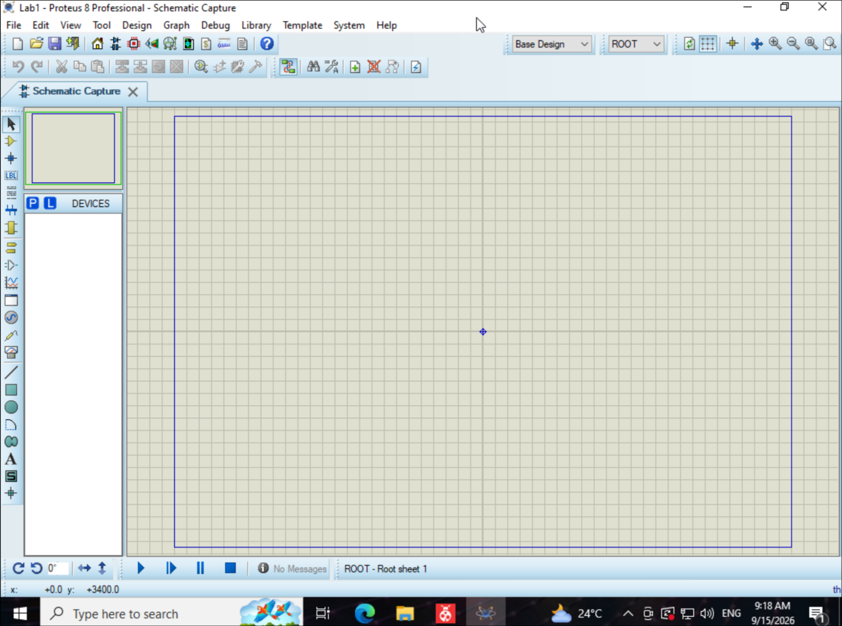
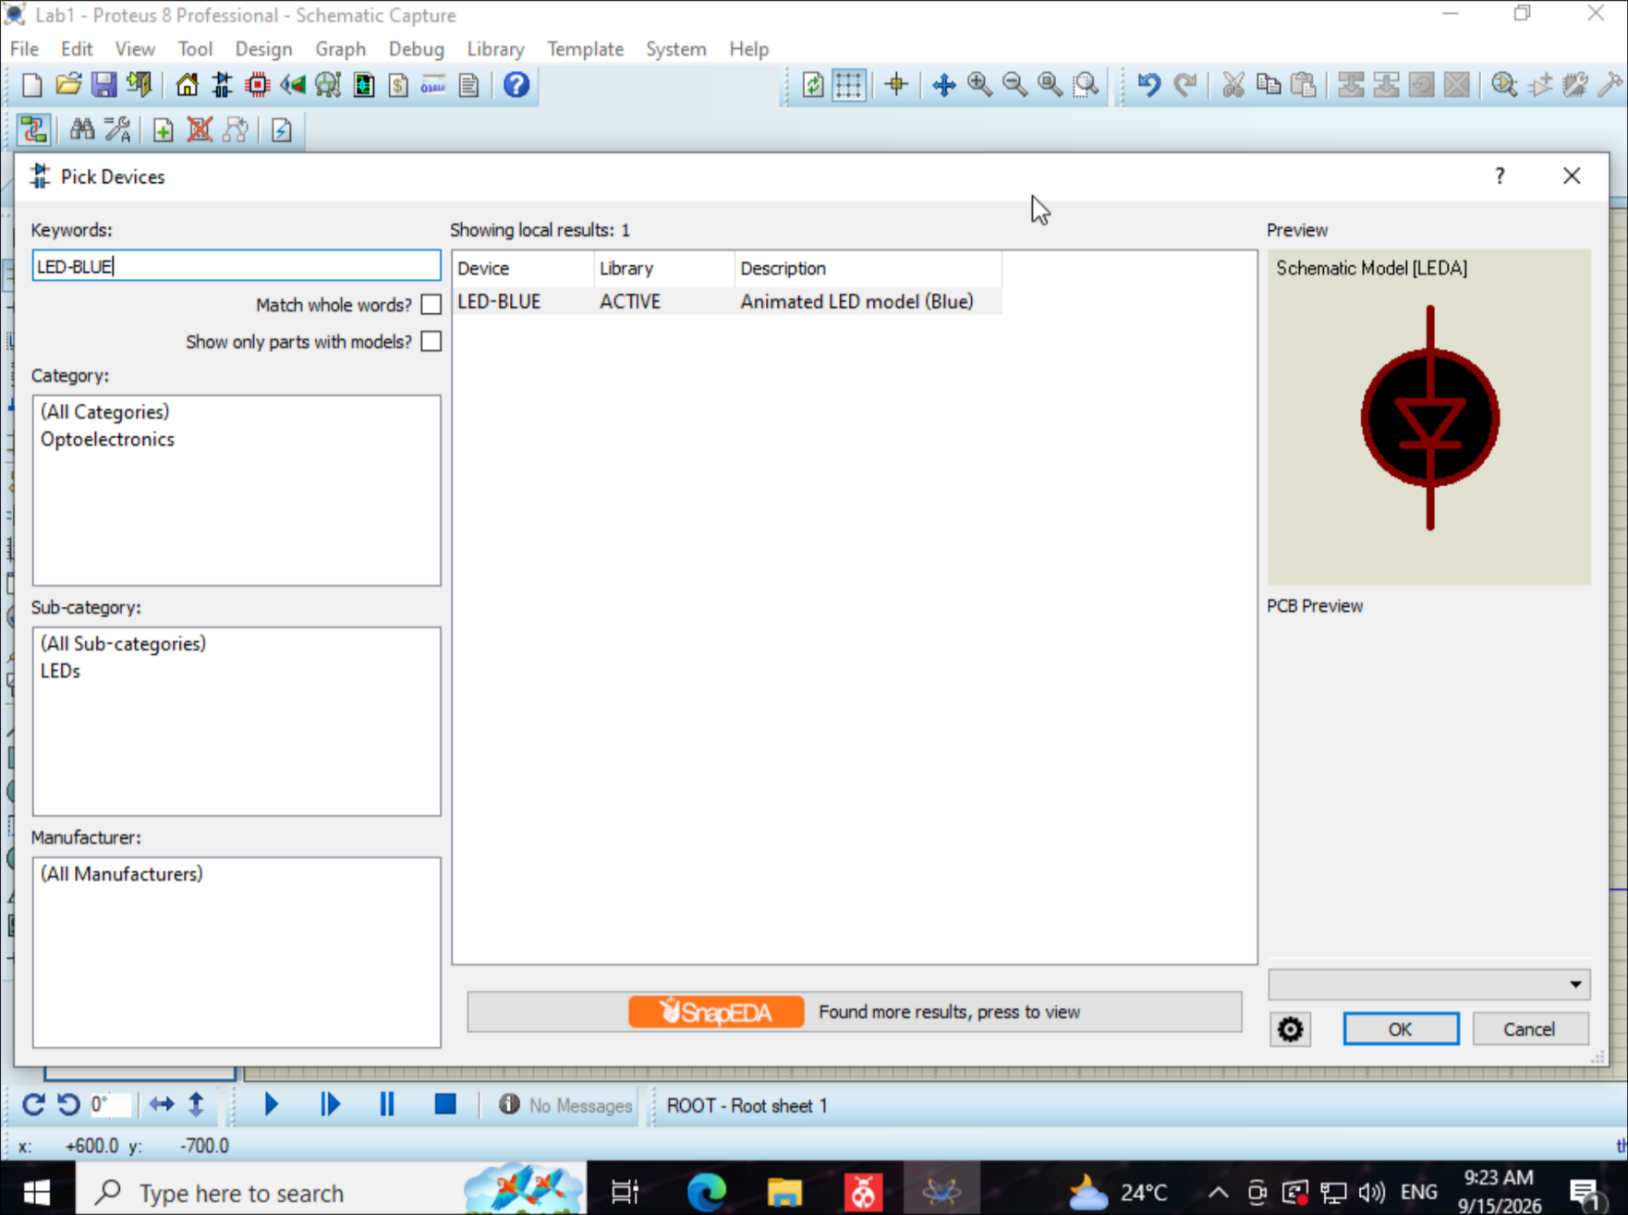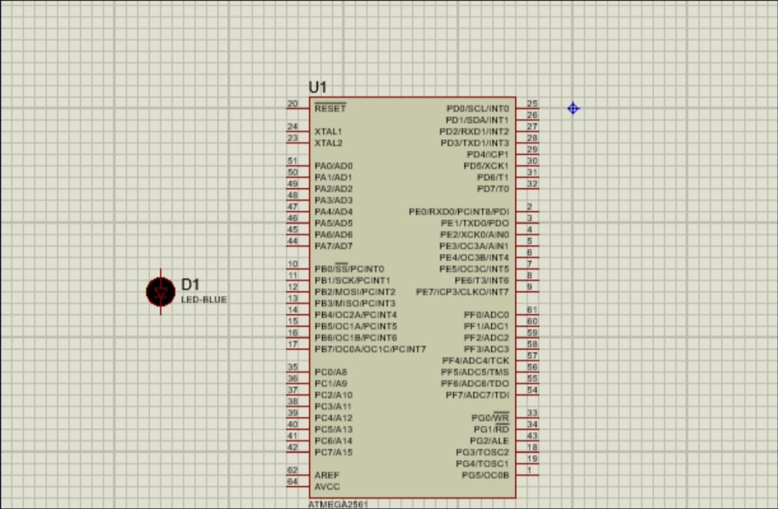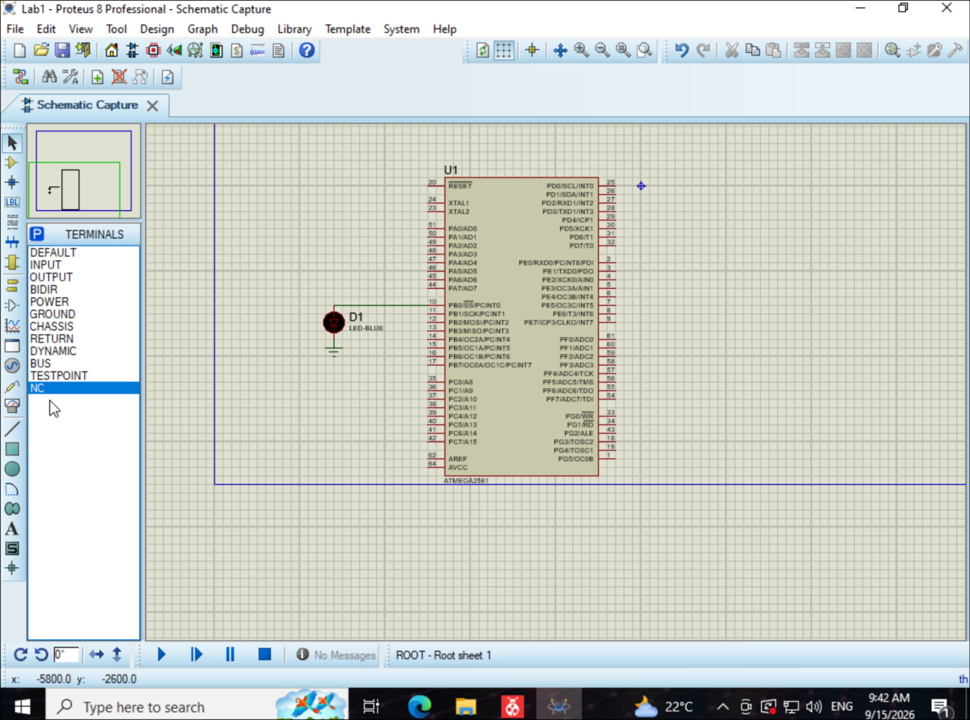

8. Load the compiled .hex file into the microcontroller's properties (Program File) and
configure the component
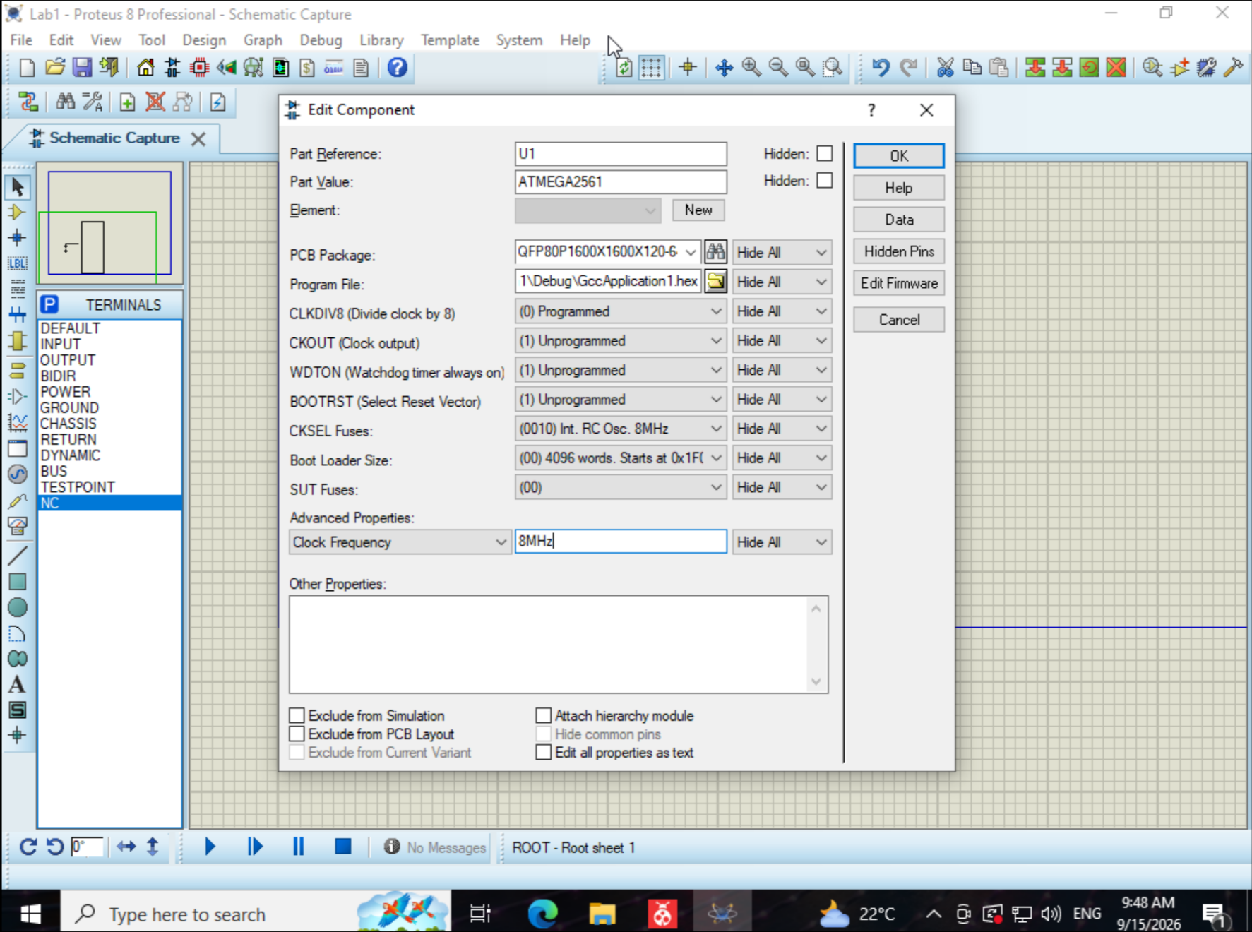
9. Run the simulation and verify that the Morse code (LED blinking) matches the letters of
the first and last name.

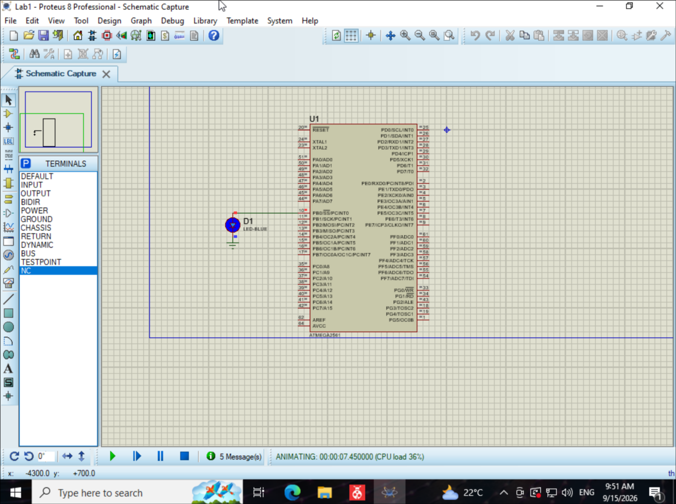

Conclusion:
In this laboratory work, I programmed the ATmega2561 microcontroller in C and tested the program in Proteus. I configured pin PB0 as an output and connected it to an LED. I created functions for short and long Morse code signals and used them to display the letters of my first name. After compiling the program, I loaded the .hex file into Proteus. The simulation showed the Morse code sequence continuously through the LED.

