Faculty of Computer Technology and Cybersecurity
Department of Computer Engineering
ARCHITECTURE AND ORGANIZATION OF COMPUTER SYSTEMS
LABORATORY WORK - 2

Date: 19.09.2026
Full Name: Daniil Kalts
Group: IT2-2404SE

PROGRESS OF WORK
1) Start the Microchip Studio.
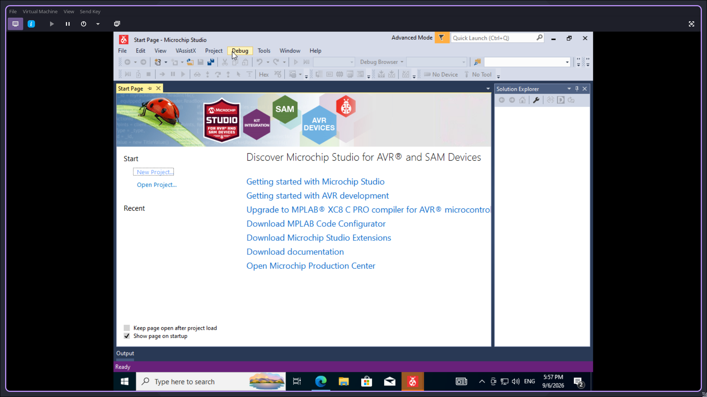

2) Create a new GCC C Executable project.
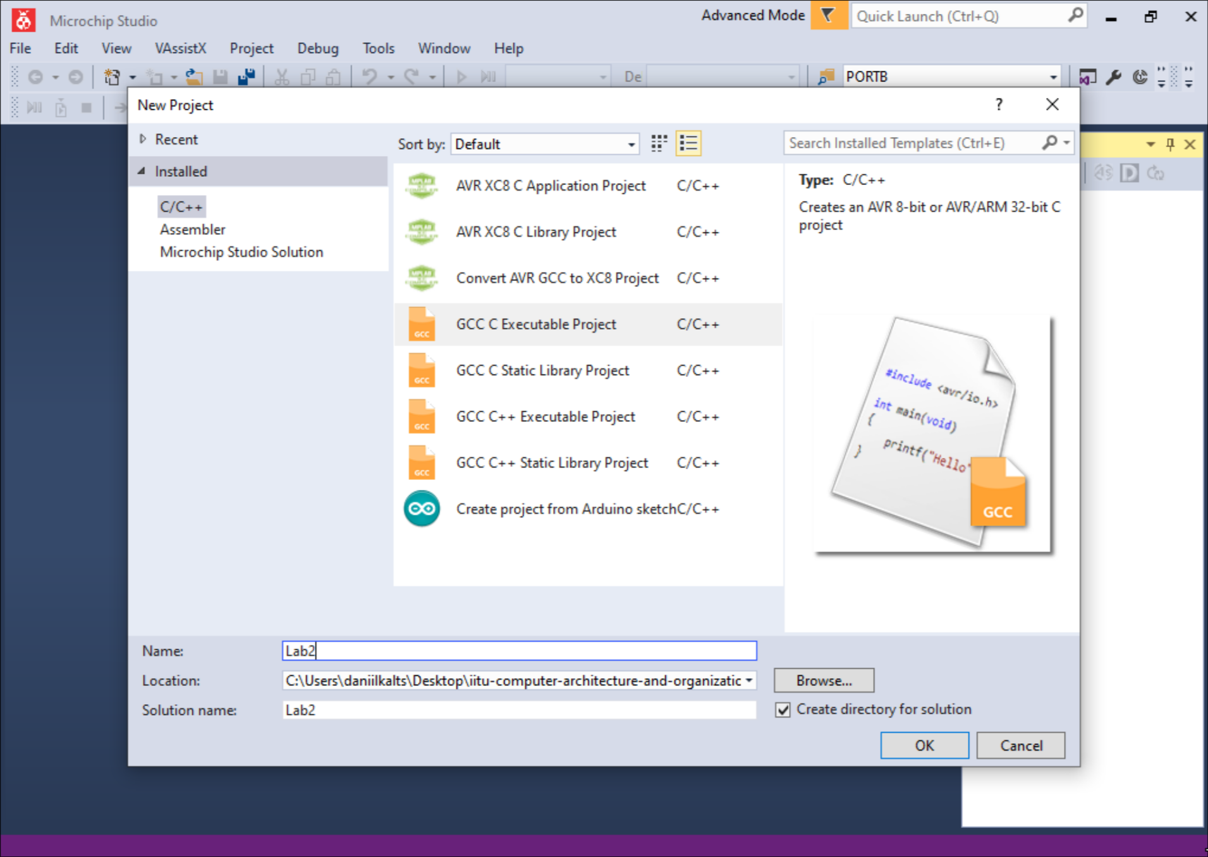

3) Select the device (in this work — ATmega2561.
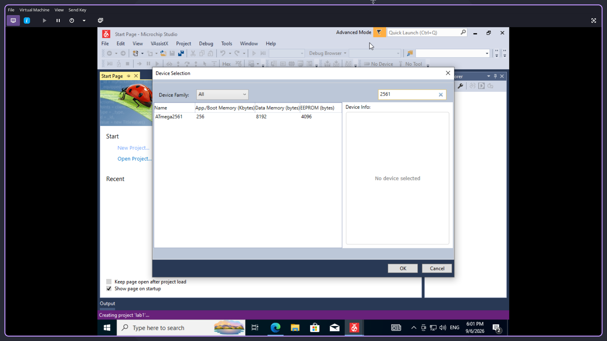
4) Next, program the microcontroller.
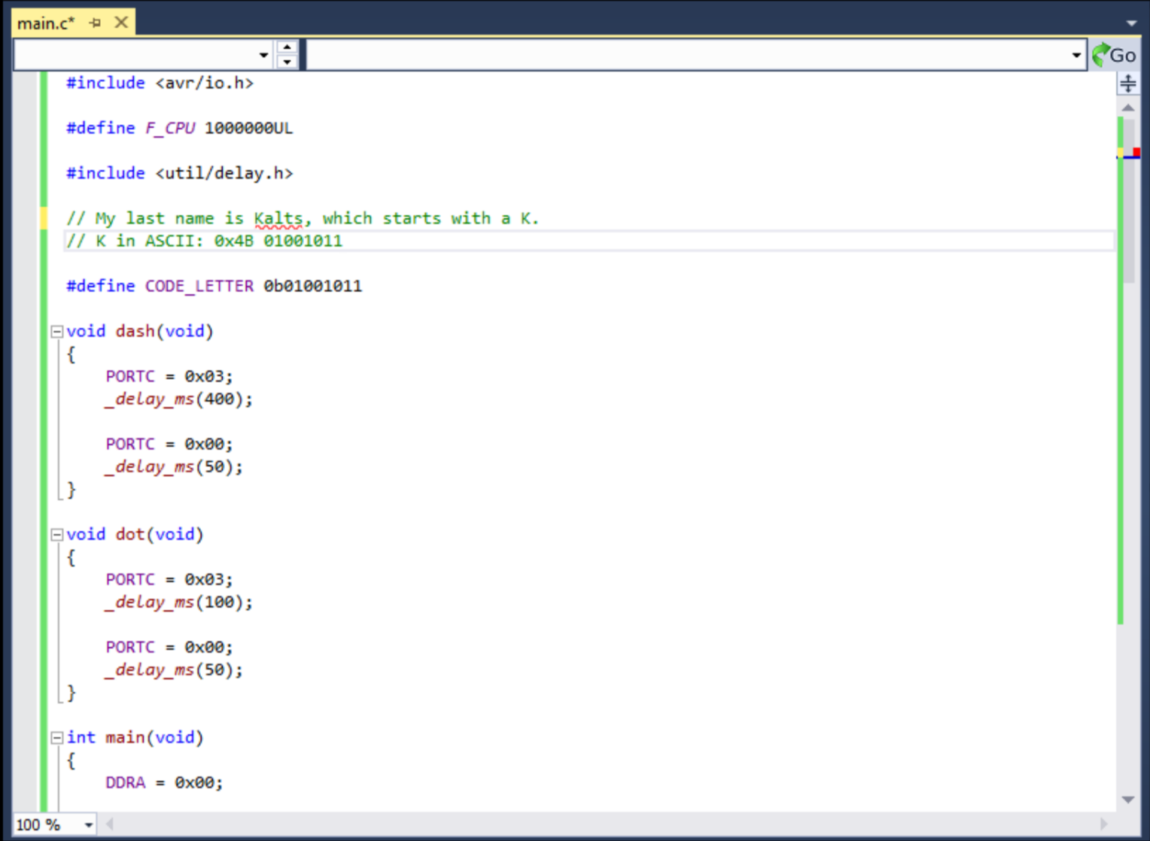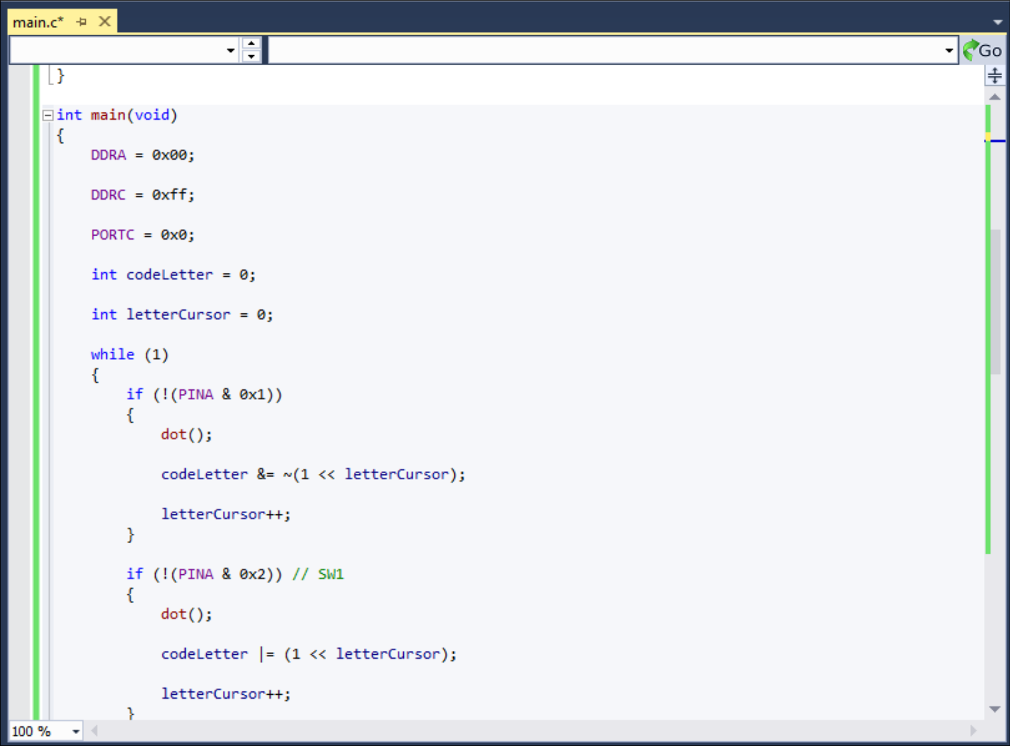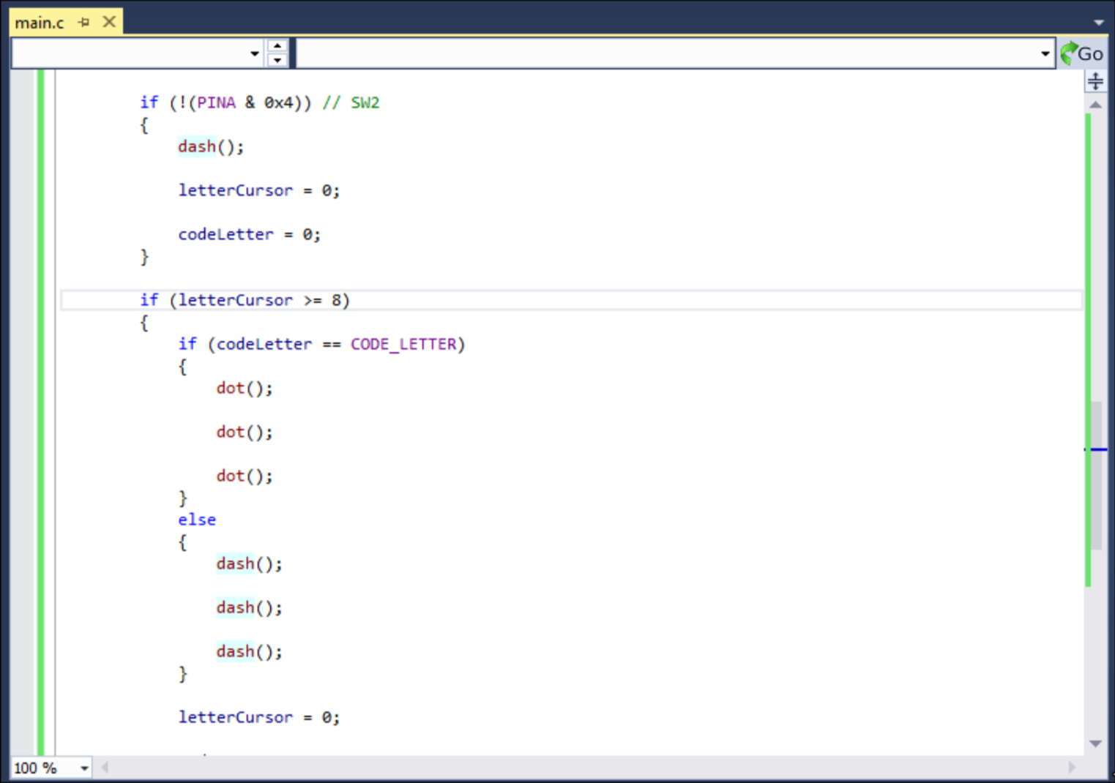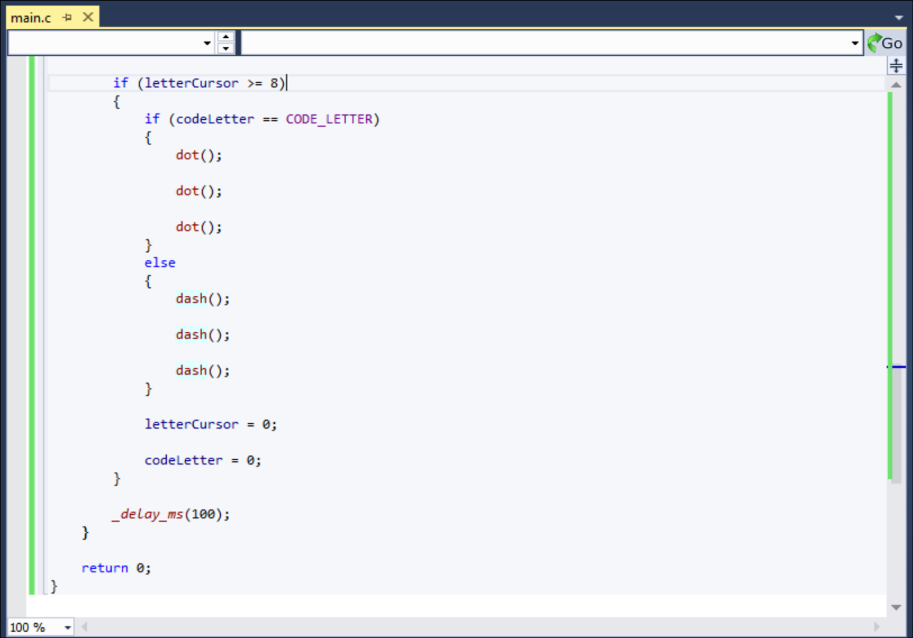

5. Compile the project and obtain the .hex file.
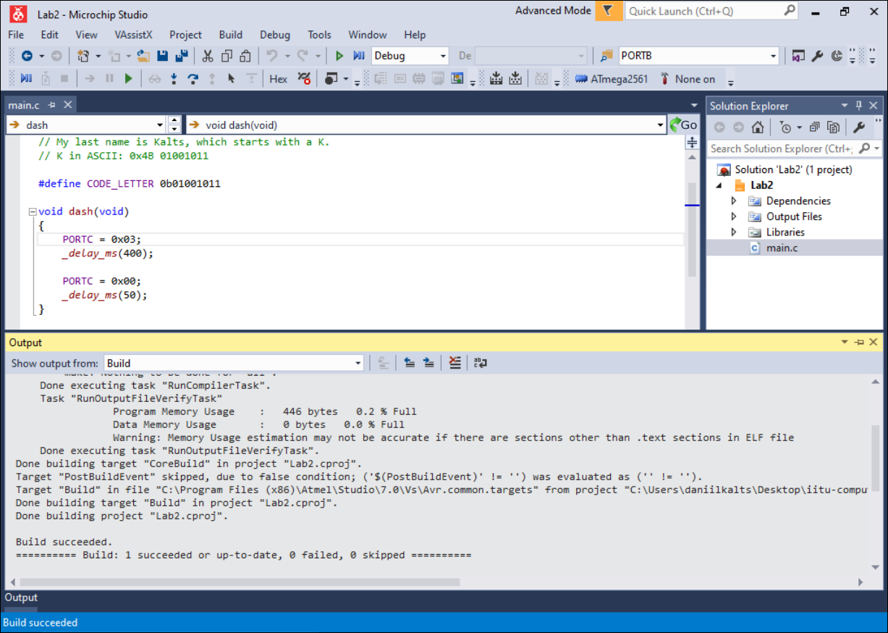

6. Open Proteus (ISIS Professional) and pick the ATmega2561, LED components and ground them.
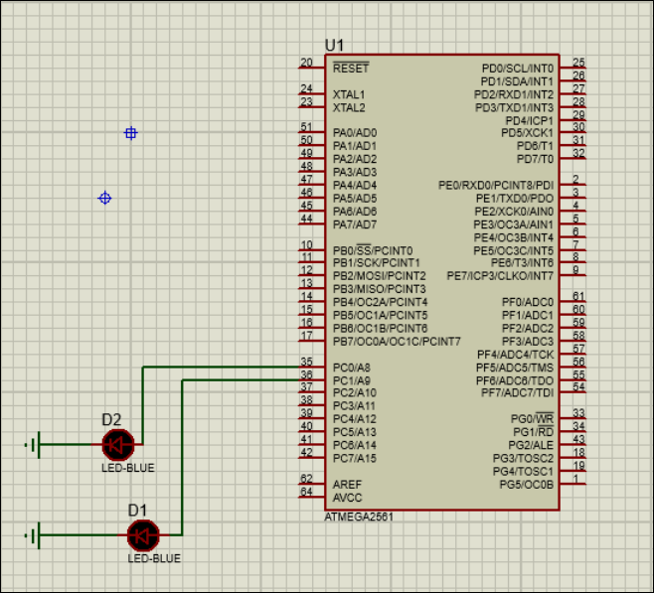

7. Add the remaining components: three buttons and three resistors.

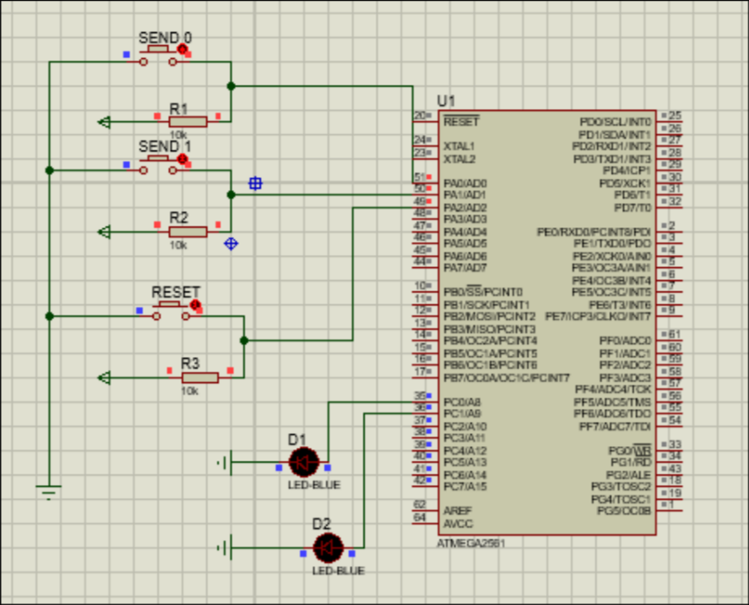

8. Load the compiled .hex file into the microcontroller's properties (Program File) and
configure the component

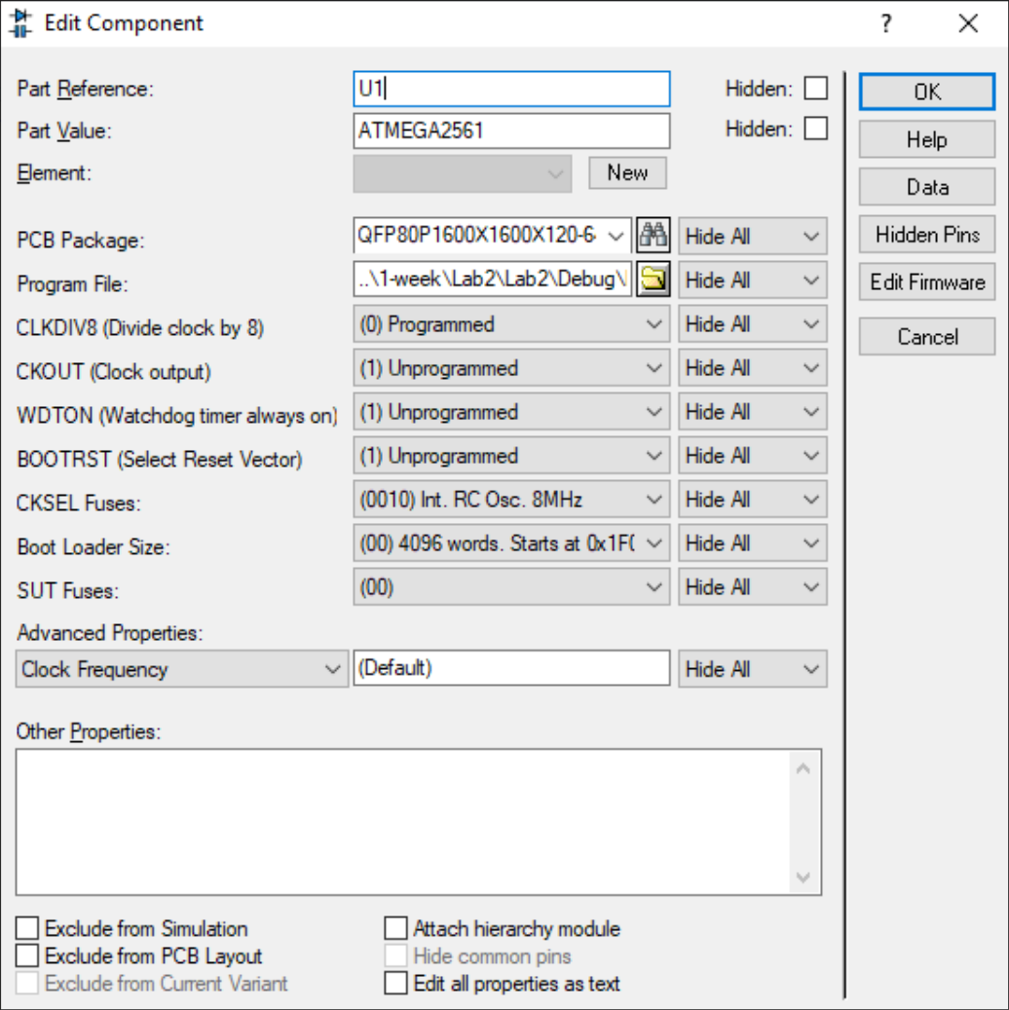

9. Run the simulation and verify that the entered ASCII code is checked correctly using the LED signals.

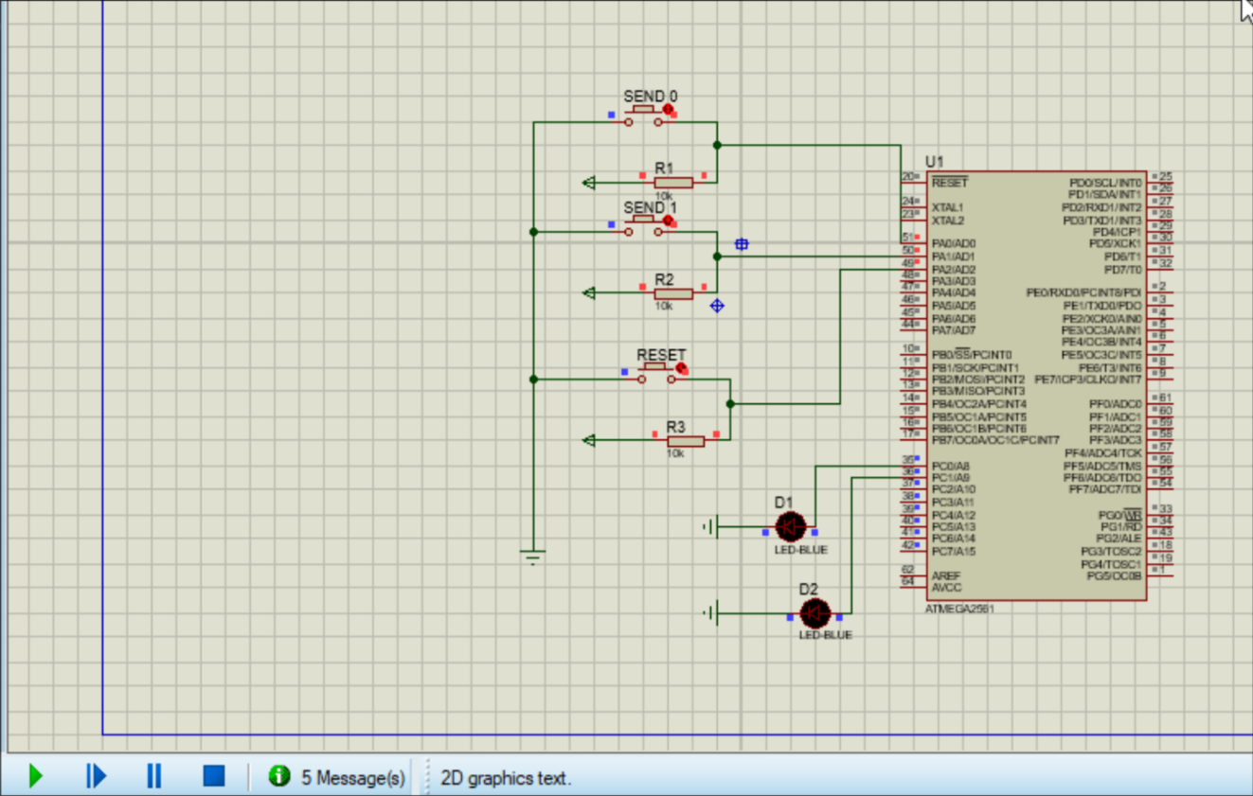

Conclusion:
In this laboratory work, I programmed the ATmega2561 microcontroller in C and tested the circuit in Proteus. Port A was configured to receive the binary ASCII code of the letter K through three buttons, while Port C controlled two LEDs. The program confirmed each entered bit with a short signal, reset the input with a long signal, and indicated whether the complete code was correct or incorrect.

