Sensitivity of MKS Cirrus 3 residual gas analyzer for the Urania-specific gas mixtures

Purpose:

The purpose of this work is to quantitavely describe the precision of MKS Cirrus 3 RGA for the analysis of the following gas mixtures:

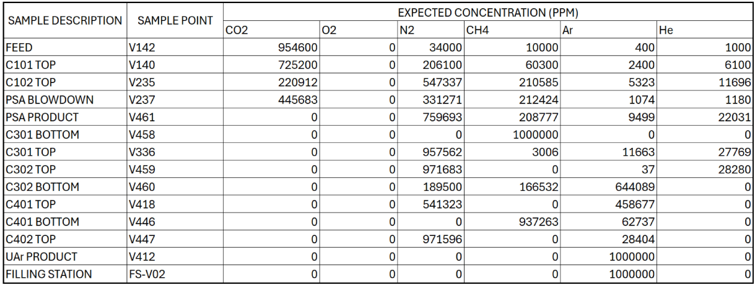
Table 1: Gas mixtures that are predicted to be analyed by RGA

Standard deviation of RGA readings would be used as a metric, that quantitavely describe precision of RGA readings. For example, if PPM of specific gas is said to be 1000±10 ppm, it means that 68% of readings of sample, that contains exactly 1000ppm of this specific gas, would fall into 990-1010ppm interval

Description of software workflow:

In order to convert raw RGA readings into concentration of gases in PPM, following algoritm is used:

1) Ionic currents and chamber pressure are inquired from RGA. Chamber pressure effectively do not change over single scan, but it is used to make ionic curent readings less dependent on pressure in gas lines. Absolute value of ionic current is divided over chamber pressure; obtained value has units of ampere/pascal metric. This value will be further reffered to as IC

2) As different gases have different ionization rates (for example, helium produces ~60 times lower ionic current than argon in the same concentration due to much higher ionization energy and much smaller atom size); IC is divided over calibration factor for specific gas. This factors are the following:

CO2 | O2 | N2 | CH4 | Ar | He
198993.795665839 | 100000 | 146258.079565515 | 154101.018002445 | 281868.233650486 | 5354.42339958041
CO2_28
15945.8734482825

Table 2: Calibration factors for establishing concentration of invididual compounds in the system. Note the second coefficient for CO₂ (CO2_28), it is used to compute overlap between CO₂ secondary peak and N₂ primary peak at M/Z=28

Raw concentration, further reffered to as RAW, is not a PPM, and it cannot be normalized to produce PPM value directly, due to the fact that RGA sensitivity varies from day to day (by approximately 5%) for the reasons that I am not aware of. However, those changes of sensitivity do not affect precision of PPM measurement; as all reaings during single scan are affected uniformally

For N₂ RAW readings, CO₂ contribution to IC for M/Z=28 peak is subtracted first. CO₂ contribution to M/Z=28 IC peak is computed as:

IC (M/Z=44) * CO2 (M/Z=28) IC->RAW coefficient / CO2 (M/Z=44) IC->RAW coefficient

Formula 2: Contribution of CO₂ to M/Z=28 IC reading

3) RAW is converted to PPM by division over all RAW’s sum and multiplying by 1’000’000

Sources of uncertainty:

The main source of imprecision for determining of compound’s concentration is imprecision of IC measurement by the RGA. Linear fit, obtained for four series of ionic current scans, shows that standard deviation of measured value is a linear function of real value’s magnitude:

M/Z = 28 | M/Z = 32 | M/Z = 40 | M/Z = 5
5929588.07018127 | 355321.76172342 | 1056299.87336386 | -231.044328725393
5840622.89511461 | 351345.244048736 | 1054824.55581221 | -13.2018942013623
5959824.37208008 | 346909.043640688 | 1019642.49632378 | 791.119202750482
6016397.37520933 | 358380.236092803 | 1051017.50802261 | -789.942254306611
6023067.93128688 | 352700.317956873 | 1039264.37730252 | -164.459325396764
5994609.10329992 | 349364.23627405 | 1022673.59614679 | 322.528637251919
6057426.00174497 | 362225.551337343 | 1078429.1126761 | 394.884395046637
6015842.70295918 | 367048.878460347 | 1082299.9144285 | -611.079777659718
6101679.5486447 | 365738.779950731 | 1063897.77638949 | -406.492931026926
5950395.22083808 | 365239.847201283 | 1097090.60163883 | -216.28218751118
6047869.33180387 | 363623.986736641 | 1081689.42175664 | 330.990864401222
6267858.75553661 | 374095.096337554 | 1111469.83988205 | -249.661166140465
5879025.68324264 | 352959.27028187 | 1049913.05037003 | 172.428490280583
5893940.52091272 | 350938.301209784 | 1053160.91918902 | -6.63209793946094
6076374.06524124 | 360724.531011041 | 1052753.28205619 | -165.640864562408
6088797.08798636 | 358417.213269194 | 1031345.83807394 | 152.514132008442
5982696.62507628 | 353907.461197597 | 1051540.71131547 | 165.637222534336
6115764.15779119 | 359800.972977349 | 1045293.21756655 | -1124.82045075342
5964404.38191571 | 364053.925720222 | 1073673.86304442 | 918.337904156657
6040380.34473399 | 370868.210219158 | 1095515.91354043 | 350.208365527809
6177730.12818649 | 370322.210262092 | 1079337.25771023 | 376.473847697362
6103955.96411109 | 364545.913593516 | 1080613.91307155 | 263.99265078302
6272696.68650109 | 374352.436134673 | 1098576.52869867 | -59.8997550518632
6313034.58817812 | 375500.616670457 | 1105258.52530232 | -52.652994517747
6046415.89760735 | 361182.668429476 | 1065649.25390343 | 6.13773686021461
122018.02173486 | 8367.53573349343 | 25748.1297002289 | 461.743344808627

Table 3: IC’s obtained during sampling of 1% O₂ 1% N₂ 1% CH₄ 1% CO₂ 1% He 95% Ar calibration bottle. Last two lines display mean and standard deviation of data sets above

Graph 1: Linear correlation between standard deviations and mean values of four data sets presented in Table 3 above

As linear fit shows strong correlation (R² = 0.999); expected standard deviation of IC measurements would be computed using following formula, where SLOPE and INTERCEPT are obtained from linear fit equation at Graph 1:

ΔIC = SLOPE*IC + INTERCEPT

Formula 2: Calculation of expected IC measurement standard deviation

In order to proceed to IC standard deviation measurements; PPM values in Table 1 need to be converted to respective IC values. In order to do so; they are multiplied by expected RAW to PPM ratio (see bullet point 2 in Description of software workflow for justification of this step), and by RAW->IC coefficients in Table 2;

During multiple scans of 999’999 PPM Ar bottle, mean RAW value was found to be 520.86. Therefore, RAW->PPM coefficient is 0.00052086.

During this procedure, following table was produced:

 | CO2 | O2 | N2 | CH4 | Ar | He
V142 | 497.212936627802 | 0 | 17.7092393100202 | 5.20859979706476 | 0.20834399188259 | 0.520859979706476
V140 | 377.727657283136 | 0 | 107.349241817505 | 31.4078567763005 | 1.25006395129554 | 3.1772458762095
V235 | 115.064219836917 | 0 | 285.085938712604 | 109.685298826488 | 2.77253767197757 | 6.09197832264694
V237 | 232.138438335521 | 0 | 172.545806337344 | 110.643160329168 | 0.559403618204755 | 0.614614776053642
V461 | 0 | 0 | 395.693680563152 | 108.743583983179 | 4.94764894723182 | 11.4750662129134
V458 | 0 | 0 | 0 | 520.859979706476 | 0 | 0
V336 | 0 | 0 | 498.755723887693 | 1.56570509899767 | 6.07478994331663 | 14.4637607764691
V459 | 0 | 0 | 506.110787661128 | 0 | 0.0192718192491396 | 14.7299202260991
V460 | 0 | 0 | 98.7029661543772 | 86.7398541404789 | 335.480183469164 | 0
V418 | 0 | 0 | 281.953486794649 | 0 | 238.906492911827 | 0
V446 | 0 | 0 | 0 | 488.182787159631 | 32.6771925468452 | 0
V447 | 0 | 0 | 506.065472842893 | 0 | 14.7945068635827 | 0
V412 | 0 | 0 | 0 | 0 | 520.859979706476 | 0
FS-V02 | 0 | 0 | 0 | 0 | 520.859979706476 | 0

Table 4: Expected RAW readings for gas mixtures encountered at Urania plant

Later, Table 4 is converted to table of predicted IC’s by multiplying the values in the table by coefficients in Table 2.

CO2 (M/Z = 44) | O2 (M/Z = 32) | N2 + CO2 (M/Z=28) | CH4 (M/Z = 15) | Ar (M/Z = 40) | He (M/Z = 4)
98942289.5137246 | 0 | 10518613.8963655 | 802650.531095008 | 58725.552983637 | 2788.90486324533
75165460.2507365 | 0 | 21723891.3719954 | 4839982.7025029 | 352353.317901822 | 17012.3196657965
22897065.8506766 | 0 | 43530921.3951823 | 16902616.2090642 | 781490.296329749 | 32619.0312805174
46194108.9643257 | 0 | 28937868.4321634 | 17050223.6417326 | 157678.109761065 | 3290.90773862949
0 | 0 | 57873397.8153769 | 16757496.9930423 | 1394585.06947892 | 61442.3630421579
0 | 0 | 0 | 80265053.1095008 | 0 | 0
0 | 0 | 72947054.3481222 | 241276.749647159 | 1712290.31112039 | 77445.0991474596
0 | 0 | 74022791.8507067 | 0 | 5432.11365098642 | 78870.229532578
0 | 0 | 14436106.2771592 | 13366699.8244314 | 94561206.7391944 | 0
0 | 0 | 41237975.5053861 | 0 | 67340151.1646891 | 0
0 | 0 | 0 | 75229464.4725701 | 9210662.54383608 | 0
0 | 0 | 74016164.1924159 | 0 | 4170101.51736806 | 0
0 | 0 | 0 | 0 | 146813882.459092 | 0
0 | 0 | 0 | 0 | 146813882.459092 | 0

Table 5: Predicted IC readings for M/Z ratios of interest for gas mixtures encountered at Urania plant

Now, for each of those values, standard deviation may be predicted using Formula 2. As concentration of specific compound is a function of six variables ( IC of every individual gas in the mixture ); it’s standard deviation is expressed as following:

