Software Engineering - T5616SN

Daniil Smirnov

Task 1

Theory:

**Version control:**

A component of software configuration management, version control, also known as revision control or source control, is the management of changes to documents, computer programs, large web sites, and other collections of information. Changes are usually identified by a number or letter code, termed the "revision number", "revision level", or simply "revision". For example, an initial set of files is "revision 1". When the first change is made, the resulting set is "revision 2", and so on. Each revision is associated with a timestamp and the person making the change. Revisions can be compared, restored, and with some types of files, merged.

The need for a logical way to organize and control revisions has existed for almost as long as writing has existed, but revision control became much more important, and complicated when the era of computing began. The numbering of book editions and of specification revisions are examples that date back to the print-only era. Today, the most capable (as well as complex) revision control systems are those used in software development, where a team of people may change the same files.

**Fundamentals of GIT:**

So, what is Git in a nutshell? This is an important section to absorb, because if you understand what Git is and the fundamentals of how it works, then using Git effectively will probably be much easier for you. As you learn Git, try to clear your mind of the things you may know about other VCSs, such as CVS, Subversion or Perforce — doing so will help you avoid subtle confusion when using the tool. Even though Git’s user interface is fairly similar to these other VCSs, Git stores and thinks about information in a very different way, and understanding these differences will help you avoid becoming confused while using it.

Most operations in Git need only local files and resources to operate — generally no information is needed from another computer on your network. If you’re used to a CVCS where most operations have that network latency overhead, this aspect of Git will make you think that the gods of speed have blessed Git with unworldly powers. Because you have the entire history of the project right there on your local disk, most operations seem almost instantaneous.

For example, to browse the history of the project, Git doesn’t need to go out to the server to get the history and display it for you — it simply reads it directly from your local database. This means you see the project history almost instantly. If you want to see the changes introduced between the current version of a file and the file a month ago, Git can look up the file a month ago and do a local difference calculation, instead of having to either ask a remote server to do it or pull an older version of the file from the remote server to do it locally.

Practical:

I have created a project with a local GIT repo.

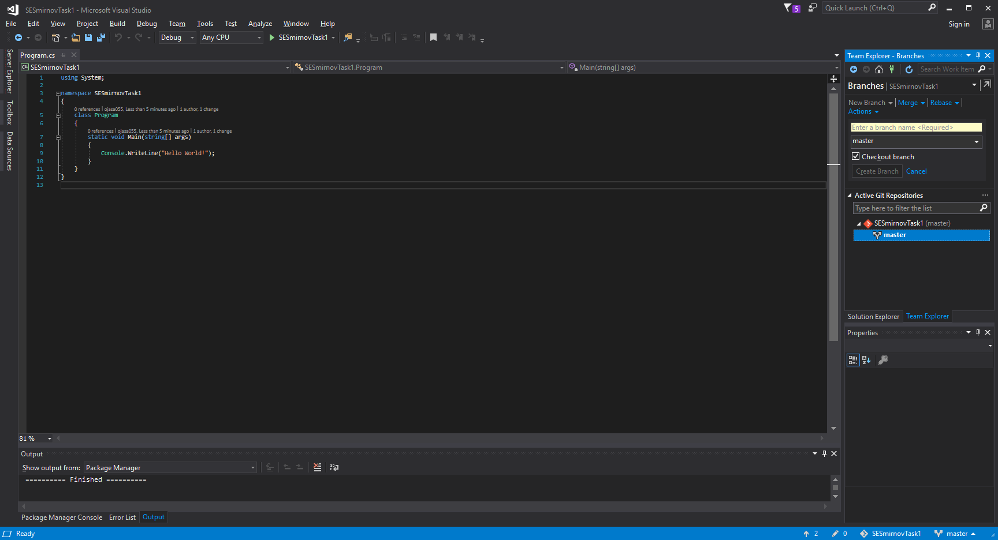

I have created some local branches:

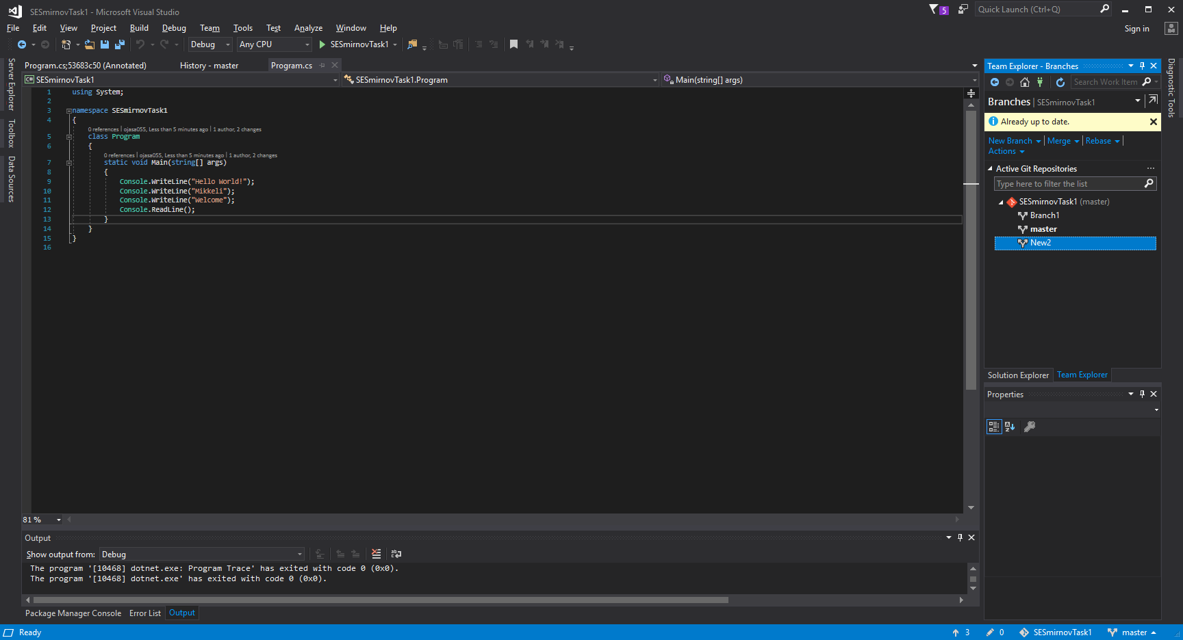

So my master branch looks like this:

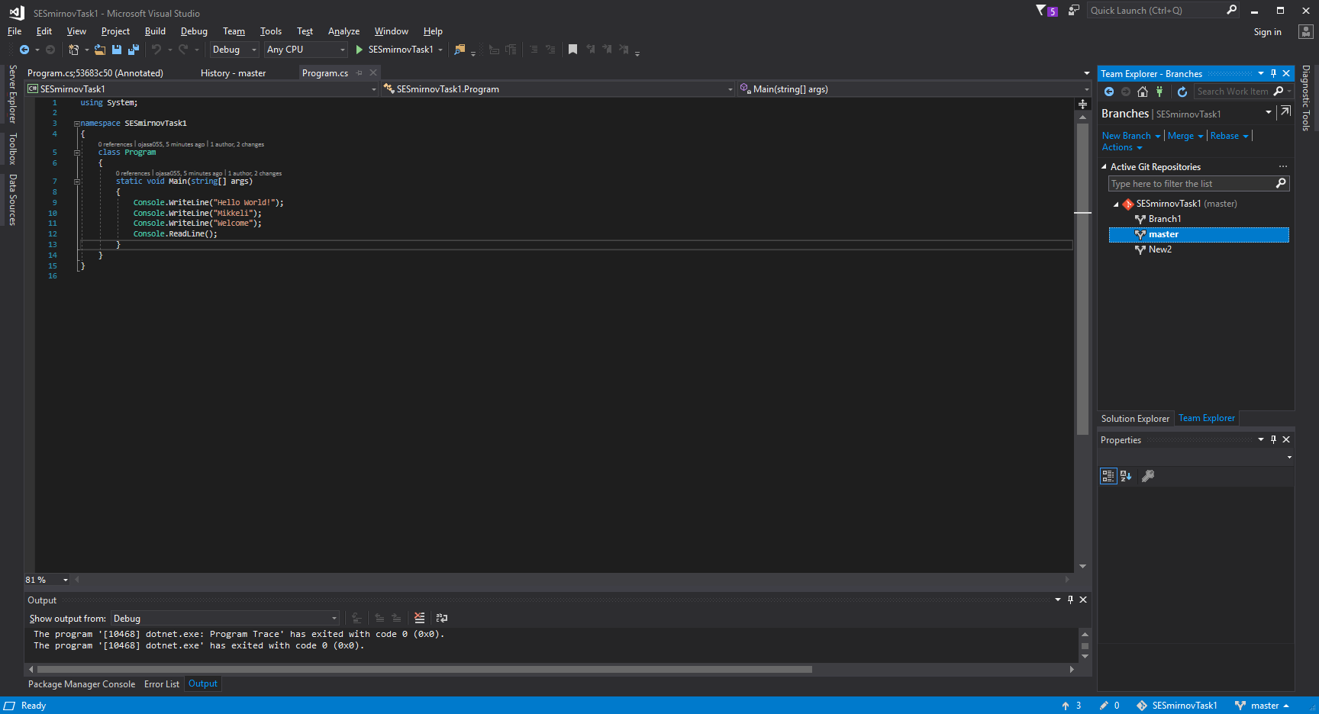

I have created an updated program in a Branch1:

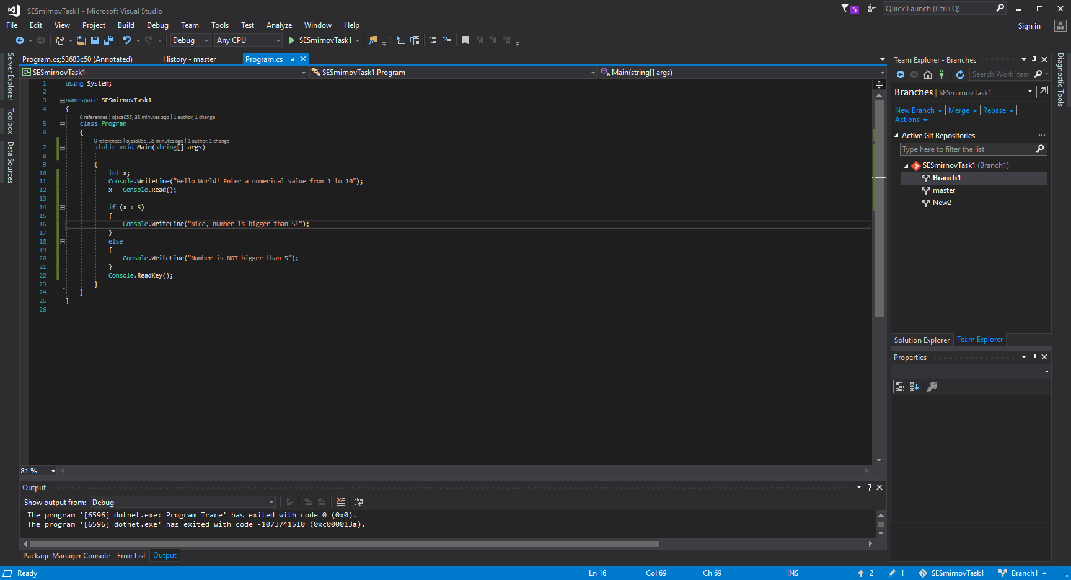

I have made a commitment message:

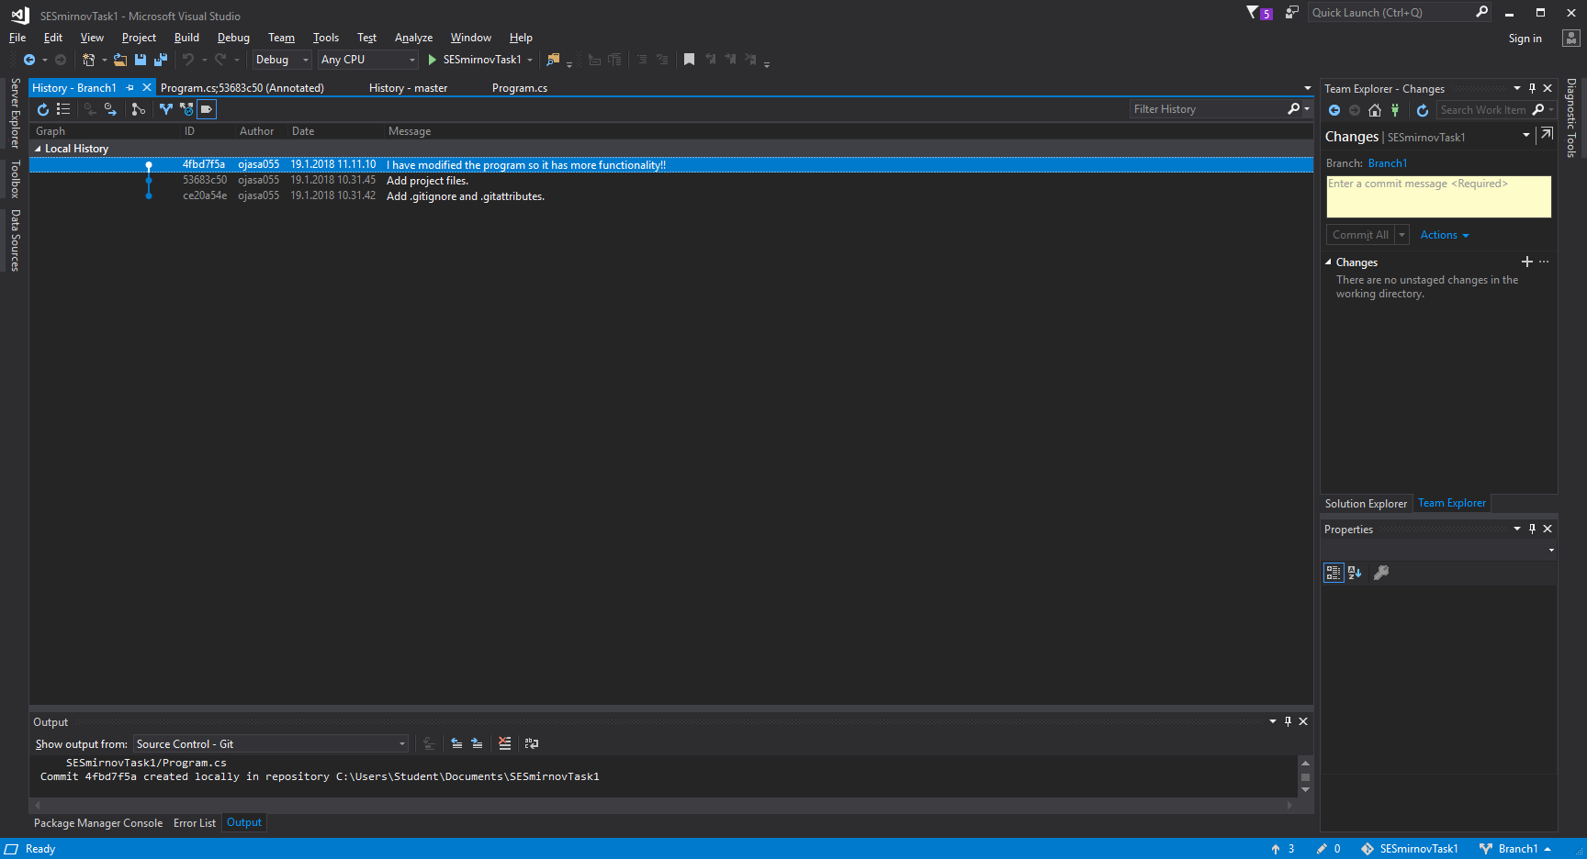

Now it is time to merge the branches. So I have merged two branches into my master branch:

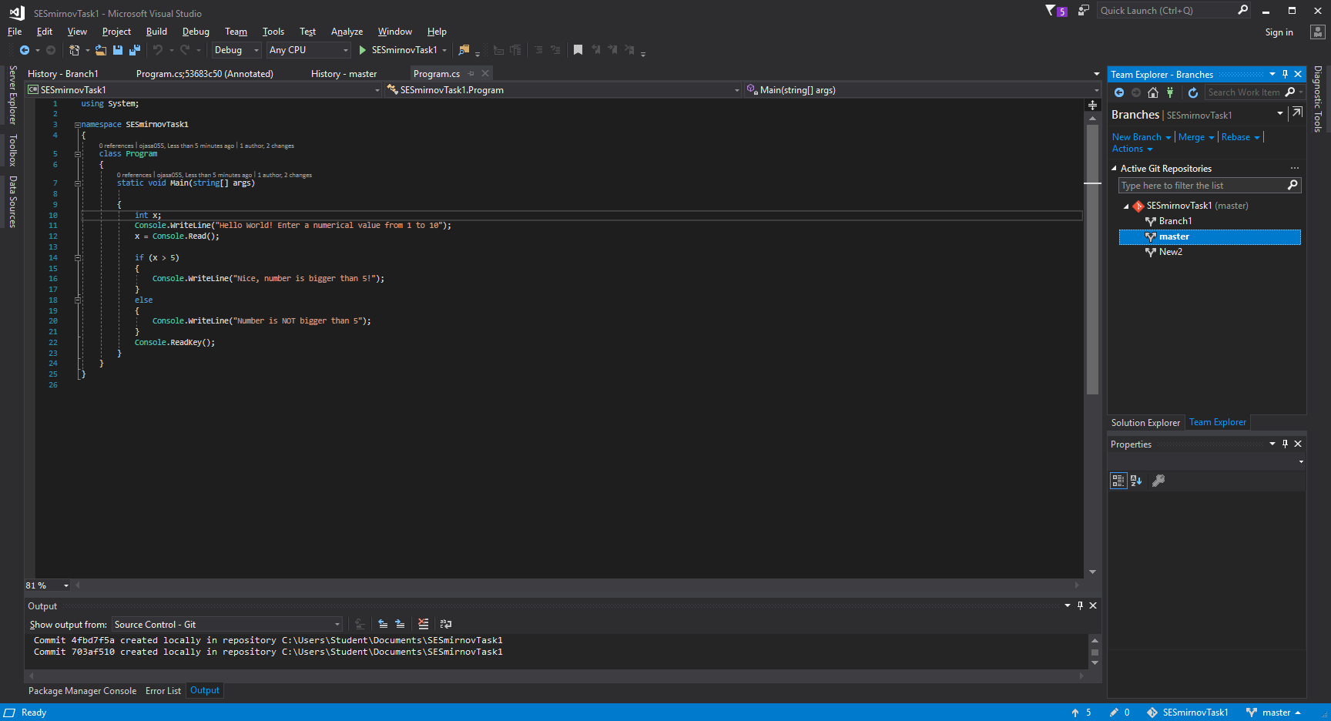

So here is how a branch looks:

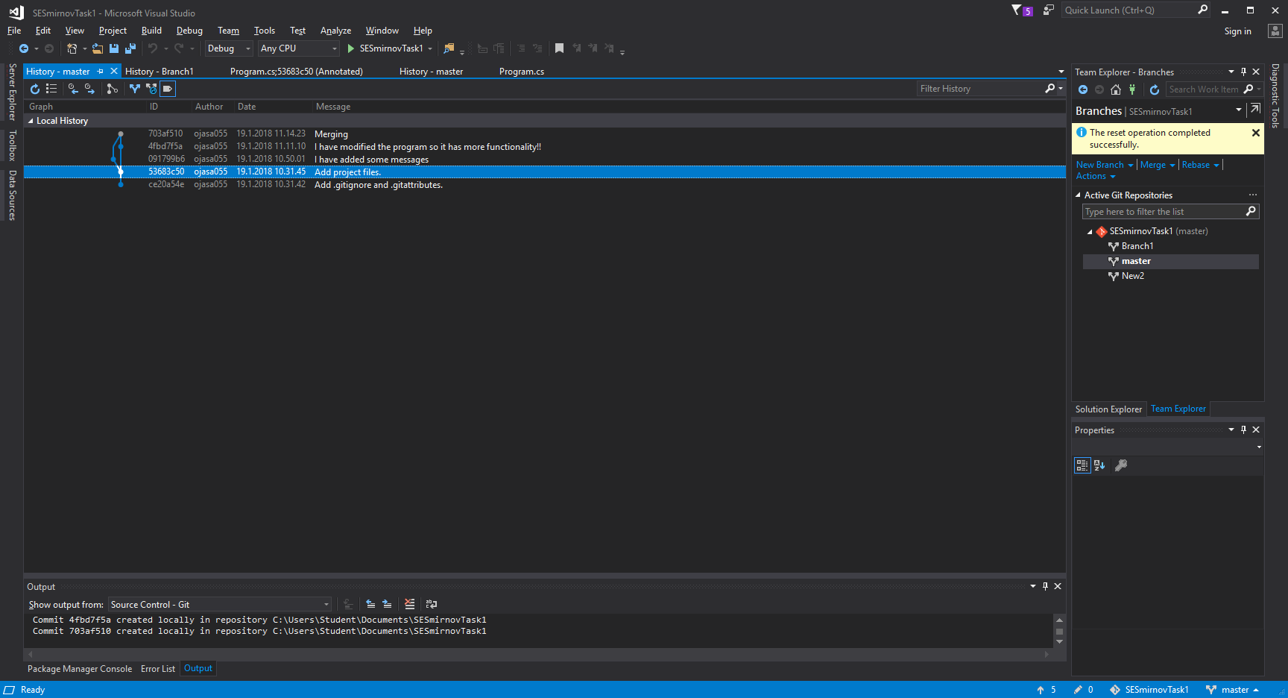

Conclusion:

I have created a very simple program to fully concentrate on exploring GIT functionality. Now I know how to create, merge branches, commit changes and revert back to the previous versions!

COOL!