Data Analysis Report

Introduction
This report explores how the physical and chemical properties of wine affect its quality. It uses a data set containing information about a sample of Portuguese wines and their associated properties. It begins by exploring the overall structure of the data set. It first addresses missing values, then examines wine quality, wine type, and the variables describing the wines’ physicochemical properties. Finally, it applies principal component analysis (PCA) to reduce the number of predictors and uses ordinal logistic regression to identify the main drivers of wine quality.

Data Set Overview
There are 6,497 observations and 14 variables in the data set, meaning that there are 6,497 unique wines described across 14 parameters. These parameters include the wine’s ID and its type, followed by 11 physicochemical properties, and finally the wine’s assigned quality. All columns in the data set are numerical, except for the type column which is categorical.

Handling Missing Values
There are 38 missing values in the data set, distributed across 34 observations and 7 variables.
To diagnose whether the data are likely to be missing completely at random (MCAR), I performed Little’s MCAR Test. This test assumes multivariate normality. While most variables are not normally distributed, the relatively large sample size improves the test’s reliability.
The test produced a Chi-Square statistic of 116.983 and a p-value greater than 0.1, providing no evidence that the data are missing at random (MAR) or missing not at random (MNAR).
Given that there is no evidence against MCAR and fewer than 1% of observations contain missing values, I decided that listwise deletion is a reasonable approach here to handle missing data. I deleted all observations that contain missing values, reducing the sample size from 6,497 to 6,463.

Wine Quality
Wine quality is recorded as an integer variable ranging from 3 to 9 (inclusive), with higher values indicating better quality. In my analysis, I treated wine quality as an ordinal categorical variable, so I transformed it accordingly.
As a categorical variable, wine quality has multiple levels with each level representing a wine score. In the data set, these levels are unbalanced and contain unequal numbers of observations, with quality ratings of 5 and 6 having over 2,000 observations each, and ratings of 3 and 9 having fewer than 50 (see Fig. 1A). Thus, for the analysis, I decided to combine some of the scores. Specifically, I combined quality ratings of 7, 8 and 9 into “good”, ratings of 3, 4 and 5 into “bad”, and transformed a quality rating of 6 into “average”. After transformation, some imbalance remained between these categories, especially between the “good” category and the others (see Fig. 1B).
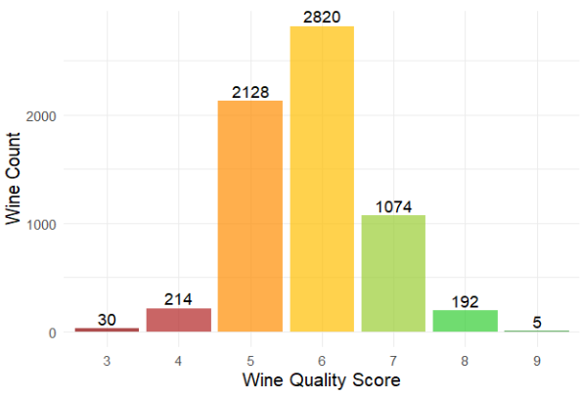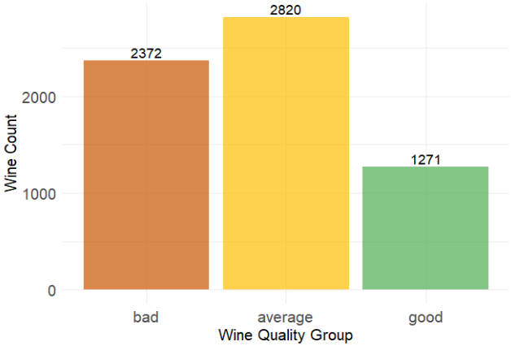
Figure 1 (A and B). Distribution of wines across the wine quality scores and categories.

Wine Type
The type variable indicates whether each wine is red or white, with white wines representing roughly 75% of the data set and red wines the remaining 25%. I assumed that different factors may contribute to the quality of red and white wines, so I examined each type of wine individually, further splitting the quality categories (see Fig. 2A).
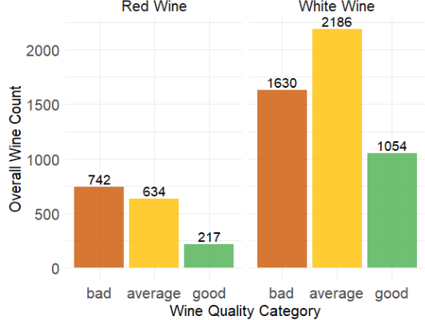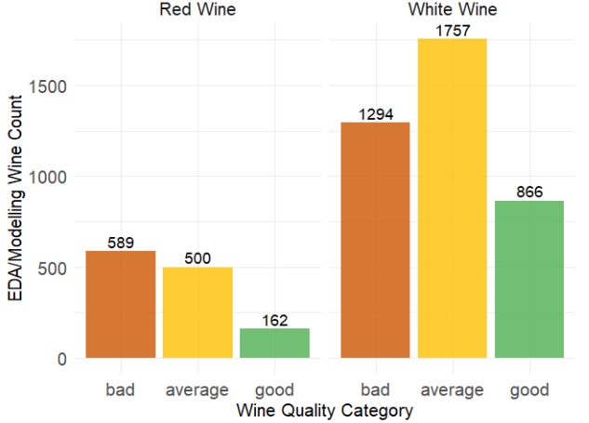
Figure 2. Sample sizes of different quality categories for white and red wines in the overall data set (A) and in the training data set (B).
Moreover, I split the data into training and test sets, randomly selecting 20% as the test set and stratifying by both wine type and quality score (not quality category) to ensure equal representation of all scores. Since the red wine sample is considerably smaller comparing to the white wine sample (see Fig. 2B), conclusions drawn for red wines are less certain.

Wine Physicochemical Properties

Univariate Analysis
Each wine is described along 11 physicochemical properties. I began by investigating how each of these properties is distributed in the data set individually. To do that, I transformed the data into a tidy format, grouping all physicochemical properties together. I then visualised each variable individually using histograms and boxplots (see Fig. 3A and 3B).
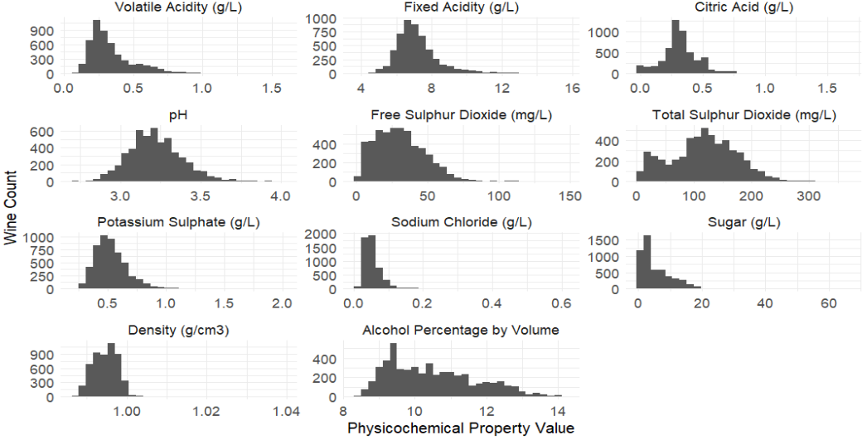
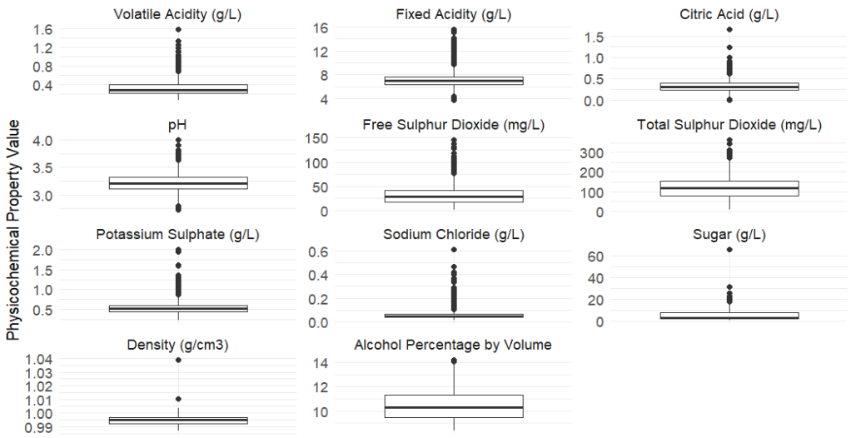
Figure 3. Histograms (A) and boxplots (B) illustrating the distribution of each physicochemical property.
After examining boxplots and histograms, I conclude that none of the variables follow a normal distribution, and most are right-skewed. All variables contain outliers, and for most, the outliers occur exclusively on the right end of the distribution. Even variables such as fixed acidity, citric acid, and pH (which have outliers at both ends) tend to have more outliers on the right.
I tried reducing number of outliers by applying square root, cube root, and log(x+1) transformations, but none of the transformations were effective. Since I do not have domain expertise to determine which outliers reflect natural variation versus likely errors, I decided to keep them in the data set.
However, I also created a winsorized data set in which, within each wine type, values below the 5th percentile and above the 95th percentile were capped at those thresholds. This data was used to for PCA and ordinal logistic regression, since both methods are sensitive to outliers.

Multivariate Analysis
Next, I investigated how each property is associated with different quality categories for red and white wines (see Fig. 4A and 4B, respectively).
On average, red wines tend to have lower volatile acidity and total sulphur dioxide, and higher fixed acidity, citric acid, potassium sulphate, and alcohol content across the three quality categories. In contrast, white wines only show lower total sulphur dioxide, and higher alcohol content. Additionally, after visualising the winsorized data, I observed that white wines tend to have lower sugar, and both red and white wines also tend to have lower sodium chloride and density.
Additionally, I uncovered that high multicollinearity is present among some variables. In particular, in white wines sugar and alcohol have VIFs close to or above 5, and density has a VIF greater than 10, indicating strong linear relationships with other predictors.

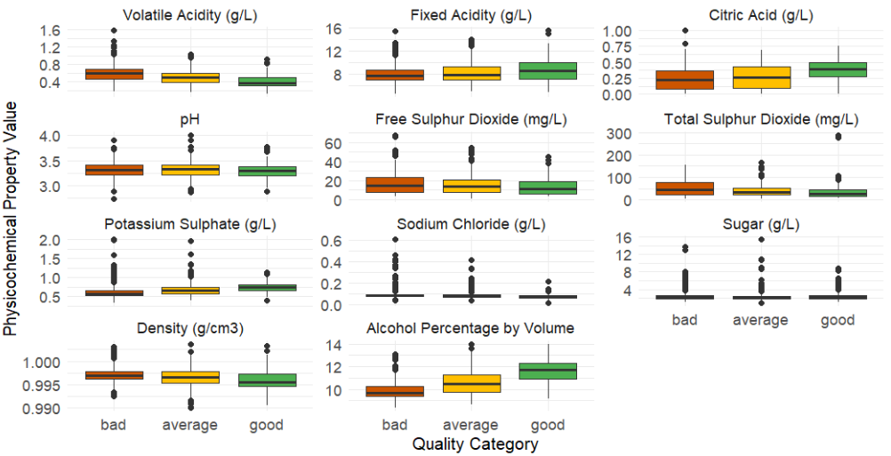
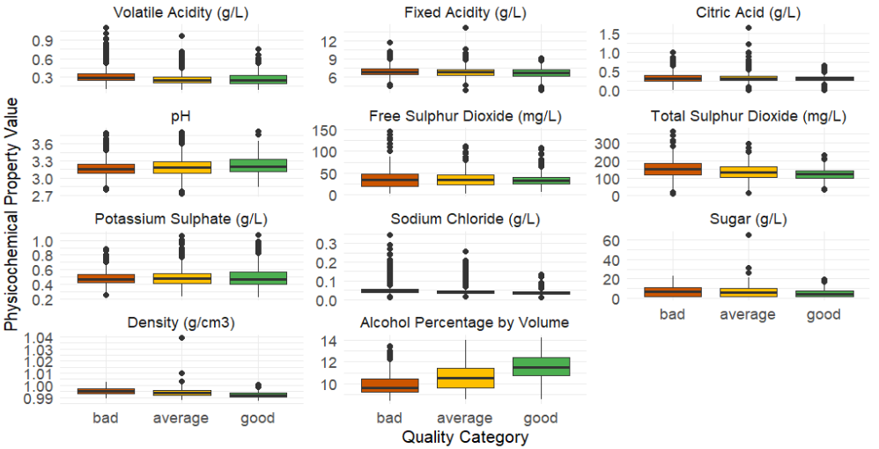
Figure 4. Distribution of wine physicochemical properties across three quality categories (“bad”, “average”, and “good”) for red (A) and white (B) wines.

Principal Component Analysis
To address the issues of multicollinearity and reduce the number of dimensions present in the data, I used principal component analysis (PCA). I used winsorized data to avoid loadings of the principal component (PC) being biased by extreme values. I selected three PCs for both red and white wines after inspecting the scree plots and concluding that the “elbow” occurs at the fourth component (see Fig. 5A and 5B). The first three PCs explain 62% of the total variance for red wines and ~57% for white wines.
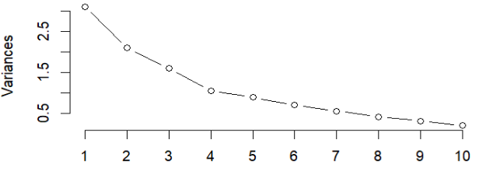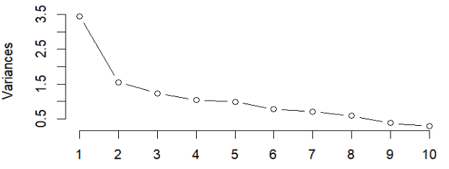
Figure 5. Scree plots of principal components for red (A) and white (B) wines.

Red Wines
For red wines (see Fig. 6A), the first PC has large positive coefficients for fixed acidity, citric acid, and density, and large negative coefficients for pH . This component appears to capture the overall acidity profile of the wine. It is also characterised by noticeable positive coefficients for sodium chloride, sugar, and potassium sulphate, and a negative coefficient for volatile acidity, reflecting a contrast between denser wines with higher chemical acidity and mineral content versus wines with lower acidity but stronger acidic aroma.
The second PC has positive coefficients for alcohol, citric acid, and potassium sulphate, and negative coefficients for total and free sulphur dioxide, volatile acidity, sodium chloride, density, and sugar. This component mirrors a lot of the patterns observed in the boxplots across the quality categories.
The third PC has noticeably large positive coefficients for free and total sulphur dioxide. This component highlights wines that, like those scoring highly on the second PC, have higher alcohol, citric acid, and potassium sulphate, but unlike them are also characterised by high sulphur dioxide and sugar, and lower fixed acidity.
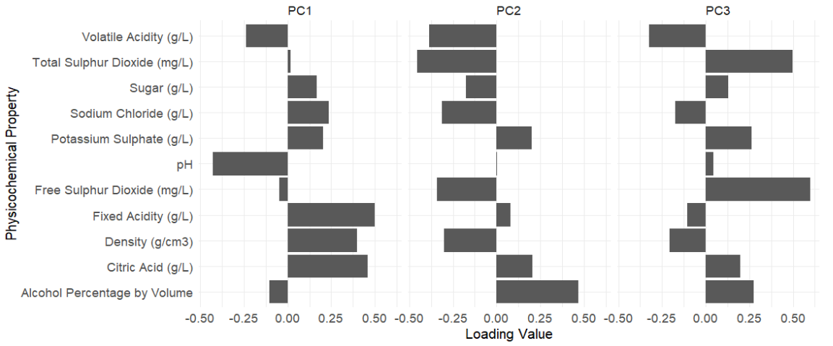
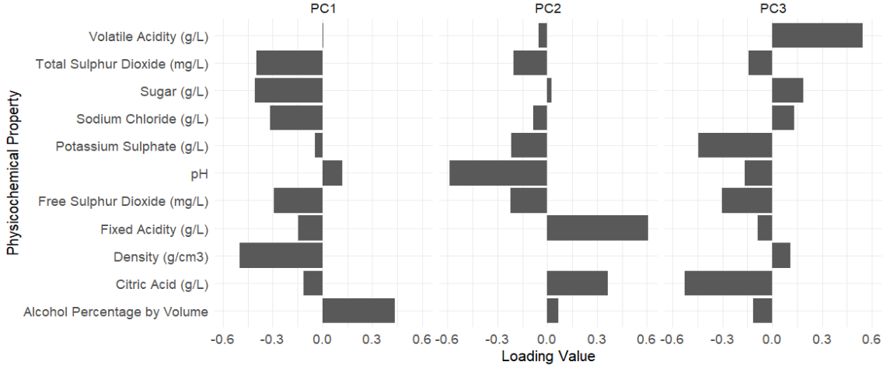
Figure 6. The first three principal components (PC) for red (A) and white (B) wines and their associated loadings.

White Wines
For white wines (see Fig. 6B), the first PC has positive coefficients only for alcohol content and pH, with all other variables having negative coefficients. Specifically, it has large negative coefficients for density, sugar, total and free sulphur dioxide, and sodium chloride. Similarly to the second PC for red wines, this component seems to reflect a lot of the differences that were noted prior between the quality categories.
The second PC appears to reflect the overall acidity of the wine, with a large negative coefficient for pH and large positive coefficients for fixed acidity and citric acid. It is also characterised by small negative coefficients for sulphur dioxide, potassium sulphate, and sodium chloride, indicating that wines scoring high on this component have a stronger acidic taste, but lower mineral content.
The third PC has a large positive coefficient for volatile acidity, and large negative coefficients for citric acid and potassium sulphate. This component captures a contrast between wines with a strong acidic aroma (high volatile acidity) and wines with higher chemical acidity and sulphate.

Ordinal Logistic Regression
I used an ordinal logistic regression to model the effect of the first three principal components (PC1, PC2, PC3) on wine quality categories (“bad”, “average”, “good”) for red and white wines.

Building Models
For red wines (Fig. 7), all three components have positive coefficients, meaning that higher scores on these components increase the likelihood of a wine being classified into a higher quality category. PC2 exhibits the largest effect (coefficient = 0.862, OR ~2.37), indicating that for a one-unit increase in PC2, the odds of being in a higher quality category are multiplied by approximately 2.37, holding other components constant. PC3 also shows a moderate positive effect (coefficient = 0.415, OR ~1.51), while PC1 has very little influence (coefficient = 0.111, OR ≈ 1.12).
Overall, wines with higher scores on PC2, that is wines that are characterised by higher alcohol, citric acid, and potassium sulphate, and lower sulphur dioxide and sugar – are more likely to belong to the “good” quality category. Wines with higher scores on PC3 (they also tend to have higher alcohol, citric acid, and potassium sulphate, but differ in having higher sulphur dioxide and sugar) and their effect on predicted quality increases more slowly. PC1, associated primarily with acidity, has very little effect.
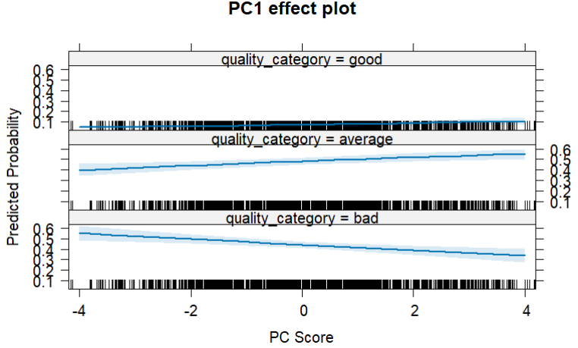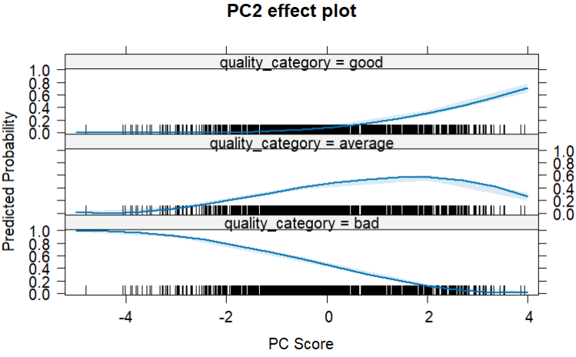
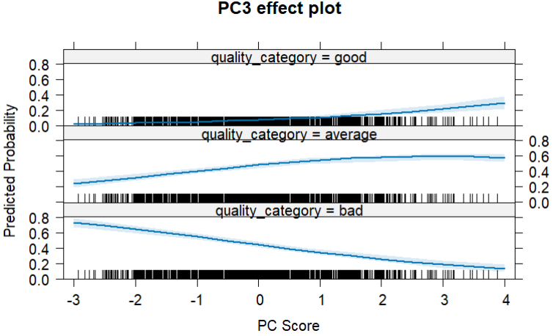
Figure 7. Effect of each principal component on the predicted quality of red wines.
For white wines (Fig. 8), PC1 has a strong positive coefficient (coefficient = 0.392, OR ≈ 1.48), indicating that higher scores on this component increase the likelihood of a wine being classified into a higher quality category. PC2 has a small negative effect (coefficient = -0.043, OR ≈ 0.96), suggesting very little or no impact on the predicted quality. PC3 has a moderate negative effect (coefficient = -0.409, OR ≈ 0.66), meaning that higher scores on this component decrease the likelihood of a wine being in a higher quality category.
Overall, wines with higher scores on PC1 – reflecting higher alcohol content and lower sugar, sodium chloride, sulphur dioxide and – are more likely to belong to the “good” quality category. In contrast, higher scores on PC3 – capturing higher volatile acidity, higher sulphur dioxide, sugar, density, and sodium chloride – are associated with lower quality wines. PC2 has little effect on wine quality, despite representing variation in acidity and mineral content.
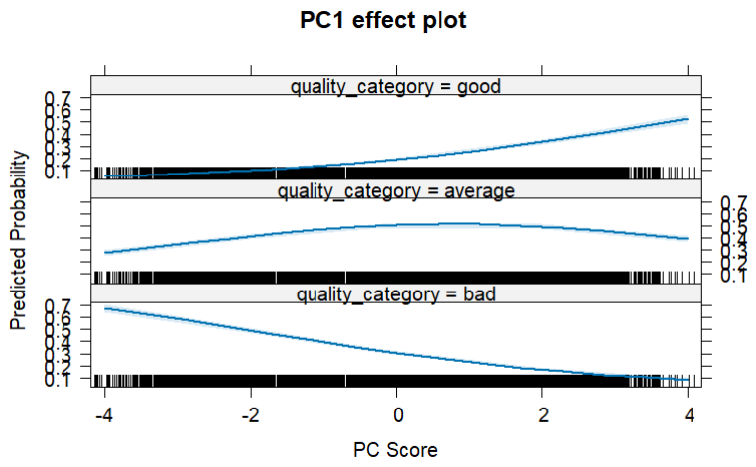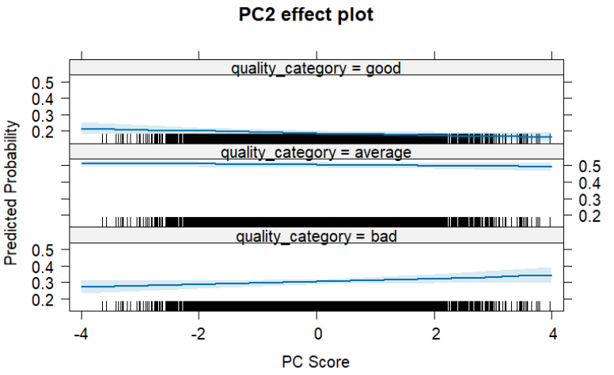
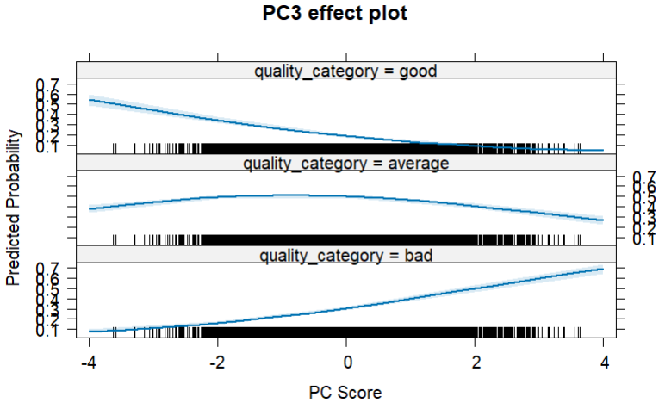
Figure 8. Effect of each principal component on the predicted quality of white wines.

Testing Models
To evaluate the performance of the ordinal logistic regression models, I first winsorized the test data using the 5th and 95th percentile cutoffs calculated from the training set. The winsorized test data was then projected onto the principal components derived from the training set, and predicted wine quality categories were generated using the fitted models. Accuracy was calculated as the proportion of correctly classified wines.
For red wines, the model correctly predicted ~53% of wines, with most misclassifications occurring between adjacent categories, particularly between “bad” and “average.” Only a small number of wines in the “good” category were misclassified as “bad.” For white wines, overall accuracy was slightly lower at ~52%, with a similar pattern of misclassification concentrated between neighbouring quality groups.

Conclusions
Overall, alcohol content emerged as the strongest and most consistent indicator of higher quality for both red and white wines. For red wines, higher citric acid and potassium sulphate, together with lower sulphur dioxide, sugar and volatile acidity, were also associated with better quality. For white wines, quality also tended to increase with lower sugar, sodium chloride, sulphur dioxide, and density, while higher volatile acidity was linked to lower quality.
Despite these patterns, the models achieved only modest predictive performance, with accuracies slightly above 50%. This highlights clear limitations, likely due to the substantial overlap between quality categories, and the influence of factors not captured in the data. Furthermore, because principal components combine multiple correlated variables, they can be difficult to interpret, and it is not possible to identify with confidence which specific physicochemical properties drive the positive effects.

Executive Summary
The aim of this summary is to present the key findings of the analysis report that investigated the main drivers of wine quality. The analysis used a dataset of over 6,000 wines, including both red and white varieties, each described by 11 physical and chemical properties. Wine quality in the dataset was originally rated on a scale from 3 to 9, but most wines scored in the middle range, so the ratings were grouped into three categories as shown in Fig. 1: higher-quality wines (scores 7–9), medium-quality wines (score 6), and lower-quality wines (scores 3–5).
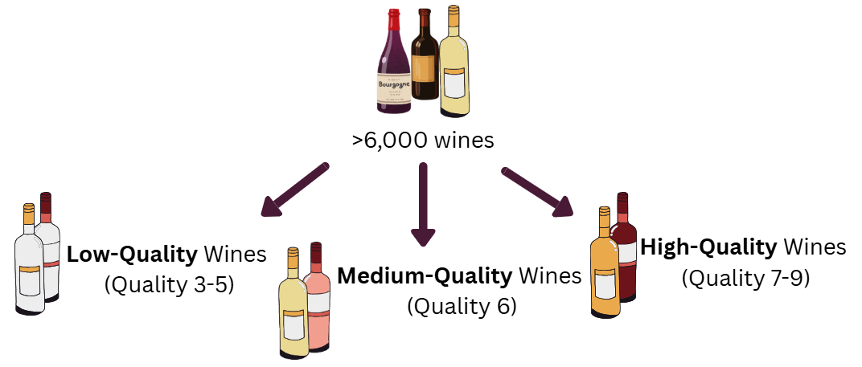
Figure 1. Wine Quality Categories.
When examining how the physical and chemical properties of wines affected their quality, I found that red and white wines both share and contrast the properties that drive their quality, as illustrated in Fig. 2. Both higher-quality red and white wines generally contained higher alcohol, were less dense and less salty, and had lower levels of sulphur dioxide. In contrast, higher-quality red wines specifically had higher chemical acidity and potassium sulphate, along with lower acidic aroma. While higher-quality white wines had lower sugar content.
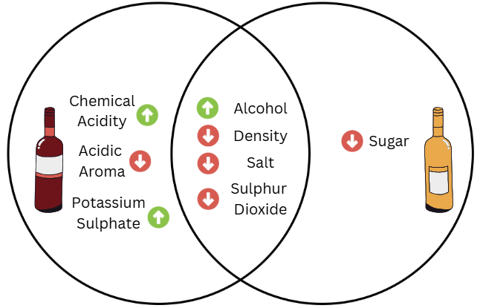
Figure 2. Shared and Distinct Characteristics of High-Quality Red and White Wines.
To better understand how these properties work together, I used a statistical method called principal component analysis (PCA). This approach combined related physical and chemical properties into a smaller number of factors, highlighting the main patterns in the data. These factors were then used to see how they relate to a wine’s quality, helping to show which wines are more likely to be high-quality.
For red wines, three main factors emerged. The first factor described the overall acidity profile of the wine, capturing how strong or mild the wine’s acid profile was. The second factor identified wines that were higher in alcohol and chemical acidity, but lower in acidic aroma and sulphur dioxide, meaning they tasted sharp but did not have a strong sour aroma and had lower preservation. The third factor captured a similar group of wines but with higher levels of sulphur dioxide, highlighting those wines that were more preserved.
For white wines, three main factors also emerged. The first factor reflected wines with higher alcohol content combined with lower levels of other chemicals, highlighting wines that were stronger in alcohol but lighter in body. The second factor described the overall acidity of the wine, indicating how sharp or mild the wine tasted. The third factor represented wines with a stronger acidic aroma and lower potassium sulphate and chemical acidity, highlighting wines that had a more pronounced smell but a milder taste.
After identifying the key factors for red and white wines, I examined which factors had the greatest influence on wine quality. As shown on the left side of the Fig. 3, for red wines the second factor had the strongest positive effect, meaning wines that were higher in alcohol and chemical acidity, but lower in preservation and acidic aroma, were more likely to be rated as high-quality. In contrast, the factor representing overall acidity had little impact. Interestingly, wines that scored high on the third factor, which captured higher preservation levels, were also more likely to be rated as high-quality, although the effect was smaller.
As shown on the right side of the Fig. 3, for white wines the first factor was most strongly associated with higher-quality wines, whereas higher scores for acidic aroma combined with milder taste were linked to lower quality. Across both wine types, alcohol consistently emerged as the property most closely associated with higher quality, while a pronounced acidic aroma tended to be linked with lower quality.
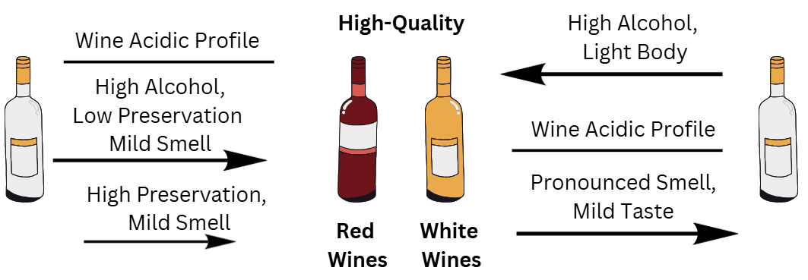
Figure 3. Key Drivers of Wine Quality in Red and White Wines.
To understand not just which factors are linked to wine quality, but also how well they could actually predict it, I tested the models using the identified factors. This allowed me to see whether wines with higher scores on certain factors were reliably rated as higher quality. Although the models provided useful insights, they achieved only moderate accuracy, correctly classifying slightly more than half of the wines. Most misclassifications occurred between neighbouring quality categories, reflecting the subtle differences in wine quality that cannot be fully captured by chemical measurements alone.
Despite the moderate predictive accuracy, the findings provide useful insights by highlighting the chemical properties most strongly associated with higher-quality wines. For red wines, higher quality tends to be linked with increased alcohol, higher chemical acidity, and certain components such as citric acid and potassium sulphate, while wines with high sulphur dioxide or strong acidic aroma are less likely to achieve top ratings. For white wines, higher-quality wines generally combine higher alcohol with lower sugar, sodium chloride, sulphur dioxide, and density, whereas wines with a pronounced acidic aroma and milder taste tend to be rated lower.

