УО «Белорусский государственный университет информатики и радиоэлектроники»
Кафедра ПОИТ

Отчет по лабораторной работе №2
по предмету «Теория информации»
Вариант 11

Выполнил:
Максименко Д. Е.
45100067
Проверил(a):
Болтак С.В.
Группа 451004

Минск 2026
Задание
Реализовать систему потокового шифрования и дешифрования для файла с любым содержимым (с любым расширением) с помощью генератора ключевой последовательности на основе линейного сдвигового регистра с обратной связью LFSR (размерность регистра согласно выданному варианту). Начальное состояние регистра ввести с клавиатуры. Поле для ввода состояния регистра должно игнорировать любые символы кроме 0 и 1. Вывести на экран сгенерированный ключ (последовательность из 0 и 1), исходный файл и зашифрованный файл в двоичном виде. На диск сохранить зашифрованный/расшифрованный файл в виде потока байтов. Программа не должна быть написана в консольном режиме. Результат работы программы – зашифрованный/расшифрованный файл.
Многочлен
x^33 + x^13 + 1

Тесты:
1) Файл до шифрования(текстовый):


Ключ: 101010101010101010101010101010101

Результат работы программы при шифрования:
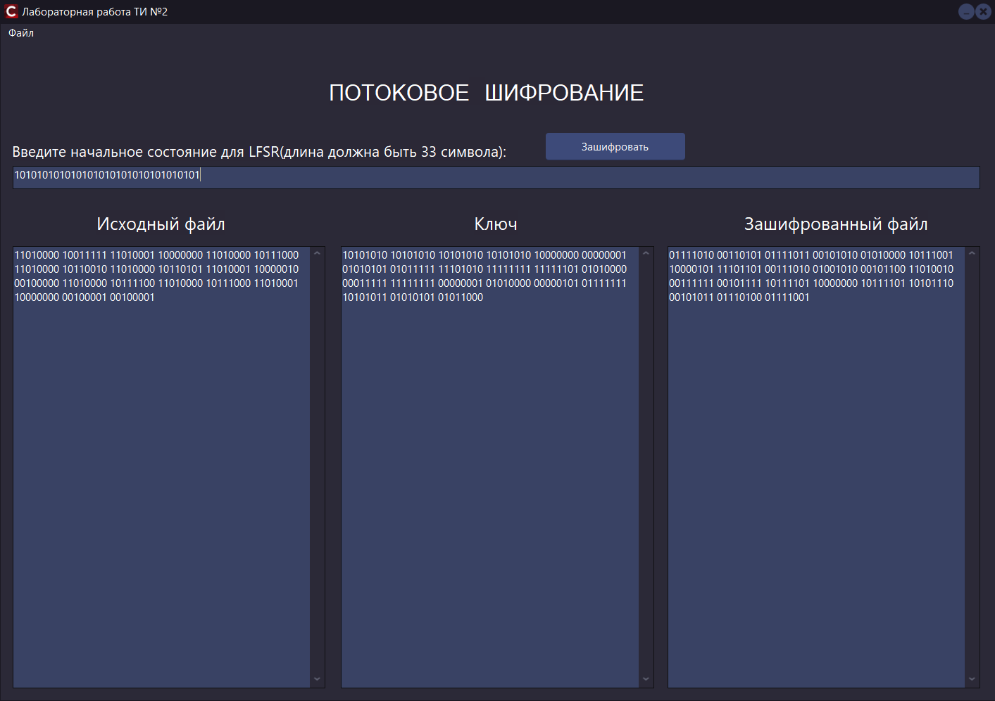

Файл после шифрования:


Результат работы программы при дешифровании:
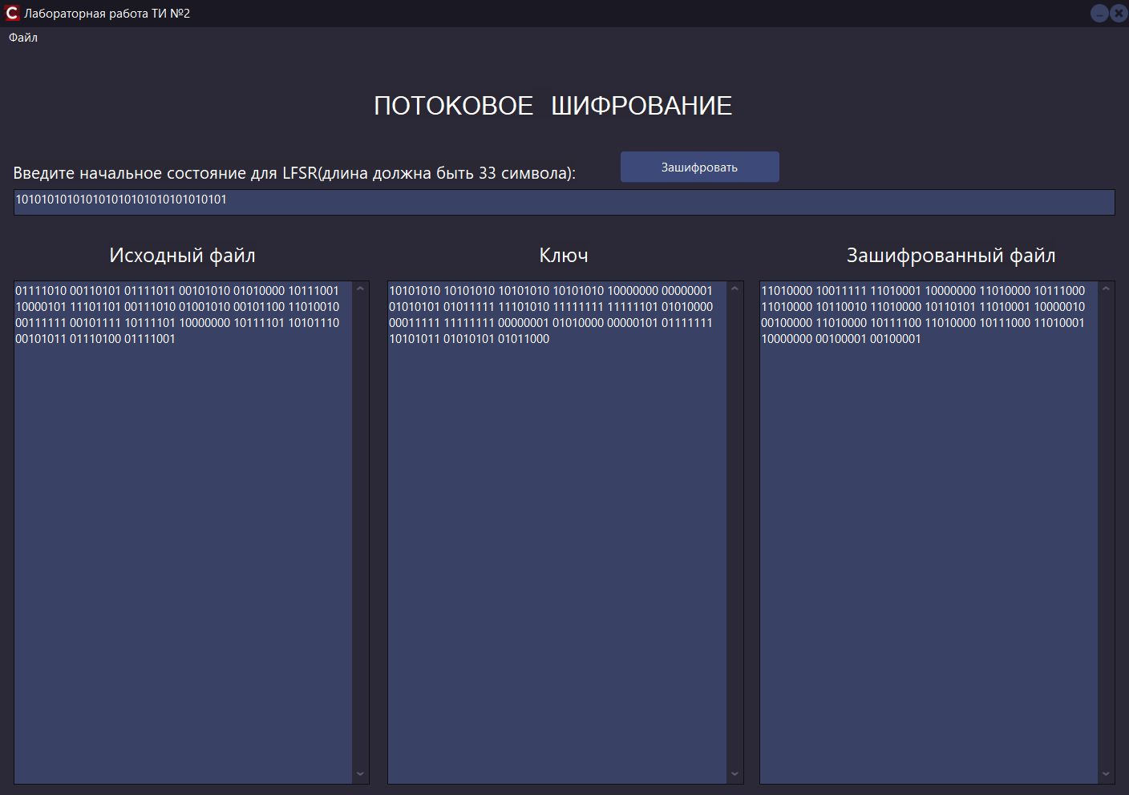

Файл после дешифрования:


2) Файл до шифрования(изображение):


Ключ: 111111111111111111111111111111111

Результат работы программы при шифрования:
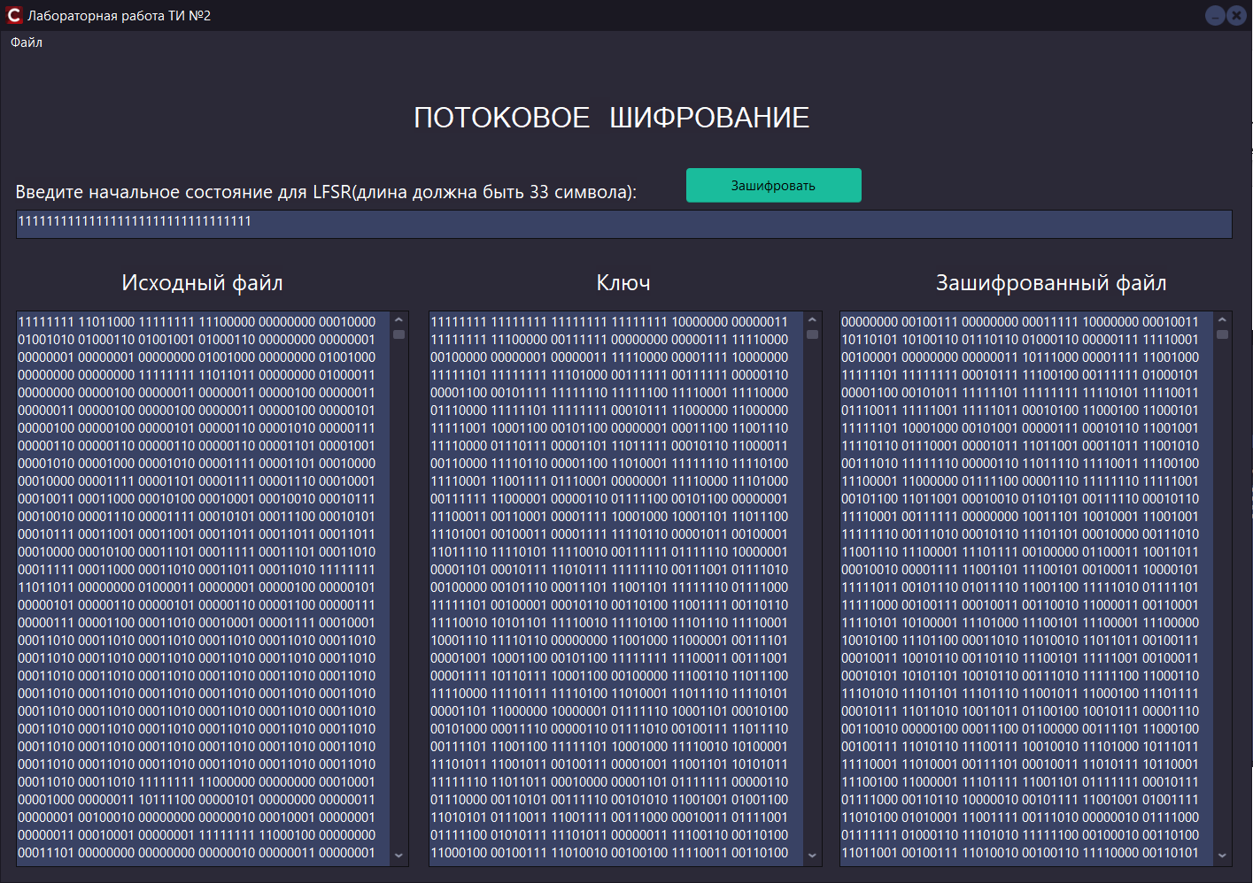

Файл после шифрования:
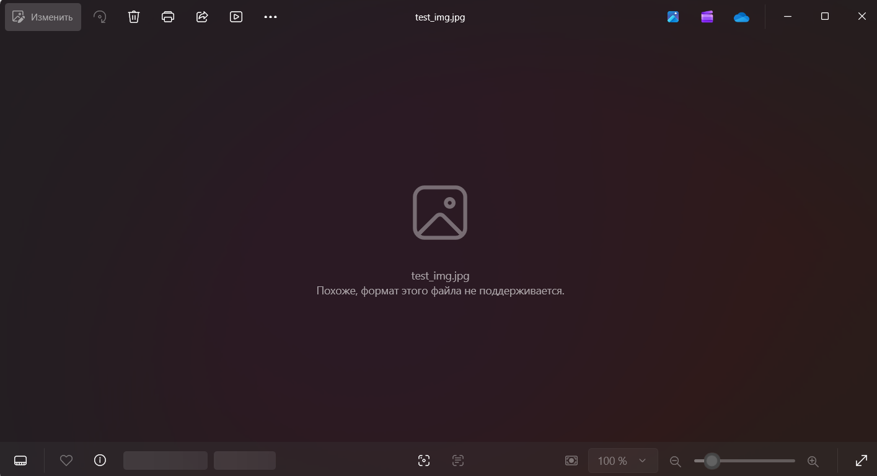

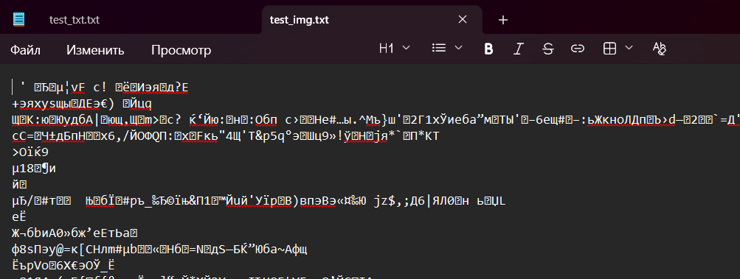

Результат работы программы при дешифровании:
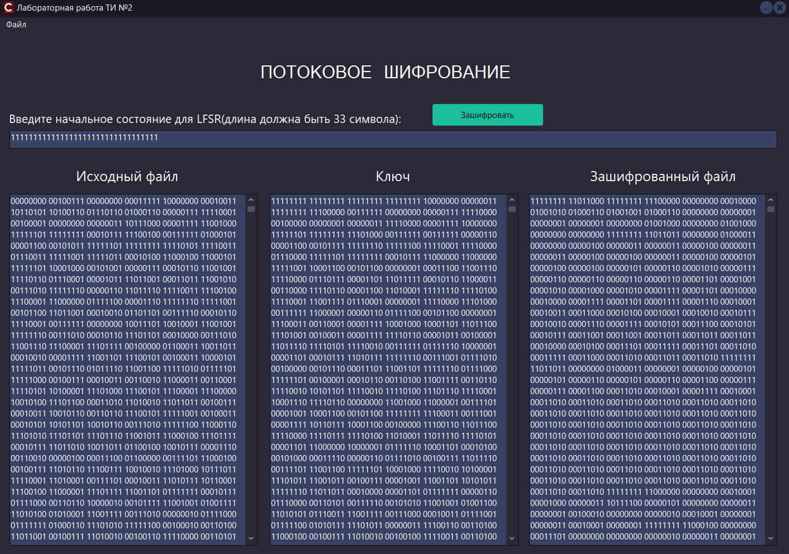

Файл после дешифрования:
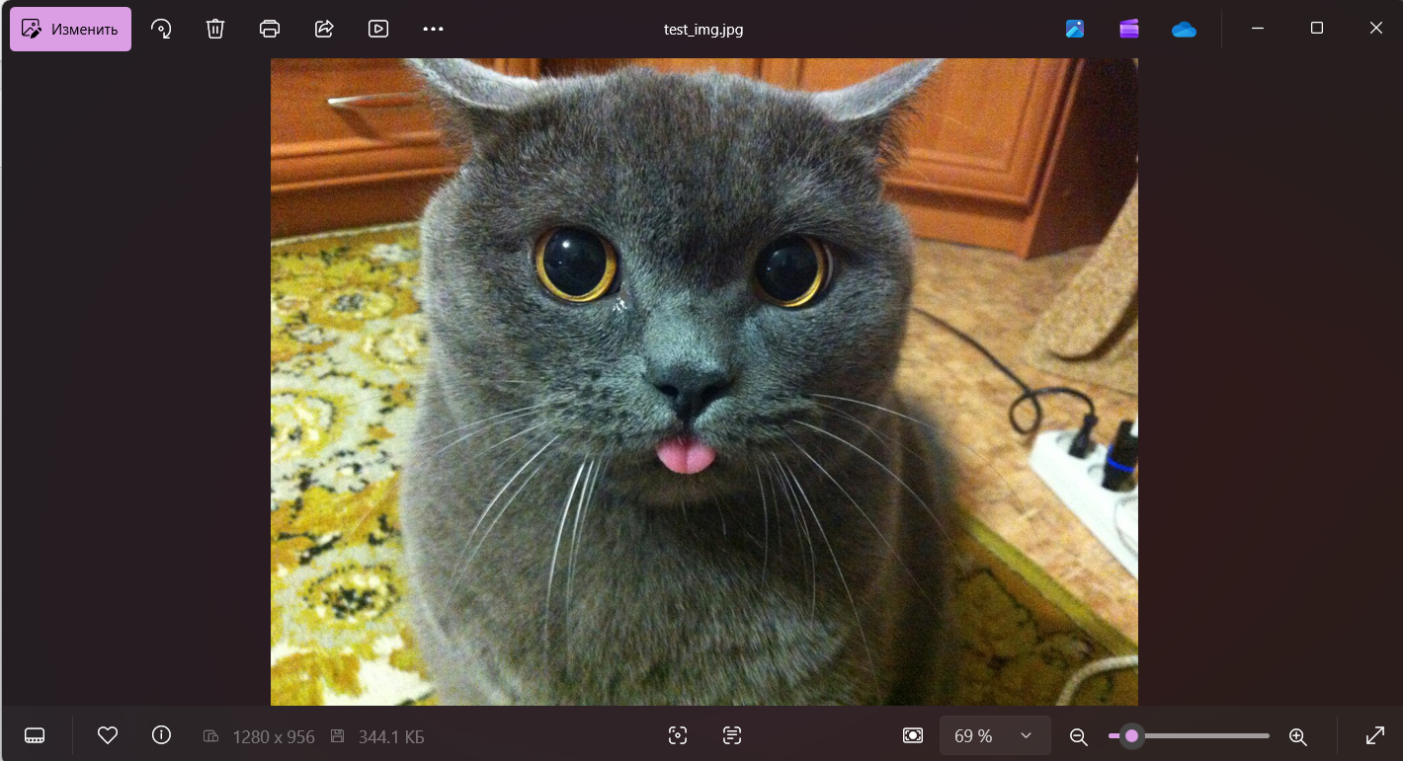

3) Файл до шифрования(аудио):


Ключ: 111111111111111111111111111111111

Результат работы программы при шифрования:
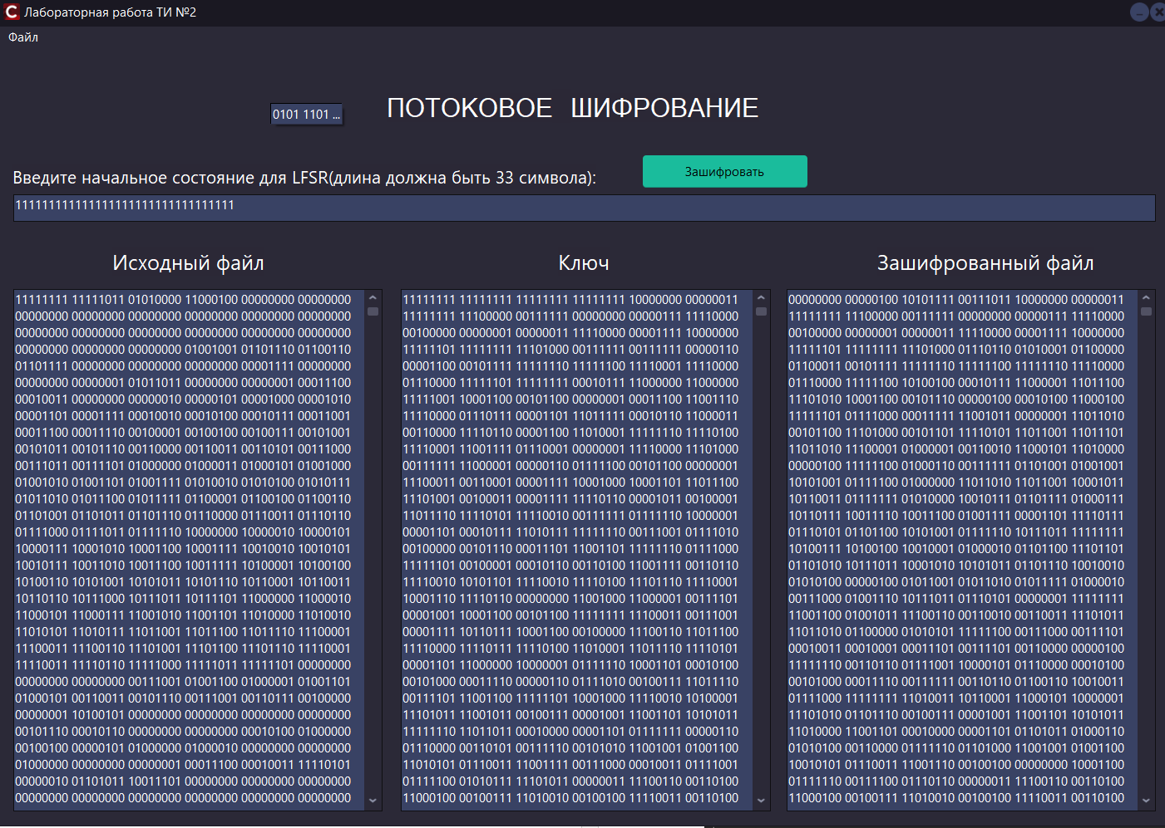

Файл после шифрования:


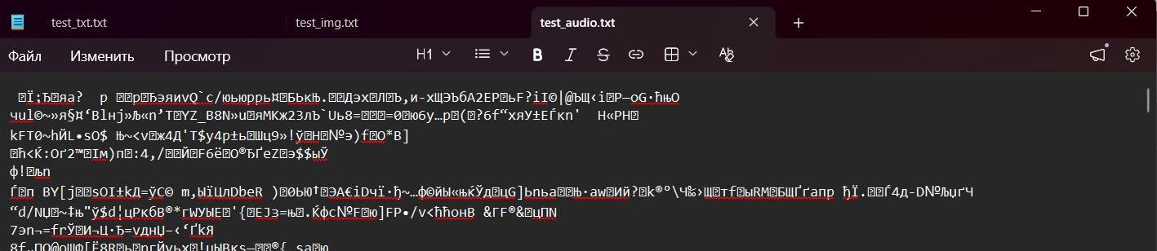

Результат работы программы при дешифровании:
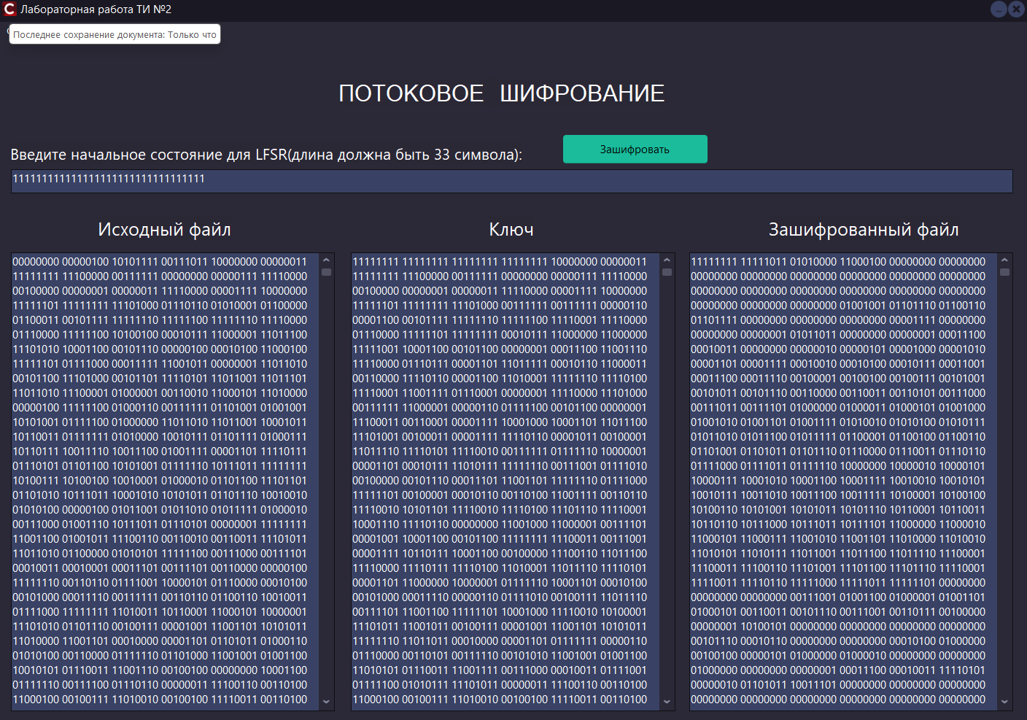

Файл после дешифрования:


Шаг | Разряд |  |  |  |  |  |  |  |  |  |  |  |  |  |  |  |  |  |  |  |  |  |  |  |  |  |  |  |  |  |  |  |  | xor
 | 33 | 32 | 31 | 30 | 29 | 28 | 27 | 26 | 25 | 24 | 23 | 22 | 21 | 20 | 19 | 18 | 17 | 16 | 15 | 14 | 13 | 12 | 11 | 10 | 9 | 8 | 7 | 6 | 5 | 4 | 3 | 2 | 1
1 | 1 | 1 | 1 | 1 | 1 | 1 | 1 | 1 | 1 | 1 | 1 | 1 | 1 | 1 | 1 | 1 | 1 | 1 | 1 | 1 | 1 | 1 | 1 | 1 | 1 | 1 | 1 | 1 | 1 | 1 | 1 | 1 | 1 | 0
2 | 1 | 1 | 1 | 1 | 1 | 1 | 1 | 1 | 1 | 1 | 1 | 1 | 1 | 1 | 1 | 1 | 1 | 1 | 1 | 1 | 1 | 1 | 1 | 1 | 1 | 1 | 1 | 1 | 1 | 1 | 1 | 1 | 0 | 0
3 | 1 | 1 | 1 | 1 | 1 | 1 | 1 | 1 | 1 | 1 | 1 | 1 | 1 | 1 | 1 | 1 | 1 | 1 | 1 | 1 | 1 | 1 | 1 | 1 | 1 | 1 | 1 | 1 | 1 | 1 | 1 | 0 | 0 | 0
4 | 1 | 1 | 1 | 1 | 1 | 1 | 1 | 1 | 1 | 1 | 1 | 1 | 1 | 1 | 1 | 1 | 1 | 1 | 1 | 1 | 1 | 1 | 1 | 1 | 1 | 1 | 1 | 1 | 1 | 1 | 0 | 0 | 0 | 0
5 | 1 | 1 | 1 | 1 | 1 | 1 | 1 | 1 | 1 | 1 | 1 | 1 | 1 | 1 | 1 | 1 | 1 | 1 | 1 | 1 | 1 | 1 | 1 | 1 | 1 | 1 | 1 | 1 | 1 | 0 | 0 | 0 | 0 | 0
6 | 1 | 1 | 1 | 1 | 1 | 1 | 1 | 1 | 1 | 1 | 1 | 1 | 1 | 1 | 1 | 1 | 1 | 1 | 1 | 1 | 1 | 1 | 1 | 1 | 1 | 1 | 1 | 1 | 0 | 0 | 0 | 0 | 0 | 0
7 | 1 | 1 | 1 | 1 | 1 | 1 | 1 | 1 | 1 | 1 | 1 | 1 | 1 | 1 | 1 | 1 | 1 | 1 | 1 | 1 | 1 | 1 | 1 | 1 | 1 | 1 | 1 | 0 | 0 | 0 | 0 | 0 | 0 | 0
8 | 1 | 1 | 1 | 1 | 1 | 1 | 1 | 1 | 1 | 1 | 1 | 1 | 1 | 1 | 1 | 1 | 1 | 1 | 1 | 1 | 1 | 1 | 1 | 1 | 1 | 1 | 0 | 0 | 0 | 0 | 0 | 0 | 0 | 0
9 | 1 | 1 | 1 | 1 | 1 | 1 | 1 | 1 | 1 | 1 | 1 | 1 | 1 | 1 | 1 | 1 | 1 | 1 | 1 | 1 | 1 | 1 | 1 | 1 | 1 | 0 | 0 | 0 | 0 | 0 | 0 | 0 | 0 | 0
10 | 1 | 1 | 1 | 1 | 1 | 1 | 1 | 1 | 1 | 1 | 1 | 1 | 1 | 1 | 1 | 1 | 1 | 1 | 1 | 1 | 1 | 1 | 1 | 1 | 0 | 0 | 0 | 0 | 0 | 0 | 0 | 0 | 0 | 0
11 | 1 | 1 | 1 | 1 | 1 | 1 | 1 | 1 | 1 | 1 | 1 | 1 | 1 | 1 | 1 | 1 | 1 | 1 | 1 | 1 | 1 | 1 | 1 | 0 | 0 | 0 | 0 | 0 | 0 | 0 | 0 | 0 | 0 | 0
12 | 1 | 1 | 1 | 1 | 1 | 1 | 1 | 1 | 1 | 1 | 1 | 1 | 1 | 1 | 1 | 1 | 1 | 1 | 1 | 1 | 1 | 1 | 0 | 0 | 0 | 0 | 0 | 0 | 0 | 0 | 0 | 0 | 0 | 0
13 | 1 | 1 | 1 | 1 | 1 | 1 | 1 | 1 | 1 | 1 | 1 | 1 | 1 | 1 | 1 | 1 | 1 | 1 | 1 | 1 | 1 | 0 | 0 | 0 | 0 | 0 | 0 | 0 | 0 | 0 | 0 | 0 | 0 | 0
14 | 1 | 1 | 1 | 1 | 1 | 1 | 1 | 1 | 1 | 1 | 1 | 1 | 1 | 1 | 1 | 1 | 1 | 1 | 1 | 1 | 0 | 0 | 0 | 0 | 0 | 0 | 0 | 0 | 0 | 0 | 0 | 0 | 0 | 1
15 | 1 | 1 | 1 | 1 | 1 | 1 | 1 | 1 | 1 | 1 | 1 | 1 | 1 | 1 | 1 | 1 | 1 | 1 | 1 | 0 | 0 | 0 | 0 | 0 | 0 | 0 | 0 | 0 | 0 | 0 | 0 | 0 | 1 | 1
16 | 1 | 1 | 1 | 1 | 1 | 1 | 1 | 1 | 1 | 1 | 1 | 1 | 1 | 1 | 1 | 1 | 1 | 1 | 0 | 0 | 0 | 0 | 0 | 0 | 0 | 0 | 0 | 0 | 0 | 0 | 0 | 1 | 1 | 1
17 | 1 | 1 | 1 | 1 | 1 | 1 | 1 | 1 | 1 | 1 | 1 | 1 | 1 | 1 | 1 | 1 | 1 | 0 | 0 | 0 | 0 | 0 | 0 | 0 | 0 | 0 | 0 | 0 | 0 | 0 | 1 | 1 | 1 | 1
18 | 1 | 1 | 1 | 1 | 1 | 1 | 1 | 1 | 1 | 1 | 1 | 1 | 1 | 1 | 1 | 1 | 0 | 0 | 0 | 0 | 0 | 0 | 0 | 0 | 0 | 0 | 0 | 0 | 0 | 1 | 1 | 1 | 1 | 1
19 | 1 | 1 | 1 | 1 | 1 | 1 | 1 | 1 | 1 | 1 | 1 | 1 | 1 | 1 | 1 | 0 | 0 | 0 | 0 | 0 | 0 | 0 | 0 | 0 | 0 | 0 | 0 | 0 | 1 | 1 | 1 | 1 | 1 | 1
20 | 1 | 1 | 1 | 1 | 1 | 1 | 1 | 1 | 1 | 1 | 1 | 1 | 1 | 1 | 0 | 0 | 0 | 0 | 0 | 0 | 0 | 0 | 0 | 0 | 0 | 0 | 0 | 1 | 1 | 1 | 1 | 1 | 1 | 1
21 | 1 | 1 | 1 | 1 | 1 | 1 | 1 | 1 | 1 | 1 | 1 | 1 | 1 | 0 | 0 | 0 | 0 | 0 | 0 | 0 | 0 | 0 | 0 | 0 | 0 | 0 | 1 | 1 | 1 | 1 | 1 | 1 | 1 | 1
22 | 1 | 1 | 1 | 1 | 1 | 1 | 1 | 1 | 1 | 1 | 1 | 1 | 0 | 0 | 0 | 0 | 0 | 0 | 0 | 0 | 0 | 0 | 0 | 0 | 0 | 1 | 1 | 1 | 1 | 1 | 1 | 1 | 1 | 1
23 | 1 | 1 | 1 | 1 | 1 | 1 | 1 | 1 | 1 | 1 | 1 | 0 | 0 | 0 | 0 | 0 | 0 | 0 | 0 | 0 | 0 | 0 | 0 | 0 | 1 | 1 | 1 | 1 | 1 | 1 | 1 | 1 | 1 | 1
24 | 1 | 1 | 1 | 1 | 1 | 1 | 1 | 1 | 1 | 1 | 0 | 0 | 0 | 0 | 0 | 0 | 0 | 0 | 0 | 0 | 0 | 0 | 0 | 1 | 1 | 1 | 1 | 1 | 1 | 1 | 1 | 1 | 1 | 1
25 | 1 | 1 | 1 | 1 | 1 | 1 | 1 | 1 | 1 | 0 | 0 | 0 | 0 | 0 | 0 | 0 | 0 | 0 | 0 | 0 | 0 | 0 | 1 | 1 | 1 | 1 | 1 | 1 | 1 | 1 | 1 | 1 | 1 | 1
26 | 1 | 1 | 1 | 1 | 1 | 1 | 1 | 1 | 0 | 0 | 0 | 0 | 0 | 0 | 0 | 0 | 0 | 0 | 0 | 0 | 0 | 1 | 1 | 1 | 1 | 1 | 1 | 1 | 1 | 1 | 1 | 1 | 1 | 1
27 | 1 | 1 | 1 | 1 | 1 | 1 | 1 | 0 | 0 | 0 | 0 | 0 | 0 | 0 | 0 | 0 | 0 | 0 | 0 | 0 | 1 | 1 | 1 | 1 | 1 | 1 | 1 | 1 | 1 | 1 | 1 | 1 | 1 | 0
28 | 1 | 1 | 1 | 1 | 1 | 1 | 0 | 0 | 0 | 0 | 0 | 0 | 0 | 0 | 0 | 0 | 0 | 0 | 0 | 1 | 1 | 1 | 1 | 1 | 1 | 1 | 1 | 1 | 1 | 1 | 1 | 1 | 0 | 0
29 | 1 | 1 | 1 | 1 | 1 | 0 | 0 | 0 | 0 | 0 | 0 | 0 | 0 | 0 | 0 | 0 | 0 | 0 | 1 | 1 | 1 | 1 | 1 | 1 | 1 | 1 | 1 | 1 | 1 | 1 | 1 | 0 | 0 | 0
30 | 1 | 1 | 1 | 1 | 0 | 0 | 0 | 0 | 0 | 0 | 0 | 0 | 0 | 0 | 0 | 0 | 0 | 1 | 1 | 1 | 1 | 1 | 1 | 1 | 1 | 1 | 1 | 1 | 1 | 1 | 0 | 0 | 0 | 0
31 | 1 | 1 | 1 | 0 | 0 | 0 | 0 | 0 | 0 | 0 | 0 | 0 | 0 | 0 | 0 | 0 | 1 | 1 | 1 | 1 | 1 | 1 | 1 | 1 | 1 | 1 | 1 | 1 | 1 | 0 | 0 | 0 | 0 | 0
32 | 1 | 1 | 0 | 0 | 0 | 0 | 0 | 0 | 0 | 0 | 0 | 0 | 0 | 0 | 0 | 1 | 1 | 1 | 1 | 1 | 1 | 1 | 1 | 1 | 1 | 1 | 1 | 1 | 0 | 0 | 0 | 0 | 0 | 0
33 | 1 | 0 | 0 | 0 | 0 | 0 | 0 | 0 | 0 | 0 | 0 | 0 | 0 | 0 | 1 | 1 | 1 | 1 | 1 | 1 | 1 | 1 | 1 | 1 | 1 | 1 | 1 | 0 | 0 | 0 | 0 | 0 | 0 | 0
34 | 0 | 0 | 0 | 0 | 0 | 0 | 0 | 0 | 0 | 0 | 0 | 0 | 0 | 1 | 1 | 1 | 1 | 1 | 1 | 1 | 1 | 1 | 1 | 1 | 1 | 1 | 0 | 0 | 0 | 0 | 0 | 0 | 0 | 1
35 | 0 | 0 | 0 | 0 | 0 | 0 | 0 | 0 | 0 | 0 | 0 | 0 | 1 | 1 | 1 | 1 | 1 | 1 | 1 | 1 | 1 | 1 | 1 | 1 | 1 | 0 | 0 | 0 | 0 | 0 | 0 | 0 | 1 | 1
36 | 0 | 0 | 0 | 0 | 0 | 0 | 0 | 0 | 0 | 0 | 0 | 1 | 1 | 1 | 1 | 1 | 1 | 1 | 1 | 1 | 1 | 1 | 1 | 1 | 0 | 0 | 0 | 0 | 0 | 0 | 0 | 1 | 1 | 1
37 | 0 | 0 | 0 | 0 | 0 | 0 | 0 | 0 | 0 | 0 | 1 | 1 | 1 | 1 | 1 | 1 | 1 | 1 | 1 | 1 | 1 | 1 | 1 | 0 | 0 | 0 | 0 | 0 | 0 | 0 | 1 | 1 | 1 | 1
38 | 0 | 0 | 0 | 0 | 0 | 0 | 0 | 0 | 0 | 1 | 1 | 1 | 1 | 1 | 1 | 1 | 1 | 1 | 1 | 1 | 1 | 1 | 0 | 0 | 0 | 0 | 0 | 0 | 0 | 1 | 1 | 1 | 1 | 1
39 | 0 | 0 | 0 | 0 | 0 | 0 | 0 | 0 | 1 | 1 | 1 | 1 | 1 | 1 | 1 | 1 | 1 | 1 | 1 | 1 | 1 | 0 | 0 | 0 | 0 | 0 | 0 | 0 | 1 | 1 | 1 | 1 | 1 | 1
40 | 0 | 0 | 0 | 0 | 0 | 0 | 0 | 1 | 1 | 1 | 1 | 1 | 1 | 1 | 1 | 1 | 1 | 1 | 1 | 1 | 0 | 0 | 0 | 0 | 0 | 0 | 0 | 1 | 1 | 1 | 1 | 1 | 1 | 0
41 | 0 | 0 | 0 | 0 | 0 | 0 | 1 | 1 | 1 | 1 | 1 | 1 | 1 | 1 | 1 | 1 | 1 | 1 | 1 | 0 | 0 | 0 | 0 | 0 | 0 | 0 | 1 | 1 | 1 | 1 | 1 | 1 | 0 | 0
42 | 0 | 0 | 0 | 0 | 0 | 1 | 1 | 1 | 1 | 1 | 1 | 1 | 1 | 1 | 1 | 1 | 1 | 1 | 0 | 0 | 0 | 0 | 0 | 0 | 0 | 1 | 1 | 1 | 1 | 1 | 1 | 0 | 0 | 0
43 | 0 | 0 | 0 | 0 | 1 | 1 | 1 | 1 | 1 | 1 | 1 | 1 | 1 | 1 | 1 | 1 | 1 | 0 | 0 | 0 | 0 | 0 | 0 | 0 | 1 | 1 | 1 | 1 | 1 | 1 | 0 | 0 | 0 | 0
44 | 0 | 0 | 0 | 1 | 1 | 1 | 1 | 1 | 1 | 1 | 1 | 1 | 1 | 1 | 1 | 1 | 0 | 0 | 0 | 0 | 0 | 0 | 0 | 1 | 1 | 1 | 1 | 1 | 1 | 0 | 0 | 0 | 0 | 0
45 | 0 | 0 | 1 | 1 | 1 | 1 | 1 | 1 | 1 | 1 | 1 | 1 | 1 | 1 | 1 | 0 | 0 | 0 | 0 | 0 | 0 | 0 | 1 | 1 | 1 | 1 | 1 | 1 | 0 | 0 | 0 | 0 | 0 | 0
46 | 0 | 1 | 1 | 1 | 1 | 1 | 1 | 1 | 1 | 1 | 1 | 1 | 1 | 1 | 0 | 0 | 0 | 0 | 0 | 0 | 0 | 1 | 1 | 1 | 1 | 1 | 1 | 0 | 0 | 0 | 0 | 0 | 0 | 0
47 | 1 | 1 | 1 | 1 | 1 | 1 | 1 | 1 | 1 | 1 | 1 | 1 | 1 | 0 | 0 | 0 | 0 | 0 | 0 | 0 | 1 | 1 | 1 | 1 | 1 | 1 | 0 | 0 | 0 | 0 | 0 | 0 | 0 | 0
48 | 1 | 1 | 1 | 1 | 1 | 1 | 1 | 1 | 1 | 1 | 1 | 1 | 0 | 0 | 0 | 0 | 0 | 0 | 0 | 1 | 1 | 1 | 1 | 1 | 1 | 0 | 0 | 0 | 0 | 0 | 0 | 0 | 0 | 0
49 | 1 | 1 | 1 | 1 | 1 | 1 | 1 | 1 | 1 | 1 | 1 | 0 | 0 | 0 | 0 | 0 | 0 | 0 | 1 | 1 | 1 | 1 | 1 | 1 | 0 | 0 | 0 | 0 | 0 | 0 | 0 | 0 | 0 | 0
50 | 1 | 1 | 1 | 1 | 1 | 1 | 1 | 1 | 1 | 1 | 0 | 0 | 0 | 0 | 0 | 0 | 0 | 1 | 1 | 1 | 1 | 1 | 1 | 0 | 0 | 0 | 0 | 0 | 0 | 0 | 0 | 0 | 0 | 0
51 | 1 | 1 | 1 | 1 | 1 | 1 | 1 | 1 | 1 | 0 | 0 | 0 | 0 | 0 | 0 | 0 | 1 | 1 | 1 | 1 | 1 | 1 | 0 | 0 | 0 | 0 | 0 | 0 | 0 | 0 | 0 | 0 | 0 | 0
52 | 1 | 1 | 1 | 1 | 1 | 1 | 1 | 1 | 0 | 0 | 0 | 0 | 0 | 0 | 0 | 1 | 1 | 1 | 1 | 1 | 1 | 0 | 0 | 0 | 0 | 0 | 0 | 0 | 0 | 0 | 0 | 0 | 0 | 0
53 | 1 | 1 | 1 | 1 | 1 | 1 | 1 | 0 | 0 | 0 | 0 | 0 | 0 | 0 | 1 | 1 | 1 | 1 | 1 | 1 | 0 | 0 | 0 | 0 | 0 | 0 | 0 | 0 | 0 | 0 | 0 | 0 | 0 | 1
54 | 1 | 1 | 1 | 1 | 1 | 1 | 0 | 0 | 0 | 0 | 0 | 0 | 0 | 1 | 1 | 1 | 1 | 1 | 1 | 0 | 0 | 0 | 0 | 0 | 0 | 0 | 0 | 0 | 0 | 0 | 0 | 0 | 1 | 1
55 | 1 | 1 | 1 | 1 | 1 | 0 | 0 | 0 | 0 | 0 | 0 | 0 | 1 | 1 | 1 | 1 | 1 | 1 | 0 | 0 | 0 | 0 | 0 | 0 | 0 | 0 | 0 | 0 | 0 | 0 | 0 | 1 | 1 | 1
56 | 1 | 1 | 1 | 1 | 0 | 0 | 0 | 0 | 0 | 0 | 0 | 1 | 1 | 1 | 1 | 1 | 1 | 0 | 0 | 0 | 0 | 0 | 0 | 0 | 0 | 0 | 0 | 0 | 0 | 0 | 1 | 1 | 1 | 1
57 | 1 | 1 | 1 | 0 | 0 | 0 | 0 | 0 | 0 | 0 | 1 | 1 | 1 | 1 | 1 | 1 | 0 | 0 | 0 | 0 | 0 | 0 | 0 | 0 | 0 | 0 | 0 | 0 | 0 | 1 | 1 | 1 | 1 | 1
58 | 1 | 1 | 0 | 0 | 0 | 0 | 0 | 0 | 0 | 1 | 1 | 1 | 1 | 1 | 1 | 0 | 0 | 0 | 0 | 0 | 0 | 0 | 0 | 0 | 0 | 0 | 0 | 0 | 1 | 1 | 1 | 1 | 1 | 1
59 | 1 | 0 | 0 | 0 | 0 | 0 | 0 | 0 | 1 | 1 | 1 | 1 | 1 | 1 | 0 | 0 | 0 | 0 | 0 | 0 | 0 | 0 | 0 | 0 | 0 | 0 | 0 | 1 | 1 | 1 | 1 | 1 | 1 | 1
60 | 0 | 0 | 0 | 0 | 0 | 0 | 0 | 1 | 1 | 1 | 1 | 1 | 1 | 0 | 0 | 0 | 0 | 0 | 0 | 0 | 0 | 0 | 0 | 0 | 0 | 0 | 1 | 1 | 1 | 1 | 1 | 1 | 1 | 0
61 | 0 | 0 | 0 | 0 | 0 | 0 | 1 | 1 | 1 | 1 | 1 | 1 | 0 | 0 | 0 | 0 | 0 | 0 | 0 | 0 | 0 | 0 | 0 | 0 | 0 | 1 | 1 | 1 | 1 | 1 | 1 | 1 | 0 | 0
62 | 0 | 0 | 0 | 0 | 0 | 1 | 1 | 1 | 1 | 1 | 1 | 0 | 0 | 0 | 0 | 0 | 0 | 0 | 0 | 0 | 0 | 0 | 0 | 0 | 1 | 1 | 1 | 1 | 1 | 1 | 1 | 0 | 0 | 0
63 | 0 | 0 | 0 | 0 | 1 | 1 | 1 | 1 | 1 | 1 | 0 | 0 | 0 | 0 | 0 | 0 | 0 | 0 | 0 | 0 | 0 | 0 | 0 | 1 | 1 | 1 | 1 | 1 | 1 | 1 | 0 | 0 | 0 | 0
64 | 0 | 0 | 0 | 1 | 1 | 1 | 1 | 1 | 1 | 0 | 0 | 0 | 0 | 0 | 0 | 0 | 0 | 0 | 0 | 0 | 0 | 0 | 1 | 1 | 1 | 1 | 1 | 1 | 1 | 0 | 0 | 0 | 0 | 0
65 | 0 | 0 | 1 | 1 | 1 | 1 | 1 | 1 | 0 | 0 | 0 | 0 | 0 | 0 | 0 | 0 | 0 | 0 | 0 | 0 | 0 | 1 | 1 | 1 | 1 | 1 | 1 | 1 | 0 | 0 | 0 | 0 | 0 | 0
66 | 0 | 1 | 1 | 1 | 1 | 1 | 1 | 0 | 0 | 0 | 0 | 0 | 0 | 0 | 0 | 0 | 0 | 0 | 0 | 0 | 1 | 1 | 1 | 1 | 1 | 1 | 1 | 0 | 0 | 0 | 0 | 0 | 0 | 1
67 | 1 | 1 | 1 | 1 | 1 | 1 | 0 | 0 | 0 | 0 | 0 | 0 | 0 | 0 | 0 | 0 | 0 | 0 | 0 | 1 | 1 | 1 | 1 | 1 | 1 | 1 | 0 | 0 | 0 | 0 | 0 | 0 | 1 | 0
68 | 1 | 1 | 1 | 1 | 1 | 0 | 0 | 0 | 0 | 0 | 0 | 0 | 0 | 0 | 0 | 0 | 0 | 0 | 1 | 1 | 1 | 1 | 1 | 1 | 1 | 0 | 0 | 0 | 0 | 0 | 0 | 1 | 0 | 0

