**Project Specifications**

1. **Items**:
   * Represents the various items available in the library or rental system.
   * Fields:
     + **ItemID**: A unique identifier for each item.
     + **Type**: The type or category of the item (could be a book, CD, DVD, etc.).
     + **Title**: The title of the item.
     + **AuthorArtist**: The author of a book or the artist of a CD/DVD.
     + **PublicationYear**: The year when the item was published or released.
     + **Genre**: Genre of the item (like fiction, non-fiction, rock, classical, etc.).
     + **Availability**: Status to denote if the item is available for borrowing.
     + **Stock**: The number of copies of the item available.
2. **Customers**:
   * Represents the library or system's customers.
   * Fields:
     + **CustomerID**: A unique identifier for each customer.
     + **Name**: Name of the customer.
     + **NumberOfLoans**: Total number of items a customer has borrowed.
     + **Balance**: Could be the balance of any unpaid dues or charges.
3. **Loans**:
   * Represents the loans or borrowings of items by customers.
   * Fields:
     + **LoanID**: Unique identifier for each loan transaction.
     + **CustomerID**: The ID of the customer borrowing the item.
     + **ItemID**: The ID of the item being borrowed.
     + **LoanDate**: Date when the item was borrowed.
     + **DueDate**: Date when the item is expected to be returned.
     + **ReturnDate**: Actual date when the item was returned.
     + Fee for late return is calculated based on the number of months the book is late for and deducted from Customer’s balance.
4. **Employees**:
   * Represents the employees of the library or rental system.
   * Fields:
     + **EmployeeID**: A unique identifier for each employee.
     + **Name**: Name of the employee.
     + **Type**: Type of employment, which can either be "Paid" or "Volunteering".
5. **Events**:
   * Represents events organized by the library or system.
   * Fields:
     + **EventID**: A unique identifier for each event.
     + **EmployeeID**: The ID of the employee organizing or responsible for the event.
     + **RoomNumber**: Room or location where the event will be held.
     + **Name**: Name or title of the event.
     + **Audience**: Target audience for the event.
     + **Price**: Cost of attending the event.
     + The cost of the event is deducted from customer’s balance.
     + **Number_of_Attendees**: Total number of attendees for the event.
     + **MAX_Attendees**: Maximum allowed number of attendees for the event.
6. **FutureItems**:
   * Represents items that the library or system plans to acquire in the future.
   * Fields:
     + **F_ItemID**: A unique identifier for each future item.
     + Most other fields are similar to the "Items" table, with the addition of **AvailabilityDate**, which denotes when the item will be available.
7. **Queries**:
   * Represents queries or concerns raised by customers to the staff.
   * Fields:
     + **QueryID**: A unique identifier for each query.
     + **CustomerID**: The ID of the customer raising the query.
     + **QueryText**: The text or description of the query.
     + **EmployeeID**: The ID of the employee addressing the query.
     + **Status**: The status of the query, either "Resolved" or "Unresolved".

A library database has specific needs and requirements to ensure smooth operations, cataloging, and user satisfaction. Let's break down the essential needs and requirements for a library database in simple terms:

1. **Cataloging Items**:
   * **Need**: Keep track of all items (books, magazines, DVDs, etc.).
   * **Simple Specification**: A list of all books and things with details like title, author, and publication year.
2. **Tracking Availability**:
   * **Need**: Know which items are available or checked out.
   * **Simple Specification**: A status for each item like "available" and "checked out".
3. **Managing Members**:
   * **Need**: Register and manage library members.
   * **Simple Specification**: A list of all people using the library with all needed information about them.
4. **Loan Management**:
   * **Need**: Monitor items borrowed by members, when they're due back, and any late fees.
   * **Simple Specification**: A record of which person took which book, when they took it, and when they should bring it back.
5. **Search Capability**:
   * **Need**: Help members and staff find items quickly.
   * **Simple Specification**: A search box to type in and find books or items by their title, author, or other details.
6. **Events and Classes**:
   * **Need**: Organize and schedule events or classes at the library.
   * **Simple Specification**: A calendar showing different events happening in the library.
7. **Employee Management**:
   * **Need**: Keep track of library staff and information about them.
   * **Simple Specification**: A list of all library workers
8. **Member Queries and Feedback**:
   * **Need**: Allow members to ask questions.
   * **Simple Specification**: A form for members to write questions and receive answers from library staff.
9. **Future Acquisitions**:
   * **Need**: Plan and keep track of items the library wants to buy or add in the future.
   * **Simple Specification**: A wishlist of books or items the library plans to get.
10. **Fine and Payment Management**:
    * **Need**: Manage any fines for late returns and collect payments.
    * **Simple Specification**: A record of any money a member owes for late returns and a way for them to pay.

**Entity-relationship model and diagram**

For the given database, I'll outline the main entities and their relationships.

**Entities:**

1. **Items**
   * Attributes: ItemID, Type, Title, AuthorArtist, PublicationYear, Genre, Availability, Stock
2. **Customers**
   * Attributes: CustomerID, Name, NumberOfLoans, Balance
3. **Loans**
   * Attributes: LoanID, CustomerID, ItemID, LoanDate, DueDate, ReturnDate
4. **Employees**
   * Attributes: EmployeeID, Name, Type
5. **Events**
   * Attributes: EventID, EmployeeID, RoomNumber, Name, Audience, Price, Number_of_Attendees, MAX_Attendees
6. **FutureItems**
   * Attributes: F_ItemID, Type, Title, AuthorArtist, PublicationYear, Genre, AvailabilityDate, Stock
7. **Queries**
   * Attributes: QueryID, CustomerID, QueryText, EmployeeID, Status

**Relationships:**

1. **Loans-Customers**: One-to-Many from Customers to Loans.
   * A customer can have many loans, but each loan is associated with one customer.
   * Foreign Key: **CustomerID** in Loans references **CustomerID** in Customers.
2. **Loans-Items**: One-to-Many from Items to Loans.
   * An item can be part of many loans (over time), but each loan refers to one item.
   * Foreign Key: **ItemID** in Loans references **ItemID** in Items.
3. **Events-Employees**: Many-to-One from Events to Employees.
   * Many events can be organized or overseen by one employee, but each event is associated with one employee.
   * Foreign Key: **EmployeeID** in Events references **EmployeeID** in Employees.
4. **Queries-Customers**: One-to-Many from Customers to Queries.
   * A customer can raise many queries, but each query is raised by one customer.
   * Foreign Key: **CustomerID** in Queries references **CustomerID** in Customers.
5. **Queries-Employees**: One-to-Many from Employees to Queries.
   * An employee can address many queries, but each query is addressed by one employee.
   * Foreign Key: **EmployeeID** in Queries references **EmployeeID** in Employees.
6. **Events-Customers**: Many-to-Many from Events to Customers.
   * A customer can attend many events, and each event is visited by many customers.

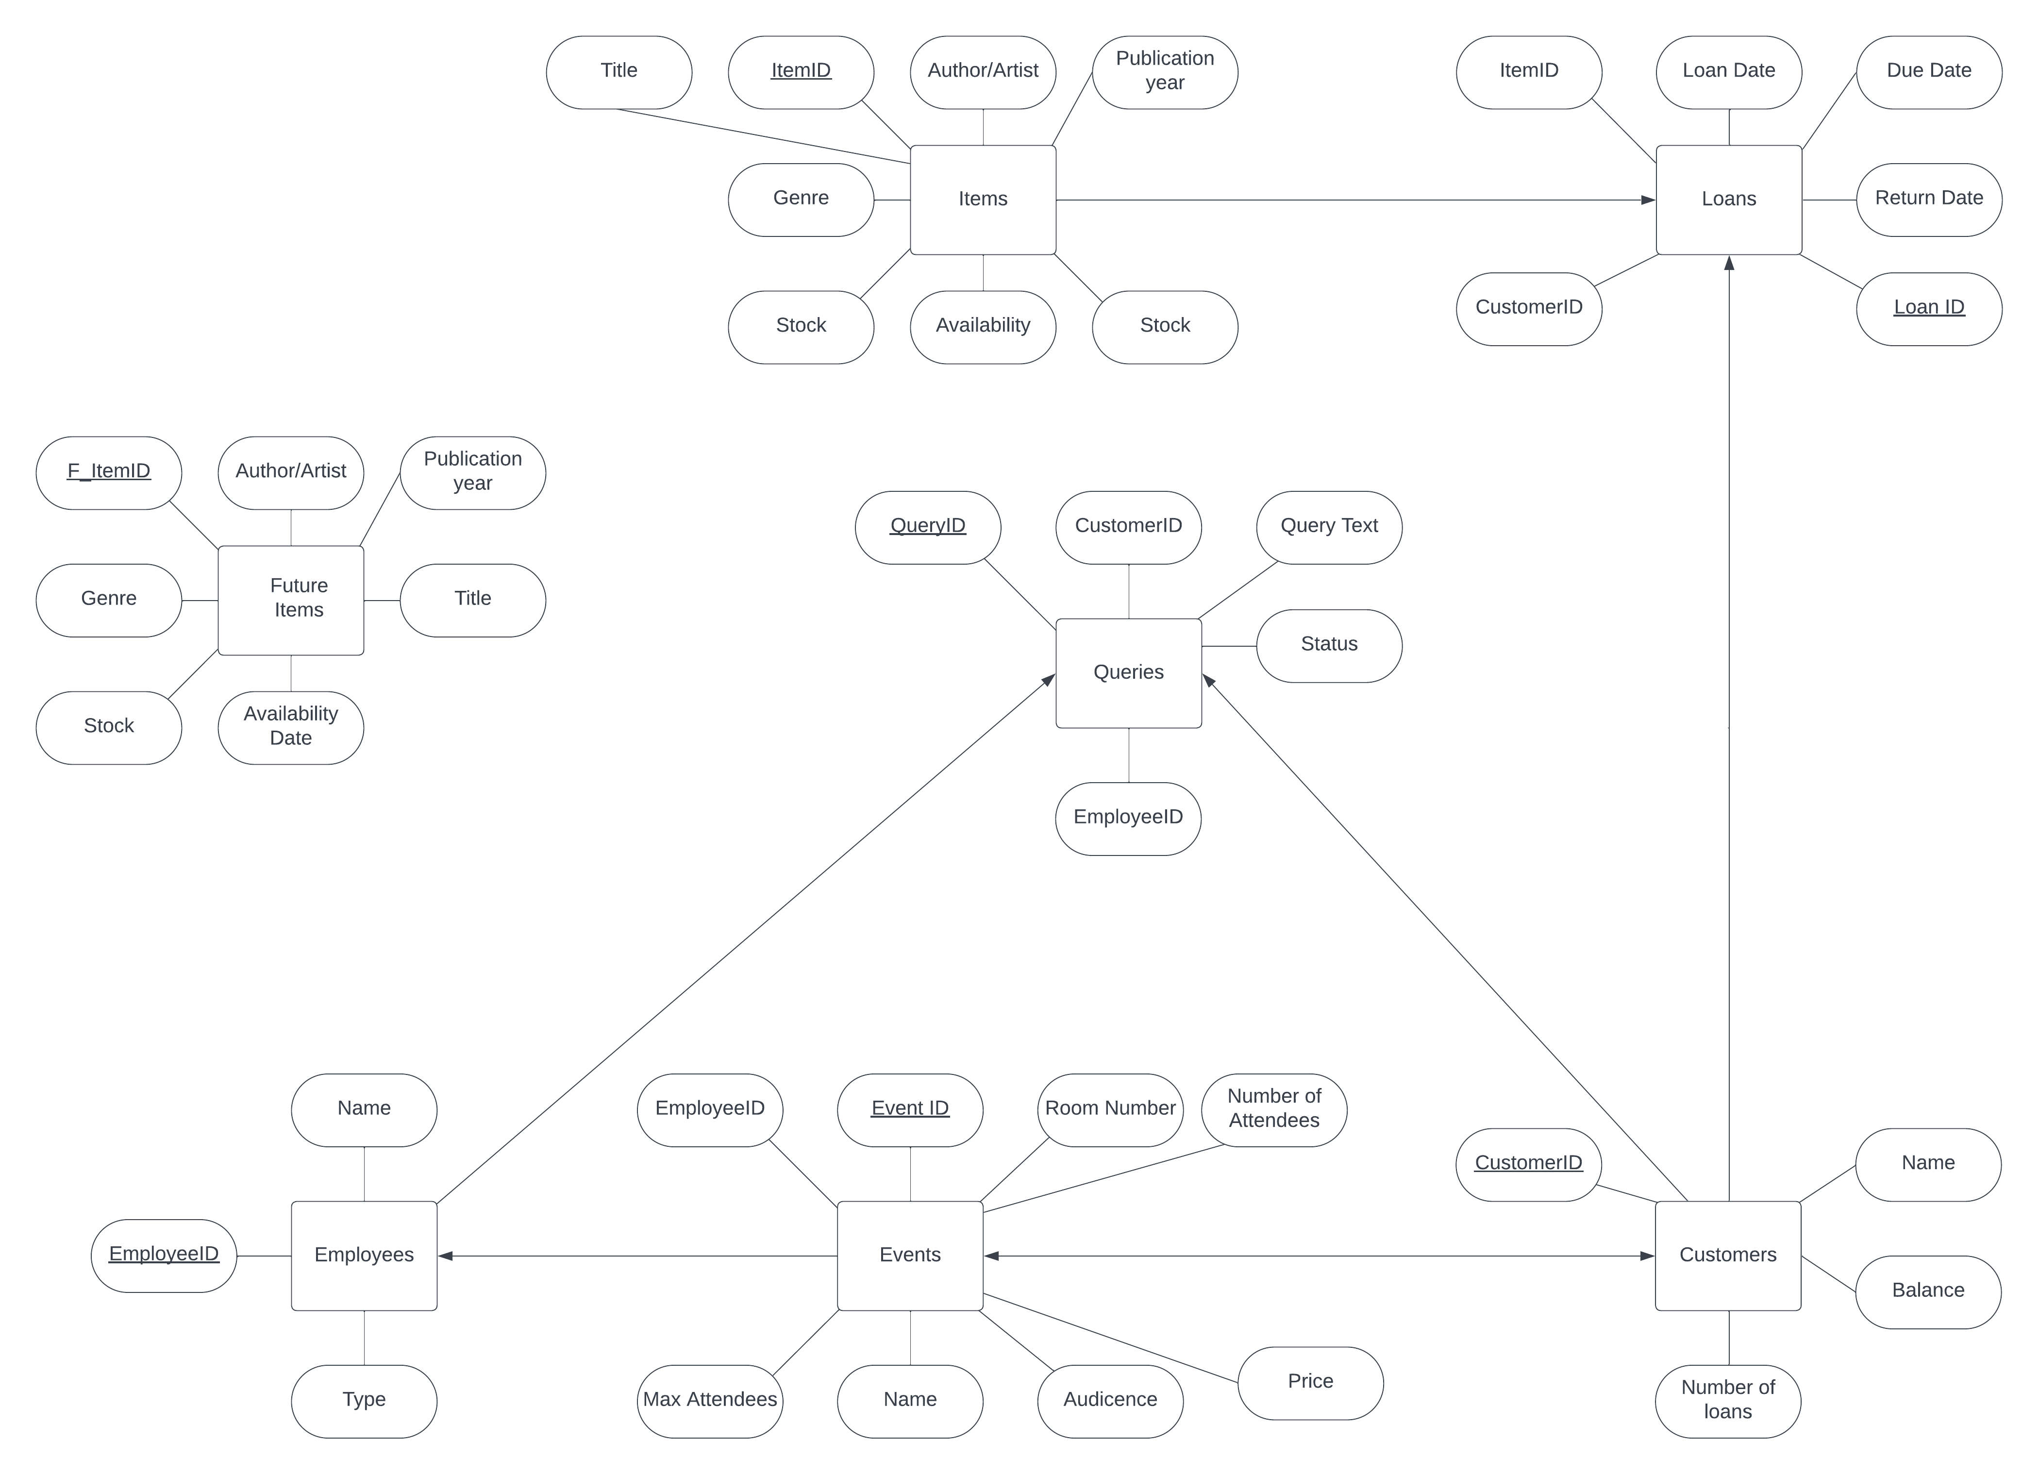

**Anomalies**

**Identifying Functional Dependencies (FDs):**

1. **Items**:
   * **ItemID** → **Type, Title, AuthorArtist, PublicationYear, Genre, Availability, Stock**
     + This suggests that the **ItemID** uniquely determines all other attributes in the table.
2. **Customers**:
   * **CustomerID** → **Name, NumberOfLoans, Balance**
     + The **CustomerID** uniquely determines the name, number of loans, and balance of the customer.
3. **Loans**:
   * **LoanID** → **CustomerID, ItemID, LoanDate, DueDate, ReturnDate**
     + Each loan has a unique **LoanID** that determines the details of the loan.
   * Note: There isn't a direct functional dependency between **CustomerID** and **ItemID** because a customer can borrow many items and an item can be borrowed by many customers over time.
4. **Employees**:
   * **EmployeeID** → **Name, Type**
     + The **EmployeeID** uniquely determines the name and type of the employee.
5. **Events**:
   * **EventID** → **EmployeeID, RoomNumber, Name, Audience, Price, Number_of_Attendees, MAX_Attendees**
     + The **EventID** determines all details of an event.
6. **FutureItems**:
   * **F_ItemID** → **Type, Title, AuthorArtist, PublicationYear, Genre, AvailabilityDate, Stock**
     + Similar to Items, the **F_ItemID** uniquely identifies upcoming items.
7. **Queries**:
   * **QueryID** → **CustomerID, QueryText, EmployeeID, Status**
     + Each query can be uniquely identified using the **QueryID**.

**Checking BCNF:**

For a table to be in BCNF:

1. It must be in 3NF.
2. For every non-trivial functional dependency *X*→*Y*, *X* should be a superkey.

By examining the FDs for each table, we see that the left side of every FD (like **ItemID**, **CustomerID**, **LoanID**, etc.) is indeed a superkey for their respective tables. Therefore, the design appears to be in BCNF.

**Proving No Bad FDs:**

To prove that there are no bad functional dependencies, we should ensure:

1. No partial dependencies: No attribute is functionally dependent on a part of a primary key. Given that all our tables with composite keys (like **Loans**) don't have attributes depending solely on a part of the key, we can confirm there are no partial dependencies.
2. No transitive dependencies: Non-key attributes shouldn't determine other non-key attributes. By examining the tables, we don't see such dependencies, which means there are no transitive dependencies.