Requirements Engineering

Book Sales System

Submitted By: Danil Kramnov (T-00257323)
Computing with Software Development

Date Submitted: 24/04/2026

Contents
1. Introduction/overview 4
2. Functional Components 5
3. User Requirements 6
3.1. BookSalesSYS will manage Customers 6
3.2. BookSalesSYS will manage Catalogue 6
3.3. BookSalesSYS will manage Orders 6
3.4. BookSalesSYS will perform administrative statistics 6
4. System Requirements 7
4.1. Book Sales System Level Use Case Diagram 7
4.2. Customers 8
4.2.1. Open Account 8
4.2.2. Update Account Details 10
4.2.3. Close Account 12
4.3. Catalogue 14
4.3.1. Add Book 14
4.3.2. Update Book Details 16
4.3.3. Discontinue Book 18
4.4. Orders 20
4.4.1. Place Order 20
4.4.2. Return Book 26
4.5. Admin 29
4.5.1. Produce Yearly Revenue Analysis 29
4.5.2. Produce Yearly Genre Analysis 31
5. System Model 33
5.1. Level-0 DFD 33
5.2. Level-1 DFD 34
5.3. Level-2 DFD (Process P1: Manage Customers) 35
5.4. Level-2 DFD (Process P2: Manage Catalogue) 36
5.5. Level-2 DFD (Process P3: Manage Orders) 37
5.6. Level-2 DFD (Process P4: Perform Admin) 38
6. Data Model (UML Class Diagram) 39
6.1. Class Diagram 39
6.2. Relational Schema 40
6.3. Database Schema 40
7. Conclusion 43

Introduction/overview
The primary goal of this project is to analyse the Book Sales System and to develop detailed specification document for its software implementation. This report will include descriptions of Functional Components, User Requirements, System Requirements, System Models, and Data Models for the Book Sales System. The system is intended to be used by two main stakeholder groups: customers and managers.

Functional Components

User Requirements

BookSalesSYS will manage Customers
    - BookSalesSYS will open account
    - BookSalesSYS will update account details
    - BookSalesSYS will close account

BookSalesSYS will manage Catalogue
    - BookSalesSYS will add a book
    - BookSalesSYS will update a book details
    - BookSalesSYS will discontinue a book

BookSalesSYS will manage Orders
    - BookSalesSYS will place a order
    - BookSalesSYS will return a book

BookSalesSYS will perform administrative statistics
    - BookSalesSYS will produce a yearly revenue analysis
    - BookSalesSYS will produce yearly genre analysis

System Requirements
There are four top-level modules in my system: Customers, Catalogue, Orders and Admin.

Book Sales System Level Use Case Diagram
The following system level use case diagram illustrates the high-level system requirements.
Manage Customers
Process Catalogue
Customer
Process Orders
Perform Admin
Manager

Customers
In the Customer module three functions will be delivered: Open Account, Update Account Details and Close Account.

Open Account
This function allows customer to create an account in the Book Sales system. Each Customer is identified by an unique AccountID.
Open Account
Customer

Use Case Name | Create Account
Use Case Id | 01
Priority | High
Source | Customer
Primary Business Actor | -
Other Participating Actors | -
Description | Creates an account for the customer in the system
Preconditions | -
Trigger | -
Expected Scenario | Customer | System
 | Step 1: The customer opens system  Step 3: Enter details:  - Forename  - Surname  - DOB  - Email  - Password  - Phone  - Street  - Town  - County  - Eircode | Step 2: Display UI  Step 4: Validate details entered:  - All fields must be entered  - Forename. Max length 30.  - Surname. Max length 30.  - DOB. Customer must be over 18.  - Email. Max length 30 and must be unique.  - Password. Max length 30. Must include at least 1 lowercase, 1 uppercase letter and 1 special character.  - Phone. Max length 10 and must include only digits and started with “0”.  - Street. Max length 50.  - Town. Max length 20.  - County. Max length 20.  - Eircode. Max length 7. Must be alphanumeric.  Step 5: Assign next AccountID  Step 6: Set account Status to ‘Active’ (‘A’)  Step 7: Save details in Accounts file:  - AccountID  - Forename  - Surname  - DOB  - Email  - Password  - Phone  - Street  - Town  - County  - Eircode  - Status  Step 8: Display information message “Account Created”
Alternate Scenarios | Customer | System
Invalid details are entered | Step 6: Re-enter invalid details | Step 5: Display UI with error message “Invalid Data detected”  Step 7: Return to step 4
Conclusions | Account has been created in the system
Post conditions | Customer navigated to Place Order form and can place orders.
Business Rules | Customer must be over 18
Implementation Constraints | -

Update Account Details
This function allows a customer to update account details in the system.
Update Account Details
Customer
<<includes>>
Login

Use Case Name | Update Account Details
Use Case Id | 02
Priority | Medium
Source | Customer
Primary Business Actor | -
Other Participating Actors | -
Description | Updates customer account details in the system
Preconditions | Account has been created in the system
Trigger | Customer wants to update account details
Expected Scenario | Customer | System
 | Step 1: The customer starts the Update Account Details function  Step 3: Change details:  - Forename  - Surname  - DOB  - Email  - Password  - Phone  - Street  - Town  - County  - Eircode | Step 2: Require email and password in order to Retrieve and load to UI account details from Accounts file for this email and password record  Step 4: Validated details:  - Forename  - Surname  - DOB  - Email  - Password  - Phone  - Street  - Town  - County  - Eircode  Step 5: Update details in Accounts file  Step 6: Display information message “Details Updated”  Step 7: Reset UI
Alternate Scenarios | Customer | System
Invalid updated details are entered | Step 7: Re-enter invalid details | Step 5: Display UI with error message “Invalid Data detected”  Step 6: Display a form to re-enter invalid details  Step 8: Return to step 4
Conclusions | Account has been updated in the system
Post conditions | -
Business Rules | Customer must be over 18
Implementation Constraints | -

Close Account
This function allows a customer to close their account. It is accessible via a button inside the Update Account Details form. It is a "soft" delete: the Account record remains in the system but Status is changed from Active (A) to Closed (C), preventing future logins possibility for a customer of interacting with the system.
Close Account
Customer
<<includes>>
Login

Use Case Name | Close Account
Use Case Id | 03
Priority | Low
Source | Customer
Primary Business Actor | -
Other Participating Actors | -
Description | Deletes customer account
Preconditions | Account has been created in the system
Trigger | Customer wants to deletes his account
Expected Scenario | Customer | System
 | Step 1: Customer enters the system  Step 3: Press the “Close Account” button  Step 5: Confirms the choice | Step 2: Display UI  Step 4: Display confirmation message “Want to close your account?”  Step 6: Set AccountStatus to ‘Closed’ (‘C’)  Step 7: Save Account Status to the Accounts file  Step 8: Display information message “Account Closed”
Alternate Scenarios | Customer | System
Customer doesn’t confirm to close an account | Step 3: Declines the choice | Step 4: Return to step 2
Conclusions | Account has been closed in the system
Post conditions | Customer can no longer interact with the system
Business Rules | -
Implementation Constraints | -

Catalogue
In the Catalogue module three functions will be delivered: Add Book, Update Book Details and Discontinue Book.

Add Book
This function allows an Admin to add a book to the system. Admin credentials (login: admin, password: admin) are required. Each Book is identified by a unique Title.This function allows a manager to add a book to the system. Each Book is identified by unique Title.

Use Case Name | Add Book
Use Case Id | 04
Priority | High
Source | Manager
Primary Business Actor | Manager
Other Participating Actors | -
Description | Adds a book to the system
Preconditions | -
Trigger | New books been ordered to expand stock amount
Expected Scenario | Manager | System
 | Step 1: The manager starts Add Book function  Step 4: Enter book details:  - BookTitle  - Author  - Genre  - Price  - StockAmount | Step 2: Retrieve genres from Genres file and load on UI.  Step 3: Display a form to enter a book details  Step 5: Validate book details:  - All fields must be entered.  - BookTitle. Max length is 50 and must be unique  - Author. Max length is 50.  - Price is a positive digit.  - Stock Amount is positive integer.  Step 6: Set BookStatus to ‘Available’ (‘A’)  Step 7: Save book details to a Books file:  - BookTitle  - Author  - Genre  - Price  - StockAmount  - BookStatus  Step 9: Display confirmation massage “Book Added”
Alternate Scenarios | Manager | System
Invalid details are entered | Step 8: Re-enter invalid details | Step 6: Display UI with error message “Invalid Data detected”  Step 7: Display a form to re-enter invalid details  Step 9: Return to step 5
Conclusions | Book been added to the system
Post conditions | Customer can find and order this book within the system
Business Rules | -
Implementation Constraints | -

Update Book Details
This function allows an Admin to update book details in the system. Admin credentials are required. A search bar is provided to find a specific book before editing. This function allows manager to update book details in the system.
Use Case Name | Update Book Details
Use Case Id | 05
Priority | Medium
Source | Manager
Primary Business Actor | Manager
Other Participating Actors | -
Description | Updates book details in the system
Preconditions | At least one book record must exist in the Books file
Trigger | Manager wants to update book details for the specific book
Expected Scenario | Manager | System
Searched book title found | Step 1: The manager starts Update Book Details function  Step 3: Enter a title (or part of) to search for  Step 5: Manager chooses the book to be updated  Step 8: Change the required details:  - BookTitle  - Author  - Genre  - Price  - StockAmount | Step 2: Display search bar  Step 4: Retrieve and display a summary of active books matching the search title from Books file and load on UI  Step 6: Retrieve and display all data for this book from Books file  Step 7: Retrieve genres from Genres file and load on UI  Step 9: Validate all book details:  - BookTitle. Max length is 50 and must be unique  - Author. Max length is 50.  - Price is a positive digit.  - StockAmount is positive integer.  Step 10: Save book details  Step 11: Display confirmation massage “Book Details Updated”
Alternate Scenarios | Manager | System
Searched book not found | Step 6: Re-enter a title (or part of) | Step 4: Display UI with info message “Book not found”  Step 5: Display a search bar to re-enter a title (or part of)  Step 7: Return to step 3
Invalid details are entered | Step 12: Re-enter invalid details | Step 10: Display UI with error message “Invalid Data detected”  Step 11: Display a form to re-enter invalid details  Step 13: Return to step 9
Conclusions | Book details been updated in the system
Post conditions | -
Business Rules | -
Implementation Constraints | -

Discontinue Book
This function allows an Admin to discontinue a book. It is accessible via a button inside the Update Book Details form. It is a "soft" delete — the Book record remains in the system but BookStatus is changed from Available (A) to Discontinued (D), preventing it from appearing in customer searches.This function suspends the book from ordering using the system. It’s a “soft” delete, meaning the Title record will still be present in the system, but there will be no possibility for customer to find and order this book in the system.

Use Case Name | Discontinue Book
Use Case Id | 06
Priority | Low
Source | Manager
Primary Business Actor | Manager
Other Participating Actors | -
Description | Deletes book details from the system
Preconditions | At least one book record must exist in the Books file
Trigger | Manager wants to delete book details for the specific book
Expected Scenario | Manager | System
 | Step 1: The manager opens system  Step 3: Enter a title (or part of) to search for  Step 5: Manager chooses the book to be discontinued  Step 6: Press the “Discontinue Book” button  Step 8: Confirms the choice | Step 2: Display search bar  Step 4: Retrieve and display the list of active books matching a title (or part of) from Books file  Step 7: Display confirmation message “Want to Discontinue this Book?”  Step 9: Set BookStatus to ‘Discontinued (‘D’)  Step 10: Save BookStatus to the Books file  Step 11: Display information massage “Book Discontinued”
Alternate Scenarios | Manager | System
Searched book not found | Step 6: Re-enter a title (or part of) | Step 4: Display UI with info message “Book not found”  Step 5: Display a search bar to re-enter a title (or part of)  Step 7: Return to step 3
Customer doesn’t confirm to discontinue a book | Step 8: Declines the choice | Step 9: return to step 4
Conclusions | Book been discontinued in the system
Post conditions | Customer can’t find and order this book in the system
Business Rules | -
Implementation Constraints | -

Orders
In Orders module two functions will be delivered: Place Order, Return Book.

Place Order
This function allows a Customer to place an order. Customer credentials (email and password) are required. Books can be searched and added to a cart. Each order is identified by a unique OrderID generated by a sequence.This function allows Customer to places an order in the system. Each order is identified by Order ID.

Customer | System

Starts Place Order Function

Display a search bar

Enter a title (or part of)

Retrieve and display Active books matching the title (or part of)

Found?
[Yes]
[No]

Choose the book

Display UI with data for chosen book

Add book to the cart
Display message “How many of this book you want to oreder?”

Enters QuantityOrdered
Validate QuantityOrdered
Error message

Valid?
[No]

[Yes]
Assign OrderID
Add BookTitle to the shop cart

[Checkout]
[Continue Shopping]
[Continue Shopping]
[Checkout]
or

Display UI with Order details and “Buy” button

Press “Buy” button

Save payment details
Save details to the Orders file
Save details to the OrderedBooks file

Display confirmation message

Use Case Name | Place Order
Use Case Id | 07
Priority | High
Source | Customer
Primary Business Actor | -
Other Participating Actors | -
Description | This function allows a customer to order a book(s)
Preconditions | -
Trigger | -
Expected Scenario | Customer | System
 | Step 1: The customer starts the Place Order function  Step 3: Enter a title (or part of) to search for  Step 5: Choose the book to be ordered  Step 8: Press the “Add Book to the Cart” button  Step 10: Enter QuantityOrdered  Step 14: Press “Checkout” button  Step 16: Press “Buy” button | Step 2: Display a search bar  Step 4: Retrieve and display the list of active books matching the title (or part of) from Books file  Step 6: Display in UI data for this book from Books file:  - BookTitle  - Author  - Genre  - Price  Step 7: Display button “Add Book to the Cart”  Step 9: Displays confirmation message “How many of this book you want to order?”  Step 11: Validate QuantityOrdered. Must be positive number and less than or equal to StockAmount from Books file.  Step 12: Assign next available OrderID , Add BookTitle to the shop cart.  Step 13: Display “Checkout” button.  Step 15: Display UI with order details and “Buy” button  Step 17: Save details to Orders file:  - OrderID  - AccountID  - TotalPrice  - DateOrdered  Step 18: For each item in the cart:  - save details to the OrderedBooks file:  - OrderID  - BookTitle  - QuantityOrdered  - Price  - Reduce StockAmount in Books file by QuantityOrdered  Step 19: Display confirmation message “Thanks for Order”
Alternate Scenarios | Customer | System
Searched book not found | Step 5: Re-enter title (or part of) | Step 3: Display UI with info message “Book not found”  Step 4: Display a search bar to re-enter title (or part of)  Step 6: Return to step 4
Customer continues shopping | Step 14: Returns to step 3
Insufficient Stock Amount | Step 14: Re-enter QuantityOrdered | Step 12: Display UI with info message “Insufficient Stock Amount”  Step 13: Display UI asking “How many of this books you want to order”  Step 15: Return to step 11
Conclusions | Order information saved into Orders file and books ordered saved into OrderedBooks file
Post conditions | Ordered books can be returned by customer
Business Rules | -
Implementation Constraints | -

Return Book
This function allows a Customer to return a previously ordered book within 14 days of the order date. Customer credentials are required. Multiple books can be added to a return cart and processed as one refund.ordered, but no later than 14 days.
Return Book
Customer
<<includes>>
Login
Use Case Name | Return Book
Use Case Id | 08
Priority | Medium
Source | Customer
Primary Business Actor | -
Other Participating Actors | -
Description | This function allows Customer to return ordered book(s)
Preconditions | Customer must order at least one book
Trigger | Customer wants to return ordered book(s)
Expected Scenario | Customer | System
 | Step 1: The customer starts Return Book function  Step 3: Enter a title (or part of) to search for  Step 6: Choose the book to be returned  Step 8: Enter amount to be returned | Step 2: Display search bar  Step 4: Retrieve all details for books where the DateOrdered is less than or equal to 14 days ago for this account matching title (or part of) from the Orders file and display it  Step 5: Retrieve and load in UI data for this book from OrderedBooks file:  - Book Title  - QuantityOrdered  - Book Price  Step 7: Display UI asking “How many of these books you want to return”  Step 9: Validate QuantityReturned:  - must be positive integer  - must be less than or equal to QuantityOrdered from OrderedBooks file.  Step 10: Add details to ReturnedBooks file:  - OrderID  - BookTitle  - QuantityReturned  - RefundAmount  Step 11: For this Order ID:  - Increment StockAmount in Books file by QuantityReturned.  - substract RefundAmount from OrderPrice in OrderedBooks file  - subtract QuantityOrdered in OrderedBooks file by QuantityReturned  - subtract RefundAmount from TotalPrice in Orders file  Step 12: Display confirmation message “Book Returned”
Alternate Scenarios | Customer | System
One book been ordered |  | Step 7: Proceed to Step 10
Searched book not found | Step 6: Re-enter title (or part of) | Step 4: Display UI with info message “Book not found”  Step 5: Display a search bar to re-enter title (or part of)  Step 7: Return to step 3
Insufficient Quantity Ordered | Step 12: Re-enter QuantityReturned | Step 10: Display UI with info message “Insufficient Quantity Ordered”  Step 11: Prompt user to re-enter QuantityReturned  Step 13: Return to step 9
Conclusions | Information about Returned Book saved into ReturnedBooks file
Post conditions | Book(s) returned to the stock
Business Rules | Customer is allowed to return a book within 14 days of the order date
Implementation Constraints | -

Display Analysis
This module allows you to display charts in which will be shown how revenue is distributed across the year divided by months. And how many books was ordered for chosen year divided by genre.

Produce Yearly Revenue Analysis
This function produces a total revenue for each month for the chosen year.
Produce Yearly Revenue Analysis
Manager
Use Case Name | Produce Yearly Revenue Analysis
Use Case Id | 09
Priority | Medium
Source | Manager
Primary Business Actor | Manager
Other Participating Actors | -
Description | The purpose of the function to evaluate financial state of the book shop during the year for any given month
Preconditions | -
Trigger | Manager wants to evaluate a total revenue for the specific year
Expected Scenario | Manager | System
Valid details are entered | Step 1: The manager opens system  Step 3: Selects a year | Step 2: Display UI  Step 4: Sum and display TotaPrice of the orders grouped by month where DateOrdered is matching year selected from Orders file
Alternate Scenarios | Manager | System
Conclusions | Revenue chart has been displayed for the chosen year
Post conditions | -
Business Rules | -
Implementation Constraints | -

Yearly Revenue Analysis Sample Report:

Month | Total Revenue, €
January | 50000
February | 48000
March | 63000
April | 55000
May | 62000
June | 61000
July | 60000
August | 57000
September | 68000
October | 59000
November | 65000
December | 70000

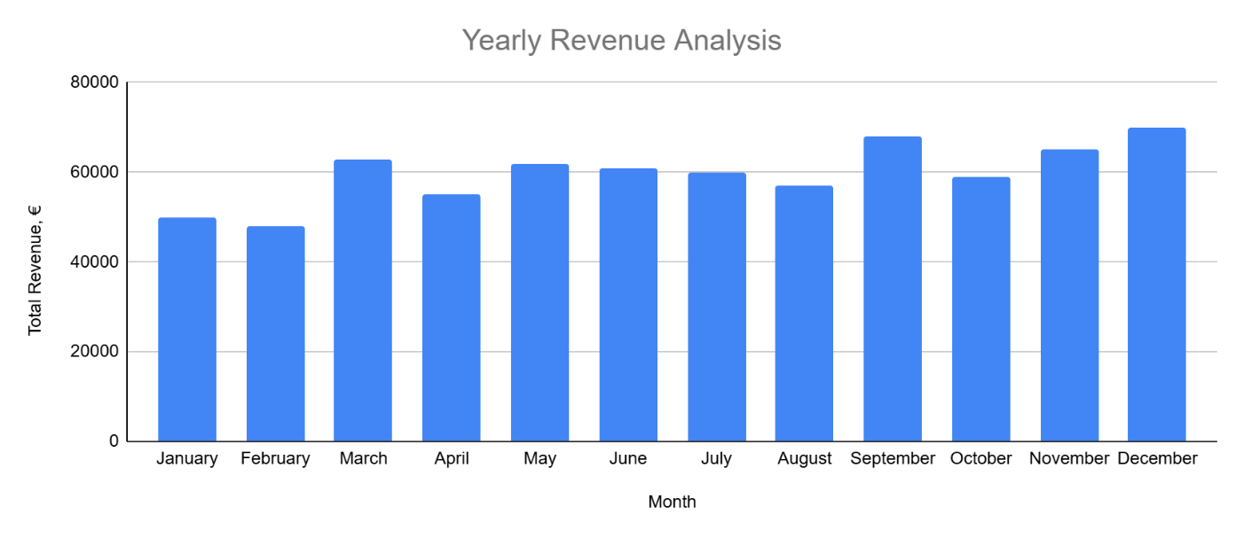

Produce Yearly Genre Analysis
This function produces quantity of book ordered for every book genre for the chosen year.
Produce Yearly Genre Analysis
Manager

Use Case Name | Produce Yearly Genre Analysis
Use Case Id | 09
Priority | Medium
Source | Manager
Primary Business Actor | Manager
Other Participating Actors | -
Description | The purpose of the function is to evaluate how many books were ordered during a specific year for the given genres
Preconditions | -
Trigger | Manager wants to evaluate how many books were ordered during a specific year for the given genres
Expected Scenario | Manager | System
Valid details are entered | Step 1: The manager opens system  Step 3: Selects a year | Step 2: Retrieve genres from Genres file and load on UI.  Step 4: Retrieve data for all orders with DateOrdered matching year selected from Orders file  Step 5: Retrieve BookTitle and QuantityOrdered of all ordered books matching OrderID from OrderedBooks file  Step 6: Sum QuantityOrdered for each Genre
Alternate Scenarios | Manager | System
Conclusions | Revenue chart has been displayed for the chosen year
Post conditions | -
Business Rules | -
Implementation Constraints | -

Genre Analysis Sample Report:
Genre | Quantity
Detective | 97
Sci-fi | 51
History | 65
Fantasy | 33
Romance | 60
Poems | 28
Biography | 69
Non-fiction | 62

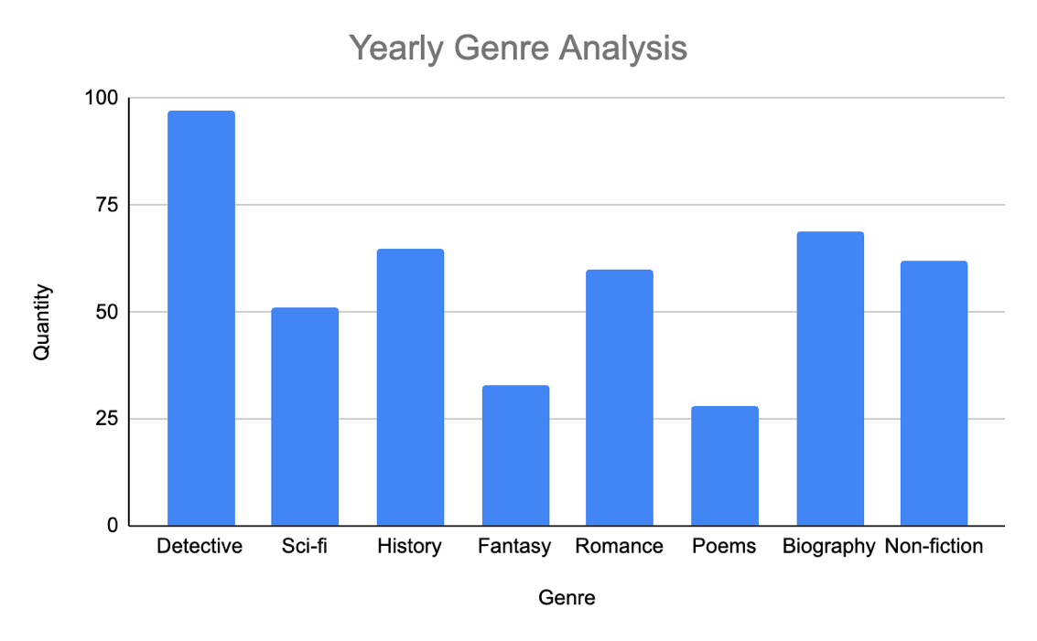

System Model
The following dataflow diagrams have been produced for the system:

Level-0 DFD
BookSalesSys
Customer
Order Details
Books

Level-1 DFD

Manage Customers
P1
D1
Accounts file
Account Details
Manage Catalogue
P2
Book Details
D2
Books file
Account Details Details
Book Details
D4
OrderedBooks file
Manage Orders
P3
Order Details
Book Details

Genres Details
D6
Genres file
Genre Details
Genres Details

Perform Admin
P4
Order Details
D3
Orders file

Book Details
Book Details
Order Details

Account Details
Book Details
Book Details
D5
ReturnedBooks file
Customer
Book Details
Book Details

Level-2 DFD (Process P1: Manage Customers)
Updated Account Details
Account Details
Open Account
P1.1
D1
Accounts file
Account Details
Update Account Details
P1.2
Close Account
P1.3

Account Details

Account Status
Customer
Account Details

Level-2 DFD (Process P2: Manage Catalogue)

Updated Book Details
Book Details
Add Book
P2.1
D2
Books file
Book Details
Update Book
P2.2
Discontinue Book
P2.3
Book Details
Book Status

D6
Genres file
Genres Details
Genres Details

Level-2 DFD (Process P3: Manage Orders)

Total Price
Order Details
Place Order
P3.1
D3
Orders file

Return Book
P3.2
D1
Accounts file
Accounts Details

Book Details
D2
Books file

Book Details
D4
OrderedBooks file
D5
ReturnedBooks file
Return Details
Book Details
Order Details
Order Details
Order Details
Book Quantity
Customer
Book Details
Return Details

Level-2 DFD (Process P4: Perform Admin)
Produce Yearly Revenue Analysis
P5.1

Produce Yearly Genre Analysis
P5.2
D3
Orders file

D6
Genres file
Orders Details
Genre Details
Orders Details
D4
OrderedBooks file
Book Details

Data Model (UML Class Diagram)
This section shows the structure, relationships and constraints of data stored in Book Sales system.

Class Diagram
Account
- AccountID*: int
- Forename: string
- Surname: string
- DOB: date
- Email: string
- Password: string
- Phone: string
- Street: string
- Town: string
- County: string
- Eircode: string
- AccountStatus: char
Order
- OrderID*: int
- TotalPrice: decimal
- DateOrdered: date

Ordered Book
QtyOrdered: int
OrderPrice: decimal
can contain

0..*
1
can have
1
1..*

Book
BookTitle*: string
Author: string
GenreCode: char
Price: decimal
StockAmount: int
BookStatus: char
Returned Book
QtyReturned: int
RefundAmount: decimal
contain
1..*
1

1
0..*
can contain

contain
1
1..*
Genre
GenreCode*: char
Description: string

associated with
1
0..*

Relational Schema

Accounts(AccountID, Forename, Surname, DOB, Email, Password, Phone, Street, Town, County, Eircode, Status)
Genres(GenreCode, Description)
Books(BookTitle, Author, GenreCode, Price, StockAmount, BookStatus)
Orders(OrderID, AccountID, TotalPrice, DateOrdered)
OrderedBooks(OrderID, BookTitle, QtyOrdered, OrderPrice)
ReturnedBooks(ReturnID, OrderID, BookTitle, QtyReturned, RefundAmount, ReturnedDate)

Database Schema

Relation: Accounts
Attributes:
AccountID Int NOT NULL UNIQUE
Forename Varchar(30) NOT NULL
Surname Varchar(30) NOT NULL
DOB Date NOT NULL
Email Varchar(30) NOT NULL UNIQUE
Password Varchar(30) NOT NULL
Phone Varchar(10) NOT NULL
Street Varchar(50) NOT NULL
Town Varchar(20) NOT NULL
County Varchar(20) NOT NULL
Eircode Varchar(7) NOT NULL
Status Char(1) NOT NULL
Primary Key: AccountID

Relation: Genres
Attributes:
GenreCode Char(2) NOT NULL UNIQUE
Description Varchar(20) NOT NULL
Primary Key: GenreCode

Relation: Books
Attributes:
BookTitle Varchar(50) NOT NULL UNIQUE
Author Varchar(50) NOT NULL
GenreCode Char(2) NOT NULL
Price Decimal(10, 2) NOT NULL CHECK (Price > 0)
StockAmount Int NOT NULL CHECK (StockAmount >= 0)
BookStatus Char(1) NOT NULL
Primary Key: BookTitle
Foreign Key: GenreCode References Genres

Relation: Orders
Attributes:
OrderID Int NOT NULL
AccountID Int NOT NULL
TotalPrice Decimal(10, 2) NOT NULL CHECK (TotalPrice >= 0)
DateOrdered Date NOT NULL
Primary Key: OrderID
Foreign Key: AccountID References Accounts

Relation: OrderedBooks
Attributes:
OrderID Int NOT NULL
BookTitle Varchar(50) NOT NULL
QtyOrdered Int NOT NULL CHECK (QtyOrdered > 0)
OrderPrice Decimal(10, 2) NOT NULL CHECK (OrderPrice >= 0)
Primary Key: OrderID, BookTitle
Foreign Key: OrderID References Orders
Foreign Key: BookTitle References Books

Relation: ReturnedBooks
Attributes:
ReturnID Int NOT NULL
OrderID Int NOT NULL
BookTitle Varchar(50) NOT NULL
QtyReturned Int NOT NULL CHECK (QtyReturned > 0)
RefundAmount Decimal(10, 2) NOT NULL CHECK (RefundAmount >= 0)
ReturnedDate Date NOT NULL
Primary Key: ReturnID OrderID, BookTitle
Foreign Key: OrderID References Orders
Foreign Key: BookTitle References Books

Conclusion
The primary objective of this project was to design and analyse a Book Sales System. In this report, I have explored various essential components for the system's development, including Functional Components, User Requirements, System Requirements, System Model, and Data Model. In conclusion, this report provides a framework for the development of the Book Sales System.

