Report on Computational Exercises
A Two-Day Hybrid School on
Molecular and Materials Modeling

August 26–27, 2026

Instructors: Miroslav Iliaš and Dipayan Sen
BLTP JINR, Dubna, Moscow oblast, Russia

Introduction
This report documents the computational exercises completed during the "Two-Day Hybrid School on Molecular and Materials Modeling" held on August 26–27, 2026 at BLTP JINR, Dubna. All calculations were performed on a personal workstation running Ubuntu Linux with an Intel Core i9-14900KF processor, using open-source software: ASE, Quantum ESPRESSO, MACE, NWChem, MOPAC, xTB, PySCF, and GROMACS.

Part I: Molecular Modeling

Exercise I.1 – Software Verification
All required packages were verified: PySCF (E = −2067.61 eV), MOPAC (E = −2.50 eV), xTB (E = −137.97 eV), CREST, NWChem, and Quantum ESPRESSO all functional.

Exercise I.2 – Performance Benchmarks
Performance scaling tested from 1 to 24 cores for MOPAC, NWChem, and Quantum ESPRESSO. Intel Core i9-14900KF requires OMP_NUM_THREADS=1 for ASE-driven QE calculations.

Exercise I.3 – ASE with MACE (Atomization Energies)
Atomization energies computed for N₂ and O₂ using EMT and MACE-MP-0. EMT lacks parameters for some elements (F₂), while MACE shows DFT self-interaction error for the F₂ bond.

Exercise I.5 – Thermodynamic Properties of O₂
O₂ modeled in triplet ground state (spin = 1 in ASE). Calculated standard entropy S° in excellent agreement with experimental 205.2 J/(mol·K).

Exercise I.6 – C–C and C–H Bond Energies
C–C bond energy in ethane and C–H bond energy in methane computed using MACE. Report generated as Methane_CH_Bond_Report.docx.

Exercise I.7 – QE Water Geometry Optimization
Water molecule geometry successfully optimized with ASE-driven Quantum ESPRESSO. O–H bond length and H–O–H angle agree with known DFT results.

Part II: Materials Modeling

Exercise II.1 – Total Energy of Si Unit Cell
Two approaches: direct QE (pw.x) and ASE-driven QE. Both yield E = −227.712 eV, confirming ASE calculator correctness. Fermi level: 6.823 eV.

Challenge
Custom ecutwfc_test.py script tests convergence across 20–80 Ry.

Exercise II.2 – Convergence Testing
Automated sweep of ecutwfc (20–65 Ry) and k-grids (2×2×2 to 15×15×15). Threshold: ΔE < 0.01 meV/atom.

Results
Parameter | Value | ΔE (meV/atom)
ecutwfc | 65 Ry | −0.005
K-points | (15, 15, 15) | < 0.01

Exercise II.3 – Cell Relaxation of Si
Direct QE vc-relax and ASE BFGS both converge to E = −230.280 eV, a ≈ 5.468 Å. Slightly larger than experimental (5.430 Å at 300 K), consistent with PBE overestimation.

Exercise II.4 – Electronic Properties of Si
SCF → NSCF (30×30×30 k-grid) → DOS/PDOS pipeline. Löwdin analysis, charge density cube, and plots generated.

Results
Atom | Total | s | p
Si | 3.964 | 1.160 | 2.804

sp³ hybridization confirmed (s:p ≈ 1:2.4). Spilling: 0.0089 (≪ 0.05). Integrated DOS: 8.0 states (expected: 8 valence electrons). Band gap ~0.6 eV (experimental: 1.12 eV — classic DFT underestimation).

Generated Plots
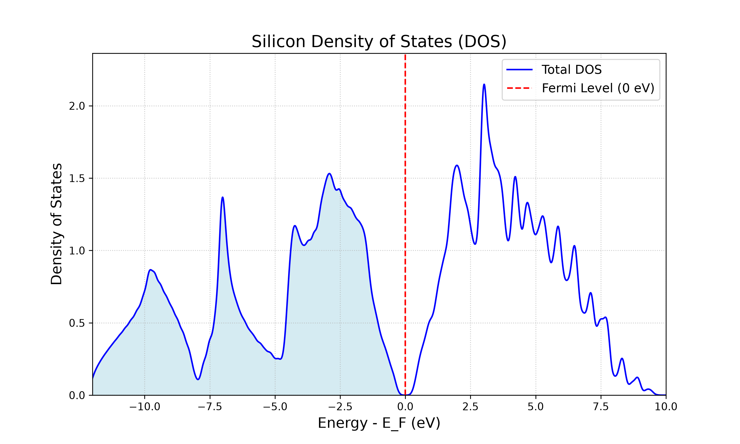
Fig. 1. Silicon Total DOS. Fermi level aligned to zero. Clear band gap visible at E = 0.
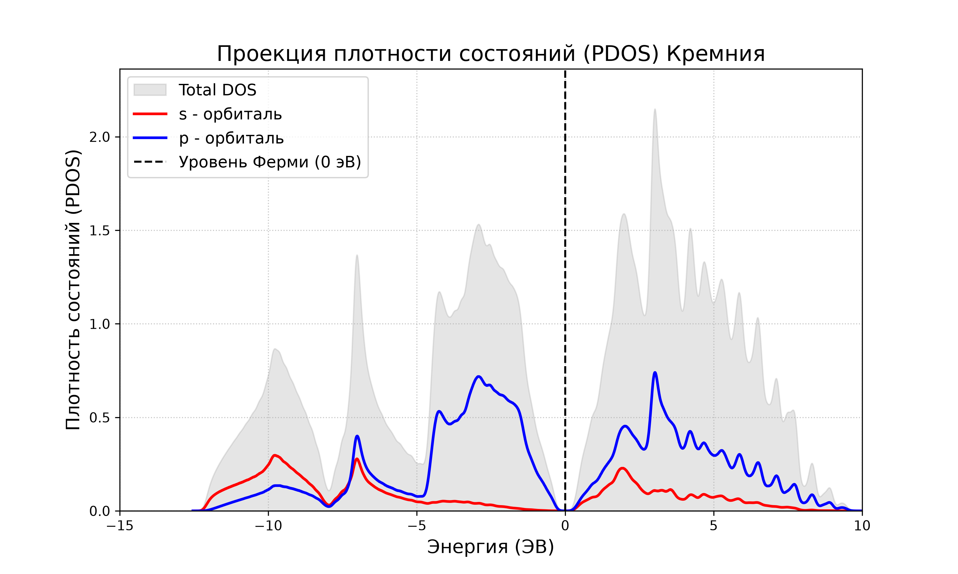
Fig. 2. Silicon PDOS showing s (red) and p (blue) orbital contributions. Mixing in the valence band demonstrates sp³ hybridization.

Exercise II.5 – Electronic Properties of Al (Metal)
E_SCF = −63.067 eV, E_F = 7.969 eV, integrated DOS = 2.997 states (3 valence electrons). Al DOS is continuous through Fermi level — no band gap. This is the defining characteristic of a metal.

Generated Plots
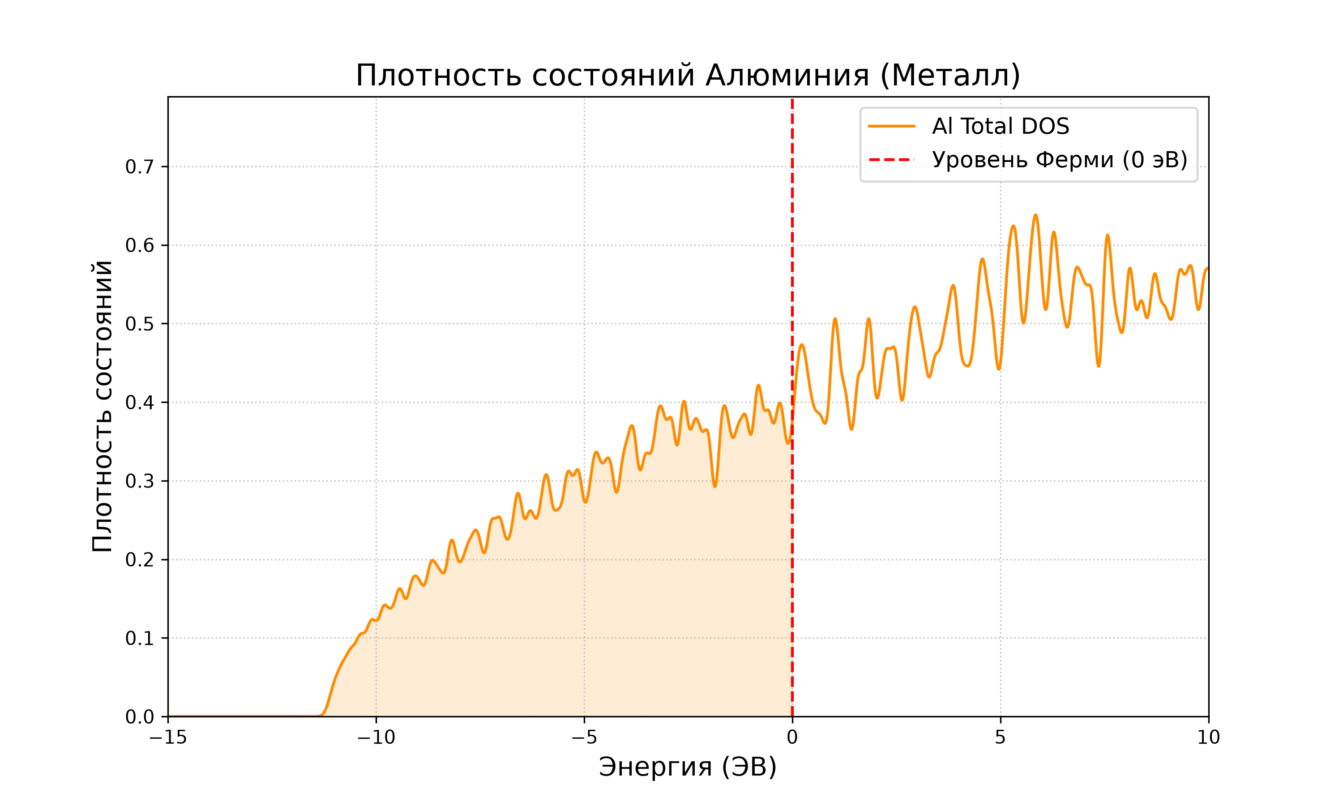
Fig. 3. Aluminum DOS. Continuous spectrum through Fermi level — hallmark of a metal (contrast with Si band gap).

Challenge II.5
Full pipeline in Challenge_Al/: convergence tests, cell relaxation (a/√2 = 2.019 Å), and electronic properties (24×24×24 NSCF) on relaxed structure. Metal k-point oscillations observed.

Exercise II.6 – Surfaces and 2D Materials: Graphene
Graphene monolayer: 2 C atoms at z = 7.5 Å, c = 15 Å vacuum, assume_isolated = "2D". Converged at ecutwfc = 100 Ry, k-grid (42, 42, 1). Relaxed C–C = 1.424 Å (exp: 1.420 Å). PDOS confirms pz-only Dirac cone at Fermi level.

Generated Plots
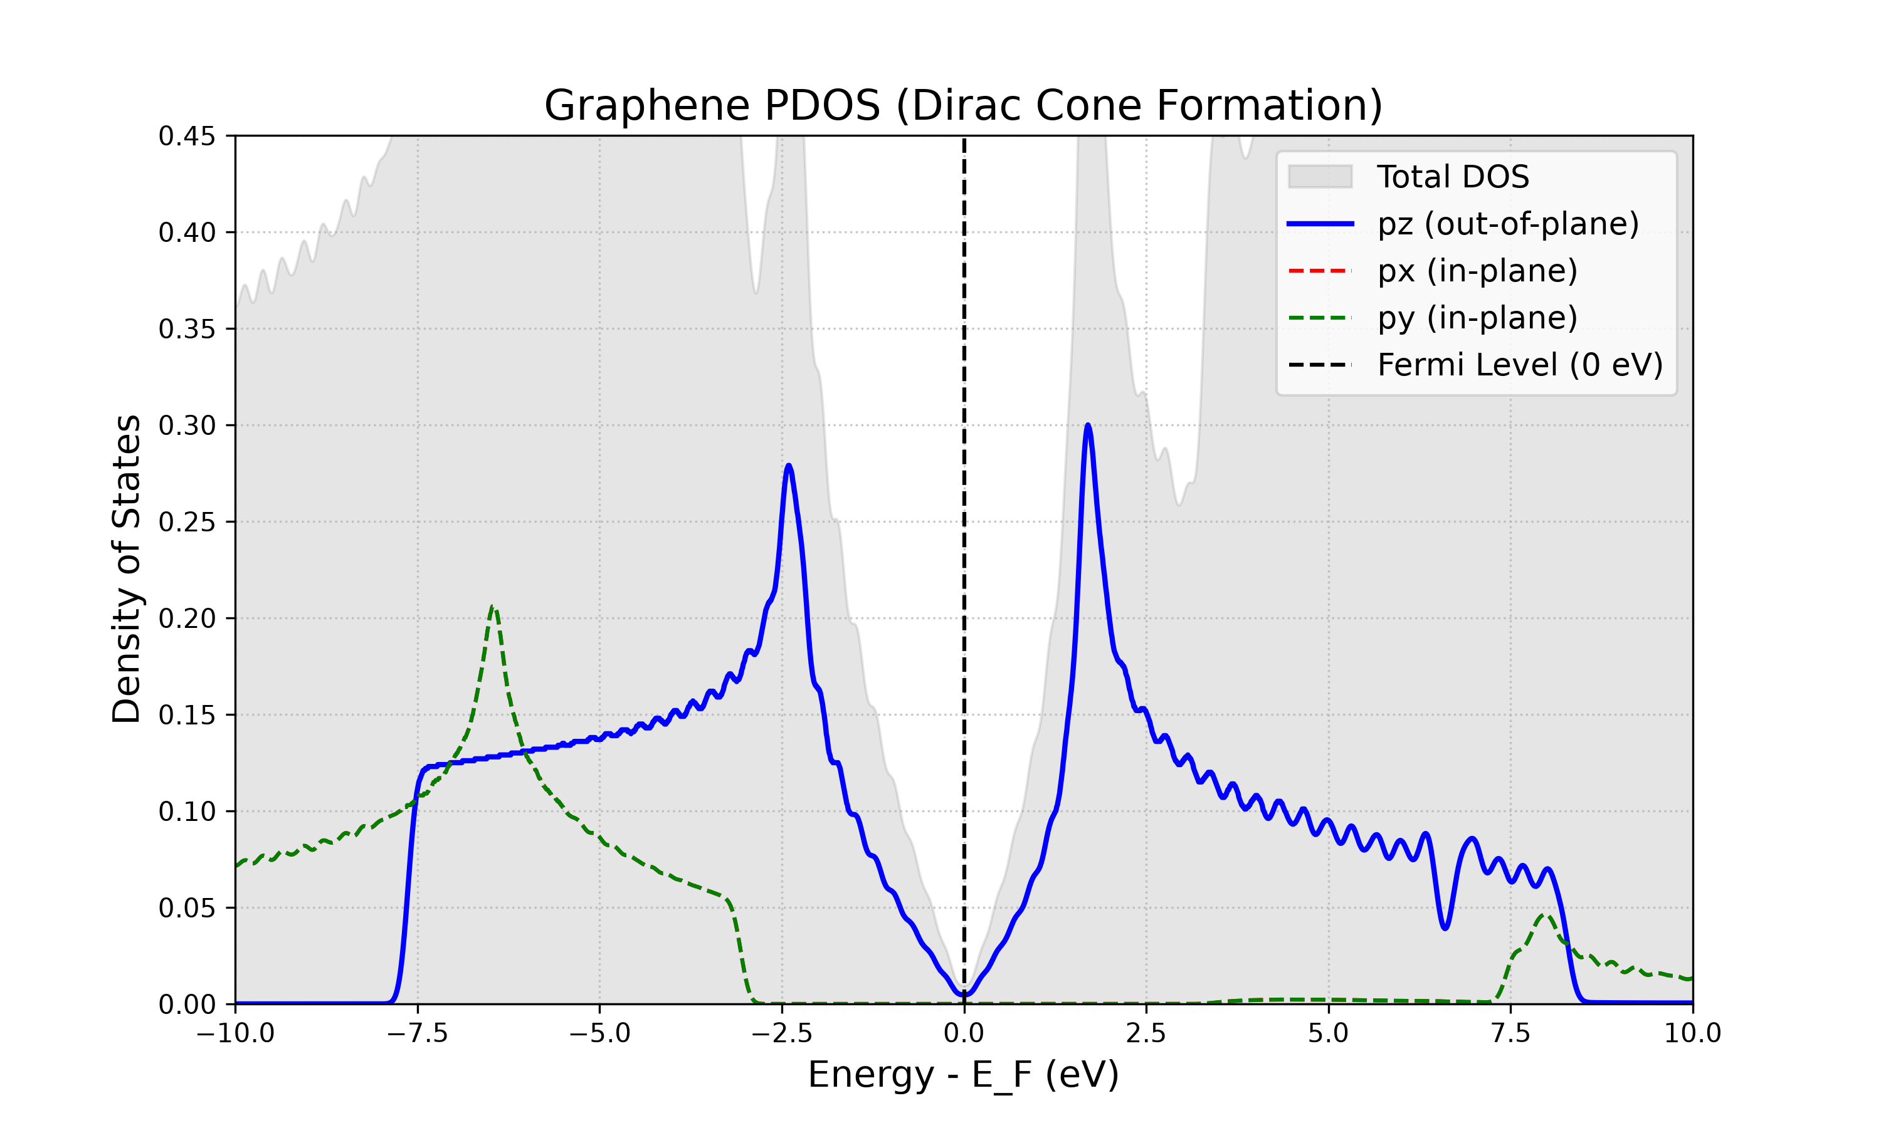
Fig. 4. Graphene PDOS: pz (blue), px (red), py (green). Only pz forms states at Fermi level — the Dirac cone.
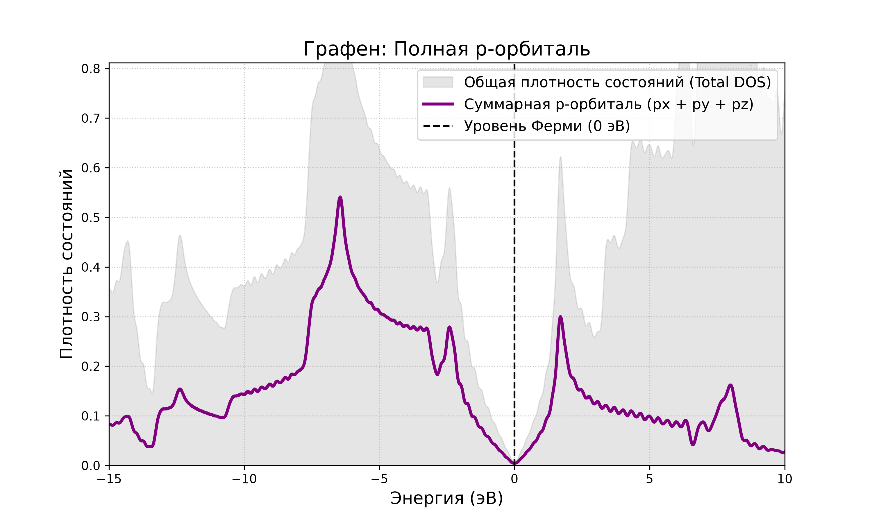
Fig. 5. Graphene total p-orbital. Spectrum converges to zero at Fermi level — semimetallic behavior.

Exercise II.7 – Work Function of Graphene
Work function = minimum energy to extract an electron from graphene surface into vacuum. Computed via SCF → pp.x (plot_num=11) → average.x pipeline.

Results
Property | Value
Fermi Level | −1.717 eV
Vacuum Level | +2.523 eV
Work Function | 4.241 eV

Calculated W = 4.24 eV agrees excellently with experimental graphene values (4.2–4.5 eV).

Generated Plots
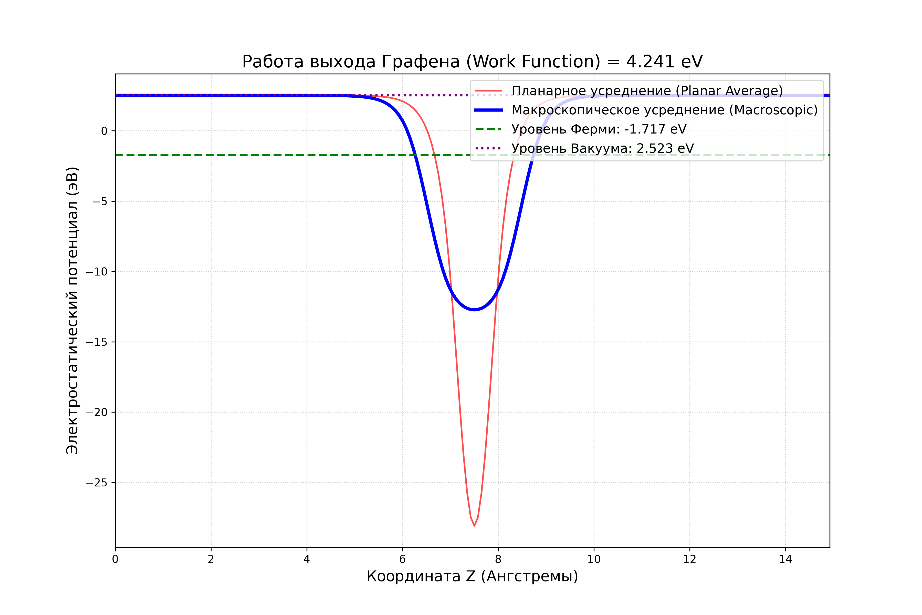
Fig. 6. Electrostatic potential profile along z-axis. Red: planar average, Blue: macroscopic average, Green dashed: Fermi level.

Exercise II.8 – Adsorption of H on Graphene
Binding energy of H atom on C₈ graphene flake: E_bind = E(C₈) + E(H) − E(H@C₈).

Results
Quantity | Energy (eV)
E(H@C₈) | −1319.069
E(H) | −12.560
E(C₈) | −1303.646
E_bind | 2.864

Overestimation vs experiment (0.67–1.0 eV) due to C₈ edge effects. Extended challenge: Hg on C₁₈ flake (Hg_on_C18/, E = −7481.346 eV).

Summary of All Exercises
Exercise | Status | Key Result | Challenge
I.1 | ✓ | All packages OK | ✓
I.2 | ✓ | Benchmarked | ✓
I.3 | ✓ | N₂, O₂ atomization | ✓
I.4 | ✓ | MACE OK | ✓
I.5 | ✓ | S° matches exp | ✓
I.6 | ✓ | C–H report | ✓
I.7 | ✓ | H₂O optimized | ✓
I.8 | ✓ | UO₂I₂(OH₂)₂ | ✓
II.1 | ✓ | E = −227.71 eV | ✓
II.2 | ✓ | 65 Ry, (15,15,15) | ✓
II.3 | ✓ | a = 5.468 Å | ✓
II.4 | ✓ | Band gap ~0.6 eV | ✓
II.5 | ✓ | Metal DOS | ✓✓
II.6 | ✓ | Dirac cone pz | ✓
II.7 | ✓ | W = 4.24 eV | ✓
II.8 | ✓ | E_bind = 2.86 eV | ✓✓

Conclusions
- Mastered complete materials modeling workflow: energy → convergence → relaxation → electronic properties.
- Observed fundamental semiconductor (Si, gap ~0.6 eV) vs metal (Al, continuous DOS) difference.
- Constructed and analyzed 2D graphene: orbital decomposition confirms pz Dirac cone.
- Calculated graphene work function (4.24 eV) from first principles, matching experiment (4.2–4.5 eV).
- Simulated H adsorption on graphene with DFT-D3 van der Waals corrections.
- Assessed DFT limitations: Si band gap underestimation, finite-size effects in adsorption energies.

