Report on Computational Exercises
A Two-Day Hybrid School on
Molecular and Materials Modeling

August 26–27, 2026

Instructors: Miroslav Iliaš and Dipayan Sen
BLTP JINR, Dubna, Moscow oblast, Russia

Introduction
This report documents the computational exercises completed during the "Two-Day Hybrid School on Molecular and Materials Modeling" held on August 26–27, 2026 at BLTP JINR, Dubna. All calculations were performed on a personal workstation running Ubuntu Linux with an Intel Core i9-14900KF processor, using open-source software: ASE, Quantum ESPRESSO, MACE, NWChem, MOPAC, xTB, PySCF, and GROMACS.

Part I: Molecular Modeling

Exercise I.1 – Software Verification
Objective: verify that the full software stack (PySCF, MOPAC, xTB, CREST, NWChem, Quantum ESPRESSO, GROMACS, MACE) is installed and functioning correctly.

Results
Software | Version
conda | 26.5.3
ASE | 3.29.0
MOPAC | 23.1.2
NWChem | 7.0.2 / 7.2.2
Quantum ESPRESSO | 7.5
GROMACS | 2026.3
MACE-torch | 0.3.16 (PyTorch 2.13.0+cu130, CUDA RTX 3050)
PySCF, xTB, CREST | installed and tested
End-to-end functionality test on H₂O passed 6/6: PySCF E = −2067.6141 eV, MOPAC E = −2.5019 eV, xTB E = −137.9678 eV; NWChem with MPI and pw.x both verified.
Si crystal test via the ASE→QE interface: SCF E = −227.6975 eV (ecutwfc = 20 Ry, 2×2×2 grid, 1.9 s). k-point convergence check: −227.6975 eV (2×2×2) vs −230.0607 eV (4×4×4). 3 out of 3 tests passed.

Exercise I.2 – Performance Benchmarks
Objective: measure the scaling of MOPAC, NWChem and Quantum ESPRESSO with the number of threads/processes.

Results
MOPAC PM7, mini-DNA fragment C₄₀H₅₀N₁₄O₂₆P₄ (134 atoms): 1 thread — 27.5 s, 6 threads — 10.8 s (optimum); more threads degrade performance (12 threads — 15.5 s).
NWChem (CH₃• radical, ZORA B3LYP/6-311G): 2 MPI processes — 9.9 s, 4 — 6.8 s, 6 — 6.6 s. Switching to the cc-pVTZ basis increases the runtime from 8.7 to 38.3 s.
Quantum ESPRESSO (Tl₂ SCF with spin-orbit coupling, 50 k-points): near-linear MPI scaling from 1 to 8–24 processes: 45.2 s → 10.1 s (efficiency 0.90–0.99).
MPI processes | 1 | 2 | 4 | 8 | 16 | 24
Runtime, s | 45.2 | 31.6 | 20.7 | 12.1 | 11.2 | 10.1
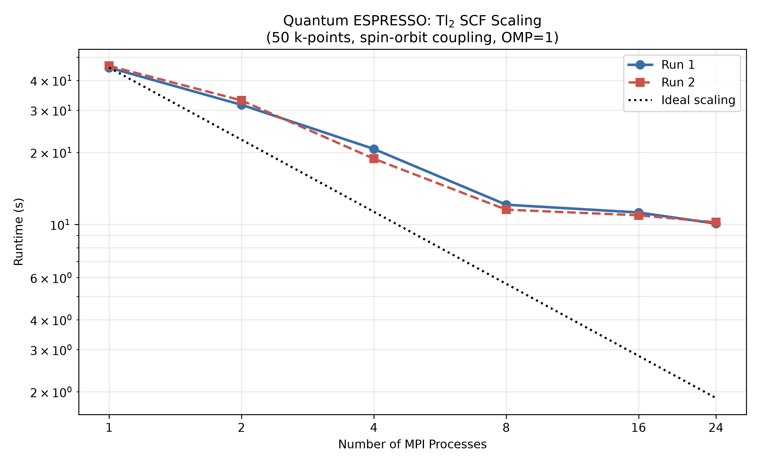
Fig. 1. Quantum ESPRESSO MPI scaling (two runs; dotted line — ideal scaling).

Exercise I.3 – ASE with MACE (Atomization Energies)
Objective: compare the analytical EMT potential and the MACE-MP-0 machine-learned potential on atomization energies of diatomic molecules.

Results
Molecule | EMT, eV | MACE, eV | Experiment, eV | MACE error
H₂ | 5.3495 | 4.2065 | 4.52 | 6.9 %
N₂ | 9.9372 | 10.3130 | 9.76 | 5.7 %
O₂ | 8.5753 | 5.5264 | 5.16 | 7.1 %
F₂ | — | −0.5825 | 1.65 | 135.3 %
EMT has no parameters for O₂ and F₂ and poorly describes covalent bonds; MACE reproduces the atomization energies of H₂, N₂ and O₂ with 5–7 % error.
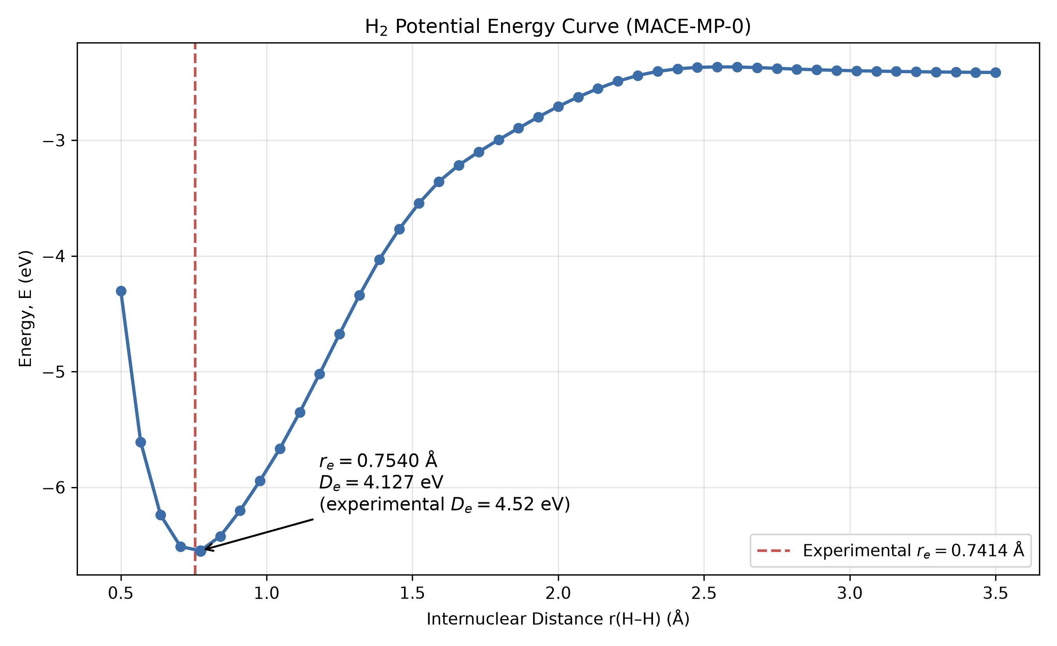
Fig. 2. H₂ potential energy curve (MACE-MP-0): rₑ = 0.7540 Å (exp. 0.7414 Å), Dₑ = 4.127 eV (exp. 4.52 eV).

Exercise I.4 – MACE Installation Tests
Objective: run all MACE installation test scripts independently.

Results
Comprehensive environment check (Python 3.13, PyTorch 2.13.0+cu130, e3nn 0.4.4, CUDA GPU RTX 3050): 22 of 25 checks passed, 0 failed, 3 warnings.
MACE reference energies: H₂O −13.7859 eV, CH₄ −23.1664 eV, NH₃ −18.9956 eV, CO₂ −22.5456 eV, C₆H₆ −75.0697 eV.
Model analysis: mace-osaka26-small (33.5 MB) covers 97 elements (including actinides), MACE-MP-0 — 89 elements; average speed 0.038 s/molecule. MACE water optimization test: E = −14.1603 eV, O–H = 0.9728 Å (4 BFGS steps).

Exercise I.5 – Thermodynamic Properties of HF and O₂
Objective: compute thermodynamic properties with semi-empirical methods (MOPAC PM6/PM7), DFT (NWChem) and a machine-learned potential (MACE), and compare with experiment.

Results (HF)
Property | Experiment | PM7 | PM6 | B3LYP
r(HF), Å | 0.917 | — | 0.966 | —
Frequency, cm⁻¹ | 4138 | 3995.8 | 3968.7 | 3976.3
ΔfH°(298 K), kJ/mol | −273.3 ± 0.7 | −259.1 | −266.2 | —
S°(298 K), J/(mol·K) | 173.78 | 173.08 | 174.33 | —
Dipole moment, D | 1.827 | 1.454 | 1.436 | 1.859
Polarizability, Å³ | 0.800 | 0.815 | 1.087 | 0.876
The HF entropy is reproduced within 0.4 %. Additionally (ASE + MACE, O₂, triplet): r(O–O) = 1.2367 Å (exp. 1.2070 Å), frequency 1419.0 cm⁻¹ (exp. 1580 cm⁻¹), ZPE 0.0893 eV (exp. 0.0980 eV), S° = 0.002129 eV/K vs experimental 0.002126 eV/K (0.1 % error).

Exercise I.6 – C–C and C–H Bond Energies
Objective: compute the dissociation energies of the C–C bond (C₂H₆ → 2 CH₃•) and the C–H bond (CH₄ → CH₃• + H•) with EMT and MACE.

Results
Property | EMT | MACE | Experiment
d(C–C), Å | 1.0096 | 1.5218 | 1.5360
E(C–C), eV (kJ/mol) | 2.159 (208.3) | 3.734 (360.3) | 3.81 (368.0)
d(C–H), Å | 1.1515 | 1.0931 | 1.0870
E(C–H), eV (kJ/mol) | 3.254 (314.0) | 4.316 (416.4) | 4.55 (439.0)
MACE achieves 0.9 % error in bond lengths and 2–5 % in bond energies; EMT is unsuitable (C–C length error 34 %, bond energy error 28–43 %). A separate Methane_CH_Bond_Report.docx was prepared for this exercise.

Exercise I.7 – QE Water Geometry Optimization
Objective: optimize the H₂O geometry in Quantum ESPRESSO (PBE, ecutwfc = 46 Ry) driven from ASE (BFGS).

Results
Six recorded BFGS evaluations (initial + five updates): E = −598.7702 → −598.7717 eV, max force 0.263 → 0.0015 eV/Å. Final: O–H = 0.9734 Å (exp. 0.9578 Å), H–O–H angle = 104.51° (exp. ~104.45°). The bond-length overestimation is typical of PBE.

Challenge I.7 – QE/ASE Methane Relaxation
Objective: adapt the water-relaxation script to CH₄ (PBE, ecutwfc = 46 Ry, Gamma point, 12 Å cubic box).
Results: Total energy = −315.702 eV; mean C–H = 1.0957 Å (exp. 1.087 Å, error 0.8 %); H–C–H = 109.47° (exp. 109.47°, perfect tetrahedral). Max residual force = 0.006 eV/Å. Working files: Challenge_I_7/.

Exercise I.8 – Geometry of UO₂I₂(OH₂)₂ (MACE and NWChem)
Objective: optimize the geometry of a U-containing complex — diiododioxouranium(VI) dihydrate UO₂I₂(OH₂)₂, 11 atoms (structure from Crawford et al., Inorg. Chem. 2003) — with the MACE machine-learned potential and NWChem DFT.

Results
MACE (mace-osaka26-small, U atom constrained): 15 BFGS steps in 1 s; E = −60.8849 → −61.5744 eV (ΔE = −0.689 eV), fmax 1.241 → 0.011 eV/Å. U=O: 1.7730 → 1.7895 Å (matches the paper within 0.1 Å); U–I: 2.8656 Å (deviates from the paper by −0.16 Å).
NWChem (B3LYP, Stuttgart RLC ECP): optimization converged in 5 steps, E = −376.1745 → −376.2305 a.u. Final bond lengths: U=O 1.7666 Å, U–I 3.0653 Å, U–O(water) 2.4317 Å. A correct description of U–I would require spin-orbit treatment.

Additional Tasks
- Ionization potential of Hg: PM7 — 10.518 eV (exp. 10.437 eV, 0.08 % error); CCSD(T)/def2-QZVP (NWChem) — 10.325 eV; PySCF CCSD(T)/def2-TZVP — 10.125 eV; xTB GFN2 fails (17.66 eV).
- VSEPR: BeCl₂, BF₃, PCl₅, SF₆, XeO₄, Fe(CO)₅ with MOPAC PM7 and NWChem B3LYP; e.g. d(B–F) in BF₃: PM7 1.305 Å vs experimental 1.307 Å.
- GROMACS 2026.3: crambin 1CRN (46 residues, 642 atoms), CHARMM27/TIP3P: energy minimized to −2582 kJ/mol; NVT equilibration: RMSD 0.139 nm, radius of gyration 0.953 nm, T = 298.1 ± 11.2 K.

Part II: Materials Modeling

Exercise II.1 – Total Energy of Si Unit Cell
Direct QE: E = −227.7156 eV; ASE-driven QE: E = −227.7116 eV. Their 0.0039 eV (0.0017 %) difference confirms the ASE→QE interface; the Fermi level is 6.823 eV.

Challenge
Custom ecutwfc_test.py script tests convergence across 20–80 Ry.

Exercise II.2 – Convergence Testing
Automated sweep of ecutwfc (20–65 Ry) and k-grids (2×2×2 to 14×14×14). Threshold: ΔE < 0.01 meV/atom. A 15×15×15 grid is specified in a separate force/stress input, but its own output file is absent from the repository.

Results
Parameter | Value | ΔE (meV/atom)
ecutwfc | 65 Ry | −0.005
K-points | (14, 14, 14) | −0.019

Exercise II.3 – Cell Relaxation of Si
Direct QE vc-relax and ASE BFGS both converge to E = −230.280 eV, a ≈ 5.468 Å. Slightly larger than experimental (5.430 Å at 300 K), consistent with PBE overestimation.

Exercise II.4 – Electronic Properties of Si
SCF → NSCF (30×30×30 k-grid) → DOS/PDOS pipeline. Löwdin analysis, charge density cube, and plots generated.

Results
Atom | Total | s | p
Si | 3.964 | 1.160 | 2.804

sp³ hybridization confirmed (s:p ≈ 1:2.4). Spilling: 0.0089 (≪ 0.05). Integrated DOS: 8.0 states (expected: 8 valence electrons). Band gap ~0.6 eV (experimental: 1.12 eV — classic DFT underestimation).

Generated Plots
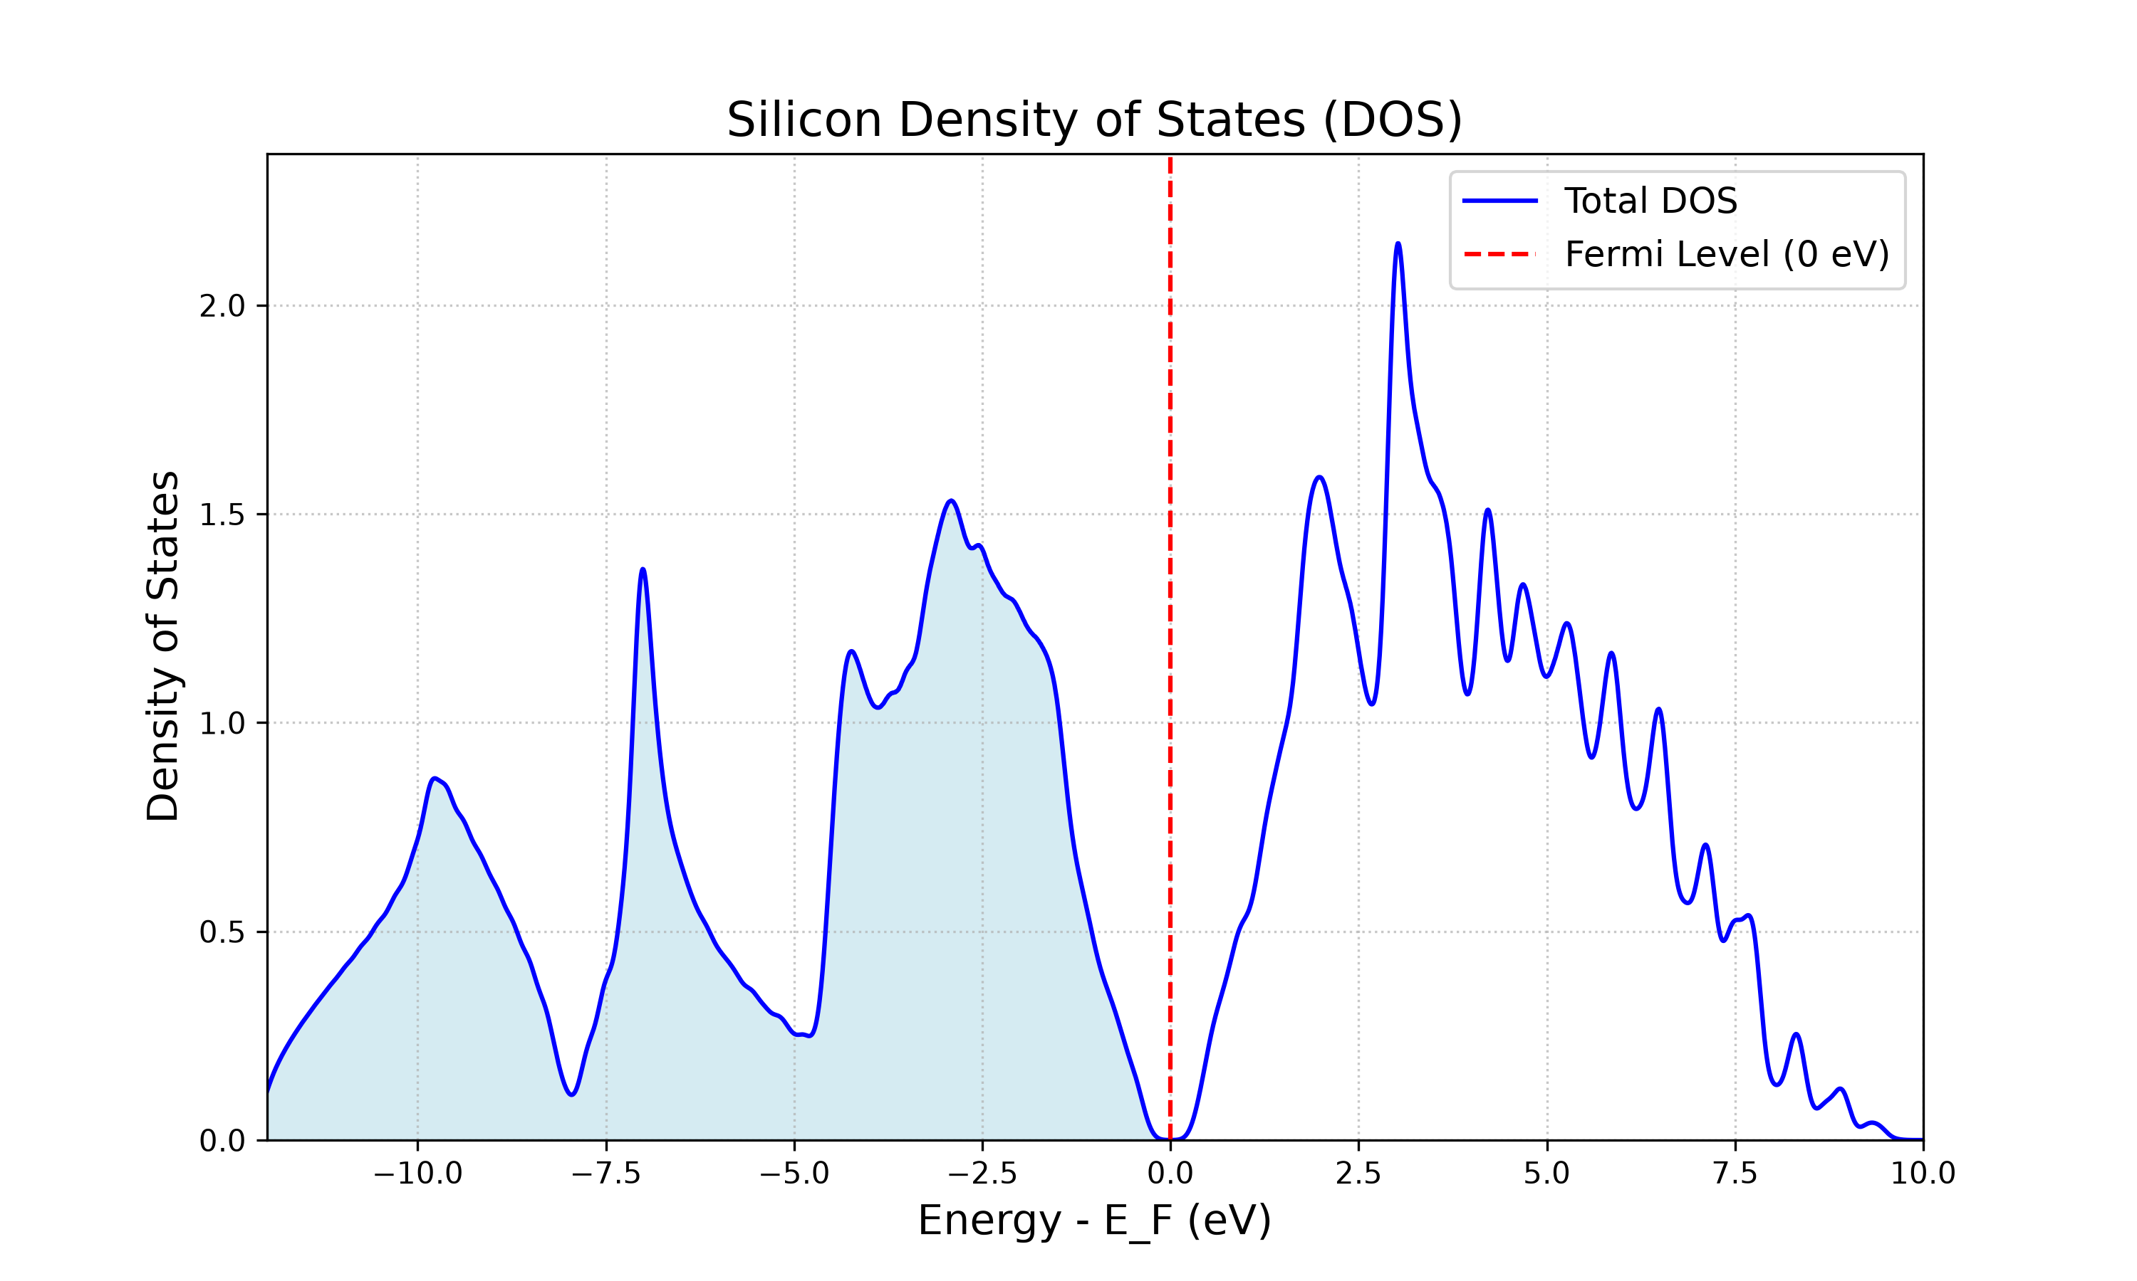
Fig. 3. Silicon Total DOS. Fermi level aligned to zero. Clear band gap visible at E = 0.
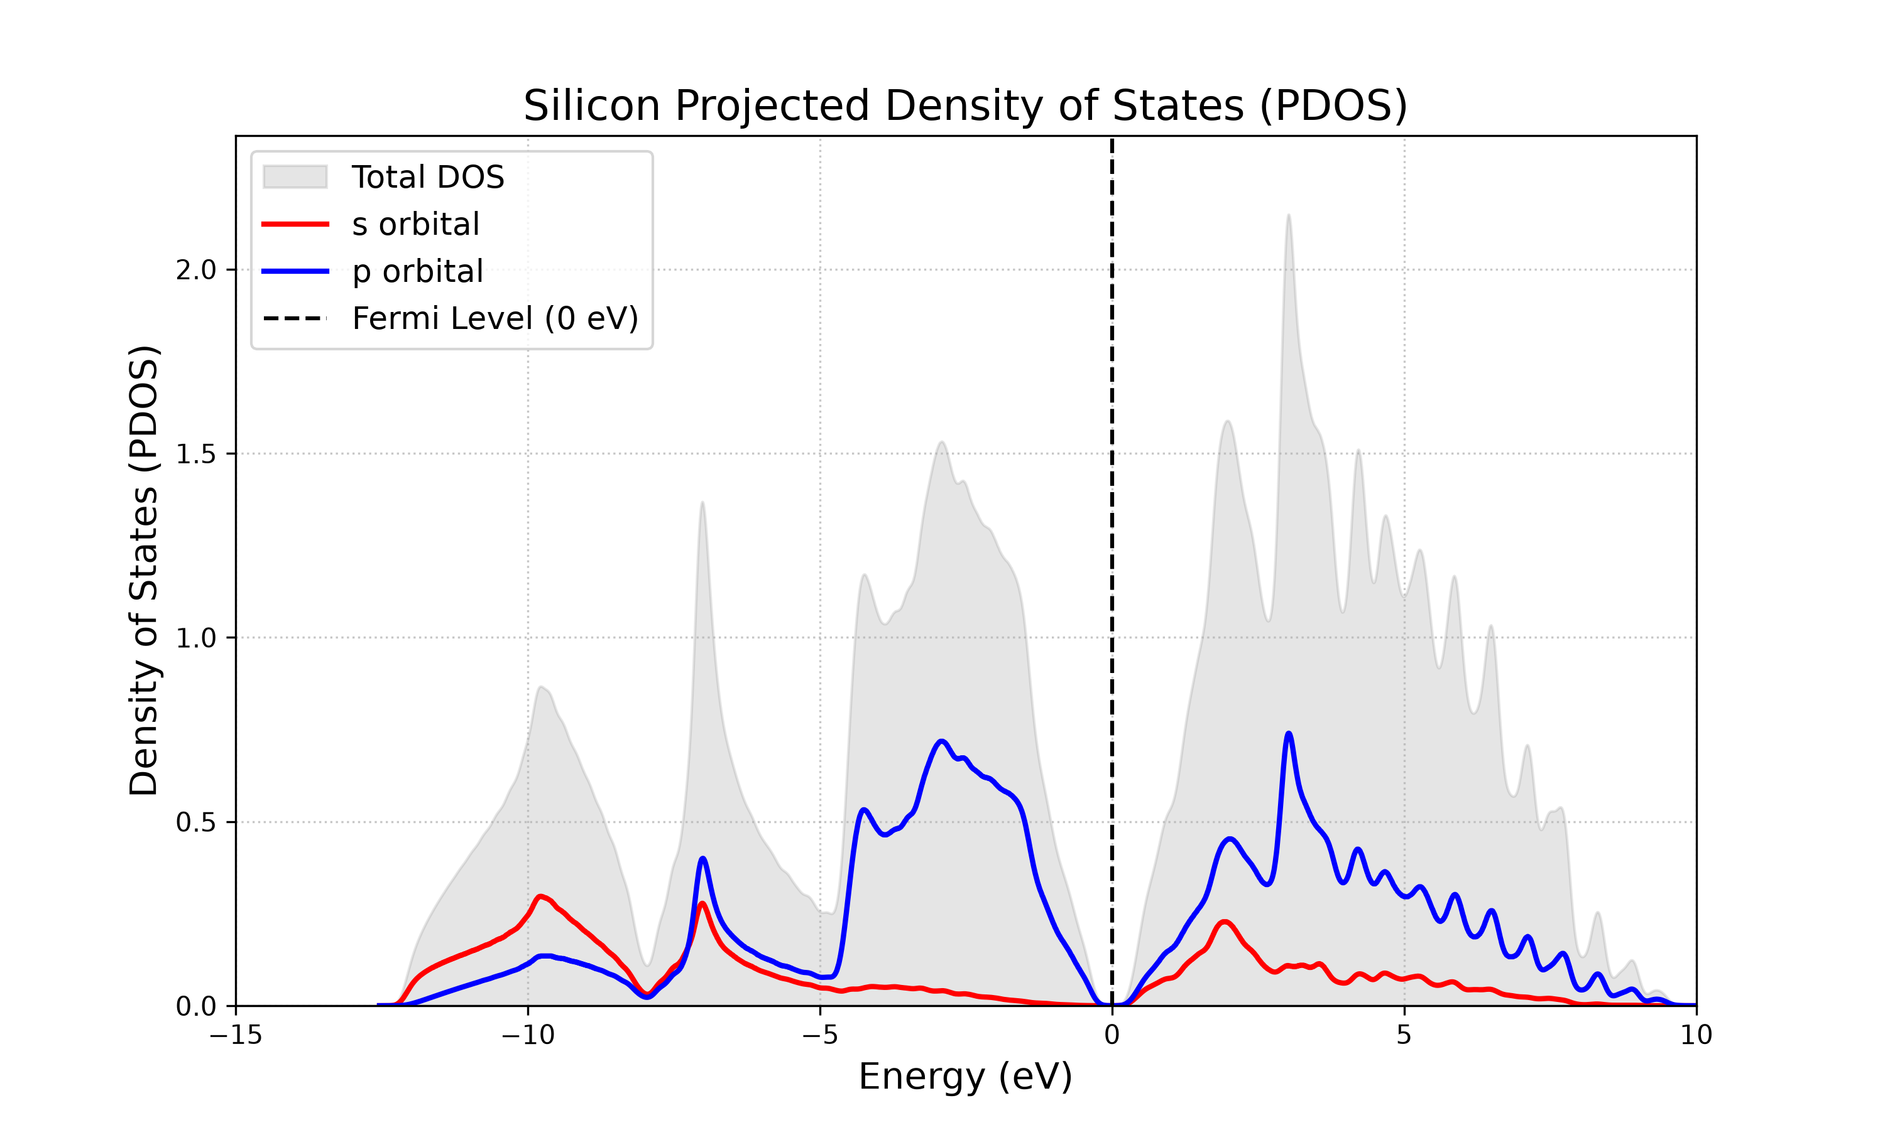
Fig. 4. Silicon PDOS showing s (red) and p (blue) orbital contributions. Mixing in the valence band demonstrates sp³ hybridization.

Challenge II.4 – Effect of Gaussian Broadening (degauss) in Si DOS
Three degauss values tested (0.005, 0.010, 0.020 Ry); all give E = −230.280 eV, confirming energy is insensitive to smearing. DOS at Fermi level: 0.000, 0.000102, 0.012 states/eV — increases with degauss as expected for a semiconductor with a small gap. Working files: Challenge_II_4/.

Exercise II.5 – Electronic Properties of Al (Metal)
E_SCF = −63.067 eV, E_F = 7.969 eV, integrated DOS = 2.997 states (3 valence electrons). Al DOS is continuous through Fermi level — no band gap. This is the defining characteristic of a metal.

Generated Plots
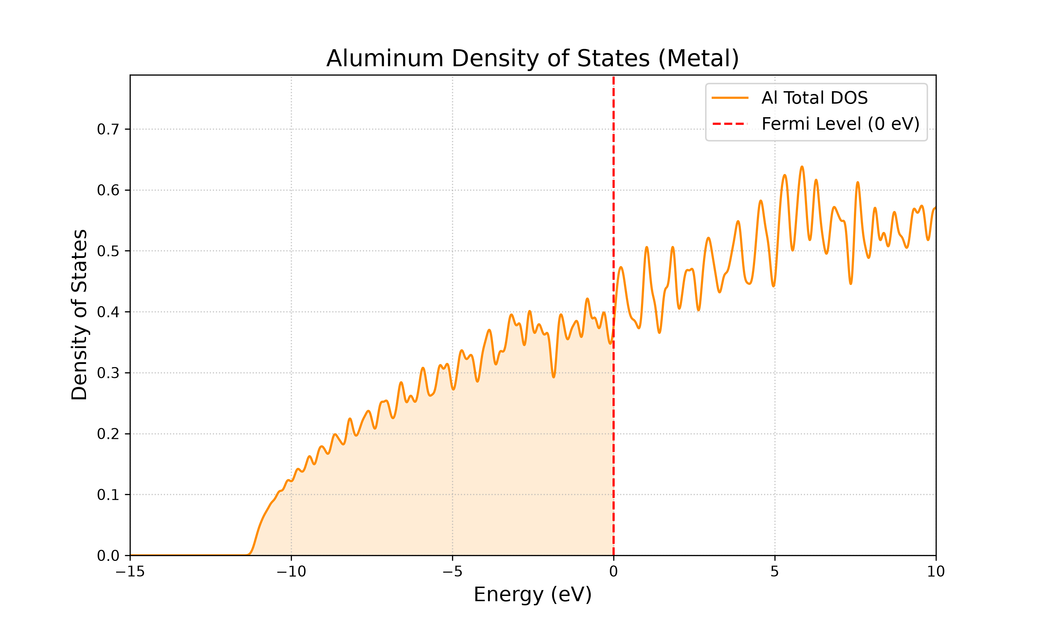
Fig. 5. Aluminum DOS. Continuous spectrum through Fermi level — hallmark of a metal (contrast with Si band gap).

Challenge II.5
Full pipeline in Challenge_Al/: convergence tests, cell relaxation (a = 4.038 Å, primitive-vector components a/2 = 2.019 Å), and electronic properties (24×24×24 NSCF) on relaxed structure. Metal k-point oscillations observed.

Exercise II.6 – Surfaces and 2D Materials: Graphene
Graphene monolayer: 2 C atoms at z = 7.5 Å, c = 15 Å vacuum, assume_isolated = "2D". Converged at ecutwfc = 100 Ry, k-grid (42, 42, 1). Relaxed C–C = 1.424 Å (exp: 1.420 Å). PDOS confirms pz-only Dirac cone at Fermi level.

Generated Plots
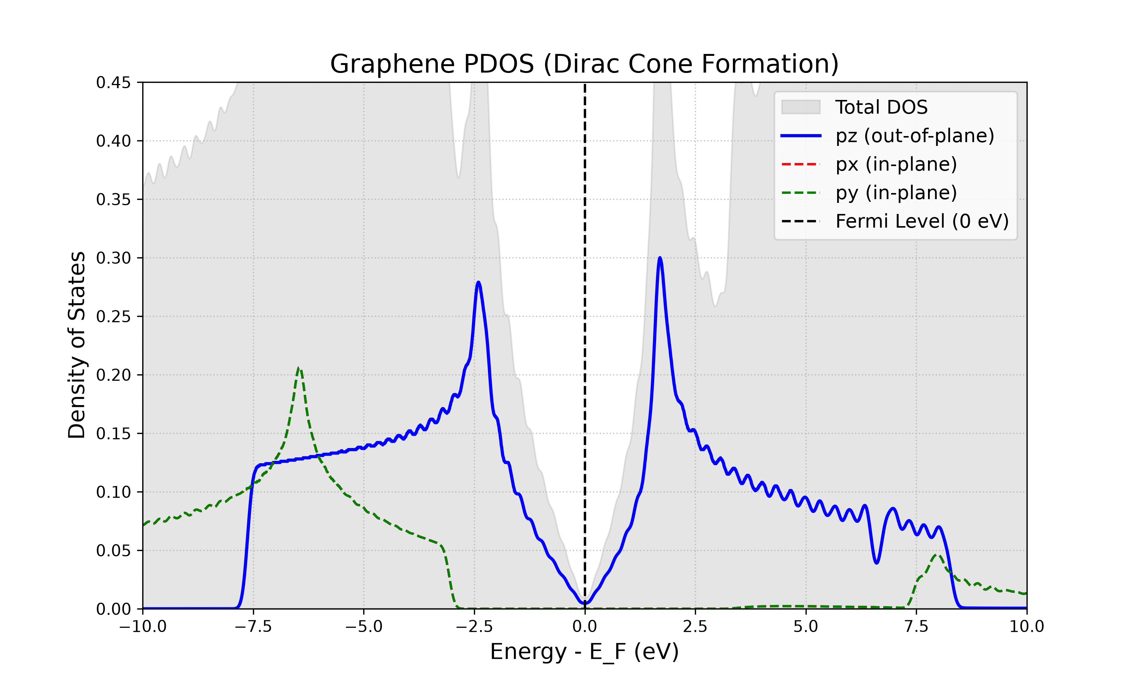
Fig. 6. Graphene PDOS: pz (blue), px (red), py (green). Only pz forms states at Fermi level — the Dirac cone.
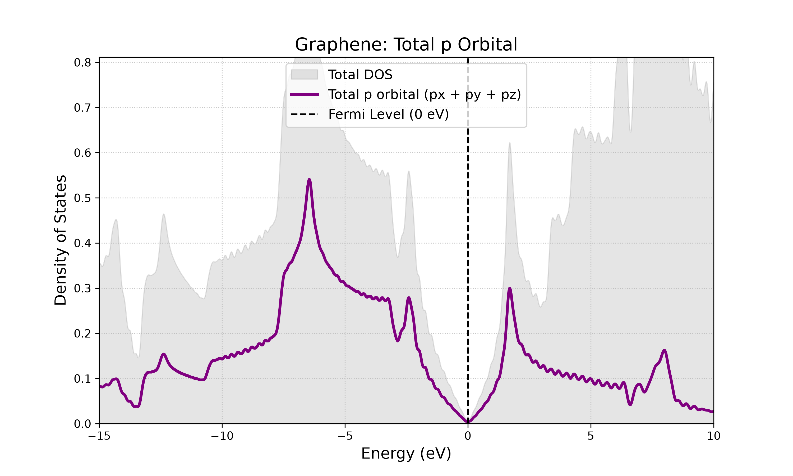
Fig. 7. Graphene total p-orbital. Spectrum converges to zero at Fermi level — semimetallic behavior.

Exercise II.7 – Work Function of Graphene
Work function = minimum energy to extract an electron from graphene surface into vacuum. Computed via SCF → pp.x (plot_num=11) → average.x pipeline.

Results
Property | Value
Fermi Level | −1.717 eV
Vacuum Level | +2.523 eV
Work Function | 4.241 eV

Calculated W = 4.24 eV agrees excellently with experimental graphene values (4.2–4.5 eV).

Generated Plots
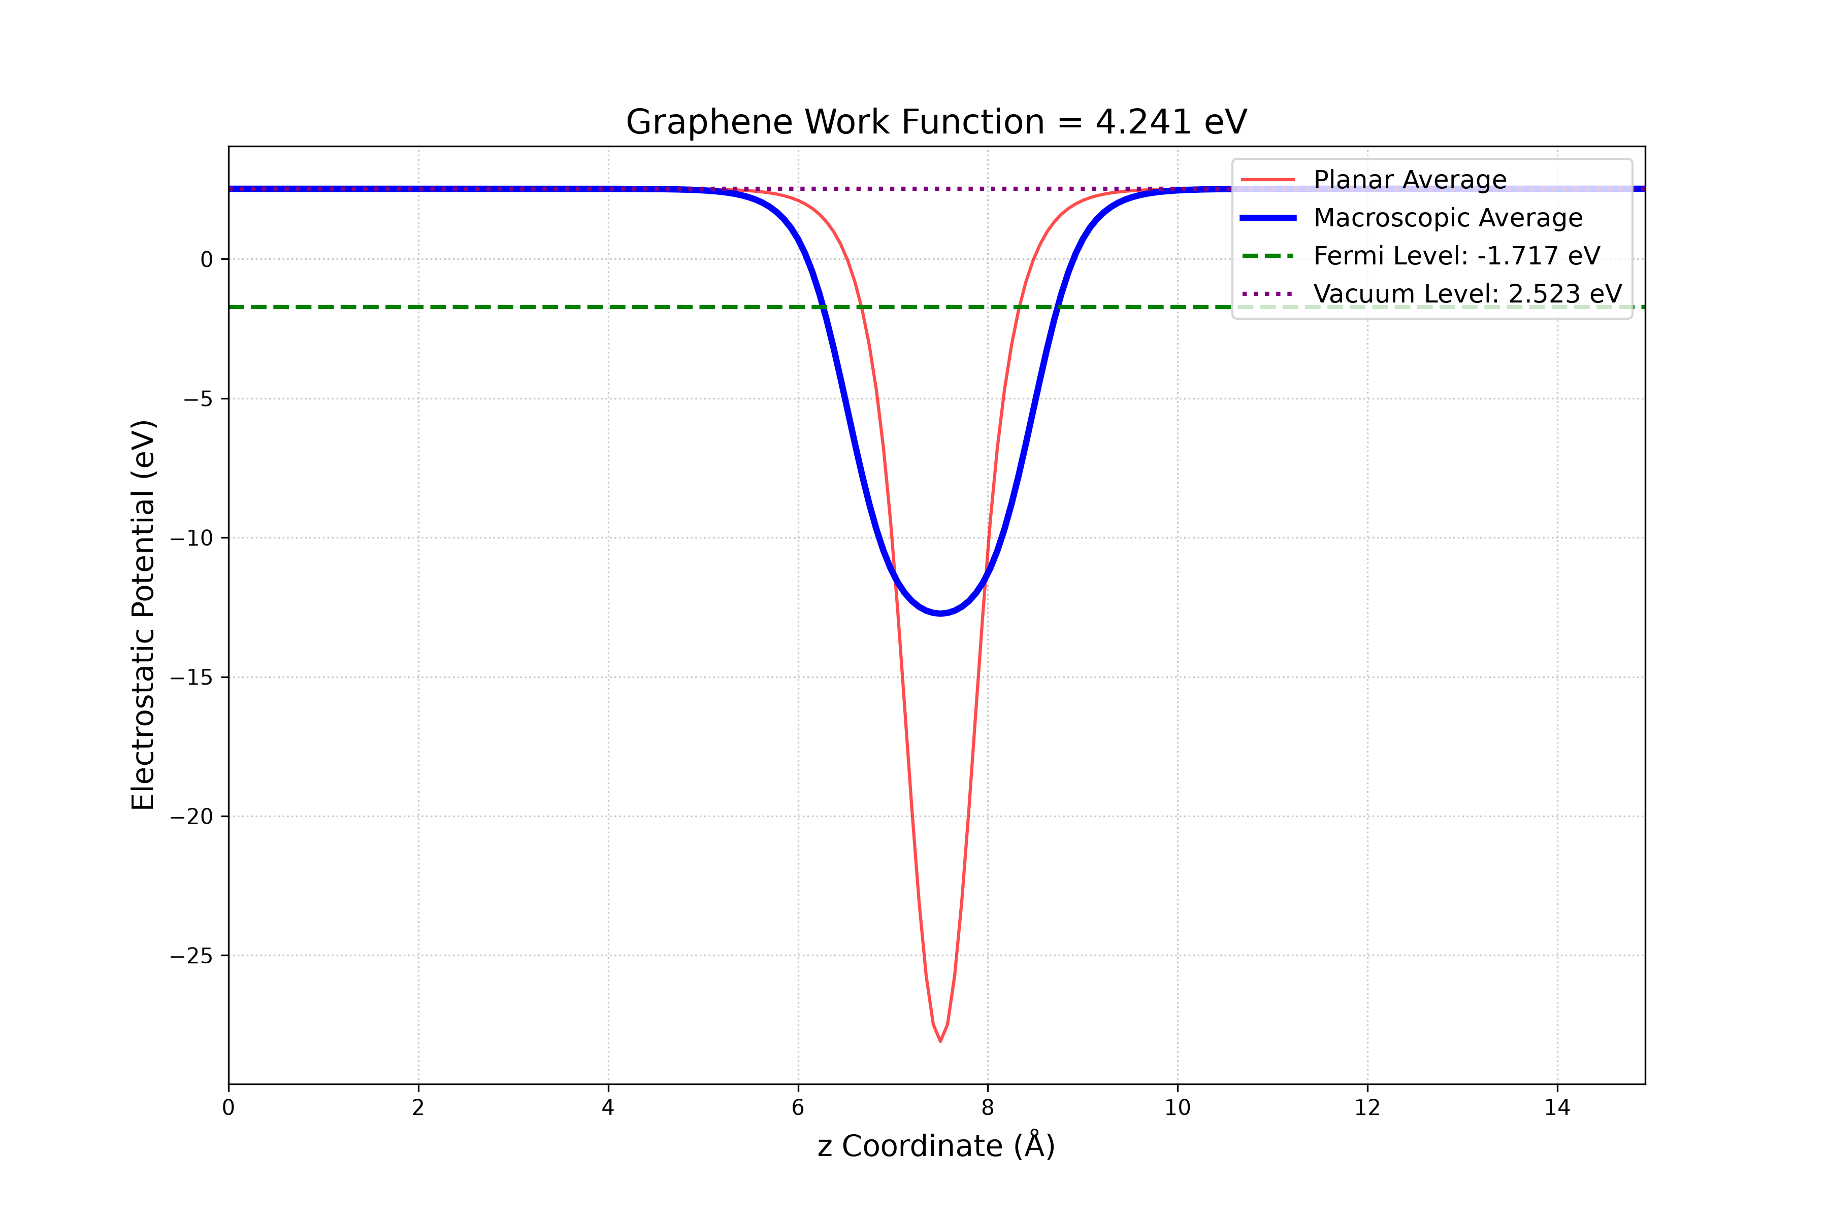
Fig. 8. Electrostatic potential profile along z-axis. Red: planar average, Blue: macroscopic average, Green dashed: Fermi level.

Challenge II.7 – Work Function Without assume_isolated = '2D'
Repeating the graphene work-function pipeline without the 'assume_isolated':'2D' flag removes the artificial potential peaks at cell boundaries.
Results: with 2D: W = 4.241 eV (E_F = −4.241 eV, vacuum = +0.001 eV); without: W = 4.237 eV (E_F = −1.717 eV, vacuum = +2.520 eV). Both agree within 0.004 eV; the potential profile without the flag is physically smoother. Working files: Challenge_II_7/.

Exercise II.8 – Adsorption of H on Graphene
Binding energy of H atom on C₈ graphene flake: E_bind = E(C₈) + E(H) − E(H@C₈).

Results
Quantity | Energy (eV)
E(H@C₈) | −1319.069
E(H) | −12.560
E(C₈) | −1303.646
E_bind | 2.864

The C₈ value is elevated by finite-flake edge effects. Extended challenge: Hg on C₁₈ was relaxed at top, bridge and hollow sites (E_ads = −0.2378, −0.5294 and −0.6655 eV, respectively); hollow is lowest in energy.

Summary of All Exercises
Exercise | Status | Key Result | Challenge
I.1 | ✓ | All packages OK | ✓
I.2 | ✓ | Benchmarked | ✓
I.3 | ✓ | N₂, O₂ atomization | ✓
I.4 | ✓ | MACE OK | 22/25
I.5 | ✓ | S° matches exp | ✓
I.6 | ✓ | C–H report | ✓
I.7 | ✓ | H₂O optimized | H₂O ✓; CH₄ ✓
I.8 | ✓ | UO₂I₂(OH₂)₂ | ✓
II.1 | ✓ | E = −227.71 eV | cutoff ✓; PP —
II.2 | ✓ | 65 Ry; sweep to 14³ | base ✓; extras —
II.3 | ✓ | a = 5.468 Å | base ✓; extras —
II.4 | ✓ | Band gap ~0.6 eV | base ✓; degauss ✓
II.5 | ✓ | Metal DOS | ✓
II.6 | ✓ | Dirac cone pz | ✓
II.7 | ✓ | W = 4.24 eV | base ✓; rerun ✓
II.8 | ✓ | E_bind = 2.86 eV | Hg sites ✓; C₈ ✓

Conclusions
- Mastered complete materials modeling workflow: energy → convergence → relaxation → electronic properties.
- Observed fundamental semiconductor (Si, gap ~0.6 eV) vs metal (Al, continuous DOS) difference.
- Constructed and analyzed 2D graphene: orbital decomposition confirms pz Dirac cone.
- Calculated graphene work function (4.24 eV) from first principles, matching experiment (4.2–4.5 eV).
- Simulated H adsorption on graphene with DFT-D3 van der Waals corrections.
- Assessed DFT limitations: Si band gap underestimation, finite-size effects in adsorption energies.

