Lab 1. Kairos dataset
The final model is a LightGBM regression of the residual on 40 features, and two thresholds tuned for macro-F1 turn the prediction into three classes. On the 17,623 test posts it gets macro-F1 0.646 (baseline 0.541), QWK 0.584 (baseline 0.458) and accuracy 0.690 (baseline 0.547).

1. Task and protocol
The label compares the reactions of a post with the author's usual level, which is the median of log(1 + reactions) over the author's earlier own posts (at least five). The residual is cut at the 20th and 80th percentiles of train into below, typical and above. Train and test are split by author: 71,395 labelled posts from 3,295 authors in train and 17,623 posts from 824 authors in test.
All choices (features, model, thresholds) were made on 5-fold cross-validation over train authors. I used GroupKFold, so the same author is never in both parts. Text models are used through out-of-fold predictions: the text score of a train post comes from a model that did not see its author. The test set was scored once per step for this report and was not used to choose anything.

2. Features
Group | Description | Count
Baseline (course) | Length, hashtags, mentions, links, type, hour, weekday; the author's level and spread, posting gap, followers; age at crawl, position in the feed | 17
Author dynamics | Previous post, mean of last 3 and last 10 posts, EWM, max of last 10 (all minus the level); mean past residual; share of past posts above and below; number of posts in the last 30 days | 9
Post fields | Reshare flag, number of images, number of tagged companies, document pages | 4
Same-kind history | Level, last post and mean of last 3 over earlier posts of the same kind (reshare or original); level by content type; share of reshares; number of earlier posts of this kind | 6
Text | Ridge predictions of the residual from TF-IDF (1–2-grams) and from Qwen3-Embedding-0.6B vectors, out of fold | 2
kNN over own posts | Mean reactions of the 5 most similar earlier posts of the author (cosine similarity of embeddings) minus the current level; max similarity | 2

All features use only earlier posts, the same way as the level. Counters of the post itself (comments, reposts, reaction types, poll votes) are outcomes like reactions, so they are not used. I also fixed a problem in the course loader. It lets pandas guess the crawledAt format from the first feed, and 515 feeds written without fractional seconds end up as missing values. Because of that the baseline gives their 10,413 posts the median age of 899 days, even if the post is fresh. In the notebook crawledAt is parsed as ISO 8601, and all feeds get a crawl time.

3. Results
Each row adds one group of features to the previous row. CV is the out-of-fold macro-F1 on train. It is computed on the same predictions that were used to tune the thresholds, so it is about 0.001 too optimistic. The last three columns are test.
Features | CV macro-F1 | Test macro-F1 | QWK | Accuracy
official baseline | - | 0.5410 | 0.4576 | 0.5465
baseline features | 0.5938 | 0.5865 | 0.4940 | 0.6443
+ author dynamics | 0.6134 | 0.6044 | 0.5258 | 0.6530
+ post fields | 0.6213 | 0.6101 | 0.5314 | 0.6613
+ same-kind history | 0.6376 | 0.6251 | 0.5513 | 0.6752
+ text (TF-IDF, embeddings) | 0.6583 | 0.6464 | 0.5836 | 0.6843
+ kNN over own posts | 0.6602 | 0.6464 | 0.5836 | 0.6897

On the baseline features, regression with tuned thresholds and the crawl time fix gives 0.587 instead of 0.541. Author history (overall and by kind of post) adds 0.039 more, text adds 0.021. With kNN, CV goes from 0.6583 to 0.6602, but test stays at 0.6464. A difference of a few thousandths is within noise on a test set of 824 authors. I kept this step because decisions were made on CV.
Final model, test | below | typical | above
F1 | 0.530 | 0.750 | 0.658
true below | 1,840 | 1,681 | 20
true typical | 1,512 | 8,121 | 858
true above | 45 | 1,353 | 2,193

Most errors are between neighbouring classes. Only 65 of the 17,623 posts are predicted as above when they are below, or the other way round.

4. What else I tried
- Multiclass LightGBM with balanced classes and class weights tuned for macro-F1. CV was 0.647, while the regression on the same features gets 0.649, so I kept the regression.
- Other LightGBM settings: L2 loss instead of Huber, 800 to 2,500 trees, 31 or 63 leaves. All within ±0.002 CV.
- Ridge alpha 3, 10 and 30 on the embeddings, and 3, 5 or 10 neighbours for kNN. Differences within ±0.001 CV.
- A trend slope over the last 10 posts, the level by content type and reshare, averaging three seeds. Each gave at most +0.001 CV, so I dropped them to keep the notebook short.
- Images and videos were not used. The media archive is 52 GB, and the rules of use do not allow sending media to an external model anyway.

5. Observations
- 41% of train posts are reshares of someone else's post, with or without a comment. Their mean residual is −0.05, compared to +0.59 for original posts, and only 10% of them are above (27% for original posts). The level mixes both kinds, so an author who reshares a lot has a low level, and their original posts beat it. By total gain, same-kind history is the strongest feature group.
- The level is a median over the author's whole past, and recent posts show whether the author is growing or fading. The mean of the last three posts of the same kind is the top feature by gain, above the level itself.
- Reactions are collected once, at crawl time, so posts younger than a week are below in about a third of cases. The model needs the post age, and this is why the crawl time bug matters.
- Text helps in cases where history does not: celebrations, personal news, tagged people and companies. The TF-IDF and embedding predictions each have about 0.46 correlation with the residual out of fold, and they work better together.
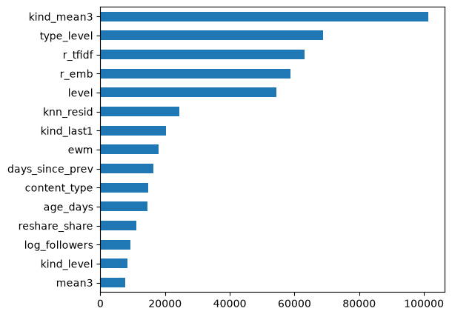
Figure 1. Top 15 features of the final model by total gain.

