Analysis of the Economic and Environmental Impacts of Climate Change Using the RICE Model
Michael Karnaushenko
The Department of Applied Math
NATIONAL RESEARCH UNIVERSITY “HIGHER SCHOOL OF ECONOMICS”
Moscow, Russia
e-mail: makarnaushenko@edu.hse.ru

Abstract—Global warming is often associated with climate change caused by the influence of anthropogenic factors, which in turn are related to human activities and the current state of production, population, economy and other factors. To date, there are quite a large number of models that can identify the relationships between these indicators. This includes the DICE (Dynamic Integrated Climate-Economy model), which has already become a classic model by William Nordhaus. Over the years, the model has been modified, including by the author of the original model. Among such modifications is a variation of the RICE (Regional Integrated Climate-Economy) model for regional data and the DICE-CH4 model, which, unlike the original DICE, takes into account not only the influence of carbon dioxide, but also the influence of methane emissions. This work examines the process of constructing and modeling a new modification that takes into account both regional data and the presence of methane.
Keywords: Economy, Global Warming, Ecology, Methane, DICE, RICE

- INTRODUCTION
The DICE model was created by Nobel laureate W. Nordhaus in 1993 [3]. It is an integration model of dynamics that takes into account economic indicators such as population and GDP, climatic (ocean temperature and atmospheric temperature), environmental (carbon dioxide emissions and their impact, climatic indicators in combination with other greenhouse gases). All modifications are aimed at maximizing public welfare through optimization of parameters.
Despite the simplifications, the model is widely used and updated (2018)[5].
In classic DICE, carbon dioxide (CO2) occupies one of the key positions among environmental components (other greenhouse gases are taken into account in the model as a single cluster). Its emissions cause a certain “damage" to the climate. At the same time, DICE-CH4 (2024) [1] takes into account methane, which has a significant effect [2].

The RICE [4] modification uses regional data, taking into account the relationship between regions (coop and noncoop parameters responsible for the interaction between regions), thereby extending the flexibility of the model and allowing it to obtain the values of predicted values for individual regions.
The objective of this work is to combine the modification of methane accounting and regional separation. However, it has several problems. Firstly, the current models are quite cumbersome. Since all the variables and equations involved in the simulation are initialized and used explicitly, any implementation in a programming language can cause some problems for an untrained user. This leads to the second problem - the unavailability of open source code. Many implementations [8] are created using the GAMS or AMPL language, which makes further research and development difficult, since despite some convenience, these languages are not as popular (unlike Python, for example) and are not as accessible (proprietary languages).

- LITERATURE REVIEW
Integrated Economic and climate models (IAM) have become a key tool for analyzing economic and climate policy. DICE (1993) [3] models economic growth, greenhouse gas emissions, and climate by evaluating strategies to reduce them. The subsequent regional version of RICE (Nordhaus & Yang, 1996)[4] distributed the world's global data into several regions, taking into account their strategic behavior. It showed that non-cooperative efforts to reduce emissions are significantly weaker than globally cooperative ones. In the future, these models became more complicated. The current version of RICE50+ [8] covers over 50 regions, detailing costs and effects by country, including new carbon removal technologies.
A scenario analysis by Nordhaus (2018) [5] showed that with minimal effort, the world will face rapid global warming, and the previously set goal of reducing rates and temperatures will remain unattainable.
Modern models separately take into account the short-term effect of CH4. Traditionally, methane has been included in the general non-CO2 index, which hides its special properties. Lynch (2019) [2] emphasizes that the aggregation of emissions in CO2 without separate accounting for CH4 leads to some loss of accuracy, since these gases vary in duration and severity of exposure.
In a recent paper by Sofia Aleshina (2024) [1], methane is explicitly embedded in the DICE model. The authors showed that an aggressive global reduction of CH4 (by 50%) combined with an increase in the price of CO2 to $500/tonne makes it possible to keep warming within °C by 2100.
These results confirm the importance of direct accounting of methane in regional models (such as the current one being developed by RICE-CH4) for a more accurate forecast and effective strategy.

- METHODS
In the practical part of the work, it is planned to implement the RICE-CH4 model, which will allow extending the results of DICE-CH4 to individual regions. All code will be written in Python but will build on several early works implemented in Python or GAMS (General Algebraic Modeling Language).
A. Problem Statement: classical DICE model
First, the DICE model has to be partially described. To begin with, there are two big components in this model. Here we will concentrate on the economic component; the climate component will be explained by Alexander. The model optimizes the following objective function (the welfare):
$W=\sum_{t=T_{0}}^{T_{max}}{}L\left(t\right)⋅\left[\frac{c{\left(t\right)}^{1−η}}{1−η}\right]⋅{\left(1+ρ\right)}^{T_{0}−t}$
where $L\left(t\right)$ is the total population on the Earth, $c\left(t\right)$ is capita consumption, $T_{0}$ and $T_{max}$ are the initial and final moments of time, respectively, and constants $η$ and $ρ$ — elasticity of the marginal utility of consumption and pure time preference. To see the variable to be optimized, it is needed to go deeper into the components of $c\left(t\right)$ function. This function is expressed as
$c\left(t\right)=\frac{C\left(t\right)}{L\left(t\right)}$
where $C\left(t\right)$ is the global consumption, which is calculated as the following:
$C\left(t\right)=Q\left(t\right)⋅\left(1−S\left(t\right)\right).$
Here $S\left(t\right)$ denotes the saving rate policy — the first objective variable, which means the share of total output to be invested in the future, and $Q\left(t\right)$ is the total output, which can be expressed as
$Q\left(t\right)=Q_{gross}\left(t\right)⋅\left(1−Λ\left(t\right)−Ω\left(t\right)\right).$
The global gross product variable $Q_{gross}\left(t\right)$ is expressed via Cobb-Douglas production function:
$Q_{gross}\left(t\right)=A\left(t\right)⋅K{\left(t\right)}^{γ}⋅L{\left(t\right)}^{1−γ}$
where $K\left(t\right)$ is the total capital (we know the $K\left(T_{0}\right)$ and the transition rule $t→t+1$), $A\left(t\right)$ is Hicks neutral technological change (this function is predefined) and $γ$ is the constant of capital elasticity in production. The transition rule for $K\left(t\right)$ is
$K\left(t+1\right)=\left(1−δ\right)K\left(t\right)+S\left(t\right)⋅Q\left(t\right)$
where $δ$ is the depreciation rate of global capital.
The second objective variable $μ\left(t\right)$ is hidden in $Λ\left(t\right)$ – abatement costs, which are expressed as
$Λ\left(t\right)=λ\left(t\right)⋅μ{\left(t\right)}^{θ}.$
Here $μ\left(t\right)$ is the control emission policy, $θ$ is the coefficient of abatement level and $λ\left(t\right)$ – cost coefficient of abatement.
All variables and parameters have been described except on $L\left(t\right)$ and $Ω\left(t\right)$. The total population is assumed to be a logistic function with a cap of 11.5 billion people. The function $Ω\left(t\right)$ is the climate damage which quadratically depends on atmosphere temperature $T_{AT}\left(t\right)$. For $T_{AT}\left(t\right)$ the situation is the same as with $K\left(t\right)$. The initial values and the transition rule are known, last includes the emission control policy $μ\left(t\right)$ that can be chosen. The transition rule will be explained by Alexander (and all climate components where you will see total emissions, ocean and atmosphere temperatures, etc.) but the main idea is the following: the trade-off is that the greater value of $μ\left(t\right)$, the more abatement costs $Λ\left(t\right)$ it is needed to incur during this year, but the less emissions the economy will produce, indirectly decreasing temperature (and hence, the damages) for the subsequent years. And it can also be observed that the standard trade-off when selecting the saving rate $S\left(t\right)$. The more the saving rate, the less consumption (and therefore, the less utility) will be in the current year, but the more capital will be preserved for the next one, indirectly benefiting the utility in the subsequent years of the model.
There are two additional natural constraints:
$0≤S\left(t\right)≤1; 0≤μ\left(t\right)≤1$
B. Adding Methane emissions: DICE-CH4
The main idea of the DICE-ch4 modification is to add a new parameter, methane, to the environmental components of the model. Unlike the classical model, in which methane emissions occupy a place among other greenhouse gases, the DICE-ch4 model uses CH4 in exactly the same way as CO2 (carbon dioxide). Such an amendment leads, as a result, to a change in the equations of climate impact. The diagram of the DICE-ch4 model is shown below in Figure 1.
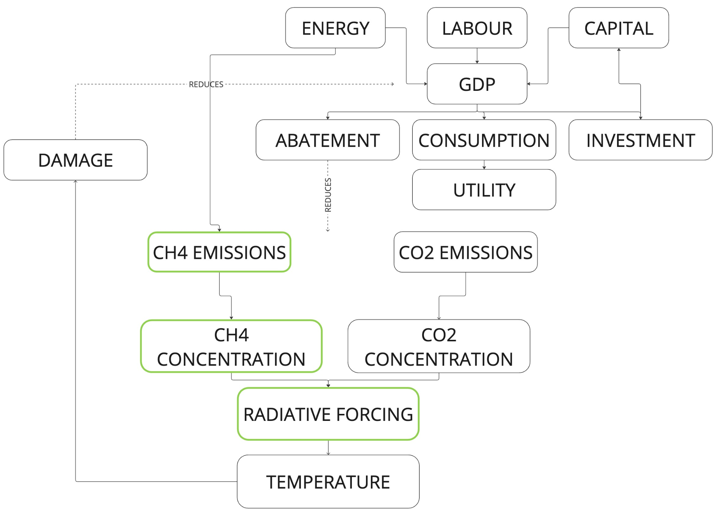
Fig. 1: DICE-ch4 diagram.
The basic environmental equations do not change, with the exception of the equation for Radiative Forcing itself. Skipping some calculations, the equation from the classical DICE model has the form:
$F\left(t\right)=κ\left(Ln\frac{C_{AT}\left(t\right)}{C_{AT}\left(O\right)}\right)+F_{non-CO_{2}}$
Here, $C_{AT}\left(t\right)$ is the current carbon dioxide content in the atmosphere, and $C_{AT}\left(O\right)$ is historical data on carbon dioxide content from pre-industrial times. $κ$ is a constant, $F_{non-CO_{2}}$ - all other forcing except carbon dioxide.
At the same time, the modification expands the classical equation:
$F\left(t\right)=κ^{CO_{2}}\left(Ln\frac{C_{AT}^{CO_{2}}\left(t\right)}{C_{AT}^{CO_{2}}\left(O\right)}\right)+$
$+κ^{CH_{4}}\left(\sqrt{C_{AT}^{CH_{4}}\left(t\right)}−\sqrt{C_{AT}^{CH_{4}}\left(O\right)}\right)+F_{other}\left(t\right)$
$C_{AT}^{CH_{4}}\left(t\right)$ is the current methane content in the atmosphere, and $C_{AT}^{CH_{4}}\left(O\right)$ is historical data. $F_{other}\left(t\right)$ now includes all other forcing except carbon dioxide and methane.
here i suggest to put sofia schema of methane including and small paragraph with describing in words without big formulas wait confirmation
C. Regional splitting
The RICE13 [6] model was chosen as the main model used in the foundation format for the RICE component. This is a fairly modern model supported by the author Marco Rogna, who works at JCR-Seville, Spain. As part of our research, we contacted the author to clarify some points in the implementation of the model.
For the most part, the structure of RICE fundamentally coincides with the structure of DICE (the model still solves the problem of optimizing social welfare), however, as mentioned above, this modification has a number of differences. First, it is the presentation of data in a regional form. If classic DICE uses global data, then RICE uses and represents most of the parameters in a regional form. For example, for RICE13, the division is carried out into 12 regions.
An important factor is the ability of regions to interact with each other, or on the contrary, to be in some form of isolation. The modes of operation of the model - $coop$ and $noncoop$- are responsible for this. In the coop mode, countries (regions) act together, and vice versa, in the non-coop mode, all actions proceed from the maximum self-benefit.
The Shared Socio-Economic Pathways (SSP) parameter is also taken into account for many DICE/RICE models. This is a set of economic and climatic scenarios for human development, usually divided into 5 main (ranked) scenarios, where SSP1 is a scenario in which humanity minimizes production and emissions, and SSP5 is a scenario with almost complete abandonment of combating negative climate change.

- RESULTS
To date, we have studied several models. Initially, to work with the RICE structure, we chose the RICE50+ model, which divides global data into 56 regions. Its use was hampered by the implementation features of this model, since it was originally created in the GAMS language. In the process, we had to obtain a foreign license in order to have access to the original data on which the model works. Due to the closed code format and the difficulties of debugging all modeling processes, it was decided to abandon this model in favor of an alternative RICE13, which in turn already has a Python implementation [7]. A similar decision was made during the study of one of the modern variations of the DICE model (2020) [9], written by Nordhaus in the AMPL language. A visualization module has been created for convenient analysis. In the future, it is planned to create more variable data display formats, including dashboards and interactive maps.
This part of the work focuses on economic indicators and a non-cooperative format of relationships. In particular, the results were obtained for such indicators as per period Utility (U), Consumption (C), and Investment (I) for various regions.

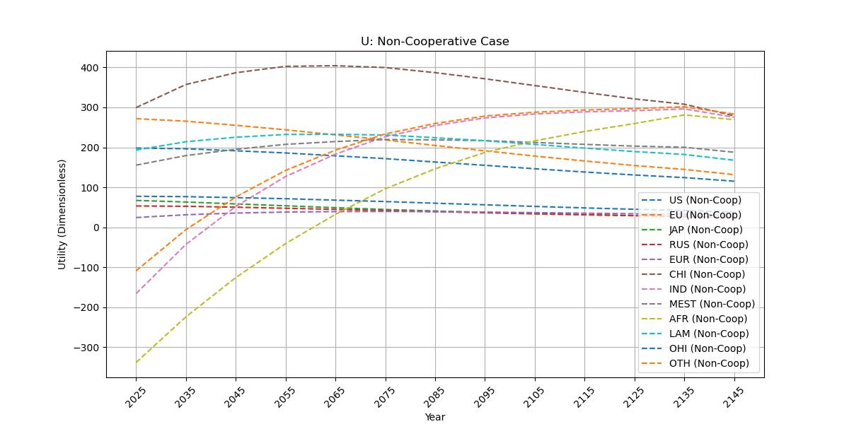
Fig. 2: U non coop.
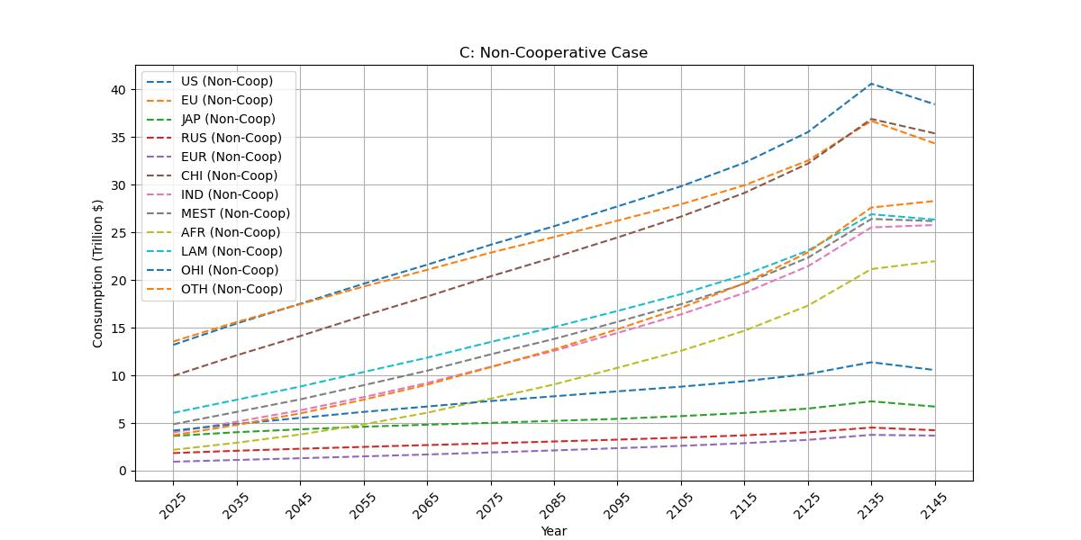
Fig. 3: C non coop.
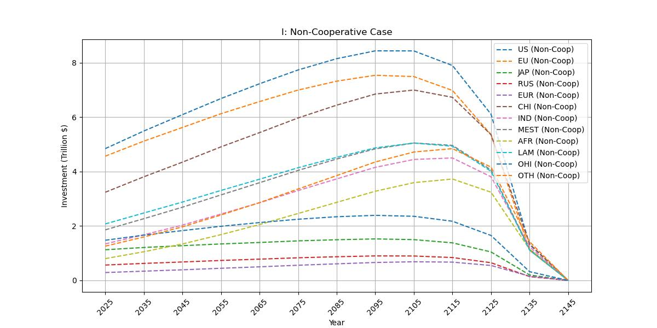
Fig. 4: I non coop.

Capital (K) and Abatement costs as proportion of gross output (AB) were also received.
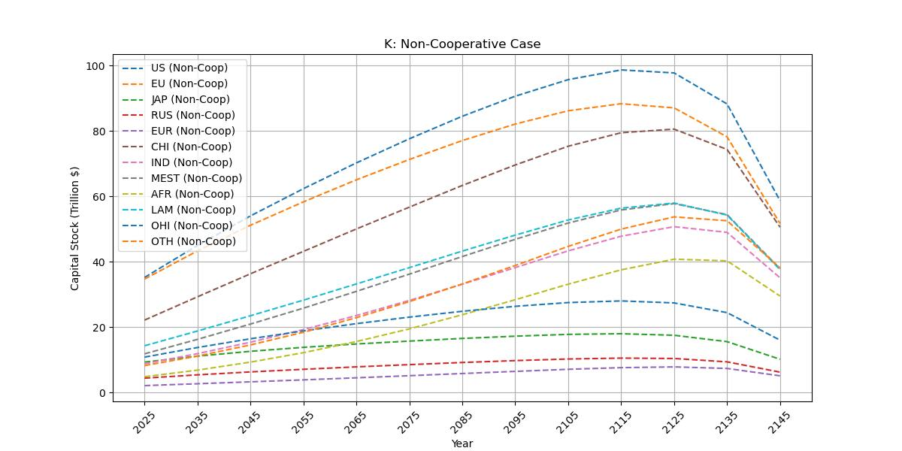
Fig. 5: K non coop.
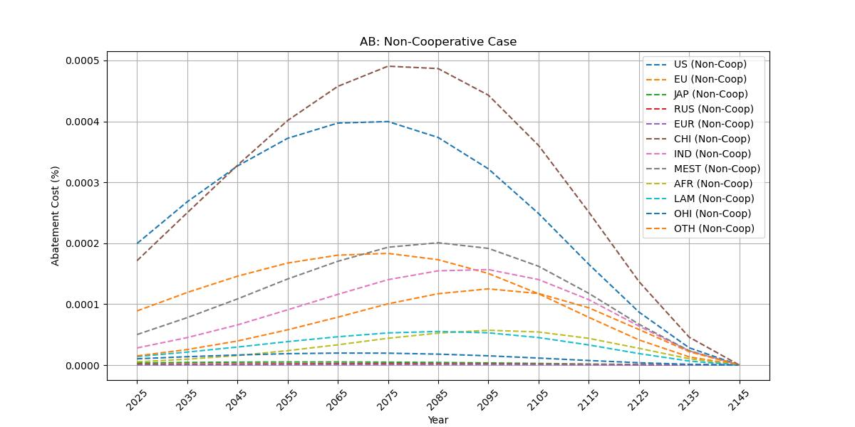
Fig. 6: AB non coop.
There is a similar module for the DICE-ch4 model, thus maximizing the compatibility of the received data.
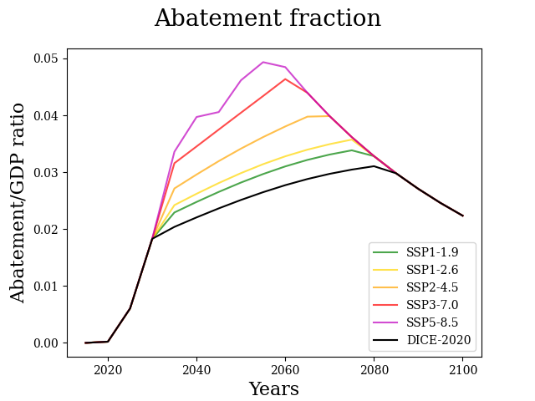
Fig. 7: AB DICE-ch4 with SSP scenarios.
Similar to these graphs, the model we are developing will provide a similar output format, including inheriting many available hyperparameters from both models. The complexity of this stage of development lies in some differences in the input data for both models. Therefore, when implementing it, it is important to take into account not only the standardization of equations connecting variables (the equations themselves, as a rule, can also vary for different modifications), but also the standardization of the data entering the model. For example, in the RICE13 model, most parameters are built iteratively based on initialized values, while DICE-ch4 accepts parameters in an already predicted form.

- CONCLUSION
This article examines the main fundamental approaches to the implementation of DICE/DICE models and their latest variations and modifications. The RICE-CH4 model being developed should provide data for forecasting and analysis, responding to the tasks set by Nordhaus in 1993. At the same time, its innovations in the use of methane should bring new knowledge in the field of economic and climatic interaction. For accessibility, the model is implemented in Python with convenient visualization.
Word Count: 2139
REFERENCES
[1] S.Aleshina, L.Delgado-Antequera, G.Gemar (2024). Assessing the economic implications of carbon emissions on climate change: Estimating the impact using methane-adjusted DICE model. Structural Change and Economic Dynamics (71).
[2] J. Lynch (2019). Availability of disaggregated greenhouse gas emissions from beef cattle production: A systematic review. Environmental Impact Assessment Review (76), 69-78.
[3] Nordhaus, W. (1993). Rolling the ‘DICE’: an optimal transition path for controlling greenhouse gases. Resource and Energy Economics, 15(1), 27–50.
[4] Nordhaus, W., Yang, Z. (1996). A Regional Dynamic General-Equilibrium Model of Alternative Climate-Change Strategies (tech. rep. No. 4).
[5] Nordhaus, W. (2018). Projections and uncertainties about climate change in an era of minimal climate policies. American Economic Journal: Economic Policy, 10(3), 333–360.
[6] Rogna, M., Vogt, C. J. (2022). Optimal climate policies under fairness preferences. Climatic Change, 174(3), 25.
[7] Github repository of the RICE13 model implementation. https://github.com/white-heomoi/RICE13_pyomo
[8] Github repository of the RICE50+ model implementation. https://github.com/witch-team/RICE50xmodel
[9] Data and code for "Climate economics support for the UN climate targets" https://www.openicpsr.org/openicpsr/project/119395/version/V1/view/

