TECHNICAL DOCUMENTATION
QalaFix – City Problem Reporting Platform
Project Type: Full Stack Web & Mobile Application
Completed by: Bratochkin Daniil, Anuarbekov Islam, Telagisov Damir

1. INTRODUCTION
QalaFix is a platform that helps people report problems in their city. If someone sees trash on the street, a broken bench, a pothole, or a streetlight that doesn't work, they can open QalaFix, take a photo, and send a report. The report goes to the right city service, and the person can track what happens next.
The main idea is simple: make it easy for citizens to report problems and make sure those problems actually get fixed.
The QalaFix project consists of three main parts. The first part is the admin website, which is used by moderators and administrators to process reports. The second part is the mobile application, which is used by regular citizens to report problems from their phones. The third part is the design in Figma, which includes all UI and UX mockups, prototypes, and the design system.
All three parts work together. The design in Figma is the foundation. The admin website and mobile app are built based on that design. They share the same data structure, so information is always in sync.
Every day, people walk past problems in their cities. Trash piles up. Benches break. Roads get damaged. Streetlights stop working. Most people just walk by because they don't know who to call or how to report it. Even if they do report it, they never hear back.
This creates frustration. People feel like their voice doesn't matter. At the same time, city services don't have a clear picture of what's happening on the ground. They rely on old systems, phone calls, and paperwork.
QalaFix solves this by creating a direct, transparent channel between citizens and city services. The mobile app makes it easy for anyone to report a problem, and the admin website gives city staff the tools they need to process those reports.
Current Status: At the current stage, the project is a fully working frontend. The admin website and mobile app run on mock data. The backend and database are designed and documented, and will be implemented in the next phase.

2. PROBLEM STATEMENT
In most cities, reporting a problem is complicated. A person might need to find the right phone number, call during working hours, explain the problem without being able to show a photo, and then wait for a response that never comes.
There is no simple, modern way to do this. And there is no transparency. Once a report is made, the person has no idea what happens next.
Existing solutions in Kazakhstan, like iKOMEK, work but are not convenient enough. They are bureaucratic and don't provide real-time feedback. People want something faster, simpler, and more transparent. And they want it on their phones.

3. PROPOSED SOLUTION
QalaFix is a platform with a simple flow. A user opens the mobile app, clicks "Report a Problem", takes a photo, and the location is detected automatically. They choose a category such as trash, roads, or lights, add an optional description, and submit the report.
After that, the report appears on the map inside the mobile app. On the admin website, a moderator sees the new report, reviews it, and assigns it to the correct city service. The status changes to "In Progress". When the service fixes the problem, the status changes to "Resolved". The user gets a notification and can see before and after photos.
QalaFix is built on five key principles. It is simple, so anyone can use it without training. It is fast, so a problem can be reported in under 30 seconds. It is transparent, so everyone can see what is happening. It is accountable, because services are rated by citizens. And it is accessible, because the mobile app works on any Android phone.

4. SYSTEM ARCHITECTURE
QalaFix follows a classic three-tier architecture. This means the system is divided into three main parts. The first part is the frontend, which is what the user sees and interacts with. The second part is the backend, which is the server that processes requests and applies logic. The third part is the database, where all the data is stored.
The mobile app and admin website both connect to the same backend. This means that a report submitted in the mobile app appears on the admin website, and a status change made by an administrator shows up in the mobile app. Everything is always in sync.
The admin website is built with React and Vite. It includes a dashboard with key metrics, a list of users with a detailed profile page, a risk activity journal, a list of all reports, a district overview page, a reports and analytics page, settings, help center, and the administrator's own profile page. Styling is done with Tailwind CSS.
The mobile app is built with React Native and Expo. It works on Android and iOS. It includes splash screen, onboarding, login and registration, a home screen with an interactive map, a list of the user's own reports, a detailed report view with before and after photos, a report creation screen, a profile with achievements, notifications, statistics, and settings. The app uses native camera access for taking photos and GPS for detecting the user's location.
The backend is planned to be built with Python and FastAPI. It will handle user registration and login, creating and managing reports, managing categories, processing ratings, sending notifications, and calculating statistics. FastAPI is a good choice because it is modern, fast, and automatically generates API documentation.
PostgreSQL is planned as the main database. It will store user accounts, reports with photos and locations, categories, status history, ratings, and notifications.
All UI and UX design is done in Figma. This includes wireframes, high-fidelity mockups, interactive prototypes, and the design system. Figma allows the whole team to collaborate in real time. Designers can share links with developers, and developers can inspect exact colors, sizes, and spacing.
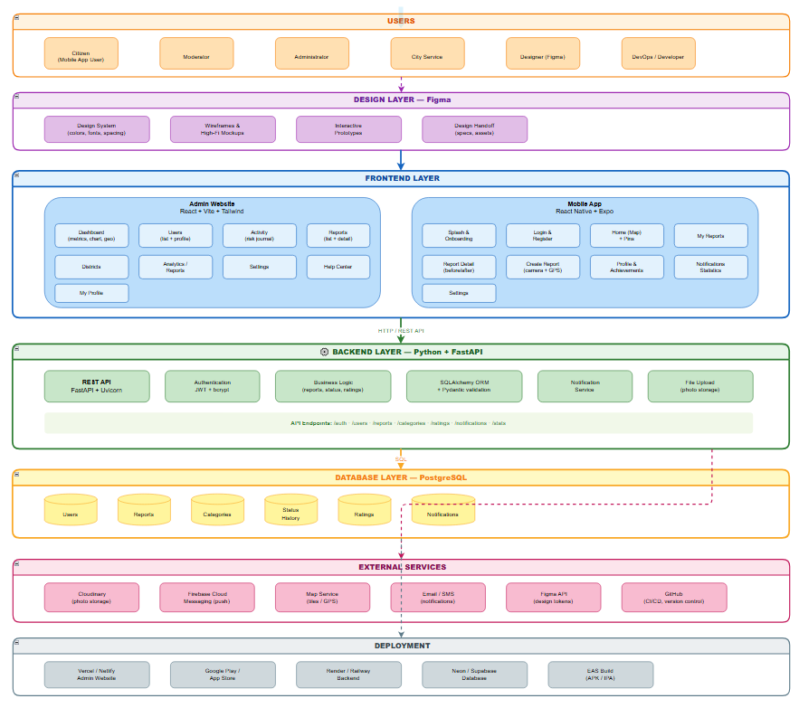
Figure 1. System Architecture
5. TECHNOLOGY STACK
All design work is done in Figma. It works in the browser and allows real-time collaboration. We use it for wireframes, mockups, prototypes, and the design system. FigJam is used for brainstorming and user flows. Unsplash and Pexels provide free images, and Flaticon and Icons8 provide icons.
The admin website is built with React for the user interface, React Router for navigation, and Vite as the build tool. Styling is done with Tailwind CSS v4. The site is fully responsive and works in any modern browser.
The mobile app uses React Native to run on both Android and iOS with one codebase. Expo simplifies development and testing. Expo Router handles navigation between screens. The app uses Expo modules for camera access, location, secure storage, and system icons. Push notifications will use Firebase Cloud Messaging in the future.
The backend will be written in Python with FastAPI. SQLAlchemy will handle the database, Pydantic will validate data, and Uvicorn will run the server. Authentication will use JWT tokens, and passwords will be hashed with bcrypt.
PostgreSQL is planned as the main database. SQLite will be used for local development and testing.
Git and GitHub handle version control. VS Code is our main editor. Expo CLI is used to run and test the mobile app. npm is used for package management. Postman will be used for testing the API.

6. DESIGN PROCESS IN FIGMA
Figma works in the browser and allows real-time collaboration. Designers create and update designs instantly. Developers can inspect exact colors, sizes, and fonts. Prototypes are shared with a simple link.
The process has four phases. First, we research existing solutions and create wireframes. Second, we design high-fidelity mockups with colors, typography, and icons. Third, we build an interactive prototype to test the flow. Fourth, we create a design system with colors, fonts, buttons, and spacing rules.
For the admin website, we designed the dashboard, user list, user profile, risk journal, reports list, districts overview, reports and analytics, settings, help center, and the administrator profile.
For the mobile app, we designed the splash screen, onboarding, login, registration, home with map, my reports, report detail with before and after photos, report creation, profile with achievements, notifications, statistics, and settings.
Developers inspect colors, sizes, and spacing in Figma, export icons and images, and access all assets in one place. All screens and components are documented in the design system.

7. DATABASE DESIGN
The database has six tables: Users, Reports, Categories, Status History, Ratings, and Notifications.
The Users table stores account information: unique ID, email, hashed password, full name, role (citizen, service, moderator, admin), and registration date.
The Reports table stores each report: unique ID, user ID, category ID, description, photo URL, GPS coordinates, address, status, creation date, and resolution date.
The Categories table defines problem types: trash, roads, street lights, bus stops, playgrounds, other. Each has an ID, name, and icon.
The Status History table tracks every status change: which report, new status, who changed it, and when. This creates a full audit trail.
The Ratings table stores user ratings after a problem is resolved: report ID, user ID, score (1–5), and optional comment.
The Notifications table stores notifications: user ID, message, read/unread flag, and creation date.
Database Diagram
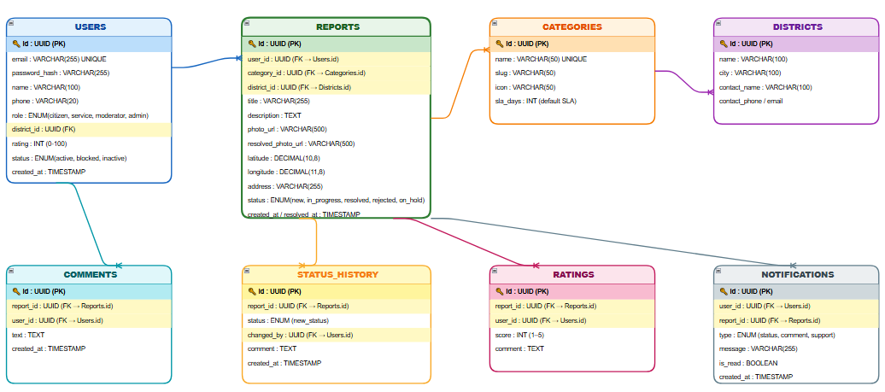
Figure 2. QalaFix Database Schema

8. USER FLOW
The user opens the mobile app, clicks "Report a Problem", takes a photo, location is detected automatically, chooses a category, adds an optional description, and clicks "Submit". The report appears on the map with a red pin. On the admin website, a moderator reviews the report and forwards it to the correct city service. The status changes to "In Progress" (yellow pin), then "Resolved" (green pin). The user gets a notification and can rate the service.
Reports move through five statuses: New (just submitted), In Progress (being worked on), Resolved (fixed), Rejected (not valid), and On Hold (waiting for information).

9. PROJECT STRUCTURE
The admin website has a src folder with components, pages, layouts, and data. Components include the sidebar and other UI elements. Pages include Dashboard, Users, UserProfile, Activity, Reports, Districts, ReportsList, Settings, Help, and MyProfile.
The mobile app has a src folder with components, screens, theme, services, and context. Components include Button, Card, Input, and StatusBadge. Screens are grouped by tabs and standalone screens. The theme folder holds colors, spacing, and font sizes.
The Figma file has pages for Cover, Research, Wireframes, Mockups, Prototype, Design System, and Handoff.

10. DEVELOPMENT PLAN
Phase one takes two to three weeks. Research, personas, wireframes, mockups, prototype, and design system in Figma.
Phase two takes two to three weeks. Build the admin dashboard, user list, user profile, risk journal, reports list, districts overview, reports and analytics, settings, help center, and administrator profile.
Phase three takes three to four weeks. Build splash, onboarding, login, registration, home with map, my reports, report detail, report creation, profile, notifications, statistics, and settings.
Phase four is ongoing. Connect the mobile app and admin website to a real backend. Add user authentication, real data storage, and notifications.

11. SECURITY
Passwords will be hashed with bcrypt. Authentication will use JWT tokens. Role-based access control will limit what each user can do. Input validation will prevent bad data. SQLAlchemy will prevent SQL injection. File uploads will be validated for type and size. CORS will be restricted to our own frontend. HTTPS will be enforced. The mobile app uses secure storage for tokens on the device.

12. CONCLUSION
QalaFix is a practical solution to a real problem. People see infrastructure problems every day, but they have no simple and transparent way to report them. Existing solutions are bureaucratic and do not provide real-time feedback. QalaFix solves this by creating a direct channel between citizens and city services.
The platform works on both the admin website and the mobile app, so it is accessible to everyone. The design is created in Figma, ensuring a consistent and beautiful user experience across all devices. The mobile app is built with React Native and Expo. The admin website is built with React and Vite.
The development plan is divided into clear phases. Phase one focuses on design. Phase two builds the admin website. Phase three builds the mobile app. Phase four connects everything to a real backend. With the right execution, QalaFix can become a real solution for cities in Kazakhstan.

