Campus HelpDesk
Project Proposal and Design Document
Project information | Details
Project domain | Campus ticketing and support
Team members | Alexandr Romanov, Andrei Filip, Danila Derii

1. Project Domain
Campus HelpDesk is a web system for university students and faculty to report problems. Technicians can claim, update, and resolve tickets, while administrators can manage the whole system.

Main Functions
Function | Description
University login | Users sign in with university credentials
Ticket management | Users create tickets; technicians assign, update, comment on, and resolve them.
Email notification | Users receive email when a ticket is created, assigned, updated, or resolved.
Peer integration | The HelpDesk exchanges ticket and enrollment data with another team’s backend.

2. Database Schema (ERD)
The database uses MySQL or PostgreSQL through Prisma ORM and Prisma migrations.
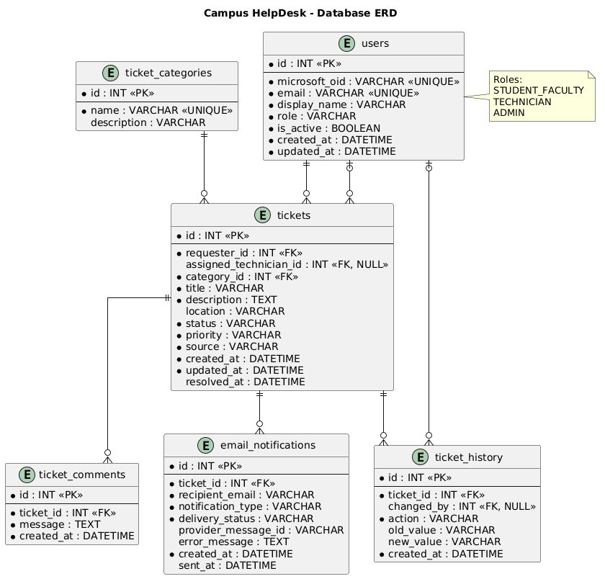

Database Tables
Table | Purpose
users | Stores AD identity, email, name, and system role.
ticket_categories | Stores selectable ticket categories.
tickets | Stores the reported problem, status, priority, requester, and technician.
ticket_comments | Stores comments belonging to a ticket.
ticket_history | Stores changes made to a ticket.
email_notifications | Stores email delivery attempts and their status.

3. RBAC Roles
Role-Based Access Control limits what each user can do.
Role | Permissions
Student / Faculty | Create tickets, view their own tickets, and add comments.
Technician | View available tickets, claim tickets, update status, and resolve tickets.
Administrator | View and manage all tickets, users, categories, and technician assignments.

4. API Integrations

Third-Party API: Brevo Email API
The backend will use Brevo to send ticket notifications. Email is an extra service; ticket operations will still succeed if an email cannot be sent. The Brevo API key will be stored in Azure Key Vault.

Peer API: Course Registration (EduCore)
Direction | Planned endpoint and use
Expose | POST /peer/tickets — EduCore can create a HelpDesk ticket when registration fails.
Consume | GET /peer/enrollments/:studentId — HelpDesk retrieves course details for registration-related tickets.
Security | Both backends authenticate with an x-api-key header. Keys are stored in Azure Key Vault.

