МИНИСТЕРСТВО ОБРАЗОВАНИЯ РЕСПУБЛИКИ БЕЛАРУСЬ

МИНИСТЕРСТВО НАУКИ И ВЫСШЕГО ОБРАЗОВАНИЯ РОССИЙСКОЙ ФЕДЕРАЦИИ

МЕЖГОСУДАРСТВЕННОЕ ОБРАЗОВАТЕЛЬНОЕ УЧРЕЖДЕНИЕ

ВЫСШЕГО ОБРАЗОВАНИЯ «БЕЛОРУССКО-РОССИЙСКИЙ УНИВЕРСИТЕТ»

Лабораторная работа №4 по дисциплине:

«Компьютерная графика»

«Алгоритмы вычерчивания окружностей»

Вариант №13

Выполнил: ст. гр. АСОИ-181

Остапенко А. К.

Проверил: Шилов А. В.

**Задание:** Составить алгоритм и программу для отображения объекта №2 методом Брезенхема.

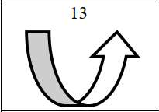

Листинг кода программы:

using System;

using System.Windows;

using System.Windows.Media;

using System.Windows.Media.Imaging;

namespace CG_lab4_Ostapenko

{

/// <summary>

/// Interaction logic for MainWindow.xaml

/// </summary>

public partial class MainWindow : Window

{

private int _imageSideLength;

private delegate void DrawPixelInQuarters(int x, int y, int xOffset, int yOffset);

private WriteableBitmap bitmap;

delegate bool ConditionCheker();

public MainWindow()

{

InitializeComponent();

}

private void CreateFigureButton_Click(object sender, RoutedEventArgs e)

{

try

{

_imageSideLength = int.Parse(ResolutionTextBox.Text);

}

catch

{

_imageSideLength = 300;

}

bitmap = new WriteableBitmap(_imageSideLength + 10, _imageSideLength + 10, 96, 96, PixelFormats.Bgr32, null);

ImageBox.Source = bitmap;

DrawEllipse(_imageSideLength / 12 * 5, _imageSideLength / 3, _imageSideLength / 4, _imageSideLength / 2, Quarter.Third);

DrawEllipse(_imageSideLength / 12 * 7, _imageSideLength / 3, _imageSideLength / 4, _imageSideLength / 2, Quarter.Third);

DrawEllipse(_imageSideLength / 12 * 7, _imageSideLength / 2, _imageSideLength / 4, _imageSideLength / 3, Quarter.Fourth);

DrawEllipse(_imageSideLength / 12 * 5, _imageSideLength / 2, _imageSideLength / 4, _imageSideLength / 3, Quarter.Fourth);

DrawLine(new Line

{

X1 = _imageSideLength / 6,

Y1 = _imageSideLength / 3,

X2 = _imageSideLength / 3,

Y2 = _imageSideLength / 3

});

DrawLine(new Line

{

X1 = _imageSideLength / 12 * 5,

Y1 = _imageSideLength / 6 * 5,

X2 = _imageSideLength / 12 * 7,

Y2 = _imageSideLength / 6 * 5

});

DrawLine(new Line

{

X1 = _imageSideLength / 4 * 3,

Y1 = _imageSideLength / 3,

X2 = _imageSideLength / 12 * 11,

Y2 = _imageSideLength / 2

});

DrawLine(new Line

{

X1 = _imageSideLength / 4 * 3,

Y1 = _imageSideLength / 3,

X2 = _imageSideLength / 12 * 7,

Y2 = _imageSideLength / 2

});

DrawLine(new Line

{

X1 = _imageSideLength / 12 * 7,

Y1 = _imageSideLength / 2,

X2 = _imageSideLength / 3 * 2,

Y2 = _imageSideLength / 2

});

DrawLine(new Line

{

X1 = _imageSideLength / 12 * 11,

Y1 = _imageSideLength / 2,

X2 = _imageSideLength / 6 * 5,

Y2 = _imageSideLength / 2

});

}

private void DrawLine(Line line)

{

double err = -(1.0 / 2.0);

double delta = (double)Math.Abs(line.Y1 - line.Y2) / (double)Math.Abs(line.X1 - line.X2);

int y;

double y2;

int x;

double x2;

if ((int)line.X1 < line.X2)

{

x = (int)line.X1;

x2 = line.X2;

y = (int)line.Y1;

y2 = line.Y2;

}

else

{

x2 = line.X1;

x = (int)line.X2;

y2 = line.Y1;

y = (int)line.Y2;

}

ConditionCheker isLineEnded;

int xCrement = 1;

int yCrement;

if (x == x2)

{

xCrement = 0;

}

if (y > y2)

{

isLineEnded = () => y <= y2 && x >= x2;

yCrement = -1;

}

else

{

isLineEnded = () => y >= y2 && x >= x2;

yCrement = 1;

}

while (!isLineEnded())

{

try

{

FillPixel(x, y);

}

catch (Exception ex)

{

MessageBox.Show(ex.Message);

break;

}

err += delta;

if (err > 0)

{

y += yCrement;

err--;

}

x += xCrement;

}

}

private void DrawEllipse(int xOffset, int yOffset, int a, int b, params Quarter[] quarters)

{

DrawPixelInQuarters drawPixel = null;

foreach(var quarter in quarters)

{

switch (quarter)

{

case Quarter.First:

drawPixel += FillPixelInFirstQuarter;

break;

case Quarter.Second:

drawPixel += FillPixelInSecondQuarter;

break;

case Quarter.Third:

drawPixel += FillPixelInThirdQuarter;

break;

case Quarter.Fourth:

drawPixel += FillPixelInFourthQuarter;

break;

default:

drawPixel = FillPixelInFirstQuarter;

break;

}

}

int x = 0;

int y = b;

double delta = 4 * Math.Pow(b * (x + 1), 2) + Math.Pow(a * (2 * y - 1), 2) - 4 * Math.Pow(a * b, 2);

while (Math.Pow(a, 2) * (2 * y - 1) > 2 * Math.Pow(b, 2) * (x + 1))

{

drawPixel(x, y, xOffset, yOffset);

x++;

if (delta < 0)

{

delta += 4 * Math.Pow(b, 2) * (2 * x + 3);

}

else

{

delta = delta - 8 * Math.Pow(a, 2) * (y - 1) + 4 * Math.Pow(b, 2) * (2 * x + 3);

y--;

}

}

delta = Math.Pow(b * (2 * x + 1), 2) + 4 * Math.Pow(a * (y + 1), 2) - 4 * Math.Pow(a * b, 2);

while (y + 1 != 0)

{

drawPixel(x, y, xOffset, yOffset);

y--;

if (delta < 0)

{

delta += 4 * Math.Pow(a, 2) * (2 * y + 3);

}

else

{

delta = delta - 8 * Math.Pow(b, 2) * (x + 1) + 4 * Math.Pow(a, 2) * (2 * y + 3);

x++;

}

}

}

private void FillPixelInFirstQuarter(int x, int y, int xOffset, int yOffset)

{

FillPixel(xOffset + x, yOffset - y);

}

private void FillPixelInSecondQuarter(int x, int y, int xOffset, int yOffset)

{

FillPixel(xOffset - x, yOffset - y);

}

private void FillPixelInThirdQuarter(int x, int y, int xOffset, int yOffset)

{

FillPixel(xOffset - x, yOffset + y);

}

private void FillPixelInFourthQuarter(int x, int y, int xOffset, int yOffset)

{

FillPixel(xOffset + x, yOffset + y);

}

private void FillPixel(int x, int y)

{

byte red = 255;

byte green = 255;

byte blue = 255;

byte[] colorData = { blue, green, red, 255 };

var rect = new Int32Rect(x, y, 1, 1);

bitmap.WritePixels(rect, colorData, 4, 0);

}

}

}

namespace CG_lab4_Ostapenko

{

enum Quarter

{

First = 1,

Second = 2,

Third = 3,

Fourth = 4

}

}

namespace CG_lab4_Ostapenko

{

class Line

{

public double X1 { get; set; }

public double Y1 { get; set; }

public double X2 { get; set; }

public double Y2 { get; set; }

public Line()

{

}

public Line(double x1, double y1, double x2, double y2)

{

X1 = x1;

Y1 = y1;

X2 = x2;

Y2 = y2;

}

}

}

Результат работы программы:

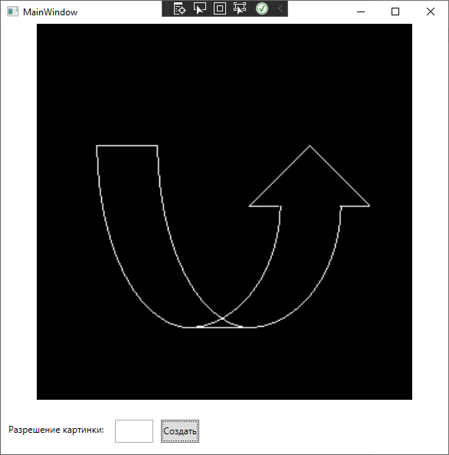

Блок-схема алгоритма:

