Белорусско-Российский университет

Кафедра ПОИТ

Дисциплина ООПП

Отчет по лабораторной работе №4

«ИЕРАРХИИ КЛАССОВ. НАСЛЕДОВАНИЕ»

Выполнил студент группы АСОИ-181

Самусев Д.А.

Проверил ______ Горбатенко Н.Н.

Могилёв 2020г

Цель работы: изучение приемов создания иерархии классов, выделение общих признаков объектов в базовый класс, организации доступа к элементам базового и производных классов.

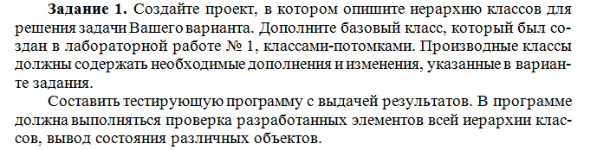

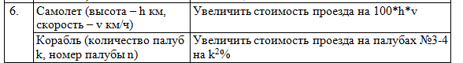

Код программы :

using System;  
  
namespace Lab4  
{  
 class Program  
 {  
 static void Main(string[] args)  
 {  
 var plane = new Plane("Plane", 10, 10, 10, 10);  
 var expensiveShip = new Ship("ExpensiveShip", 15, 15, 5, 3);  
 var ship = new Ship("Ship", 15, 15, 5, 2);  
   
 Console.WriteLine($"Plane info: name - {plane.Name}, speed - {plane.Speed}");  
 Console.WriteLine($"Ship info: name - {ship.Name}, deckNumber - {ship.DeckNumber}");  
  
 Console.WriteLine($"Total price for plane {plane.CalculateTravelPrice()}");  
 Console.WriteLine($"Total price for expensive ship {expensiveShip.CalculateTravelPrice()}");  
 Console.WriteLine($"Total price for ship {ship.CalculateTravelPrice()}");  
   
 Console.ReadKey();  
 }  
 }  
}

public class Vehicle  
{  
 protected string _name;  
 protected double _distance;  
 protected double _price;  
  
 public string Name  
 {  
 get => _name;  
 set => _name = value;  
 }  
  
 public double Distance  
 {  
 get => _distance;  
 set => _distance = value;  
  
 }  
 public double Price  
 {  
 get => _price;  
 set => _price = value;  
 }  
  
 public Vehicle()  
 {  
 _name = "Bus";  
 Distance = 10;  
 Price = 10;  
 }  
  
 public Vehicle(string name, double distance, double price)  
 {  
 _name = name;  
 Distance = distance;  
 Price = price;  
 }  
  
 public string GetFields()  
 {  
 return $"Name: {_name}, distance: {_distance}, price: {_price}";  
 }  
  
 public double CalculateTravelPrice()  
 {  
 return _distance * _price;  
 }  
}

public class Plane : Vehicle  
{  
 private double _height;  
 private double _speed;  
  
 public double Height  
 {  
 get => _height;  
 set => _height = value;  
 }  
  
 public double Speed  
 {  
 get => _speed;  
 set => _speed = value;  
 }  
  
 public Plane(string name, double distance,   
 double price, double height, double speed) :   
 base(name, distance, price)  
 {  
 _price *= height * speed;  
 _height = height;  
 _speed = speed;  
 }  
}

public class Ship : Vehicle  
{  
 private int _deckCount;  
 private int _deckNumber;  
  
 public int DeckCount  
 {  
 get => _deckCount;  
 set => _deckCount = value;  
 }  
  
 public int DeckNumber  
 {  
 get => _deckNumber;  
 set => _deckNumber = value;  
 }  
  
 public Ship(string name, double distance,   
 double price, int deckCount, int deckNumber) :  
 base(name, distance, price)  
 {  
 _deckCount = deckCount;  
 _deckNumber = deckNumber;  
   
 if (deckNumber == 3 || deckNumber == 4)  
 {  
 _price += price / 100 * Math.Pow(deckCount, 2);  
 }  
 }  
}

