**Лабораторная работа №11**

Разработка распределённого приложения при помощи служб WCF

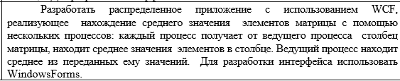

using System;

using System.Collections.Generic;

using System.Linq;

using System.Windows.Forms;

namespace LAB_11

{

public partial class Form1 : Form

{

public static int N;

public static int M;

public static int[,] Matrix;

public Form1()

{

InitializeComponent();

}

private void button1_Click(object sender, EventArgs e)

{

int.TryParse(textBox1.Text, out N);

int.TryParse(textBox2.Text, out M);

Matrix = new int[N, M];

for(int j = 0; j < M; j++)

{

dataGridView1.Columns.Add("column" + j, j.ToString());

}

for(int i = 0; i < N; i++)

{

dataGridView1.Rows.Add();

}

}

private void button2_Click(object sender, EventArgs e)

{

ServiceReference1.Service1Client client = new ServiceReference1.Service1Client();

for(int i = 0; i < N; i++)

{

for (int j = 0; j < M; j++)

{

Matrix[i, j] = Convert.ToInt32(dataGridView1[j, i].Value);

}

}

double[] averages = new double[M];

for (int j = 0; j < M; j++)

{

List<int> values = new List<int>();

for (int i = 0; i < N; i++)

{

values.Add(Matrix[i, j]);

}

averages[j] = client.GetAverage(values.ToArray());

}

double avg_result = averages.Average();

textBox3.Text = avg_result.ToString();

}

}

}

using System;

using System.Collections.Generic;

using System.Linq;

namespace WcfServiceLibrary1_LAB_11

{

public class Service1 : IService1

{

public string GetData(int value)

{

return string.Format("You entered: {0}", value);

}

public CompositeType GetDataUsingDataContract(CompositeType composite)

{

if (composite == null)

{

throw new ArgumentNullException("composite");

}

if (composite.BoolValue)

{

composite.StringValue += "Suffix";

}

return composite;

}

public double GetAverage(List<int> values)

{

return values.Average();

}

}

}

[ServiceContract]

public interface IService1

{

[OperationContract]

string GetData(int value);

[OperationContract]

CompositeType GetDataUsingDataContract(CompositeType composite);

[OperationContract]

double GetAverage(List<int> values);

}

