**Лабораторная работа №2**

Работа с процессами и потоками

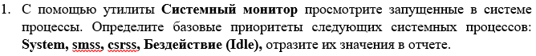

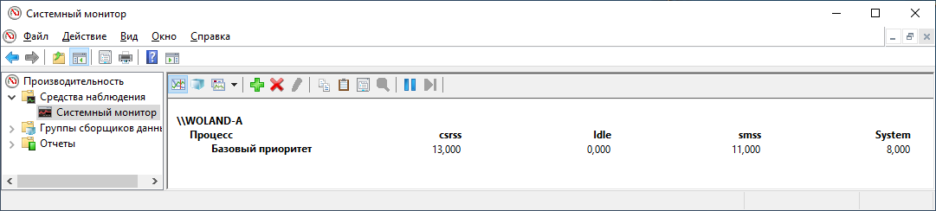

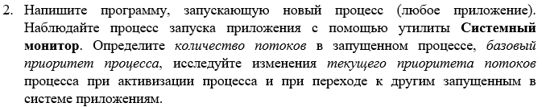

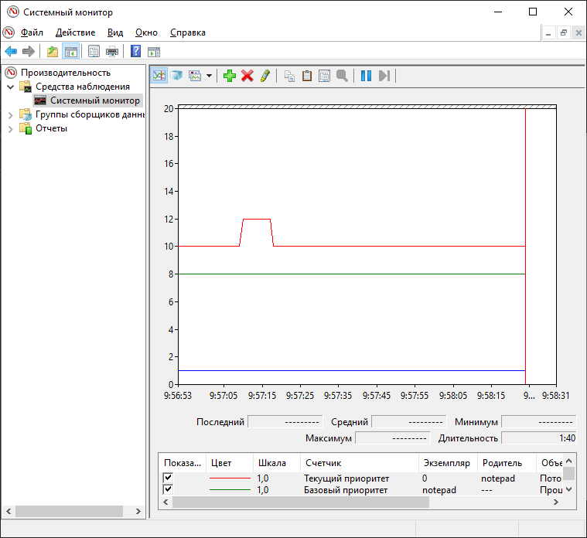

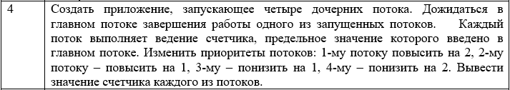

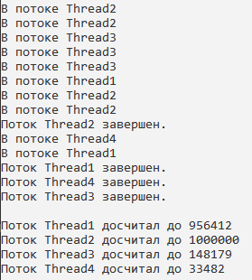

Код программы:

using System;

namespace SPO_lab2_3_Ostapenko

{

class Program

{

public static void Main()

{

int countLimit = 1000000;

var thread1 = new MyThread("Thread1", countLimit);

var thread2 = new MyThread("Thread2", countLimit);

var thread3 = new MyThread("Thread3", countLimit);

var thread4 = new MyThread("Thread4", countLimit);

thread1.thread.Priority += 1;

thread2.thread.Priority += 1;

thread3.thread.Priority -= 1;

thread4.thread.Priority -= 2;

thread1.thread.Start();

thread2.thread.Start();

thread3.thread.Start();

thread4.thread.Start();

thread1.thread.Join();

thread2.thread.Join();

thread3.thread.Join();

thread4.thread.Join();

Console.WriteLine();

Console.WriteLine("Поток " + thread1.thread.Name + " досчитал до " + thread1.Count);

Console.WriteLine("Поток " + thread2.thread.Name + " досчитал до " + thread2.Count);

Console.WriteLine("Поток " + thread3.thread.Name + " досчитал до " + thread3.Count);

Console.WriteLine("Поток " + thread4.thread.Name + " досчитал до " + thread4.Count);

}

}

}

using System;

using System.Threading;

namespace SPO_lab2_3_Ostapenko

{

class MyThread

{

private int _count;

private int _countLimit;

private static bool _stop = false;

private static string _currentName;

public Thread thread;

public int Count

{

get => _count;

set

{

if (value > 0)

{

_count = value;

}

}

}

public int CountLimit

{

get => _countLimit;

set => _countLimit = value;

}

public MyThread(string name, int countLimit)

{

Count = 0;

thread = new Thread(new ThreadStart(this.Run))

{

Name = name

};

_currentName = name;

CountLimit = countLimit;

}

private void Run()

{

Console.WriteLine("Поток " + thread.Name + " стартовал. ");

do

{

Count++;

if (_currentName != thread.Name)

{

_currentName = thread.Name;

Console.WriteLine("В потоке " + _currentName);

}

} while (_stop == false && Count < 1000000);

_stop = true;

Console.WriteLine("Поток " + thread.Name + " завершен.");

}

}

}