Белорусско-Российский университет

Кафедра ПОИТ

Дисциплина ООПП

Отчет по лабораторной работе №11

«РАЗРАБОТКА WINDOWS-ПРИЛОЖЕНИЙ»

Выполнил студент группы АСОИ-181

Самусев Д. А.

Проверил ______ Горбатенко Н.Н.

Могилёв 2020г

Цель: разработка графического интерфейса для Windows-приложений с помощью технологии Windows Forms. Работа с диалогами открытия и сохранения файлов.

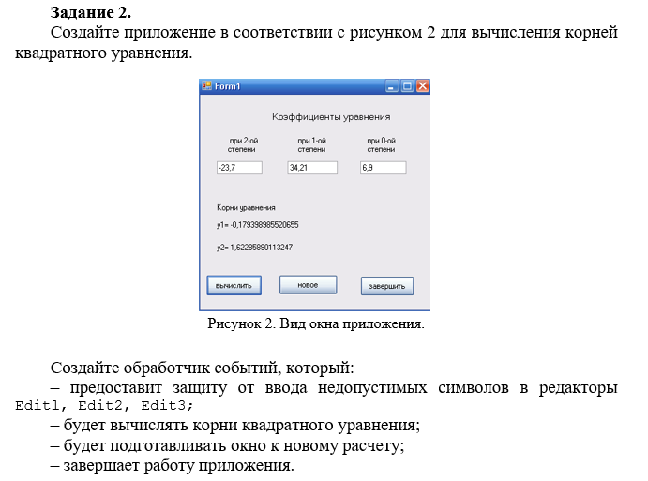

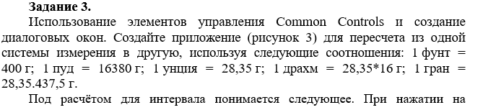

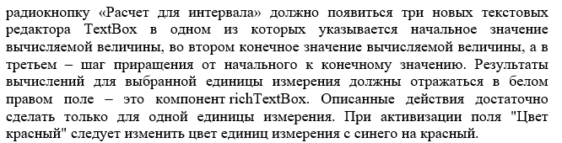

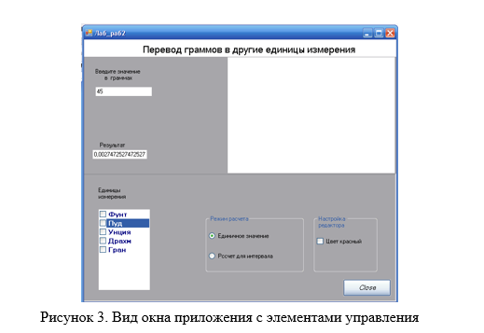

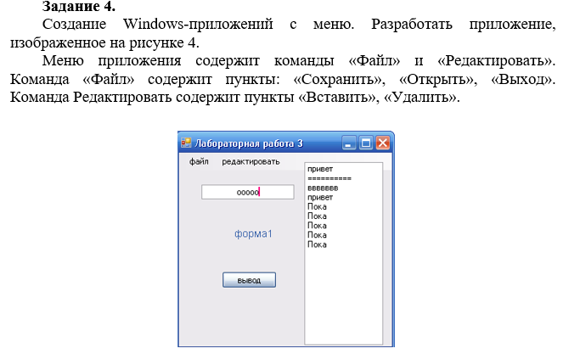

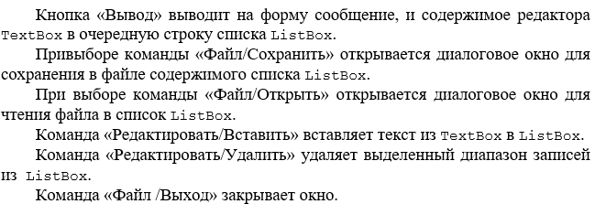

Код программы :

public partial class Form1 : Form

{

private double a;

private double b;

private double c;

public Form1()

{

InitializeComponent();

}

public void textBox1_TextChanged(object sender, System.EventArgs e)

{

if (!double.TryParse(textBox1.Text, out a))

{

textBox1.Text = string.Empty;

}

}

public void textBox2_TextChanged(object sender, System.EventArgs e)

{

if (!double.TryParse(textBox2.Text, out b))

{

textBox1.Text = string.Empty;

}

}

public void textBox3_TextChanged(object sender, System.EventArgs e)

{

if (!double.TryParse(textBox3.Text, out c))

{

textBox1.Text = string.Empty;

}

}

private void button1_Click(object sender, System.EventArgs e)

{

double D = Math.Pow(b, 2) - 4 * a * c;

label5.Text = "Y1 = " + ((-b - Math.Sqrt(D)) / (2 * a)).ToString();

label6.Text = "Y2 = " + ((+b + Math.Sqrt(D)) / (2 * a)).ToString();

}

private void button2_Click(object sender, EventArgs e)

{

textBox1.Text = string.Empty;

textBox2.Text = string.Empty;

textBox3.Text = string.Empty;

label5.Text = string.Empty;

label6.Text = string.Empty;

a = 0;

b = 0;

c = 0;

}

private void button3_Click(object sender, EventArgs e)

{

Application.Exit();

}

}

Задание 2

public Dictionary<string, double> dictionary = new Dictionary<string, double>();

public Form1()

{

InitializeComponent();

dictionary.Add("Фут", 400);

dictionary.Add("Пуд", 16380);

dictionary.Add("Унция", 28.35);

dictionary.Add("Драхм", 448);

dictionary.Add("Гран", 437.5);

checkedListBox1.Items.AddRange(dictionary.Select(i => i.Key).ToArray());

}

public void CheckBox3_Checked(object sender, EventArgs e)

{

checkedListBox1.ForeColor = System.Drawing.Color.Red;

}

private void radioButton2_CheckedChanged(object sender, EventArgs e)

{

label4.Visible = radioButton2.Checked;

label5.Visible = radioButton2.Checked;

label6.Visible = radioButton2.Checked;

textBox3.Visible = radioButton2.Checked;

textBox4.Visible = radioButton2.Checked;

textBox5.Visible = radioButton2.Checked;

}

private void button1_Click(object sender, EventArgs e)

{

if (radioButton1.Checked)

{

dictionary.TryGetValue(checkedListBox1.CheckedItems[0].ToString(), out double result);

textBox2.Text = (double.Parse(textBox1.Text) * result).ToString();

}

else

{

double i = double.Parse(textBox5.Text);

for (; i <= double.Parse(textBox4.Text); i += double.Parse(textBox3.Text))

{

dictionary.TryGetValue(checkedListBox1.CheckedItems[0].ToString(), out double result);

string item = (i * result).ToString();

richTextBox1.Text += $"{item} \n";

}

}

}

}

Задание 3

using System;

using System.IO;

using System.Windows.Forms;

namespace Lab11_3

{

public partial class Form1 : Form

{

public Form1()

{

InitializeComponent();

ToolStripMenuItem fileItem = new ToolStripMenuItem("Файл");

ToolStripMenuItem editItem = new ToolStripMenuItem("Редактировать");

editItem.DropDownItems.Add(new ToolStripMenuItem("Вставить"));

editItem.DropDownItems.Add(new ToolStripMenuItem("Удалить"));

editItem.DropDownItems[0].Click += Insert_Click;

editItem.DropDownItems[1].Click += Delete_Click;

fileItem.DropDownItems.Add(new ToolStripMenuItem("Сохранить"));

fileItem.DropDownItems.Add(new ToolStripMenuItem("Открыть"));

fileItem.DropDownItems.Add(new ToolStripMenuItem("Выход"));

fileItem.DropDownItems[0].Click += Save_Click;

fileItem.DropDownItems[1].Click += Load_Click;

fileItem.DropDownItems[2].Click += Exit_Click;

menuStrip1.Items.Add(fileItem);

menuStrip1.Items.Add(editItem);

}

private void button1_Click(object sender, EventArgs e)

{

label1.Text = textBox1.Text;

listBox1.Items.Add(label1.Text);

}

private void Save_Click(object sender, EventArgs e)

{

SaveFileDialog saveFileDialog1 = new SaveFileDialog();

saveFileDialog1.Filter = "txt files (*.txt)|*.txt|All files (*.*)|*.*";

saveFileDialog1.FilterIndex = 2;

saveFileDialog1.RestoreDirectory = true;

if (saveFileDialog1.ShowDialog() == DialogResult.OK)

{

string filename = saveFileDialog1.FileName;

File.WriteAllText(filename, listBox1.Text);

}

}

private void Load_Click(object sender, EventArgs e)

{

OpenFileDialog openFileDialog1 = new OpenFileDialog();

if (openFileDialog1.ShowDialog() == DialogResult.Cancel)

return;

string filename = openFileDialog1.FileName;

string fileText = File.ReadAllText(filename);

listBox1.Items.Add(fileText);

}

private void Exit_Click(object sender, EventArgs e)

{

Application.Exit();

}

private void Insert_Click(object sender, EventArgs e)

{

listBox1.Items.Add(textBox1.Text);

}

private void Delete_Click(object sender, EventArgs e)

{

listBox1.Items.Clear();

}

}

}