**Лабораторная работа № 7.**

**Использование персистентных классов.**

Самусев Д. А. АСОИ-181

**Цель**: Познакомиться с технологией работы с персистентными классами на примере Entity Framework.

**Задание**

Приведенное приложение следует усложнить, доработав интерфейс с базой данных, добавив методы для поиска, редактирования (ввода новых) записей и удаления.

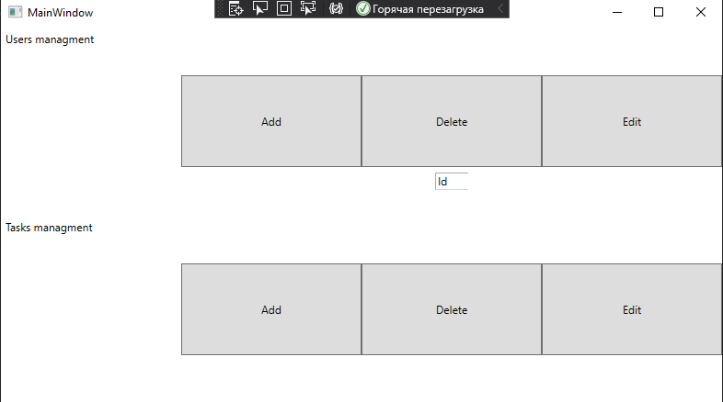

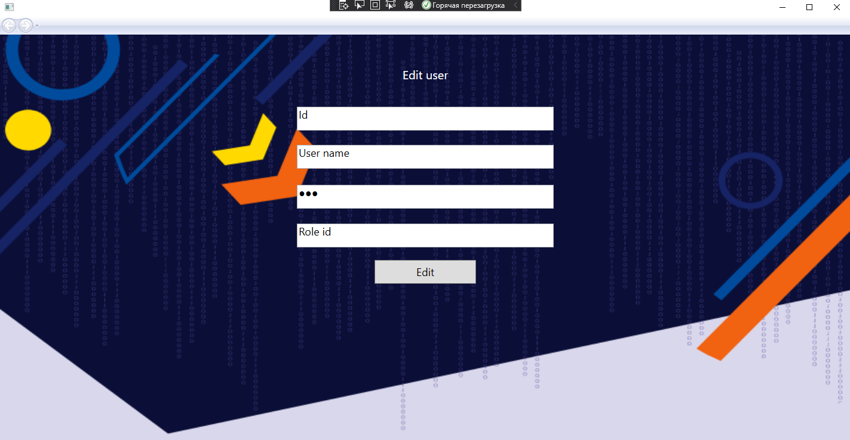

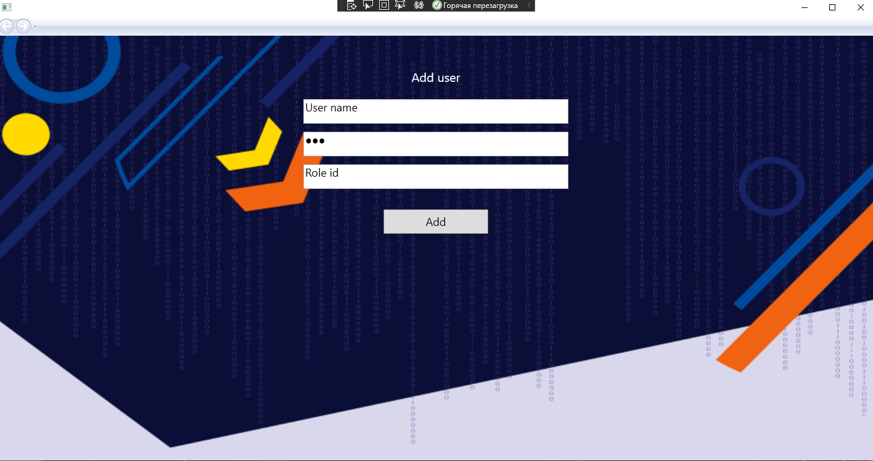

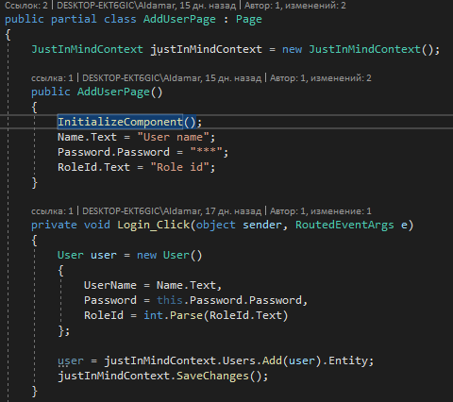

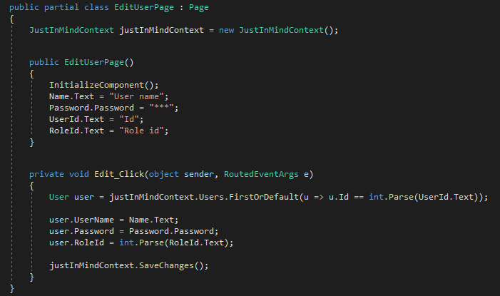

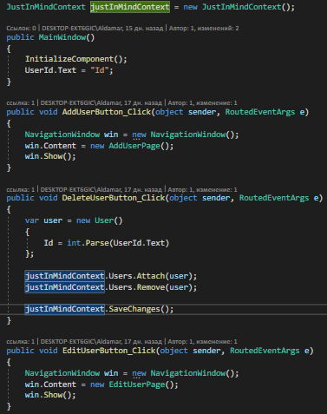

<Page x:Class="Lab20.UI.AddUserPage"

xmlns="http://schemas.microsoft.com/winfx/2006/xaml/presentation"

xmlns:x="http://schemas.microsoft.com/winfx/2006/xaml"

xmlns:mc="http://schemas.openxmlformats.org/markup-compatibility/2006"

xmlns:d="http://schemas.microsoft.com/expression/blend/2008"

xmlns:local="clr-namespace:Lab20.UI"

mc:Ignorable="d"

d:DesignHeight="450" d:DesignWidth="800"

Title="AddUserPage">

<Grid>

<Grid.RowDefinitions>

<RowDefinition Height="auto" />

<RowDefinition Height="auto" />

<RowDefinition Height="auto" />

<RowDefinition Height="auto" />

<RowDefinition Height="auto" />

<RowDefinition Height="auto" />

<RowDefinition Height="*" />

</Grid.RowDefinitions>

<Grid.Background>

<ImageBrush ImageSource="D:\MyProjects\JustInMind\JustInMindApp\Lab20.UI\Login.png" />

</Grid.Background>

<TextBlock

Grid.Row="0"

Width="250"

Height="30"

Margin="0,53,0,0"

HorizontalAlignment="Center"

VerticalAlignment="Top"

FontSize="20"

Foreground="White"

Text="Add user"

TextAlignment="Center"

TextWrapping="Wrap" />

<TextBox

x:Name="Name"

Width="430"

Height="40"

Margin="0,103,0,0"

HorizontalAlignment="Center"

VerticalAlignment="Top"

FontSize="18"

TextWrapping="Wrap"/>

<PasswordBox

Name="Password"

Grid.Row="1"

Width="430"

Height="40"

Margin="0,13,0,0"

HorizontalAlignment="Center"

VerticalAlignment="Top"

FontSize="18">

</PasswordBox>

<TextBox

x:Name="RoleId"

Grid.Row="2"

Width="430"

Height="40"

Margin="0,13,0,0"

HorizontalAlignment="Center"

VerticalAlignment="Top"

FontSize="18"

TextWrapping="Wrap">

</TextBox>

<Button

x:Name="Login"

Grid.Row="3"

Width="170"

Height="40"

Margin="0,33,0,0"

HorizontalAlignment="Center"

VerticalAlignment="Top"

Click="Login_Click"

Content="Add"

FontSize="18" Grid.RowSpan="2"/>

</Grid>

</Page>

<Window x:Class="Lab20.UI.MainWindow"

xmlns="http://schemas.microsoft.com/winfx/2006/xaml/presentation"

xmlns:x="http://schemas.microsoft.com/winfx/2006/xaml"

xmlns:d="http://schemas.microsoft.com/expression/blend/2008"

xmlns:mc="http://schemas.openxmlformats.org/markup-compatibility/2006"

xmlns:local="clr-namespace:Lab20.UI"

mc:Ignorable="d"

Title="MainWindow" Height="450" Width="800">

<Grid>

<Grid.RowDefinitions>

<RowDefinition></RowDefinition>

<RowDefinition></RowDefinition>

</Grid.RowDefinitions>

<Grid.ColumnDefinitions>

<ColumnDefinition></ColumnDefinition>

<ColumnDefinition></ColumnDefinition>

<ColumnDefinition></ColumnDefinition>

<ColumnDefinition></ColumnDefinition>

</Grid.ColumnDefinitions>

<Label Grid.Column="0" Grid.Row="0" Content="Users managment"></Label>

<Button Grid.Column="1" Grid.Row="0" Content="Add" Click="AddUserButton_Click" Height="100"></Button>

<Button Grid.Column="2" Grid.Row="0" Content="Delete" Click="DeleteUserButton_Click" Height="100"></Button>

<TextBox x:Name="UserId" Grid.Column="2" Grid.Row="0" Width="40" Margin="80,159,80,28" ></TextBox>

<Button Grid.Column="3" Grid.Row="0" Content="Edit" Click="EditUserButton_Click" Height="100"></Button>

<Label Grid.Column="0" Grid.Row="1" Content="Tasks managment"></Label>

<Button Grid.Column="1" Grid.Row="1" Content="Add" Click="AddTaskButton_Click" Height="100"></Button>

<Button Grid.Column="2" Grid.Row="1" Content="Delete" Click="DeleteTaskButton_Click" Height="100"></Button>

<Button Grid.Column="3" Grid.Row="1" Content="Edit" Click="EditTaskButton_Click" Height="100"></Button>

</Grid>

</Window>