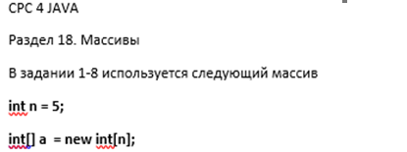

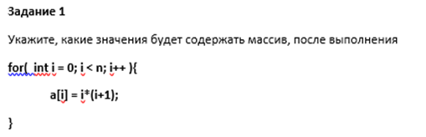

**Ответ:**

|  |  |  |  |  |
| --- | --- | --- | --- | --- |
| **0** | **2** | **6** | **12** | **20** |

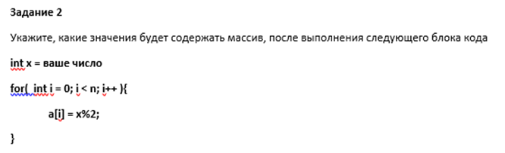

**Ответ при x=9:**

|  |  |  |  |  |
| --- | --- | --- | --- | --- |
| **1** | **1** | **1** | **1** | **1** |

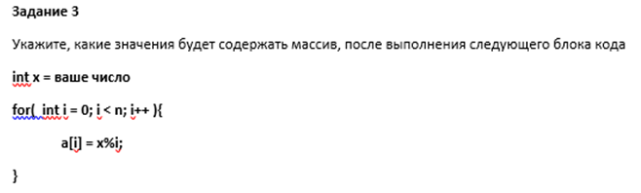

**Ответ:**

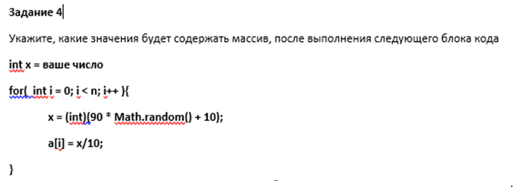

**Ответ при x = 5:**

|  |  |  |  |  |
| --- | --- | --- | --- | --- |
| **3** | **6** | **9** | **5** | **6** |

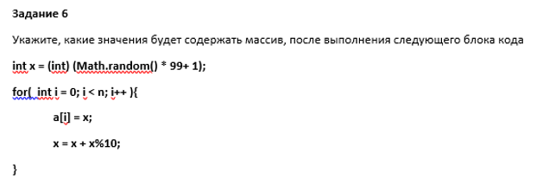

**Ответ:**

|  |  |  |  |  |
| --- | --- | --- | --- | --- |
| **72** | **74** | **78** | **86** | **92** |

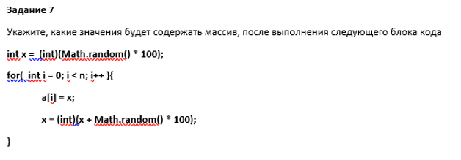

**Ответ:**

|  |  |  |  |  |
| --- | --- | --- | --- | --- |
| **85** | **163** | **173** | **204** | **225** |

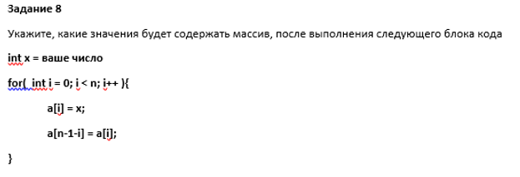

**Ответ при x = 9:**

|  |  |  |  |  |
| --- | --- | --- | --- | --- |
| **9** | **9** | **9** | **9** | **9** |