Project: Dynamic Commission Calculator for Sales Teams
Student: Ishimwe Daniel
ID: 27296
Course: Database Development with PL/SQL (INSY 8311)
Institution: Adventist University of Central Africa (AUCA)
Lecturer: Eric Maniraguha
Completion Date: December 8, 2025
Project Type: Capstone Project (Final Exam)

➢ Introduction
The Dynamic Commission Calculator for Sales Teams is a system designed to automate, streamline, and enhance how sales commissions are calculated within an organisation. Traditionally, many companies rely on manual spreadsheets and fixed percentage rules,
which are time-consuming, error-prone, and difficult to update when sales policies change. This project solves these challenges by building a flexible PL/SQL-based solution that automatically computes commissions based on sales performance, product categories, sales targets, and personalised business rules.
The system ensures accuracy, fairness, and transparency between management and sales teams. It also improves productivity by reducing administrative workload and providing immediate feedback on sales performance. The project is suitable for companies with varying commission structures, including tiered schemes, product-specific percentages, or incentive bonuses.

🎯 Problem Statement
Sales organizations struggle with manual, error-prone commission calculations that lack real-time processing, dynamic rule application, and comprehensive analytics. This system automates commission calculations with business intelligence capabilities to solve:

- Manual calculation errors and delays

- Lack of real-time commission processing

- Inconsistent application of commission rules

- Limited analytics for decision-making

- No comprehensive audit trail

➢ Entities and relationship
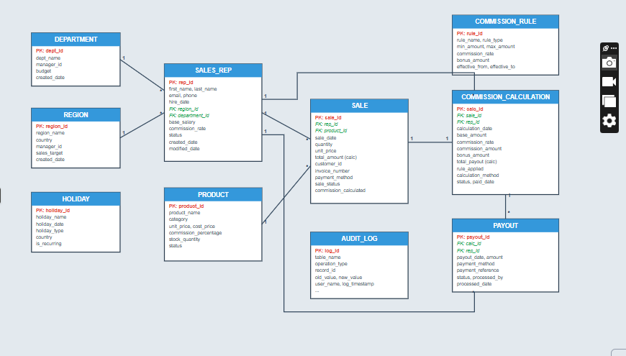

RELATIONSHIPS IN THE DIAGRAM

1. DEPARTMENT → SALES_REP
Relationship:
- DEPARTMENT (1)——(∞) SALES_REP
FK:
- SALES_REP.dept_id → DEPARTMENT.dept_id
Meaning:
Each department has many sales reps; every sales rep belongs to one department.

2. REGION → SALES_REP
Relationship:
- REGION (1)——(∞) SALES_REP
FK:
- SALES_REP.region_id → REGION.region_id
Meaning:
Each region has many sales reps; every rep belongs to one region.

3. REGION → HOLIDAY
Relationship:
- REGION (1)——(∞) HOLIDAY
FK:
- HOLIDAY.region_id → REGION.region_id
Meaning:
Every holiday is defined for one region; each region can have many holidays.

4. PRODUCT → SALE
Relationship:
- PRODUCT (1)——(∞) SALE
FK:
- SALE.product_id → PRODUCT.product_id
Meaning:
A sale references one product; each product can be sold many times.

5. SALES_REP → SALE
Relationship:
- SALES_REP (1)——(∞) SALE
FK:
- SALE.rep_id → SALES_REP.rep_id
Meaning:
Each sale is performed by one sales rep; a rep can have many sales.

6. COMMISSION_RULE → COMMISSION_CALCULATION
Relationship:
- COMMISSION_RULE (1)——(∞) COMMISSION_CALCULATION
FK:
- COMMISSION_CALCULATION.rule_id → COMMISSION_RULE.rule_id
Meaning:
A commission rule is applied many times in commission calculations.

7. SALE → COMMISSION_CALCULATION
Relationship:
- SALE (1)——(1) COMMISSION_CALCULATION
FK:
- COMMISSION_CALCULATION.sale_id → SALE.sale_id
Meaning:
Each sale generates one commission calculation.

8. COMMISSION_CALCULATION → PAYOUT
Relationship:
- COMMISSION_CALCULATION (1)——(∞) PAYOUT
FK:
- PAYOUT.calc_id → COMMISSION_CALCULATION.calc_id
Meaning:
A commission calculation can result in multiple payouts (e.g., split payments).

9. SALE → AUDIT_LOG
Relationship:
- SALE (1)——(∞) AUDIT_LOG
FK:
- AUDIT_LOG.sale_id → SALE.sale_id
Meaning:
A sale may appear in audit logs multiple times (eg. updates, corrections).

- Process Overview
The Dynamic Commission Calculator automates the end-to-end workflow of sales commission processing, from transaction recording through payment disbursement, with built-in approval workflows and comprehensive auditing.
- Main Components

1. Transaction Recording & Validation
- Actors: Sales Representatives, System

- Flow: Sales reps record transactions in real-time through the system interface. The system validates data against business rules (customer validation, product codes, pricing limits) and stores valid transactions in the database with complete audit trails.

2. Commission Calculation Engine
- Actors: System (Automated)

- Flow: Upon transaction validation, the system retrieves applicable commission rules based on product category, sales territory, and representative tier. It calculates base commission, applies performance multipliers, checks target achievement for bonuses, and generates preliminary commission records. Calculations consider factors like: base rate (%), tier multiplier (bronze/silver/gold/platinum), target achievement bonus, product-specific rates, and team vs. individual sales split.

3. Approval Workflow
- Actors: System, Sales Managers, Finance Department

- Flow: Commissions below a threshold (e.g., $5,000) are auto-approved. Higher amounts require manager approval. Managers review commission details, sales documentation, and performance metrics. They can approve, reject with feedback, or escalate to finance for complex cases. Rejected commissions return to sales reps for clarification.

4. Payment Processing
- Actors: Finance Department, System

- Flow: Approved commissions are batched by pay period (weekly/biweekly/monthly). Finance validates total amounts against budgets, processes batch payments through the payroll system, updates payment status, and generates financial reports for accounting reconciliation.

5. Dispute Resolution
- Actors: Sales Representatives, Sales Managers, Finance

- Flow: Sales reps can dispute commission calculations within 30 days. The system flags disputed records, managers investigate by reviewing transaction history and rule application, and resolutions result in either recalculation or dispute closure with documentation.
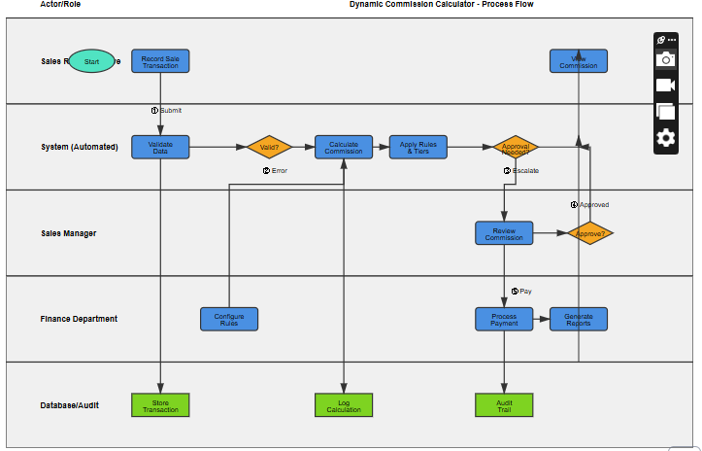
Phase IV: Database Creation
Objective: Create and configure Oracle pluggable database
Deliverable: Database creation scripts + configuration
Key Components:
- Database: mon_27296_daniel_DynamicCommissionCalculator_db
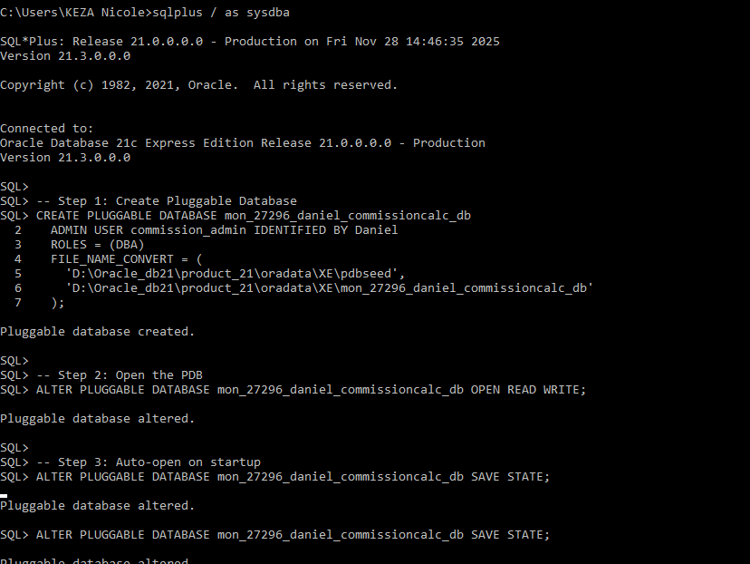
- Tablespaces for data, indexes, and temp storage
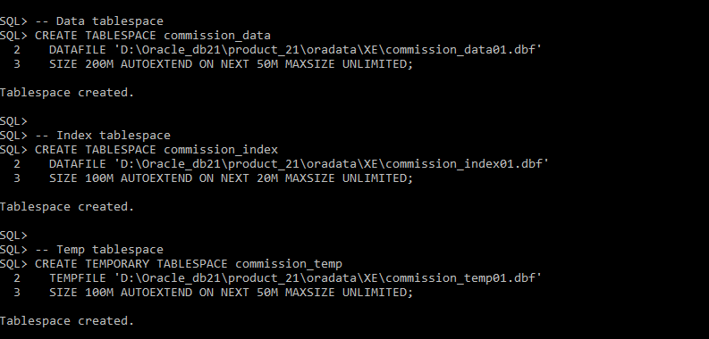
- Users: admin (commission_admin), application (commission_app), reporting (commission_report)

- Archive logging enabled
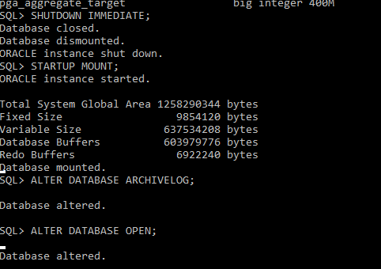
- Memory parameters optimized
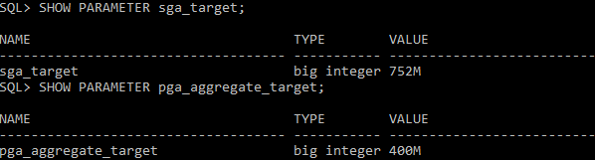
Phase V: Table Implementation & Data Insertion
Objective: Build physical database structure with realistic test data
Deliverable: CREATE/INSERT scripts + validation queries
Key Components:
- 9 Main Tables:
  - SALES_REP - Sales representative information
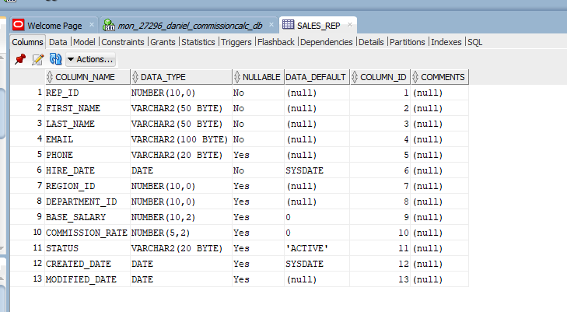
  - DEPARTMENT - Department data
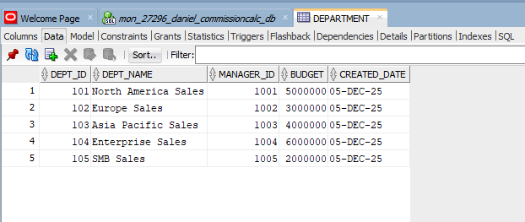
  - REGION - Regional information
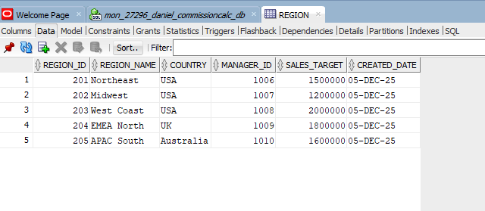
  - PRODUCT - Product catalog
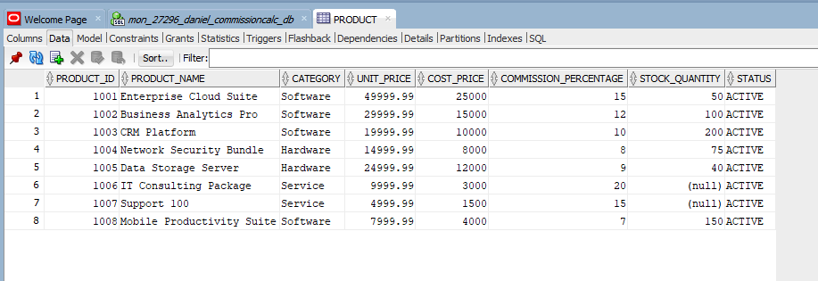
  - SALE - Sales transactions
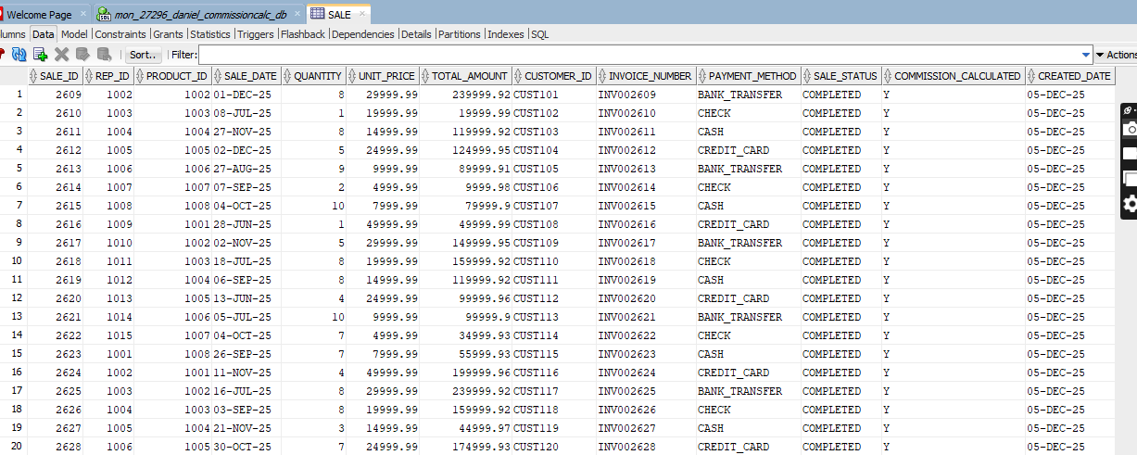
  - COMMISSION_RULE - Commission calculation rules
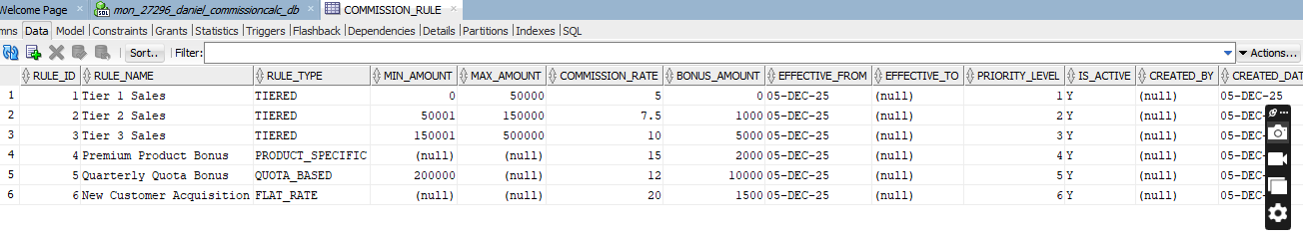
  - COMMISSION_CALCULATION - Calculated commissions
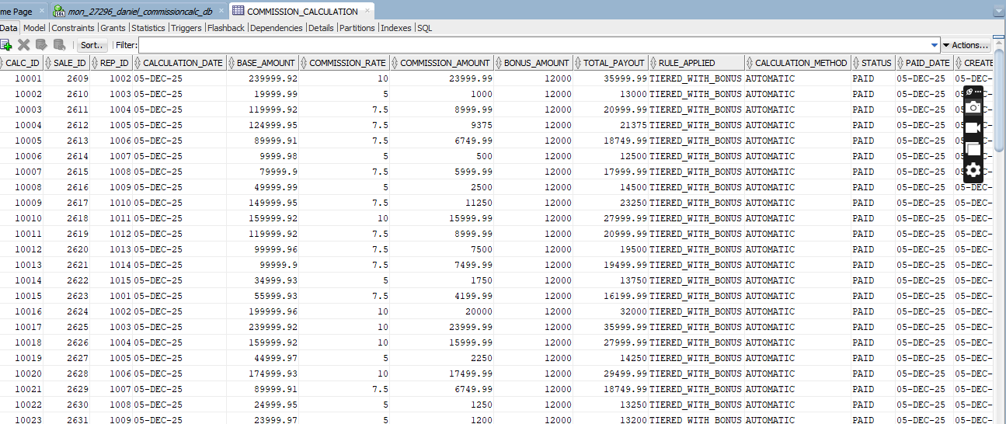

  - PAYOUT - Commission payout records
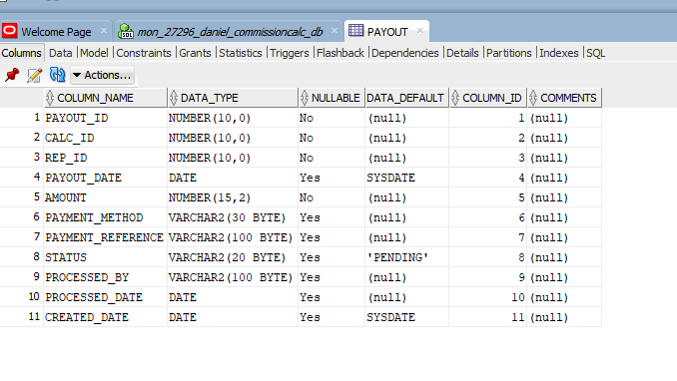
  - AUDIT_LOG - Comprehensive audit trail
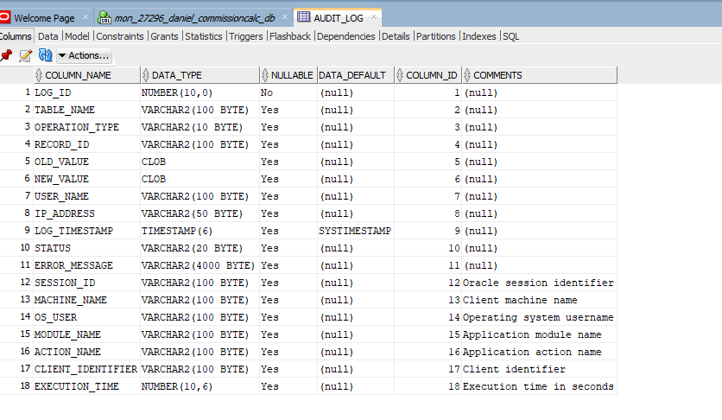
- 500+ realistic records across all tables
- Constraints: PK, FK, CHECK, NOT NULL, UNIQUE, DEFAULT
- Indexes for performance optimization
- Sequences for ID generation
Phase VI: PL/SQL Development
Objective: Develop procedures, functions, packages, and cursors
Deliverable: PL/SQL scripts + test results
5 Core Procedures:
- calculate_sale_commission() - Calculate commission for individual sales
- process_monthly_payout() - Process bulk commission payments
- generate_sales_report() - Generate detailed sales reports
- bulk_update_product_prices() - Update prices with business rules
- update_rep_commission_rate() - Update commission rates with validation
5 Key Functions:
- get_tiered_commission_rate() - Determine rates based on sales tiers
- calculate_quarterly_bonus() - Calculate performance bonuses
- get_performance_rating() - Star ratings for sales reps (1-5 stars)
- check_promotion_eligibility() - Promotion eligibility checks
- validate_email() - Email format validation
Packages & Cursors:
- COMMISSION_PKG package with specification and body
- Explicit cursors for multi-row processing
- Parameterized cursors for flexible queries
- Window functions for advanced analytics
Phase VII: Advanced Programming & Auditing
Objective: Implement triggers, business rules, and comprehensive auditing
CRITICAL BUSINESS RULE:
Employee CANNOT INSERT/UPDATE/DELETE on:
1. WEEKDAYS (Monday-Friday)
2. PUBLIC HOLIDAYS (upcoming month only)
Implementation Components:
- Holiday Management System:
  - HOLIDAY table with recurring holidays
  - Sample holidays for upcoming month
- Enhanced Audit System:
  - Comprehensive AUDIT_LOG table with session/client info
  - Autonomous transaction logging function
- Restriction Functions:
  - is_weekday() - Check if date is Monday-Friday
  - is_holiday() - Check if date is public holiday
  - can_employee_perform_dml() - Enforce business rule
- Triggers:
  - 4 Simple triggers for basic DML restriction
  - 1 Compound trigger with comprehensive auditing
  - Business rule triggers for salary/commission validation
- Testing Requirements Met:
✅ Trigger blocks INSERT on weekday (DENIED)
✅ Trigger allows INSERT on weekend (ALLOWED)
✅ Trigger blocks INSERT on holiday (DENIED)
✅ Audit log captures all attempts
✅ Error messages are clear
✅ User info properly recorded

➢ Conclusion
The Dynamic Commission Calculator is a robust, flexible, and innovative solution that significantly improves how sales commissions are determined and managed. By automating calculations, supporting multiple commission schemes, and providing clear analytical feedback, the system enhances fairness, transparency, and operational efficiency. It is designed with scalability in mind, allowing organisations to adapt the calculator as business needs evolve.

