**CHAPTER 1**

**INTRODUCTION**

Technology is an essential part of our lives today, the peak of technological innovation everything is being automated and computerized from processing of data to advertising services and other business transactions.

A computer-based records system comprises an information filter for assuring that record data units offered to the system for storage are complete and not redundant. These record data units may be electronic in nature, scanned from paper, digitally formed from audio, video or otherwise formed as digital data information media, an objective of the disclosed system being to eliminate paper or microform record keeping. If record data units comprising documents are incomplete or redundant, the data units may be queued for special handling.

The project focuses mainly on monitoring of patient information, generating patient information reports and providing them an efficient way of storing and getting information. transactions with the patient or customer.

A database management system (DBMS) makes it possible for end users to create, read, update and delete data in a database. The DBMS essentially serves as an interface between the database and end users or application programs, ensuring that data is consistently organized and remains easily accessible. The database management system manages three important things: the data, the database engine that allows data to be accessed, locked and modified – and the database schema, which defines the database’s logical structure. These three foundational elements help provide concurrency, security, data integrity and uniform administration procedures. Typical database administration tasks supported by the database management system include change management, performance monitoring/tuning and backup and recovery.

* 1. **Background of Study**

Dr. Helen Claveria Salinas handles the and clinic with his/her secretary, the clinic uses file system in which they store the patient information on the logbooks records.

The business hours of the clinic 8:00am – 5:00pm, the price of the services depends on the result of check-up or damage.

The services being offered by the clinic are

* Oral Prophylaxis
* Permanent Filling
* Extraction
* Anterior Tooth
* Posterior Tooth
* Root Fragment
* Temporary Filling
* Desensitization
* Dental X-ray

The Dental Specialist is currently using the Manuel File System, wherein they use the log record book on saving and retrieving the data information of new/old patient.

patient comes in the secretary or the dental specialist gather information whether if he/she is a new patient. They have this so-called Manual File System where they stored some of the information of their past patient, if you are an old patient, they will find your record and update it to the service you acquired.

* 1. **Project Business Process**
* **Inquiry**

Upon the arrival of the patient, the dental specialist or his/her secretary will ask the patient if he/she is a new or old patient. And the

* **Registration**

The dental specialist or his/her secretary will give the form to the patient to fill out necessary information containing the name of the patient, age, gender, address, contact details. After that the dental specialist or secretary will ask the problem or what dental service the patient needs.

* **Retrieval of Patient Dental Information**

In retrieving of patient dental Information, the secretary or dental specialist will ask the last name of the patient then he/she will search for it in the file cabinet and it was arranged alphabetically. But since the clinic uses a manual system, the clinic has the inability to get to patient information upon immediate need.

* **Appointment**

There are two types of how to get an appointment. One is thru phone call/text the dental specialist or his/her secretary would just get the name of the caller or texter’s number and note it on a piece of paper and ask for the desired date. After getting the information the dental specialist or his/her secretary will check the calendar on the table if the doctor is available on the asked date. After checking, the secretary or dental specialist will confirm it if the dental specialist would like to set an appointment on the said date. If not, then the dental specialist will ask to find another schedule that would fit for the both parties. Same to the walk-in patient who wanted to appoint schedule his/her operation.

* **Payment Method** The dental specialist clinic accepts only a cash payment.

The business uses manual procedures and a file system to conduct and manage their Patient Information. The files system they used to keep records of each day that track the records of the patients in the clinic.

Their current system of acquiring information is the use of forms. With this they allow their clients to input their information such as their name, age, birthday, cellphone number.

They collect and store these data in a logbook of records. The current one is kept at the shelf of the clinic, ready to be used by dental specialist or secretary if they need to update any information of old patient, logbooks holds previous records and is kept and maintained by the Dental Specialist or his/her secretary. The logbooks in the shelf is not numerous which means that storage is not much of an issue for their system.

The logbooks of records can be easily retrieved in the shelf whenever they need to find a specific record. It however, requires the dentist or his/her secretary to inspect page by page of the logbook to find the record. The logbooks are arranged chronologically where the oldest information of patient is at the bottom of the pile.

**1.3 Statement of the Problem**

**1.3.1 General Problem**

The general problem is how to develop, design and implement a computerized Patient Information system for the Dental Specialist Clinic that can help manage, monitor and facilitate all operations in the Clinic.

**1.3.2 Specific Problem**

* How will the proponents create a module that register the new patient, retrieve the old patient information, update by putting the acquired service of the patient and delete information of the patients in a very efficient way.
* How will the proponents develop a module that decreases the time in monitoring of Transaction the was made with the patient? especially when you have a too many patients it takes a lot of time searching.
* How will the proponents develop a module that lessen the time of scheduling a patient and by making sure that there will be no conflict of appointment
  1. **Statement of Objectives**

**1.4.1 General Objectives**

The general objective is to design, develop and implement a computerized Patient Information system for Dental Specialist Clinic that can help manage, monitor, schedule and facilitate all operations in a lesser amount of time.

**1.4.2 Specific Objectives**

* Design and develop a module that will register new patient in a computerized way, retrieving the patient’s data in a very efficient way that lessen the time of searching, update or delete information of the patient.
* Design and develop a module that monitors the transaction that was made with patient, by developing such thing this will give the dental specialist knowledge about the history or services made with the patient.
* Design and develop a module that lessen the time of scheduling a patient

**1.5 Significance of the Study**

The purpose of developing a computerized patient information system for the clinic is to help modernize their current system for their clinic. At the moment they are using a manual procedure and a file system of records via logbooks. By developing a software application that helps monitor all of the patient information, update, delete and even schedule patient, track transactions made with the patient. The clinic can easily handle the different records and may also help the proponents to quick searches and inquiries for specific patient information this will increase the efficiency and accuracy of searches and reduce the time needed to find a patient information.

**1.6 Scope and Limitations of the Study**

**Scope**

The computerized patient information system will accept two kinds of patient information, the old patient that will be updated regarding about the service he/she obtain, the new patient has a **registration module** under this module are patient information which consist of last name, first name, middle name (if necessary), birthdate, and cellphone number. Dental Information which is consist of medical history of the patient, dental char module consists of service acquire (at least one) and the type of treatment (at least one) acquired by the patient.

In the **patient module**, it will have a retrieval of record under this module are edit personal info, edit or add dental treatment information.

**Dental specialist module** it consists of Edit Personal Information, Account (**Add another user of Application ‘Like Secretary or Assistance that can only add and read information’)**. **Scheduling module** that will allows the dentist or secretary schedule a patient on a particular availability date of dental specialist.

**Report Module** consist of Transactions such as List of patient information (new patient), (updated patient), and the Other Transactions. **Maintenance module** consist of Add or Delete Services being offered by the clinic. **Back up module** restores the data or back it up to another computerized storage.

**Limitations:**

The following limitation of the developed system are, it will not compute for billing or printing of the receipt and the system is limited to one user at a time and it will not compute the net income of the clinic

**CHAPTER 2**

**2.0 Methodology of the Study**

A system development life cycle is a conceptual model that describes the phases involved in an information system development project. It is possible to complete some activities in one phase in parallel with some activities of another phase. Phase are repeated as required until an acceptable system is found.

The proponents use this model because of the advantages when it comes to developing the ideal system for the company such as the looping of the model that helps them to enhance the system repeatedly making the system cope up with the advancement of technology.

**Figure – 1.0 System Development Life Cycle Model**

**Planning Phase**

The process of defining clear discrete activities and the work needed to complete each activity within a single project. Its primary objective is identifying the scope of the new system ensures that the project is feasible and to develop a schedule, resource plan, and budget for the remainder of the project.

The gathering of all information about background and business process of the company by series of interviews to develop the ideal system. The data helps to visualize the ideal system from the information they gathered.

**Analysis Phase**

The analysis phase is where teams consider the functional requirements of the project or solution. It's also where system analysis takes place or analyzing the needs of the end users to ensure the new system can meet their expectations. The examining of the data to confirm the ideal system is possible. Every decision and module to be made generate another set of problems to be solved.

**Design Phase**

The design phase describes, in detail the necessary specifications, feature's and operations that will satisfy the functional requirements of the proposed system will be in place

The designing of the proposed system that shows the detailed system in a feasible way.

**Implementation Phase**

In this phase Implementing of the design into source code through coding, combine all the modules together into training environment that detects errors and defects. A test report which contains errors is prepared through test plan that includes test related tasks such as test case generation, testing criteria, and resource allocation for testing. Integrate the information system into its environment and install the new system.

The implementing of the proposed system that will help the business and benefited the company.

**Maintenance**

Include all the activities such as phone support or physical on-site support for users that is required once the system is installing. Implement the changes that software might undergo over a period of time, or implement any new requirements after the software is deployed at the customer location. It also includes handling the residual errors and resolve any issues that may exist in the system even after the testing phase. Maintenance and support may be needed for a longer time for large systems and for a short time for smaller systems.

The system maintenance will be based on the feedback of the system user, any adjustment to be done will start from the beginning of the System development life cycle.

**CHAPTER 3**

**3.0 Data Gathering Procedures and Output**

This chapter discusses the procedures in gathering of data,

Transcript of Interview

Interviewee: Dr. Salinas, Helen Claveria

Position: Dental Specialist

Date of Interview: September 10, 2018

Interviewer: Sarceda, Mark Lyndon T.

Questionnaire:

1. What kind of System you are using File or Computerized System? Elaborate.

Patient Form

1. How do you collect patient information?

Logbook

1. What is the Information you collect to new and old patient? Explain further.

Name,Age Birthday and Cellphone #

1. How many staff do you have?

One

1. Who are the employees and their respective position in the company?

Secretary

1. What are the services offered by the clinic?

Oral Prophylaxis, Permanent Filling, Anterior Tooth, Posterior Tooth, Root Fragment, Temporary Filling, Desensitazation, Dental XRAY

1. Does the patient make the appointment or reservation, or the patient just walk in?

Appiontment

1. How do you schedule your patient?

Time and Day

1. How do you update information in your records?

Write /add accounts follow up result

**CHAPTER 4**

**4.0 The Existing System**

The existing system being used by the dental specialist clinic was the File system being monitored and secured by the Doctor and his/her secretary.

**4.1 Company Background**

The company aims to provide the best dental care solution to every people patient

**4.2 Description of the System**

The File system being used by the dental specialist clinic are known to be the first system file being used, upon the arrival of the patient he/she will be ask by the secretary or dental specialist itself if he/she is new or an old patient. After gathering data about the patient it’s up to the dental specialist or secretary wither to give the patient information form that will be save on the log and to their file system cabinet or just get the history or track record to update for those old patients.

**4.3 Data Flow Diagram**

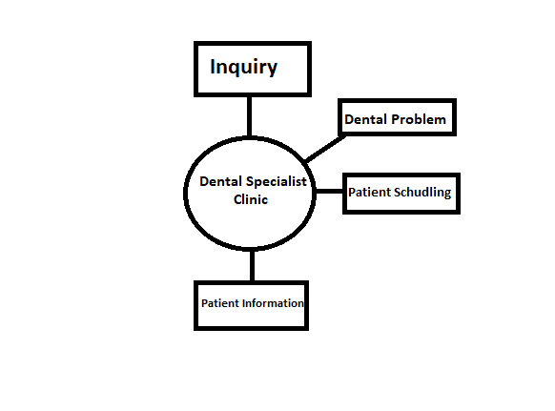

A data flow diagram (DFD) is a graphical representation of the “Flow” of data through an information system, modelling its process aspects. A DFD is often used as a preliminary step to create an overview of the system without going into great detail, which can later be elaborated. DFD’s can also be used for the visualization of data processing.

**4.4 Data Dictionary**

A data dictionary is a collection of descriptions of the data objects or items in a data model for the benefit of programmers and others who need to refer to them. A first step in analyzing a system of objects with which users interact is to identify each object and its relationship to other objects. This process is called data modeling and results in a picture of object relationships. After each data object or item is given a descriptive name, its relationship is described (or it becomes part of some structure that implicitly describes relationship), the type of data (such as text or image or binary value) is described, possible predefined values are listed, and a brief textual description is provided. This collection can be organized for reference into a book called a data dictionary.

These are the data that the dental clinic get from their patient.

* Name
* Age
* Birthday
* Cellphone Number

**4.5 Problem Areas**

Dental public health clinics promote dental health through organized community efforts. The clinics serve to educate the public through group dental care programs with the goal of preventing and controlling dental diseases on a community-wide basis. Dental public health clinics offer such services as finding a dentist, developing dental care programs for schools, providing information on fluoridation in the community, answering common questions about oral health, and providing other oral health resources and support materials to their community.

**CHAPTER 5**

**5.0 The Proposed System**

The Dental Specialist Clinic Patient Information and Appointment Reservation System is created to help the clinic when it comes to the processes that includes the documentation of the information of the patients, it is also created to help the accuracy of appointments being reserved for both the patients and the dental specialist. The system itself is equipped with features that is specifically made to resolve the problems in specific areas an example of that is the processing of adding, updating, appointments and generating reports of the patients, which is one of the major problems in the current system as there has been a lot of security and accuracy issues. With the help of the system, it is expected that most processes that it will be used with, will be expedited at least 50% faster than the system they are currently using right now.

**5.1 System Overview**

The current system that the clinic uses is manual process. They have no existing or record of having a computerized system that they used to help in their patient information processes. The current system sure has a lot of flaws but the management was able to find alternatives and solutions, they may not be the exact solution but it helps with the processes. Still there are some unsolved problems like the lack of efficiency and accuracy of the patient’s information and lack of accuracy and multi-tasking of queuing patient’s appointment reservation.

**5.2 Process Specification**

A process specification is a method used to document, analyze and explain the decision-making logic and formulas used to create output data from process input data. Its objective is to flow down and specify regulatory/engineering requirements and procedures. High-quality, consistent data requires clear and complete process specifications.

A process specification reduces ambiguity, allowing an individual or organization to obtain a precise description of executed tasks and accomplishments and validate system design, including the data dictionary and data flow diagrams.

**5.2.1 Data Flow Diagram**

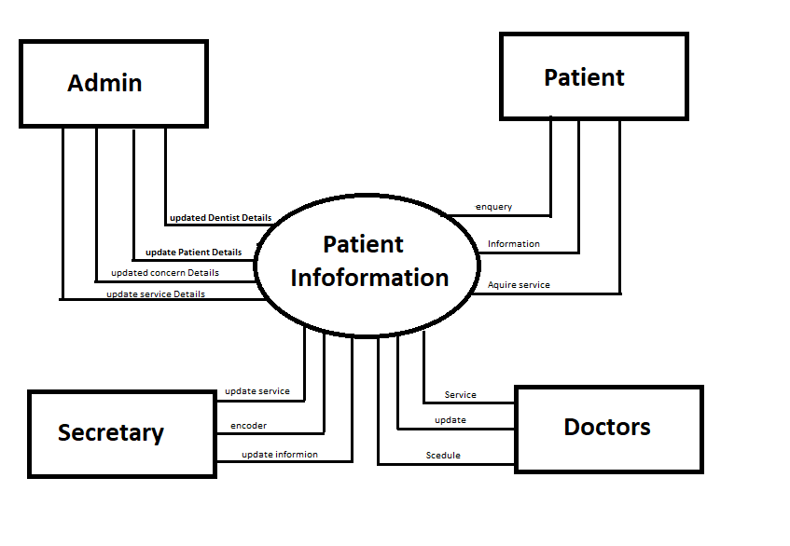

**5.2.2 Data Dictionary**

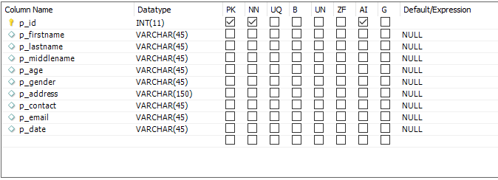

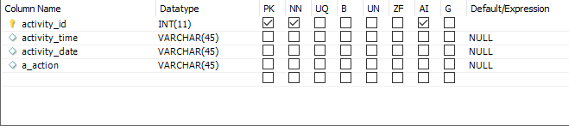

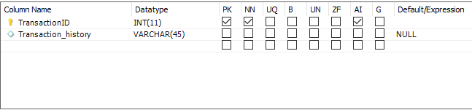

**5.3 Data Specifications**

A data specification consists of a number of *sorts*, a number of *constructors* for each sort, a number of *mappings*, and a set of *equations*. A data specification is an equational specification, in which sorts denote data types. The semantics of a sort is a non-empty set. The elements of the semantics of a sort are described by its constructors, whereas the mappings are functions defined on the semantics of sorts. The equations (axioms) describe equational properties of functions and elements of the semantics.

Note that every element of the semantics of a sort can be constructed from its constructors (this is a property also known as “no junk”). It may however be the case that an element can be described by several constructors (in which case it violates a property commonly known as “no confusion”). The only exception to this are the Booleans; true and false are distinct elements.

A data definition specification may be developed for any organization or specialized field, improving the quality of its products through consistency and transparency. It eliminates redundancy (since all contributing areas are referencing the same specification) and provides standardization, making it easier and more efficient to create, modify, verify, analyze and share information across the enterprise.[[1]](https://en.wikipedia.org/wiki/Data_definition_specification#cite_note-1)

**5.3.1 Entity Relationship Diagram**

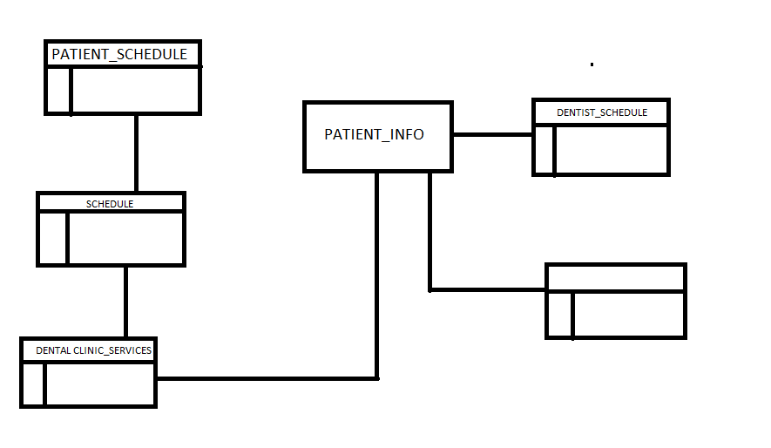

**5.4 Screen Layout/Specification/Report Form**

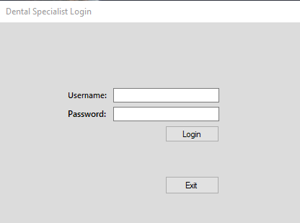

The Login form of the system.

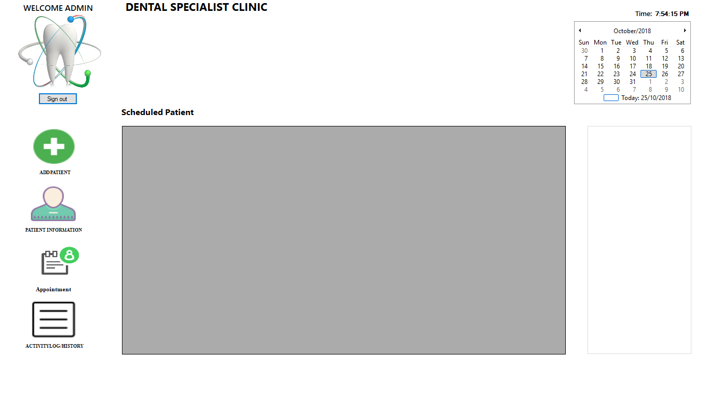

Main form of the system.

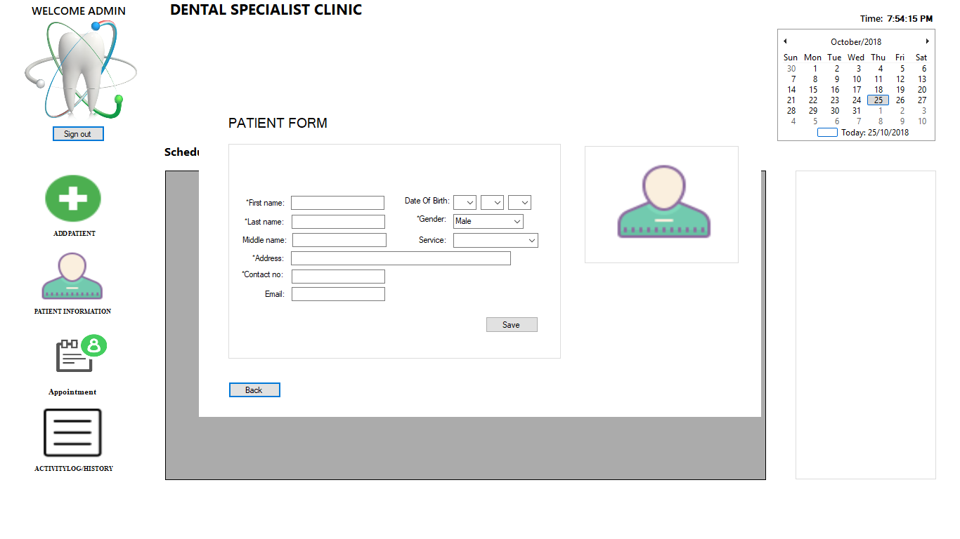

Add Patient Form of the System.

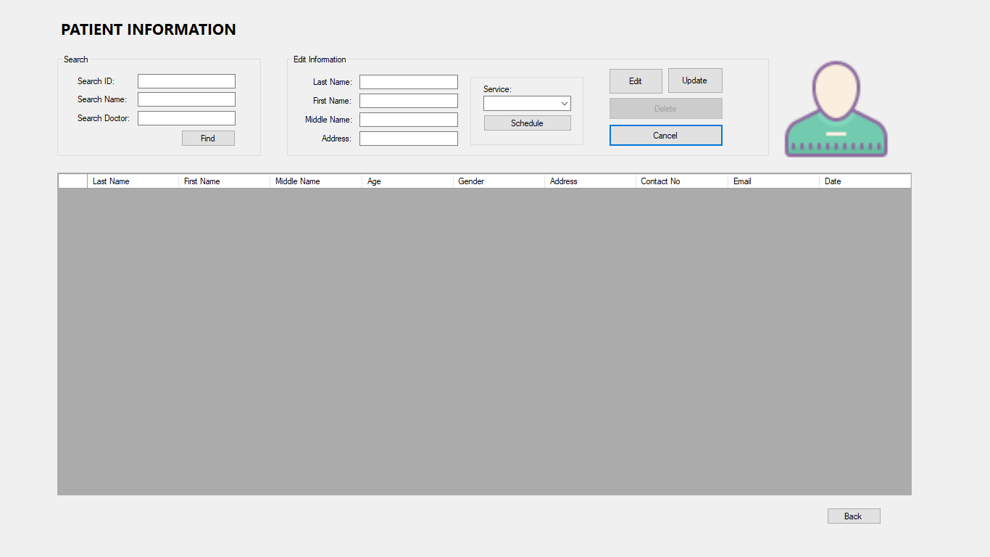

Patient Information Form of the System.

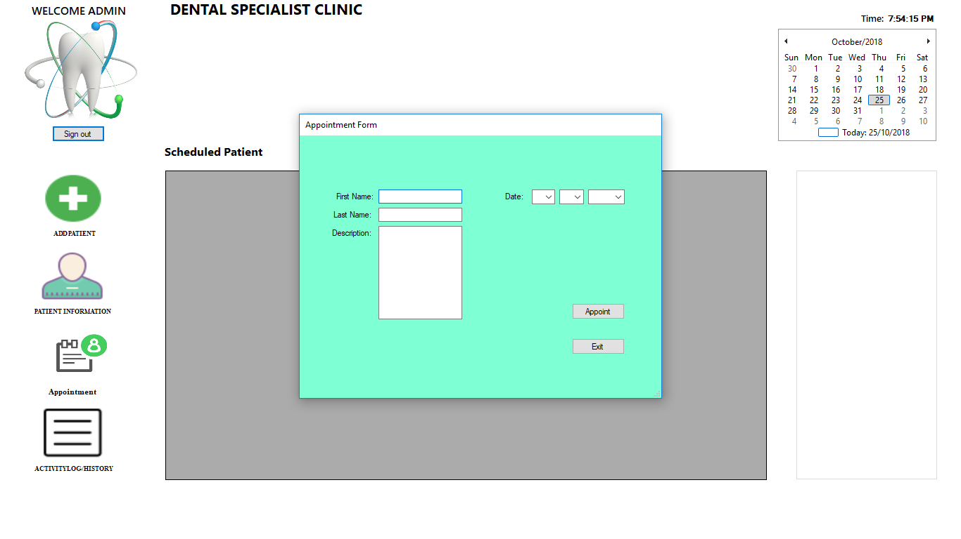

Appointment Form of the System.

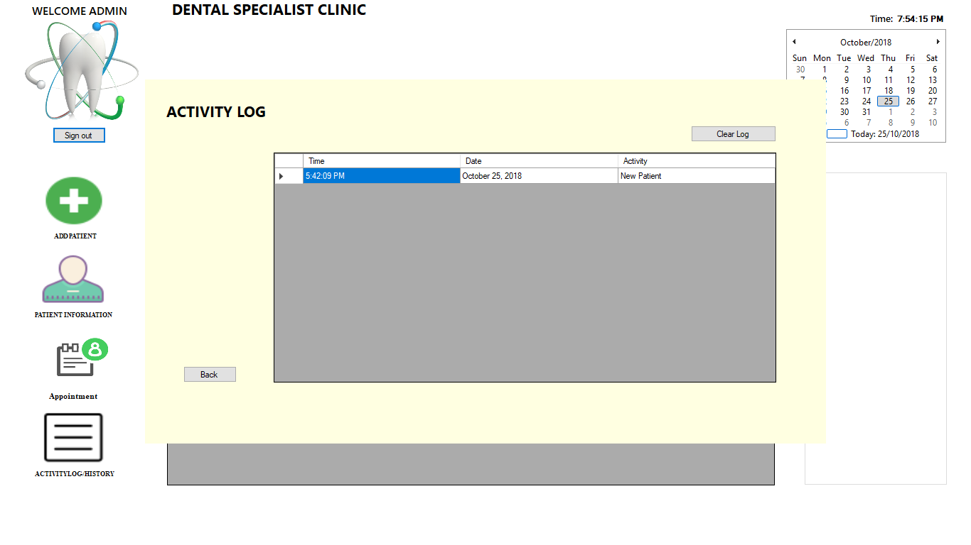

Activity Log of the System.

**CHAPTER 6**

**6.0 System Coding (Prototype)**

Prototype-based programming is a style of object-oriented programming in which behavior reuse (known as inheritance) is performed via a process of reusing existing objects via delegation that serve as prototypes. This model can also be known as prototypal, prototype-oriented, classless, or instance-based programming.

**6.1 Programming Language**

C# is a multi-paradigm programming language encompassing strong typing, imperative, declarative, functional, generic, object-oriented (class-based) and component-oriented programming disciplines. It was developed by Microsoft within its .NET initiative and later approved as a standard by Ecma (ECMA-334) and ISO [ISO/IEC 23270:2006**]**

C# is one of the programming languages designed for the Common Language Infrastructure. C# is built on the syntax and semantics of C++. Allowing C programmers to take advantages of .NET and the common language runtime C# is intended to be a simple, modern, general-purpose, object-oriented programming language. Its development team is led by [Anders Hejsberg]

**6.2 Special Purpose Language Tools**

Microsoft Word

MySQL database

Visual Studio C#

**CHAPTER 7**

**7.0 System Testing Plan**

A test plan is a document describing software testing scope and activities. It is the basis for formally testing any software/product in a project. ISTQB Definition. test plan: A document describing the scope, approach, resources and schedule of intended test activities.

**7.1 Testing Stages**

The testing process should therefore proceed in stages where testing is carried out incrementally in conjunction with system implementation. The most widely used process consists of five stages: Unit Testing: Individual components are tested to ensure that they operate correctly.

**7.2 Testing Schedules**

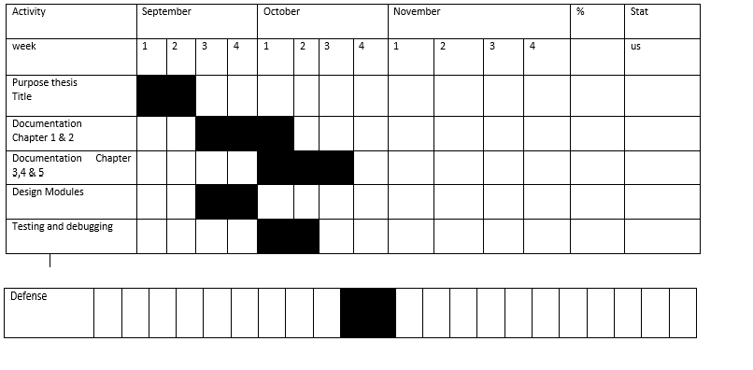

**CHAPTER 8**

**8.0 System Implementation Plan**

Systems implementation is the process of: ... ensuring that the information system is operational and used, ensuring that the information system meets quality standard

**8.1 Resources Requirements**

* Hardware Requirements

Monitor

Mouse

Processor: Core i3 1.7 GHz

Video Card

500MB RAM

100MB ROM

* **Software Requirements**

Windows 7, 8, 10 Operating System

Visual Basic

MySQL

* **Human Resource Requirements**

The user of the project should be knowledgeable in computer functions. The operation of the system should be user friendly so that the user could easily understand the instructions. The users are categorized as doctor and secretary. Secretary and doctors are responsible on the back end and the front end of the system.

**8.2 Implementation Plan**

Implementation is the carrying out, execution, or practice of a plan, a method, or any design, idea, model, specification, standard or policy for doing something. As such, implementation is the action that must follow any preliminary thinking in order for something to actually happen.

* **Site Preparation**

Site preparation involves the demolition or wrecking of buildings and other structures, clearing of building sites and sale of materials from demolished structures. Site preparation also entails blasting, test drilling, landfill, levelling, earth-moving, excavating, land drainage and other land preparation.

* **Personnel Training**

Personnel training, also known as employee training, means training employees on operating procedures and standards. ... Free Management Library states that employee training increases efficiency, effectiveness and productivity along with morale and job satisfaction.

* **System Conversion**

Conversion from one information system (IS) to another is common in all organizations, regardless of type, size or location. On the information technology (IT) side, conversion can involve hardware, operating system (OS), database management system (DBMS) and the database it supports, and/or application portfolio.

* **Data Conversion**

Data conversion is the conversion of computer data from one format to another. Throughout a computer environment, data is encoded in a variety of ways. For example, computer hardware is built on the basis of certain standards, which requires that data contains, for example, parity bit checks.

* **Implementation Schedule**

Project Implementation Schedule: The Key Components. ... The project implementation schedule is an important time management document that defines and schedules the major phases of project work being carried out to fulfill the desired project objective(s) and achieve the expected deliverables.

**Chapter 9**

**9.0 System Maintenance Plan**

Systems Maintenance also called IT maintenance, System Maintenance.

Support, Maintenance Management Software, Information Technology Maintenance. DEFINITION: The modification of a system to correct faults, to improve performance, or to adapt the system to a changed environment or changed requirements.

* Maximizing system availability to meet the operational requirements. This has to take into account the designed-in reliability and maintainability of the system and resources available.
* Preserving system operating potential through proper planning of system scheduled maintenance. This requires a reliability-centered maintenance strategy that incorporates preventive maintenance in order to preempt failures, thereby extending the mean time between corrective maintenance, as well as enhancing the availability of the system.
* Segmentation of maintenance activities for potential outsourcing of non-critical activities to approved maintenance subcontractors as to optimize scarce technical manpower resources and maintenance/repair turn-around times.
* Harnessing IT technology for maintenance management. This involves rigorous and systematic capturing and tracking of operating and maintenance activities to facilitate analysis and planning.