

Software Engineering Department  
ORT Braude College

Capstone Project Phase A – 61998

**Miracle of Luck**

**24-1-D-26**



**Supervisor:**

Zecharias Frankel- [zfrenkel@braude.ac.il](mailto:%7afr%65%6ek%65%6c@b%72%61%75de%2eac%2e%69l)

**Authors:**

Mahmoud Kraiem - 208525717 - [Mahmoud.Kraiem@e.braude.ac.il](mailto:Mahmoud.Kraiem@e.braude.ac.il)

Alexander Danilov - 3274747946 - [Alexander.Danilov@e.braude.ac.il](mailto:%41%6ce%78%61nde%72%2eD%61%6e%69%6co%76@e%2e%62%72a%75de.%61%63%2e%69l)

**Abstract**

The growing participation within the lottery, in addition to the more accessibility and reputation of online structures, highlights the need for an innovative approach to enhance the lottery experience and revolutionize the way people engage with lotteries, leveraging the power of online platforms to create a more seamless, interactive, and enjoyable experience for both organizers and participants alike.

Currently, organizing and taking part in a lottery can be complicated and time-consuming, with growing potential barriers to entry and possibilities, however, character participation and the shortage of inner and social connections in conventional lottery systems limits the potential for creating a feel of belonging and camaraderie among participants, consequently detracting from the general experience and potential for shared excitement and entertainment.

One of the particular competencies of our website is the potential to create lotteries primarily based on social media like Facebook pages. Using Facebook’s huge achievement and engagement, customers can participate in the lottery draw without problems by means of actually sharing and liking posts on genuine pages. This new method not only simplifies the lottery manner but also increases the extent of interplay and engagement amongst individuals.

In addition to standard lottery price ticket purchases, our platform empowers customers to without trouble create their very own lottery. Whether it is fundraising, network activities, or non-public tasks, clients have the choice to tailor their lottery experience to their particular dreams and opportunities.

**Introduction**

The world of lotteries is expanding fast and online platforms are now the most favourite ways for people to take part in the lotteries. While in this change of operative process, some tools are being replaced by others, the development of a new strategy comes as a necessity to make the lottery appealing and accessible to different categories of customers.

Although incorporating lottery participation has been a trend for a long time, social media may be another dynamic ground to bring this activity to a whole new level, where engaging on Facebook through liking and sharing could be as easy as participating in a Facebook-integrated lottery. This platform not only makes it easy to participate in the lottery but also connects people through social networks to work together and become a community.

Furthermore, our site has Facebook-based lotteries along with many lottery kinds catering to both traditional preferences and the necessity to customize as some users use them to increase funds or to cover local events or private businesses. Same users can as well personalize their lottery experience with their preferences and objectives.

Our open platform comes with an intuitive browser-based application that allows you to query and analyse data in real time as well as deliver meaningful analytics. The users can also be provided with the details on the past drawings, the number of participants, and the lottery results, thereby enabling them to make informed decisions and plan for future lotteries.

By adopting innovation and social interaction, we will create a platform where people will conduct activities together thereby recreating the whole lottery experience in a new way where they will be able to participate, interact, and have the joy of winning great prizes. It doesn't matter if you are a lottery fanatic or have started to play casual games, just this game can conquer all stars thus letting you know that the more you play the more you know.

The achievement of the project will be seen through the increase in the number of new users, user happiness, the number of customers, and the transactions the website helps customers make. Besides, it is necessary to measure the influence of the website on reduced waste, the promotion of green consumption practices, and the formation of an informal community.

**Related Work**

For an insightful approach and better assessment of this competing market, it is crucial to research the lottery platforms in the market with similar functionalities.

Here are some examples we examined:

RandomPicker: Like RandomPicker, the service allows users to conduct random drawings and competitions. RandomPicker is a tool that can be used across different industries and for a variety of purposes, such as academic research, event management, and charitable fundraising. This technology is equipped with features like developing forms of entry that can be tailored to the requirements of an organization, algorithms for the selection of winners, and processes of verification of results that ensure transparency of the system.  Consequently, RandomPicker is a perfect solution for an organization that is looking to run the event in a fair and transparent manner online.

https://www.randompicker.com

Lotto247: Lotto247 is a lottery gaming platform where you can play global lotteries from different countries of the world using the internet. It is the place for lotteries with so many of them there like Powerball and Mega Millions. The platform can help them to buy tickets, check results, and control their accounts.

https://www.lotto247.com

The Lotter: Offering a multitude of lotteries from all over the world, The Lotter is among many other online lottery platforms that provide access to such activities. It is also a convenient way to order tickets, synthesize plays, and subscribe to services. The platform includes lottery results, jackpot information, customer services, and other relevant features.

https://www.thelotter.com

Social networks such as Facebook and Instagram are frequently used as social media for hosting giveaways and contests. They use the ability of social media to connect millions in a short time as well as encourage joining efforts and sharing of ideas. Nevertheless, they usually do not have the specialized features and security measures that are necessary for a legal and practical raffle, and this becomes a legal and logistical problem for the organizers.

Through the scrutiny of the working processes of platforms and technologies that are already prevalent, it becomes possible to acquire useful pieces of information regarding the functionality, the user has experience, and the challenges that come with online raffles. We recognize the significance of this research in our website’s development. This will aid us in building a competitive site that will be in line with the needs of lottery enthusiasts, giving participants an enjoyable and seamless experience online.

**Background**

The introductory part of an online raffle platform implies the creation of an environment that allows a large number of users to join by resolving technical, organizational, and legal issues. Before we start talking about our project, it is important to explain the basic information that will help us to decide on the design and development of our project.

The environment of online platforms has been a trending topic for some time already, being affected by technological developments, growing consumer habits, and new regulatory requirements. The appearance of digital commerce, social media, and digital marketing markets has brought new prospects for businesses to get in touch with their consumers, conduct promotions, and attract their clients to interact with them.

In this context, online raffles are becoming a very popular way of depicting user engagement, the promotion of products and services, and the fundraising of charitable causes. In contrast to physical ticket-based raffles which are often limited by the geographical factor and dozens of logistical challenges, online raffles offer a proven scalable solution that is valid for a global audience and requires no or little overhead.

Nevertheless, while switching to online drawings may provide a powerful benefit it also has specific issues concerning security, fairness, and compliance. The building of the trustworthiness of drawings of the raffle, the security of the user data, and compliance with the regulations and legal requirements are crucial aspects that any online raffle platform has to take into account. Besides, users' experience as well as the generation of and processing of payments and scalability of the whole platform have to be properly designed in a way for users to engage in the process and organizers to run their activities smoothly.

To address these challenges properly, our project proposes a holistic approach to uniting the best usual practices of software engineering, cyber security, and regulatory compliance. With the help of proven methods and technologies, we are working to develop a secure and reliable online raffle platform that satisfies the requirements of organizers and participants while maintaining compliance with the relevant laws and regulations.

**Key components of our approach include:**

1. Technologies that we will use: The stack of technologies which is a collection of tools and languages deployed at the front end as well as the back end to ensure that the platform is reliable, scalable, and secure.

2. Setting up a Client-Server Architecture: The creation of a client-server architecture to support the communication between the users and the platform is the way to bring about smooth interaction and data exchange.

3. Data Management: Organizing data in such a way using databases, data checks, and encryption techniques will be needed to guarantee user information security and retain the integrity of data.

4. Security Measures: Involvement of industry standards approaches security architectures like authentication, authorization, encryption, and rate limiting to prevent malicious breaches to data and attacks.

5. Regulatory Compliance: Use of relevant laws and regulations that apply to online raffles, such as those on gambling, consumer protection, privacy, and data security, to avoid legal risks and conduct ethically.

Our goal is to take care of the fundamental points in the background of our project to mark the beginning of a process to build an online raffle site that would be well-researched and prepared. The next chapters will incorporate the detailed technologies, methodologies in the next chapters, and strategies that will be used to implement the vision and to cover the challenges that exist in this task.

**Technologies that we will use:**

**1.**  Building a Secure Full Stack Web Application, Implementing Protection Measures and Best Practices, Full Stack Web Development:

**1.1. Front-end:**

For front-end development, React is a suitable technology to use. React offers such conveniences as fast and reactive user interfaces making development simple. among HTML, CSS alongside All JavaScript, is employed to develop all Front-End components and handle user interactions; the consist dutifully of code editors like Visual Studio Code, build tools such as webpack and even Parcel, which deal with code bundling, optimization, and package managers like npm or yarn, which are meant to manage dependencies as well as browser developer tools for debugging and testing.

**1.2. Back-end:**

For the back-end development: The word "node." js with Express: Node. The language such as js, a JavaScript runtime, can be utilized for multi-purpose development, however, it can be used for server-client-development areas. An Express web application is largely a system of libraries and different technologies that aim at empowering web developers. js, which is a backend programming language that is easy to use and flexible to handle HTTP requests, routing, and data manipulation on the server side. Using Node. Having node.js + Express extend our capacity to apply JavaScript as a full stack one is very much possible. Besides HTTP and HTTPS, we apply RESTful APIs (or GraphQL) to facilitate the sending of requests from the client side to the server side and then the server sends back responses.

**1.3. Testing:**

Quality testing is one of the pillars of every development process to achieve the mission-critical reliability of the software system in every layer.

**Unit Testing:**

Unit testing is focused on the validation of the individual components or modules of our platform, which are independent of each other. We employ frameworks such as Jest as well as Enzyme to produce test cases representing functions, methods, and classes in our backend code base to ensure their correctness. Unit tests eliminate the chances of bugs during the coding process as they enable developers to address bugs in the initial stage of designing and it ensures high calibre and dependable code.

**GUI Testing:**

GUI testing, which is graphical user interface testing, is the process of evaluating the user interface of our platform to ensure that it is usable and consistent. Through things like Selenium WebDriver, we do browser testing automatically and simulate a user's graphical stuff of the application. In GUI tests, user interface validation covers the usability of the app by verifying the responsiveness, layout, and program functions across several browsers and devices, which gives the app a perfect user experience**.**

**Backend Testing:**

The backend testing is aimed at verifying the working and the performance of the server-side components of our platform. Integration testing is run to ensure the correctness of the interaction between different service layer modules and the consistency of the data. We adopt command line tools such as Postman to test the APIs and check if the RESTful endpoints perform as expected and whether data transferring between the front and backend is correct as well. Back-end testing also includes security testing, which is aimed at uncovering and resolving such vulnerabilities as injections and data leaks.

Thorough testing helps us to achieve a complete coverage of our online giveaway point that ensures its functioning, usability, and security as well as its backend on various layers of the application. To deliver a platform that has high quality and reliability, we keep testing and updating. We encourage users to utilize the platform as we do our best to meet their needs.

**2. Setting up a Client-Server Architecture:**

In a client-server architecture, there are two primary components: The client side and the server side.

Client-side, which is usually developed using JavaScript, is a major part of creating a dynamic and interactive user experience. In the context of our project, the development of the interface for users is accomplished by using React. interactive components. These elements exploit JavaScript which is a scripting language that enables the UI to be dynamically updated with user interstellar and data alterations.

Server-side, which is responsible for the back-end operations such as receiving requests from clients, accessing the database, and generating responses. To run the server, we choose Node. js - a language runtime environment and Express, in tandem, to build the rending js web application. js, a web framework for the web. Express. js helps eliminate developers from the hustle of writing monotonous code. In this sense, it exposes a detailed set of resources for handling routes, middleware, and request handling.

When it comes to the client side, React components, and JavaScript are used to achieve an intuitive and responsive user experience. The server side, on the other hand, is under NodeJS' focus. js and Express. JS is used to manage the backend operations and to enable the client and the server to communicate and process data smoothly.

**2.1 Communication between the client and server**

Our lottery website is crucial for ensuring smooth interaction and functionality. Here is a high-level overview of how the communication process works:

**Client-Side Communication:**

- If a person from the user side interacts with the site by participating in the raffle, watching the results, and so doing with any action, the client-side code (the script is typically written in HTML, CSS, and JavaScript) will be responsible for accepting the inputs and interactions.

- Having been entrusted with the task of triggering fetch requests from the server is a JavaScript function, which mainly relies on either the AJAX or Fetch APIs.

- Here, these requests can be for anything like the user credentials, the lottery entries, or even such details as specific information.

**Server-Side Processing:**

- A back-end application is broadcast on the server side by the software, which is remotely received.

- From handling the incoming requests to processing and authenticating them, the server performs the necessary operations depending on which type of request was received.

- It may encompass seeking information from a database or storing it, running the business logic, generating the lottery results, or handling the authentication and authorization.

**Response to Client:**

- When the machine has completed processing the request, it then returns the response to the client.

- The response can be sending required data to the client, acknowledgment of the success of operations, sending error messages if failures appear, or any other data that is relevant.

- Responses are, as a rule, sent in the format of JSON (JavaScript Object Notation) or XML, which can be easily parsed and manipulated by JavaScript on the client side.

**Handling Asynchronous Behaviour:**

- Because communication between the client and server usually consists of asynchronous operations, like waiting for the dismissal of the server, the up-to-date web development techniques use asynchronous programming paradigms.

- Promises, async/await syntax or call-back functions are widely prevalent tools to handle the a synchronicity behaviour that can cause bad user experience, hence creating the need for responsiveness in the apps.

**Security Considerations:**

- Security is the most important factor in client-server communication, especially when the user data or financial transactions are concerned.

- In this way, HTTPS encryption, input validation, authentication mechanisms (e. g.  JSON web tokens), and proper error handling techniques could be adopted to reduce security issues and provide user privacy protection.

Enforcing a comprehensive client-server communication method and by following the latest web development practices, we make sure our website has a positive user experience, that is successful, fast, and enjoyable among the customers.

**3.Data Base:**

In our project, we incorporated a powerful and effective SQL (Structured Query Language) database system to handle the data of our lottery website.

Here are some points about the database we used:

**Database Type:**

- Our database system is relational and made on SQL. This database is of a kind that delivers the functions of the highest level and flexibility to manage the data and execute the queries.

**Database Role:**

- The database works as a warehouse for a large range of information, such as the details of the users registered on the website, the details of the lotteries, the lottery results, and so on.

- It gives faster and more efficient access to the latest data and it supports such queries with search, update, and delete as easy inputs.

**Design and Structure:**

- To make the data easy to access and maintain, we constructed our database with consideration for efficient structure. In our study of database design, we learned to make tables and associate them using primary keys and foreign keys.

**Security and Safety:**

- Adequate protection of privacy of using data was a particular concern for us. Through installation layers and access restrictions, we made certain that only the allowed users could access the sensitive information in the database.

**Associated Tools:**

- To contain and take care of up-to-date databases, typically we used all kinds of technical tools like MySQL Workbench or phpMyAdmin. These tools help with managing and undertaking commands on a database effectively and the process is easy and comfortable to use.

Thanks to the database, we were able to build an effective and stable infrastructure for the site and the whole range of lottery activities we have.

**4.Input validation:**

To make our lottery website more secure, input validation is among the most important things we need to do. Technologies such as tokens, API encryption and binding, and the use of cryptographically secure transmissions are implemented on both client and server sides, thus allowing us to protect against SQL injection and XSS threats that are widely used to compromise the integrity of our database and the security of user data.

**4.1. Cross-Site Scripting (XSS):**

Cross-site scripting (XSS) is a flaw that enables attackers to insert malicious scripts into web pages that other users will be viewing.

To counter XSS attacks, we implemented the following measures:

- We checked and sanitized all the user-generated content, including input fields, comments, and user profiles, to trap or escape any potentially damaging HTML or JavaScript code.

- We applied CSP headers to a list of trusted domains where the content executions should be allowed and scanned for any malicious processes.

- To prevent the XSS vulnerabilities, we used output encoding techniques which converted the user input to plain text instead of interpreting it as HTML or JavaScript.

By integrating these input validation measures, we were able to drastically diminish the incidence of SQL injection and XSS attacks, thus increasing the extent to which we were able to fortify the security of the system while upholding the user's privacy and data.

**4.2.SQL Injection:**

SQL injection is a sort of cyber attack where crafted SQL commands are inserted into the input fields, which lets the aggressor control the database.

 To mitigate this risk, we implemented through input validation techniques:

- We cleaned all user input before running them in the SQL queries.

- We applied parameters to queries or utilized prepared statements to separate data from SQL logic so that it does not allow attackers to inject harmful code into our system.

- We can be considered as being one of the virtuous database accounts that we practice least privilege principles, allowing appropriate account and database access permissions, which minimizes any impact of potential attacks.

**5.Authentication:**

Authentication is a procedure of verification of the person accessing the system.

To authenticate users, we employed the following practices:

- People had to fill in their credentials, like usernames and passwords when logging in.

- Hashed and stored passwords were put into the database using a one-way encryption mechanism to prevent identity theft.

- Authentication of third-party authentication providers were encrypted using secured and trusted protocols such as OAuth and OpenID CT for user credentials to be safe during the authentication process.

- Multi-factor authentication (MFA) was used to add an extra layer of security, which meant that users had to provide other verification factors such as SMS codes or biometric data, in addition to their usual login IDs.

**6.Authorization:**

Authentication identifies authenticated individuals, while authorization determines the level of access and the permissions granted to these authenticated users.

To implement authorization effectively, we adopted the following strategies:

- RBAC was one of the security models that was applied to assign specific users’ roles depending on their duties or privileges in the computer safeguard system.

- Access control lists (ACLs) were the ones that were used to specify the granular permissions for each resource or functionality, which made it possible for the administrators to fine-tune the access levels for the different user roles.

- Implemented ABAC (attribute-based access control), based on the principle of evaluation of specific data access from the perspective of user attributes, resources, and external conditions.

- We were also implementing various audits and reviews of user permissions to ensure the right level of access in compliance with an organization's policies and legal requirements.

We achieved data integrity and confidentiality and at the same time, we protected sensitive data and resources from unauthorized access by implementing strong authentication and authorization mechanisms.

**7.Hashing:**

Hashing uses one-way cryptography to turn ordinary text into a fixed-length representation known as a hash string.

In our system:

- We were very specific about which hashing algorithms we used, for example, we could mention the use of SHA-256 which are very secure for sensitive information like passwords.

- Rather than in plaintext, passwords were stored in the database in hashed form, so that if the database fell into the wrong hands, the passwords would remain unintelligible.

- Jointly, salt was diffused into passwords just before the process of hashing to further protect the passwords. A special salt value was generated for each user, and thus the attackers would find it more difficult to perform precomputed hash attacks.

**8.Encryption:**

Encryption is a cryptographic process that acts in two ways. First, the plaintext data (regular text) gets converted to ciphertext with the help of an encryption algorithm and a secret key.

 In our system:

- We encrypted sensitive data like personally identifiable information (PII), financial details, or session tokens before they were stored in the database or transmitted over the network.

- The enhanced RSA algorithm was targeted. Secure key management practices using AES (Advanced Encryption Standard) were activated to ensure the privacy and integrity of the encrypted data.

- TLS protocols were implemented to encrypt the information that is communicated through client-server as this prevents the data from being eavesdropped or tampered with in malicious hands.

By integrating the hashing and encryption techniques, we kept the confidentiality, integrity, and authenticity of the sensitive data, thus reducing the risk of unauthorized access and data breaches in our system.

**9.Rate Limiting and Throttling:**

Restrict the quantity of requests per minute or hour from a single IP address, thereby preventing abuse or attacks such as DDoS.

Rate limiting and throttling are two methods of controlling and limiting the number of requests. It has been created by a client at a certain time.

These ideas are broken down:

**9.1. Rate Limiting:**

Rate limiting is one tool to mitigate DDoS attacks by limiting the number of client requests to the server within a certain time framework.

In our implementation:

- We put constraints on the number of requests per second, minute, or hour, based on the sensitivity of the operation and the expected usage patterns.

- The duration of the block is shorter and the client can be either temporarily blocked from sending further requests or an error message like HTTP status code 429 (Too Many Requests) is returned to him.

- The rate limiter acts as a protection against the misuse of the system, that is DoS attacks or brute force login attempts (and so on) which are typically carried out at a very fast rate.

**9.2. Throttling:**

Throttling also has that as rate-limiting does, but it is more concentrated on data transmission rate adjustments.

In our system:

- The data examination between client and server was made slower by us using throttling mechanisms which limited the bandwidth or throughput of those transfers.

- Throttling aids in minimizing network congestion, optimizing the use of resources and ensuring that the resources are fairly distributed among clients.

- As an example, representing different rate flows in streaming or file transfer, throttling can allow for regulating the amount of data a user is consuming at any given time by limiting the rate at which data is transferred.

**9.3. Advantages of this ideas:**

Enhanced Security: Rate limiting and throttling are the tools that can be used to avoid the risk of abuse, like DoS attacks, brute-force attacks, or API abuse, by limiting incoming requests.

Improved Performance: Through the power of regulating, rate limiting, and throttling a web server idles from overload, retains system stability, and guarantees speedy performance for all users.

Resource Optimization: These mechanisms are aimed to maximize resource utilization capability by keeping down high consumption of the server resources like CPU, memory, and network bandwidth for instance.

Fairness and Equity: Rate limiting and throttling are the tools that guarantee equitable resource allocation among the clients and avoid the situation when any single client uses too many resources and others don't get enough.

Through implementing the rate limiting and throttling protocols, the system became stronger, stable, and performant while promoting an optimal user experience and fair resource distribution.

**10.Protecting information:**

Data protection and privacy are the most important issues in our system. We have to make sure that users are protected and that the system is compliant with data protection regulations.

Here is how we addressed this crucial aspect:

**Data Minimization:** We collected and kept only the bare-bone personal information that was essential during the functioning of our system. Sensitive or needless data fields were eliminated to have little chance of a data breach taking place.

**Encryption of Data:** Our database was encrypted using the most secure algorithms for the storage of personal data. This included aspects of the user identity, sensitive profile information, and all pieces of personally identifiable information.

**Secure Transmission:** TLS provided an encryption protocol, which enabled communication between the client and the serving mechanism to be encrypted to prevent eavesdropping and man-in-the-middle attacks.

**Data Integrity:** The focus was on the accuracy and freshness of personal information, using automatic systems to validate the data. This was accompanied by validation during data entry and data validation processes daily.

**User Consent and Transparency:** The users were given detailed and specific instructions on the classification, processing, and utilization of personal information which will be monitored. Explicit opt-in options were created to get permission for each activity in the data collection process.

**Data Retention Policies:** Data retention policies were provided while ensuring that such personal information was to be kept only when necessary and for no longer than needed for the purpose other than it was collected. Data that was not less significant was systematically discarded and anonymously for security purposes.

**Regular Audits and Compliance Checks:** There were regular audits and compliance checks to ensure that our data protection practices complied with relevant laws and regulations, such as the General Data Protection Regulation (GDPR).

We were very sensitive about our users' personal information, we strove to keep their trust and preserve our reputation in general as private data protection is our core principle.

**11.Payment:**

On our website, users can follow these steps:

**Select Payment Method:** The user has to select the payment method that is most suitable for them, for example, credit card, PayPal, or any other payment method that is accepted on the website.

**Enter Payment Details:** Then the next step will be to select the payment method (credit card, debit card, or other online payment). After that, the user will enter their payment information such as card number, expiration date, card holder's name, and security code (CVV).

**Proceed with Payment:** Then, the user will need to provide the payment details, and, by clicking the button “Pay”, which usually is located at the bottom of the site, or on a separate page, the user will proceed with the final payment.

**Verification and Confirmation:** After the payment has been made, the website will check with the payment system to make sure the transaction is valid. The difference is if the transaction goes through, the user will get a confirmation message.

**Confirmation and Success Message:** When the payment confirmation is done, the user will be sent a message about the ongoing transaction which will have details such as the payment amount, recipient details, and confirmation of payment.

Furthermore, the users may also save their payment information for future orders through their profile on the website. This allows them to automate their payment process and also manage their payment details. The only thing they can do is update the payment details through their account to improve the overall process.

**12.HTTPS:**

Securing Data Transmission and Protecting User Privacy: HTTPS, instead, does such encrypting of the data that is transmitted over HTTP. On the other hand, the HTTP protocol is not encrypted by itself.

In conclusion, HTTPS protects the data and information that are transmitted using the HTTP protocol. Using HTTP encryption between the server and the client provides a good level of assurance about the data transmission's confidentiality and integrity over the network.

Encryption by HTTP ensures unauthorized access prevention, eavesdropping prevention, and information integrity. The most common and standard way of enciphering HTTP traffic is HTTPS (HTTP Secure), which is the secure version of HTTP. HTTPS makes use of encryption by using the SSL/TLS (Secure Sockets Layer/Transport Layer Security) protocols that encrypt the data that is transmitted between the server and client.

When you enter the HTTPS site, this encrypts the communication between the HTTP client and HTTP server through Secure Socket Layer (SSL) and Transport Layer Security․(TLS) protocols. This encryption guarantees that the data transferred between the client and the server remains secret and can't be easily intercepted or understood by unauthorized persons.

Encryption Layer: SSL/TLS protocols establish a secure communication channel between the client and the server.

Data Encryption: This secure channel can be likened to the TLS tunnel in HTTPS. As such, the data being transferred in the form of HTTP requests and responses is encrypted using symmetric keys such as AES.

This encryption will make the content unreadable by anyone except for those who have the proper decryption key. Authentication: SSL/TLS not only has authentication and integrity checking properties. Make sure the words email marketing in the given sentence are used correctly.

The server gets its digital certificate (it contains a public key) and shows it to the client. The client also checks the validity of the certificate and uses the public key to establish a secure connection.

Through this mechanism, a customer is protected from heartless middlemen and acts like an impersonator or a malicious person altering data.

HTTPS, through this encrypting the traffic, makes sure of the privacy and integrity of the data exchanged, and hence, succeeds in guarding whatever sensitive information is being exchanged, such as login credentials, and personal details among other financial data. It needs to be emphasized that the encryption of the communication channel is not the same thing as what happens on the web server which still processes the HTTP requests and gives HTTP responses.

The separation from the standard networking protocol is the fact that the data inside these packets and responses are ciphered and secure from prying and interference.

HTTPS on the top of the HTTP protocol, creates a security layer that ensures that the data transferred between the client and server is not able to be viewed around by anyone else. It's important to note that using HTTPS not only protects sensitive user data but also helps establish trust with your users, as they see the padlock symbol and "https: The // (two forward slashes) in the address bar of the browser, means a secure connection.

TLS (HTTPS) ensures the security of the transport level, however, the JWT is a way by which the application can be more strongly authenticated and has its operations protected from unauthorized access. In contrast to the other methods of data encapsulation, JWT is not restricted to the use of HTTPS.

**13.Chat**

Employing live chat that uses WebSockets technology, promotes and builds up customer interaction and makes it possible for users to communicate in real-time.

Here's how you can implement it:

1. Integration of WebSockets: Use WebSockets in our website’s backbone to expand the possibility of setting up real-time connections between user and website admins. This technique boils down to establishing the WebSocket server endpoints which will receive the connections and make it possible to exchange the messages between the client and admin.

2. Real-time Messaging Interface: Work out a user-friendly messaging portal within our website's front end where buyers will be enabled to have conversations in real time. The interface of this application shall incorporate sending text messages, emojis, and file attachments and can support sending voice messages too.

3. User Authentication: Carry out user authentication methods to make sure that only authorized users can get access to the chat feature. Developing an integration with our existing user authentication system like the OAuth approach for login with help from third-party plots like Google or Facebook.

4. Message Persistence: we make it mandatory to store chat messages in a database to enable message history and persistence of sessions. This feature lets users re-read their past conversations and get up to date on messages they might have missed.

5. Notification System: Set up a notification system that will inform the users about new messages and chat actions once again allowing users to be up-to-date while they are away from a chat.

6. Security Considerations: we include message encryptions, input validations, and rate limits to deal with common security threats (e.g., XSS attacks and spam).

7. Scalability: We check that the WebSocket server can handle a very large number of concurrent connections and messages, especially during periods of peak usage.

Once WebSockets is integrated into our lottery site, it becomes a lively and interactive platform where users can communicate together live creating a good environment and communication between buyers and website admins.

**14.APIs**

APIs, abbreviation for Application Programming Interfaces, work like links that connect web applications and make them communicate and transfer data among themselves. These are the rules and protocols that are created for this communication, which we consider as the contracts between software systems. With APIs we can easily hook up to numerous services and products, so building a universal connection is a sure way. Using common cloud-based APIs allows smooth integration with external devices, and through that, processes native cloud application development, in return, increasing the flexibility and scalability of our infrastructure.

For our website, we will need the following API.

**Payment Gateway API:** This API is needed to facilitate secure payment processing, allowing our users to purchase lottery tickets or conveniently redeem prizes. Using a hybrid with a trusted payment gateway API such as PayPal or Credit card ensures that we process our payment transactions securely and efficiently.

**Email Service API:** Our website relies on this API to send important communication emails, notifications, and updates to our users. By integrating with trusted email service APIs such as SendGrid, Mailchimp, or Amazon SES, we can ensure that our emails are delivered quickly and reliably, to our user’s communication and stakeholders have increased.

**SMS Gateway API:** This API plays an important role in enabling us to send SMS notifications directly to our users’ phones. Integrating an SMS gateway API such as Twilio or Nexmo allows us to send timely updates, loyalty codes, and reminders via text message, ensuring our users stay informed and involved, even on tour.

**Social Media APIs:** These APIs are important for integrating our website with popular social media platforms like Facebook, Twitter, or Instagram. By using social media APIs, we empower our users to easily make lottery announcements, results, and promotions, and their social networks, available to us, are great and increase user engagement. In addition, we may use social media APIs for seamless user authentication and profile integration, allowing users to connect their social media accounts to our website for greater convenience

**Expected Achievements**

In our project, we expect to achieve significant goals and accomplishments, including the following:

1. Functional and Efficient Product: The objective will be to utilize the most advanced technology and develop an internet lottery website with an outstanding user interface and full functionality for the users. The website will act as a platform where users can participate in the lotteries and win the top prizes without any hassle. In addition, a clean and user-friendly interface will be offered.

2. Secured Safety and Security: This project will include data security apps such as SSL/TLS encryption, authentication, and recursion. These measures will prevent square bracket injection and cross-scripting sites, among other attacks.

3. Development of Management System and User Management: A comprehensive user interface will be designed to facilitate site administrators in running lotteries and data tracking and managing user data and payments.

4. Improvement of User Experience: A continuous input of user research and feedback is emphasized, which will further enable us to upgrade and design the user interface. The end in view in this case is to achieve the peak taste in terms of convenience and usability.

5. Success and Promotion: By merely mentioning the idea stages, marketing, and advertising will be complemented with digital campaigns, social media marketing, and promotions based on a set of criteria of performance and on-the-site statistics.

6. Increase in Users and Revenue: Integration of marketing strategies that focus on customer retention, keeps the user levels up, thereby increasing the revenue and institutional culture growth.

Each of these achievements will be a major boost for the project's overall, will enhance its growth levels, and will bring in more users which will result in the success of the project.

Yet another important aspect of our prediction is the expected subsequent addition of users as well as the income from ads. Feeding the beast means that, if the number of people using the site keeps growing, their friends can get more natural traffic to the site using search engine queries. By doing so, businesses can leverage SEO, SMM, and AdWords online. Through organic SRP, we will have more stable (more stable and regular) advertising revenues.

Further, we envisage boosting the user experience by retaining and incorporating user feedback in construing the new changes that the site will go through. This includes enhancements of user interface design, implementation of new functions, and new function realization to match and accommodate the needs of the users better. Therefore, the implication is that users will have a stable base and improved conditions for any session on the site.

**The main screens:**

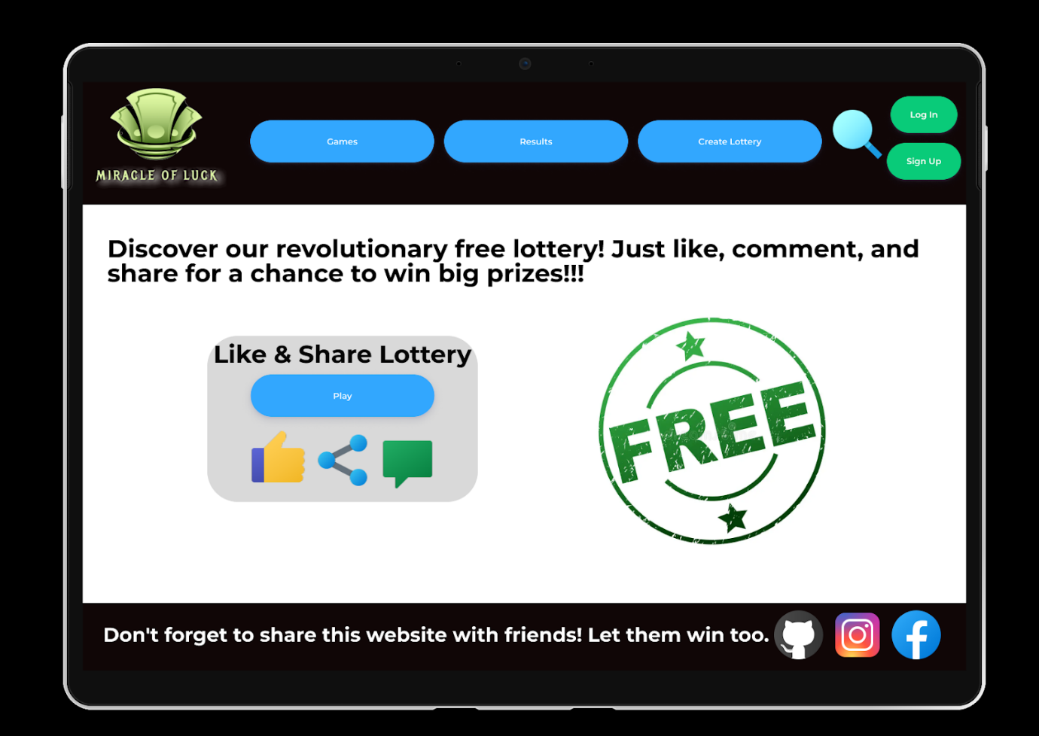

The purpose of the lottery web page is to promote user engagement and navigation starting with the first page. On the first look, the site presents a flashy and ecstatic design which signifies the level of enthusiasm and effort put into the lotto games.

**Header:**

The header at the top comprises the website logo, navigation bar, and user account information. The menu navigation of the website enables you to get directed to different sections instantly such as "Home," "Games," "Results," and "Create Lottery".

**Games:**

The principal part is where users can find information about the existing lotteries and preview the upcoming ones. Each game is listed with a short description, and the "Play Now" button is captioned to proceed with the game. They can seamlessly search for the preferred games in the menu - all it takes is to click "on".

**Results:**

It is emphasized in a specially outlined block containing the summary of the last results and recent triumphs. Users can get a hold of the most recent draw outcomes, browse through past results, and view highlights of the recent big winners along with the amounts awarded to them. In this portion of the project, trust and excitement will be built by presenting a case study that occurred in real life.

**Create Lottery:**

A distinguishing feature of the website is a category called "Create Lottery", which includes the creation of own lotteries. This part of the guide gives procedures for putting it on the table, such as assigning the prize, adopting the ticket price, and creating the game rule. After that user could share the lottery promotions with others in the neighbourhood which will give the lottery something individual and interactive.

**Footer:**

The footer of our website will have icons of social networks.

Simply put, the homepage is meant to be visually attractive, informative, and easy on the eyes; it has all the data and tools that the users will require when they participate in lottery games confidently and in an enjoyable way.

**Create Account screens:**

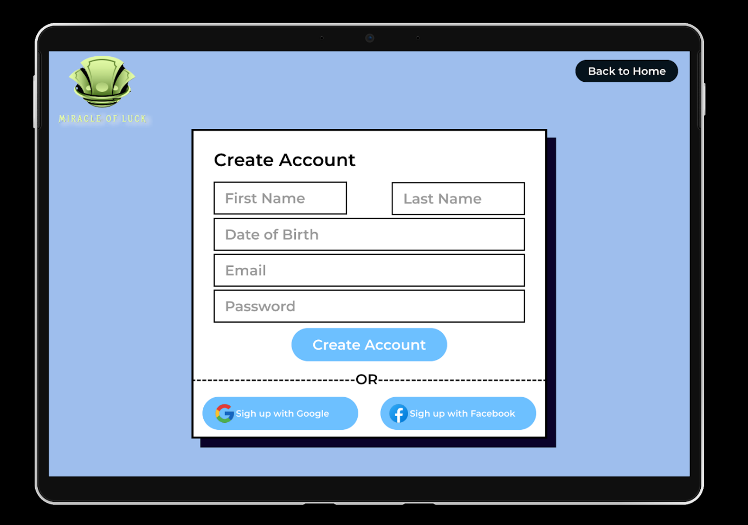

The "Create Account" page for lottery accounts on the website is purposefully simple to use and navigate so that it can minimize the time taken to create a user account and participate in lottery games.

**Header:**

The topmost part has the website logo and a navigation bar including tabbed options including "Home". This ensures the user can seamlessly switch between the main navigation pages anytime they want.

**Registration Form:**

The main content area features a clean and organized registration form with the following fields:

**1. Personal Information:**

- First Name and Last Name: The names of the users will be required during the account set-up.

- Date of Birth: Players are requested to disclose their dates of birth which must be sufficient to guarantee that they are aged to legally participate in lottery games.

**2. Contact Information:**

- Email Address: An email ID, which will be required for account creation, activation of notifications, and password recovery, must be furnished by the users.

**3. Account Details:**

- Password: A strong password is a must-be, and guidelines are provided for making a password secure (e.g). (Passwords are case-sensitive and chastise one’s solemnity, and fastness, no use of special characters).

Submit Button:

The site features the most visibly "Create Account" button, from here they submit their information and fulfill the registration process. Users may click on the link at any time after that and receive the confirmation message with the verification code to activate their accounts.

In summary, the “Create Account” page should be the platform where the main new users will have the domain to navigate and engage in the lottery game, they will start participating by just finishing the onboarding process with simplicity, security, and convenience.

**Results**

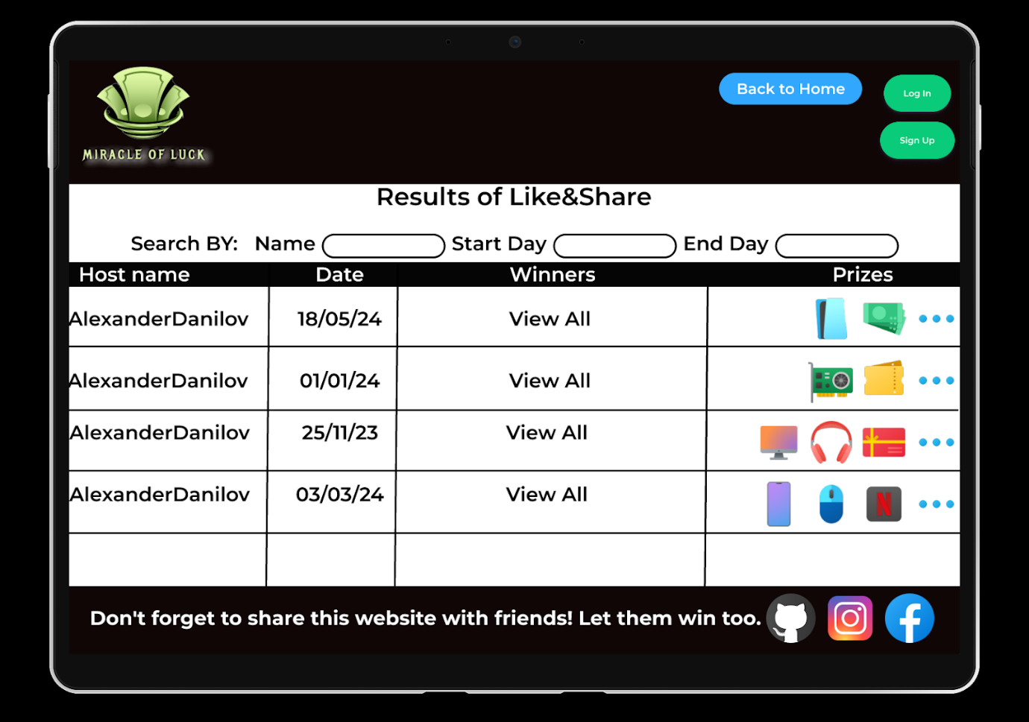

The result page of the website lottery is imbued to give the users not only a chance but also quick and easy access to the latest draw results combined with the historical results. It has been organized in a way such that users can effectively search and get the answers they require.

**Header:**

First, the header of the website contains the website’s logo and a set of options for the user account.

**Latest Results:**

Each lottery game is listed with the following details

- Host Name

- Draw Date

- Winners: Shown clearly and in GitHub markdown style easy-to-read format.

- Prizes: Highlighted list of prizes.

**Search and Filter Options:**

A search and filter bar enables the users to get the winning information easily. Users have options of searching by hostname and draw date. Filter options may include:

- Date Range: The home screen displays historical data with the user able to adjust the range of time in view.

- Host Name: People can use the additional function to order according to various types of hostnames provided on the website.

**User-Friendly Interface:**

The design of this page is very simple and easy to follow which helps the user to browse through the content and locate the information exactly as they require. Distinctive colours and big fonts are used to make the winning figures and the key details readable despite the blur found in normal car accidents.

Generally, the results page would be carefully orchestrated to be concise, readily accessible, and interesting with all the details available about the lottery draws being sharp as a tack and the proceeding clearly and attractively.

**The Process:**

**1. Creating a Lottery:**

- The user enters his or her email and password to log into his or her internet account.

- They click "Create Lottery" in the options below.

- The user enters all lottery metrics, namely title, description, image if possible, and conditions to include in the lottery.

- Once the lottery is made, then it is subsequently installed on the user’s profile as one of the lotteries available.

**2. Publishing the Lottery:**

- Thereafter, the user will have the chance to share the link generated to potential lottery entrants through their social networking sites or any unique URL.

- Participants can decide to disclose the lottery on Facebook, Twitter, Instagram, meaning any other social media networks, or send a Unique ID to pals and relatives via email iMessage, and other messaging applications.

**3. Participating in the Lottery:**

   - Users who wish to participate in the lottery join the link sent to them or displayed on social networks.

   - They enter the required details and confirm their participation.

   - After the registration period ends, the lottery is automatically conducted by the system.

**4. Notification of Results:**

- The lottery system takes care of all this checking process for the administrator. It sends an automatic notification to the creator of the report regarding the results.

- They find out who won and what prizes they have earned as winners.

- Furthermore, the lottery participants also get a reminder automatically sent through email or on the website as well, specifying the result of the lottery and the winners.

By this, they can effectively create lotteries and publish them across various social networks, thus gaining popularity and winning a prize through participating as participants. So, it becomes possible for them to build an entertaining and enjoyable lottery through platforms of whatever time they have.

Additional Process:

**5. Participating in Paid Lotteries:**

   - In addition to creating and participating in free lotteries, users have the option to join paid lotteries.

   - Paid lotteries require users to pay a certain amount of money to participate.

   - Users interested in joining a paid lottery select the option to participate and proceed to make the payment.

**6. Payment Process:**

   - Upon selecting to participate in a paid lottery, users are directed to the payment gateway.

   - They choose their preferred payment method and enter the necessary payment details.

   - Once the payment is successfully processed, the user is automatically registered for the paid lottery.

   - Confirmation of payment and participation is provided to the user via email or within the website.

By incorporating paid lotteries into the process, users have the opportunity to not only create and participate in free lotteries but also engage in paid lotteries where they can potentially win prizes after making a payment. This adds another dimension to the lottery experience on the website.

**Methodology and Development:**

**1. Requirement Gathering:**

   - Conduct thorough research and analysis to gather requirements for the project.

   - Utilize various techniques such as document analysis and observations to gather comprehensive requirements from the supervisor.

**2. System Design:**

   - Develop an architectural design for the system, focusing on scalability, reliability, and security.

   - Design the database structure, user interface, and system components to meet the functional and non-functional requirements.

**3. Implementation:**

   - Utilize appropriate programming languages and frameworks to develop the website's backend and frontend components.

   - Implement features such as user authentication, lottery creation, participation, and payment processing.

   - Ensure adherence to coding standards, best practices, and security guidelines during development.

**4. Testing:**

   - Conduct rigorous testing of the system to identify and rectify any defects or issues.

   - Perform unit testing, integration testing, and system testing to ensure the functionality, performance, and security of the website.

   - Utilize automated testing tools and manual testing techniques to validate the system against the defined requirements.

**5. Deployment:**

   - Deploy the developed system on a suitable hosting environment, ensuring scalability and availability.

   - Configure server settings, database connections, and security measures to optimize system performance and protect against threats.

   - Perform post-deployment testing to verify the system's functionality in the production environment.

**6. Maintenance and Support:**

   - Provide ongoing maintenance and support services to address any issues or enhancements required post-deployment.

   - Monitor system performance, security vulnerabilities, and user feedback to proactively identify and resolve issues.

   - Regularly update the system with new features, improvements, and security patches to ensure its continued effectiveness and relevance.

By following this methodology and development process, we aim to deliver a robust, secure, and user-friendly lottery website that meets the needs and expectations of our users while adhering to industry standards and best practices.

**PRODUCT**

**Functional Requirements**

1. User Registration: Users should be able to create an account on the website by providing necessary details such as email address and password.

2. User Login: Registered users should be able to log in to their accounts using their credentials.

3. Lottery Creation: Users should have the ability to create new lotteries by providing relevant details such as title, description, start/end date, and entry fee (if applicable).

4. Lottery Participation: Users should be able to participate in available lotteries by submitting their entries and paying any required fees.

5. Payment Processing: The website should integrate with payment gateways to securely process payments for participating in paid lotteries.

6. Random Selection: The system should randomly select winners from the pool of participants after the lottery has ended.

7. Winner Notification: Winners of lotteries should be notified via email or within the website about their winnings and instructions for claiming prizes.

8. Prize Distribution: The system should facilitate the distribution of prizes to winners, ensuring transparency and fairness in the process.

9. Lottery Management: Users should have access to a dashboard where they can manage their created lotteries, view participant lists, and monitor the status of ongoing lotteries.

10. User Profile Management: Users should be able to edit their profile information, update passwords, and manage communication preferences.

11. Social Sharing: Users should have the option to share details of created lotteries on social media platforms to attract more participants.

12. Search Functionality: The website should include a search feature that allows users to easily find specific lotteries based on keywords or categories.

13. Filtering Options: Users should be able to filter lotteries based on criteria such as entry fee, prize amount, duration, and popularity.

14. Language Support: The website should support multiple languages to cater to a diverse user base.

15. Mobile Responsiveness: The website should be responsive and accessible on various devices, including smartphones and tablets.

16. Accessibility Compliance: The website should adhere to accessibility standards to ensure it is usable by people with disabilities.

17. Security Measures: The system should implement security measures such as encryption, secure authentication, and protection against common web vulnerabilities.

18. Error Handling: The website should provide informative error messages and gracefully handle errors to enhance user experience.

19. Activity Logging: The system should log user activities such as logins, lottery creations, and participation for auditing and tracking purposes.

20. Reporting and Analytics: The website should offer reporting and analytics features to track lottery performance, user engagement, and revenue generation.

**Non-Functional Requirements**

1. Performance: The website should load quickly and respond to user interactions promptly, with minimal latency.

2. Scalability: The system should be able to handle a large number of concurrent users and lottery entries without experiencing degradation in performance.

3. Reliability: The website should be highly available and reliable, with minimal downtime or service interruptions.

4. Availability: The website should be accessible to users 24/7, with a high uptime percentage.

5. Security: The system should implement robust security measures to protect user data, transactions, and sensitive information.

6. Compliance: The website should comply with relevant data protection regulations to ensure user privacy and data security.

7. Usability: The website should have an intuitive user interface and navigation structure, making it easy for users to find information and perform actions.

8. Compatibility: The website should be compatible with a wide range of web browsers, devices, and operating systems.

9. Mobile Responsiveness: The website should be optimized for mobile devices, providing a seamless experience across different screen sizes and resolutions.

10. Localization: The website should support multiple languages and locales to cater to users from diverse geographic regions.

11. Performance Monitoring: The system should include monitoring tools to track key performance metrics such as response time, throughput, and error rates.

12. Disaster Recovery: The system should have disaster recovery measures in place to minimize data loss and ensure business continuity in the event of a catastrophic failure.

13. Backup and Restore: The system should regularly backup data and provide mechanisms for restoring data in case of accidental deletion or corruption.

14. Logging and Auditing: The system should log user activities and transactions for auditing, troubleshooting, and compliance purposes.

15. Error Handling: The website should provide informative error messages and gracefully handle unexpected errors to prevent user frustration.

16. Capacity Planning: The system should undergo capacity planning to ensure sufficient resources are available to accommodate future growth and demand.

17. Performance Testing: The system should undergo regular performance testing to identify bottlenecks and optimize performance.

18. Code Quality: The website's codebase should adhere to coding standards and best practices to maintain readability, maintainability, and extensibility.

19. Documentation: The system should have comprehensive documentation covering installation, configuration, usage, and troubleshooting procedures for administrators and users.

**Architecture Overview:**

**1. Presentation Layer:**

   - The presentation layer is responsible for the user interface (UI) of the website.

   - It includes web pages, forms, and user interactions that users interact with.

   - The UI is designed to be intuitive, responsive, and accessible across various devices and screen sizes.

**2. Application Layer:**

   - The application layer contains the business logic and functionality of the website.

   - It handles user authentication, lottery creation, participation, payment processing, and winner selection.

   - This layer interacts with the database and external services to perform various operations.

**3. Database Layer:**

   - The database layer stores and manages data related to users, lotteries, transactions, and other entities.

   - It includes relational databases such as MySQL, PostgreSQL, or MongoDB, depending on the requirements.

   - Data modelling and schema design ensure efficient storage and retrieval of data.

**4. Integration Layer:**

   - The integration layer facilitates communication between the application layer and external services.

   - It integrates with payment gateways (e.g., PayPal, credit card) for processing payments securely.

   - Integration with third-party APIs is required for features such as social sharing and email notifications.

**5. Security Layer:**

   - The security layer implements measures to protect the website against common security threats and vulnerabilities.

   - It includes encryption of sensitive data, secure authentication mechanisms, input validation, and protection vulnerabilities.

   - Regular security audits and updates ensure the website remains resilient to emerging threats.

**6. Infrastructure Layer:**

   - The infrastructure layer comprises the underlying infrastructure and hosting environment for the website.

   - It may utilize cloud services (e.g., AWS, Azure, Google Cloud) or on-premises servers based on scalability, cost, and performance requirements.

   - Infrastructure as code (IaC) practices streamline deployment and management of resources.

**7. Monitoring and Analytics:**

   - Monitoring and analytics tools are used to track the performance, availability, and usage of the website.

   - Metrics such as response time, error rates, and user engagement are monitored to identify areas for optimization and improvement.

   - Analytics data provides insights into user behaviour, preferences, and trends, informing decision-making and strategic planning.

This architecture is designed to support the core functionalities of our lottery website while prioritizing scalability, reliability, security, and user experience. Continuous monitoring, optimization, and iteration ensure the website remains robust and responsive to evolving user needs and market trends.

**Interfaces**

1. User Interface (UI): The user interface is the front-end component of the website that users interact with directly. It includes elements such as web pages, forms, buttons, and menus. The UI should be visually appealing, intuitive, and responsive across different devices and screen sizes to ensure a positive user experience. For example, users should be able to easily navigate through the website, create lotteries, participate in them, and view lottery results through a user-friendly interface.

2. APIs (Application Programming Interfaces): APIs serve as the interface between different software applications, allowing them to communicate and exchange data seamlessly. In the context of the lottery website, APIs enable integration with external services such as payment gateways, social media platforms for sharing lottery details, and third-party analytics tools. These APIs facilitate the flow of information and functionality between the website and external systems, enhancing its capabilities and interoperability.

**Simulation Flow**

The simulation flow outlines the sequence of steps involved in simulating the lottery process within the website. It begins with the creation of a new lottery by a user and progresses through participant enrolment, winner selection, and prize distribution. Here's a brief overview of the simulation flow:

1. Lottery Creation: A user initiates the lottery creation process by providing details such as the title, description, start/end dates, and entry fee (if applicable). The system validates the input and generates a unique identifier for the lottery.

2. Participant Enrolment: Users interested in participating in the lottery submit their entries by selecting the desired lottery and completing the entry process. If the lottery requires an entry fee, participants are prompted to make the payment securely through integrated payment gateways.

3. Winner Selection: Once the lottery entry period has ended, the system randomly selects winners from the pool of participants based on predefined criteria. The selection process ensures fairness and transparency, adhering to the rules and regulations of the lottery.

4. Prize Distribution: Winners are notified of their winnings through email notifications or within the website. Instructions for claiming prizes are provided, and the system facilitates the distribution of prizes to the winners securely and efficiently.

**Brief Flow**

The brief flow encapsulates the core steps involved in the lottery process, providing a concise overview of the key stages from lottery creation to prize distribution. It serves as a high-level summary for users and supervisor to understand the main functionalities of the website. For example:

1. User creates a new lottery.

2. Participants enrol in the lottery and make payments if required.

3. Winners are selected randomly.

4. Prizes are distributed to the winners.

**Expansion Flow**

The expansion flow elaborates on the brief flow by providing additional details and considerations for each step of the lottery process. It delves deeper into the nuances of lottery creation, participant enrolment, winner selection, and prize distribution, offering insights into the underlying mechanisms and functionalities of the website. This detailed flow aids developers, testers, and administrators in understanding the intricacies of the system and ensuring its smooth operation. For instance:

1. Lottery creation involves specifying parameters such as lottery type, ticket prices, maximum number of participants, and eligibility criteria.

2. Participant enrolment includes user registration, entry submission, payment processing, and verification of participant details to prevent fraud or misuse.

3. Winner selection employs randomization algorithms to ensure impartiality and integrity, with mechanisms in place to handle tiebreakers or disputes.

4. Prize distribution encompasses logistical aspects such as shipping arrangements, tax implications, and communication with winners to facilitate a seamless and satisfactory experience.

**Data Analysis and Classification**

Data analysis and classification play a crucial role in understanding user behaviour, optimizing website performance, and improving decision-making processes. Here's how it can be implemented in the context of our lottery website:

**1. User Behaviour Analysis:**

   - Analyse user interactions with the website to identify patterns, preferences, and trends.

   - Use tools such as Google Analytics or custom tracking scripts to collect data on user activities, including page views, clicks, and conversions.

   - Classify users based on their behaviour, such as frequent participants, inactive users, or high-value customers.

   - Leverage machine learning algorithms to predict user behaviour and personalize the user experience accordingly.

**2. Lottery Performance Analysis:**

   - Analyse the performance of individual lotteries to determine their popularity, profitability, and effectiveness.

   - Classify lotteries based on criteria such as ticket sales, participation rates, and revenue generated.

   - Identify successful strategies and factors contributing to the success of certain lotteries, allowing for optimization of future offerings.

**3. Transaction Analysis:**

   - Analyse transaction data to track payment trends, detect fraudulent activities, and ensure compliance with financial regulations.

   - Classify transactions based on factors such as payment method, transaction amount, and frequency.

   - Implement anomaly detection algorithms to flag suspicious transactions for further investigation.

**4. User Segmentation:**

   - Segment users into distinct groups based on demographic information, geographic location, or behavioural characteristics.

   - Use clustering algorithms such as k-means or hierarchical clustering to identify meaningful user segments.

   - Tailor marketing strategies, promotions, and content to target specific user segments effectively.

**5. Predictive Analytics:**

   - Use historical data to build predictive models for forecasting future outcomes, such as lottery ticket sales or user engagement.

   - Apply regression analysis, time series forecasting, or machine learning techniques to predict key performance metrics.

   - Use classification algorithms to predict user preferences and recommend relevant lotteries or promotions.

**6. Sentiment Analysis:**

   - Analyse user feedback, reviews, and social media mentions to gauge sentiment towards the website and its services.

   - Classify sentiments as positive, negative, or neutral using natural language processing (NLP) techniques.

   - Use sentiment analysis to identify areas for improvement, address customer concerns, and enhance overall satisfaction.

**7. Compliance and Risk Management:**

   - Analyse data to ensure compliance with regulatory requirements and mitigate risks associated with fraud, money laundering, or illegal activities.

   - Classify transactions or user behaviours that may pose a risk to the website's integrity or reputation.

   - Implement proactive measures to address compliance issues and enhance security protocols.

**Diagrams**

**1.Use case diagram:**

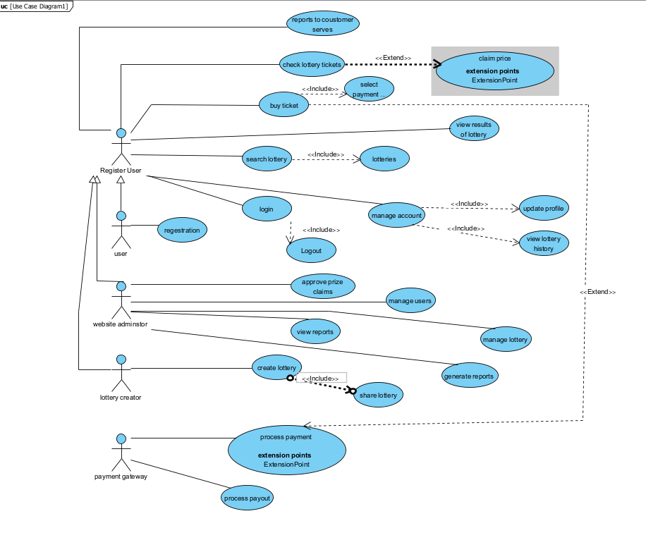

**2. Activity diagram:**

This diagram will show the flow of activities from selecting a lottery to completing the purchase.

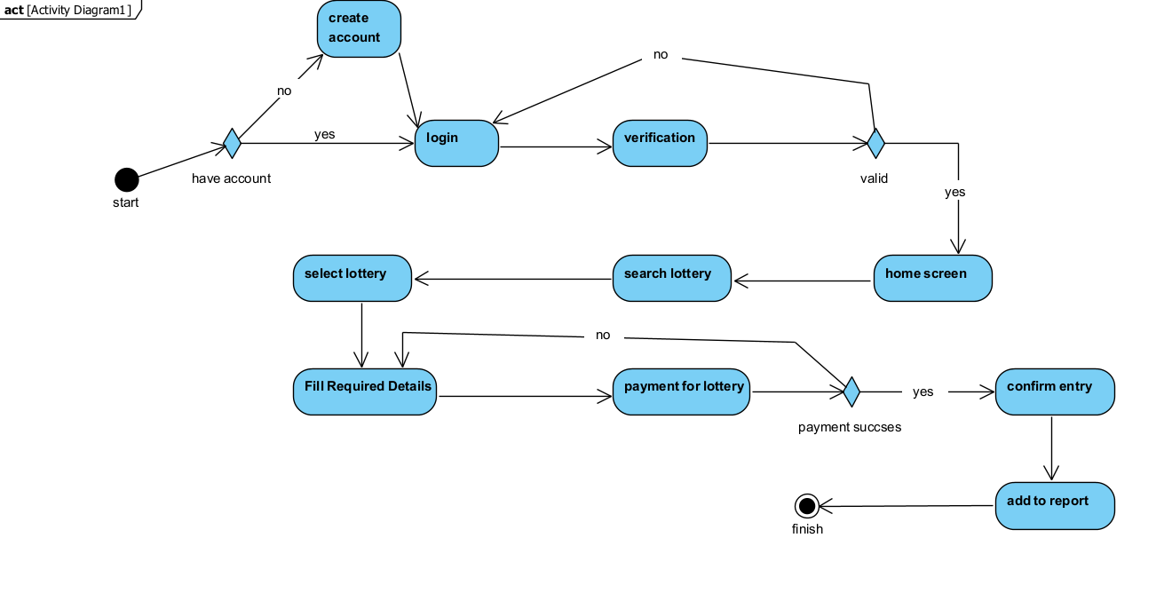

Activity diagram illustrating the process of creating a new lottery game on our lottery website:

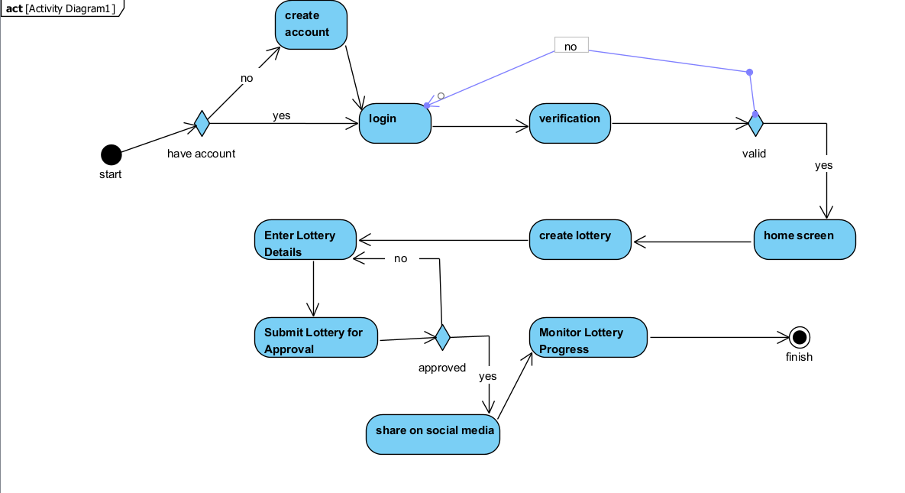

**3. Sequence diagram:**

*. Below is a sequence diagram illustrating the process of logging in to our lottery website:

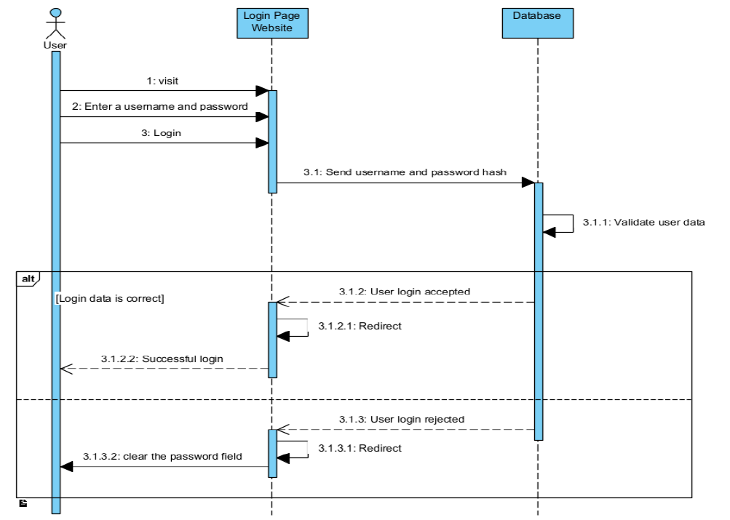

*. Below is a sequence diagram illustrating the process of purchasing tickets on our lottery website:

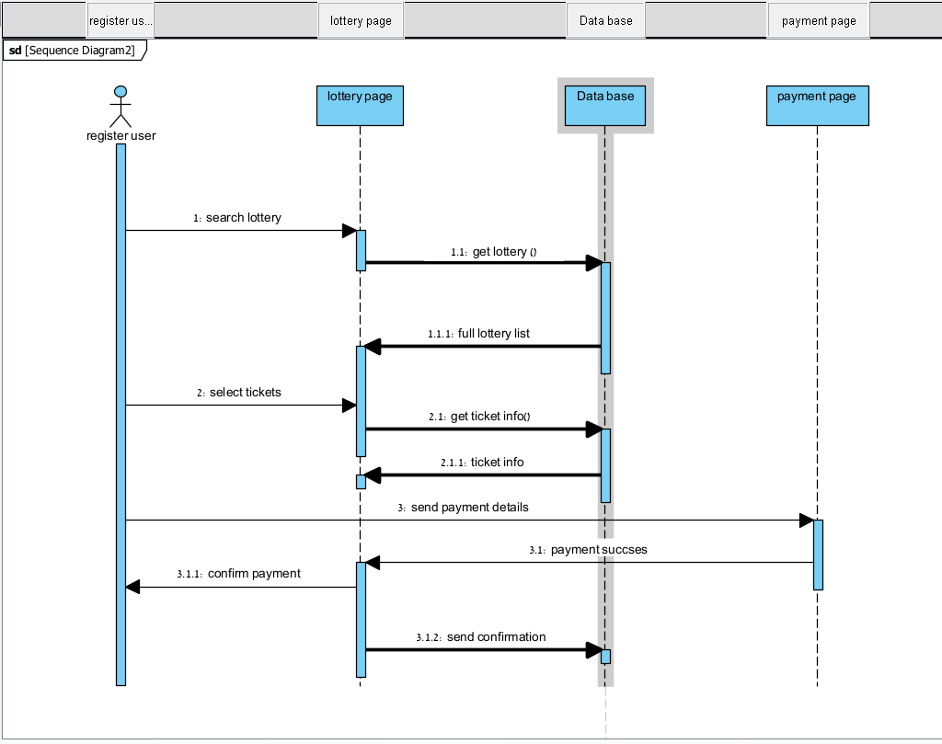

*. Below is a sequence diagram illustrating the process of creating lottery on our lottery website:

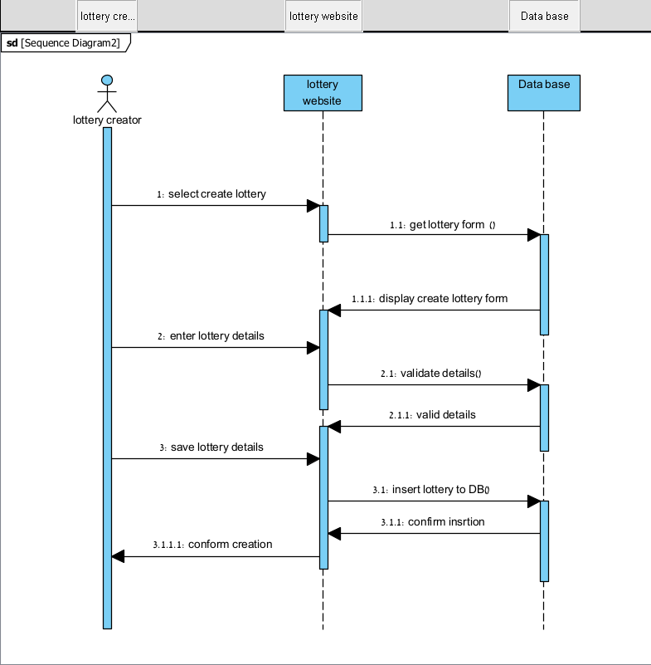

**Verification and Evaluation**

**Verification:**

Testing the code:

1. Signing into the website.
2. Signing up to the website.
3. Creating a lottery on the website.
4. Buying a ticket for our lottery on the website.

**1. Signing into the website:**

|  |  |  |  |  |
| --- | --- | --- | --- | --- |
| **Test Name** | **Description** | **Expected Results** | **Actual Results** | **Comments** |
| Signing in with valid credentials. | Sign in with a valid username and password. | The user should be redirected to the main page after successful login. | Successful login and redirected to the main page after showing the message “Welcome back”. | The user successfully logged in. |
| Signing in with invalid credentials. | Verify the handling of incorrect login credentials. | The user should receive an error message indicating invalid credentials and remain on the login page. | Invalid credentials and show the user message “one of the credentials is incorrect ”. | The user received an error message and remained on the login page. |
| Signing in with a locked account. | Verify the handling of attempting to sign in with a locked account. | The user should receive an error message indicating that the account is locked and should contact support. | Locked the account and showed the user the message “Account locked please contact support “. | The user received an error message and was instructed to contact support. |
| Signing in with an expired password. | Verify the handling of attempting to sign in with an expired password. | The user should be prompted to reset their password and redirected to the password reset page. | An expired password message is shown to the user and interaction. | The user was prompted to reset the password and redirected to the reset page. |

**2. Signing up to the website:**

|  |  |  |  |  |
| --- | --- | --- | --- | --- |
| **Test Name** | **Description** | **Expected Results** | **Actual Results** | **Comments** |
| Signing up with valid information. | Verify the ability to create a new account with valid information. | The user should be successfully registered and redirected to the login page with a confirmation message. | Successful registration and redirected to the login page after showing the message “Signing success “. | The user successfully registered and redirected to the login page with confirmation. |
| Signing up with an existing email. | Verify the handling of attempting to sign up with an email that is already registered. | The user should receive an error message indicating that the email is already in use and remains on the registration page. | Shown message to user “Email already in use “and stay on this page. | The user received an error message and remained on the registration page. |
| Signing up with a weak password. | Verify the handling of attempting to sign up with a weak password. | The user should receive an error message indicating that the password is too weak and remains on the registration page. | Shown a message to the user “Weak password “and stay on this page. | The user received an error message and remained on the registration page. |
| Signing up with an invalid email format. | Verify the handling of attempting to sign up with an invalid email format. | The user should receive an error message indicating that the email format is invalid and remains on the registration page. | Shown message to the user “Invalid email “and stay on this page. | The user received an error message and remained on the registration page. |

**3.Creating a lottery on the website:**

|  |  |  |  |  |
| --- | --- | --- | --- | --- |
| **Test Name** | **Description** | **Expected Results** | **Actual Results** | **Comments** |
| Creating a lottery with valid information. | Verify the ability to create a new lottery with valid details. | The user should be able to successfully create the lottery and see it listed on the website. | Shown message to the user” Successful creation”. | Lottery successfully created and listed on the website. |
| Creating a lottery with missing information. | Verify the handling of attempting to create a lottery with missing required fields. | The user should receive an error message indicating the missing information and remain on the creation form. | Shown message to the user “Missing information “and stay on this page | The user received an error message and remained on the creation form. |
| Creating a lottery with a past end date. | Verify the handling of attempting to create a lottery with an end date in the past. | The user should receive an error message indicating that the end date must be in the future and remain on the creation form. | Shown message to the user “Past end date “and stay on this page. | The user received an error message and remained on the creation form. |
| Creating a duplicate lottery. | Verify the handling of attempting to create a lottery with the same name as an existing one. | The user should receive an error message indicating that a lottery with the same name already exists and remains on the creation form. | Shown message to use “Duplicate lottery “and stay on this page. | The user received an error message and remained on the creation form. |

**4. Buying a ticket for lottery on the website:**

|  |  |  |  |  |
| --- | --- | --- | --- | --- |
| **Test Name** | **Description** | **Expected Results** | **Actual Results** | **Comments** |
| Purchasing a ticket for an active lottery. | Verify the ability to purchase a ticket for an active lottery. | The user should be able to select a lottery, choose the number of tickets, make payment, and receive a confirmation message with ticket details. | Shown message to the user” Successful purchase”. | The ticket was successfully purchased. Confirmation message received. |
| Purchasing a ticket for an inactive or non-existent lottery. | Verify the handling of attempting to purchase a ticket for an inactive or non-existent lottery. | The user should receive an error message indicating that the lottery is not available for ticket purchase. | Shown message to use “Inactive or non-existent lottery “and stay on this page. | The user received an error message indicating lottery status. |
| Purchasing a ticket with insufficient funds. | Verify the handling of attempting to purchase a ticket without sufficient funds. | The user should receive an error message indicating insufficient funds and be prompted to add funds to their account. | Shown message to use “Insufficient funds “and stay on this page. | The user received an error message and instructions to add funds. |
| Purchasing multiple tickets simultaneously. | Verify the ability to purchase multiple tickets in a single transaction. | The user should be able to select multiple tickets, make payment once, and receive confirmation for all tickets purchased. | Shown user message” Successful multiple ticket purchase”. | Multiple tickets were purchased successfully in a single transaction. |

**Evaluation:**

**1. Functionality Evaluation:**

   - Assess the functionality of the website, including user registration, lottery creation, ticket purchasing, winner selection, and notification features.

   - Verify that all functional requirements are implemented correctly and that the system behaves as expected.

   - Evaluate the ease of use and intuitiveness of the user interface for both participants and administrators.

**2. Performance Evaluation:**

   - Measure the website performance under various conditions, including normal usage, peak loads, and stress scenarios.

   - Evaluate response times, throughput, and resource utilization to ensure that the system can handle expected user traffic.

   - Identify any performance bottlenecks or scalability issues and take steps to optimize system performance.

**3. Security Assessment:**

   - Conduct security assessments to identify and mitigate potential vulnerabilities and threats.

   - Perform penetration testing and vulnerability scanning to assess the system's resilience to attacks such as SQL injection and cross-site scripting (XSS).

   - Evaluate the effectiveness of authentication mechanisms, data encryption, and access controls in safeguarding user data and system resources.

**4. User Acceptance Testing:**

   - Engage end-users to participate in user acceptance testing to gather feedback on the usability and functionality of the website.

   - Evaluate user satisfaction with the overall user experience, interface design, and ease of navigation.

   - Incorporate user feedback to make necessary improvements and enhancements to the website.

**5. Feedback and Continuous Improvement:**

   - Gather feedback from the supervisor, including participants and administrators, to identify areas for improvement.

   - Establish a process for continuous monitoring and evaluation to track the performance and effectiveness of the website over time.

   - Implement iterative improvements based on feedback and evaluation results to enhance the website functionality, performance, security, and compliance.

By conducting a thorough evaluation across these key areas, you can ensure that the lottery website project meets its objectives, delivers value to stakeholders, and operates effectively and securely by industry standards and regulations.

**References**

1. **Article about Improvement of fairness in lottery draws:**

<https://www.researchgate.net/publication/304453518_DEVELOPING_AND_MODELING_A_NEW_E-LOTTERY_SYSTEM_USING_ANONYMOUS_SIGNATURES>.

1. **Lottery website:** <https://www.thelotter.com>.
2. **Lottery website:** <https://www.lotto247.com>.
3. **An online tool that helps choose random winners**: <https://www.randompicker.com>.
4. **Lottery global market report:** [Lottery Global Market Report 2024 - Research and Markets](https://www.researchandmarkets.com/report/lottery).