Untitled2

Requirement Report

Author: <Author name>

Revision: 0.1

|  |  |
| --- | --- |
| NA |  |
| NA | Date: abril 10, 2018 |

**Revision History**

|  |  |  |  |
| --- | --- | --- | --- |
| **Revision** | **Date** | **Reason For Changes** | **Author** |
| 1.0 | Jan 02, 1990 | <Release> | <Author Name> |
| 0.1 | Jan 01, 1990 | <Initial draft> | <Author Name> |
|  |  |  |  |

**Table of Contents**

Microsoft Word users please click here and press F9 to create Table of Contents.

OpenOffice.org users please remove this text and select Insert Table of Content from menu.

**Table of Figures**

Microsoft Word users please click here and press F9 to create Table of Contents.

OpenOffice.org users please remove this text and select Insert Table of Content from menu.

**Executive Summary**

This section previews the main points of a report. The executive summary contains enough information for a reader to get familiarized with what is discussed in the full report without having to read it.

# Introduction

## Purpose

<This document provides requirements with their properties including requirement id, requirement name, requirement text and the dependencies.>

## Scope

<Provide a short description of the system being specified and its purpose, including relevant benefits, objectives, and goals.>

## Overview

<Describe what the document contains and explain how the document is organized>

# Your Requirements Project

## 1 Business requirements

### BR-1 Business requirement1

The system shall do term1

**customNumberingData:**

Multi-levelɲɪɳtrueɲɪɳfalseɲɪɳBR-ɲɪɳɲɪɳ3ɲɪɳ_17_0_4beta_1b3a0482_1355297412593_609711_22854ɲɪɳ_11_5EAPbeta_be00301_1147873236436_846958_2313ɲɪɳ_11_5EAPbeta_be00301_1147873190330_159934_2220ɲɪɳtrue

#### BR-1.1 Business requirement2

The system shall do term2

**Derived:**

|  |  |
| --- | --- |
| 611732300.png | FR-1.1 Find companion |

|  |  |
| --- | --- |
| -1332058945.png | NFR-1.1 Design constraint1 |

**Traced From:**

|  |  |
| --- | --- |
| 611732300.png | FR-1.1 Find companion |

|  |  |
| --- | --- |
| -711111710.png | Use case1 |

|  |  |
| --- | --- |
| -1332058945.png | NFR-1.1 Design constraint1 |

#### BR-1.2 Business requirement3

The system shall do term2

**Derived:**

|  |  |
| --- | --- |
| 611732300.png | FR-1.2 Find a safe route |

|  |  |
| --- | --- |
| -1421853680.png | NFR-1.2 Interface requirement1 |

|  |  |
| --- | --- |
| 887432052.png | NFR-1.3 Performance requirement1 |

**Traced From:**

|  |  |
| --- | --- |
| 611732300.png | FR-1.2 Find a safe route |

|  |  |
| --- | --- |
| -711111710.png | Use case2 |

|  |  |
| --- | --- |
| -711111710.png | Use case3 |

|  |  |
| --- | --- |
| -1421853680.png | NFR-1.2 Interface requirement1 |

|  |  |
| --- | --- |
| 887432052.png | NFR-1.3 Performance requirement1 |

#### BR-1.3 Business requirement4

The system shall do term2

## 2 Domain model

## 3 System requirements

### 3.1 Functional requirements

#### FR-1 Provide a safe way to return home

The system shall provide information about other people going to the same place and allow you to contact with them

##### FR-1.1 Find companion

The system shall find people who go to the same area

**Derived From:**

|  |  |
| --- | --- |
| -270268993.png | BR-1.1 Business requirement2 |

**Traced To:**

|  |  |
| --- | --- |
| -270268993.png | BR-1.1 Business requirement2 |

**Traced From:**

|  |  |
| --- | --- |
| -294913209.png | NA |

**Refines:**

|  |  |
| --- | --- |
| -711111710.png | Use case1 |

###### FR-1.1.1 NA

##### FR-1.2 Find a safe route

The system shall show the safest way to arrive home

**Derived From:**

|  |  |
| --- | --- |
| -270268993.png | BR-1.2 Business requirement3 |

**Traced To:**

|  |  |
| --- | --- |
| -270268993.png | BR-1.2 Business requirement3 |

#### FR-2 Modify info

The system shall store the new information entered by the user

#### FR-3 Panic button

The system shall provide access to the panic button in case of danger

#### 3.1.1 Use cases

### 3.2 Non-functional requirements

#### NFR-1 Non-functional requirement1

The system shall do term1

##### NFR-1.1 Design constraint1

The system shall do term2

**Derived From:**

|  |  |
| --- | --- |
| -270268993.png | BR-1.1 Business requirement2 |

**Traced To:**

|  |  |
| --- | --- |
| -270268993.png | BR-1.1 Business requirement2 |

##### NFR-1.2 Interface requirement1

The system shall do term2

**Derived From:**

|  |  |
| --- | --- |
| -270268993.png | BR-1.2 Business requirement3 |

**Traced To:**

|  |  |
| --- | --- |
| -270268993.png | BR-1.2 Business requirement3 |

**Refines:**

|  |  |
| --- | --- |
| -711111710.png | Use case2 |

##### NFR-1.3 Performance requirement1

The system shall do term2

**Derived From:**

|  |  |
| --- | --- |
| -270268993.png | BR-1.2 Business requirement3 |

**Traced To:**

|  |  |
| --- | --- |
| -270268993.png | BR-1.2 Business requirement3 |

## 4 Traceability

### 4.1 Coverage validation

# Appendix A: Diagram

## Business requirement diagram

NA

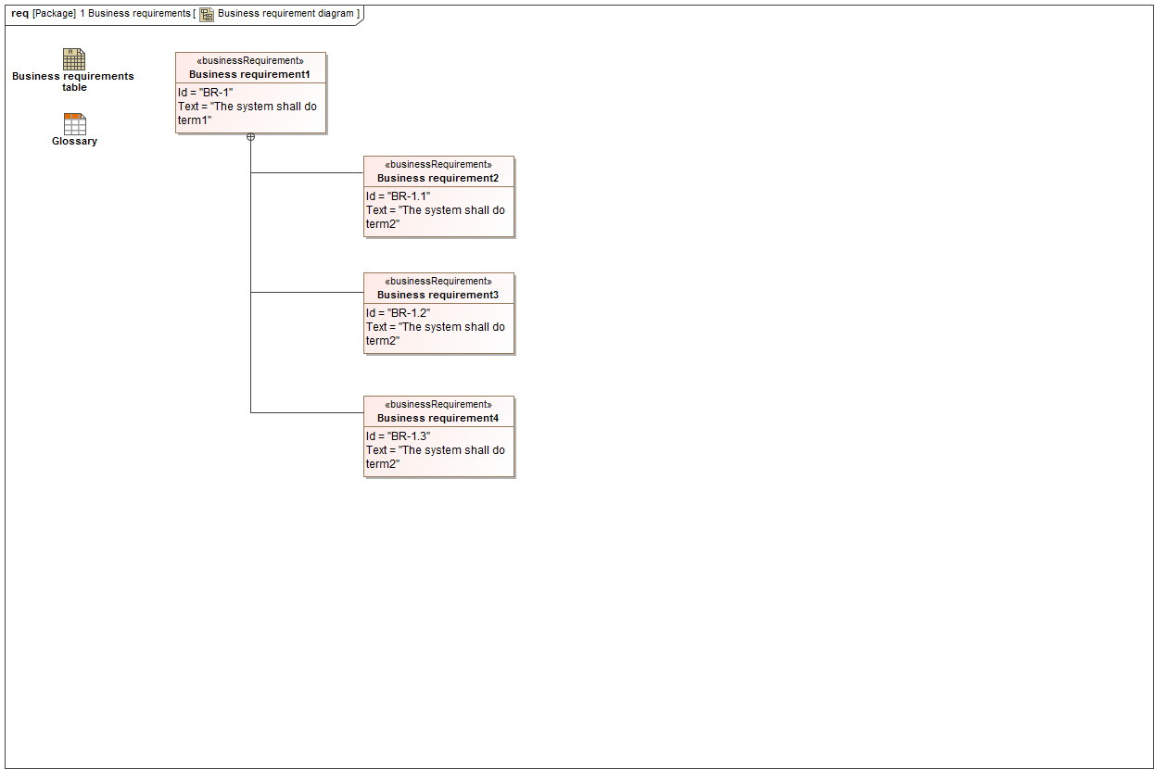

1. Business requirement diagram

## Business requirements table

NA

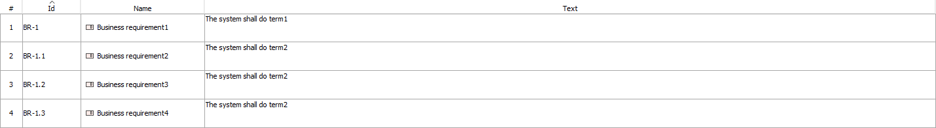

1. Business requirements table

## Derive FR and NFR from business requirements

NA

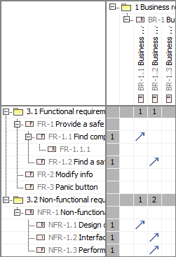

1. Derive FR and NFR from business requirements

## Domain model

NA

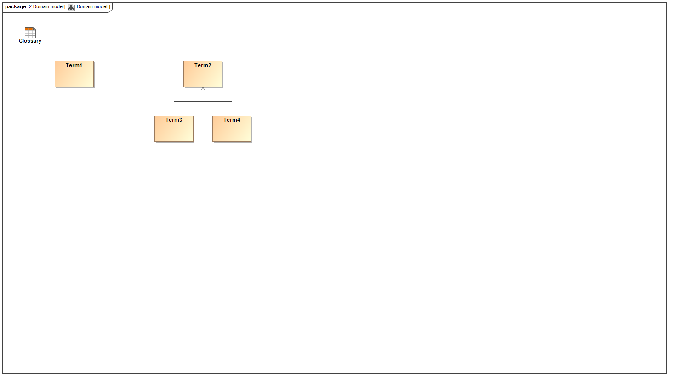

1. Domain model

## Flow

NA

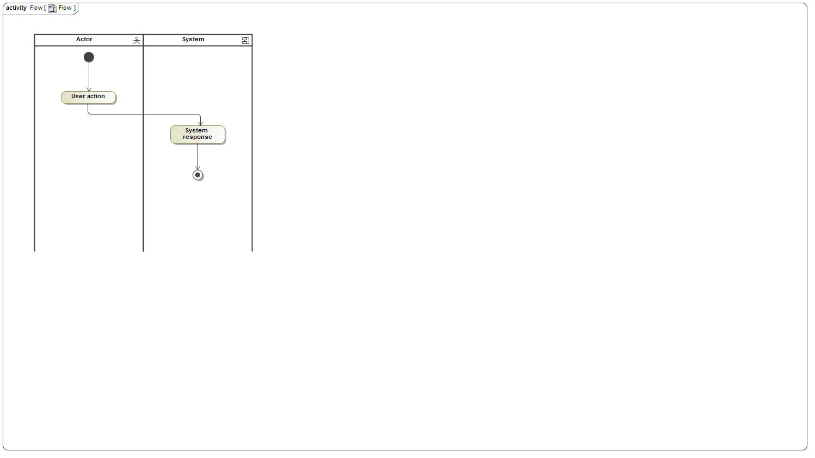

1. Flow

## Flow

NA



1. Flow

## Flow

NA



1. Flow

## FR diagram

NA

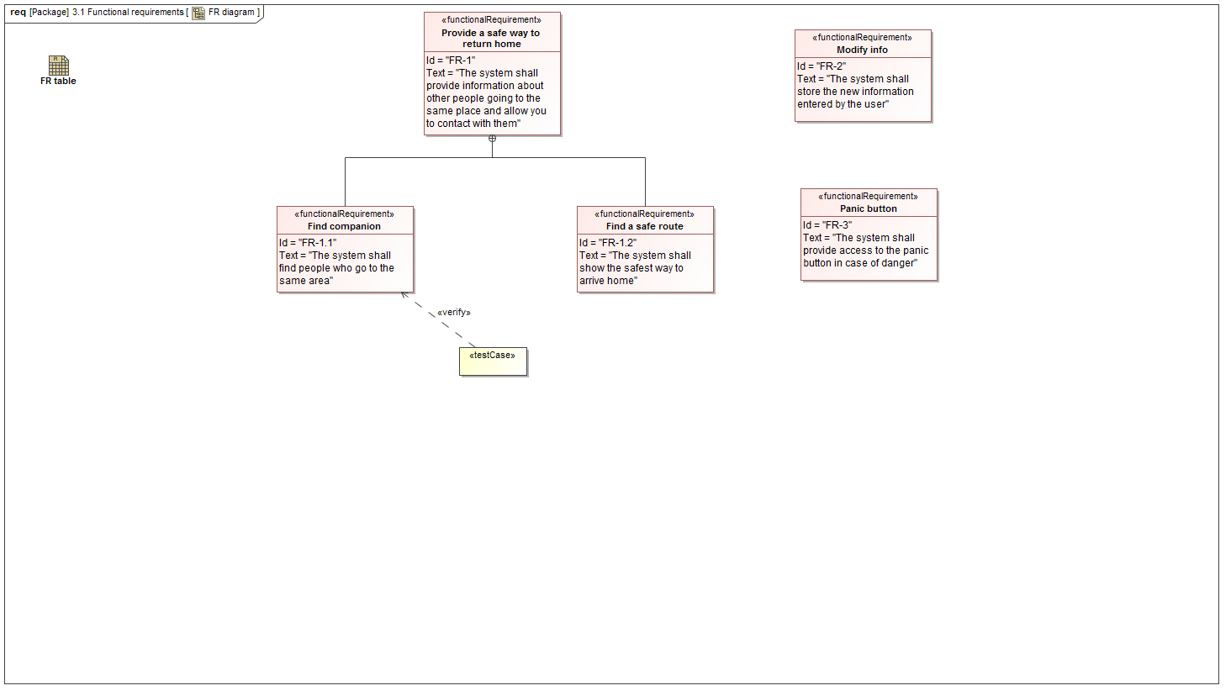

1. FR diagram

## FR table

NA

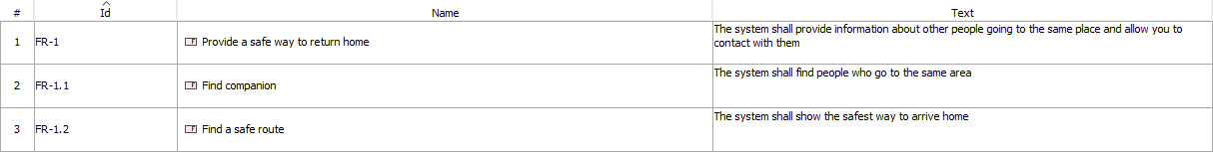

1. FR table

## Full traceability

NA

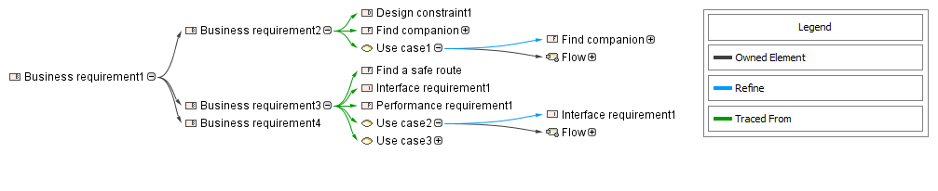

1. Full traceability

## Glossary

NA

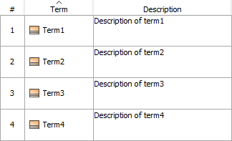

1. Glossary

## Intro

NA

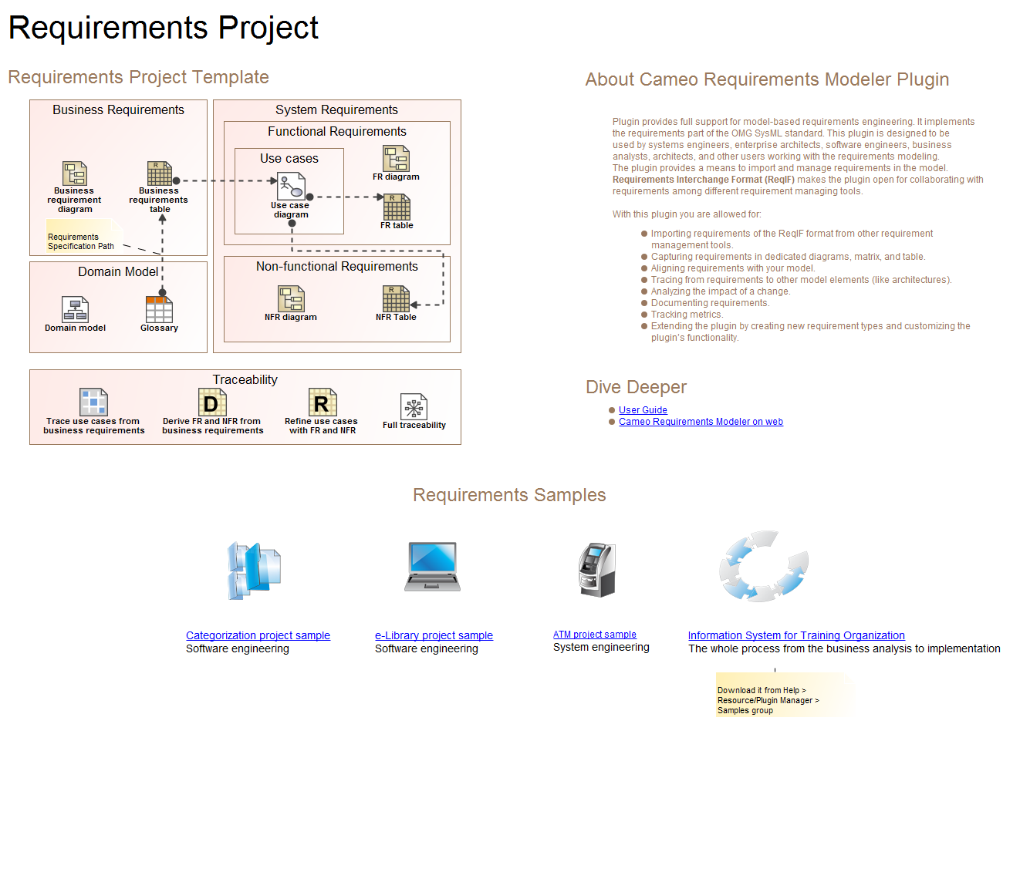

1. Intro

## NFR diagram

NA

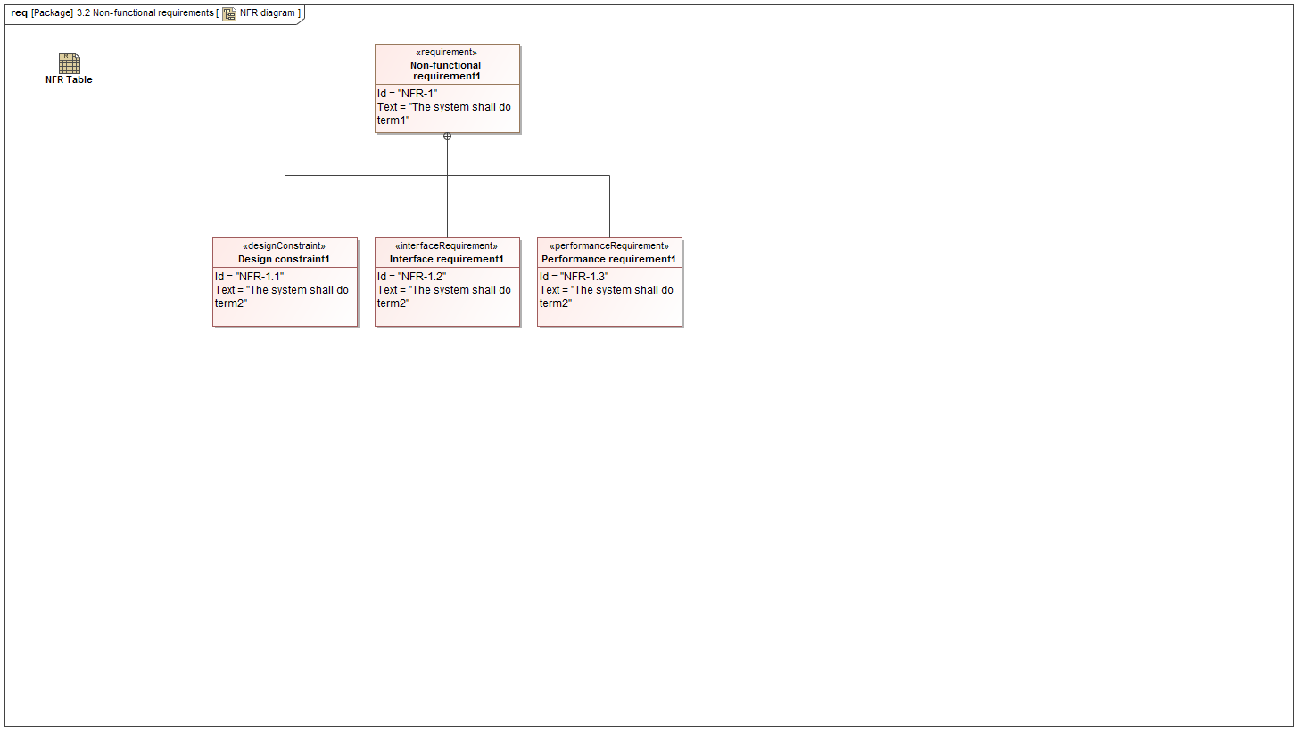

1. NFR diagram

## NFR Table

NA

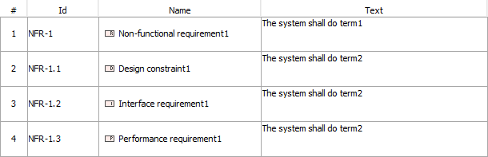

1. NFR Table

## Refine use cases with FR and NFR

NA

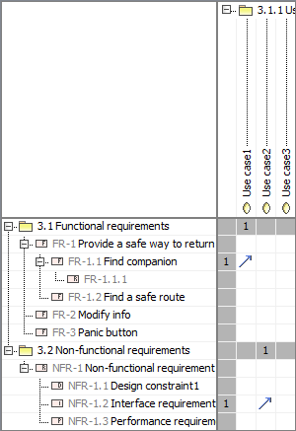

1. Refine use cases with FR and NFR

## Trace use cases from business requirements

NA

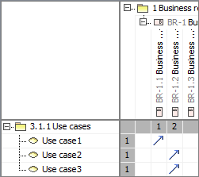

1. Trace use cases from business requirements

## Use case diagram

NA

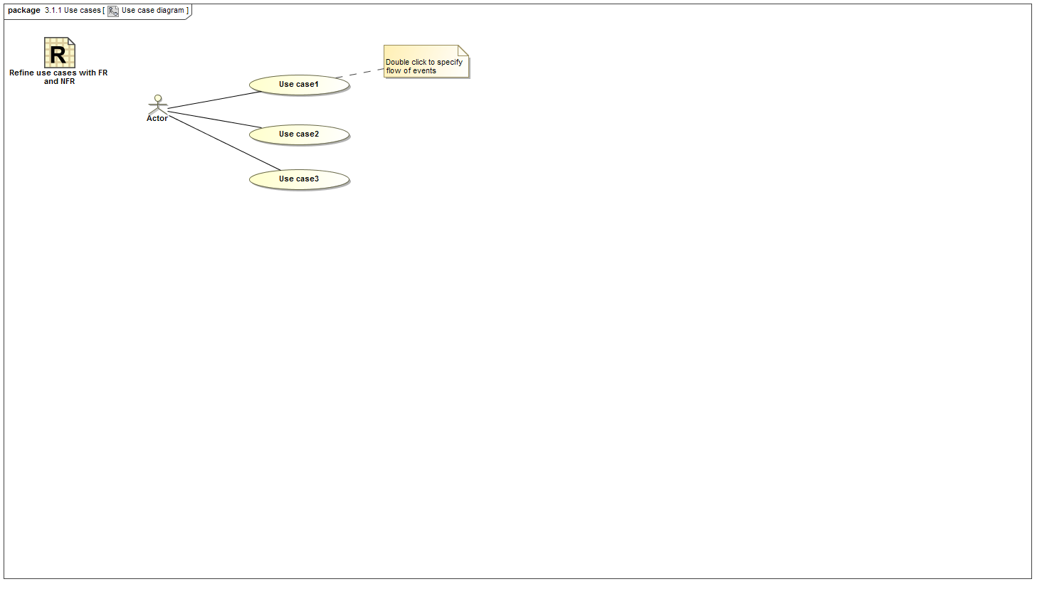

1. Use case diagram