Display Driver Uninstaller (DDU) Tutorial

By - [/u/GhostMotleyXT](https://www.reddit.com/user/GhostMotleyXT/)

This tutorial was written for DDU version 17.0.2.1, future versions may differ slightly. I will try and keep this guide as updated as possible, however please feel free to contact me via PM on Reddit if you think I should update the guide.

**DISCLAIMER**: I take no responsibility for any damages caused if you don’t follow the steps correctly, you proceed at your own risk and take full responsibility. It should also be noted any settings or profiles you’ve created in your GPU control panel will be removed - you may need to re-enable things like SLI, CrossfireX, tweak colour settings etc...

Q: **What is DDU?**

A: Display Driver Uninstaller (DDU) is a driver removal tool that can help you completely uninstall AMD (ATI), NVIDIA and Intel graphics drivers from your system, without leaving leftovers behind (such as registry keys, folders, files, driver store)

Over time these leftover files can cause compatibility issues, such as drivers failing to install or reducing performance in certain games. By using DDU you can remove these leftovers and solve many of the common issues related to GPU drivers.

***Step 1 - Download the latest GPU drivers*** (do not run them yet)Before we go ahead and use DDU to remove our GPU drivers I highly recommend beforehand you head to your GPU manufacturers website and download the appropriate drivers for your GPU and OS configuration (I always recommend you use the latest stable drivers available)

Here are the official download links for NVIDIA, AMD (ATI) and Intel

* Be sure to select the right options

NVIDIA: <http://www.nvidia.com/Download/index.aspx?lang=en-us>

AMD (ATI): <http://support.amd.com/en-us/download>

Intel: <https://downloadcenter.intel.com/?_ga=1.151382769.912532102.1466365025>

*Note: With some computers you may have to acquire your GPU drivers from the OEMs website (HP, Dell, Lenovo). Some GPUs may have custom hardware IDs that only officially work with the OEM specific drivers; however this isn’t common.

***Step 2 - Download DDU!***

After you’ve downloaded your GPU drivers we can now go ahead and download DDU, I recommend you download DDU from Guru3D, they are an official mirror for DDU and you can be sure it’s safe from any Malware or Viruses.

DDU Download: <http://www.guru3d.com/files-details/display-driver-uninstaller-download.html>

I always recommend you download the latest version of DDU, it gets updated quite regularly to keep up with the changes they make to their GPU drivers, as I’m making this guide the latest version is 17.0.2.1.

The latest version is at the bottom, unless they change this in the future.

***Step 3 - Extract and run DDU***

Once you’ve download DDU you need to extract it, I recommend extracting it to the Desktop for ease of access.

To extract an archive simply Right Click and select “Extract All...” and select the destination you wish to extract to, I recommend the Desktop.

Once you’ve done this you should now see a new folder on the Desktop, or where you extracted the folder to. Simply open this folder and run the DDU application (.exe)

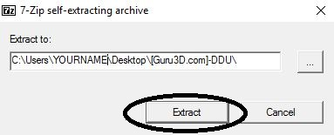

Once you’ve extracted DDU (again) to the destination folder you should see several new files appear, we’re interested in the “Display Driver Uninstaller” one; run this file.

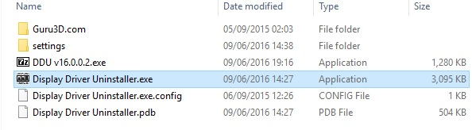

After you’ve ran “Display Driver Uninstaller” you should be presented with a Warning box, advising you to launch DDU in Safe Mode, I highly recommend you use DDU in Safe Mode to minimize any potential issues; however you can use DDU in Normal Windows mode.

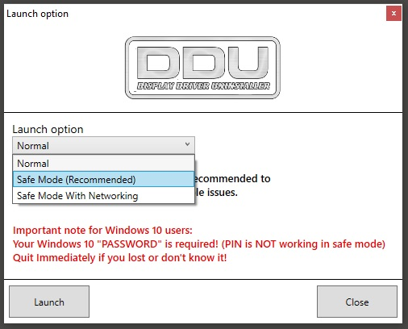

If you select Safe Mode (w/wo Networking) your PC should reboot into Safe Mode and DDU will start, if you select Normal Windows mode, click Launch and DDU will open in Normal Windows Mode.

*Note: If you use DDU in Normal Windows Mode I recommend you close down any background programs, such as games, browsers, media players etc…

After launching DDU (in Safe Mode or not) you will be presented with this screen, instead of simply clicking one of the removal buttons I recommend you head to the options and tweak how DDU removes the drivers.

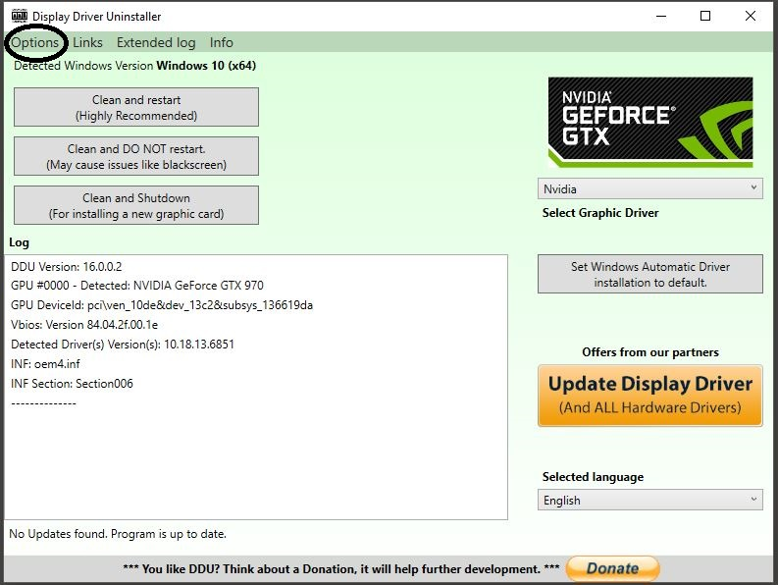

By default DDU 17.0.2.1 comes with these options pre-applied

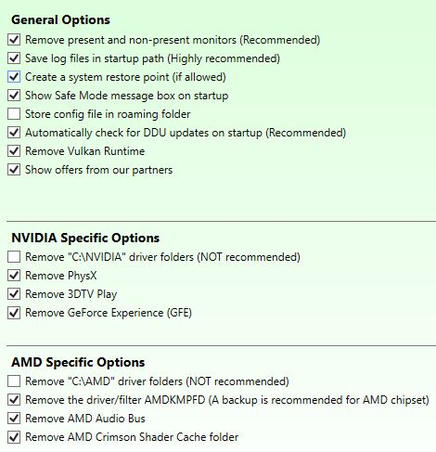

I recommend you tick to remove the C:\NVIDIA and C:\AMD folders

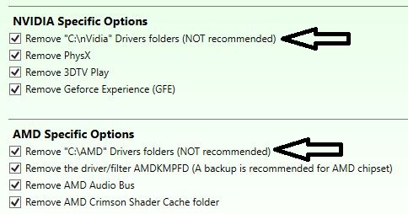

These folders are the default locations where the NVIDIA or AMD driver installation files are unpacked, once the driver is installed these folders can safely be deleted.

Once this has been done exit the options menu and now we can begin using DDU to remove our GPU drivers.

On the right side you’ll see a drop down box that allows you to select what GPU drivers you want to remove, it should automatically detect which GPU vendor you have.

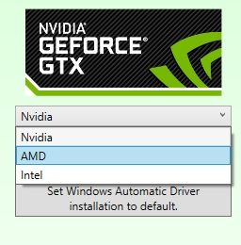

If you previously had an AMD (ATI) GPU in your system and then made the switch to NVIDIA (or vice versa) in the same Windows Install you will want to remove the AMD drivers and then the NVIDIA drivers (or vice versa).

Intel iGPU (HD, Iris graphics) drivers shouldn’t cause any conflictions between AMD or NVIDIA drivers. However, having assets of AMD drivers installed on an NVIDIA system, or vice versa can cause issues.

On the left side of the interface you’ll see three buttons, all are relatively quite simple but I’ll run through them quickly.

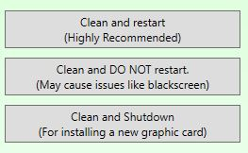

* Clean and restart  
  Will remove the current selected GPU drivers and reboot into Normal Windows Mode  
    
  This is great if you’ve only had a single GPU installed and you want to clean your drivers. It will reboot and you can start clean with the drivers you downloaded earlier
* Clean and DO NOT restart  
  This is the option you’d want to select if you’ve had multiple GPUs installed in the past, remove the AMD (ATI) drivers, change it to NVIDIA and remove the drivers (or vice versa)  
    
  This allows you to completely remove any GPU driver traces from your system and start completely fresh.
* Clean and shutdown  
  Will remove the currently selected GPU drivers and shutdown your system  
    
  This should be used if you intend to swap out your GPU, this is primarily for those who plan on jumping moving from one brand to another.

Now all we have left to do is remove our drivers, personally I use the ‘Clean and DO NOT restart’ option the most and recommend others do the same, it allows you to see what’s being removed and you can select between AMD (ATI), NVIDIA and Intel to make sure no conflicts are occurring if you’ve had different GPUs in your system. Your screen may go black for a few seconds while DDU is removing the GPU drivers - this is perfectly normal and should only last a few seconds.

Select your GPU vendor  
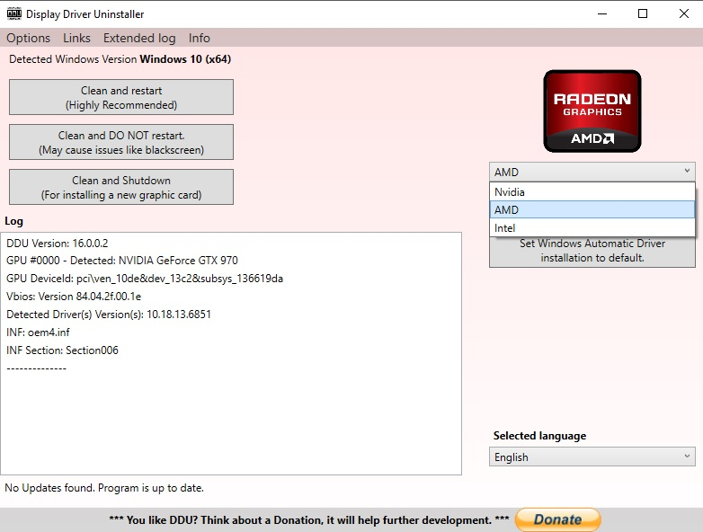

Select one of the removal options, I recommend you click ‘Clean and DO NOT restart’

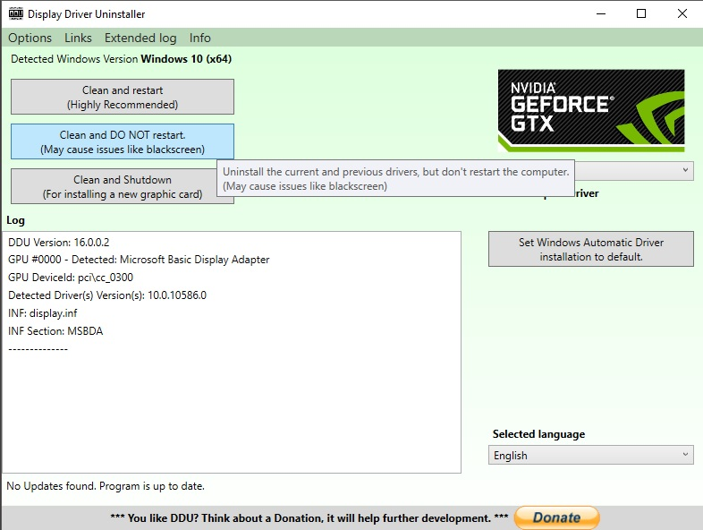

DDU will now remove the selected GPU drivers from your system, this will vary depending on the speed of your system

I just want to reiterate one more time, if you’ve had an AMD (ATI) or NVIDIA GPU in the same install of Windows I highly recommend you select and remove both GPU drivers to make sure there aren’t any conflicts.

While DDU is in operation you can see what it’s removing

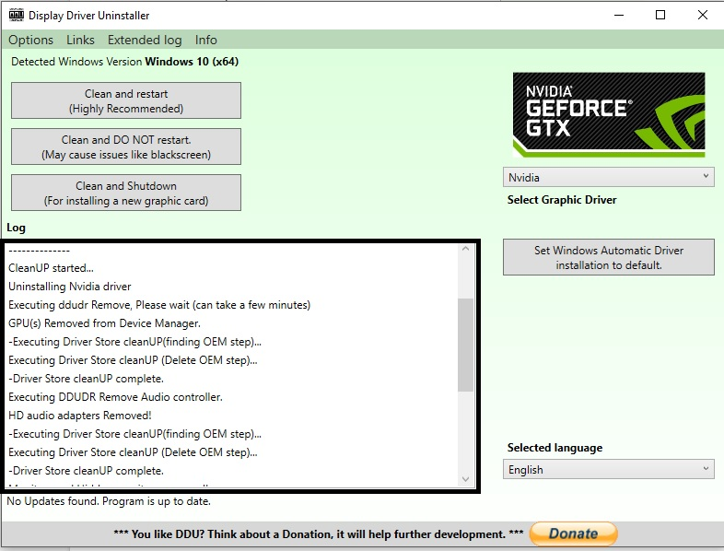

Once DDU has completed the removal of the selected GPU drivers you will be prompted with this message

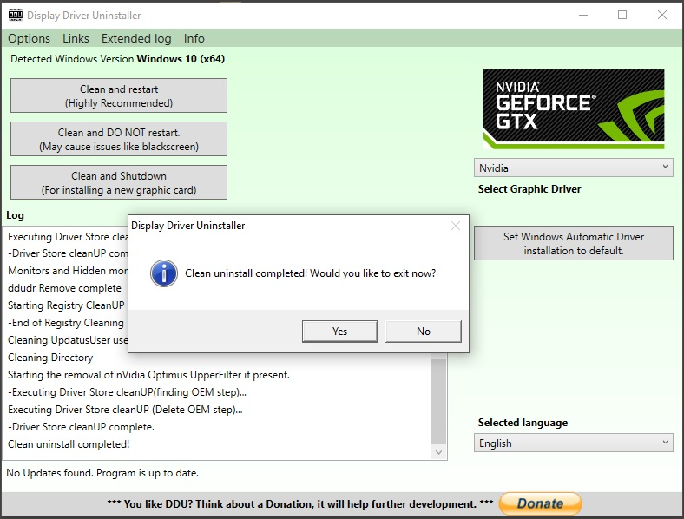

Once complete select ‘Yes’ to exit the program and restart Windows. Now you can start fresh with the GPU drivers you downloaded earlier.

As a side note I always recommend you update your GPU drivers through the official installer, programs like GeForce Experience and others can cause issues when updating drivers

Hopefully this guide has helped you resolve any GPU driver related issues you may have encountered, although I realise this guide won’t help everyone. GPU drivers are incredibly complex pieces of software and this is merely one fix. Below I have other tutorials that may help you resolve any issues that are related to GPU drivers (will be added later)

Interim help

* Try scanning your PC for any Malware/Viruses - [Tutorial here](https://docs.google.com/document/d/16er6ZmSj4nUHBP-80EQLZjNgLNIDHyE93u0Vu8e6wV0/edit)
* Make sure your OS isn’t corrupt - [Tutorial here](https://docs.google.com/document/d/1Y7HOS6UiOBXAWtNFBJ0w70f14izRQcBYD9puuSw6Ghs/edit?usp=sharing)
* For Windows 10 users, make sure you are on version 1511 at least. Press the Windows Key + R and type “winver”. If you are on an older version of Windows you will need to update.

