**EC-850-CORE-D02R04**

**User Guide**

Assembly line Inspection Monitor

# Contents

**About This Guide …………….....................................................................1**

# Chapter 1. Log into Your Device For Configuration. . . . . . . . . . . . . . . . . . 3

# Chapter 2. Configure Server Details . . . . . . . . . . . . . . . . . . . . . . . . . . . . . . 6

## Chapter *1*

# Log into Your Device For Configuration

Chapter 1Device Configuration

With a Web-based utility, it is easy to configure and manage the device. The Web-based utility can be used on any Windows, or UNIX OS with a Web browser, such as Microsoft Internet Explorer, Mozilla Firefox or Apple Safari.

Follow the steps below to log into your router.

Method # 1:- (Using DHCP)

1. Connect device to any network it will Obtain an IP address automatically(DHCP) and connect your Laptop to that network.
2. visit the IP assigned to the device e.g 192.168.3.177:7104 it depends on the network on which device connected with. log in with admin for username and extens1tyAdm1n for password.

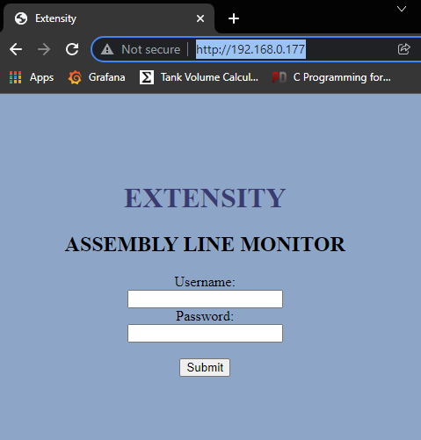

Local device IP

**Note:**If the login window does not appear, wait for some 20 seconds and visit again or restart the controller

Method # 2:- (Using Static IP)

1. Connect device to laptop(with patch cord) it will assigned a static IP of 192.168.4.1 to itself.

For windows go to: Control_Panel->

All_Control_Panel_Items-> Network_Connections->

Ethernet properties and Set laptop IPv4 to static IP in the range of 192.168.4.X and set submit mask 255.255.255.0 and save it. Now laptop and device are on same network

1. Set Run button to configuration mode it will turn off the run button led (mean it will go to configuration mode now)
2. visit the IP address 192.168.4.1 form any browser. log in with admin for username and extens1tyAdm1n for password.

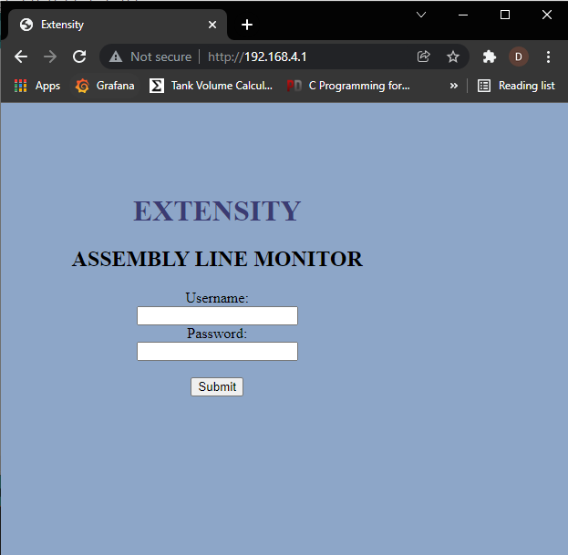

Local device IP

**Note:**If the login window does not appear, wait for some 20 seconds and visit again

## Chapter *2*

# Configure Server Details

* After successfully log in to the Device configuration page will appear with Server details in which device in currently configured.

* Edit the desire field and submit individually
* For default value submit the **configure default** field
* After configuration pressed submit for **save** **configure & close**
* After completion, turn back Run button to their previous run state.