

**SEMESTER A242**

**SQIT 3073: Business Analytic Programming**

**INDIVIDUAL PROJECT**

**TITTLE :**

**TECHNICAL MANUAL: MALAYSIAN TAX INPUT PROGRAM**

**PREPARED FOR:**

DR. AMEER ADEEB

**PREPARED BY:**

MUHAMMAD DANISH IMRAN BIN MOHD AFZANIZAM

299316

**8 MAY 2025**

# 1. Introduction

This technical manual describes the structure, logic, and flow of the Malaysian Tax Input Program developed in Python. The system allows users to calculate income tax payable based on input income and tax relief, following Malaysian tax rules.

# 2. Objectives

The objectives of this program are:  
- To provide a simple interface for users to compute income tax  
- To demonstrate file handling, user authentication, and basic tax logic in Python  
- To save user records into a CSV file

# 3. File Structure

The program is divided into the following files:  
- main.py: The main script for user input and logic control  
- functions.py: Contains reusable functions for verification, calculation, and file handling  
- users.txt: Stores registered users’ ID and IC  
- tax_records.csv: Stores all tax calculation records

# 4. Program Flow

The flow of the Malaysian Tax Input Program begins with the user launching the system, where they are presented with a main menu offering three options: register as a new user, log in as an existing user, or exit the program. If the user selects the registration option, they will be prompted to enter a unique user ID, a 12-digit IC number, and a password, which must match the last four digits of their IC number. These details are stored in a text file for future authentication. If the user chooses to log in instead, they are required to input their user ID, IC number, and password. The system verifies the credentials using predefined functions to ensure the IC is 12 digits and the password matches the last four digits of the IC. If the login fails, the user is notified and returned to the main menu. Upon successful login, the user proceeds to the tax input section, where they enter their annual income and eligible tax relief amount. The program then calculates the chargeable income by subtracting the relief from the total income. Based on this chargeable income, the program determines the amount of tax payable using Malaysia’s progressive tax rate system. The final tax amount is displayed to the user and the entire set of data—including the user's ID, IC number, income, relief, and tax payable—is saved into a CSV file for record-keeping. The user then has the option to return to the main menu for another operation or exit the program, marking the end of the session

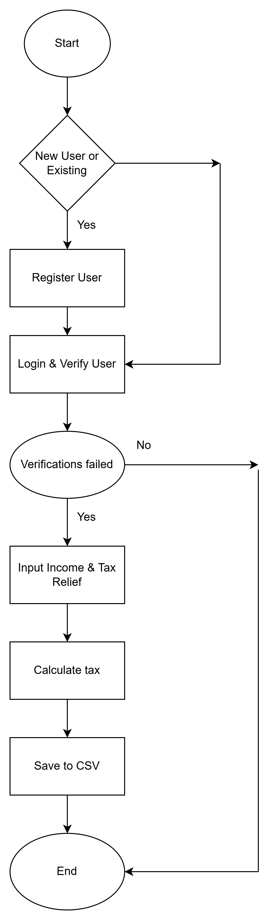

# 5. Function Descriptions

verify_user(ic_number, password): Checks that the password matches the last 4 digits of the IC number.

calculate_tax(income, tax_relief): Calculates tax payable based on a tiered structure.

save_to_csv(data, filename): Appends new user tax records to a CSV file.

read_from_csv(filename): Reads tax record data from a CSV file.

# 6. Sample Input/Output

User enters ID, IC, and password.  
User inputs income = RM 50,000, tax relief = RM 10,000.  
Output: Tax Payable = RM 1,800.00

# 7. Conclusion

This program is a simplified model of the Malaysian income tax system, suitable for learning file I/O, conditionals, and modular programming.